



Anne Scott

Line Cook

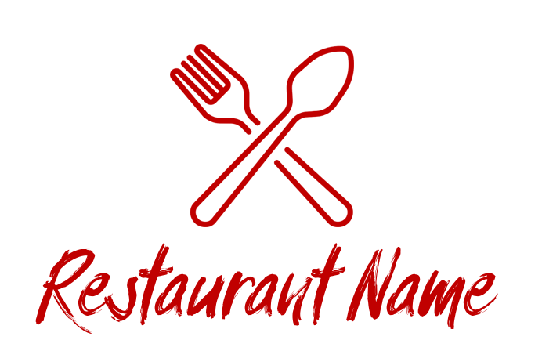

Organizational Chart

Olivia Smith

Wine Runner

Isaac Newton

Head Bartender

Maxwell Clerk

Beverage Leader

Bill Simpson

Busser

Sandra Bailey

Server

Alessandro Volta

Host

Blaise Pascal

Chef

James Watt

Assistant Chef

Will Thomson

Dining Room Leader

Alfred Nobel

HR Manager

Max Planck

Admin

Nikola Tesla

Restaurant Manager

Johan Kepler

Finance Manager



Thomas Edison

Owner

