Form: Leave of absence request

(Revised June 2018)

**REQUEST FOR LEAVE OF ABSENCE DURING TERM TIME**

1

**Please authorise absence for:** of form

of form

**I request authorisation for my child/children to be absent from school due to**:

Immediate family member’s bereavement, crisis, serious illness or funeral Wedding of immediate family member (please provide evidence) Religious observance (please specify)

Service personnel about to go on deployment (please provide letter from the Commanding Officer)

To participate as a competitor at a sporting event / competition (please provide evidence from organising body)

Examinations (please provide evidence from organising body) Medical appointments for half a day or longer *

Other (please specify)

Please attach letter / evidence for absences of half a day or longer.* Schools are unable to authorise any request for absence relating to holidays in term time, unless under exceptional circumstances. If you feel your circumstances are exceptional, please complete this form with a detailed letter to the Head Teacher.

*Half a day is defined as being from morning registration until lunch time, or from lunch time until the end of the school day.

**Time** From:

To:

**Date** From:

To:

**Name of Parent/Carer:**

**Address:**

I/We understand that the school is not obliged to authorise this request.

**Signature of Parent/Carer**:

**Absence Authorised**

**Absence Not Authorised**

**Signed by Head of House:**

**Date:**

Percentage attendance:

*(Office use only)*

Date received by office:

**REQUEST FOR LEAVE OF ABSENCE DURING TERM TIME** RETURN TO PARENT(S)/CARER(S)

**Student name/s:** of form:

of form:

**Time** From:

To:

**Date** From:

To:

**Absence Authorised**

**Absence Not Authorised**

**Signed by Head of House:**

**Date:**

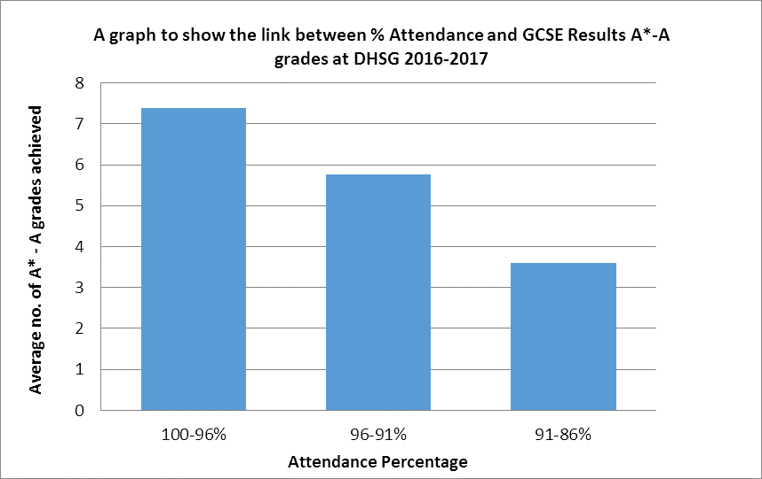

**SCHOOL ATTENDANCE - LEAVE OF ABSENCE IN TERM TIME**

**INFORMATION FOR PARENTS / CARERS**

DHSG is committed to providing a full and effective educational experience for all students. We

believe that if students are to fully benefit from education, excellent attendance is crucial. As a school, we will do all that we can to ensure maximum attendance for all students.

Schools may authorise absence during term time but approval is not automatic.

The Head Teacher will only grant leave of absence during term time if there are exceptional

circumstances. The Head Teacher will determine the number of school days a student can be away from school if the leave is granted.

The duration of the absence and the date of return should be agreed by the School before making

any arrangements.

National data for Secondary School attendance tells us that the benchmark for good attendance is

94.9% (RAISE 2015). This is the standard for comparison that is used by OFSTED to make judgements and as such we will use this to set a threshold of 95% attendance when considering an application for leave of absence.

Following DfE guidance, if the school refuses a request for term time leave and the student is still

taken out of school, this will be recorded as unauthorised absence.

There is a strong connection between attendance and achievement at school. Absence is proven to

have a significant negative impact upon a child’s educational attainment. The graph below demonstrates this relationship clearly and uses data from the Year 11 DHSG cohort 2016-2017.

.

2

Attendance over one school year (190 school days) – If a student had:

* 98% attendance = less than 4 days absent from school
* 95% attendance = less than 10 days absent from school
* 90% attendance = 4 weeks absent from school
* 85% attendance = 5½ weeks absent from school
* 80% attendance = 7½ weeks absent from school