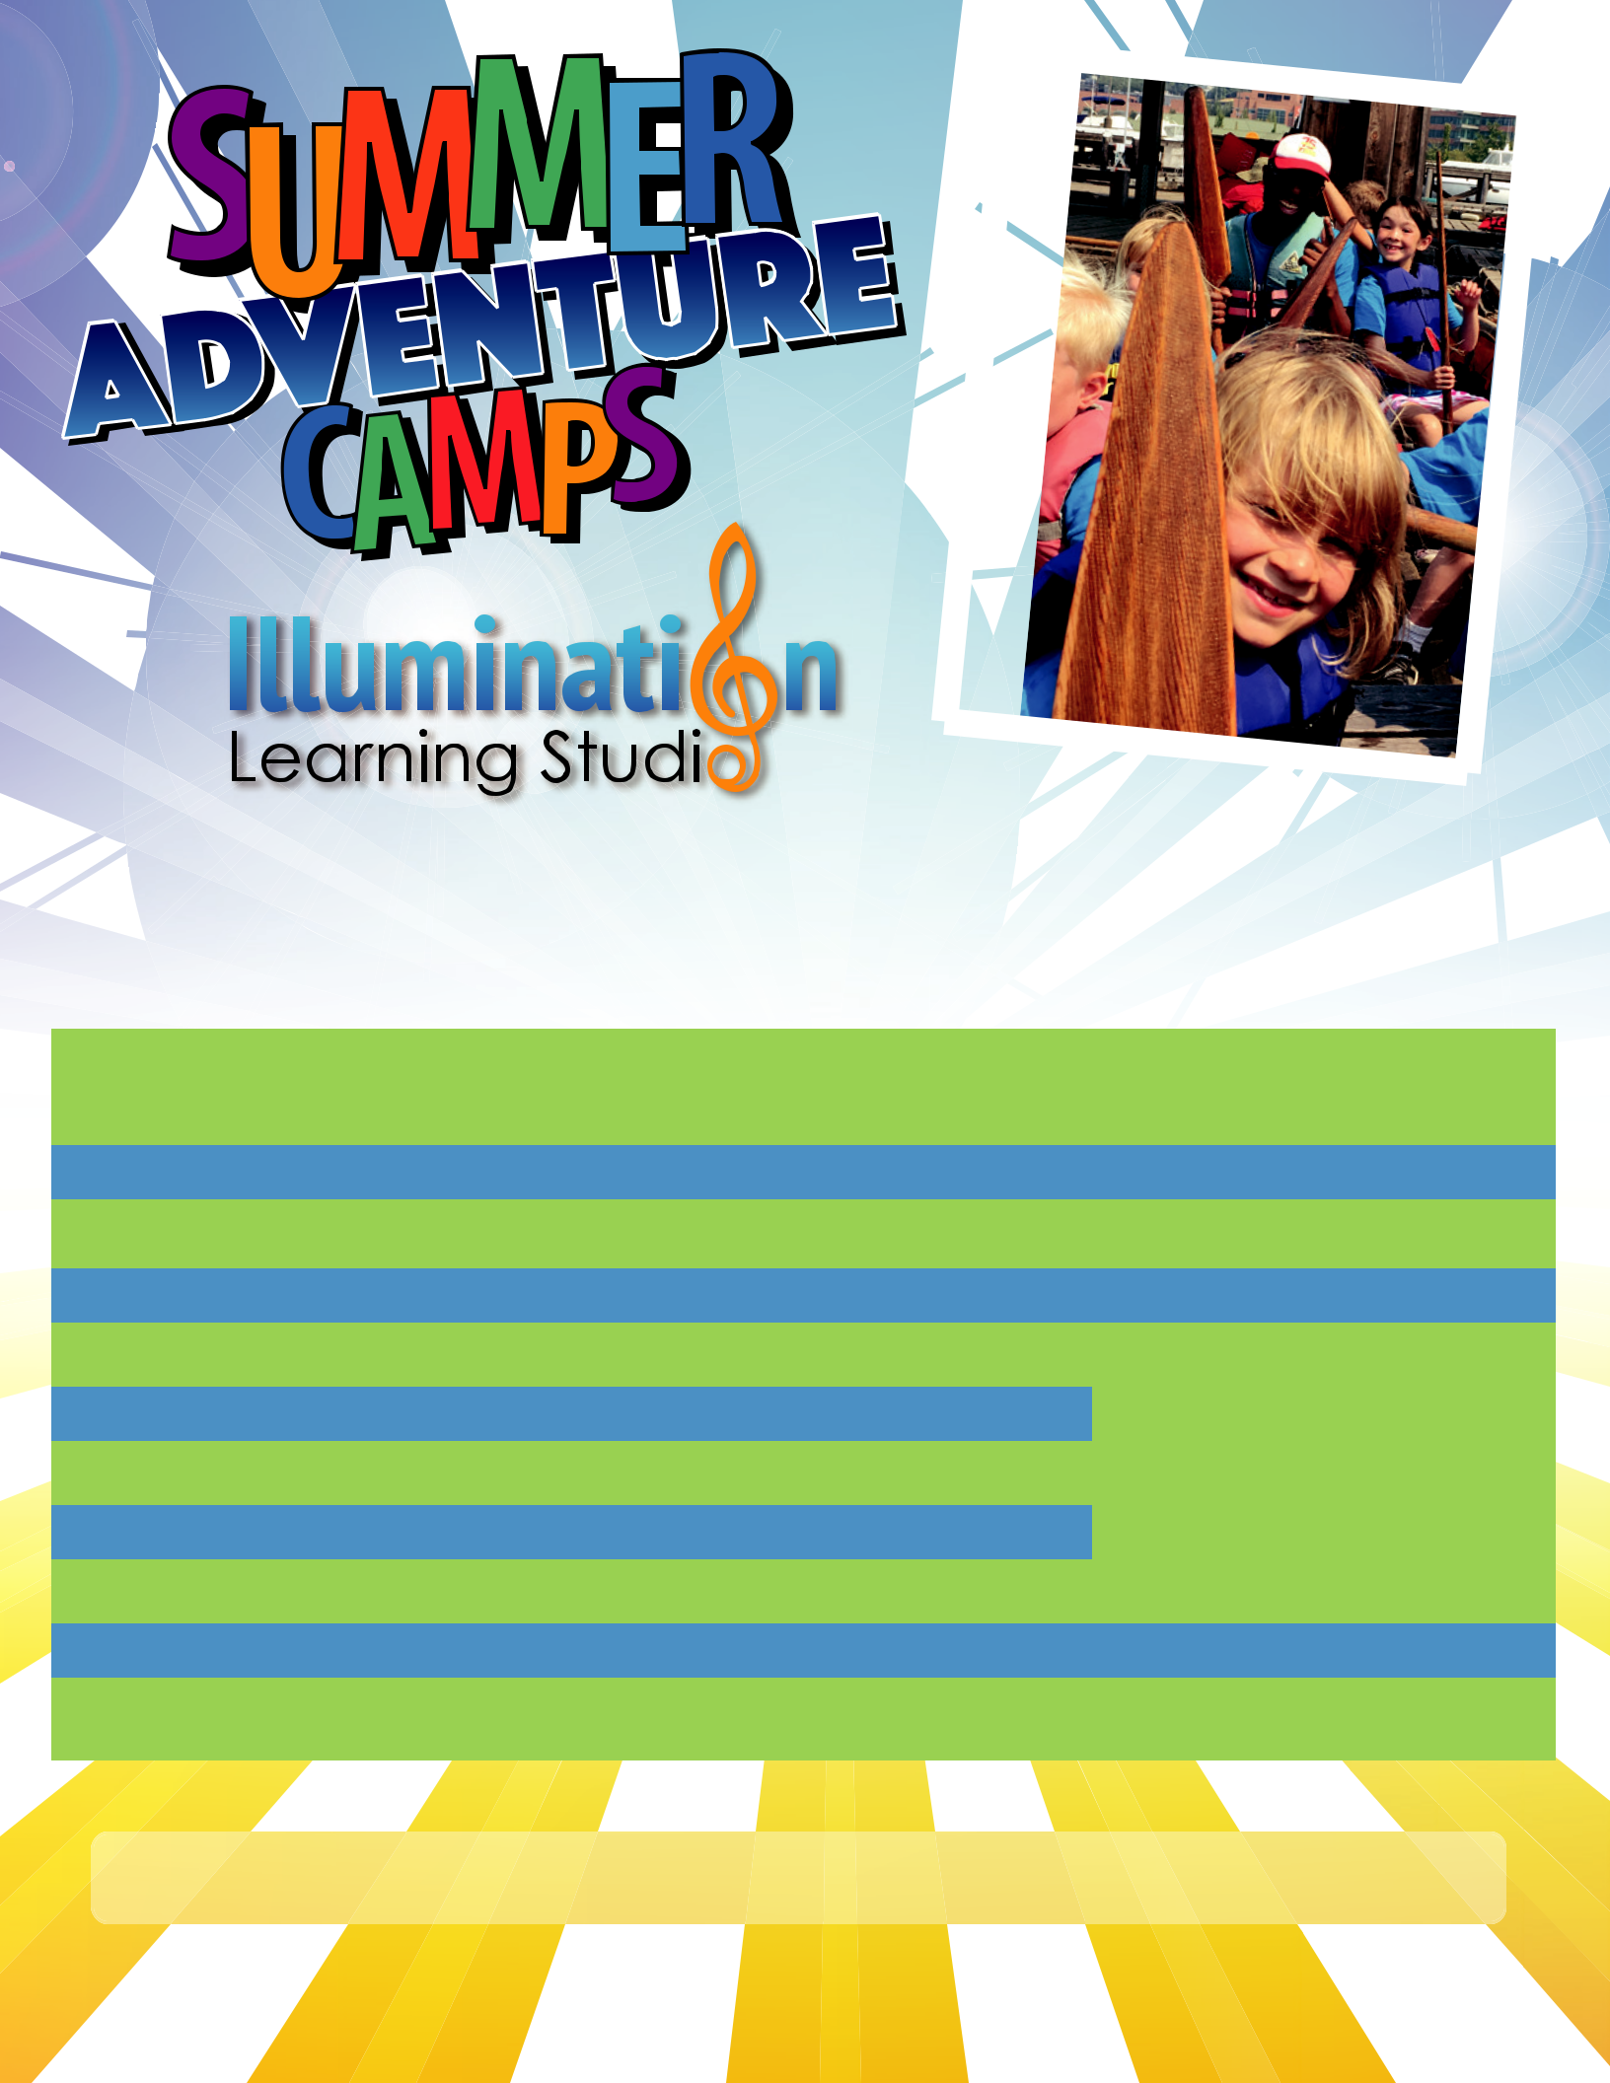

A Cultural, Performing and Fine Arts Academy

Summer Camps by Location

WEEKS

Week 1 – 6/24

Week 2 – 7/1 (4-days)

Week 3 – 7/8

Week 4 – 7/15

Week 5 – 7/22

Week 6 – 7/29

Week 7 – 8/5

Week 8 – 8/12

Week 9 – 8/19

Week 10 – 8/26

GREENWOOD LOCKS BALLARD
(Greenwood/78th) | (Market/28th) | (Market/8th)

CANCELED | CANCELED |  | —
Heroes vs. Villains | Lego Architects |  | —
Jedi Training Academy | Art of the Fantastic Beast |  | —
NW Marine Pirate Voyage | Heroes vs. Villains |  | Art of the Fantastic Beast*
Art of the Fantastic Beast | Jedi Training Academy
Art of the Fantastic Beast | Jedi Training Academy |  | NW Marine Ecologist *
Jurassic Adventures | Time Travelers |  | Musical: Charlie Chocolate Factory*
Lego Architects | Hogwarts: Tri-Wizard |  | Game Builders*
Time Travelers | Musical: Charlie Chocolate Factory |  | Jedi Training Academy
Game Builders | NW Marine Pirate Voyage |  | Hogwarts: Tri-Wizard
Musical: Charlie Chocolate Factory | Jurassic Adventures |  | Time Travelers
 |  | *Specialized Camp for Older Students ages 9-13

WEEKLY FIELD TRIPS - EDUCATIONAL - ENERGETIC - FUN OUTDOORS

Register at www.ILSKids.com or call to inquire at 206-900-7452


Spend the Summer with Illumination Learning Studio and make friends and memories to last a lifetime. Whether families need one week over the summer, a month,
or the whole summer, our camps are fun and educational for kids while convenient and a ordable for parents. Our Adventure themed camps give kids plenty of outdoor activities and also serve to keep the enthusiasm for learning alive during the long Summer-break. Each themed adventure camp includes eld-trips, engaging lessons, outdoor play time and weekly visits to play in the water, either at our local beaches or water spray parks.

 Camp runs 9:00am-4:00pm, Monday through Friday unless a holiday week

Options to extend Before Camp 8:00-9:00am and After Camp from 4:00-6:00pm

 Option to add weekly music lessons at reduced summer rate

 Small Camp Sizes with low Camp-leader to Student ratio (1:10)

 Each Camper gets a Summer Camp t-shirt

Summer Camp Descriptions 2019

Full-day Camps 9:00-4:00 with before/after options

Art of the Fantastic Beast. During a week of imagination and discovery, campers will bring their own magical creatures to life. Come learn about mythical creatures, especially those inspired by those found in Newt’s handbag from the movie Fantastic Beasts. Campers will design their own magical creatures by sketching, sculpting, and painting their beasts to life. Field trip to Point Defiance Zoo.

Game Builders. Press “play” and let the games begin. Campers will learn about the history of video games from Pong to Minecraft. Gamers will bring their favorite video games to life with Mario obstacle courses, giant Tetris, and Pokémon scavenger hunts. Working in teams, they will create their own games to challenge other teams. The week of games will feature a trip to play games and afternoon of adventure and fun!

Heroes vs. Villains. Good vs. Bad, DC vs. Marvel, and all the best rivals. This week heroes and villains alike will assemble in the ILS super-dome for adventure and action! Come to camp dressed as your favorite superhero or supervillain. Uncover new powers while under-taking incredible missions. The plot thickens as we create our own original characters and comic books. Campers will fly at Elevated Sportz in Bothell.

Hogwarts: Tri-Wizard Tournament. Aspiring Witches and Wizards converge for a week of magic in this spellbinding, Hogwarts themed camp. Campers will be sorted into four houses, compete in a Tri-Wizard Tournament, discover and create imaginative super-spells and concoct entrancing potions. There will be a special appearance from the fantastical George A. Magician.

Jedi Training Academy. Join us as we transverse to a galaxy far-far away in a week of Star Wars themed camp. Padawan campers will undergo Jedi training, take off on an inner-stel-lar space mission and design their own imaginative alien life forms. Campers will graduate as Jedi Masters after training with the Jet City Saber Guild.

Jurassic Adventures. Campers will dig this Jurassic themed week loaded with relics from Earth’s past. Dinosaur learning and discovery will top the list of adventures. Trek outdoors to hunt for dino-eggs, dig for fossils, and complete paleontology themed challenges. The week

will also feature awesome Dinosaur-inspired art projects and activities. Campers will visit the Reptile Zoo in Monroe.

Lego Architects. Come adventure with us at for a week of building fun in this special Lego Architects Camp. Campers will ignite their imaginations as young architects, to design Lego buildings, bridges, castles and creatures. Learn to use blueprints and step-by-step instructions along with teamwork to take on quickfire challenges and hands-on creativity. Field trip to Wunderkind.

Musical: Charlie and the Chocolate Factory. Grab the spotlight for a week of musical the-atre performance. Campers will act, sing, and dance, performing in a mini production of Charlie and the Chocolate Factory at the end of the week. We will enlist the help of Seattle Children’s Theatre for a performance workshop. Beyond the show, join us for set-building, improv, and Willy Wonka inspired games, art and activities.

NW Marine Pirate Voyage. Raise the pirate’s flag and set sail for a week of marine themed adventures. Campers put on their pirate’s garb and explore the ocean’s floor for sunken trea-sures and signs of underwater life. Play some jaunty games and get out on the water at the Center for Wooden Boats for a ride on the Kamiaks. Beyond the pirate’s fun, campers will learn about our Oceans, from sharks to jelly fish and how to preserve our seas.

Time Travelers. Journey all around the world, eclipse space and time and learn about our world during different eras of humanity. Campers will journey to a different part of the world and a different era each day, taking part in activities, art, and performance. From Ancient Asia to Medieval Europe to the Wild West and even the future! We will immerse ourselves in each place, imagining and recreating our experiences together.

**Summer Camp field trips are subject to change without notice. Camp schedules and details will be sent 1-week prior to each camp with instructions for what to pack with your child.

Register at www.ILSKids.com or call to inquire at 206-900-7452

