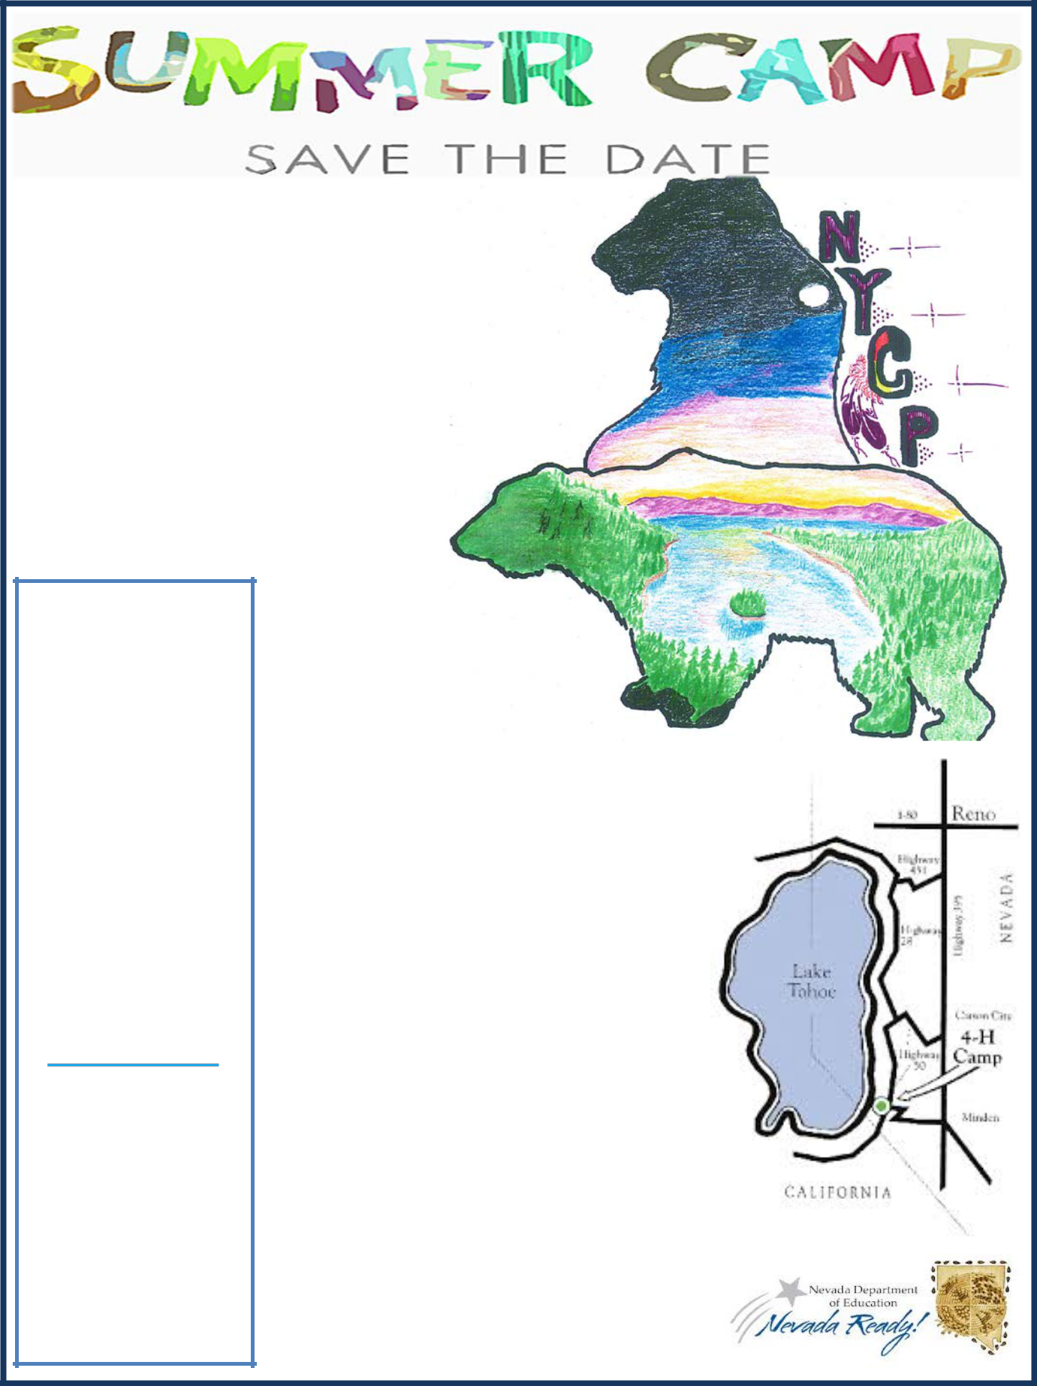

1st Annual Native American Youth Summer Camp

EmbracingOurPast, Present , and Future

August 14-17, 2019

Nevada State 4-H Camp Lake Tahoe Stateline, Nevada

2019 Summer Camp
Registration
Registration packets available after registering
Registration link
https://

app.smartsheet.com/b/

form/

e53b223079e34d43a0ef1f

5582882f08
Registration Questions
Contact: Kathy Griffin
nycp@doe.nv.gov
Camp Information

Contact: Fredina Romero fromero@doe.nv.gov or (775) 687-9143

This is a Nevada Department of Education opportunity sponsored
through the Native Youth Community Project Grant

In collaboration with Yerington Paiute Tribe Walker River Paiute Tribe Ft. McDermitt Paiute-Shoshone Tribe

What to Expect:
Students in 7th-12th grades are
invited to attend the 1st Annual
Native American Indian Cultural Summer Camp in beautiful Lake Tahoe at the Nevada 4-H Camp.

The camp is hosted by the Nevada Department of Education's Native Youth Community Project (NYCP) Grant, with partnerships from the Inter- Tribal Council of Nevada and the University of Nevada, Reno.
Invited Presenters:
Presenters include tribal members and elders from the Washoe, Northern Paiute, Southern Paiute and Western Shoshone tribes, as well as special guests from the Native Wellness Institute’s Indigenous 20 Something Project (I20SP) and the United National Indian Tribal Youth (UNITY), inc.
Other information
The 4-H Camp is located in Stateline, Nevada. The arrival date is Wednesday, August 14; check in time is 3:00pm. The departure date is Saturday, August 17; check out time is in the morning.

Check the Nevada Department of Education website for camp updates.

http://www.doe.nv.gov/IndianEducation

5/24/19

