
Summer Horse Camp
No school
means it’s time
to rope and ride!

What: KB Horse Camp’s Summer Camps
When: Session I: Sun. June 14 @ 9:00 a.m. – Sat. June 20 @ 7:00 p.m.
Session II: Sun. June 28 @ 9:00 a.m. – Fri. July 4 @ 7:00 p.m.
Session III: Sun. July 12 – Fri. July 18
You can also come individual days. Please call for more information.

Where: KB Horse Camp - 5548 Bent Creek Circle, Hahira, Georgia
Cost: $550.00
($200.00 non-refundable deposit to guarantee a spot;
remainder due first day of camp)
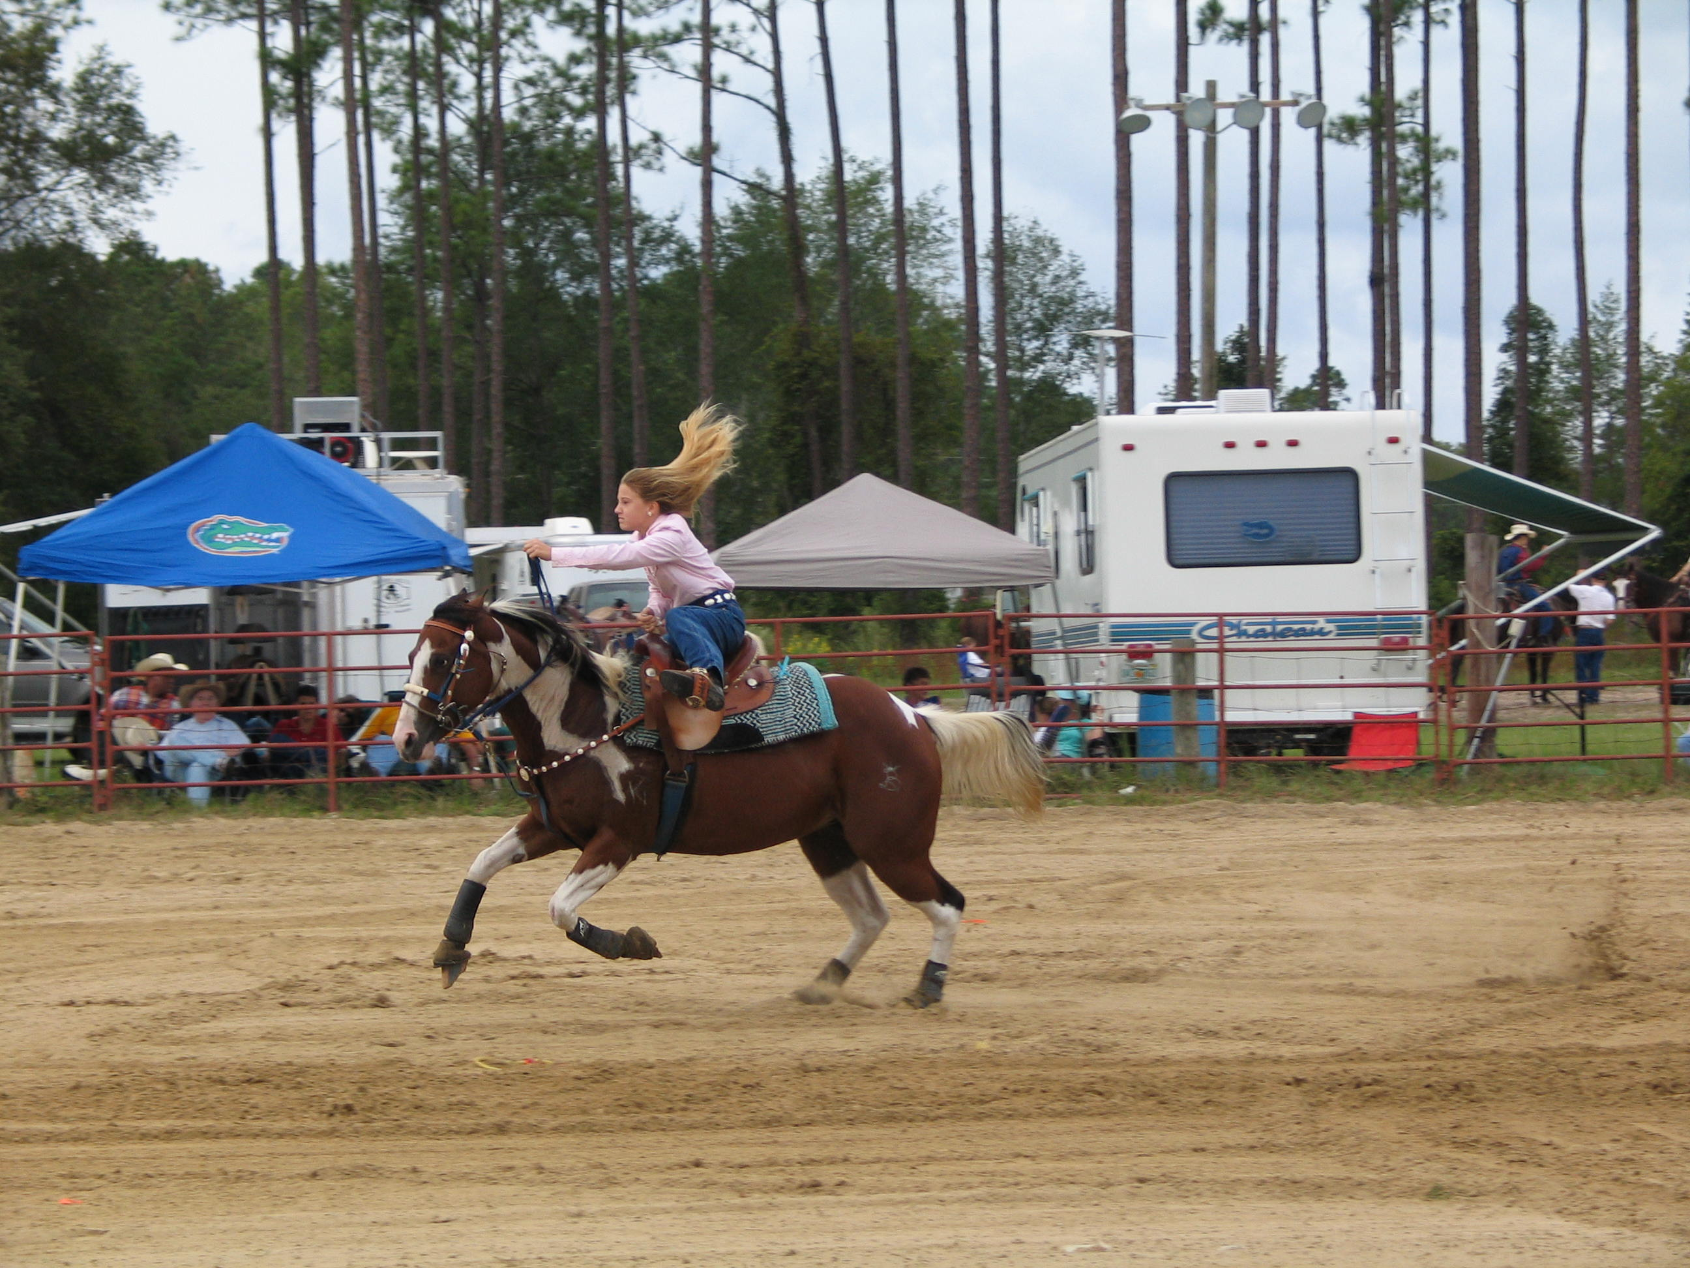
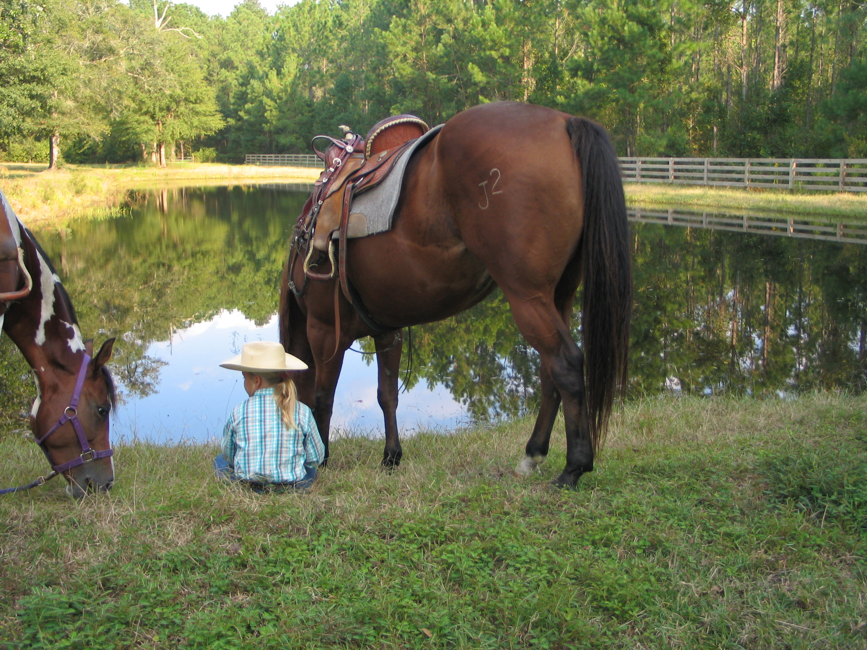
- We’ll be working on horsemanship skills, goat tying, roping, and trail riding.
- We’ll visit a western store and
a horse auction.
- We will attend a Baptist church on Sunday.
- Lunch will be provided each day.

We’ll have a RODEO at the end of each week for all camp participants. Parents are invited to see what your children have learned!

What to bring
Riding clothes, boots, & swimwear
Spending Money
for snacks & our trip to Boot Hill Western Wear in Valdosta
Copy of insurance card (both sides)

Sign up as soon as possible,
to guarantee your child a spot.
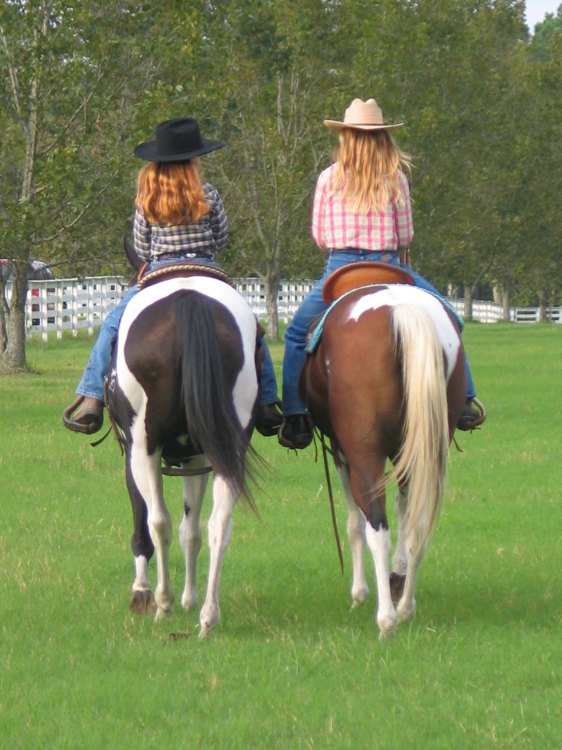
For More Information:
Log onto WWW.KBHORSECAMP.COM
Or Call: (229) 794-5275, (229) 794-3598, or (229) 392-0499

SEE YALL COWFOLKS AT THE RANCH,
Kim McGhee

