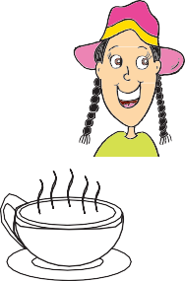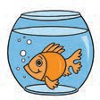

2

**Grade 3 Sample English Spelling test**

Listen to the sentences.

Write the missing letter or word in the space in each sentence.

Practice questions

**P1** There is a word missing. Write the missing word.

I am on the .

1. The is shining.
2. I am wearing a .
3. I drink from a .
4. Eat good every day.
5. I play on the weekend.
6. We eat with our .
7. I can the pizza.
8. This is a .
9. The is happy.

.

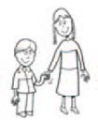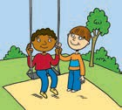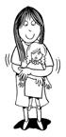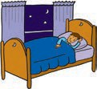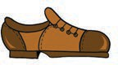

3

1. My is ten years old.
2. The children in the park.
3. I my doll.
4. I at night.
5. The shoe is
6. Milk is used to make .
7. The story was very .
8. The book is on the .
9. We went to some clothes.

End of sample English Spelling test.

Stop here.

Wait for your teacher’s instructions



4

**Grade 5 Sample English Writing test**

Colors

Choose the correct word for each color. The first one has been done for you.

*pink*

**1**

**2**

**3**

**4**

**5**

~~pink~~ blue brown yellow red green

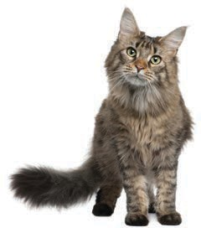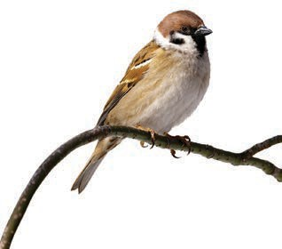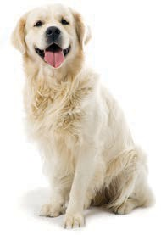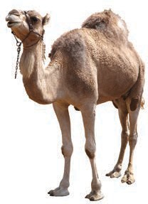

5

Animals

Write the names of the animals.

**6**

**7**

**8**

**9**

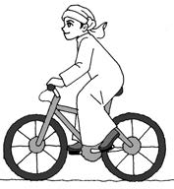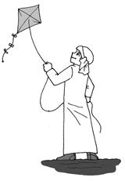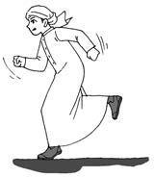

6

What can Khaled do?

Write a sentence for each picture to show what Khaled can do. Use the words under the pictures.

The first one has been done for you.

bicycle *Khaled can ride a bicycle.*

kite **10**

fast **11**

songs **12**

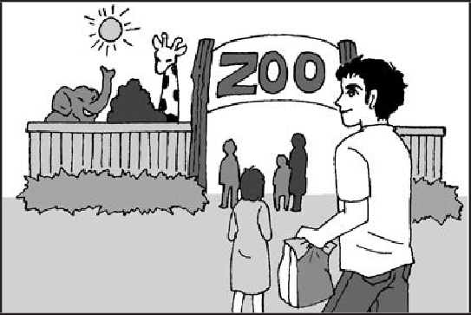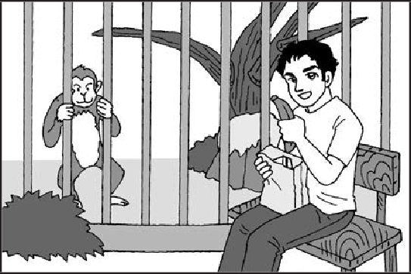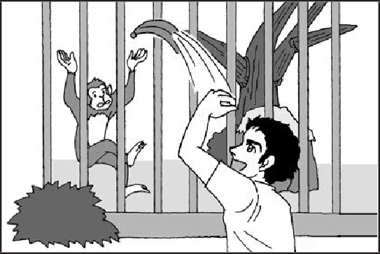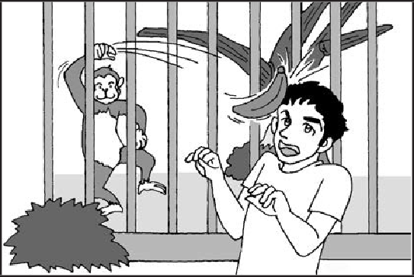

7

At the zoo

Look at the pictures. They tell a story. Tell the story by writing **TWO (2)**

sentences beside each picture.

The first one has been done for you.

*Yesterday Hamad went to the zoo. He took some lunch in a bag.*

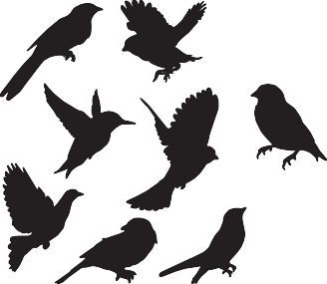

8

Birds

Write about birds.

Write as much as you can. Write inside the box.

End of English Spelling and Writing sample test.