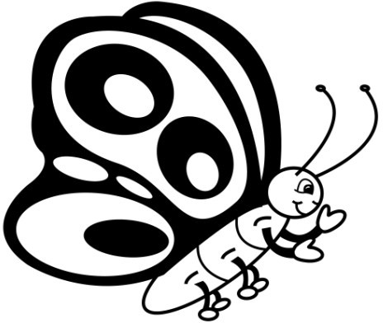

Name

**Sight Word Assessment**

**Lists 1-3**

**List One**

**List Two**

**List Three**

Date

get

them

like

one

this

my

would

me

will

yes

big

went

are

come

if

now

long

no

came

ask

very

an

over

your

its

**Total**

Date

look

is

her

there

some

out

as

be

have

go

we

am

then

little

down

do

can

could

when

did

what

so

see

not

were

**Total**

Date

the

to

and

he

a

I

you

it

of

in

was

said

his

that

she

for

on

they

but

had

at

him

with

up

all

**Total**



Name

**Sight Word Assessment**

**Lists 4-6**

**List Four**

**List Five**

**List Six**

Date

again

play

who

been

may

stop

off

never

seven

eight

cold

today

fly

myself

round

tell

much

keep

give

work

first

try

new

must

start

**Total**

Date

away

old

by

their

here

saw

call

after

well

think

ran

let

help

make

going

sleep

brown

yellow

five

six

walk

two

or

before

eat

**Total**

Date

ride

into

just

blue

red

from

good

any

about

around

want

don’t

how

know

right

put

too

got

take

where

every

pretty

jump

green

four

**Total**



Name

**Sight Word Assessment**

**Lists 7-9**

**List Seven**

**List Eight**

**List Nine**

Date

wash

show

hot

because

far

live

draw

clean

grow

best

upon

these

sing

together

please

thank

wish

many

shall

laugh

**Total**

Date

warm

ate

full

those

done

use

fast

say

light

pick

hurt

pull

cut

kind

both

sit

which

fall

carry

small

under

read

why

own

found

**Total**

Date

black

white

ten

does

bring

goes

write

always

drink

once

soon

made

run

gave

open

has

find

only

us

three

our

better

hold

buy

funny

**Total**



Name

**Sight Word Progress Summary**

Number of Words

Date

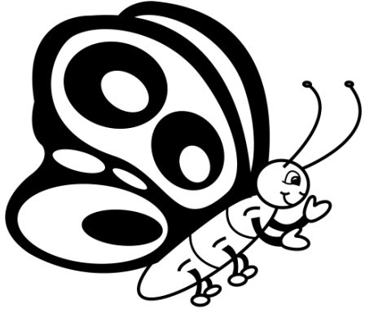

Name

**Words I Know Lists 1-3**

**75**

**70**

**65**

**60**

**55**

**50**

**45**

**40**

**35**

**30**

**25**

**20**

**15**

**10**

**5**

Date



Name

**Words I Know Lists 4-6**

**75**

**70**

**65**

**60**

**55**

**50**

**45**

**40**

**35**

**30**

**25**

**20**

**15**

**10**

**5**

Date



Name

**Words I Know Lists 1-9**

**220**

**210**

**200**

**190**

**180**

**170**

**160**

**150**

**140**

**130**

**120**

**110**

**100**

**90**

**80**

Date

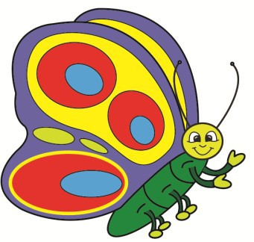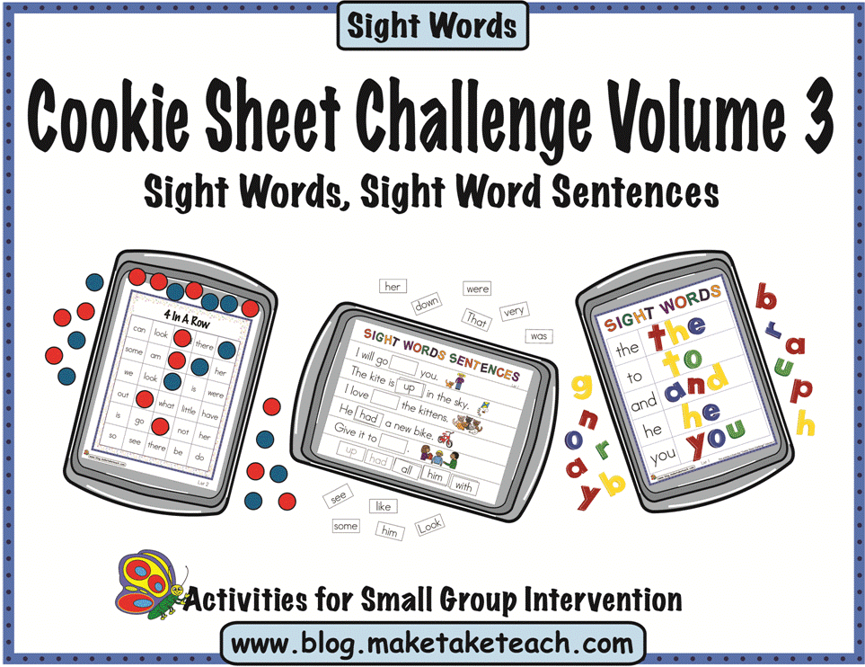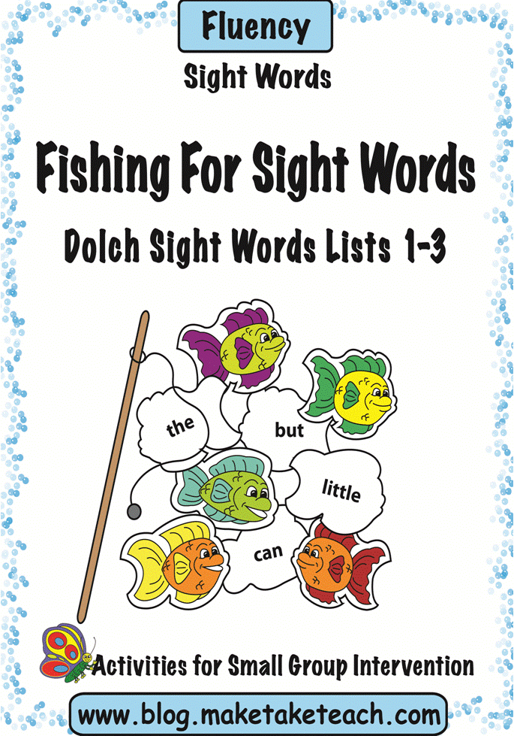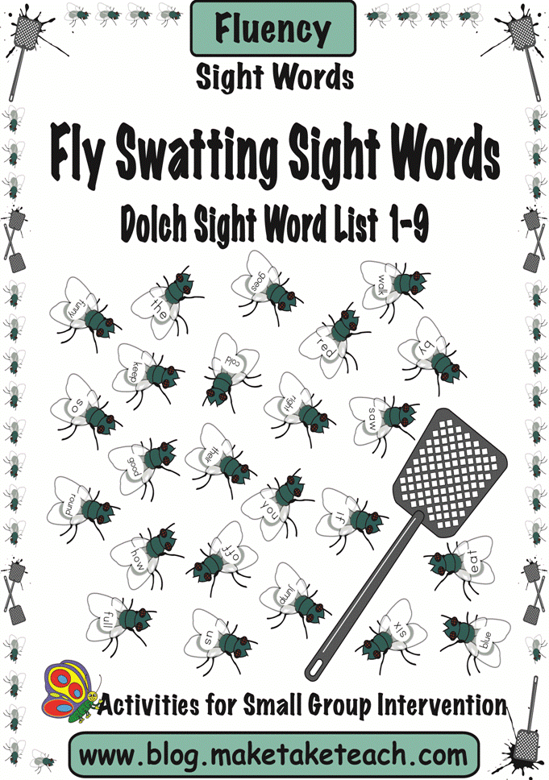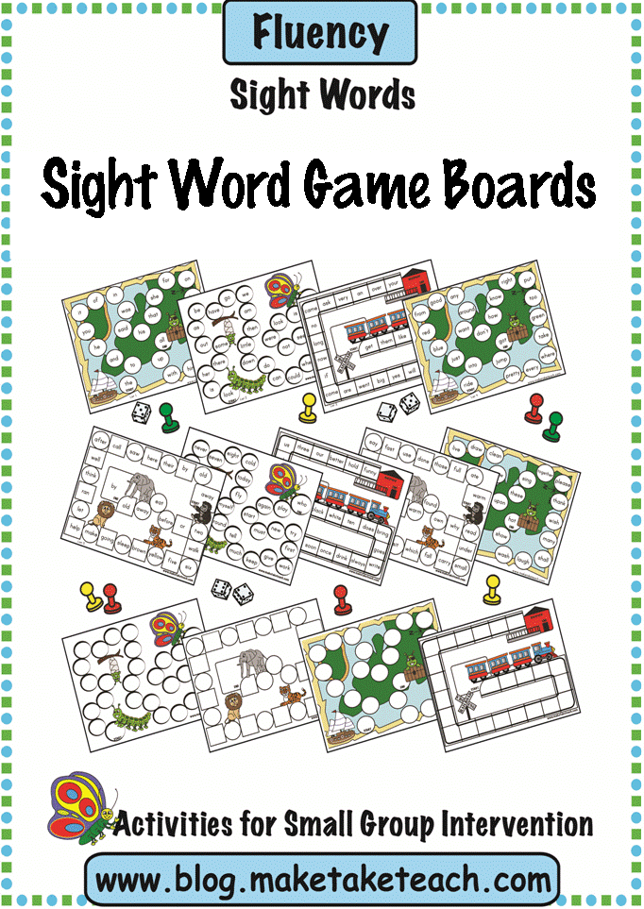

Make, Take & Teach Sight Word Activities

All Make, Take & Teach sight word activities are based on the Dolch 220 Sight

Words.

Consider using these

products during your small group intervention or

within your literacy centers.

**Cookie Sheet Challenge Volume 3**

Contains 67 templates for use on a cookie sheet. This product targets the following skills: sight word building, sight word identification and using sight words within sentences.

Visit the Make, Take & Teach Teachers Pay Teachers Store or Teacher’s

Notebook for more sight word activities! available too.

Seasonal and Holiday games