Running Head: FRIDAY SPELLING TESTS

1

How Do I Spell “Spel?”

Friday Spelling Tests and the Memorization Approach to Spelling Retention

Amanda K. Queally

University of New England

EDU 690 Action Research

**Statement of Academic Honesty**: I have read and understand the plagiarism policy as outlined in the “Student Plagiarism and Academic Misconduct” document relating to the Honesty/Cheating Policy. By attaching this statement to the title page of my paper, I certify that the work submitted is my original work developed specifically for this course and to the MSED program. If it is found that cheating and/or plagiarism did take place in the writing of this paper, I acknowledge the possible consequences of the act/s, which could include expulsion from the University of New England.

FRIDAY SPELLING TESTS

2

**Abstract**

Certain teaching practices are difficult to let go of when they have been used consistently

over a long period of time. The tradition of Friday spelling tests as an assessment of elementary

students’ spelling abilities was one of these practices. In a second-grade classroom in

Scarborough, Maine, the teacher set out to determine whether her long-standing routine of Friday

spelling tests was an effective assessment tool. The Friday spelling test was a custom for the

majority of teachers at this elementary school, and was an expectation of parents. However, the

faults of this form of assessment were too substantial to disregard, and a case study was

conducted to formally determine its validity as an assessment tool. This article presents in detail

the research and findings of this case study, and provides an action plan for progress.

FRIDAY SPELLING TESTS

3

Table of Contents

Abstract

2

Introduction

5

Rationale for Study

5

Statement of the Problem

5

Primary Research Questions

6

Hypothesis

6

Support Needed

6

Review of Literature

7

Comprehensive Research Plan

12

Explanation of Intervention

12

Data Collection Sources

13

Timeline

13

Data Source Validity

14

Results

16

Data Presentation

16

Discussion of Findings

20

Limitations of the Study

21

Significance/Implications/Applications

22

Action Plan

22

Conclusions

28

References

29

FRIDAY SPELLING TESTS

4

Appendices

31

Appendix A: Friday Spelling Test Template

31

Appendix B: Teacher Survey

33

Appendix C: Student Survey

34

Appendix D: Spelling Word List

35

Figure 2.1: Graph of Teacher Survey Question 1

36

Figure 2.2: Graph of Teacher Survey Question 2

36

Figure 2.3: Graph of Teacher Survey Question 3

36

Figure 2.4: Graph of Teacher Survey Question 4

36

Figure 2.5: Graph of Teacher Survey Question 5

37

Figure 2.6: Graph of Teacher Survey Question 6

37

Figure 2.7: Graph of Teacher Survey Question 7

37

Figure 2.8: Graph of Teacher Survey Question 8

37

Figure 2.9: Graph of Teacher Survey Question 9

37

Figure 3.1: Results of Spelling Words- Student A

38

Figure 3.2: Results of Spelling Words- Student B

39

Figure 3.3: Results of Spelling Words- Student C

40

Figure 3.4: Results of Spelling Words- Student D

41

Figure 3.5: Results of Spelling Words- Student E

42

FRIDAY SPELLING TESTS

5

**Introduction**

**Rationale for Study**

Second graders take a “Spell Check” every Friday on a list of spelling words with a

common word family or pattern that they have been studying for that week. With relative

consistency, students are spelling their words correctly on the front of their test (words written

individually, out of context), but spell them incorrectly within sentences on the back of their test.

Additionally, students are not retaining the spelling knowledge, and are not carrying over their

spelling abilities into their daily writing. Friday spelling tests are somewhat of an “unwritten

rule” according to the other first and second grade teachers in this K-2 school, and have begun to

be expected by parents. Students study their words at home in various ways, and parents are

always very involved in this work, and are anxious to see how their child did on his or her

spelling test. The concern is whether all of this studying and work for a test is the most effective

way for second graders to learn word families and other word patterns.

**Statement of the Problem**

Students’ spelling tests indicate that they are not able to retain knowledge of a spelling

word from one side of a page to the next. Even when reminded (verbally) to make sure words are

spelled consistently on the front and back, students are not taking the time to check this. In daily

and weekly journal and creative writing, students are spelling many of their sight words and

spelling words incorrectly, despite getting the words correct on a Friday test.

FRIDAY SPELLING TESTS

6

**Primary Research Questions**

1. Are weekly spelling tests an effective way to teach and assess elementary

students?

2. What are possible models for studying spelling words at the elementary level that

may increase retention of word families and patterns?

3. What are possible models for holding students accountable for spelling grade level

words correctly in their writing, without losing focus on the content of their writing?

4. If spelling tests are not administered, what other assessment strategies can be

used

to determine if students are learning grade-level spelling patterns and sight

words?

**Hypothesis**

Weekly spelling tests are not an effective assessment tool for determining if a second grader has correctly learned how to spell grade level words. Their ability to write the words on a consistent basis in the text of their independent writing is a better measure of their learning.

**Support Needed**

Parents, principal, and grade-level colleagues will be both informed of this case study and

used as a support system.

FRIDAY SPELLING TESTS

7

**Review of Literature**

Evidence is mounting that teachers at the elementary and middle grade levels are

concerned about both their instructional approaches to teaching spelling, and their students’

abilities to retain and apply spelling knowledge across the curriculum. In her case study,

“Teachers’ Concerns About Spelling Instruction,” Fresch (2007) reports that, “spelling holds an

important yet undefined place in many teachers’ curriculum” (p.327). Teachers are aware that

instructional methods need to change, but feel burdened by this change due to a lack of resources

and the need for new word lists from which to develop a new approach to teaching spelling

(Fresch, 2007). A primary concern of teachers who feel this burden is that they are practicing an

instructional approach that emphasizes the need for students to memorize spelling words. These

teachers have ample evidence that the memorization approach is not effective for most learners.

Spelling involves graphophonemic relations, semantic application, syntactic structure and

contextual, or pragmatic use of the word (Rosencrans 2002). When a posttest is given on a list of

isolated words, students are not being asked to activate such applications.

The authors of “How Words Cast Their Spell,” (2008) were intrigued by the consistency

of the memorization approach to teaching spelling among educators, and traced its usage back to

the 1920’s (Joshi, Trieman, Carreker & Moats, 2008). It was during this decade that studies

showed that deaf children spelled nearly as well as hearing children, allowing researchers to

draw the conclusion that the relationship between sounds and how they are spelled is variable. In

the 1920’s, some people believed that spelling ability was achieved through rote memorization.

Current research now suggests that memorization may not be the most effective way to teach

spelling strategies to young children. We now understand that good spellers learn to develop

what is called, “orthographic memory,” or knowledge of the internal structure of words. In order

FRIDAY SPELLING TESTS

8

to achieve this knowledge, specific instruction in word structure, origin and meaning appears to

be essential (Joshi et al. 2008).

John Dewey sheds his intellectual light on memorization as an instructional strategy. His

belief was that a learner has to “personally struggle” with a concept, or else the information

might not be entered into memory. (Fresch, 2007) Dewey goes farther to describe this as “static,

cold-storage knowledge.” (Fresch, 2007) What many teachers are discovering is that the words,

once accessed in short-term memory for a Friday spelling test, get very “cold” and are not then

used accurately in independent writing only days later. This is leading teachers to question their

age-old methods of spelling lists and Friday tests, and to seek out alternative approaches to

teaching young children to spell. Spelling is, after all, an integral part of a child’s development

of reading, writing and communicating. In other words, spelling is the “mortar that helps

students master the basics of language” (Jones, 2009 p. 1).

**Spelling Makes the News**

In addition to their concern about the memorization approach to teaching spelling,

teachers are also apprehensive about eliminating the practice of administering a Friday spelling

test due to parental expectations. The topic of spelling has been in the mainstream news

recently, due in large part to teachers’ changing instructional techniques and some parents being

concerned about these changes. In a 2009 interview with parents and teachers from Clear Creek

Elementary School district in Houston, TX, teachers voiced their worry that spelling tests are a

“contrived context,” while parents expressed concern that eliminating the tests would eliminate

“accountability.” (Mellon, 2009). The Friday test has been around for a long time, parents and

grandparents recall their own experiences with them in school. An elementary principal in

Omaha, Nebraska, who has helped to initiate a new approach to spelling instruction focusing less

FRIDAY SPELLING TESTS

9

on rote memorization and more on word study, stated that, "There are still parents that think

we're not teaching spelling because they don't see the weekly lists that come home.” (Mellon,

2009) Some teachers find it difficult to forgo the practice of Friday testing despite the

knowledge of its inefficiency to increase student learning because it has been ingrained both in

institutional practice, and in the minds of parents. In her monthly newsletter, spelling instructor

and author, Rebecca Sitton (2007), reminds teachers that “when parents determine that their

child can only spell on a test and not in writing and that its beginning to negatively influence the

child’s written work and writing tests scores, parents will still be discontent.” (p. 1)

**Memorization vs. Word-study Approach**

The research that promotes a more whole-language, word-study approach to teaching

spelling suggests that learning to spell is a very complex, knowledge-based process, rather than

one that uses simple, visual memory. (Brown & Morris, 2005) Spelling learners need to acquire

the ability to solve a problem when faced with a difficult word, using a process that allows them

to use the best strategy that they know, and if that doesn’t work, have other strategies to try. If

knowledge of word patterns and English language rules do not exist, learners don’t have

strategies to solve spelling problems. (Rosencrans, 2002). This can also be described as learning

how to “walk through” words, or having the ability to understand word pattern and meaning

relationships. (Fresch, 2007) Friday testing can also send a message to students (especially very

young learners) that “spelling” is a stand-alone practice. When it is not taught within the context

of writing, and assessment is just a weekly test, students may get the idea that the subject of

spelling is about “remembering the hard words,” or “doing well on the test.”(Rosencrans, 2002 p.

59). When assessment is done within the context of independent writing, students will better see

the connection between accurate spelling and effective written communication.

FRIDAY SPELLING TESTS

10

The Friday test measures a student’s ability to activate his or her short-term memory. If

these words are then not revisited weeks, or even days later, many students will not have

transferred the words from short-term to long-term memory, and correct spellings will have been

forgotten (McMurray, 2006). These kinds of tests also limit the ability to differentiate

assessment. In a group of twenty-five or more students, there is assuredly going to be various

spelling abilities. A memorization approach to teaching spelling, however, administers the same

list of words to all twenty-five kids, in the same way, with the same expectations. This approach

is especially inefficient for teaching students with learning disabilities. In her own classroom

observations, Kelly Loeffler (2005) concluded that students with learning disabilities often did

well on Friday spelling tests because they could memorize the words. However, they were not

able to internalize the spelling patterns or recognize when these same words were spelled

incorrectly in their writing the following week. Her solution to this problem was to adopt a

word-study approach to teaching spelling, and use a detailed rubric as an assessment tool that

required her students to become aware of their spelling within the context of their writing

(Loeffler, 2005).

**Teacher Concerns**

In her national survey about spelling instruction, Fresch (2007) surveyed 355 teachers

who provided statements about their specific anxieties about both their own instruction

strategies, and their students’ learning abilities. Teachers were most concerned about the

following situations: 1) students don’t remember how to spell words from week to week, 2) what

is being taught is not carrying over into their writing, (students aren’t making the connection

between spelling lists and using those words in their writing), and 4) students are more

FRIDAY SPELLING TESTS

11

concerned about getting 100% on their test than they are about spelling words correctly in

independent writing (Fresch, 2007).

How does a teacher go about changing his or her current practice of teaching through

memorization and posttest? Rosencrans (2002) offers a variety of assessment strategies such as,

spelling logs, using writing conferences, a dictated rewrite of a student’s personal writing, and

finally analyzing independent writing. All of these approaches require the student to reflect on

known spelling strategies and patterns.

Changing course and incorporating a spelling program that uses both phonics instruction

and whole language learning, and assesses using differentiated methods is a challenge for many

teachers who feel pressured by administrators, colleagues and parents to maintain the status-quo

of spelling routines. Despite this, the knowledge that rote-memorization is not an effective

teaching method for something so important as spelling is apparently seeping into many school

districts across the nation.

FRIDAY SPELLING TESTS

12

**Table 1**

**Data Matrix and Comprehensive Research Plan**

**Explanation of Intervention**

The normal spelling instruction and assessment model in a second-grade classroom was

altered in order to determine whether a word study approach was more effective than a

memorization approach. All nineteen students were involved in the instructional change.

However, five specific second graders were the focus of the study. These five students (three

females and two males) demonstrated weak retention of grade-level spelling patterns in the past.

Instead of receiving a list of spelling words with a common spelling pattern each Monday to

study at home in anticipation for a test on Friday, students were encouraged to develop a more

personal understanding of the rules of English spelling through a word-study approach using

word sorts, spelling logs, and analyzing common letter clusters. Students were asked to use the

words they had been studying in their journal writing the following week. The writing of the

five focus students was assessed for spelling accuracy.

Research Questions

Data Source 1

Data Source 2

Data Source 3

1. Weekly word lists and Friday spelling tests effective way to teach?

Teacher survey

Active Participant Spelling Survey

Participant Observer Fieldnotes

2.Weekly spelling test accurate way to assess?

Teacher Survey

Participant Survey

Participant Observer Field Notes

3. Assessing within student writing more authentic?

Active Participant Observer (Teacher)

Participant Observer Fieldnotes

Unit artifacts (student writing samples)

FRIDAY SPELLING TESTS

13

**Data Collection Sources**

Diverse strategies will be employed to collect data in order to ensure triangulation of the

research. Active participants (students) will write in *spelling logs*, which will serve as a data tool

to demonstrate their learning. Their writing samples, or *unit artifacts*, will also provide evidence

of learning. Students will also be administered a *spelling interview* to gain data on how the

memorization approach to spelling has affected their personal understanding of spelling

strategies. In addition, other first and second grade teachers at Pleasant Hill School will be asked

to fill out a *teacher survey* on how they teach and assess grade level spelling words, and how

effective their methods are. The active participant observer (Mrs. Queally, teacher) will generate

*field notes* reflecting on both the memorization approach to teaching and the word-study

approach.

**Timeline**

Week 1 *(February 22-28)* Students will take a spelling interview, prior to any changes in the

spelling instruction model in order to determine their personal connection to and feelings

towards spelling. Grade one and two teachers will be asked to take the teacher survey. A

traditional Friday spelling test will be administered on Friday, February 26th on grade level

words with common suffixes.

Week 2 *(March 1-March 7)* Students will write in journals on Monday, March 1st, and will be

asked to use spelling words and strategies from the previous week (grade-level “No Excuse

Words”). The teacher will analyze and compare the Friday spelling tests of five students and

compare them with student writing produced on the following Monday to determine if word

strategies have been retained or learned from one week to the next. Analysis will be documented

in teacher field notes. Students will not receive new spelling words for the week to “memorize at

FRIDAY SPELLING TESTS

14

home.” Instead, they will engage in word-study lessons (word sorts, cloze activities, and spelling

logs) to further study the word patterns. A traditional Friday spelling test will not be

administered on Friday (parents will be informed of this change and the reasons for it).

Week 3 *(March 8-14)* The teacher will read student journals and review previously studied word

families that are commonly misspelled in student journals using a word-study approach.

Week 4 *(March 15-21)* Students will write in journals on Monday, March 15th, and the teacher

will analyze the spelling of the five focus students, looking for accurately spelled and misspelled

grade-level “No Excuse” words. Data will be collected in teacher’s field notes.

Week 5 *(March 22-28)* All data will be analyzed and a first draft of the action research will be

written.

Week 6 *(March 29-April 4)* The action research will continue to be written in draft form.

Week 7 *(April 5-11)* A draft of the introduction and conclusion will be written.

Week 8 *(April 12-18)* Final draft of the action research will be completed and submitted for peer

and professor review.

Week 9 *(April 19-25)* After reflection on peer and professor review, the final version of the

action research will be written and complete.

**Data Source Validity**

The data instruments and research questions for this study were reviewed by Peggy

Wallace, Literacy Specialist at the K-2 level for the Scarborough, ME School Department. Ms.

Wallace is also a teacher at the University of New England, teaching literacy education at the

graduate level. She declared the data tools “complete and well thought out,” yet cautioned the

researcher not to convey any bias in both the primary research questions and in the teacher and

student survey data instruments. This suggestion was heeded, and alterations with language

FRIDAY SPELLING TESTS

15

were made. In addition, Ms. Wallace was concerned that the word “effective” may not produce

quantifiable data results as it related to the second primary research question: “Are weekly

spelling tests an effective way to assess the retention of grade level spelling words of elementary

students?” The term “effective” was change to “accurate” in this case, to ensure that the data

results were less subjective. Overall, Ms. Wallace was intrigued by the data collection tools and

was eager to learn about the results. Her professional suggestions were taken into consideration

and aided in ensuring data validity for the research.

Both the student and teacher spelling surveys were altered from their original design per

the guidelines outline by Mills (2007), who suggests to “avoid lengthy questionnaires,” and to

“include an ‘Other Comments section’” (p.69). Surveys were proofread carefully before

administering, and were evaluated for purposeful questions.

These surveys provide just one instrument for data collection. As Mills (2007) suggests, a data

matrix is used to provide a visual representation of the triangulation, or “multi-instrument”

approach (p.56). The matrix details how answers to the primary research questions will be

determined using three different data sources, such as field notes, active participant observers,

unit artifacts, and surveys. By using these varied data collection tools, the researcher is engaged

in three primary fieldwork strategies of “experiencing, enquiring, and examining” (Mills 2007, p.

57).

FRIDAY SPELLING TESTS

16

**Results**

**Results of teacher survey.**

A total of six first and second grade teachers were surveyed in order to gather data about

approaches to and attitudes towards spelling assessment (See Appendix B). Question one asked

teachers if they gave weekly spelling tests to their students every Friday. Five out of six teachers

answered “yes.” The second question asked why teachers administered these weekly tests.

Results varied, with the following answers:

“For parents.” “To assure knowledge of spelling words.” “To see if the spelling words were

mastered and understood and practiced enough.” “To assess word families and No Excuse

Words.” And finally, “To meet district sight words and word family words and to help me keep

records that we completed the list of words.” The sixth teacher, who did not administer Friday

spelling tests did not answer question two.

The third question asked teachers if they had ever tried giving a spelling test on a Friday,

and then testing students on the same words the following week. Four out of six teachers

answered “no.” One of these teachers made the additional comment, “I bet a lot of children

wouldn’t do so well because of memorization.” The two teachers that answered “yes” were

asked to comment further about what they found out. One teacher said she found very similar

results, and the other mentioned that it depended on the student, for some the skill stayed

mastered, for some it stayed misspelled.

Teachers at Pleasant Hill School are provided with The Rebecca Sitton Spelling Program,

but its use within the spelling curriculum varies from teacher to teacher. Question four asked

teachers to rate how often they use this word study approach to spelling by circling “All the

time,” “Sometimes,” or “Never.” Five teachers said they used it “sometimes” and the sixth

FRIDAY SPELLING TESTS

17

teacher did not circle any answer, but remarked that she didn’t know. Question five inquired

about the student work sources that teachers use most commonly to provide information to

parents about students’ spelling abilities. Two teachers circled all three choices (journal writing,

weekly spelling tests, and free writing), indicating that they use a combination of the three to

determine a student’s spelling capabilities. Two teachers (who do administer Friday spelling

tests) circled both journal writing and free writing, indicating that they do not use weekly

spelling tests as a student source to inform parents about spelling progress. The sixth teacher

circled journal writing and also circled weekly spelling tests, but noted that she gives quarterly

spelling tests, not weekly spelling tests.

Teachers were then asked, in question six, how often they worked with the weekly

spelling words with their students in class. Four teachers worked for one hour per week on

weekly spelling word lists, while two teachers worked for more than one hour per week.

Question seven asked for teachers’ opinions as to which of two options was more important to

their students: getting 100% on a weekly spelling test, or spelling words correctly in their

journals and creative writing. Two teachers answered “getting 100% on a weekly spelling test,”

while the other four thought “spelling words correctly in their journals and creative writing” was

more important to their first and second graders. Question eight gathered information about the

number of years teachers had been administering Friday spelling tests. The answers were: “10+

years,” “7 years,” “4 years,” “6 years,” “30+ years” and one teacher, who previously indicated

she did not administer weekly tests, did not answer.

The final question of the teacher survey asked if teachers had ever tried another form of

assessment. One teacher answered no, while the remaining five circled yes. When asked to

comment on what the other form of assessment was, teachers’ answers varied from: “I would be

FRIDAY SPELLING TESTS

18

willing to try if I came up with a system I liked,” “I’ve tried just assessing writing,” “Daily

writing,” “Dictation,” “Rebecca Sitton’s Unit Reviews, fitting in the words in context, and also a

game during reading time that I play with my reading groups.”

**Results of student survey.**

Second grade students were administered a brief, four-question survey about their

feelings concerning spelling and assessment procedures. Sixteen out of a total of twenty-two

students were present to take the survey. Question one asked students how they think they get to

be better spellers. Answers varied, but common themes were found. Seven students said some

variation of “study and practice.” Three students thought they got to be better spellers by

reading books. Two students wrote that “making mistakes” helps them to be better spellers, and

similarly, one student wrote, “Spelling it your own way!” Two students answered that writing

more stories helps them be better spellers, and finally, one student wrote that “spelling the word

100 times” helps her be a better speller.

Question two asked students if they enjoyed taking Friday spelling tests. Three of the

sixteen students answered no, twelve answered yes, and one student wrote in her own answer of

“sort of.” An additional part of this question asked students to write why they answered yes or

no. Again, answers varied, but commonalities were found. Of the three students who answered

no, two wrote that they didn’t like the tests because they “are scary,” while the third student

circled no because “the words are *to* easy and it *dosent* teach you.” The one student who wrote in

her own answer “sort of,” explained that spelling tests “make you a *beter* speller and *becas* it is

hard.” Students that said they enjoyed taking Friday spelling tests mentioned the following

reasons: “Because it is fun,” “I want to see if I get better every time,” “Because they make your

FRIDAY SPELLING TESTS

19

mind work,” “Because you don’t have to study on the weekend!” “Because I get to be a better

speller,” “I learn from my mistakes,” and “They tell me what I need to work on.”

The third question required students to think about how they transfer spelling knowledge

over time. They were asked whether they think they can spell their words from a previous week

correctly when they write in their journals the following week. Seven students believed they

could transfer their knowledge of spelling words from week to week, two students answered no,

and the remaining seven circled “sometimes.”

Finally, students were asked what makes them feel more like a good speller, a) Spelling words

correctly when I free write or write in my journal, or b) Getting all my words correct on my

spelling test. Ten students circled a) and six circled b).

**Results of Friday spelling test.**

Students were given a list of twenty spelling words that have been previously

incorporated in their weekly spelling words lists since the start of the 2009-2010 school year.

These words are listed on their weekly spelling lists as “No Excuse Words.” Twenty of these

words were gathered together to create a new weekly spelling word list (see Appendix D). All

students were given this list to study for one week, and were then tested on their words with a

Friday Spell Check (see Appendix A). Although all students took the test, the results of only

five students were analyzed and compared to weekly journal writing the following week. Their

results are as follows. Student A: 19/20 words correct. Student B: 10/20 words correct. Student

C: 15/20 words correct. Student D: 12/20 words correct. Student E: 10/20 words correct.

**Results of spelling in weekly journals.**

On the Monday following the Friday spelling test, students wrote in journals for twenty-

five minutes. The journals of students A,B,C,D, and E were reviewed in order to compare the

FRIDAY SPELLING TESTS

20

spelling of the twenty grade-level sight words (see Appendix D) and determine if students

spelled differently on their spelling test (see appendix A). The results are displayed in figures

3.1-3.5. Student A used five of the sight words in her journal writing. She spelled four out of the

five words differently than how she had spelled them on the Friday spelling test. The fifth word

was spelled incorrectly, but was consistent with the way she had spelled it on her test. Student B

used eight of the sight words in her writing, and spelled two of them differently than she had

spelled them on her test the previous Friday. Student C only used four of the sight words in his

writing, yet spelled two of the four words differently than on his test. Student D also used only

four of the sight words in her writing, and spelled three out of those four words differently than

she had on her test. Finally, Student E used only two of the sight words in his journal on

Monday, and spelled them incorrectly, but was consistent with how he had spelled them on his

test.

**Discussion of Findings**

Data sources were analyzed to determine a conclusion to the study. It is evident that

administering Friday spelling tests is tradition among the first and second grade teachers at this

school, yet not all teachers give the test for the same reason. Three out of the six teachers

seemed unconvinced that Friday tests were an accurate measure of a student’s retention of

correct spelling. Although five out of six teachers administered Friday spelling tests on a regular

basis, three out of these five answered that they mostly use student writing to provide students’

parents with information about spelling abilities, rather than the results of Friday spelling tests.

One must then question the necessity of these tests in determining whether a child has retained

spelling skills in his or her long- term memory. The majority of students (sixteen in all)

mentioned that they disliked taking Friday spelling tests. Teacher field notes also revealed that

FRIDAY SPELLING TESTS

21

certain students displayed more signs of anxiety directly prior to Friday spelling tests than during

the rest of the week. Again, given these data results, a conclusion can be made that

memorization of spelling words for a Friday test is not the most accurate measure of spelling

retention, and in addition, causes more anxiety in students. This was further highlighted in the

comparison of students’ Friday spelling tests with their journal writing only three days later.

Figures 3.1-3.5 reveal that four out of the five students did not retain the spelling words

from Friday’s test in order to spell them the same way in their writing. Of the sixteen students

surveyed, ten of them wrote that they felt it was more important to spell words correctly in their

writing than to spell them correctly on their test. What this question was not able to determine

was whether these students actually believed this, or whether they felt like it was the right

answer to give. Six students seemed confident that spelling tests were very important, and that

getting all words correct on a test was more important to them than correct spelling in their

writing. In this second grade classroom, then, the tradition of Friday spelling tests had caused

six students to believe that memorizing words for a test was of more value than retaining the

knowledge into long-term memory.

**Limitations of the Study**

The intention of this study was to gain information about the validity and effectiveness of

word memorization for Friday spelling tests, and whether this kind of testing was an accurate

measure of student spelling knowledge. With fewer time constraints, the study could have been

more thorough in its data collection, allowing for other methods of spelling assessment to be

analyzed for effectives (such as quarterly testing of district-mandated sight words, rather than

weekly testing). Additionally, with such a small window for data collection, it was difficult to

review student writing for the twenty sight words. These twenty words are frequently used in

FRIDAY SPELLING TESTS

22

student writing, but as results proved, only several of the words were used in the student writing

sample that was used for comparison in this study. This limited the number of words that could

be compared between spelling tests and writing.

The study was also limited in its capacity to determine best practice for teaching students

to retain spelling of sight words. A word study approach, rather than a memorization approach

was used for a week during this study. If this approach was used in lieu of Friday tests and

memorization for the course of one academic year, it may have more accurately revealed

whether a word study approach with assessment done within writing was a better method of

teaching than the practice of memorization and Friday testing.

**Significance/Implications/Applications**

Given the results displayed in figures 3.1-3.5, this study provides evidence that it is

difficult for some students to retain the spelling words in long-term memory. Students had

different spellings for words on Monday than they did on Friday. The memorization approach

may be effective for some learners, but not all. Additionally, teachers are engaged in an

assessment practice, some of them for more than three decades, which may not be an accurate

measure of learning.

**Action Plan**

**Description of Previous Situation**

The practice of giving weekly spelling words and assessing students’ knowledge of these

words with a Friday spelling test was used consistently, yet reluctantly, in a second grade

classroom. This method of assessment focused on a student’s ability to memorize a list of words

with a common word family, and then spell the words correctly, out of context, on a Friday

spelling test. The shortfalls of this form of assessment were exemplified when students spelled

FRIDAY SPELLING TESTS

23

words correctly on a test on Friday, and then spelled those same words incorrectly within the

context of their writing the following week. Additionally, several students expressed high levels

of anxiety about these tests. The routine of this form of assessment had become expected by first

and second grade teachers at Pleasant Hill School, and also by parents. These unquestioned

expectations, coupled with the limitations of the Friday spelling test as an accurate assessment,

were the catalysts for this action research. The results of the research supported the original

hypothesis that a Friday spelling test is not an accurate assessment of all students’ spelling

abilities.

**Rationale for Proposing Action**

These evidence-based results are cause for reconsideration of the use of a Friday spelling

test as the only form of spelling assessment in the second grade classroom. This assessment took

up nearly thirty minutes of instructional time each Friday afternoon, yet did not provide the

teacher, parent, or student with an accurate measure of spelling ability. A memorization

approach to learning is one that works for some, but not all students. Spelling instruction and

assessment needs to be differentiated to better meet the needs of diverse learners.

The specific second-grade classroom in which the research was conducted is a grade one

and two looping class. Students, teacher, and parents have all been accustomed to the practice of

studying for and taking a Friday spelling test each week as a way to learn grade-level words for

nearly two academic years. Completely altering this routine now, as a result of the research,

would mean a change for only the final quarter of the school year. Therefore, complete action is

proposed to begin with the new academic year, beginning in August 2010, with only minor

changes to the current classroom spelling procedures. The anticipated outcome of the minor

changes proposed to begin immediately is that students will begin to recognize that spelling

FRIDAY SPELLING TESTS

24

words correctly within their writing is more important than getting a 100% on a spelling test.

Changes in the spelling program for the 2010-2011 school year will be more fundamental and

reflective of the conclusions of this action research.

**Detailed Description of Action**

For the remainder of the 2009-2010 School Year:

1)

Student journals will be reviewed weekly by the teacher for both content and correct

spelling of curriculum-required words. Students will write in journals on Monday,

and on Friday, after the teacher has circled the misspelled words, students will edit

their writing for spelling. Students will be able to correct their misspelled words with

the help of a peer editor, dictionaries, and classroom wordbooks and word walls.

2)

The routine of the Friday spelling test will remain consistent for the rest of the school

year, but this additional practice of editing weekly writing for spelling will be an

additional requirement. It is of importance to note that only the spelling of required

grade-level words will be checked. Students in this classroom have been regularly

encouraged to use big words in their writing, and to not let spelling worries get in the

way of being creative. Maintaining this creativity and freedom remains important in

the second-grade classroom. Students will be held accountable only for the spelling

of words they studied previously and are required to know how to spell by the

school’s curriculum standards.

For the 2010-2011 school year:

The proposed action plan for the 2010-2011 school year requires more significant

changes to spelling instruction and assessment in the classroom.

FRIDAY SPELLING TESTS

25

1) Become more familiar with the Rebecca Sitton word study approach to spelling.

This is an instructional tool supported and provided by the school system, but used

infrequently at Pleasant Hill School. It is a way to both teach and assess spelling

patterns using a spiraling approach to word study. Different forms of assessments are

used, such as recognizing and circling misspelled words within context, fixing

incomplete sentences, filling in cloze passages with correctly spelled words, and

adding additional words to lists with common spelling patterns. *The Spelling Book*

(Rosencrans 1998) is an additional resource that will be studied in order to supplement

the Rebecca Sitton approach. It too, provides alternatives to the Friday spelling test.

This first step, of becoming familiar with both of these spelling programs will be

professional development work conducted in the summer of 2010.

2) Make a spelling log for each student. Spelling logs are reflective journals where

students can record their knowledge or understanding of spelling patterns and

discoveries. After a given lesson on a certain word family, a student writes his/her

understanding of the pattern and lists other words that follow the same pattern. This is a

journal that will be written in every week as students study grade-level spelling patterns,

and will serve both as a student resource, and an assessment piece to determine a

student’s comprehension of patterns being taught.

3) Create and plan word-study lessons based on the both the Rebecca Sitton and the

Gladys Rosencrans approach. Students will be given a list of possible ways to study a

spelling pattern at home. In the classroom, students will engage in guided and

independent word sorts, spelling discussions (in which students and teacher discuss

spelling mistakes and the thinking that was involved in choosing a specific spelling for a

FRIDAY SPELLING TESTS

26

word), cloze passages, and will write weekly in spelling logs. All of these more hands-

on and exploratory approaches are an alternative to the memorization and Friday test

method.

4) Develop a new way of assessing students’ spelling knowledge on a consistent basis,

so as to provide the teacher with knowledge about spelling patterns not yet mastered, as

well as to inform parents of student progress. The weekly spelling log will serve as one

source of student-learning evidence. Another form of “test” will be attempted, which is

much more student-centered and provides a way for students to self-monitor their

progress. Students will be administered a “test” each week by a partner. The words for

the test will come directly from the student’s spelling log (words that are commonly

misspelled in their writing). These words will be chosen at random by the partner, so

there is no pre-studying of words. At the end of the dictated test, the student will then

compare their spelling on the test with the spelling in their spelling logs, marking the

words which need further study. These can then be brought home to parents. This form

of testing deemphasizes grades and lessens anxiety in students, and encourages

responsibility for individual learning and growth.

**Anticipated Outcome of Action Plan**

The stakeholders of this action plan are students and parents accustomed to the traditional

model of spelling instruction, as well as grade-level colleagues and the principal of Pleasant Hill

School. Because the long-term action plan is set to begin with a fresh group of incoming first

graders, they will be introduced to the new classroom spelling model at the start of a new school

year. Additionally, parents will be educated at the start of the school year about spelling

requirements, procedures, and expectations and, if need be, the reasoning for them.

FRIDAY SPELLING TESTS

27

The traditional model of a memorization and dictated Friday test is not a written

requirement of teachers at Pleasant Hill School. It is, rather, an “understood and under-

questioned” spelling model, that has been maintained due to tradition and varying teacher

perspectives. Given the supportive nature of the school community, grade-level colleagues both

share lessons and methodologies, as well as use independent methods. The principal has been

informed of the findings of this action research, and is fully supportive of any positive

instructional change that results. This support encourages the implementation of this action plan.

It is anticipated that this change in approach to spelling instruction and assessment will

allow students to have a more profound understanding of English spelling patterns and the

English language in general. Additionally, those students for whom Friday spelling tests were a

great source of anxiety will hopefully be relieved of some of that tension and will be more open

to making mistakes and learning from them. The action plan will also help to shift the focus of

importance from getting 100% on a spelling test to mastering spelling patterns, using words

correctly within writing, and being inquisitive and active learners.

**Further Research**

This action plan will be shared with grade-level colleagues during weekly planning

meetings. There is also an opportunity to share these findings at Scarborough School System’s

“Share the Wealth” workshops, which are dedicated to providing a grassroots approach to

professional development. Teachers within the school system are encouraged to make a short

presentation to colleagues about lessons, research, or alternative and progressive educational

issues. This forum will provide an ideal setting in which to present the results of this action

research, and the proposed action plan.

FRIDAY SPELLING TESTS

28

**Conclusions**

The results of this case study indicate that the memorization and Friday spelling test

approach is not an effective measure of all students’ spelling abilities. The mere fact that

students were not consistent with their spelling on Friday and the following Monday is evidence

that students may memorize words and get them correct on a test, but they may not be able to

write those words within the context of their writing only days later. Several of the student

surveys indicated that Friday tests were a source of anxiety, and a few of the students felt both

personal and external pressure to do well. As educators, it is vital that the assessment tools we

use are reflective of student learning. Elementary teachers offered varied reasons for maintaining

the same assessment practice over many years, and these reasons are not always linked to student

learning, but to both external and internal pressures (parents and school traditions). Progress is

essential to thoughtful and productive education. When a teaching practice has been analyzed

for effectiveness, and results indicate that the practice does not measure what it set out to

measure, this is when action must be taken to change one’s teaching practices. This case study

serves as evidence that the Friday spelling test is a tradition that should be either supplemented

or reassessed in the elementary school classroom.

FRIDAY SPELLING TESTS

29

References

Brown, Judy. & Morris, Darrell. (2005). Meeting the needs of low spellers in a second grade classroom*.*

*Reading & Writing Quarterly*. (21) 165–184.

Educator’s Publishing Service. (2007) Rebecca Sitton’s Appleseed: Plant the Seeds to Grow Spelling

and Word Skill Literacy*.* Retrieved February 10, 2010 from [www.sittonspelling.com.](http://www.sittonspelling.com/)

Fresch, Mary Jo. (2007). Teachers’ Concerns About Spelling Instruction: A National Survey. *Reading*

*Psychology*. (28) 301-330.

Hull, Nancy. (10 November). Teaching children to spell moves beyond memorizing*.* Knight Ridder

Tribune Business News,1. Retrieved January 30, 2010, from ProQuest.

Jones, Susan M. (2009) The Importance of Spelling*.* Retrieved February 11, 2010 from

[www.Spellingcity.com.](http://www.Spellingcity.com/)

Joshi, M. & Treiman, R. & Carreker, S. & Moats, L. (2008) How words cast their spell: spelling is an

integral part of learning the language, not a matter of memorization*. American Educator*. Winter

2008-2009. (6-43).

Loeffler, Kelly A. (2005) No More Friday Spelling Tests? An Alternative Spelling Assessment for

Students with Learning Disabilities*. Council for Exceptional Children*. (37) (4) 24-27.

McMurray, Sharon. (2006) Learning to spell: raising standards in spelling and

independent writing*. Support for Learning*. 21(2) 100-107.

Mellon, Ericka. (2009, December 25). Schools take new direction on spelling Some parents balk at

eliminating traditional quizzes*.* SPELLING: Weekly tests ineffective*.* Houston Chronicle, p. 1.

Retrieved January 30, 2010, from ProQuest.

Mills, G.E. (2007). Action research: A guide for the teacher researcher. (3rd ed.). Upper Saddle River,

NJ: Pearson Education.

FRIDAY SPELLING TESTS

30

Rosencrans, Gladys. (2002) The Spelling Book: Teaching Children How to Spell, Not What to Spell.

*Ongoing Assessment and Evaluation of Students’ Spelling.* International Reading Association,

Inc. 57-68.



FRIDAY SPELLING TESTS

31

Appendix A: *Friday Spelling Test Template (p.1)*

**Spell Check**

Name

Date_ _ _ _

1._ _ _ _

15._ _ _ _

2. _ _

16._ _ _

3. _ _

17._ _ _

4. _ _

18._ _ _

5. _ _

19._ _ _

6. _ _

20._ _ _

7. _ _

21._ _ _

8. _ _

22._ _ _

9. _ _

23._ _ _

10._ _ _

24._ _ _

11. _ _

25._ _ _

12._ _ __

13._ _ __

14._ _ __



FRIDAY SPELLING TESTS

32

Appendix A: *Friday Spelling Test Template (p.2)*

**Challenge Words!**

**1.__ _ _ __**

**2.__ _ _ __**

**3.__ _ _ __**

**_ _ _ _ _ _ _**

**_ _ _ _ _ _ _**

**_ _ _ _ _ _ _**

**_ _ _ _ _ _ _**

**_ _ _ _ _ _ _**

**_ _ _ _ _ _ _**

**_ _ _ _ _ _ _**

**_ _ _ _ _ _ _**

I think I did…

1. GREAT!
2. OK
3. Not So Good

FRIDAY SPELLING TESTS

33

Appendix B: *Teacher Survey*

1. Do you give a weekly spelling test to your students every Friday?

YES

NO

2. Why do you give a weekly spelling test?

3. Have you ever tried giving a spelling test on Friday, and then testing the kids on the same

words the following week?

YES

NO

If YES, what did you find out?

4. How often do you use the Rebecca Sitton word study approach to teaching spelling?

ALL THE TIME

SOMETIMES

NEVER

5. If you were to tell a child’s parent about his or her spelling abilities, from what student source would you most likely get your information?

Weekly Spelling Tests

Journal Writing

Free Writing

6. How often do you work with the week’s spelling words with your kids during class?

1. None (the kids work on them at home only)
2. 1 hour per week
3. More than 1 hour per week

7. In your opinion, what is more important to your students?

1. Getting 100% on a weekly spelling test
2. Spelling words correctly in their journals/creative writing

8. For how many years have you been administering spelling tests on Friday as part of your regular instructional practice?

9. Have you ever tried another form of assessment? YES

NO

If YES, what?

10. Other comments?

FRIDAY SPELLING TESTS

34

Appendix C: *Student Survey*

**Mrs. Q wants to know…**

1. How do you think you get to be a better speller?

_ _ _ _ _

_ _ _ _ _

_ _ _ _

2. Do you enjoy taking Friday Spell Checks? Circle one and then tell me why!

YES

NO

_ _ _ _ _ _ _

_ _ _ _ _

_ _ _ _ _

_ _ _ _ _

3. When you write in your journal on Mondays, do you think you can spell your spelling words from the last week correctly? Circle one.

YES

SOMETIMES

NO

4. What makes you feel like more like a good speller? Circle one.

a. Spelling words correctly when I free write or write in my journal.

b. Getting all my words correct on my spelling test!

FRIDAY SPELLING TESTS

35

Appendix D: *Spelling Word List*

Skill- “No Excuse” Spelling Words

1. very

11. who

2. what

12. because

3. some

13. made

4. water

14. like

5. each

15. more

6. been

16. these

7. does

17. know

8. many

18. there

9. said

19. little

10. your

20. where

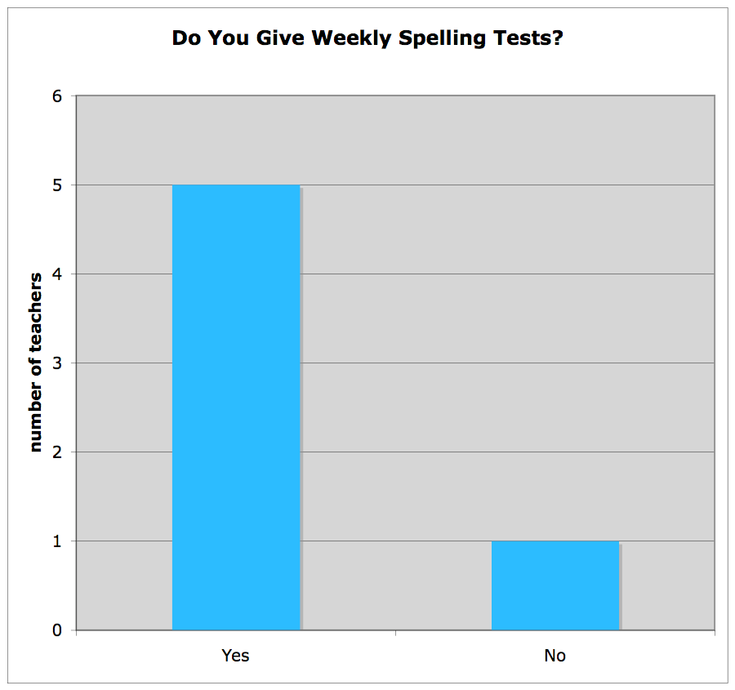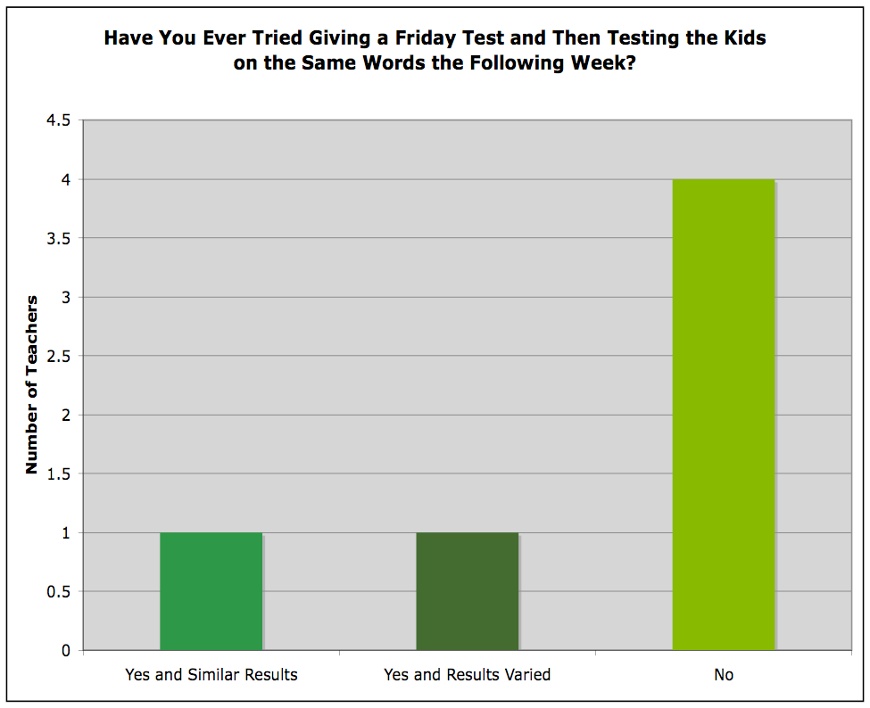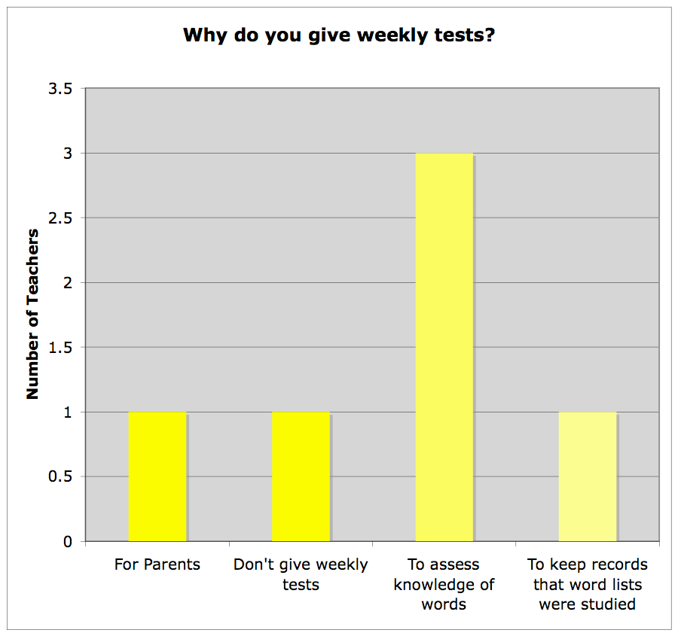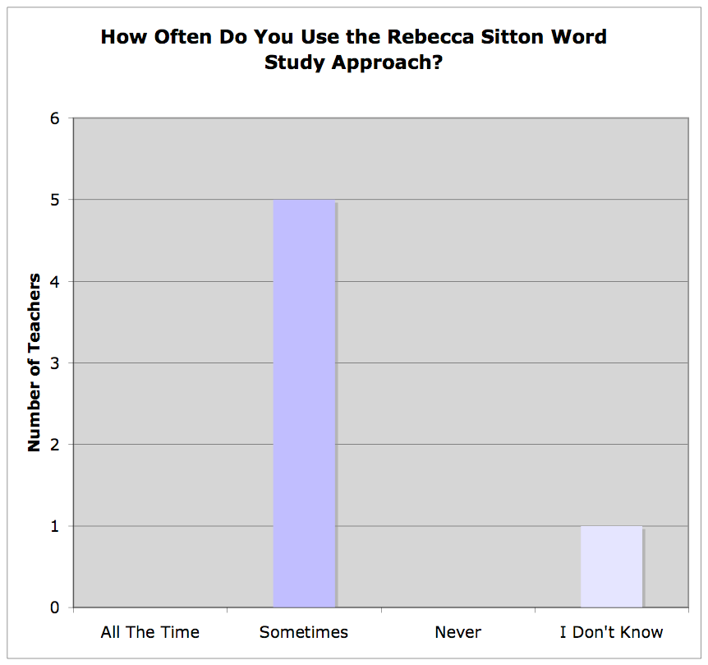

FRIDAY SPELLING TESTS

36

Figure 2.1: *Teacher Survey: Question 1*

Figure 2.2*:Teacher Survey: Question 2*

Figure 2.3*: Teacher Survey: Question 3*

Figure 2.4*: Teacher Survey: Question 4*

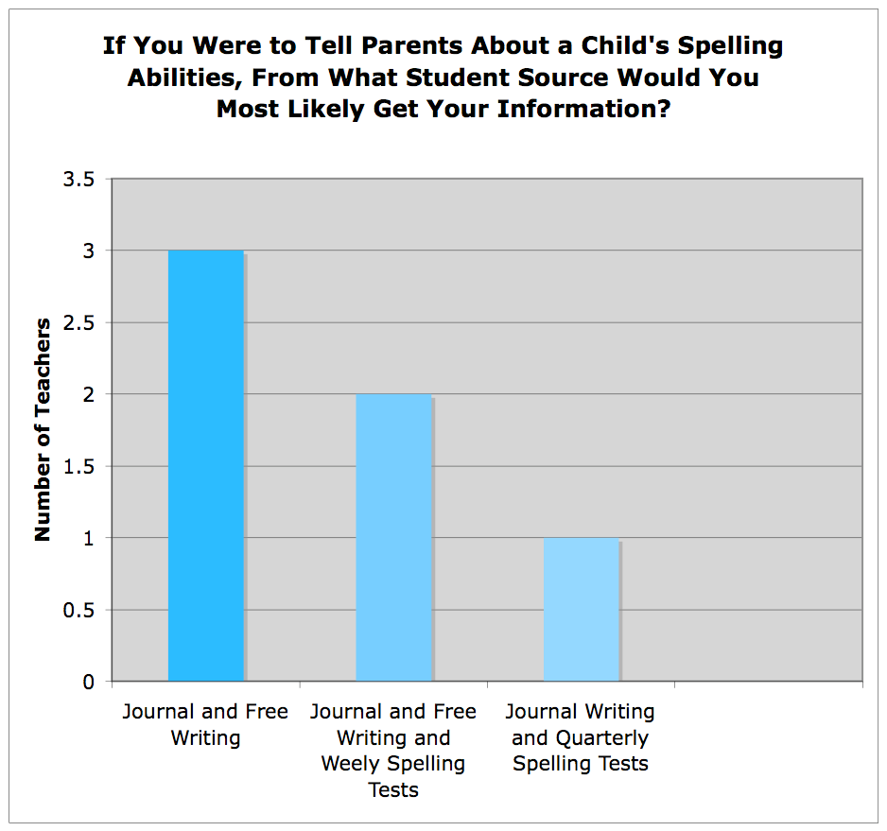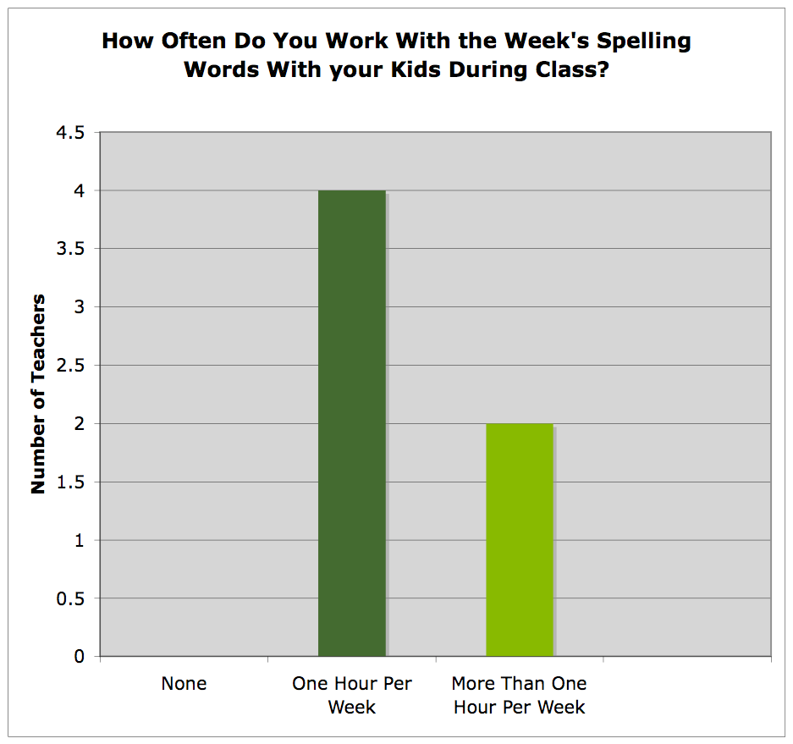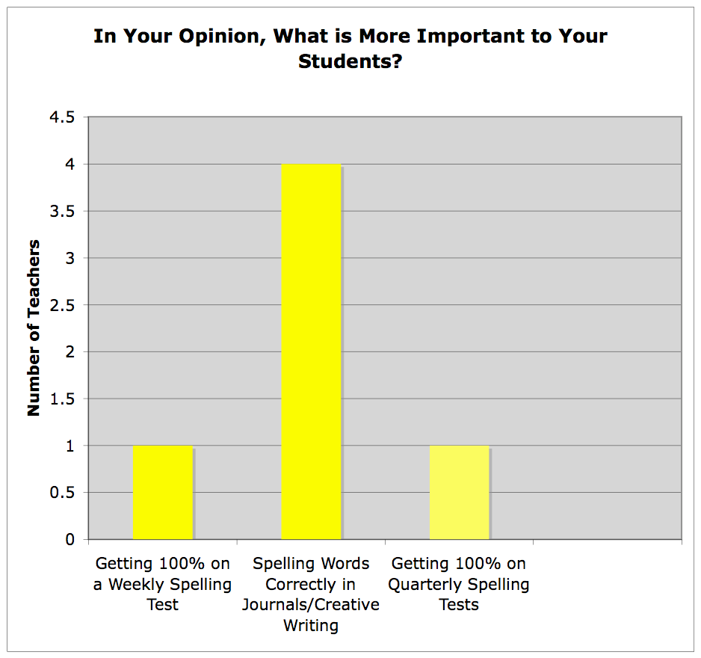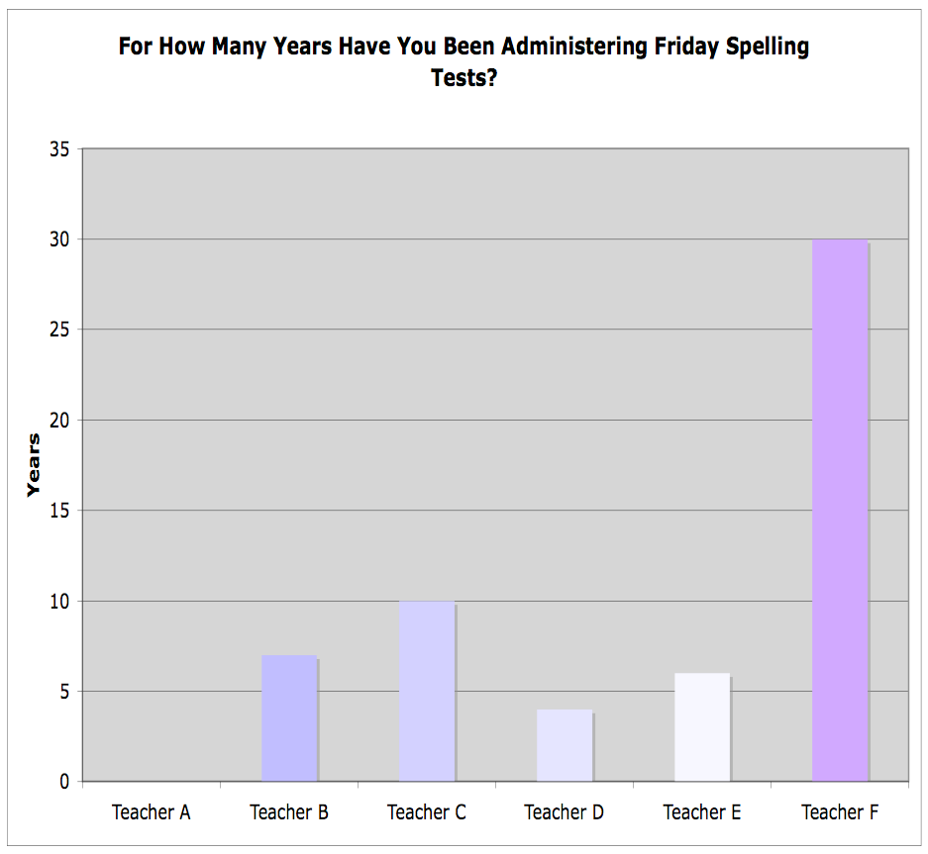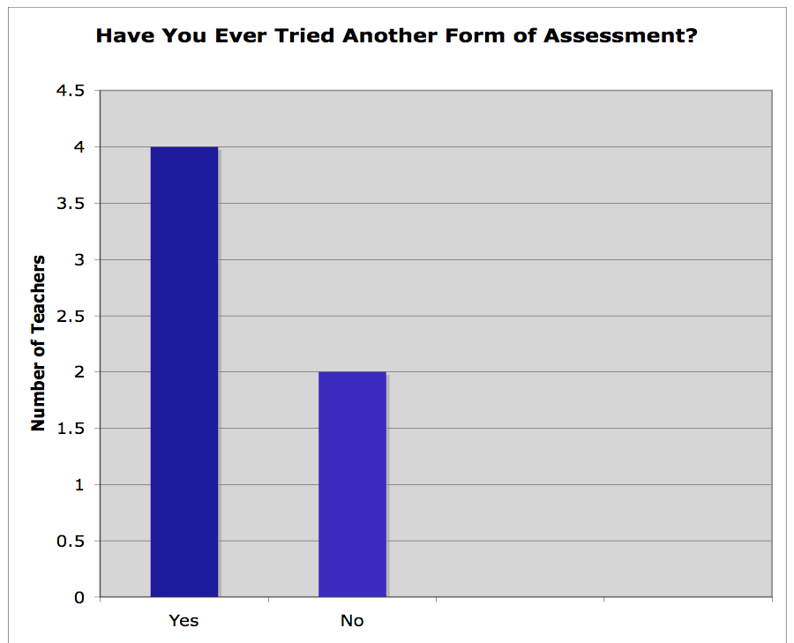

FRIDAY SPELLING TESTS

37

Figure 2.5*: Teacher Survey: Question 5*

Figure 2.6*: Teacher Survey: Question 6*

Figure 2.7*: Teacher Survey: Question 7*

Figure 2.8*: Teacher Survey: Question 8*

Figure 2.9*: Teacher Survey: Question 9*

FRIDAY SPELLING TESTS

38

Figure 3.1*:Results of Spelling Words Student A*

Spelling Word

Spelling on Test

Spelling in Journal Writing

very

vary

vary

what

what

some

sume

water

water

each

each

been

bhen

does

duse

many

maeny

said

said

sead

your

your

who

how

because

becase

becas

made

made

like

like

more

more

these

theas

know

know

there

thare

thaer

little

little

where

whar

whare

FRIDAY SPELLING TESTS

39

Figure 3.2*:Results of Spelling Words Student B*

Spelling Word

Spelling on Test

Spelling in Journal Writing

very

very

what

what

some

some

water

water

each

each

each

been

been

does

buse

dose

many

mane

said

siad

siad

your

your

who

who

who

because

because

becase

made

made

like

like

more

more

more

these

theas

know

know

know

there

there

there

little

little

where

were

FRIDAY SPELLING TESTS

40

Figure 3.3*:Results of Spelling Words Student C*

Spelling Word

Spelling on Friday Test

Spelling in Journal Writing

very

veay

what

what

some

sum

water

water

each

each

been

been

does

dus

dus

many

meny

said

said

your

your

who

hoo

because

becase

becase

made

mad

made

like

like

more

more

these

these

know

know

there

there

three

little

little

where

were

FRIDAY SPELLING TESTS

41

Figure 3.4*:Results of Spelling Words Student D*

Spelling Word

Spelling on Friday Test

Spelling in Journal Writing

very

very

what

what

some

some

water

water

each

each

been

been

does

does

many

many

said

sad

sad

your

your

who

who

how

because

because

becaus

made

made

like

like

more

more

these

these

know

know

there

there

little

little

where

where

were

FRIDAY SPELLING TESTS

42

Figure 3.5*:Results of Spelling Words Student E*

Spelling Word

Spelling on Test

Spelling in Journal Writing

very

vary

what

what

some

sum

water

watter

each

each

been

been

does

does

many

meny

meny

said

sed

your

your

who

because

becuase

made

mayed

like

like

more

more

these

these

now

now

there

thare

thare

little

little

where

whare