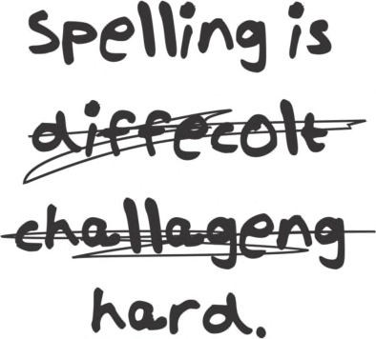



**Simplifying Spelling**

**Richard Scott**

Please see page 39 for a list of resources that have informed this booklet.

Aug 2018. Kindly contributed by Richard Scott, Warwickshire Adult & Community Learning. Search for Richard on [www.skillsworkshop.org](http://www.skillsworkshop.org/)

E1-L2 Functional English (writing). For related resources and curriculum links visit the download page for this resource at skillworkshop.

Page **1** of **43**

This bullet point means there is a tip that you can use.

**?** This bullet point means there is a task for you to do.



**Simplifying Spelling**

Name Date

**Contents**

Aug 2018. Kindly contributed by Richard Scott, Warwickshire Adult & Community Learning. Search for Richard on [www.skillsworkshop.org](http://www.skillsworkshop.org/)

E1-L2 Functional English (writing). For related resources and curriculum links visit the download page for this resource at skillworkshop.

Page **2** of **43**

**Page**

**Topic**

4

Common misspellings (with corresponding Functional English levels)

5

My spelling list (with general spelling tips)

6

What is spelling and why it is important?

7

What can cause misspelling?

8

How do you check your spelling?

9

Using a spell-checker

10

How to improve your spelling:

11

Break words up – compound words

12

Break words up – syllables

13

Break words up – words in words

14

Break words up – affixes

15

Break words up – affixes - prefixes

16

Break words up – affixes - suffixes

17-19

Using different senses – visual memory – word shapes

20

Using different senses – other visual memory aids

21

Using different senses – auditory memory – say it oddly

22

Using sentences (mnemonics) – silent letters, acrostics

23

Using sentences (mnemonics) – words in words, visual memory



**Simplifying Spelling**

Name Date

**Contents (continued)**

Aug 2018. Kindly contributed by Richard Scott, Warwickshire Adult & Community Learning. Search for Richard on [www.skillsworkshop.org](http://www.skillsworkshop.org/)

E1-L2 Functional English (writing). For related resources and curriculum links visit the download page for this resource at skillworkshop.

Page **3** of **43**

**Page**

**Topic**

24

Additional tips and tricks including: word origins, vowels, LSCWC

25

Look-Say-Cover-Write-Check template

26

Spelling rules: plurals

27

plurals (continued), adding -es to verbs

28

double consonants and silent/magic ‘e’

29

suffixes

30

prefixes, homonyms

31

letter sounds, ‘i’ before ‘e’,

32

verbs, abbreviations, capital letters

33-34

Spelling Practice

35

Notes / Questions

36

Answers Syllables

37

Compound words. words in words

38

Prefixes, suffixes, sentences (words in words)

39

Resources that have informed this booklet, and further reading

40-43

Functional skills English mapping



**Simplifying Spelling**

Name Date

*Levels E1, E2 & E3 link to the Entry Level spelling expectations published in the appendix of the 2018

Functional English Content which comes into effect in September 2019.

*DfE (Feb 2018), Subject content functional skills: mathematics https:*[*//www.gov.uk/government/publications/functional-skills-subject-content-mathematics*](http://www.gov.uk/government/publications/functional-skills-subject-content-mathematics)Also see pages 41-43 of this resource.

Aug 2018. Kindly contributed by Richard Scott, Warwickshire Adult & Community Learning. Search for Richard on [www.skillsworkshop.org](http://www.skillsworkshop.org/)

E1-L2 Functional English (writing). For related resources and curriculum links visit the download page for this resource at skillworkshop.

Page **4** of **43**

1

acceptable

It is not acceptable to smoke in the toilets.

E3

2

remember

Please remember to bring your ID.

E2

3

accommodation

The accommodation was 5-star.

L1-2

4

occasion

You will never have an occasion to wear it again.

E3

5

achieve

To achieve you must study at home.

E3

6

relevant

I will learn spellings that are relevant to me.

L1-2

7

argument

They had an argument about paying the bill.

E2

8

beautiful

It is a beautiful day.

E2

9

separate

You need to separate the laundry.

E3

10

because

I did it because I wanted to.

E1

11

knowledge

Knowledge is power.

E2

12

believe

I believe in you.

E2

13

calendar

Can you check your calendar?

E2

14

definite

Give me a definite answer.

E3

15

business

The business went bust.

E3

16

difficult

I can be difficult.

E2

17

embarrass

I didn’t mean to embarrass you.

L1-2

18

Wednesday

Today is Wednesday.

E1

19

equipment

Can you get the equipment?

E2

20

friend

Add me as a friend on Facebook.

E2

21

communication

Communication is key to a happy relationship.

E3

22

necessary

It is necessary to practise at home.

L1-2

23

queue

There was a big queue for the cinema.

L1-2

24

a lot

There were a lot of ants in the nest.

E1

25

receipt

Please can I have a receipt?

L1-2

26

restaurant

The food in the restaurant was lovely.

L1-2

27

said

They said it would be easy.

E1

28

neighbour

My neighbour is a pain.

L1-2

29

successful

To be successful you need to work hard.

E3-L1

30

write

Please write down your address.

E1

**Common misspellings** *Level





**Simplifying Spelling**

Name Date

**My spelling list**

Keep a personal dictionary or a list of spellings that are important and useful to

you. Use the space below (and maybe store the list on your phone) and keep revisiting these spellings. Use extra paper if you run out of space.

Only learn a few words at a time. Do not overcrowd your brain.

Concentrate on the part you have got wrong. You already know how to spell the rest of the word.

Use the tips in this booklet to help.

Aug 2018. Kindly contributed by Richard Scott, Warwickshire Adult & Community Learning. Search for Richard on [www.skillsworkshop.org](http://www.skillsworkshop.org/)

E1-L2 Functional English (writing). For related resources and curriculum links visit the download page for this resource at skillworkshop.

Page **5** of **43**

**Spelling**

**Sentence and/or tip.**

1

2

3

4

5

6

7

8

9

10

11

12

13

14

15





**Simplifying Spelling**

Name Date

**What is spelling and why is it important?**

•

Your aim is to make spelling automatic so there is no hesitation when writing.

To save time in an exam underline or highlight words you

are not sure of and come back to them later.

•

You need to take risks as a writer and a speller. Have a go at spelling

unfamiliar words and you might surprise yourself.

If you really cannot think of the spelling replace it with a

word that has a similar meaning (synonym). See the cover of this book for an example.

•

You must be able to check your work for mistakes. Make sure you see

exactly what is on the page rather than what you think is written.

Reading the written piece backwards (word by word - not

reading the words backwards) can help.

•

English has evolved over time and has borrowed many words from different

languages. This complicates English spelling. This 10-minute video provides a fun summary of some of the main historical influences:

[www.youtube.com/watch?v=H3r9bOkYW9s](http://www.youtube.com/watch?v=H3r9bOkYW9s) History of English (The Open University)

•

Poor spelling irritates and distracts the reader. It disrupts the flow of his or

her reading.

•

Be positive about your spelling. You can spell!

You just need a method to help you.

Aug 2018. Kindly contributed by Richard Scott, Warwickshire Adult & Community Learning. Search for Richard on [www.skillsworkshop.org](http://www.skillsworkshop.org/)

E1-L2 Functional English (writing). For related resources and curriculum links visit the download page for this resource at skillworkshop.

Page **6** of **43**





**Simplifying Spelling**

Name Date

**What can cause misspelling?**

•

Lack of visual memory/recognition of a word’s shape.

•

Poor handwriting, poor letter shapes and the lack of a flowing hand.

Using clear joined-up writing helps you see and feel the word’s shape compared to print writing.

•

The English spelling system is complex – too many exceptions to the rule.

•

Sound-symbol relationship of English – 44 sounds represented by 26

letters (20 of these sounds use the vowels, including the letter ‘y’).

•

How you and others pronounce the word.

•

You’ve used the incorrect spelling for so long and

corrected.

have

never

been

•

You over-rely on IT or other resources to spell for you.

Aug 2018. Kindly contributed by Richard Scott, Warwickshire Adult & Community Learning. Search for Richard on [www.skillsworkshop.org](http://www.skillsworkshop.org/)

E1-L2 Functional English (writing). For related resources and curriculum links visit the download page for this resource at skillworkshop.

Page **7** of **43**



**Simplifying Spelling**

Name Date

**How can you check your spelling?**

**Using other resources to help with your spelling is helpful but be careful not to**

**over-rely on them. These resources may not be around when you need them, e.g. in an exam.**

•

Predictive text on a mobile phone

* Does not always get you the right spelling

Speech-to-text recognition software (computer, phone, etc)

* Does not always get you the right spelling because of accent, homophones, etc.

Books

•

•

o

Dictionaries (definition) and Thesauri/Thesauruses (synonyms –

similar meaning words) Online

Paper

Electronic

o o o

o

Aurally

Coded

English

(ACE)

Spelling

Dictionary (ordered

phonetically not alphabetically)

Etymology (origins on words)

Mobile apps

[www.urbandictionary.com](http://www.urbandictionary.com/) (for everyday (slang) words that you won’t find in the dictionary and is created by the general public i.e. selfie)

o

o o

•

Word processor (i.e. Microsoft Word)

o o

o

Red line – spelling

Green line – grammar

Blue line – homonyms, ‘Are you sure you wanted to use that word?’ (Microsoft Office 2010 onwards)

* See next page

•

Ask someone else

o Assuming they know the correct spelling – they may not

Aug 2018. Kindly contributed by Richard Scott, Warwickshire Adult & Community Learning. Search for Richard on [www.skillsworkshop.org](http://www.skillsworkshop.org/)

E1-L2 Functional English (writing). For related resources and curriculum links visit the download page for this resource at skillworkshop.

Page **8** of **43**



**Simplifying Spelling**

Name Date

**Using a spell-checker**

Using a spell-checker can be useful but be careful. The following poem on the

left was run through Microsoft’s spell-checker and it only highlighted 6 mistakes.

Aug 2018. Kindly contributed by Richard Scott, Warwickshire Adult & Community Learning. Search for Richard on [www.skillsworkshop.org](http://www.skillsworkshop.org/)

E1-L2 Functional English (writing). For related resources and curriculum links visit the download page for this resource at skillworkshop.

Page **9** of **43**

**Original**

**Translation**

**Ode to Spell Checker**

Eye halve a spelling checker It came with my pea sea

It plainly marks four my revue Miss steaks eye kin knot sea.

Eye strike a key and type a word And weight four it two say Weather eye am wrong oar write It shows me strait a weigh.

As soon as a mist ache is maid It nose bee fore two long

And eye can put the error rite Its rare lea ever wrong.

Eye have run this poem threw it I am shore your pleased two no Its letter perfect awl the weigh

My checker tolled me sew.

**Ode to Spell Checker** I have a spell checker It came with my PC

It plainly marks for my review Mistakes I cannot see.

I strike a key and type a word And wait for it to say Whether I am wrong or right It shows me straight away.

As soon as a mistake is made It knows before too long

And I can put the error right It’s rarely ever wrong.

I have run this poem through it I am sure you’re pleased to know

It’s letter perfect all the way

My checker told me so.

red = spelling query (none) green = grammar query blue = homonyms query



**Simplifying Spelling**

Name Date

**How to improve your spelling**

Regular reading may improve your spelling and reading because you are looking

at words and storing them away in your visual memory. Your visual memory is

like a filing cabinet full of pictures, or shapes, of words. Good readers read by just looking very quickly at a word and recognising its shape.

Even more useful is to do what weak spellers don’t like – writing! When you **read**,

the correct spellings are on the page in front of you. When you **write**, you have to find the spellings from your memory’s filing system, which may be in a bit of a muddle. The more often you task your brain with finding words you want, the

more the words will stick.

Brains are naturally quite lazy but you can improve your filing system if you make

your brain work harder.

It is very important to practise your spellings every day. The practice will only

take one or two minutes so you could, for example, do it during a commercial break when watching your favourite TV programme.

People who practice every day become better spellers. Those who try to get

away with it with once or twice a week, unfortunately, are not likely to remember the spellings forever.

Even if you think you have got the spelling after the second or third time, you

should continue practising the spelling for the rest of the week to commit the spelling to memory.

**Pages 11-25 describe a range of spelling strategies and ideas.**

**Pages 26-32 list some common spelling rules.**

**Find the ones that work for you and your spellings.**

Aug 2018. Kindly contributed by Richard Scott, Warwickshire Adult & Community Learning. Search for Richard on [www.skillsworkshop.org](http://www.skillsworkshop.org/)

E1-L2 Functional English (writing). For related resources and curriculum links visit the download page for this resource at skillworkshop.

Page **10** of **43**



**Simplifying Spelling**

Name Date

There are many ways you can break up words:

•

•

•

•

•

Small words

Syllables

Words within words

Prefixes and Suffixes

Say it oddly

Some people are good at remembering **sounds**

in

a word. Others are better at

knowing what a word **looks** like. When you split up a word aim for groups of

roughly three letters and avoid leaving one letter on its own.

A compound word is made when two words are joined together to make a new

word. For example, joining ‘tooth’ and ‘paste’ gives you the new word ‘toothpaste’.

snow

tooth break news hose

hand

paste

paper pipe fast bag

man

toothpaste

Aug 2018. Kindly contributed by Richard Scott, Warwickshire Adult & Community Learning. Search for Richard on [www.skillsworkshop.org](http://www.skillsworkshop.org/)

E1-L2 Functional English (writing). For related resources and curriculum links visit the download page for this resource at skillworkshop.

Page **11** of **43**

**?** Can you think of some more compound words? Write them below.

**?** Match the following words together to create a new longer word. Draw lines between them and then write the new compound word on the dotted line.

**Compound Words**

Break Words Up

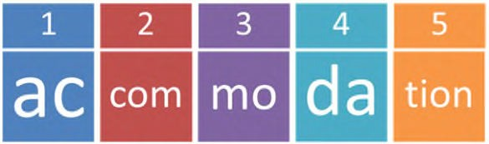



**Simplifying Spelling**

Name Date

Finding syllables in words is one of the best ways to break up words. A syllable

is one letter or a group of letters, which forms part of a word – sometimes it can be the whole word itself.

There are many ways to describe a syllable. A syllable is:

1. A **beat** in a word. Think about beating time to a word with a drum. The number

of beats in the word should be the same as the number of syllables.

2. A **push** of breath. Each syllable uses its own bit of breath as you breathe out.

3. A chunk of a word with **one vowel sound** in it.

4. The sound you make when you speak and you **jaw drops** down. Rest you chin

on the back of your hand and feel each syllable when you say a word.

All words can be broken into syllables. A word can contain one syllable or several.

**Example:**

The word ‘accommodation’ splits into 5 syllables.

Aug 2018. Kindly contributed by Richard Scott, Warwickshire Adult & Community Learning. Search for Richard on [www.skillsworkshop.org](http://www.skillsworkshop.org/)

E1-L2 Functional English (writing). For related resources and curriculum links visit the download page for this resource at skillworkshop.

Page **12** of **43**

**?** Use the list on page 4 or your own spelling list. Split each word into syllables. Use the syllables to practise, and then test yourself.

It may help to write the word’s syllables down, cut them up and then stick them onto coloured paper with a small gap between each syllable.

If you struggle to work out syllables, this website may help:

[http://www.howmanysyllables.com](http://www.howmanysyllables.com/)

Break Words Up

**Syllables**



**Simplifying Spelling**

Name Date

Most of us are confident about spelling and reading short words. You can use

these short words to help spell longer ones. Memory is a strange thing. You are more likely to remember something that is a bit odd, funny or rude.

Look at the word ‘**library**’. Can you see anything a bit odd, funny or rude inside

the word?

Can you see the **bra**

in **library**?

o

vegetable

o

many

o

shorter

o

words

o

inside

them

o

Aug 2018. Kindly contributed by Richard Scott, Warwickshire Adult & Community Learning. Search for Richard on [www.skillsworkshop.org](http://www.skillsworkshop.org/)

E1-L2 Functional English (writing). For related resources and curriculum links visit the download page for this resource at skillworkshop.

Page **13** of **43**

**?** How many small words can you find in the following words (without reordering the letters)?

Break Words Up

**Words in Words**



**Simplifying Spelling**

Name Date

Break Words Up

**Affixes**

Some words are made up of a main word (also called ‘base word’ or ‘root word’)

with groups of letters added to the beginning or the end of a word. These groups of letters are called ‘affixes’ (affix means to fix to).

The group of letters that are added to the beginning of a word is called a **prefix**

(from Latin circa 15th Century - ‘pre’ meaning before and ‘fix’ meaning fix)

**Example:**

**Prefix**

**Base**

**New word**

unhappy

un + happy

=

The group of letters that are added to the end of a word is called a **suffix** (from

Latin circa 15th Century ‘suf’ meaning on top of and ‘fix’ meaning fix)

**Example:**

**Base**

comfort +

**Suffix**

able

**New word**

comfortable

=

Sometimes there are many prefixes and suffixes in one word; for example,

‘**antidisestablishmentarianism**’. If you break it into smaller parts **YOU CAN SPELL IT!**

**anti**

Prefix

**dis**

Prefix

**establish**

Base

**ment**

Suffix

**arian**

Suffix

**ism**

Suffix

Now you have broken it up you have lots

of small

words to help you spell the

larger word. Some you may already be able to spell.

Aug 2018. Kindly contributed by Richard Scott, Warwickshire Adult & Community Learning. Search for Richard on [www.skillsworkshop.org](http://www.skillsworkshop.org/)

E1-L2 Functional English (writing). For related resources and curriculum links visit the download page for this resource at skillworkshop.

Page **14** of **43**



**Simplifying Spelling**

Name Date

Base words to match with the prefix:

Aug 2018. Kindly contributed by Richard Scott, Warwickshire Adult & Community Learning. Search for Richard on [www.skillsworkshop.org](http://www.skillsworkshop.org/)

E1-L2 Functional English (writing). For related resources and curriculum links visit the download page for this resource at skillworkshop.

Page **15** of **43**

**?** Can you think of some more words with prefixes? Write them below.

mortem

frost

form

storey

agree

sleep

fair

paid

play

**Prefix meaning**

**Prefix**

**Base**

**Total meaning**

pre

post

over

uni

multi

re

de

un

dis

**?** Match each prefix with a base word. (There may be more than one combination). Then work out the meaning of the prefix.

Break Words Up

**Prefixes**



**Simplifying Spelling**

Name Date

Base words to match with the prefix:

Aug 2018. Kindly contributed by Richard Scott, Warwickshire Adult & Community Learning. Search for Richard on [www.skillsworkshop.org](http://www.skillsworkshop.org/)

E1-L2 Functional English (writing). For related resources and curriculum links visit the download page for this resource at skillworkshop.

Page **16** of **43**

**?** Can you think of some more words with suffixes? Write them below.

friend

arrange

accept

table

walk

reply

box

use

hope

**Base**

**Suffix**

**Suffix meaning**

**Total meaning**

ed

ing

s

es

able

ful

ment

less

ly

**?** Can you match each suffix with a base word? (N.B. There may be more than one combination). Then work out the meaning of the suffix.

Break Words Up

**Suffixes**



**Simplifying Spelling**

Name Date

The more senses you use, the more likely you are to remember a word. In

addition to sight and sound, you can also use touch and movement. For example, using magnetic letters on a fridge or writing on sandpaper.

•

•

•

•

Visual memory – what you remember by using your eyes

Auditory memory – what you remember by using your ears Motor memory – what you remember by using movement Tactile memory – what you remember by using touch

Most people practise their spelling by using pen and paper but you do not have

to. If you have a hobby you can use these to help with your spelling.

•

•

•

If you like painting, use paint and paint your spellings

If you like sewing, use needle and thread and sew your spellings If you like woodwork, use tools to carve your spellings into wood

We are good at remembering diagrams, pictures, shapes and colour (by using

our visual memory) but we are **not** so good when it comes to small, black marks on white paper (writing). Use your visual memory to help.

You may find the shape of the word, with some colour added, is

easier to remember than just the letters on their own. The word ‘daily’ makes a shape which is not the same as most other words:

Making a picture out of a difficult word can also help your

visual memory. For example, some people find it helps to draw a bus around the first three letters of ‘business’.

Aug 2018. Kindly contributed by Richard Scott, Warwickshire Adult & Community Learning. Search for Richard on [www.skillsworkshop.org](http://www.skillsworkshop.org/)

E1-L2 Functional English (writing). For related resources and curriculum links visit the download page for this resource at skillworkshop.

Page **17** of **43**

**Visual Memory - Word Shape**

Using different senses



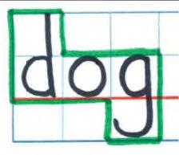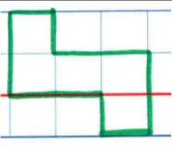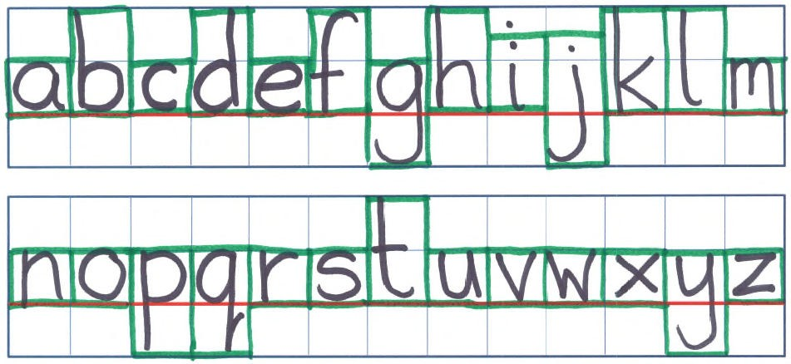

**Simplifying Spelling**

Name Date

**Example:**

Aug 2018. Kindly contributed by Richard Scott, Warwickshire Adult & Community Learning. Search for Richard on [www.skillsworkshop.org](http://www.skillsworkshop.org/)

E1-L2 Functional English (writing). For related resources and curriculum links visit the download page for this resource at skillworkshop.

Page **18** of **43**

The word ‘dog’ looks like this.

So the word shape is this.

**?** Choose a word that you find difficult to spell. Use the blank grid guide on the next page and write the word. The red line is the main line to write on. Ensure the letters fill the spaces as much as you can (see alphabet below for a guide

on how to write each letter to make use of the space).

Using different senses

**Visual Memory - Word shape (continued)**

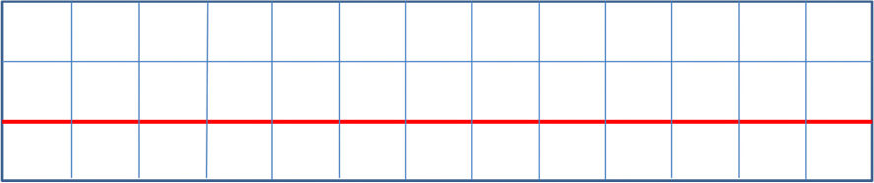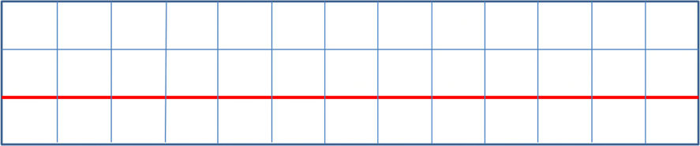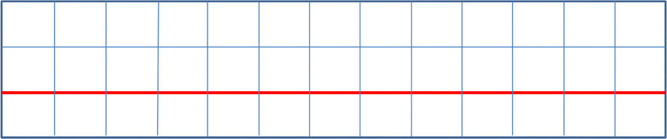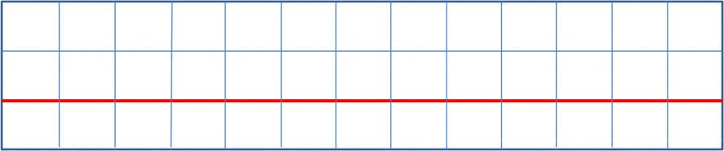

**Simplifying Spelling**

Name Date

**Visual Memory - Word shape (continued)**

**?** Write the spelling word below. Then draw around it with a coloured pen.

**?** Now draw just the shape in this box, without the letters.

Aug 2018. Kindly contributed by Richard Scott, Warwickshire Adult & Community Learning. Search for Richard on [www.skillsworkshop.org](http://www.skillsworkshop.org/)

E1-L2 Functional English (writing). For related resources and curriculum links visit the download page for this resource at skillworkshop.

Page **19** of **43**

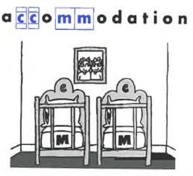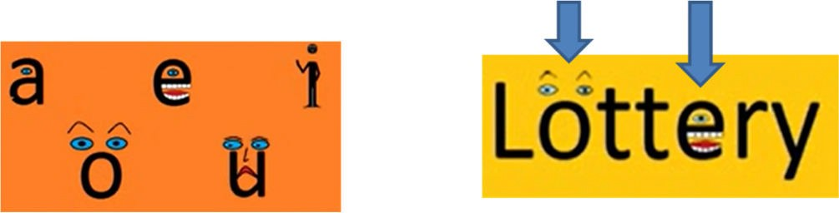



**Simplifying Spelling**

Name Date

Sometimes just highlighting

of a word may be all that is

.

You might remember that the word ‘accommodation’ has two ‘c’s and two

‘m’s if you picture accommodation with two cots and two mattresses:

You might remember that the word ‘necessary’ if you picture the ‘c’

nose and the ‘s’s as two hissing snakes:

as

a

Give the letters human characteristics. ‘**Surprised’** and **‘happy’** they won.

Aug 2018. Kindly contributed by Richard Scott, Warwickshire Adult & Community Learning. Search for Richard on [www.skillsworkshop.org](http://www.skillsworkshop.org/)

E1-L2 Functional English (writing). For related resources and curriculum links visit the download page for this resource at skillworkshop.

Page **20** of **43**

need

ed

parts

differ

ent

Using different senses

**Other Visual Memory Aids**





**Simplifying Spelling**

Name Date

Many words are said the way they are written but there are plenty that

are not. Try pronouncing the word in a different way to help with the spelling.

**For example:**

When we say the word ‘Wednesday’ we do not pronounce the ‘d’ so when you

are spelling ‘Wednesday’ break the word up and say the ‘d’

Aug 2018. Kindly contributed by Richard Scott, Warwickshire Adult & Community Learning. Search for Richard on [www.skillsworkshop.org](http://www.skillsworkshop.org/)

E1-L2 Functional English (writing). For related resources and curriculum links visit the download page for this resource at skillworkshop.

Page **21** of **43**

**?** Choose a difficult word that is not said how it is written.

Show below how you can break the word up and/or say it oddly to help you with the spelling.

**Wed**

**nes**

**day**

as in to marry

Using different senses

**Auditory memory – say it oddly**





**Simplifying Spelling**

Name Date

For spellings with silent letters, there are a couple of tricks you can use:

Simply remember it has a **silent letter**

Say it oddly

Create a sentence with words that share the same letter.

* The **w**riter **w**rote about **w**rong **w**rinkles.
* The gover**n**ment gover**n** the country.
* The **k**night **k**new the **k**nack of **k**nitting **k**nickers
* The si**g**n si**g**nals what to do.

**Auditory Memory - Acrostics**

In an acrostic the first letter of each word spells out a word or message.

‘**s**mall **a**nimals **i**n **d**anger’ spells the word ‘**said**’: **s**mall

**a**nimals

**i**n **d**anger

‘**t**hat **h**orrible **o**range **u**mbrella **g**ave **h**arry **t**rouble’ spells the word ‘**thought**’

Aug 2018. Kindly contributed by Richard Scott, Warwickshire Adult & Community Learning. Search for Richard on [www.skillsworkshop.org](http://www.skillsworkshop.org/)

E1-L2 Functional English (writing). For related resources and curriculum links visit the download page for this resource at skillworkshop.

Page **22** of **43**

**?** Create an acrostic for a word you find difficult to spell. This can take a bit of work but is worth the effort. There are many sources on the internet that can

provide ideas to get you started (search ‘mnemonic generator’).

**?** Find a word where the silent letter causes you difficulty. Search for words that share the same letter and create sentences like those above.

Using sentences (mnemonics)

**Auditory Memory - Silent Letters**





**Simplifying Spelling**

Name Date

Find a smaller word in the spelling word and then create a memorable sentence.

**Example:**

o

Please can I have a **pie**ce of pie?

o o o o

o

If you lie to me I won’t **believe** you.

Add an **address** to your letter. The **secretary** will keep his secret.

Since I must rely on you, I am, **sincerely** yours.

You might have to spit when you are in **hospital**.

**Sentences and visual memory**

You can make sentences that help you picture something in your mind’s eye

or that indicate the difficult parts of word.

* It is ne**c**e**ss**ary to have **1 c**ollar and **2 s**leeves on a shirt.
* The **CID** investigates in**cid**ents and ac**cid**ents.
* If you are emba**rr**a**ss**ed you will have **2 r**ed cheeks and **2 s**carlet ears.
* **W**illiam **K**. **W**illiams is an a**wkw**ard boy.
* Math**e**matics is **e**asy.

Aug 2018. Kindly contributed by Richard Scott, Warwickshire Adult & Community Learning. Search for Richard on [www.skillsworkshop.org](http://www.skillsworkshop.org/)

E1-L2 Functional English (writing). For related resources and curriculum links visit the download page for this resource at skillworkshop.

Page **23** of **43**

**?** Find the smaller words in the word that is bold and underlined. Then find that word again in the sentence. Highlight or circle it.

Using sentences (mnemonics)

**Word within words**





**Simplifying Spelling**

Name Date

**Additional Tips and Tricks**

Knowing the origin of a word can help with the spelling as it will remind you

why the word does not follow English spelling rules. For this you will need an etymology dictionary which can be found in book stores or on the internet.

Focus on the vowels in the word; i.e. s**e**nt**e**nc**e** (all ‘**e**’s), th**e**y (‘**e**’ not ‘a’,

although sounds like an ‘a’).

Try spelling and writing the word with your eyes closed so that you get a

‘feel’ of the spelling. Do this using sandpaper or other rough paper to give you a greater input/feel for the word (useful for people with dyspraxia too).

Look-say-cover-write-check

Use the template on the next page or copy it onto another piece of paper. Write the correct spelling in the 1st row.

Look at it.

Say it out loud and/or use a trick that helps you remember the spelling. Cover the correct spelling so you cannot see it.

Imagine the spelling on the paper in front of you or in your mind’s eye.

Wait at least 3 seconds before you try to write it (the longer you leave between looking and writing will increase the chance of the spelling staying in your long-term memory).

Write your spelling on the next blank row.

Double check what you have written and make changes if you need to.

1.

2.

3.

4.

5.

6.

7.

8.

9.

1. Check what you have written with the correct spelling in the 1st row.
2. Repeat steps 3-10 in the 3rd row and then again in the 4th row.
3. Read your work backwards to check for spelling. Reading forward checks for

sense and you may miss spelling errors as you know what the writing is supposed to say.

Aug 2018. Kindly contributed by Richard Scott, Warwickshire Adult & Community Learning. Search for Richard on [www.skillsworkshop.org](http://www.skillsworkshop.org/)

E1-L2 Functional English (writing). For related resources and curriculum links visit the download page for this resource at skillworkshop.

Page **24** of **43**



**Simplifying Spelling**

Name Date

**Look-Say-Cover-Write-Check Template**

Aug 2018. Kindly contributed by Richard Scott, Warwickshire Adult & Community Learning. Search for Richard on [www.skillsworkshop.org](http://www.skillsworkshop.org/)

E1-L2 Functional English (writing). For related resources and curriculum links visit the download page for this resource at skillworkshop.

Page **25** of **43**

Correct spelling

Attempt 1

Attempt 2

Attempt 3



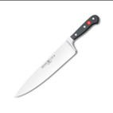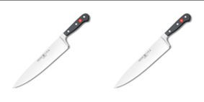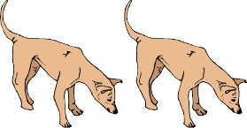

**Simplifying Spelling**

Name Date

Spelling Rules source: <http://www.parkhurstss.eq.edu.au/index.php/about-parkhurst-state-school/curriculum/spelling/>

**Spelling Rules: Quick Guide**

**Plurals**

Aug 2018. Kindly contributed by Richard Scott, Warwickshire Adult & Community Learning. Search for Richard on [www.skillsworkshop.org](http://www.skillsworkshop.org/)

E1-L2 Functional English (writing). For related resources and curriculum links visit the download page for this resource at skillworkshop.

Page **26** of **43**

When a word ends in ‘**o**’ and

6 comes after a consonant,

add ‘**es**’ to make the plural. **one** ding**o** **two** dingo**es**

When words end in ‘**f**’ or ‘**fe**’

5 change the ‘**f**’ or ‘**fe**’ to a ‘**v**’ before adding ‘**es**’.

**one** kni**f**e **two** kni**ves**

When words end in ‘**ay**’,

4 ‘**ey**’, ‘**iy**’, ‘**oy**’ and ‘**uy**’ add an ‘**s**’ to make the **plural.**

**one** turkey **two** turkey**s**

When the letter before a ‘**y**’

3 is a consonant, change the ‘**y**’

to an ‘**i**’ before adding an ‘**es**’. **one** poppy **two** popp**ies**

Add ‘**es**’ to words ending

2 in ‘ch’, ‘sh’ ‘s’, ‘ss’, ‘x’ or ‘z’

to make the **plural**. **one** box **two** box**es**

Most words add ‘**s**’

1

to make the **plural**.

**one** apple **two** apple**s**



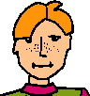

**Simplifying Spelling**

Name Date

Spelling Rules source: <http://www.parkhurstss.eq.edu.au/index.php/about-parkhurst-state-school/curriculum/spelling/>

**Adding - es to verbs**

Aug 2018. Kindly contributed by Richard Scott, Warwickshire Adult & Community Learning. Search for Richard on [www.skillsworkshop.org](http://www.skillsworkshop.org/)

E1-L2 Functional English (writing). For related resources and curriculum links visit the download page for this resource at skillworkshop.

Page **27** of **43**

When a verb word ends with a

The pirate bur**i**es

12 consonant followed by a ‘**y**’, change

his treasure.

the ‘**y**’ to an ‘**i**’ before adding ‘**es**’.

When a verb ends with a hissing

sound (‘sh’, ‘ch’, ‘ss’, ‘x’, ‘z’) add an ‘**es**’ Emma waltz**es** with

11

to make the 3rd person singular Les on Friday night.

present tense.

Some words, particularly those

10 from other languages, may have

**exceptions** when making plurals. **one** analysis **two** analys**es**

It may be confusing making

9 **compound words** into plural forms.

The significant word is made plural. My **sisters**-in-law are twins

Sometimes, a word stays the same in

8

both its **singular** and **plural** form.

**one** sheep **two** sheep

Sometimes, a word may

7 completely **change** its form

when a plural is made. **one** child **two** child**ren**

**Spelling Rules: Quick Guide**

**Plurals (continued)**



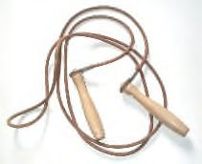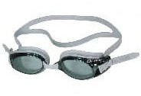

**Simplifying Spelling**

Name Date

Spelling Rules source: <http://www.parkhurstss.eq.edu.au/index.php/about-parkhurst-state-school/curriculum/spelling/>

**Spelling Rules: Quick Guide**

**Double consonants and silent/magic ‘e’**

Aug 2018. Kindly contributed by Richard Scott, Warwickshire Adult & Community Learning. Search for Richard on [www.skillsworkshop.org](http://www.skillsworkshop.org/)

E1-L2 Functional English (writing). For related resources and curriculum links visit the download page for this resource at skillworkshop.

Page **28** of **43**

For words ending in a silent

Kookaburras are

18 ‘**e**’, you must first drop very nois**y** birds.

the ‘**e**’ before adding a ‘**y**’.

When a word ends in a silent ‘**e**’,

Dave loves platform

17 drop the ‘**e**’ before adding an ‘**ing**’. div**ing** on weekends.

The magic ‘**e**’ runs away!

Double the last letter of words Patrick enjoys

16 ending in a short vowel followed by a laying back on a

single consonant before adding a ‘**y**’. sun**n**y day.

Double the last letter before adding

She’s a great

15 ‘**er**’ or ‘**est**’ to words that have a short swimm**er**.

vowel followed a single consonant.

Double the consonant before adding Grandad was si**tt**ing

14 ‘ing’ to words that have a short vowel in his chair all

followed by a consonant at the end. morning.

When a word ends with a short vowel She skip**ped** for

13 followed by a consonant, **double** the last 20 minutes at

consonant before adding ‘ed’. the gym.



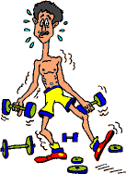

**Simplifying Spelling**

Name Date

Spelling Rules source: <http://www.parkhurstss.eq.edu.au/index.php/about-parkhurst-state-school/curriculum/spelling/>

**Spelling Rules: Quick Guide**

**Suffixes**

Aug 2018. Kindly contributed by Richard Scott, Warwickshire Adult & Community Learning. Search for Richard on [www.skillsworkshop.org](http://www.skillsworkshop.org/)

E1-L2 Functional English (writing). For related resources and curriculum links visit the download page for this resource at skillworkshop.

Page **29** of **43**

Just add a ‘**y**’ to words ending in

The last few days have

25 two consonants to form been quite wind**y** here.

describing words.

When adding a vowel suffix

Vikings liv**ed** many,

24 to words ending in a silent ‘**e**’, many years ago.

drop the ‘**e**’ and add the suffix.

Before adding ‘**er**’ and ‘**est**’ to words

Dean is the skinn**i**est

23 ending in a consonant, followed by a member at the gym.

‘**y**’, change the ‘**y**’ to an ‘i’.

The painting was very

22 The suffix ‘**ful**’ only has one ’l’. colourfu**l**.

When adding ‘**ly**’ to words

Amanda scored the

21 which end in ‘**y**’, change the ‘**y**’ goal quite dainti**ly**.

to an ‘**i**’ before adding the ‘**ly**’.

Often ‘**ly**’ is added to base words

The jelly turned out

20 to turn them into **adverbs** or perfectly.

**adjectives**.

For action words that end

Matthew enjoys l**y**ing on

19 in ‘**ie**’, change the ‘**ie**’ to a his back to watch clouds.

‘**y**’ before adding an ‘**ing**’.



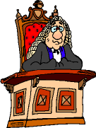

**Simplifying Spelling**

Name Date

Spelling Rules source: <http://www.parkhurstss.eq.edu.au/index.php/about-parkhurst-state-school/curriculum/spelling/>

**Homonyms**

Aug 2018. Kindly contributed by Richard Scott, Warwickshire Adult & Community Learning. Search for Richard on [www.skillsworkshop.org](http://www.skillsworkshop.org/)

E1-L2 Functional English (writing). For related resources and curriculum links visit the download page for this resource at skillworkshop.

Page **30** of **43**

**Homographs** are words that A calculator is a useful

30 may have more than one **object**.

meaning or pronunciation. The lawyer said, “I

**object**!”.

**Homophones** are words that have

A **pair** of scissors.

29 the same sound but a different

A **pear** is a fruit.

meaning and spelling.

Some **prefixes** ending in a It’s **im**possible for cows to talk.

28 consonant vary depending on the Cows are **in**capable of

first letter of the base word. speech.

**Prefixes** ending in vowels are added

We must all

27 directly to base words. They change the try to **re**cycle.

meaning the meaning of the word.

**Prefixes** are added to roots to Mr Smith predicts

26 form new words. Roots often have a hot summer.

meanings from other languages. ‘pre’ means ‘before’

and ‘dict’ means ‘say’ (Latin)

**Spelling Rules: Quick Guide**

**Prefixes**



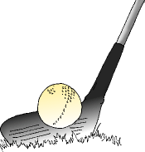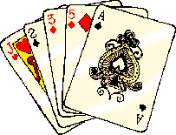

**Simplifying Spelling**

Name Date

Spelling Rules source: <http://www.parkhurstss.eq.edu.au/index.php/about-parkhurst-state-school/curriculum/spelling/>

**I before E**

Aug 2018. Kindly contributed by Richard Scott, Warwickshire Adult & Community Learning. Search for Richard on [www.skillsworkshop.org](http://www.skillsworkshop.org/)

E1-L2 Functional English (writing). For related resources and curriculum links visit the download page for this resource at skillworkshop.

Page **31** of **43**

Some people bel**ie**ve

‘**i**’ before ‘**e**’ except after ‘**c**’ that unicorns exist.

36

(when the sound is “ee”). I rec**ei**ved a toy unicorn

in the post.

The **k**night rode on his horse. It

35 English has many clim**b**ed the hill slowly because of

‘**silent letters**’.

the wei**gh**t of the armour.

The letter ‘**c**’ may have a soft

34 or hard sound. When ‘**c**’ meets **c**entipede (soft **c**)

an ‘**e**’, ‘**i**’ or ‘**y**’ its sound is soft.

The letter ‘**c**’ may have a soft

33 or **hard** sound. When ‘**c**’ meets **c**ards (hard **c**)

an ‘**a**’, ‘**o**’ or ‘**u**’ its sound is hard.

The letter ‘**g**’ may have a soft

32 or hard sound. A soft ‘**g**’ is usually ‘**g**’ in ‘**g**em’ is soft

followed by an ‘**i**’ or ‘**e**’.

The letter ‘g’ may have a soft or hard

31 sound. A hard ‘**g**’ is usually followed ‘**g**’ in ‘**g**olf’ is hard

by a consonant or an ‘**a**’, ‘**o**’ or ‘**u**’.

**Spelling Rules: Quick Guide**

**Letter sounds**



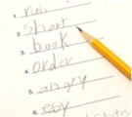

**Simplifying Spelling**

Name Date

Spelling Rules source: <http://www.parkhurstss.eq.edu.au/index.php/about-parkhurst-state-school/curriculum/spelling/>

**Abbreviations**

**Capital letters**

Aug 2018. Kindly contributed by Richard Scott, Warwickshire Adult & Community Learning. Search for Richard on [www.skillsworkshop.org](http://www.skillsworkshop.org/)

E1-L2 Functional English (writing). For related resources and curriculum links visit the download page for this resource at skillworkshop.

Page **32** of **43**

Missing **CAPITAL** letters can My best friend is a

42

cause confusion. swede.

**CAPITAL** letters are also Let’s visit this well

41 used at the beginning of known **B**ritish

**proper adjectives.** landmark.

**CAPITAL** letters are used at

**U**luru is a well known

40 the beginning of **proper nouns** landmark in **A**ustralia.

(names and places).

Sometimes when writing, words I need an appointment

39 may be shortened. These are to see **Dr** Phillips.

known as **abbreviations**. (Doctor)

Some irregular verbs

He **learned** his spellings.

38 have more than one He **learnt** his spellings.

spelling in the past tense.

There are some verbs that do not

I bought (buy) some

37 follow the usual spelling pattern, sweets.

they are called ‘**irregular verbs**’.

**Spelling Rules: Quick Guide**

**Verbs**



**Simplifying Spelling**

Name Date

**Spelling Practice**

Aug 2018. Kindly contributed by Richard Scott, Warwickshire Adult & Community Learning. Search for Richard on [www.skillsworkshop.org](http://www.skillsworkshop.org/)

E1-L2 Functional English (writing). For related resources and curriculum links visit the download page for this resource at skillworkshop.

Page **33** of **43**

**Practice 1**

**Practice 2**

**Practice 3**

1

1

1

2

2

2

3

3

3

4

4

4

5

5

5

6

6

6

7

7

7

8

8

8

9

9

9

10

10

10

11

11

11

12

12

12

13

13

13

14

14

14

15

15

15

16

16

16

17

17

17

18

18

18

19

19

19

20

20

20

21

21

21

22

22

22

23

23

23

24

24

24

25

25

25

26

26

26

27

27

27

28

28

28

29

29

29

30

30

30



**Simplifying Spelling**

Name Date

**Spelling Practice**

Aug 2018. Kindly contributed by Richard Scott, Warwickshire Adult & Community Learning. Search for Richard on [www.skillsworkshop.org](http://www.skillsworkshop.org/)

E1-L2 Functional English (writing). For related resources and curriculum links visit the download page for this resource at skillworkshop.

Page **34** of **43**

**Practice 4**

**Practice 5**

**Practice 6**

1

1

1

2

2

2

3

3

3

4

4

4

5

5

5

6

6

6

7

7

7

8

8

8

9

9

9

10

10

10

11

11

11

12

12

12

13

13

13

14

14

14

15

15

15

16

16

16

17

17

17

18

18

18

19

19

19

20

20

20

21

21

21

22

22

22

23

23

23

24

24

24

25

25

25

26

26

26

27

27

27

28

28

28

29

29

29

30

30

30



**Simplifying Spelling**

Name Date

**Notes / Questions**

Aug 2018. Kindly contributed by Richard Scott, Warwickshire Adult & Community Learning. Search for Richard on [www.skillsworkshop.org](http://www.skillsworkshop.org/)

E1-L2 Functional English (writing). For related resources and curriculum links visit the download page for this resource at skillworkshop.

Page **35** of **43**



**Simplifying Spelling**

Answers, bibliography and functional skills mapping

**Answers**

Aug 2018. Kindly contributed by Richard Scott, Warwickshire Adult & Community Learning. Search for Richard on [www.skillsworkshop.org](http://www.skillsworkshop.org/)

E1-L2 Functional English (writing). For related resources and curriculum links visit the download page for this resource at skillworkshop.

Page **36** of **43**

No. of syllables

Syllables

1

acceptable

4

ac-cept-a-ble

2

remember

3

re-mem-ber

3

accommodation

5

ac-com-mo-da-tion

4

occasion

3

oc-ca-sion

5

achieve

2

a-chieve

6

relevant

3

rel-e-vant

7

argument

3

ar-gu-ment

8

beautiful

3

beau-ti-ful

9

separate

2 or 3

sep-arate sep-a-rate

10

because

2

be-cause

11

knowledge

2

knowl-edge

12

believe

2

be-lieve

13

calendar

3

cal-en-dar

14

definite

3

def-i-nite

15

business

2

busi-ness

16

difficult

3

dif-fi-cult

17

embarrass

3

em-bar-rass

18

Wednesday

2

Wednes-day

19

equipment

3

e-quip-ment

20

friend

1

friend

21

communication

5

com-mu-ni-ca-tion

22

necessary

4

nec-es-sar-y

23

queue

1

queue

24

a lot

2 words, 1 syllable in each

a lot

25

receipt

2

re-ceipt

26

restaurant

3

res-tau-rant

27

said

1

said

28

neighbour

2

neigh-bour

29

successful

3

suc-cess-ful

30

write

1

write

**Syllables** **Page 12**

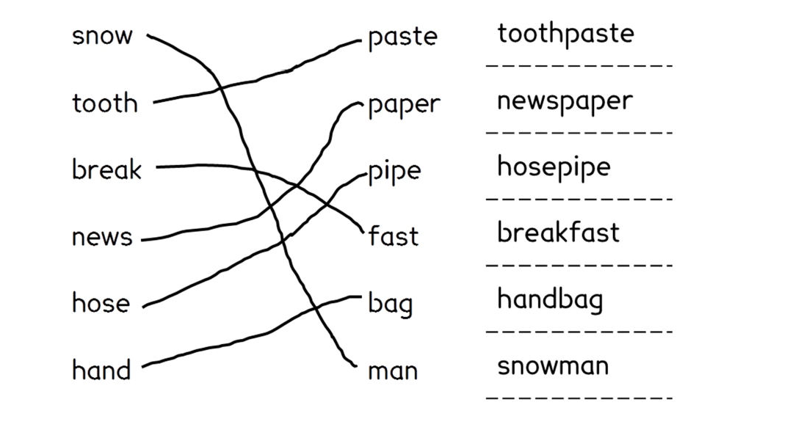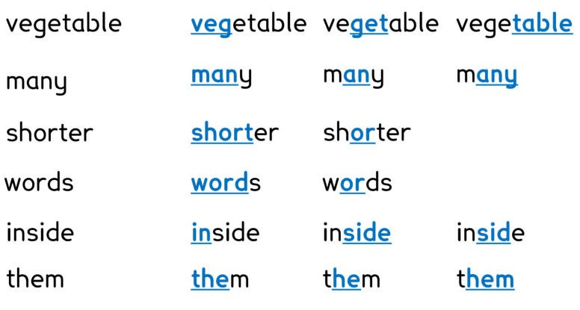



**Simplifying Spelling**

Answers, bibliography and functional skills mapping

Here are some examples of the words you may have found. You may have

found more.

Aug 2018. Kindly contributed by Richard Scott, Warwickshire Adult & Community Learning. Search for Richard on [www.skillsworkshop.org](http://www.skillsworkshop.org/)

E1-L2 Functional English (writing). For related resources and curriculum links visit the download page for this resource at skillworkshop.

Page **37** of **43**

**Words in words** **Page 13**

**Compound Words** **Page 11**



**Simplifying Spelling**

Answers, bibliography and functional skills mapping

Here are some answers for the prefix exercise. You may have found more.

Here are some answers for the suffix exercise. You may have found more.

o

If you lie to me I won’t believe you.

o

o

Add an address to your letter.

The secretary will keep his secret.

o

Since I must rely on you, I am, sincerely yours.

o

You might have to spit when you are in hospital.

Aug 2018. Kindly contributed by Richard Scott, Warwickshire Adult & Community Learning. Search for Richard on [www.skillsworkshop.org](http://www.skillsworkshop.org/)

E1-L2 Functional English (writing). For related resources and curriculum links visit the download page for this resource at skillworkshop.

Page **38** of **43**

**Using Sentences - Words in Words** **Page 23**

**Base**

**Suffix**

**Suffix meaning**

**Total meaning**

walk

ed

past tense

to walk in the past

reply

ing

present tense

to reply in the present

table

s

plural

more than one table

box

es

plural

more than one box

accept

able

fit for

fit to be accepted

use

ful

full of

full of use

arrange

ment

product of

result of arranging

hope

less

without

without hope

friend

ly

like

like a friend

**Suffixes** **Page 16**

**Prefix meaning**

**Prefix**

**Base**

**Total meaning**

before

pre

paid

paid before

after

post

mortem

after death

too much

over

sleep

too much sleep

one

uni

form

one form (one for all)

many

multi

storey

many levels

again

re

play

play again

to take away

de

frost

to take away frost

not

un

fair

not fair

not

dis

agree

to not agree

**Prefixes** **Page 15**



**Simplifying Spelling**

Answers, bibliography and functional skills mapping

**Resources that have informed this booklet and further reading**

•

•

•

•

•

•

•

<http://www.spellingcity.com/richardscott/> <http://www.beatingdyslexia.com/spelling-strategies.html> <http://www.howtospell.co.uk/spellingquiz.php> <http://www.gamesgames.com/games/spelling> <http://www.vocabulary.co.il/adult-spelling-programs-how-they-can-help-you/>

<http://grammar.yourdictionary.com/spelling-and-word-lists/Practice-My-Spelling.html>

<http://www.oxforddictionaries.com/spelling-challenge>

**Spelling list sources:**

•

<http://www.telegraph.co.uk/finance/jobs/11498666/top-ten-spelling-mistakes-job-> seekers-employees-cvs-curriculum-vitae.html https://oupeltglobalblog.com/2010/09/30/20-most-commonly-misspelt-words-in- english/

<http://www.dailymail.co.uk/news/article-2782743/Embarrassment-fluorescent-> accommodate-named-50-words-Britons-difficulty-spelling.html <http://businesswriting.com/tests/commonmisspelled.html>

<http://www.oxforddictionaries.com/words/common-misspellings>

•

•

•

•

**Spelling rules (pages 26-32) all adapted from:**

•

<http://www.parkhurstss.eq.edu.au/index.php/about-parkhurst-state->

school/curriculum/spelling/

•

Chambers Adult Learner's Guide to Spelling by Anne Betteridge ISBN: 0550102248 or 9780550102249

Teaching Spelling and Handwriting: A Guide for Undergraduates by D Brook ISBN: 0901437859 or 9780901437853

Spell It Out: The Singular Story of English Spelling by David Crystal

ISBN: 1846685680 or 9781846685682

•

•

**Font**

The main font used is '**Lexie Readable**'. https://[www.k-type.com/lexie-readable/](http://www.k-type.com/lexie-readable/)

(Regular and bold typefaces are free for personal, educational and charity use).

Aug 2018. Kindly contributed by Richard Scott, Warwickshire Adult & Community Learning. Search for Richard on [www.skillsworkshop.org](http://www.skillsworkshop.org/)

E1-L2 Functional English (writing). For related resources and curriculum links visit the download page for this resource at skillworkshop.

Page **39** of **43**



**Simplifying Spelling** Functional skills English mapping

***Source:*** *DfE (Feb 2018), Subject content functional skills: English* ***Source:*** *DfE (Feb 2018), Subject content functional skills: English* https[://www.gov.uk/government/publications/functional-skills-subject-content-english](http://www.gov.uk/government/publications/functional-skills-subject-content-english)

Aug 2018. Kindly contributed by Richard Scott, Warwickshire Adult & Community Learning. Search for Richard on [www.skillsworkshop.org](http://www.skillsworkshop.org/)

Page **40** of **43**

**Subject content - FUNCTIONAL SKILLS ENGLISH**

→ = not covered in detail in this resource but included to show progression across levels. ✓ indicates **content** covered in this resource, although this will vary with the student group and how the resource is used by the teacher. (C*ontent at each level subsumes and builds upon the content at lower levels.)*

**Purpose and learning aims of Functional Skills English**

**Functional Skills English** specifications enable students to develop confidence and fluency in, and a positive attitude towards, English. They should be able to demonstrate their competence by using English in real-world situations as well as demonstrating a sound grasp of basic English knowledge and skills.

They need to provide assessment of students’ **underpinning knowledge** (i.e. spelling) as well as their ability to apply this in different contexts.

**Entry Levels:** a qualification to demonstrate the ability at an appropriate level to read, write, speak, listen and communicate in English and provide the basis for further study at Levels 1 and 2. Students should, with some direction and guidance, be able to apply these (Entry Level) English functional skills to informal and some formal contexts, in familiar situations.

**Levels 1 and 2:** a qualification for work, study and life. Achievement of the qualification demonstrates the ability at an appropriate level to read, write, speak, listen and communicate in English, and apply these skills effectively to a range of purposes in the workplace and other real life situations. Students should be able to communicate with confidence, effectiveness and an increasing level of independence, in a range of formal and informal contexts.

**Functional English - Writing**

‘Writing’ within Functional Skills English qualifications is defined as the independent construction of written language to communicate in specific contexts. Text can be written on paper or electronically.

**Learning aims for writing**

**E1,2 & 3.** Write straightforward texts and documents with clarity and effectiveness, and demonstrate a sound grasp of spelling, punctuation and grammar.

**L1-2** (i) Write texts of varying complexity, with accuracy, effectiveness, and correct spelling, punctuation and grammar (ii) Understand the situations when, and audiences for which, planning, drafting and using formal language are important, and when they are less important.

**Spelling, punctuation and grammar (SPaG) content descriptors**

**Entry Level 1**

**Entry Level 2**

**Entry Level 3**

**Level 1**

**Level 2**

E1.15. Spell correctly words designated for Entry Level 1* ✓

E2.14 Form regular plurals ✓ E2.16 Spell correctly words designated for Entry Level 2* ✓

E3.14 Form irregular plurals → E3.17 Spell correctly words designated for Entry Level 3* ✓

L1.21 Spell words used most often in work, study and daily life, including specialist words✓

L2.22 Spell words used in work, study and daily life, including a range of specialist words ✓

**Scope of study – learners should write texts that include** *(content/text types at each level subsume previous levels)*

short simple messages and notes

short, straightforward letters, emails and simple narratives

straightforward narratives, instructions, explanations and reports

straightforward narratives, instructions, explanations and reports of varying lengths

straightforward and complex articles, explanations, narratives, and reports of varying lengths

* Refer to the appendix of *Subject content functional skills: English (DfE, Feb 2018*) or pages 41-43 of this resource.



**Simplifying Spelling** Functional skills English mapping

***Source:*** *DfE (Feb 2018), Subject content functional skills: English* ***Source:*** *DfE (Feb 2018), Subject content functional skills: English* https[://www.gov.uk/government/publications/functional-skills-subject-content-english](http://www.gov.uk/government/publications/functional-skills-subject-content-english)

**Functional Skills Entry Level 1 – Expectations for spelling**

*The words have been chosen because they are common words.*

**Notes for tables on pages 41, 42 & 43:** the correspondences between sounds and letters shown in the tables are not exact and should be interpreted flexibly, especially where there are

difference dues to regional accent. The letters underlined in the ‘Letters’ columns correspond to the ‘Sound(s)’ in the adjacent column. These letters may need special attention for spelling. The sounds are shown using the symbols of the International Phonetic Alphabet (IPA) for clarity. It is not necessary for those using the programme of study to understand the symbols, as the letters underlined in the word examples give the sounds represented by the symbols. Students are not expected to understand or use IPA symbols.

Aug 2018. Kindly contributed by Richard Scott, Warwickshire Adult & Community Learning. Search for Richard on [www.skillsworkshop.org](http://www.skillsworkshop.org/)

Page **41** of **43**

**Letters**

Sound

**Letters**

Sound(s)

In addition, Entry Level 1 students are expected to spell the words described below. Words in brackets are examples. Words and letters in bold are not examples; they are specific words or spellings that students are expected to both read and spell correctly.

* all common words with one or two

syllables, where the most probable correspondences between sounds and letters are the correct ones (e.g., it, nut, and, stop, rush, thing, himself)

* common two syllable words where

/iː/ at the end is spelled with ‘y’

(e.g., twenty)

* common one or two syllable words with ay and oy, knowing that ay and oy usually correspond to /eɪ/ and /ɔɪ/ at the end of words (e.g., day, runway, boy)
* -ed for the past tense, when the root word remains unchanged (e.g., wanted, opened, jumped)
* the following contractions:

**Mr, Mrs**

**n’t** (e.g., didn’t)

**’ll** (e.g., I’ll)

**’re** (e.g., we’re)

**’s** (e.g., it’s)

**can, act, look, back, school**

/k/

**put, push, pull would, could, should, full, look, good**

/ʊ/

**off**

/f/

**do, to, into, who, too, you, group, two, room**

/u:/

**miss, cross, house**

/s/

**day, say, way, made, make, take, came, same, late, they**

/eɪ/

**who**

/h/

**high, right, might, find, mind, child, Friday, by, my, myself, reply, like, time, life, while, I, write**

/aɪ/

**write, wrote, wrong**

/r/

**out, about, without, around, now, how, down**

*/aʊ/*

**will, well, tell, still, hello**

/l/

**own, follow, so, no, go, old, over, open, most, only, both, told, hold, don’t, close, show**

*/əʊ/*

**get, give**

/ɡ/

**boy**

*/ɔɪ/*

**change, large**

/dʒ/

**saw, draw, walk, all, call, small, also, water**

*/ɔ:/*

**have, give, live, of**

/v/

**or, for, morning, door, floor, poor, more, before, warm, four, your**

*/ɔ:/ or /ɔ:r/*

**is, his, as, has, Wednesday**

/z/

**her, person, Thursday, Saturday, girl, first, work, word, world, were**

*/3ː/ or /3ːr/*

**come, some**

/m/

**fast, last, past, plant, path, ask, after**

*/æ/ or /aː/*

**know, done, one, gone**

/n/

**are, our**

*/aː/ or /aːr/*

**think**

/ŋ/

**air, where, there, their**

*/cə/ or/cər/*

**when, which, what, while, white**

/w/

**near, here, dear, year**

*/ɪə/or /ɪər/*

**see, seem, feel, meet, week, eat, real, be, he, me, we, she, even, every**

/iː/

**the, between, until, today, together, number, other, after, never, under**

*/ə/*

**enjoy**

/ɪ/

**Tuesday, use, new, few**

*/juː/*

**head, any, many, anyone, thank, said, again, says**

/e/

**little**

/ ə l /

**come, done, some, other, brother, money, Monday, does**

/m/

**one, someone, anyone**

/ w ʌ /

**was, want, what, because**

/0/



**Simplifying Spelling** Functional skills English mapping

***Source:*** *DfE (Feb 2018), Subject content functional skills: English* ***Source:*** *DfE (Feb 2018), Subject content functional skills: English* https[://www.gov.uk/government/publications/functional-skills-subject-content-english](http://www.gov.uk/government/publications/functional-skills-subject-content-english)

**Functional Skills Entry Level 2 – Expectations for spelling**

*The words have been chosen because they are common words that are not straightforward to spell.*

Aug 2018. Kindly contributed by Richard Scott, Warwickshire Adult & Community Learning. Search for Richard on [www.skillsworkshop.org](http://www.skillsworkshop.org/)

Page **42** of **43**

**Letters**

Sound

**Letters**

Sound(s)

In addition, Entry Level 2 students are expected to spell the words described below. Words in brackets are examples. Words and letters in bold are not examples; they are specific words or spellings that students are expected to both read and spell.

* words with prefixes where the root word remains

unchanged (e.g., unsure, disappoint, mistake, return, subject, interact, supermarket, autograph)

* words with prefixes where in-, changes to il-, im-, ir-,

before root words that begin with ‘l’, ‘m’, ‘p’, ‘r’ (e.g., illegal, immoral, impossible, irregular)

* words with suffixes where the root word remains

unchanged (e.g., payment, witness, careful, careless, partly)

* words with suffixes where the last ‘e’ in a root word is

dropped before adding a suffix beginning with a vowel (e.g., hoping, liked, safer)

* words with suffixes where a root word ends with a short

vowel sound and a single consonant letter, and the single consonant letter at the end of the root word is doubled before adding a suffix beginning with a vowel or ‘y’ (e.g., chopped, winner, getting, sunny)

* words with suffixes where ‘y’ at the end of the root word

is changed to ‘i’ before adding a suffix beginning with a vowel (e.g., ladies, replied, happier, happiest), but not before ‘–ing’ to avoid ‘ii’ (e.g., replying)

* Words with suffixes ending in ‘-tion’ (e.g., mention,

question, position, action)

* common words with letters corresponding to sounds that are often not pronounced (e.g., February, library, often, every, everything, interest, ordinary)
* the following homophones: **there, their, they’re; here, hear; one, won; to, too, two.**

**letter, better**

/t/

**woman**

/ʊ/

**differ, different, difficult,**

/f/

**move, blue, blew, truly, fruit, group, through**

/u:/

**address, promise, city, circle, decide, notice, since, sentence, once, answer,**

/s/

**eight, eighteen, eighty, weigh, weight, daily, great, break, obey, straight**

/ei/

**sure, sugar, pressure, machine, special**

/ʃ/

**find, behind, quiet, quite, eye, height,**

/ai/

**whole**

/h/

**thought, caught, naughty, cause, always**

/ɔ:/

**arrive, carry**

/r/

**forward(s), forty, fourteen, quarter, therefore**

/ɔ:/ or

/ɔ:r/

**add, address**

/d/

**perhaps, thirteen, thirty, surprise, year, early, heard, learn, earth**

/3ː/ or

/3ːr/

**guard, guide**

/ɡ/

**remember, grammar, calendar, surname, pressure, forward**

/ə/ or /3ːr/

**age, page, strange,**

/dʒ/

**half**

/aː/ or /æ/

**breathe**

/ð/

**care, bear, bare,**

/cə/ or

/cər/

**position, possess, potatoes, cause**

/z/

**our, hour**

/aʊə/ or

/aʊr/

**imagine**

/n/

**seven, decide, address, arrive, important, probably, woman, second, difficult**

/ə/

**mean, people, believe, complete, extreme, everything, everybody**

/iː/

**idea, material**

/iə/

**busy, business, minute, build, women, pretty**

/i/

**six, next**

/ks/

**friend, anything**

/e/

**music, beautiful, computer**

/juː/

**won, son, among, young, touch, double, trouble, country, something, month**

/i'/

**possible, example, animal**

/əl/

**watch, knowledge**

/0/



**Simplifying Spelling** Functional skills English mapping

***Source:*** *DfE (Feb 2018), Subject content functional skills: English* ***Source:*** *DfE (Feb 2018), Subject content functional skills: English* https[://www.gov.uk/government/publications/functional-skills-subject-content-english](http://www.gov.uk/government/publications/functional-skills-subject-content-english)

**Functional Skills Entry Level 3 – Expectations for spelling**

*The words have been chosen because they build on Entry Level 2 by including more of the common words that are often misspelt.*

Aug 2018. Kindly contributed by Richard Scott, Warwickshire Adult & Community Learning. Search for Richard on [www.skillsworkshop.org](http://www.skillsworkshop.org/)

Page **43** of **43**

**Letters**

Sound

**Letters**

Sound(s)

In addition, Entry Level 3 students are expected to spell the words described below. Words in brackets are examples. Words and letters in bold are not examples; they are specific words or spellings that students are expected to both read and spell.

* common words with the following suffixes or endings

-ion (e.g., competition, discussion)

-ian (e.g., electrician, politician)

-cious, -tious (e.g., suspicious, cautious)

-cial, -tial (e.g., artificial, essential)

-ation, -ant, -ance (e.g., observation, observant, observance)

-ent, -ency (e.g., frequent, frequency)

-able, -ably (e.g., comfortable, comfortably)

-able, -ably, after ‘ge’ and ‘ce’, where ‘e’ is not dropped before adding the suffix (e.g., changeable, noticeably)

-ible’, ‘-ibly (e.g., possible, possibly)

* common words with hyphens to join a prefix to a root word, if the prefix ends in a vowel letter and the root word also begins with one (e.g., re-enter, co-operate)
* common words with letters representing sounds that are often not

pronounced (e.g., desperate, separate, history, category, natural, business, favourite, government, environment)

* the following words that are homophones or near-homophones:
  + **who’s, whose** • **mail, male** • **guessed, guest**
  + **accept, except** • **meat, meet** • **led, lead**
  + **berry, bury** • **missed, mist** • **past, passed**
  + **brake, break** • **peace, piece** • **aloud, allowed**
  + **fair, fare** • **plain, plane** • **desert, dessert**
  + **groan, grown** • **scene, seen** • **steal, steel**
  + **heel, he’ll** • **weather, whether**
  + **knot, not** • **farther, father**

**appear, opposite, apply**

/p/

**committee, achieve**

/i:/

**doubt, debt, attach, minute**

/t/

**average, equip, bargain**

/ɪ/

**scheme, occasion, according,**

/k/

**curiosity, qualify, qualification**

/0/

**picture, actual**

/tf/

**island**

/aɪ/

**rough, tough, cough, enough**

/f/

**though, although,**

/eʊ/

**listen, fasten, whistle, criticise, receive, purpose, increase, recent, centre, exercise, medicine, experience**

/s/

**bought, brought, ought, therefore**

/ɔ:/

**especially, appreciate,**

/f/

**sugar, popular, particular, regular, centre**

/e/ or

/3:r/

**guarantee**

/g/

**competition, correspond, determined, develop, frequently, explanation, dictionary, definite, thorough, borough, describe, experiment, purpose, opposite, suppose, famous, various, certain**

/e/

**knowledge, college**

/d3/

**experience**

/ɪe/

**ease, criticise, position, cause**

/z/

**excellent**

/ks/

**measure, treasure, pleasure**

/3/

**communicate, community, education**

/ju:/

**committee, bomb, thumb, crumb, climb, condemn, column, autumn**

/m/

**available**

/el/

**knot, knee, knife, knowledge**

/n/