Name

Date

Lesson

**Write Each Spelling Word Three Times**

1.

2.

3.

4.

5.

6.

7.

8.

9.

10.

11.

12.

13.

14.

15.

Name

Date

Lesson

**Write Your Words in ABC Order**

1.

2.

3.

4.

5.

6.

7.

8.

9.

10.

11.

12.

13.

14.

15.



Name

Date

Lesson

**Write Five Sentences Using Your Spelling Words**

Use at least one spelling word per sentence;

your spelling words.

1.

2.

3.

4.

5.

Write the words you did not use:

Graphics by: graphicsfactory.com © whysospecial.com

box



Name

Date

Lesson

**Spelling Pretest**

1.

2.

3.

4.

5.

6.

7.

8.

9.

10.

11.

12.

13.

14.

My Spelling Pretest Score:

15.

Graphics by: graphicsfactory.com © whysospecial.com

15

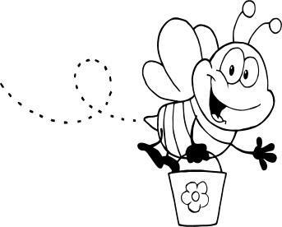

Name

Date

Lesson

**Spelling Test**

1.

2.

3.

4.

5.

6.

7.

8.

9.

10.

11.

12.

13.

14.

My Spelling Test Score:

15.

15

Graphics by: graphicsfactory.com © whysospecial.com