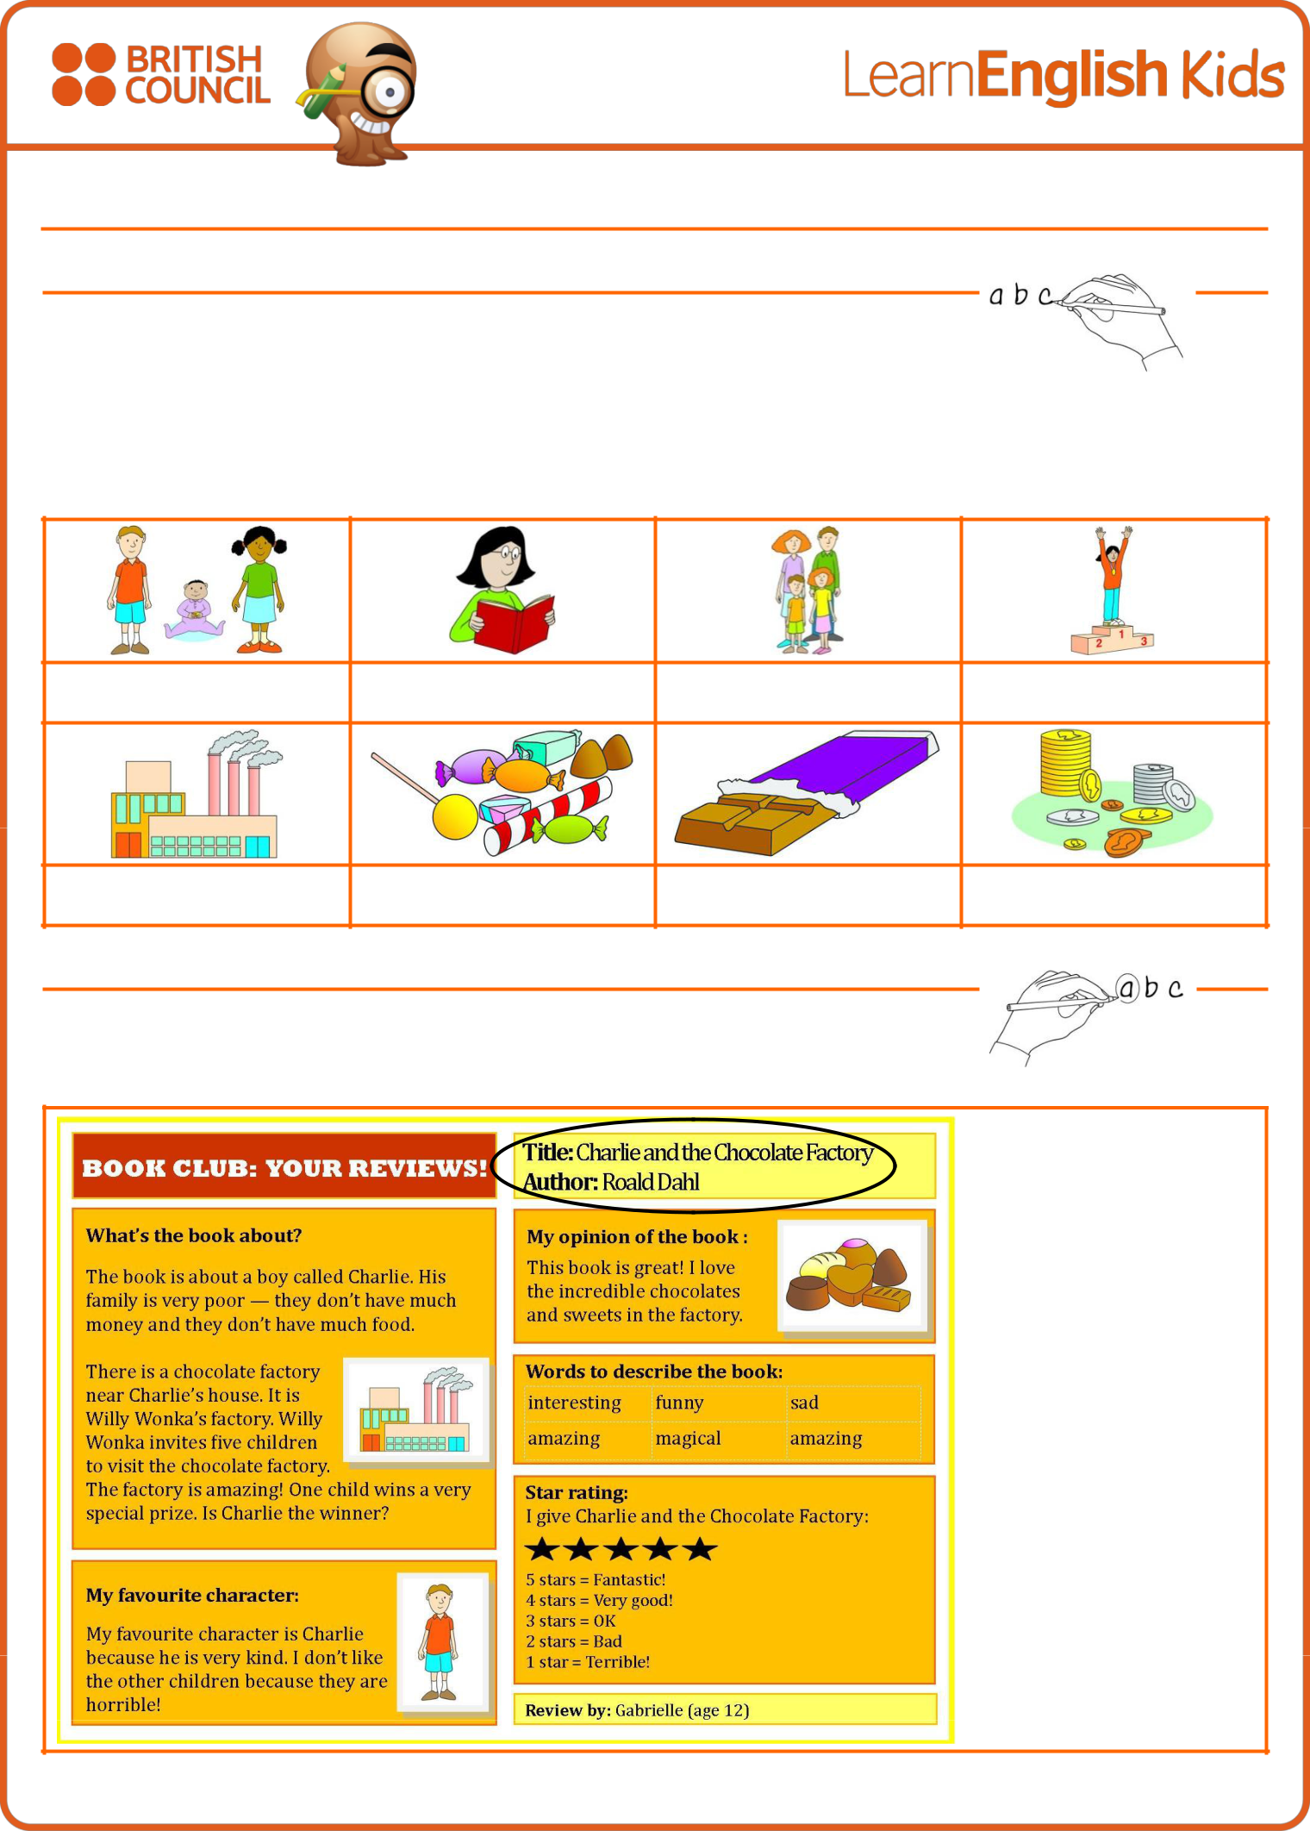

Book review

1. What’s the word?

Write the word under the pictures.

read a book | chocolate | factory | family
money | children | winner | sweets

read a book

2. Read and circle!

Read the book review and circle the examples of the top tips.

Top tips for writing book reviews!

1. Start with the title and author.

2. Explain the story but don’t say the ending.

3. Give your opinion of the book.

4. Use adjectives to describe the book.

www.britishcouncil.org/learnenglishkids

© The British Council, 2016 The United Kingdom’s international organisation for educational opportunities and cultural relations. We are registered in En gland as a charity.
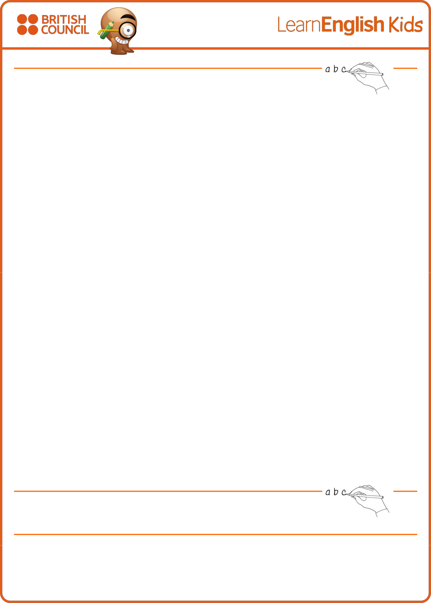

3. What’s the order?

Put the words in the correct order.

a. |  | a | The | is | about | boy | Charlie. | book | called
 |  | The book is about a boy called Charlie.
b. |  | family | poor. | His | very | is
 | __________________________________________________________________________
c. |  | chocolate | is | house. | Charlie’s | There | factory | a | near
 | __________________________________________________________________________
d. |  | factory | The | amazing! | is
 | __________________________________________________________________________
e. |  | is | Charlie. | favourite | My | character
 | __________________________________________________________________________
f. |  | children. | like | don’t | other | the | I
 | __________________________________________________________________________
g. |  | book | great! | This | is
 | __________________________________________________________________________
h. |  | the | I | incredible | love | sweets. | and | chocolates
 | __________________________________________________________________________

4. Practise writing!

Write a review of a book you read recently, using the template on the next page.

Remember to look at the example book review to help you.

www.britishcouncil.org/learnenglishkids

© The British Council, 2016 The United Kingdom’s international organisation for educational opportunities and cultural relations. We are registered in En gland as a charity.
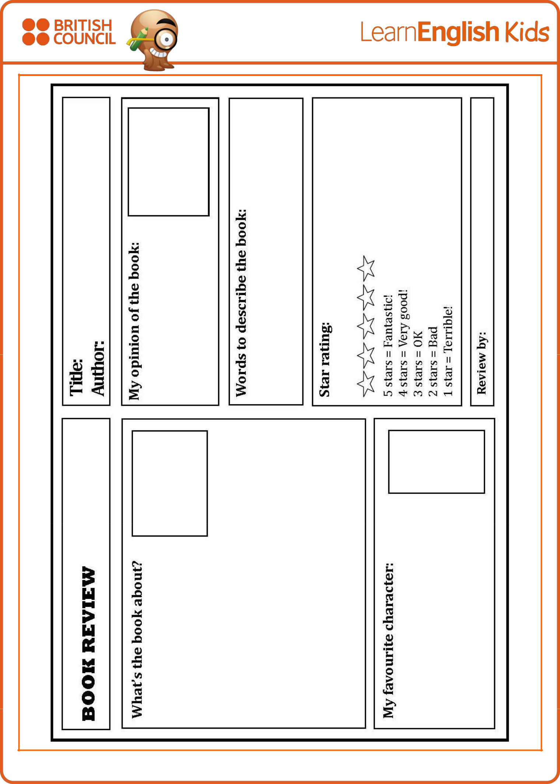

www.britishcouncil.org/learnenglishkids

© The British Council, 2016 The United Kingdom’s international organisation for educational opportunities and cultural relations. We are registered in En gland as a charity.

