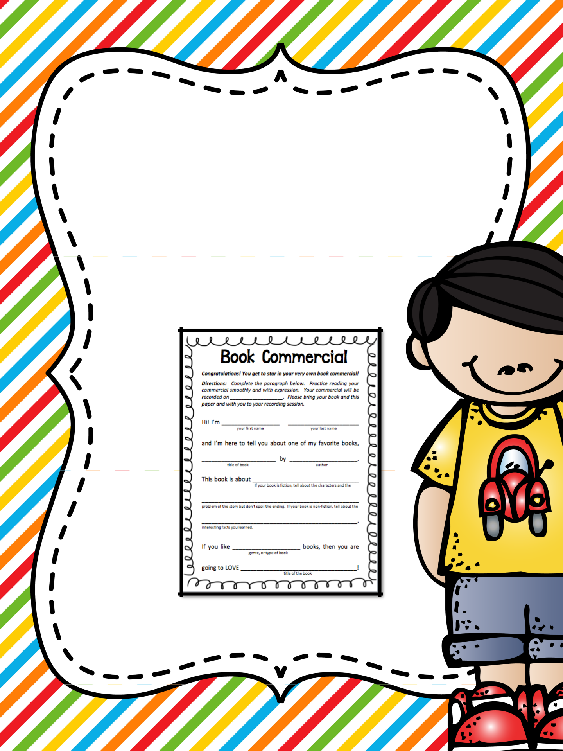
Book Review Template

A Book Commercial

Created by Wendy Arentz

Read With Me ABC


Book Review

Template

Directions:

1. Students select or are assigned a book to read.

2. After reading the book, they complete the book commercial template.

- Students practice their book talks. 4. The book talks are recorded or
presented in class.

Additional Notes:

Students can display/hold up the book during their presentation.

If you record the talks, consider filming in front of a Smart Board with the book displayed on the screen.

Share your book talks with another class, present them at an assembly, or broadcast them on school TV.

Wendy Arentz @ Read With Me ABC


Book Commercial

Congratula*ons! You get to star in your very own book commercial!

Direc*ons: Complete the paragraph below. Prac2ce reading your commercial smoothly and with expression. Your commercial will be recorded on ___________________. Please bring your book and this paper and with you to your recording session.

Hi! I’m __________________ ______________________
your first name your last name

and I’m here to tell you about one of my favorite books,

_______________________ by _____________________.
Dtle of book author

This book is about _________________________________
If your book is ficDon, tell about the characters and the

________________________________________________
problem of the story but don’t spoil the ending. If your book is non-‐ficDon, tell about the

________________________________________________.
interesDng facts you learned.

If you like _____________________ books, then you are
genre, or type of book

going to LOVE ____________________________________!
Dtle of the book

Wendy Arentz @ Read With Me ABC

Thanks for downloading this activity! I hope you enjoy using it with your students.

If you love what you see, please leave feedback in my store and be sure to follow me for updates.
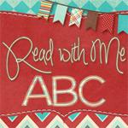

Contact me with any questions or comments at http://ReadWithMeABC.blogspot.com.

Fonts and Graphics by:

My Clip Art Store

Melonheadz

Creative Clips

Lovin Lit

Darcie Baldwin Sweet - Shoppe Designs

