

Book Review Writing:

A guide for young reviewers
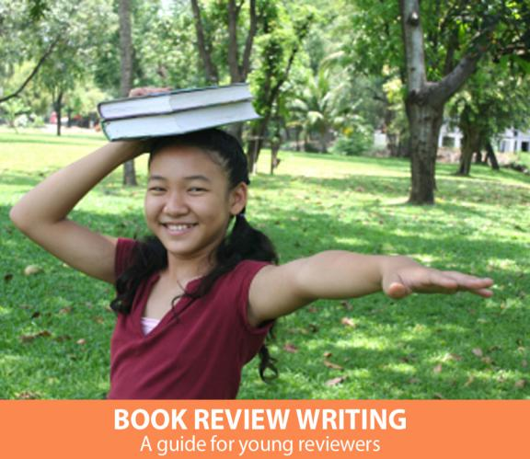

This series of guides was designed to meet the needs of gifted children for extension beyond the standard curric-ulum with the greatest ease of use for the educator. The guides may be given to the students for individual self-guided work, or they may be taught in a classroom or a home -school setting. This particular guide is primarily effec-tive in a classroom setting. Assessment strategies and rubrics are included. The lessons were developed by Lisa Van Gemert, M.Ed.T., the Mensa Founda-tion’s Gifted Children Specialist.

Introduction

If you love to read, at some point you will want to share a book you love with others. You may already do this by talking about books with friends. If you want to share your ideas with more people than your circle of friends, the way you do that is by writing a review. By publishing the reviews you write, you can share your ideas about books with other readers around the world.

It’s natural for young readers to confuse book reviews with book reports, yet writing a book review is a very different process from writing a book report. Book reports focus on the plot of the book. Frequently, the purpose of book reports is to demonstrate that the books were read, and they are often done for an assign-ment.

A book review is a totally different task. A book review’s purpose is to help people decide whether or not the book would interest them enough to read it. Reviews are a sneak peek at a book, not a summary. Like wonderful smells wafting from a kitchen, book reviews lure readers to want to taste the book themselves.

This guide is designed to help you become a strong book reviewer, a reader who can read a book and then cook up a review designed to whet the reading appetites of other book lovers.

© This guide is the property of the Mensa Education & Research Foundation, www.mensafoundation.org. It is provided as a complimentary service to the public.

Reproduction and distribution without modification is allowed. Images, links and linked content referenced herein are the property of the originating entities.

Form: What should the review look like?

HOW LONG SHOULD IT BE?

The first question we usually ask when writing something is “How long should it be?” The best answer is “As long as it takes,” but that’s a frustrat-ing answer. A general guideline is that the longer the book, the longer the review, and a review shouldn’t be fewer than 100 words or so. For a long book, the review may be 500 words or even more.

If a review is too short, the review may not be able to fulfill its purpose. Too long, and the review may stray into too much plot summary or lose the reader’s interest.

The best guide is to focus less on how long to write and more on fulfilling the purpose of the review.

HOW DO YOU CREATE A TITLE?

The title of the review should convey your overall impression and not be overly general.

Strong titles include these examples:

- “Full of action and complex characters”

- “A nail-biter that will keep you up all night”

- “Beautiful illustrations with a story to match”

- “Perfect for animal lovers”

Weak titles may look like this:

- “Really good book”

- “Three stars”

- “Pretty good”

- “Quick read”

HOW SHOULD IT BEGIN?

Although many reviews begin with a short sum-mary of the book (This book is about…), there are other options as well, so feel free to vary the way you begin your reviews.

In an introductory summary, be careful not to tell too much. If you retell the entire story, the reader won’t feel the need to read it him/herself, and no one appreciates a spoiler (telling the end). Here are some examples of summaries reviewers from The New York Times have written:

“A new picture book tells a magically simple tale of a lonely boy, a stranded whale and a dad who rises to the occasion.”

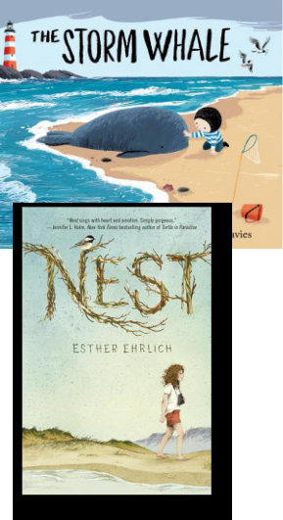

“In this middle-grade novel, a girl finds a way forward after the loss of her mother.”

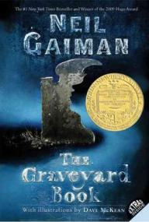

“Reared by ghosts, were-wolves and other residents of the hillside cemetery he calls home, an orphan named No-body Owens wonders how he will manage to survive

among the living having learned all his lessons from the dead. And the man Jack — who killed the rest of Nobody’s family — is itching to finish the job.”
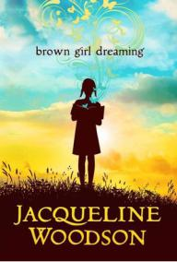

“In vivid poems that reflect the joy of finding her voice through writing stories, an award-win-ning author shares what it was like to grow up in the 1960s and 1970s in both the North and the South.”

© This guide is the property of the Mensa Education & Research Foundation, mensafoundation.org. It is provided as a complimentary service to the public.

Reproduction and distribution without modification is allowed. Images, links and linked content referenced herein are the property of the originating entities.

2 | Mensa Foundation Guide: WRITING BOOK REVIEWS



Other ways to begin a review include:
- Quote: A striking quote from the book (“It was a bright cold day in April, and the clocks were strik-ing thirteen.”) can make for a powerful beginning. This quote begins George Orwell’s novel 1984.

- Background: What makes this book important or interesting? Is the author famous? Is it a series? This is This is how Amazon introduces Divergent:
“This first book in Veronica Roth’s #1 New York Times bestselling Divergent trilogy is the novel the inspired the major motion picture.” George Orwell’s novel 1984.

- Interesting Fact: For nonfiction books in partic-ular, an interesting fact from the book may create a powerful opening for a review. In this review of The Middle East by Philip Steele, Zander H. of Mid-America Mensa asks, “Did you know that the Saudi Arabia’s Rub’ al-Khali desert reaches temperatures of 140 degrees Fahrenheit in the day and plum-mets to the freezing point at night?

- Explanation of a term: If a word or phrase in the book or title is confusing or vitally important to understand, you may wish to begin the review explaining that term.

Process: What should I write about?

Deciding what to say about the book can be challenging. Use the following ideas as a guide, but remember that you should not put all of this into a single review – that would make for a very long review! Choose the things that fit this particular book best.

GENERAL INFORMATION: What the reader ought to know

- What kind of book is it? (Picture book? Historical fiction? Nonfiction? Fantasy? Adventure?)
- Does the book belong to a series?

- How long is the book? Is it an easy or a chal-lenging read?

- Is there anything that would be helpful for the reader to know about the author? For instance, is the author an expert in the field, the author of other popular books, or a first-time author?

- How does the book compare to other books on the same topic or in the same genre?

- Is the book written in a formal or informal style? Is the language remarkable in any way?

- What ages is the book geared to?

- Is the book written in normal prose? If it is writ-ten in poetic form, does it rhyme?

PLOT: What happens?

Writing about the plot is the trickiest part of a review because you want to give the reader a feel for what the book is about without spoiling the book for future readers. The most important thing to remember is that you must never give away the ending. No one likes a spoiler.

One possibility for doing this is to set up the prem-ise (A brother and a sister find themselves lost in the woods at the mercy of an evil witch. Will they be able to outsmart her and escape?).

Another possibility is to set up the major conflict in the book and leave it unresolved (Sometimes the waiting is the hardest part or He didn’t know what he stood to lose or Finding your purpose in life can be as easy as finding a true friend. )

Try to avoid using the tired phrase “This book is about ….” Instead, just jump right in (The stuffed

rabbit wanted more than anything to live in the big old house with the wild oak trees.)

© This guide is the property of the Mensa Education & Research Foundation, mensafoundation.org. It is provided as a complimentary service to the public.

Reproduction and distribution without modification is allowed. Images, links and linked content referenced herein are the property of the originating entities.

Mensa Foundation Guide: WRITING BOOK REVIEWS | 3

CHARACTERS: Who lives in the book? Reviews should answer questions about the char-acters in fiction books or non-fiction books about people. Some possible questions to answer include:

- Who are the main characters? Include the pro-tagonist and antagonist

- What makes them interesting?

- Do they act like real people act or are they too good or too evil to be believable?

- Are they human?

- What conflicts do they face?

- Are they likeable or understandable?

- How do they connect with each other?

- Do they appear in other books?

- Could you relate to any of the characters in the story?

- What problems did the main characters face?

- Who was your favorite character, and why?

- We learn about characters from things they do and say, as well as things other characters say about them. You may wish to include examples of these things.

THEME: What is the book about at its heart? What is the book really about? This isn’t the plot, but rather the ideas behind the story. Is it about the triumph of good over evil or friendship or love or hope? Some common themes include: change, desire to escape, facing a challenge, heroism, the quest for power, and human weaknesses.

Sometimes a book will have a moral – a lesson to learn. If so, the theme is usually connected to that moral.

As you write about the theme, try to identify what makes the book worth reading. What will the reader think about long after the book is finished?

Ask yourself if there any particular lines in the book that strike you as meaningful.

SETTING: Where are we?

The setting is the time and place the story occurs. When you write about the setting in a review, include more than just the location. Some things to consider:

- Is the book set in the past, present or future?

- Is it set in the world we know or is it a fantastical world?

- Is it mostly realistic with elements of fantasy (animals that can talk, for example)?
- Is the setting unclear and fuzzy, or can you eas-ily make the movie in your mind?

- How much does the author draw you into the setting and how does s/he accomplish that?

OPINION & ANALYSIS: What do you really think? This is where the reviewer shares his/her reactions to the book that go beyond the essential points described above.

You may spend half of the review on this section.

Some possible questions to address include:

- Why do you think other readers would enjoy it? Why did you enjoy it (if you did) or why didn’t you (if you didn’t).

- What ages or types of readers do you think would like the book?

- How does it compare with other books that are in the same genre or by the same author?

- Does the book engage your emotions? If a book made you laugh or cry or think about it for days, be sure to include that.

- What do you like or dislike about the author’s writing style? Is it funny? Is it hard to follow? Is it engaging and conversational in tone?
- How well do you think the author achieved what s/he was going for in the writing of the book? Do you think you felt what the author was hoping you would feel?

- Did the book feel complete, or did it feel as though key elements were left out?

- How does the book compare to other books like it you’ve read?

© This guide is the property of the Mensa Education & Research Foundation, mensafoundation.org. It is provided as a complimentary service to the public.

Reproduction and distribution without modification is allowed. Images, links and linked content referenced herein are the property of the originating entities.

4 | Mensa Foundation Guide: WRITING BOOK REVIEWS

- Are there parts that are simply not believable, even allowing for the reader’s understanding that it is fiction or even fantasy?

- Are there mistakes?

- Would you describe the book as for entertain-ment, self-improvement, or information?

- What was your favorite part of the book?

- Would you have done anything differently had you been the author?

- Would any reader enjoy this book? If not, to what ages or type of reader would it appeal?

Special situations: Nonfiction and young reviewers

Some of the tips and ideas above work best for fiction, and some of it is a little too complicated for very young reviewers.

NONFICTION: What to do if it’s real

When reviewing a book of nonfiction, you will want to consider these questions:

- What was the author’s purpose in writing the book? Did the author accomplish that purpose?
- Who is the target audience for the book?

- What do you think is the book’s greatest value? What makes it special or worthwhile?

- Are the facts shared accurate?

- Is the book interesting and hold your attention?

- Would it be a useful addition to a school or public library?

- If the book is a biography or autobiography, how sympathetic is the subject?
- Is it easy to understand the ideas?

- Are there extra features that add to the enjoy-ment of the book, such as maps, indexes, glossa-ries, or other materials?

- Are the illustrations helpful?

YOUNG REVIEWERS: Keeping it simple Reviewing a book can be fun, and it’s not hard at all. Just ask yourself these questions:

- What is the book about? You don’t need to tell the whole story over – just give an idea of what it’s about.

- Do you think other people would like it?

- Did you think it was funny or sad?

- Did you learn something from the book?

- Did you think it was interesting?

- Would you want to read it again?

- Would you want to read other books by the same author or about the same subject?
- What was your favorite part?

- Did you like the pictures?

Remember! Don’t give away the ending. Let’s keep that a surprise.

GENERAL TIPS & IDEAS

Use a few quotes or phrases (keep them short) from the book to illustrate the points you make about the book.

If there are illustrations, be sure to comment on those. Are they well done? Has the illustrator done other well-known books?

Make sure you include a conclusion to the review

– don’t leave it hanging. The conclusion can be just one sentence (Overall, this book is a terrific choice for those who … ).

You can use the transition word handout at the end of the Writer’s Toolbox at bit.ly/mfk-toolbox to find ideas for words to connect the ideas in your review.

If you would like to read some well-written reviews, look for reviews of books for young people at The New York Times (bit.ly/nyt-children) or National Public Radio (bit.ly/npr-kids).

© This guide is the property of the Mensa Education & Research Foundation, mensafoundation.org. It is provided as a complimentary service to the public.

Reproduction and distribution without modification is allowed. Images, links and linked content referenced herein are the property of the originating entities.

Mensa Foundation Guide: WRITING BOOK REVIEWS | 5

RATING BOOKS: How to award stars?

Most places you post reviews ask you to rate the book using a star system, typically in a range of from one to five stars.

In your rating, you should consider how the book compares to other books like it. Don’t compare a long novel to a short poetry book – that’s not a valid comparison.

It’s important to remember that it’s not asking you to only give five stars to the very best books ever written.
5 Stars | I’m glad I read it or I loved it
 | (this doesn’t mean it was your
4 Stars | favorite book ever).
4 Stars | I like it. It’s worth reading.
3 Stars | It wasn’t very good.
2 Stars | I don’t like it at all.
1 Star | I hate it.

Examples: Learn from the efforts of others

Learning how to write strong reviews takes time and not a little effort. Reading the reviews others have done can help you get a feel for the flow and flavor of reviews.

 | This book was about a bird who didn’t yet know how to fly.
 | The bird has to decide if it will try to fly, but it was not sure if it wants to. The
 | bird thought, “If I never forever endeavor” then I won’t ever learn. On one
 | wing, he worries he might fail and on the other wing he thinks of how he
 | may succeed. He worries that if he tries, he may get lost in the world. That
 | makes him want to stay in his nest where he’s safe.
Review by | I think this book would help other children to learn that trying new things
Review by | can be scary, but sometimes when we try, we can find things that make us happy
Hayden, | too. And this book will help others know that mistakes are okay and part of learn-
age 4 | ing.
Southeast | My favorite part is that the bird tried and learned that she could fly. I also liked that
Michigan
Mensa | I read this book because it gave me a chance to talk to mom about making mistakes
 | and how I don’t like making them. Then I learned they are good and part of learn-
 | ing.
 | Boys and girls who are 3 to 8 years old would like this book because it teaches about
 | trying a new thing and how it’s important to get past being scared so you can learn
 | new things.
 | I give the book 5 stars since I think it’s important for other children to learn about
 | courage.
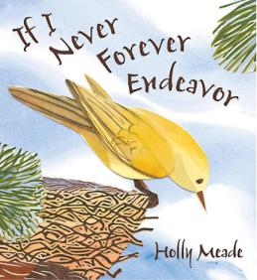

© This guide is the property of the Mensa Education & Research Foundation, mensafoundation.org. It is provided as a complimentary service to the public.

Reproduction and distribution without modification is allowed. Images, links and linked content referenced herein are the property of the originating entities.

6 | Mensa Foundation Guide: WRITING BOOK REVIEWS

I liked this book. People who are interested in national disasters and US history as well as immigration will most probably be interested in reading this book.
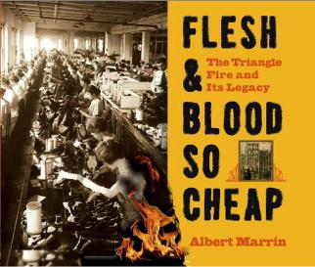

Readers can gain knowledge of what it was like to work in New York City in the early 1900s. One of the things that was especially interest-ing was that there were no safety laws at work. Also, there was a big contrast between the rich and the poor. Some people may not like this book because it is very depressing, but it is an important event in his-

Review by tory to remember.

Umar B.,

age 8, This book was very well written. It has black and white photos along with descrip-Central New tions of the photos. These photos give us a better idea of what people’s lives were Jersey Mensa like. This book is suitable for 9-20 year olds.

I give this book 5 stars.

 | Journey To Juno is the second book of the Galaxy Zack series. It is just as
 | good as the first one. It’s awesome!
 | Zack joins the Sprockets Academy Explorers Club at school. They fly on a
 | special trip to Juno, a new planet no one has ever visited. Zack gets paired
 | up with Seth, the class bully, and that’s dreadful but Zack is excited when he
 | finds a huge galaxy gemmite. A gemmite that large had not been found in
 | 100 years! Kids will love this book!
 | Boys and girls will both like it. It’s an easy chapter book with pictures on ev-
Review | ery page. I love the illustrations. I think ages 6-8 would like this but younger
Review | kids would like the story being read to them.
by Young
Mensan | My favorite parts are the galactic blast game (it is similar to baseball except there are
Connor C., | robots playing), recess at Zack’s school where everything is 3-D holographic images,
age 6, Boston | the rainbow river in a crystal cave on Juno, and the galaxy gemmite that Zack finds
Mensa | on Juno. I also loved when a life-size holographic image of his Earth friend appears
 | in Zack’s room because he calls him on a hyperphone. I give this book one hundred
 | stars! There is a “to be continued” at the end so you have to read the next book see
 | what’s in store. I can’t wait to find out what happens!!!

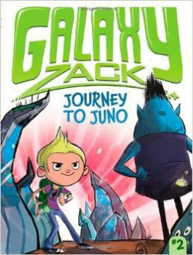

© This guide is the property of the Mensa Education & Research Foundation, mensafoundation.org. It is provided as a complimentary service to the public.

Reproduction and distribution without modification is allowed. Images, links and linked content referenced herein are the property of the originating entities.

Mensa Foundation Guide: WRITING BOOK REVIEWS | 7

Dodie Smith’s novel I Capture the Castle is a journey through the mind of a young writer as she attempts to chronicle her daily life. Seventeen-year-old Cassandra Mortmain has recently learned to speed-write, and she decides to work on her writing skills by describing the actions and conversations of those around her.
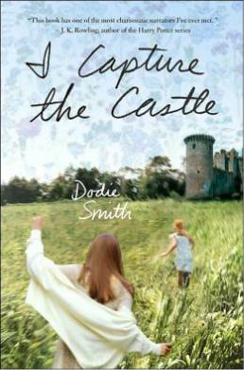

Cassandra lives in a fourteenth- century English castle with an interesting cast of characters: her beautiful older sister, Rose; her rather unsociable au-thor father and his second wife, artist-model Topaz; Stephen, the garden boy; a cat and a bull terrier; and sometimes her brother Thomas when he is home from school. One fateful day they make the acquaintance of the Cotton fam-ily, including the two sons, and a web of tangled relationships ensues.

Review by Lauren W., age 17, Mensa in Georgia

While I definitely recommend this book to other readers, I would recommend it to older teenagers, mainly because it will resonate better with them. The writing is tame enough that younger teens could also read it, but most of the characters are adults or on the verge of adulthood. Older readers would take the most from it since they can not only relate, but they may also better pick up on and appreciate Cassan-dra’s sometimes subtle humor.

Over the course of the novel, Cassandra undergoes a definite transformation from child to mature young adult, even though it’s only over the course of several months. I love that I could see into her mindset and read exactly what she was feel-ing when she thought out situations. Her thoughts flowed well and moved the book along very quickly.

Cassandra’s narrative voice is wonderful. She is serious at times, but also very witty, which makes for an engaging read. It feels absolutely real, as though I’m reading someone’s actual journal. Sometimes I forget that I am reading a story and not a real-life account. Her emotions and the dialogue are so genuine, and they are spot-on for a seventeen-year-old girl in her situation.

Cassandra has many wonderful insights on life, on topics ranging from writing to faith to matters of the heart. I personally have had some of the same thoughts as Cassandra, except Ms. Smith was able to put them into words.

I Capture the Castle should be essential reading for aspiring writers, those looking for historical fiction or romance, or anyone who loves reading amazing classic books. Dodie Smith is an exceptional writer, and I Capture the Castle is a book that will never become obsolete.

© This guide is the property of the Mensa Education & Research Foundation, mensafoundation.org. It is provided as a complimentary service to the public.

Reproduction and distribution without modification is allowed. Images, links and linked content referenced herein are the property of the originating entities.

8 | Mensa Foundation Guide: WRITING BOOK REVIEWS

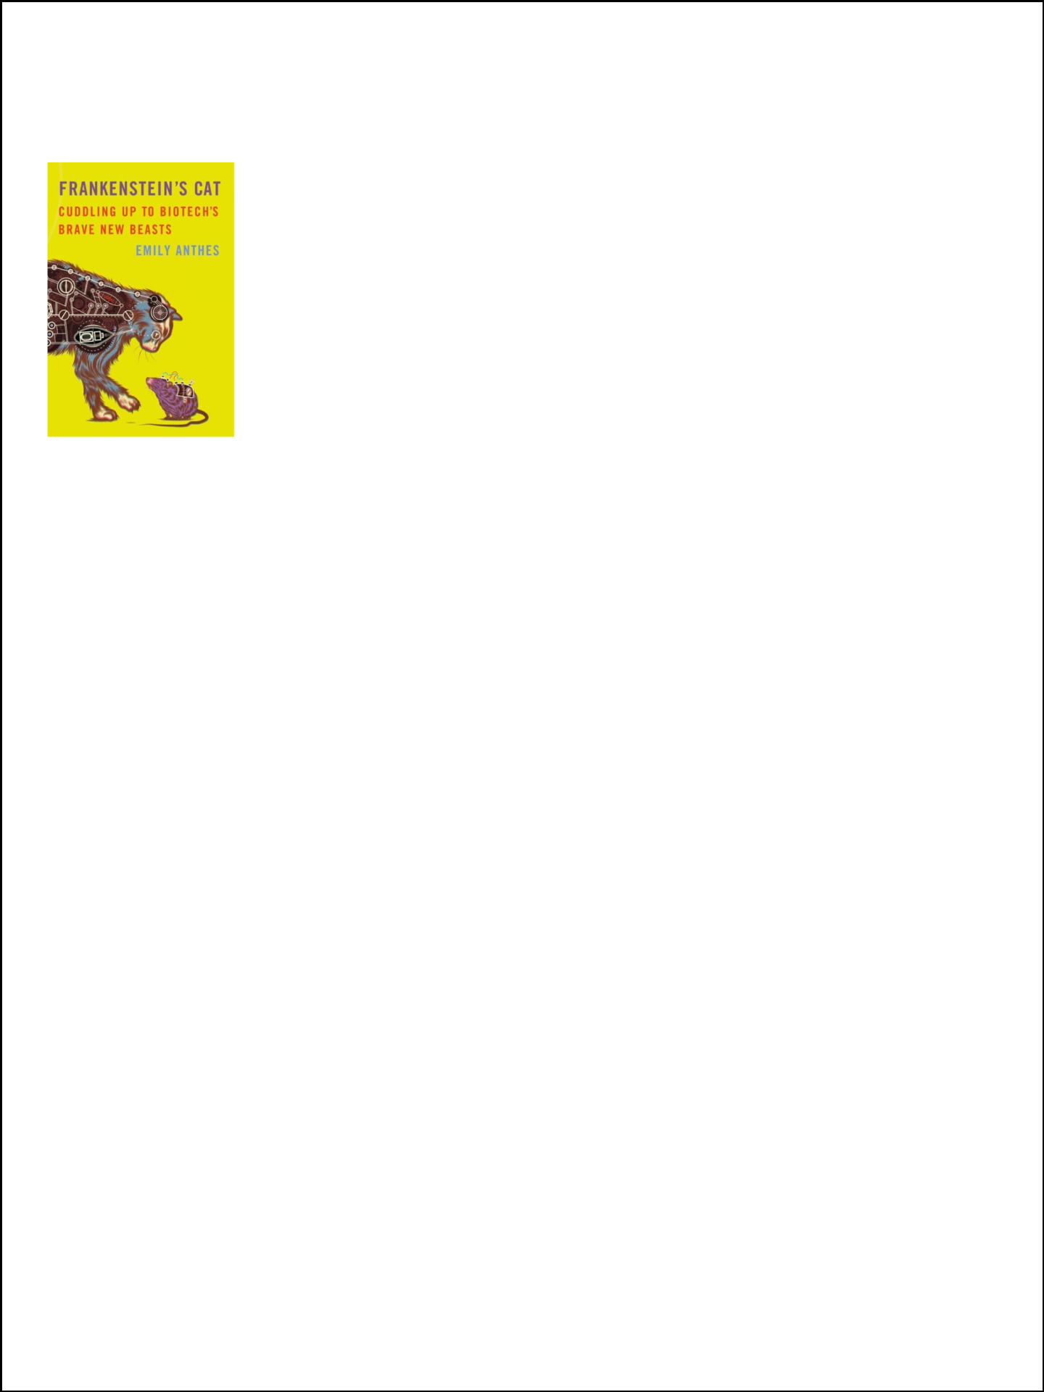

Review by Zander H., age 12, Mid-America Mensa
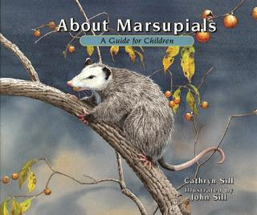

Review by Connor C., age 6, Boston Mensa

I appreciated Frankenstein’s Cat for its fascinating explanation about the often baffling subject of bioengineering and its sister sciences. Emily Anthes explains the many sides of today’s modern technology, such as gene modifi-cation, cloning, pharmaceutical products (from the farm), prosthesis, animal tag and tracking and gene cryogenics. This book provides a well-rounded summary of these complicated sciences without being boring or simply factual. Her real world examples take us on a journey from the farm, to the pet store and then from the pharmacy to the frozen arc.

Have you ever wondered if the neighborhood cat is spying on you? Read about Operation Acoustic Kitty and find out if this feline fantasy fiction or fact. Do you think bugs are creepy? What about a zombified cyborg beetle?

Is Fido so special that you want two of him? Money can buy you an almost exact copy of your pooch BUT don’t expect the same personality. Emily Anthes makes you crave more information. She makes you want to know the future of Earth’s flora and fauna, as well as humanity itself.

I would highly recommend this book to anyone who desires a guide to the future of biological science and technology. Frankenstein’s Cat is best read by the light of a

glow-in-the-dark fish, while cuddling your favorite cloned dog and drinking a glass of genetically modified milk.

About Marsupials is the title so the book is about...marsupials, of course. It’s non-fiction. I really think everyone would like the book. I think someone who likes animals would especially like to read it.

The glossary of facts in the back of About Marsupials is the most useful part. I thought the most interesting parts were that some marsupials have their pouch at their back legs and one marsupial, the Yellow-foot-ed Rock Wallaby, is very small but can jump 13 feet wide!

Kids in the 4-8 age range would like this book. Even though it’s not a story book, 4 year olds would like the few words on each page and they would love the beauti-ful pictures. But older kids would like it because of all the facts in the back of the book. There’s a lot of information for each animal. I think boys and girls (and parents) would enjoy reading it. This book is very interesting. I give it 4 stars.

© This guide is the property of the Mensa Education & Research Foundation, mensafoundation.org. It is provided as a complimentary service to the public.

Reproduction and distribution without modification is allowed. Images, links and linked content referenced herein are the property of the originating entities.

Mensa Foundation Guide: WRITING BOOK REVIEWS | 9

 | Every day, people around the world use maps. Whether it is an airplane pilot
 | or businessman, housewife or museum group, maps have always and will
 | continue to provide useful information for all.
 | Mapping the World talks about the uses of maps, as well as how to differenti-
 | ate between the type of map projection and type of map.
 | In this series, we travel to the past and learn about historical mapmakers,
 | from Claudius Ptolemy (who stated the idea that the Earth is at the center
Review | of the universe) to Gerardus Mercator (who created one of the most widely
Review | used map projections) and more. This series goes into tremendous detail on the
by Umar | cartographer’s life and maps. We then journey to the present era to learn about
A-B, age 10, | map projections and the diverse types of maps used today. You might ask, “What is
Central New | the difference between the two? They sound the same to me.” No map projection is
Jersey Mensa | perfect, because you cannot really flatten a sphere into a rectangle. An uncolored
 | projection could be used in many ways. We could use it for population concentra-
 | tion, highways, land elevation, and so many other things!
 | For example, we could make a topographic map of the U.S., which shows land eleva-
 | tion. We could make it a colorful map that shows the amount of pollution in differ-
 | ent areas, or it could be a population map, or it could even be a map that shows the
 | 50 states, their capitals and borders! Our last step in this amazing excursion is the
 | near future, where we see some hypothetical solutions as to what maps will be used
 | for. Currently, we are working on better virtual map technology.
 | Now, scientists have been able to put maps on phones. Back in the early 1900s,
 | people had to lug a lot of maps around to find your way from place to place, or just
 | keep asking for directions. Now, all the information is on a phone or global position-
 | ing system (GPS). It is amazing how much maps have changed technology and the
 | world in this century.
 | The Mapping the World 8-book set goes into amazing levels of detail. It is a long
 | read, but it gives an immense range and amount of information that you would not
 | find in any other book or series on maps. The flowing way the chapters and books
 | are organized makes it easy to link passages from different books in this series
 | together. Mapping the World is a treasure box, filled with the seeds of cartography.
 | Collect and plant them, and you soon will have the fruits of cartography, beneficial
 | to those who want to be cartographers. Use this series to the utmost, then the fruits
 | of mapping will be sweet for all who endeavor to succeed in cartography.
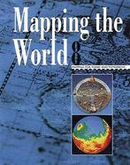

© This guide is the property of the Mensa Education & Research Foundation, mensafoundation.org. It is provided as a complimentary service to the public.

Reproduction and distribution without modification is allowed. Images, links and linked content referenced herein are the property of the originating entities.

10 | Mensa Foundation Guide: WRITING BOOK REVIEWS

