HADC Use Only

Specialist Assigned:

Tenant Number:

Annual Effective:

Notice to Vacate Packet Cover Sheet

The following documents are required to initiate the move process:

    - Notice to Vacate Form

  - Annual Recertification Packet (enclosed)

- Income verifications for all family members (see attached checklist for

verification requirements)

Failure to submit the required documents will result in denial of the notice to vacate request and will delay processing.

For Official HADC Use Only

Date 60 Day Notice to Vacate Received:

All Documents/Verifications Submitted: (yes/no)

Request Approved:

Request Denied:
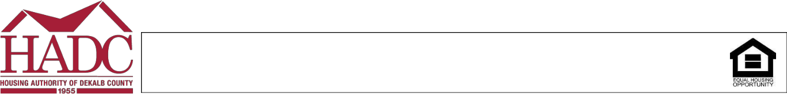

If you require special assistance or reasonable accommodations due to a disability, including the need to receive documents or communications in alternative formats, please contact the Housing Choice Voucher Program Office at (404) 270-2500. For Georgia Relay Service, please dial 7-1-1.

HADC Use Only

Specialist Assigned: __________________

Tenant Number: _____________________

Annual Effective: ____________________

- Day Notice-To-Vacate (Mutual Termination of Lease)

Participant Name: _________________________________________________

Address: __________________________________ | City, State, Zip: ____________________________
Telephone: ________________________________ (Cell, Home, Work - circle one)
Owner/Property Manager Name: _________________________________________________
Address: __________________________________ | City, State, Zip: ___________________________

Telephone: ________________________________ (Cell, Home, Work - circle one)

By agreement, the above-mentioned parties agree that the leasing agreement for the rental unit listed above shall be terminated on: __________________________ (must be on the last day of the month).

(Tenant):

I, ______________________________ (Participant Name), agree that I will be moving from my current

unit on the date listed above, I understand that if I remain in the unit after the above-mentioned termination date; the Housing Authority of DeKalb County will not be responsible for my rent. I further understand that this agreement does not remove any rights or responsibilities under the laws set forth in DeKalb County’s jurisdiction.

Tenant’s Signature: _____________________________________ Today’s Date: ____________________

(Owner):

I, ______________________________ (Owner/Management Name), agree with the conditions and

further understand that the Housing Authority of DeKalb County will not be responsible for any rent portion after the move-out date stated above. I understand that the Housing Authority of DeKalb County is not a party to the lease and cannot assist with collections of outstanding debts. I further understand that this agreement does not remove any rights or responsibilities under the laws set forth in DeKalb County’s jurisdiction.

Owner/Management Signature: ___________________________ Today’s Date: ___________________

***Note: this form WILL NOT be approved if you are in your initial lease term or if the participant has been issued a proposed termination. You MUST submit the attached reexamination packet and supporting documentation when returning this notice. Failure to do so WILL RESULT in denial of notice to vacate request.

Owners: If your unit is currently under abatement; the abatement will remain in effect. Please refer to the contract termination letter sent to you by the Housing Authority of DeKalb County’s Inspection Department.
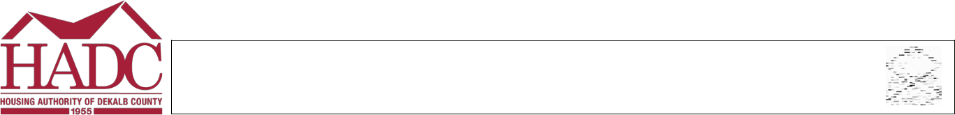

If you require special assistance or reasonable accommodations due to a disability, including the need to receive documents or communications in alternative formats, please contact the Housing Choice Voucher Program Office at (404) 270-2500. For Georgia Relay Service, please dial 7-1-1.

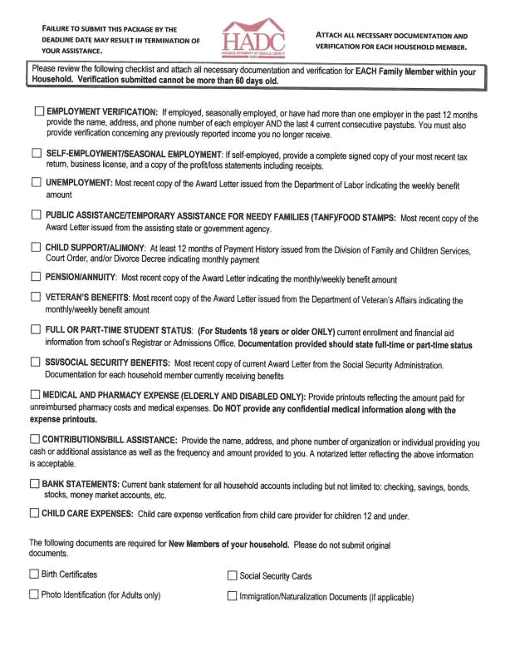
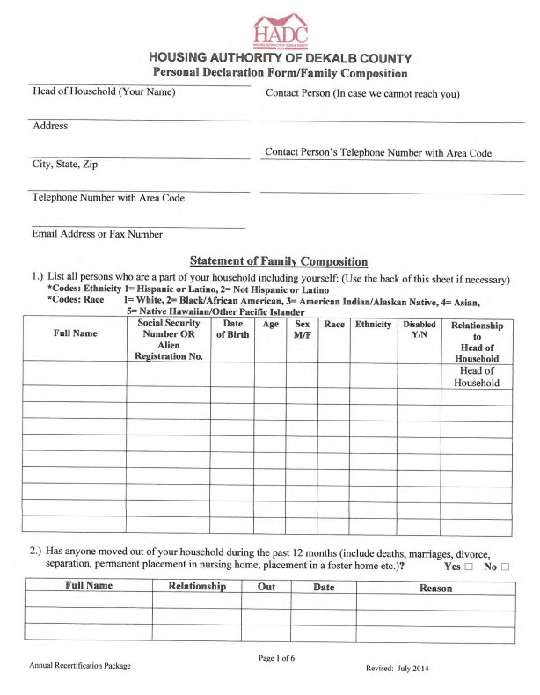

Transfer - NTV


