Pharmacy Policies and Procedures Manual

Last updated: Month, Day, Year
Last reviewed: Month, Day, Year

Links and references updated: June 21, 2016
Table of Contents
1.0 Introduction 1
1.1 Definitions 1
2.0 General Operations 2
2.1 Pharmacy Information 2
2.2 Staff Information 3
2.3 Security 4
2.3.1 Pharmacy Access 4
2.3.2 Mandatory Pharmacist Presence 4
2.3.3 Opening and Closing Procedures 4
2.3.4 Keys 4
2.3.5 Alarm 4
2.3.6 Lock and Leave 4
2.3.7 Hardware and Software Security 5
2.3.8 Armed Robbery 5
2.3.9 Pharmacy Break-ins or Burglaries 5
3.0 Dispensary Operations 5
3.1 Systems and Software 5
3.1.1 Data Backup 5
3.1.2 Netcare User ID and Password Security 6
3.1.3 Affiliate Agreements 6
3.1.4 Systems and Software Training 6
3.2 Stock Layout or Planogram 6
3.3 Work Flow (Text and Diagram) 7
3.4 Prescription Filing System (Hardcopy and Electronic) 7
3.5 Retention of Prescription and Patient Records 7
3.5.1 Retention of Prescriptions (Written, Electronic) 8
3.5.2 Retention of Patient Records (Written, Electronic) 8
3.5.3 Retention of Disclosure of health information 8
3.5.4 Offsite Storage 8
3.6 Audit Trail - General (Text, Diagram) 8
3.7 Prescribing 8
3.7.1 Adapting 9
3.7.2 Prescribing in an Emergency 10
3.7.3 Prescribing for Initial Access and Management of Ongoing Therapy 10
3.8 Documentation and Assessment Tools 11
3.8.1 SOAP Notes 11
3.8.2 Prescription Adaptation Notification 12
3.8.3 Collaborative Care Communication Form 13
3.8.4 Informed Consent Form(s) 14
3.8.5 Record of Disclosure Form 14
3.9 Fax Standards Compliance 14
3.10 Counselling 14
3.11 Sale of Schedule 2 and 3 Products 14
3.12 Ordering Laboratory Tests and Use of Laboratory Data 15
3.13 Repackaging Prescriptions 15
3.14 Delivery and Mailing of Prescriptions 16
3.15 Long Term Care Pharmacy 16
3.16 Compounding 17
3.16.1 Non-Sterile Products 17
3.16.2 Sterile Products 26
3.16.3 Contracts 29
3.17 Narcotics and Controlled Substances 30
3.17.1 Triplicate Prescription Program (TPP) 30
3.17.2 Narcotics and Controlled Substances Receipts Report 31
3.17.3 Narcotics and Controlled Substances Inventory Management 32
3.17.4 Managing Expired or Returned Stock 32
3.17.5 Loss or Theft Form 32
3.17.6 Suspected Forgery 33
3.17.7 Forgery Reporting Form 33
3.17.8 Opioid Dependence Treatment 33
3.18 Benzodiazepines and Other Targeted Substances 35
3.19 Child Resistant Containers 36
3.20 Administration of Drugs by Injection 36
3.21 Cold Chain Management 36
3.21.1 Refrigerator Temperature Log 37
3.22 Ordering 38
3.23 Prescription Balances or Owings 38
3.24 Prescriptions Not Picked Up 38
3.25 Inventory Management 38
3.26 Special Access Programs (SAPs) 38
3.27 Waste Management 39
3.27.1 Expired Drugs/Returned Stock 39
3.27.2 Sharps Disposal 39
3.27.3 Needlestick Injury 39
3.28 Quality Assurance and Safety 39
3.28.1 Drug Error (Drug Incident) Reporting 39
3.28.2 Drug Error (Drug Incident) Follow-Up Process 40
3.28.3 Adverse Event Reporting 40
4.0 Patient Concerns 40
5.0 Privacy Policy 40
5.1 Custodians of Health Information 41
5.2 Use and Disclosure of Health Information 41
5.3 Disposal of Health Information 41
6.0 Confidentiality 42
6.1 Confidentiality Agreements 42
6.2 Affiliate Agreements 42
6.3 Handling Media Calls, Public Speaking, Press Releases 42
7.0 Pharmacy Signage 42
8.0 Pharmacy Website 42
9.0 Reference Library 43
10.0 Code of Ethics 45
11.0 Standards of Practice 45
11.1 Standards for Practice for Pharmacists and Pharmacy Technicians 45
11.2 Standards for the Operation of Licensed Pharmacies 45
12.0 Human Resources 45
12.1 Job Descriptions 46
12.2 Supervising Registered Pharmacy Interns 47
12.3 Staffing Levels 47
12.4 Dress Code 47
12.5 Performance Appraisal 47
12.6 Sick Leave 47
12.7 Leaves of Absence 47
12.8 Vacation Requests 47
12.9 Pandemic Preparedness Plan 48
12.10 Harassment in the Workplace 48
13.0 Business Operations 48
13.1 Internet and Electronic Communication 48
13.2 Opening and Closing Cash 48
13.3 Charge Accounts 48
13.4 Cheques 48
13.5 Staff Purchases 48
13.6 Telephones 48
13.7 Accounts Receivable 49
13.8 Accounts Payable 49
13.9 Banking 49
13.10 Pricing Policies 49
13.11 Return Policies 49
14.0 Contacts 49
14.1 Manager 49
14.2 Staff 49
14.2.1 Relief Pharmacists 50
14.3 Alarm Company 50
14.4 Wholesaler(s) 50
14.5 Supplier(s) 50
14.6 Local Physicians 50
14.7 Third Party: 51
14.8 Emergency Services 51
14.8.1 Staff with CPR and First Aid Training 51

1.0 Introduction
These operational procedures are specific to the provision of pharmacy services by [insert pharmacy name here]. All other activities are encompassed in separate policies and procedures, sections of which are complementary to these.
These procedures apply to all pharmacy employees who provide services on behalf of [insert pharmacy name here].

These procedures will be reviewed every [insert time period]

1.1 Definitions
[Insert other definitions where applicable to your pharmacy or organization]

(a) “adverse drug event” means an unexpected and undesired incident that results in patient injury or death or an adverse outcome for a patient, including injury or complication;

(b) “drug error” means an adverse drug event or a drug incident where the drug has been released to the
patient;

(c) “drug incident” means any preventable event that may cause or lead to inappropriate drug use or patient harm. Drug incidents may be related to professional practice, drug products, procedures or systems, and include:

(i) prescribing;
(ii) order communications;
(iii) product labeling, packaging, nomenclature;
(iv) compounding;
(v) dispensing;
(vi) distribution;
(vii) administration;
(viii) education;
(ix) monitoring; and
(x) use;
(d) “drug therapy” means
(i) dispensing a Schedule 1 drug or blood product,
(ii) selling a Schedule 2 or Schedule 3 drug, or
(iii) prescribing a Schedule 1 drug or blood product;

(e) “individual” means an individual employed in a pharmacy and “employ” includes a volunteer relationship;

(f) “patient” means any person to whom a pharmacist provides a service that is within the practice of pharmacy;

(g) “patient’s agent” means a family member, caregiver or another person who has a close personal relationship with the patient;

(h) “pharmacist” means a clinical pharmacist, a provisional pharmacist, a courtesy pharmacist or a student pharmacist, unless the context requires otherwise;

(i) “pharmacist service” means any service that falls within the practice of pharmacy;

(j) “practice of pharmacy” and “pharmacy practice” mean the scope of practice described in section 3 of schedule 19 to the Health Professions Act;

(k) “prescriber” means a regulated health professional who is authorized to prescribe schedule 1 drugs or blood products;

(l) “professional relationship” means a relationship formed with a patient for the purpose of optimizing the patient’s health and drug therapy;

(m) “proprietor” means a person who owns, manages or directs the operation of a facility in which a licensed pharmacy is located and exercises a significant degree of control over the management and policies of the licensed pharmacy, or the conduct of the pharmacists and pharmacy interns, if any, who are employed by the licensed pharmacy;

(n) “regulated health professional” means a health professional who practises under the terms of the Health Professions Act or similar legislation that governs a profession in Alberta;

(o) “restricted activity” means any restricted activity referred to in section 16 of the Pharmacists
Profession Regulation;
(p) “Schedule 1 drug” means a Schedule 1 drug within the meaning of the Pharmacy and Drug Act;
(q) “Schedule 2 drug” means a Schedule 2 drug within the meaning of the Pharmacy and Drug Act;
(r) “Schedule 3 drug” means a Schedule 3 drug within the meaning of the Pharmacy and Drug Act

2.0 General Operations

2.1 Pharmacy Information
Pharmacy Name:
Pharmacy License #:
Address:
City:
Postal Code:
Hours of Operation:
Pharmacy Manager:
Pharmacy Proprietor(s) (e.g. owner, regional pharmacy director, director of operations):
Pharmacy Website(s):

2.2 Staff Information
Pharmacists
1.
2.
3.
4.
5.
6.
Pharmacy Technicians
1.
2.
3.
Pharmacy Assistants
1.
2.
Other Staff
1.
2.
3.
4.
5.
6.

2.3 Security

2.3.1 Pharmacy Access

2.3.2 Mandatory Pharmacist Presence

2.3.3 Opening and Closing Procedures
Opening:

Closing:

2.3.4 Keys
Procedure for key holders:

Procedure for relief pharmacists:

2.3.5 Alarm
Procedure:

Alarm Contacts:

2.3.6 Lock and Leave
Procedure:

Securing Schedule 2 products:

Securing Schedule 3 products:

Safe:

2.3.7 Hardware and Software Security
Procedure:

2.3.8 Armed Robbery
http://abpharmacy.ca/sites/default/files/BurglaryPreventionTips.pdf
Procedure:

2.3.9 Pharmacy Break-ins or Burglaries
http://abpharmacy.ca/sites/default/files/BurglaryPreventionTips.pdf
Procedure:

3.0 Dispensary Operations

3.1 Systems and Software
Computer information:

3.1.1 Data Backup
Procedure:

Repair contact:

Supplies contact:

Dispensary software contact:

3.1.2 Netcare User ID and Password Security (DO NOT list user ids and passwords here)
Systems User ID and Password Security:

Security Procedure:

Netcare User ID and Password Security
Security procedure:

3.1.3 Affiliate Agreements
Insert list of agreements with affiliate IT providers:

3.1.4 Systems and Software Training

3.2 Stock Layout or Planogram

Supplies:

3.3 Work Flow (Text and Diagram)
http://www.qp.alberta.ca/574.cfm?page=2006_129.cfm&leg_type=Regs&isbncln=9780779758197

Role of Pharmacy Technician:

Role of Pharmacy Assistant:

3.4 Prescription Filing System (Hardcopy and Electronic)
A prescription for a Schedule 1 drug may legally be filled for 12 months from the date on which the prescription was written and may be refilled for 18 months past the date on which the prescription was first filled.
New prescriptions:

Refill prescriptions:

Logged prescriptions:

3.5 Retention of Prescription and Patient Records
http://abpharmacy.ca/sites/default/files/RecordRetentionChart.pdf

3.5.1 Retention of Prescriptions (Written, Electronic)
Written prescriptions and transaction records for schedule 1 drugs that have been dispensed should be filed systematically and retained for at least two years past the completion of therapy with regard to the prescription or for 42 months, whichever is greater.
Procedure (including backup plan):

3.5.2 Retention of Patient Records (Written, Electronic)
The patient record must provide a history of all interactions required to be documented for a patient under the Standards of Practice for Pharmacist and Pharmacy Technicians and must be maintained for a period not less than 10 years after the last pharmacy service or two years past the age of majority, whichever is greater.

Procedure (including access, retention and backup plan):

3.5.3 Retention of Disclosure of health information
When a custodian discloses a record containing individually identifying diagnostic, treatment and care information without consent, the disclosing custodian must make a notation of the name of the recipient, the date and purpose of the disclosure and a description of the information disclosed. The disclosure notation may be in paper or electronic form, may be put on the individual’s health or drug record or in a book or “disclosure log.” This record is to be kept for 10 years following the date of disclosure.
Procedure:

3.5.4 Offsite Storage
Request form:
http://abpharmacy.ca/sites/default/files/RecordsMaintenance.pdf
Procedure:

3.6 Audit Trail - General (Text, Diagram)

3.7 Prescribing

http://abpharmacy.ca/standards-practice

3.7.1 Adapting
Refer to Standard 11-15 in the Standards of Practice for Pharmacists and Pharmacy Technicians
Informed Consent:

Adaptation notification form:

Communication (Refer to the Information Exchange Protocol of the electronic health record):

Documentation and rationale (refer to Standard 18 and Appendix A in Standards of Practice for Pharmacists and Pharmacy Technicians):
Disclosure per Health Information Act:

3.7.1.1 Restrictions on Altering a Dose
Procedure:

Documentation:

3.7.1.2 Renewing a Prescription
Procedure:

Documentation:

3.7.1.3 Therapeutic Substitution
Procedure:

Documentation:

3.7.2 Prescribing in an Emergency
Procedure:

Documentation:

3.7.3 Prescribing for Initial Access and Management of Ongoing Therapy
Procedure:

Documentation:

3.8 Documentation and Assessment Tools

3.8.1 SOAP Notes
SUBJECTIVE/OBJECTIVE | ASSESSMENT |  |  | PLAN
Problem:  Subjective & Objective Evidence | Etiology / Risk Factors | Evaluate need for therapy; evaluate current therapy; discuss treatment options | Recommended treatment plan: specific drug & non-drug therapy; therapeutic rationale; further tests; follow-up |  | Patient Education
CURRENT MEDICATIONS |  |  | GOALS & MONITORING

3.8.2 Prescription Adaptation Notification
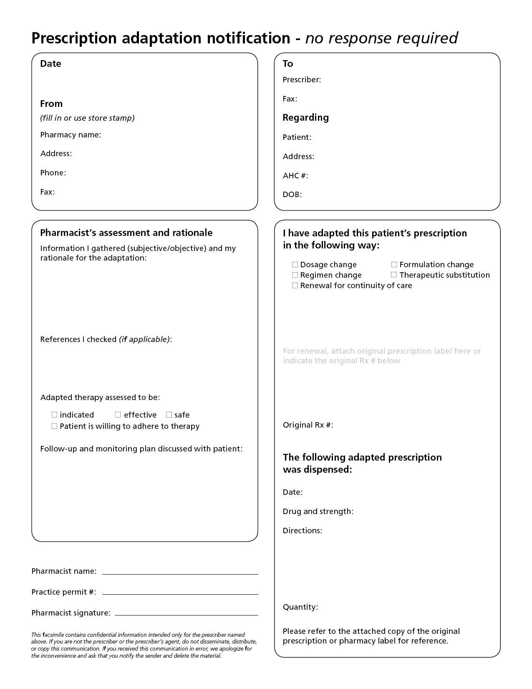

3.8.3 Collaborative Care Communication Form
Collaborative Care Communication Form
TO: (Original Prescriber):__________________________________Date:________________
Address:______________________________________________________________________
Phone:________________________________________ Fax:___________________________
FROM: (Pharmacist):____________________________________________________________
Pharmacy Name:_______________________________________________________________
Address:______________________________________________________________________
Phone Number: _________________________________ Fax:___________________________
RE: Patient Name:________________________________________________________________________
Address:______________________________________________________________________
Phone Number:_______________________ Alberta Health Care Number:__________________
DRUG THERAPY PROBLEMS
□ Drug therapy not required □ Adverse drug reaction
□ Needs additional drug therapy □ Drug dose too high
□ Drug therapy not working □ Noncompliance
□ Drug dose too low □ Other:_________________________
□ ACTION COMPLETED:
Pharmacist completing action:__________________________________________________
□ RECOMMENDATION:

□ ACTION REQUESTED – Please respond to pharmacy
Pharmacist requesting action:__________________________________________________

For fax back confirmation of action:
Original Prescriber’s Signature:____________________________________ Date:_______________
□ INFORMATION ONLY - No Immediate Action Necessary
Disclaimer: Insert company disclaimer regarding the privacy and security of information on this form. For example, “The information contained above is intended for the recipient only and it is disclosed under the authority of the HIA for the purpose of providing continuing treatment and care to the patient. Please notify sender if fax received in error.”

3.8.4 Informed Consent Form(s)
Procedure:

Insert form(s) here

3.8.5 Record of Disclosure Form
Procedure:

Insert form(s) here or location of documentation in database

3.9 Fax Standards Compliance
http://abpharmacy.ca/sites/default/files/CommunicationOfMedicationPrescriptions.pdf
https://www.oipc.ab.ca/media/604264/guide_guidelines_on_facsimile_transmission_oct2002.pdf

3.10 Counselling
Procedure:

Documentation:
Insert form here or location in database for documentation

Audit trail:

3.11 Sale of Schedule 2 and 3 Products
Procedure:

Documentation:

3.12 Ordering Laboratory Tests and Use of Laboratory Data
Procedure:

Documentation and Rationale (refer to Standard 18 and Appendix A in the Standards of Practice for Pharmacists and Pharmacy Technicians):

Communication of results (Refer to the Information Exchange Protocol of the electronic health record):

3.13 Repackaging Prescriptions
Refer to Standards 7 and 21 in the Standards of Practice for Pharmacists and Pharmacy Technicians
Procedure:

Patient Records:

Quantity:

Repackaging area:

Labeling Requirements:

Audit Trail:

Quality assurance:

Documentation:

Storage:

3.14 Delivery and Mailing of Prescriptions
Section 12.1 of the Pharmacy and Drug Regulations requires that where a prescription is not picked up at the pharmacy by the patient or the patient’s agent, the pharmacy must document “the method of delivery of the drug to the patient and the method of dealing with environmental concerns where appropriate.”

Procedure:

Documentation:

Audit trail: Insert delivery log template here

3.15 Long Term Care Pharmacy
Policies:

Procedure:

Patient assessments:

Collaboration with other health care providers:

Confidentiality agreements:

Patient records:

Supply:

Labels:

Audit trail:

Documentation:

Delivery:

Storage:

Disposal:

Contracts:
Quality assurance:

Billing:

3.16 Compounding
Refer to Standard 10 in Standards of Practice for Pharmacists and Pharmacy Technicians.
Refer to Standard 7 in Standards for the Operation of Licensed Pharmacies.
http://www.hc-sc.gc.ca/dhp-mps/compli-conform/gmp-bpf/docs/pol_0051-eng.php#a7
http://napra.ca/Content_Files/Files/Guidelines_to_Pharmacy_Compounding_Oct2006.pdf

3.16.1 Non-Sterile Products
3.16.1.1 Compounding area
The compounding area should be kept clean, sanitary, and orderly to prevent contamination and/or mix-ups among ingredients and containers. Food and drink should not be placed within the compounding area. Only one compound should be prepared within the compounding area at a time.
Compounding area:

Sanitation schedule and agents (i.e. isopropyl alcohol) used:

3.16.1.2 Equipment:
Equipment should be kept clean, protected from contamination, properly maintained, and used appropriately. The equipment should be periodically checked for proper functioning and calibrated. Always inspect equipment for cleanliness and proper functioning before starting to compound.
Equipment cleaning and maintenance procedure:

Measuring equipment calibration and documentation:

3.16.1.3 Personnel
During the compounding process, only a limited number of personnel should be within the compounding area. Compounding should be completed or supervised by a regulated pharmacy technician or pharmacist who has the appropriate compounding knowledge and skills. Minimum requirements for health conditions (i.e. open lesions) and hygienic behaviours (hand-washing, attire) of personnel should be set in order to prevent drug contamination and provide personnel protection.
Personnel health, hygiene and attire:

Protective gear (gloves, mask):

WHMIS training and MSDS location (MSDS should be readily available to personnel):
3.16.1.4 Formulas
Standard 10: Each time a pharmacist or a pharmacy technician compounds a drug or a blood product, the pharmacist or the pharmacy technician must ensure that the compounded drug or blood product is prepared according to:
a) a written compounding formula, and
b) a written preparation process
Standard 10.2: Whenever possible a pharmacist or a pharmacy technician who compounds a drug or blood product must do so according to a compounding formula from a reputable source such as a pharmacy text or peer-reviewed published journal.
Standard 10.3: If no formula is available, a pharmacist must use the pharmacist’s pharmaceutical knowledge, including but not limited to knowledge in pharmaceutics, pharmacology, medicinal chemistry and therapeutics to create a formula and reduce it to writing.
Master formula documentation:
http://abpharmacy.ca/sites/default/files/CompoundForumulaPreparationInstr_web.pdf
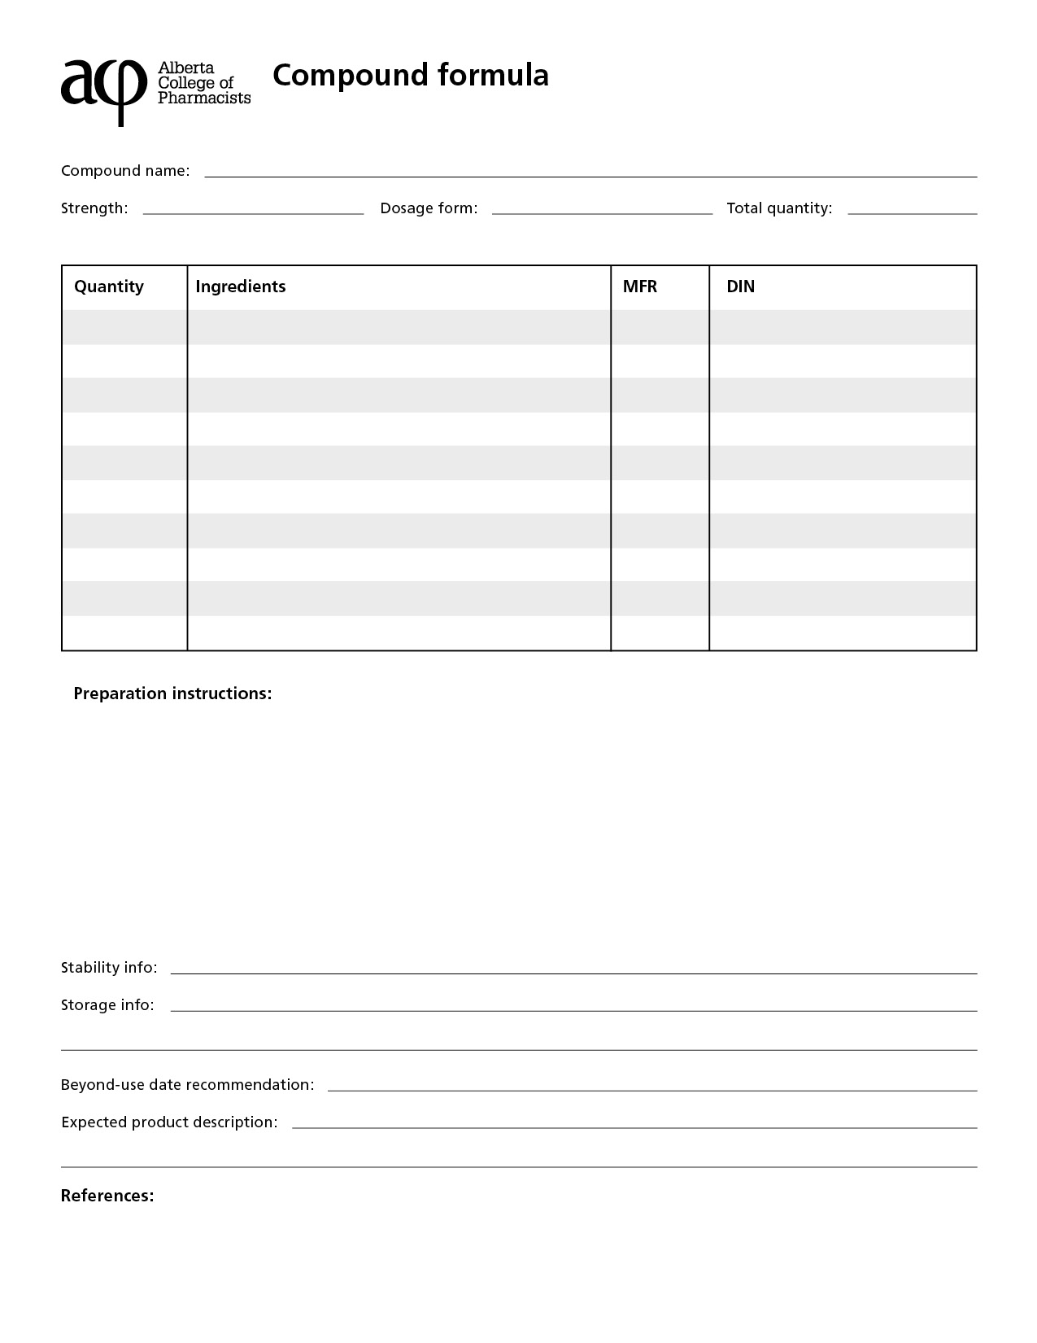
Standard 10.4: Whenever possible, a pharmacist or a pharmacy technician who compounds a drug or blood product must ensure that deviations from the written preparation process are avoided.
Standard 10.7: A pharmacist or a pharmacy technician who deviates from the written process while preparing a compound must ensure that the deviation and the rationale for it are documented.
Procedure for deviating from formulas:

3.16.1.5 Pre-compounding procedure:
Standard 10.8: A pharmacist or a pharmacy technician who compounds a drug or blood product must ensure that all ingredients used in compounding have an approved designation of standard of quality such as:
a) BP (British Pharmacopeia),
b) USP (United States Pharmacopeia), or
c) NF (National Formulary)
unless such a designation does not exist for the ingredient.

For ingredients that do not have an expiration date, assign a conservative expiration date to the ingredient that is no later than 3 years after receipt.

All ingredients used in compounding should be stored in a clean area and at a temperature/humidity level appropriate for the ingredient. Ingredients should be handled in a way that will prevent confusion and cross contamination with other ingredients.

Inspect all ingredients prior to using them in a compound preparation. For each ingredient, confirm the identity, assess the quality by examining its organoleptic properties (size, shape, color, homogeneity, consistency, purity, microbial growth, smell, taste, touch), and expiration date.

Possible signs of instability:
- Solid dosage forms (capsules, tablets, powder, granules, effervescent tablets): cracks or chips on tablet surfaces; mottling or discoloration; fusion; appearance of liquid droplets or crystal deposits; clumping; swelling of mass; gas formation; microbial growth
- Liquid dosage forms (solutions, elixirs, syrups, emulsions, suspensions, tinctures): microbial growth; cloudiness/precipitation; emulsion separation; non-resuspendable caking of suspension; discoloration; turbidity; gas formation; odor
- Semisolid dosage forms (cream, ointment, suppositories): discoloration; change in consistency; odor; crystal deposits; microbial growth; granule formation; hardening; separation
Prior to compounding:
- Retrieve master formula
- Inspect equipment (function and cleanliness)
- Gather and inspect ingredients (quality, identity, expiration date)
- Place all ingredients to be weighed on the left of scale
- All ingredients should be labeled to prevent confusion
- Have compounding documentation forms available
Pre-compounding procedure:

3.16.1.6 Compounding procedures and documentation:
Documentation:
Standard 10.11: In addition to the documentation requirements for dispensing a drug or blood product in Standards 18.1 and 18.2, a pharmacist or a pharmacy technician who compounds a drug or blood product must ensure that a record is created that includes the:
a) name, lot number, expiry date and quantity of each ingredient used to prepare the compounded drug or blood product;
b) formula used to prepare the compounded drug or blood product
c) beyond-use date assigned to the compounded drug or blood product; and
d) a clear audit trail that identifies all individuals who were involved in the preparation and verification of the compounded drug or blood product, and the role of each individual.
Documentation form:

Audit trail:

Bulk preparations:

Assigning batch #s:

http://abpharmacy.ca/sites/default/files/CompoundPreparationDocumentation_web.pdf

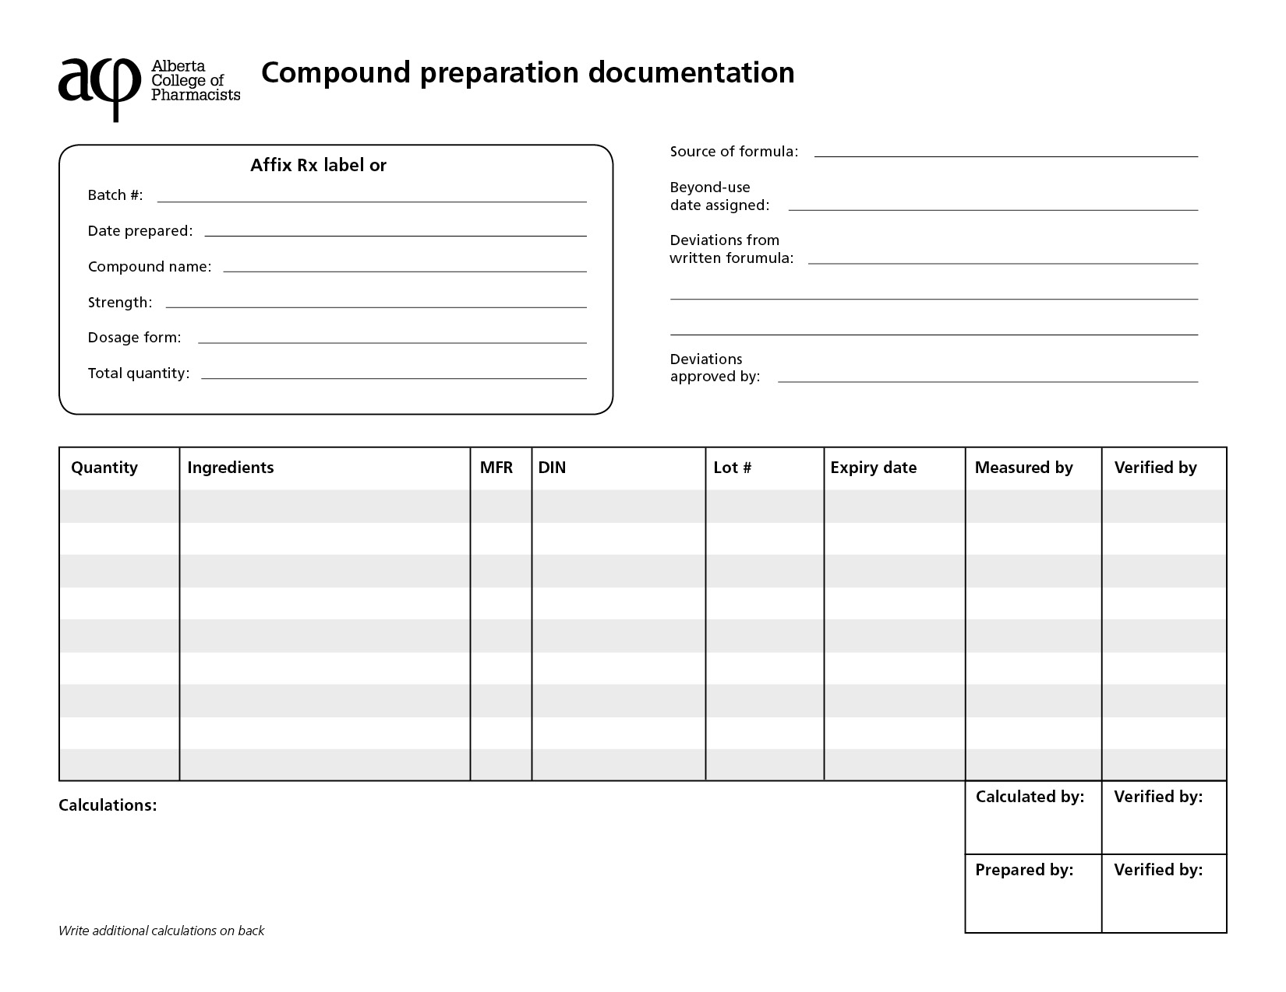
3.16.1.7 Product assessment:
Standard 10.14: A pharmacist or a pharmacy technician must perform a final check of all compounded drugs or blood products to be satisfied that each step in the compounding process has been completed accurately by verifying that:
a) the drug, strength, manufacturer and quantity compounded are correct;
b) the compound was correctly prepared according to the written formula and process;
c) calculations and measures were completed accurately;
d) the label includes the information required in these standards; and
e) the package and packaging material are appropriate to protect the compounded product from light and moisture as necessary and to minimize the potential for interaction between a drug or health care product and the container.
Standard 10.15: Whenever possible, a final check of a compounded product must be performed by a pharmacist or a pharmacy technician who did not prepare the label, complete calculations, select the ingredients from stock or prepare the compound.
The final product should be examined for quality assurance. Examine the compounded preparation’s quantity and organoleptic properties (size, shape, color, consistency, homogeneity, purity, smell, taste, touch). Compare the description of your preparation with the description on the master formula. Document your description of the final product.
Post compounding procedure:
- Inspect final product (organoleptic properties)
- Confirm quantity of final product
- Verify ingredients used
- Verify calculations
- Compare the preparation instructions used against the master formula
- Compare your final product’s description against the master formula
- Ensure proper packaging and labeling
- Assign beyond-use date
- Ensure proper storage
- Complete a documentation form that records the ingredients used, formula used, beyond-use date assigned, and audit trail
Post compounding procedure:

3.16.1.8 Packaging:
The packaging should protect the compound from light and moisture and be appropriate for the compound. Packaging containers and closures should be stored appropriately to prevent contamination and maintain cleanliness.

Packaging requirements:

3.16.1.9 Labeling:
The label of the compound should include, in addition to the requirements set out in Standard 7, the list of active ingredients and strength, dosage form, batch # (if applicable), storage instructions and beyond-use date.

Labeling requirements:

Beyond use date assignment:
According to United States Pharmacopeia (2012):
- Beyond-use dates (BUD) should be assigned conservatively. When assigning a BUD, compounders shall consult and apply drug-specific and general stability documentation and literature when available and shall consider:
  - the nature of the drug and its degradation mechanism
  - the dosage form and its components
  - the potential for microbial proliferation in the preparation
  - the container in which it is packaged
  - the expected storage conditions
  - the intended duration of therapy
- When a manufactured product is used as the source of the active pharmaceutical ingredient for a non-sterile compounded preparation, the product expiration date cannot be used solely to assign a BUD for the compounded preparation.
- At all steps in the compounding, dispensing, and storage process, the compounder shall observe the compounded drug preparation for signs of instability.
- In the absence of stability information that is applicable to a specific drug and preparation, the following table presents maximum beyond-use dates recommended for non-sterile compounded drug preparations that are packaged in tight, light-resistant containers and stored at controlled room temperature, unless otherwise indicated. Drugs or chemicals known to be labile to decomposition will require shorter BUDs.

By Type of Formulation
For Non-aqueous Formulations: | The BUD is not later than the time remaining until the earliest expiration date of any active pharmaceutical ingredient or 6 months, whichever is earlier.
For Water-Containing Oral Formulations: | The BUD is not later than 14 days when stored at controlled cold temperatures.
For Water-Containing Topical/Dermal and Mucosal Liquid and Semisolid Formulations: | The BUD is not later than 30 days.
(United States Pharmacopeial Convention, 2012)
3.16.1.10 Storage:

3.16.1.11 Pricing guidelines:

3.16.1.12 Disposal and clean up procedure:

3.16.2 Sterile Products
3.16.2.1 Aseptic area:
Laminar flow hood operations, maintenance, and documentation:

Opening and closing procedures:

Environmental monitoring and documentation:

Sanitation schedule and agents used:

Sanitation documentation:

3.16.2.2 Equipment:
Equipment cleaning and maintenance procedure:

Measuring equipment calibration and documentation:

3.16.2.3 Personnel:
Personnel training requirements:

Personnel validation process:

Untrained personnel policies:

Personnel health, hygiene and attire:

Hand washing:

Protective gear used:

WHMIS training and MSDS location:

3.16.2.4 Formulas:
Master formula documentation:

Procedure for deviating from formulas:

3.16.2.5 Pre-compounding procedure:
Ingredient assessment:

Pre-compounding procedure:

Cytotoxic agents:

3.16.2.6 Compounding procedure and documentation:
Aseptic techniques:

Sterility testing procedure:

Documentation form:

Audit trail:

Bulk preparations:

Assigning batch #s:

3.16.2.7 Product assessment:
Post compounding procedure:

3.16.2.8 Packaging:

3.16.2.9 Labeling:

3.16.2.10 Storage:

3.16.2.11 Pricing guidelines:

3.16.2.12 Disposal and clean up procedure:

3.16.3 Contracts
http://abpharmacy.ca/sites/default/files/CompoundingAndRepackagingAgreement.doc
Insert compounding contract template

3.17 Narcotics and Controlled Substances
Procedure for narcotic signing authority:

Prescription Regulations Chart:
http://abpharmacy.ca/sites/default/files/PrescriptionRegulations.pdf

3.17.1 Triplicate Prescription Program (TPP)
Pharmacy Resources (Information for the Pharmacist)
http://abpharmacy.ca/triplicate-prescription-program
Stolen TPP Pads
http://abpharmacy.ca/triplicates-stolenmissing
Procedure:

Frequently Asked Questions
http://abpharmacy.ca/faq?shs_term_node_tid_depth=191
Information for the Prescriber
http://www.cpsa.ca/wp-content/uploads/2015/09/Information_for_prescribers_and_dispensers.pdf?a81143
Handling Logged Prescriptions and Refills
Procedure:

3.17.2 Narcotics and Controlled Substances Receipts Report
 | Pharmacy Narcotic and Controlled Drug Register | Record of Receipts of Narcotics and Controlled Drugs

Date | Quantity | Name of Drug or Specialty | Received From |  | Date | Quantity | Name of Drug or Specialty | Received From

3.17.3 Narcotics and Controlled Substances Inventory Management
Procedure for narcotic and controlled substances counts:

Procedure for storage of narcotics and controlled substances:

3.17.4 Managing Expired or Returned Stock
Procedure for Return (include template for documenting returned products from patients and expired products in the pharmacy):

Procedure for Disposal (include procedure for requesting authorization from Health Canada for destruction):

For all controlled substances - with the exception of targeted substances - pharmacists, hospitals, nursing stations and practitioners must apply for destruction through the Office of Controlled Substances in Ottawa.
The Compliance Unit requires the following by letter:
- date of the request
- full name and address of the pharmacy
- list of drugs by name including quantity, strength, lot# and expiry date
- one list for products from the pharmacy inventory and a separate list for products returned to the pharmacy by patients
- the name and license number of the pharmacist requesting permission to destroy the items
There is a dedicated phone and fax line for inquiries.
Telephone: (613) 954-1541
Fax: (613) 957-0110
The office prefers a fax over a phone call if the fax lists the drugs to be destroyed.

3.17.5 Loss or Theft Form
http://www.hc-sc.gc.ca/hc-ps/substancontrol/substan/compli-conform/loss-perte/index-eng.php
http://www.hc-sc.gc.ca/hc-ps/alt_formats/hecs-sesc/pdf/substancontrol/substan/compli-conform/loss-perte/form_4010-eng.pdf
Procedure:

3.17.6 Suspected Forgery
Procedure:

3.17.7 Forgery Reporting Form
http://www.hc-sc.gc.ca/hc-ps/alt_formats/hecs-sesc/pdf/substancontrol/substan/compli-conform/loss-perte/forgery_rep-rap-fau_ordonance.pdf
ACP forgery reporting form
http://abpharmacy.ca/forgery-alerts
Procedure:

3.17.8 Opioid Dependence Treatment
https://abpharmacy.ca/sites/default/files/ODTGuidelines.pdf
3.17.8.1 General
Prescription authentication procedure:

Prescriber exemption verification:

Patient verification procedure:

Patient assessment and documentation:

Patient pick up schedule:

New patient agreement (i.e. expectations, obligations, pick up schedule, identification):

3.17.8.2 Administration
Witnessing administration:

Initial dosing of Suboxone:

Missed dose:

Lost/stolen dose:

Spoiled dose:

Vomited dose (methadone and Suboxone):

Withholding dose:

Administration records:

Physician collaboration:

Dispensing container:

3.17.8.3 Preparation
Methadone preparation (equipment, audit trail, and documentation):

Bulk compounding (concentration, quantity, labeling, stability, documentation):
Storage location of medications:

Disposal:

3.17.8.4 Carries
Patient eligibility:

Requirements and restrictions:

Agreement:

Labelling and packaging:

Signature and documentation:

Delivery and documentation:

Bottle return and documentation:

Alternative witness agreement:

3.18 Benzodiazepines and Other Targeted Substances
http://abpharmacy.ca/benzodiazepines-other-targeted-substances
Procedure (diversion, receipt, storage, records maintenance, refills, transfers, destruction):

3.19 Child Resistant Containers

3.20 Administration of Drugs by Injection
Refer to Standards 16-17 in the Standards of Practice for Pharmacists and Pharmacy Technicians
http://abpharmacy.ca/authorization-inject
http://abpharmacy.ca/seasonal-influenza-information
Procedure:

Informed consent:

3.21 Cold Chain Management
http://abpharmacy.ca/sites/default/files/ColdChainManagement.pdf

3.21.1 Refrigerator Temperature Log

http://www.albertahealthservices.ca/assets/info/hp/cdc/if-hp-cdc-temp-mntrng-log.pdf

3.22 Ordering
Procedure:

Wholesalers:

Special order:

3.23 Prescription Balances or Owings
Procedure:

3.24 Prescriptions Not Picked Up
Procedure:

3.25 Inventory Management
Maintenance:

Short-dated/expired stock:

3.26 Special Access Programs (SAPs)
Procedure:

3.27 Waste Management

3.27.1 Expired Drugs/Returned Stock
Procedure:

3.27.2 Sharps Disposal
Procedure:

3.27.3 Needlestick Injury
Prevention:

Procedure for managing injuries:

3.28 Quality Assurance and Safety
(a) Within 24 hours of initial discovery, the licensee must ensure that any suspected drug error is investigated and, if verified, is documented.

(b) The staff member(s) involved in the drug error must document an account of the error as soon as possible after the discovery. If the staff member(s) involved are not on duty at the time of discovery, the staff member who discovers the drug error must initiate the documentation.

(c) Drug error documentation must:

(i) be in a format that can be easily audited and reviewed, and

(ii) be maintained for at least 10 years after the error is discovered.

(d) The documentation must include a description of factors contributing to the drug error and actions taken to prevent recurrence.

(e) The report must clearly identify whether it relates to a drug incident or an adverse drug event.

3.28.1 Drug Error (Drug Incident) Reporting
Drug Error (Drug Incident) Reporting Form:
http://abpharmacy.ca/drug-error-management
Procedure for preventing, reporting, investigating, documenting and evaluating drug errors (drug incidents):

Procedure for dealing with complaints or concerns:

3.28.2 Drug Error (Drug Incident) Follow-Up Process
http://abpharmacy.ca/sites/default/files/DrugIncidentQuarterlyReview.pdf

The licensee must, at least quarterly:

(a) review the drug-error reports for the licensed pharmacy to evaluate whether practice changes or preventative measures are required to prevent future drug errors; and

(b) assess whether any changes implemented as a result of a drug error were successful in advancing patient safety.

Procedure to conduct regular review of procedures to prevent drug errors (drug incidents):

3.28.3 Adverse Event Reporting
http://www.hc-sc.gc.ca/dhp-mps/alt_formats/pdf/medeff/report-declaration/ser-des_form-eng.pdf

4.0 Patient Concerns
http://abpharmacy.ca/sites/default/files/PatientConcernPoster.pdf
Complaints procedure:

5.0 Privacy Policy
http://abpharmacy.ca/federal-legislation
http://abpharmacy.ca/provincial-legislation

5.1 Custodians of Health Information
https://abpharmacy.ca/sites/default/files/HIAGuide.pdf
Custodians of health information (list and define where appropriate)
- Pharmacists:
- Pharmacy Managers:
- Affiliates (specify):
- Others (specify):

5.2 Use and Disclosure of Health Information
https://abpharmacy.ca/sites/default/files/HIAGuide.pdf
Procedure (define limitations on type, access and use of health information):

Procedure for disclosure:

Procedure for documentation and retention of record of disclosure:

5.3 Disposal of Health Information
Procedure:

Shredding:

6.0 Confidentiality

6.1 Confidentiality Agreements

6.2 Affiliate Agreements

6.3 Handling Media Calls, Public Speaking, Press Releases
Procedure:

7.0 Pharmacy Signage
□ Pharmacy hours posted (must be posted in public view)
□ Pharmacy license (must be posted in public view)
□ Code of Ethics poster (must be posted in public view)
http://abpharmacy.ca/sites/default/files/CodeOfEthics.pdf
□ Patient Concerns poster (must be posted in public view)
http://abpharmacy.ca/sites/default/files/PatientConcernPoster.pdf
□ Patient Information Collection poster
http://abpharmacy.ca/sites/default/files/PatientInfoCollection.pdf
□ Returned medication cards
http://abpharmacy.ca/sites/default/files/StandardsMiniPoster.pdf
□ Relevant Certification (e.g. CDE, CGP)

8.0 Pharmacy Website
http://abpharmacy.ca/manage-your-pharmacy
Requirements:

Procedure for updating:

9.0 Reference Library
Please refer to the attached link for the up-to-date list of required references in the following categories.
http://abpharmacy.ca/sites/default/files/RequiredReferences.pdf
1. Federal/Provincial Professional Legislation

2. Canadian Compendium

3. Drug Interaction Text

4. Therapeutic Text

5. Dispensatory/Foreign Drug Text

6. Medical Dictionary

7. OTC Reference

8. Natural Health Products and Alternative Therapies Text

10.0 Code of Ethics
The Code of Ethics must be posted in public view.
http://abpharmacy.ca/code-ethics
Policy to disclose services not available because of conscientious objection (Principle V. Respect each patient’s right to healthcare):
A pharmacist shall assist each patient to obtain appropriate pharmacy services from another pharmacist or health professional within a timeframe fitting the patient’s needs if that pharmacist is unable to provide the pharmacy service or will not provide the service due to a conscientious objection. A pharmacist will arrange the condition of his/her practice so that the care of his/her patients will not be jeopardized when he/she will not provide certain pharmacy services due to a conscientious objection.
Insert policy and procedure here

11.0 Standards of Practice

11.1 Standards for Practice for Pharmacists and Pharmacy Technicians

http://abpharmacy.ca/standards-practice

11.2 Standards for the Operation of Licensed Pharmacies
http://abpharmacy.ca/standards-practice

12.0 Human Resources
http://www.qp.alberta.ca/574.cfm?page=2006_129.cfm&leg_type=Regs&isbncln=9780779758197

12.1 Job Descriptions
Pharmacy Manager:
Insert description

Pharmacist:
Insert description

Regulated Pharmacy Technician
Insert description

Pharmacy Assistant:
Insert description

Pharmacy Intern:
Insert description

Pharmacy Student:
Insert description

Other Staff:
Insert description

Volunteers:
Insert description

12.2 Supervising Registered Pharmacy Interns

http://abpharmacy.ca/sites/default/files/PostGradEvalGuide.pdf

12.3 Staffing Levels
Qualifications of staff:

Number of staff:

12.4 Dress Code

12.5 Performance Appraisal

12.6 Sick Leave
Procedure:

12.7 Leaves of Absence
Procedure:

12.8 Vacation Requests
Procedure:

12.9 Pandemic Preparedness Plan
Plan for staff:

Plan for store:

12.10 Harassment in the Workplace

13.0 Business Operations

13.1 Internet and Electronic Communication

13.2 Opening and Closing Cash
Procedure:

13.3 Charge Accounts
Procedure:

13.4 Cheques
Procedure:

13.5 Staff Purchases
Procedure:
Pricing policies:

13.6 Telephones
Procedure:

13.7 Accounts Receivable
Procedure:

13.8 Accounts Payable
Procedure:

13.9 Banking
Procedure:

13.10 Pricing Policies
List drug plans and contact information

13.11 Return Policies
Prescription drugs:

Non-prescription drugs:

Other health care products:

14.0 Contacts

14.1 Manager
Phone number:
E-mail:

14.2 Staff
Name:
Phone number:
E-mail:

14.2.1 Relief Pharmacists
Name:
Phone number:
E-mail:

14.3 Alarm Company
Name:
Address:
Phone number:
E-mail:

14.4 Wholesaler(s)
Name:
Address:
Phone number:
E-mail:

14.5 Supplier(s)
Name:
Address:
Phone number:
E-mail:

14.6 Local Physicians
Name:
Address:
Phone number:
Fax number:

14.7 Third Party:
Name:
Phone number:
Provider number:

14.8 Emergency Services
Police:
Fire/Ambulance:

14.8.1 Staff with CPR and First Aid Training

United States Pharmacopeial Convention. (2012, August 1). Chapter 795 Pharmaceutical Compounding—Nonsterile Preparations. Retrieved from USP-NF Online: www.uspnf.com

