POLICY & PROCEDURE TEMPLATES
for
GENERAL INFECTION PREVENTION & CONTROL

CPSA IPAC PROGRAM

April 2018

Please use these templates as starting documents to support best practices for general infection prevention and control in your medical office. Do not simply print and use these templates as written as some sections are incomplete and others may require amendments to reflect your specific clinic operations and actual practices.

GENERAL INFECTION PREVENTION & CONTROL
Templates – Policies & Procedures
Contents
POLICY: Hand Hygiene (Standard G.1.1.1) 3
PROCEDURE: Hand Hygiene (Standard G.1.1.1) 4
POLICY: Point-of-Care Risk Assessment (Standard G.1.1.2) 6
PROCEDURE: Point-of-Care Risk Assessment (Standard G.1.1.2) 7
POLICY: Selection and Use of Personal Protective Equipment (Standard G.1.1.3) 10
PROCEDURE: Selection and Use of Personal Protective Equipment (Standard G.1.1.3) 11
POLICY: Environmental Cleaning and Disinfection (Standard G.1.1.4) 13
PROCEDURE: Environmental Cleaning and Disinfection (Standard G.1.1.4) 14
POLICY: Handling of Blood and Body Fluid (Standard G.1.1.5) 17
PROCEDURE: Handling of Blood and Body Fluid (Standard G.1.1.5) 18
POLICY: Decontamination of Blood and Body Fluid (Standard G.1.1.6) 19
PROCEDURE: Decontamination of Blood and Body Fluid (Standard G.1.1.6) 20
POLICY & PROCEDURE: Management of Blood and Body Fluid Exposure (Standard G.1.1.7) 22
POLICY: Recommended Immunizations for Employees (Standard G.1.1.8) 23
PROCEDURE: Recommended Immunizations for Employees (Standard G.1.1.8) 24
POLICY: Exclusion or Work Restriction During Staff Illness (Standard G.1.1.9) 26
PROCEDURE: Exclusion or Work Restriction During Staff Illness (Standard G.1.1.9) 27
POLICY & PROCEDURE: Cleaning and Disinfection of Toys (Standard G.1.1.10) 31
POLICY & PROCEDURE: Cold Chain Management of Vaccines (Standard G.1.1.11) 33
POLICY & PROCEDURE: Medical Device Reprocessing (Standard G.1.1.12 and M.1.1) 34

POLICY: Hand Hygiene
(Standard G.1.1.1)

Date: Approved by:

Purpose: Hand hygiene is the most effective way of preventing the transmission of healthcare-associated infection (HAI) to patients, staff, and visitors in all healthcare settings.

1. Hand hygiene shall be performed:

- Before contact with a patient or patient’s environment
- Before a clean or aseptic procedure
- After exposure or risk of exposure to blood and/or body fluids
- After contact with a patient or patient’s environment

2. Alcohol-based hand rubs (ABHRs) containing 60-90% alcohol shall be used for performing hand hygiene.

3. Plain soap and water shall be used to wash hands in the following circumstances:

- When hands are visibly soiled with food, dirt, blood, body fluids and/or a buildup of ABHR.
- Following glove removal when providing care for patients with diarrhea and/or vomiting.

4. Hand washing sinks shall be dedicated for hand hygiene and shall not be used for other purposes (e.g. equipment cleaning, waste disposal, food preparation).

5. Employees that cannot perform adequate hand hygiene (e.g. wearing casts, dressings or splints, experiencing dermatitis) must not perform tasks that require hand hygiene.

6. Artificial nails, nail enhancements, chipped nail polish, and hand jewelry (other than a plain band) shall not be worn.

7. All employees shall be educated in proper hand hygiene techniques.

References:
- Alberta Health Services Infection Prevention & Control. 2011. Hand Hygiene Policy PS-02. https://extranet.ahsnet.ca/teams/policydocuments/1/clp-hand-hygiene-ps-02-policy.pdf
- Canadian Patient Safety Institute. 2015. Your 4 Moments of Hand Hygiene. http://www.patientsafetyinstitute.ca/en/education/Pages/Hand-Hygiene-Education.aspx
- College of Physicians & Surgeons of Alberta. 2016. General Infection Prevention & Control Assessment.
http://www.cpsa.ca/wp-content/uploads/2016/06/General-IPAC-Standards.pdf?x91570
- Public Health Agency of Canada. 2012. Hand hygiene practices in healthcare settings. http://publications.gc.ca/site/eng/430135/publication.html

PROCEDURE: Hand Hygiene
(Standard G.1.1.1)

Date: Approved by:

Purpose: Hand hygiene is the most effective way of preventing the transmission of healthcare-associated infection (HAI) to patients, staff, and visitors in all healthcare settings.

- Procedure for using alcohol-based hand rub (ABHR):
- Ensure hands are not visibly soiled and are dry before use;
- Apply an adequate amount of ABHR to cover all hand surfaces;
- Vigorously rub ABHR over all surfaces of the hands and wrists, including palms, between fingers, back of hands, wrists, fingers, fingertips, and thumbs;
- Hands should remain wet for a minimum of 15 seconds;
- Hands should be rubbed until completely dry.

- Procedure for washing hands with soap and water:

- Wet hands with warm water and enough soap;
- Apply enough soap to ensure lathering of all hand surfaces;
- Vigorously rub all surfaces of hands and wrists, including palms, between fingers, back of hands, wrists, fingers, fingertips, and thumbs;
- Rub hands for a minimum of 15 seconds;
- Rinse hands under warm, running water;
- Dry hands with disposable paper towels;
- Avoid re-contaminating hands after washing. Turn off faucet and open doors with a paper towel;
- Discard paper towels in waste receptacle.

- Position hand hygiene products as close as possible to the point-of-care. Wall-mount or place ABHR dispensers in appropriate designated areas away from sinks and in accordance with the Alberta Fire Code. Areas include, but are not limited to:
- Examination rooms
- Public areas (e.g. building entrance/exits, desk, waiting room)
- Nursing stations
- Medication carts
- Staff rooms
- Computer stations
- Medical device reprocessing area
- Medication preparation areas

- Check expiration dates and do not use hand hygiene products beyond expiration date.
- Do not use sinks dedicated for hand hygiene for other purposes (e.g. equipment cleaning, waste disposal, food preparation).
- Ensure that hand hygiene products are available for patients and visitors.

References:
- Alberta Health Services Infection Prevention & Control. 2011. Hand Hygiene Procedure PS-02-01. https://extranet.ahsnet.ca/teams/policydocuments/1/clp-hand-hygiene-ps-02-01-procedure.pdf
- Canadian Patient Safety Institute. 2015. Your 4 Moments of Hand Hygiene. http://www.patientsafetyinstitute.ca/en/education/Pages/Hand-Hygiene-Education.aspx
- College of Physicians & Surgeons of Alberta. 2016. General Infection Prevention & Control Assessment.
http://www.cpsa.ca/wp-content/uploads/2016/06/General-IPAC-Standards.pdf?x91570
- Public Health Agency of Canada. 2012. Hand hygiene practices in healthcare settings. http://publications.gc.ca/site/eng/430135/publication.html

POLICY: Point-of-Care Risk Assessment
(Standard G.1.1.2)

Date: Approved by:

Purpose: A point-of-care risk assessment (PCRA) is performed by healthcare workers to determine the appropriate infection prevention and control measures for safe patient care (i.e. to protect the patient from transmission of microorganisms) and to protect the healthcare worker and other patients from exposure to microorganisms (e.g. from sprays of blood, body fluids, respiratory tract or other secretions or excretions and contaminated needles and other sharps)⁴.

The following shall apply to risk assessment of patients in the clinic setting:

- A PCRA shall be conducted at the start of each patient’s appointment to evaluate the likelihood of exposure to blood, body fluids or airborne secretions and to choose the appropriate actions needed to minimize the risk of exposure to infectious agents.
- Appropriate actions shall include hand hygiene, use of additional precautions if required, choosing safe accommodation in waiting or examination/treatment rooms, appropriate environmental cleaning, and appropriate use of personal protective equipment (e.g. gloves, gowns, facial protection, etc.).
- Coughing, febrile patients who are unable to cover or contain their cough shall be instructed to wear a mask or shall be accommodated at least 2 meters away from other patients or in an examination/treatment room.
- Employees shall be educated regarding how to perform PCRA and implement routine practices and additional precautions.
- Cases of notifiable communicable disease shall be reported to the Medical Officer of Health (MOH). A current list of notifiable diseases shall be readily available for reference¹.
References:
- Alberta Health. 2015. Notifiable Disease and Diseases Under Surveillance List. http://www.health.alberta.ca/documents/Notifiable-Disease-List-2015.pdf
- Alberta Health Services Infection Prevention & Control. 2013. Point of Care Risk Assessment for Use of Routine Practices. http://www.albertahealthservices.ca/ipc/hi-ipc-acute-care-pcra.pdf
- College of Physicians & Surgeons of Alberta. 2016. General Infection Prevention & Control Assessment. http://www.cpsa.ca/wp-content/uploads/2016/06/General-IPAC-Standards.pdf?x91570
- Public Health Agency of Canada. 2013. Routine practices and additional precautions for preventing the transmission of infection in healthcare settings. http://publications.gc.ca/site/eng/440707/publication.html

PROCEDURE: Point-of-Care Risk Assessment
(Standard G.1.1.2)

Date: Approved by:

Purpose: A point-of-care risk assessment (PCRA) is performed by healthcare workers to determine the appropriate infection prevention and control measures for safe patient care (i.e. to protect the patient from transmission of microorganisms) and to protect the healthcare worker and other patients from exposure to microorganisms (e.g. from sprays of blood, body fluids, respiratory tract or other secretions or excretions and contaminated needles and other sharps)⁵.

Definitions:

- Routine Practices: Infection prevention and control practices for use in the routine care of all patients at all times in all healthcare settings and are determined by the circumstances of the patient, the environment and the task to be performed.

Routine practices include⁵:

- Hand hygiene
- Source control (i.e. triage, early diagnosis and treatment, respiratory hygiene, spatial separation)
- Patient placement, accommodation, and flow
- Aseptic technique
- Appropriate use of personal protective equipment (PPE)
- Sharps safety and prevention of bloodborne pathogen transmission
- Management of the patient care environment
- Cleaning of the patient care environment
- Cleaning and disinfection of non-critical patient care equipment
- Handling of waste and linen

- Additional Precautions: Additional precautions are applied when the transmission characteristics of, or impact of, infection with a specific microorganism are not fully prevented by routine practices. These precautions should also be used when medical procedures increase the risk of transmission of a specific infectious agent or when the clinical situation prevents consistent application of routine practices (e.g. young children, incontinent adults, or cognitively impaired individuals).
Additional precautions include⁵:

- Contact precautions, for epidemiologically significant microorganisms or microorganisms with very low infective dose or situations where heavy contamination of the patient’s environment is anticipated.
- Droplet precautions, for microorganisms primarily transmitted by the large droplet route.
- Airborne precautions, for microorganisms transmitted through the air over extended time and distance by small particles.

- Respiratory Etiquette: A combination of measures to be taken by an infected person designed to minimize the transmission of respiratory microorganisms (e.g. influenza). Includes covering cough, hand hygiene, wearing a mask if unable to contain cough⁵.

Procedure:
- At the beginning of each appointment, each patient is assessed regarding the infectious risk they may present in the clinic setting. This can be done by observing the patient, asking pertinent questions regarding the reason for their visit, presence of fever ≥38°C, recent travel, exposure to communicable disease, or by posting a notice that asks this information.
- Coughing, febrile patients should be instructed in respiratory etiquette, and provided with tissues or a mask.
- If patient is vomiting or unable to reliably contain their cough, they should be placed immediately into an examination room if possible. Alternately, they should be separated by at least 2 meters from others in the waiting room.
- For information regarding diseases and conditions that require additional precautions refer to Alberta Health Services Infection Prevention and Control (IPC) Diseases and Conditions Table: Recommendations for Management of Acute Care Patients².
- Refer to algorithm on next page for assistance in choosing appropriate personal protective equipment (PPE)³.
- If the patient is diagnosed with a notifiable communicable disease, ensure and document that the diagnosing physician or designate notifies the Medical Officer of Health (MOH) as per the Alberta Health Notifiable Disease List¹.

References:
- Alberta Health. 2015. Notifiable Disease and Diseases Under Surveillance List. http://www.health.alberta.ca/documents/Notifiable-Disease-List-2015.pdf
- Alberta Health Services Infection Prevention & Control. 2014. Infection Prevention and Control (IPC) Disease and Conditions Table: Recommendations for Management of Acute Care Patients. http://www.albertahealthservices.ca/assets/healthinfo/ipc/hi-ipc-resource-manual-main-document.pdf
- Alberta Health Services Infection Prevention & Control. 2013. Point of Care Risk Assessment for Use of Routine Practices.
http://www.albertahealthservices.ca/ipc/hi-ipc-acute-care-pcra.pdf
- College of Physicians & Surgeons of Alberta. 2016. General Infection Prevention & Control Assessment. http://www.cpsa.ca/wp-content/uploads/2016/06/General-IPAC-Standards.pdf?x91570
- Public Health Agency of Canada. 2013. Routine practices and additional precautions for preventing the transmission of infection in healthcare settings. http://publications.gc.ca/site/eng/440707/publication.html
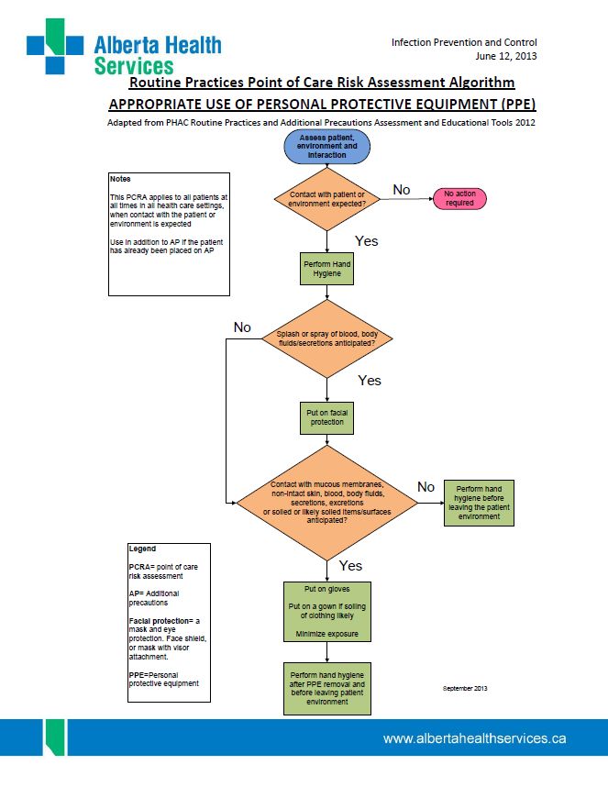

POLICY: Selection and Use of Personal Protective Equipment
(Standard G.1.1.3)

Date: Approved by:

Purpose: Personal protective equipment (PPE) is an essential element in preventing the transmission of disease causing microorganisms. If used incorrectly, PPE will fail to prevent transmission and may facilitate the spread of disease. Appropriate PPE will also protect staff from exposure to chemical and physical hazards in the workplace.

The following shall apply when selecting and using PPE:

- Adequate supplies of appropriately sized disposable gloves, sterile gloves for aseptic procedures, gowns, eye protection, procedure masks and if applicable, N95 respirators shall be provided by the employer for employee use.
- N95 respirators, if used, shall be fit tested for each employee and results of testing shall be documented.
- Staff shall be trained in correct use and donning/doffing procedures for PPE.
- Gloves and other single-use PPE (e.g. gowns, masks, eye protection, face shields) shall be worn once for a single patient/procedure and shall be discarded following use. Gloves shall not be washed.
- Reusable PPE (e.g. gowns, eye protection, face shields) shall be worn once for a single patient/procedure, then cleaned and disinfected following each use.

References:
- Alberta Health Services Infection Prevention & Control. 2016. Community-Based Services Resource Manual. http://www.albertahealthservices.ca/assets/healthinfo/ipc/hi-ipc-community-based-services-resource-manual.pdf
- College of Physicians & Surgeons of Alberta. 2016. General Infection Prevention and Control Assessment. http://www.cpsa.ca/wp-content/uploads/2016/06/General-IPAC-Standards.pdf?x91570
- Public Health Agency of Canada. 2013. Routine practices and additional precautions for preventing the transmission of infection in healthcare settings. http://publications.gc.ca/site/eng/440707/publication.html

PROCEDURE: Selection and Use of Personal Protective Equipment
(Standard G.1.1.3)

Date: Approved by:

Purpose: Personal protective equipment (PPE) is an essential element in preventing the transmission of disease causing microorganisms. If used incorrectly, PPE will fail to prevent transmission and may facilitate the spread of disease. Appropriate PPE will also protect staff from exposure to chemical and physical hazards in the workplace.

- General:

Appropriate personal protective equipment (PPE) is to be worn when exposure to blood or body fluids is anticipated. Assess the situation or task before selecting which PPE to wear. For example, only gloves are required for phlebotomy or contact with mucous membranes, while facial protection and a gown must be worn in addition to gloves if patient is vomiting. PPE must only be worn for a single patient or procedure.

- Gloves:

- shall never be washed
- shall be changed between patients
- shall not be worn when accessing clean or sterile supplies or when charting or using electronic equipment such as computers, phones or personal devices.
- shall be worn when handling contaminated equipment or devices and when cleaning and disinfecting contaminated surfaces or equipment.

Hands must be cleaned before putting on and after removing gloves.

- Masks, Eye Protection and Face Shields:

- Masks, eye protection, and face shields work together to protect the mucous membranes (i.e. eyes, nose, and mouth) of healthcare workers from droplets, splashes or sprays of blood or body fluids (e.g. cough or sneeze, release of drainage from skin lesions, etc.).
- If a risk assessment indicates the need for a mask, eye protection is also required as the eyes are also a portal of entry for microorganisms.
- Proper eye protection must protect eyes in all directions and should be worn when splashes, sprays, or droplets of fluid are expected. Prescription eyewear is not considered adequate eye protection or PPE. An additional eye protection barrier must be worn.
- Gowns

- Long-sleeved gowns protect uncovered skin and clothing during procedures and patient care activities likely to produce soiling or generate splashes or sprays of blood, body fluids, secretions, or excretions.
- Gowns should be cuffed and cover the front and back of the healthcare worker from the neck to mid-thigh.
- The type of gown selected is based on the potential for blood and body fluid penetration of the gown (i.e. fluid repellence when heavy liquid contamination is anticipated) as well as the requirement for sterility in some procedures (e.g. surgery, central line insertion, etc.).
- Gowns can be reusable or disposable. Gowns should be worn once for a single patient/procedure and laundered if reusable or discarded if disposable.

- PPE must be donned and doffed using the following specific sequence to prevent contamination of healthcare workers and the environment.

Donning PPE:

- Perform hand hygiene.
- Put on gown with opening to the back. Fasten closures.
- Put on mask. Secure ties to head or elastic loops behind ears. Mould the flexible band to the bridge of nose. Ensure snug fit to face and below chin with no gaping or venting.
- Put on protective eyewear or face shield.
- Put on gloves by pulling the gloves over the cuffs of the gown.

Doffing PPE:

- Remove gloves by grasping the outside cuff of one glove near the wrist and peel away from the hand, turning the glove inside out. Hold the glove in the opposite gloved hand. Slide finger or thumb under the wrist of the remaining glove and peel the glove off and over the first glove. Discard gloves in the garbage.
- Perform hand hygiene.
- Remove gown by unfastening closures and grasping the outside of the gown at the back of the shoulders, pulling the gown down over the arms. Turn the gown inside out during removal. Discard gown in laundry hamper if reusable or in garbage if disposable.
- Perform hand hygiene.
- Remove protective eyewear or face shield by grasping headband or earpieces and carefully pulling away from face. Place reusable items in a container for later cleaning and disinfection, or discard disposable items in garbage.
- Perform hand hygiene.
- Carefully remove mask by bending forward slightly, touching only the ties or elastic loops. Undo the bottom tie first then undo the top tie. Discard the mask in the garbage.
- Perform hand hygiene.

References:
- Alberta Health Services Infection Prevention & Control. 2016. Personal Protective Equipment. http://www.albertahealthservices.ca/info/Page6422.aspx
- College of Physicians & Surgeons of Alberta. 2016. General Infection Prevention & Control Assessment. http://www.cpsa.ca/wp-content/uploads/2016/06/General-IPAC-Standards.pdf?x91570
- Public Health Agency of Canada. 2013. Routine practices and additional precautions for preventing the transmission of infection in healthcare settings. http://publications.gc.ca/site/eng/440707/publication.html

POLICY: Environmental Cleaning and Disinfection
(Standard G.1.1.4)

Date: Approved by:

Purpose: A clean environment will minimize the presence and subsequent transmission of microorganisms. Regular cleaning activities using effective products and techniques are an important component of infection prevention and control in the clinic setting.

The following principles shall apply when cleaning the clinic environment:

- Low-level or intermediate-level environmental cleaning disinfectants shall be used for cleaning and disinfection of clinical surfaces. It is not necessary to use disinfectant products when cleaning floors, unless cleaning up spills of blood or body fluids.
- Disinfectant products used for environmental cleaning shall be approved by Health Canada and have a Drug Identification Number (DIN) or Natural Product Number (NPN).
- The disinfectant product manufacturer’s instructions shall be followed for use, contact time, storage, and shelf life.
- Clinical contact surfaces (e.g. examination tables, procedural work surfaces, etc.) shall be cleaned and disinfected between patients.
- A regular schedule for periodic environmental cleaning shall be established and documented.
- Staff and contractors responsible for environmental cleaning shall follow the clinic’s environmental cleaning policies and procedures.
- Vacuum cleaners, if used, shall be fitted with a HEPA filter.

References:
- Alberta Health Services Infection Prevention & Control. 2013. Guidelines for principles of environmental cleaning and disinfection. http://www.albertahealthservices.ca/assets/infofor/hp/if-hp-ipc-bpg-cleaning-principles.pdf
- College of Physicians & Surgeons of Alberta. 2016. General Infection Prevention & Control Assessment. http://www.cpsa.ca/wp-content/uploads/2016/06/General-IPAC-Standards.pdf?x91570
- Ontario Agency for Health Protection and Promotion, Provincial Infectious Diseases Advisory Committee. 2012. Best practices for environmental cleaning for prevention and control of infections in all health care settings. 2nd ed. http://www.oahpp.ca/resources/documents/pidac/Environmental%20Cleaning%20BP_ENGLISH_FINAL_2012-07-15.pdf

PROCEDURE: Environmental Cleaning and Disinfection
(Standard G.1.1.4)

Date: Approved by:

Purpose: A clean environment will minimize the presence and subsequent transmission of microorganisms. Regular cleaning activities using effective products and techniques are an important component of infection prevention and control in the clinic setting.

- Responsibility:

Clinic staff is responsible for cleaning examination/procedure rooms between patients.
______________________________________ (Name of in-house or contracted environmental cleaning service provider) is responsible for scheduled (e.g. end of day) environmental cleaning.

- Disinfectant Product:

Follow manufacturer’s instructions for use for product concentration, contact time, recommended personal protective equipment (PPE), and material compatibility.

- If disinfectant product is a concentrate:

- Check expiration date prior to use.
- Wear gloves when preparing and using disinfectant.
- Dilute product according to manufacturer’s instructions.
- Prepare _______________________ (name of disinfectant solution) by adding _____ml of concentrate to ______ml water.
- Dispense mixed disinfectants into clean, dry, appropriately- sized containers that are clearly labeled and dated. Discard after the expiry date.
- If containers are reusable, empty, wash, and dry prior to refilling.
- Never top-up existing disinfectant in container with fresh disinfectant.

- If disinfectant product is ready-to-use:

- _________________________________ (name of ready-to-use disinfectant product) is used for environmental cleaning and disinfection in the clinic.
- Check expiration date prior to use.
- Wear gloves when using disinfectant.
- Never top-up existing disinfectant in container with fresh disinfectant.
- Discard single-use disinfectant containers when empty.
- If using disinfectant wipes, ensure container is securely closed between uses.
- Cleaning Methods:

- Between-patient cleaning of clinical areas:

- Wash hands and put on gloves before commencing cleaning.
- Remove items from surfaces to be cleaned. (e.g. procedure trays, bed coverings, etc.)
- If surfaces are visibly soiled, a two-step process is followed. First clean surfaces to remove soil and then use a clean cloth soaked with disinfectant to disinfect the area. If surfaces are not visibly soiled, a one-step process using a cleaner-disinfectant is acceptable.
  - Use __________________________ (single-use cleaner-disinfectant wipe OR single-use or reusable cloth soaked with cleaner-disinfectant product).
- Proceed from:
  - clean to dirty areas (e.g. counter top before bed or chair);
  - high surfaces to low surfaces (e.g. clean top of IV pole before cleaning wheels); and
  - low frequency touch items/surfaces (e.g. walls) to high frequency touch items/surfaces (e.g. reflex hammer, B.P. cuff).
- Allow disinfectant product to air-dry and ensure wet contact time of ______ minutes is achieved (consult label instructions).
- Remove gloves and wash hands after performing environmental cleaning.

- Scheduled cleaning (daily, weekly, quarterly, annually):

- Wash hands and put on gloves before commencing cleaning.
- Remove items from surfaces to be cleaned. (e.g. magazines, packages, etc.)
- If a surface is visibly soiled, a two-step process is followed. First clean surfaces to remove soil and then use a clean cloth or mop to disinfect the area.
- Dip cloth into cleaning solution only once. Do not “double-dip” into cleaning solution.
- Proceed from:
  - clean to dirty areas (e.g. furniture, sinks before toilet);
  - high surfaces to low surfaces (e.g. clean top of IV pole before cleaning wheels); and
  - low frequency touch surfaces (e.g. walls) to high frequency touch surfaces (e.g. door knob, light switch).
- Allow disinfectant to air-dry and ensure wet contact time of ______ minutes is achieved (consult label instructions).
- Remove gloves and wash hands after performing environmental cleaning.
- Document the date, time, and name of person responsible for cleaning in a log when scheduled (e.g. daily, weekly, annual) cleaning is done.

- Cleaning Tools:

- Reusable cloths and mop heads must be laundered and dried following use.
- Single-use wipes or cloths must be discarded after each use.
- Mops, cloths, and buckets used to clean the decontamination area of the medical device reprocessing area shall not be used in other areas of the clinic.
- Clean and disinfect reusable cleaning tools (e.g. pails, buckets, mop handles) following use. Store cleaning tools and supplies in ___________________________ (indicate designated area for storage of cleaning supplies).

- Frequency of Cleaning:

AREA | FREQUENCY
Contact surfaces in examination and treatment rooms | Between patients
Floors, bathrooms, sinks, waiting rooms, chairs, reception desk, and high contact surfaces (e.g. door knobs, light switches, call buttons, etc.). Vacuum carpet and furniture upholstered with woven fabric. | Daily and when visibly soiled
Endoscope storage cabinets | Weekly and when visibly soiled
Sterile supply storage area | Quarterly and when visibly soiled
Walls, baseboards, windows/window coverings, air vents, carpets, furniture upholstered with woven fabric. | Annually and when visibly soiled

References:
- Alberta Health Services Infection Prevention & Control. 2013. Guidelines for principles of environmental cleaning and disinfection. http://www.albertahealthservices.ca/assets/infofor/hp/if-hp-ipc-bpg-cleaning-principles.pdf
- Canadian Standards Association. 2013. Z314.0-13 Medical device reprocessing-General requirements. http://shop.csa.ca/en/canada/sterilization/z3140-13/invt/27035312013
- College of Physicians & Surgeons of Alberta. 2016. General Infection Prevention & Control Assessment. http://www.cpsa.ca/wp-content/uploads/2016/06/General-IPAC-Standards.pdf?x91570
- Ontario Agency for Health Protection and Promotion, Provincial Infectious Diseases Advisory Committee. 2012. Best practices for environmental cleaning for prevention and control of infections in all health care settings. 2nd ed. https://www.publichealthontario.ca/en/eRepository/Best_Practices_Environmental_Cleaning_2012.pdf

POLICY: Handling of Blood and Body Fluid
(Standard G.1.1.5)

Date: Approved by:

Purpose: An essential element in any healthcare worker safety program includes prevention of exposure to bloodborne pathogens (e.g. Hepatitis B, Hepatitis C, human immunodeficiency virus [HIV]). It is assumed that all blood and body fluids are potentially infectious, regardless of the source. For this reason, routine practices must be followed at all times when handling blood and body fluid. The greatest risk of transmission is via contaminated sharps such as needles, scalpels, lancets, etc. In the healthcare setting, bloodborne pathogens can also be transmitted via exposed non-intact skin and mucous membranes of the eyes, nose or mouth³.

The following actions are necessary when handling blood and body fluids:

- It shall be assumed that each patient can potentially carry bloodborne pathogens and the same level of precautions shall be exercised with all blood and body fluids.
- A point-of-care risk assessment (PCRA) shall be done prior to interaction with each patient and appropriate PPE shall be worn to protect employees from exposure to blood and body fluids¹.
- Safety-engineered sharp devices shall be used wherever possible and the safety of patients and healthcare workers should be considered when selecting safety-engineered sharp devices³.
- Needles shall not be recapped³.
- Used needles and other used single-use sharp items shall be disposed of immediately into designated puncture-resistant containers that are easily accessible at the point-of-care³.
- Sharps containers shall be single-use, clearly labeled, puncture-resistant, tamper-proof, closeable and leak-proof ².
- Sharps containers shall be replaced when the fill mark is reached or when ¾ full and filled containers shall be stored in a secure area².

References:
- Alberta Health Services Infection Prevention & Control. 2016. Personal Protective Equipment. http://www.albertahealthservices.ca/info/Page6422.aspx
- College of Physicians & Surgeons of Alberta. 2016. General Infection Prevention & Control Assessment. http://www.cpsa.ca/wp-content/uploads/2016/06/General-IPAC-Standards.pdf?x91570
- Public Health Agency of Canada. 2013. Routine practices and additional precautions for preventing the transmission of infection in healthcare settings. http://publications.gc.ca/site/eng/440707/publication.html

PROCEDURE: Handling of Blood and Body Fluid
(Standard G.1.1.5)

Date: Approved by:

Purpose: An essential element in any healthcare worker safety program includes prevention of exposure to bloodborne pathogens (e.g. Hepatitis B, Hepatitis C, human immunodeficiency virus [HIV]). It is assumed that all blood and body fluids are potentially infectious, regardless of the source. For this reason, routine practices must be followed at all times when handling blood and body fluid. The greatest risk of transmission is via contaminated sharps such as needles, scalpels, lancets, etc. In the healthcare setting, bloodborne pathogens can also be transmitted via exposed non-intact skin and mucous membranes of the eyes, nose or mouth³.
- Procedure for specimen handling:

- Perform a point-of-care risk assessment (PCRA) prior to each patient encounter.
- Select appropriate personal protective equipment (PPE) following assessment of the patient and situation or type of care being provided.
- Wear gloves, at a minimum, when performing phlebotomy.
- Following specimen collection:
  - Discard collection needle (if used) into sharps container;
  - Place labeled specimen container into a specimen bag and seal the bag;
  - Remove gloves and perform hand hygiene;
  - Place the requisition in the outside pouch of the bag.

- Procedure for changing sharps containers:

- Change sharps containers when ¾ full or filled to the fill line;
- Wear gloves when handling sharps containers;
- Seal the container opening;
- Handle containers by the top. Do not hold containers against arms or body due to the potential for sharps to poke through sides of containers;
- Carry filled containers to secure area for storage;
- Remove gloves and perform hand hygiene;
- Replace sharps container.

References:
- Alberta Health Services Infection Prevention & Control. 2016. Personal Protective Equipment. http://www.albertahealthservices.ca/info/Page6422.aspx
- College of Physicians & Surgeons of Alberta. 2016. General Infection Prevention & Control Assessment. http://www.cpsa.ca/wp-content/uploads/2016/06/General-IPAC-Standards.pdf?x91570
- Public Health Agency of Canada. 2013. Routine practices and additional precautions for preventing the transmission of infection in healthcare settings. http://publications.gc.ca/site/eng/440707/publication.html

POLICY: Decontamination of Blood and Body Fluid
(Standard G.1.1.6)

Date: Approved by:

Purpose: When environmental surfaces are contaminated with blood or body fluids, there is an increased risk of transmission of pathogenic microorganisms. For this reason, small and large spills of blood or body substances such as urine, feces, and emesis are to be dealt with immediately using routine infection prevention and control precautions.

The following shall be adhered to when decontaminating spills of blood and body fluid:

- Spills of blood or body fluids are potentially infectious and shall be managed using routine infection prevention and control precautions.
- Cleaning and decontamination of any spill of blood or body fluid shall commence immediately.
- Employees responsible for cleaning spills shall wear gloves and additional personal protective equipment (PPE) as appropriate, depending on the size of the spill.
- A two-step process of removing visible soil followed by disinfection of the spill area shall be followed.
- A low-level or intermediate-level disinfectant approved by Health Canada shall be used to disinfect blood and body fluid spills. Alternately, a freshly prepared 1:10 bleach solution (1 part bleach to 9 parts water) with a minimum contact time of ten minutes can be used.

References:
- Alberta Health Services Infection Prevention & Control. 2014. Routine Practices.
http://www.albertahealthservices.ca/ipc/hi-ipc-routine-practices-info.pdf
- Alberta Health Services Infection Prevention & Control. 2016. Blood and Body Fluid Spills, Community-Based Services Resource Manual.
http://www.albertahealthservices.ca/assets/healthinfo/ipc/hi-ipc-blood-body-fluid-spills.pdf
- College of Physicians & Surgeons of Alberta. 2016. General Infection Prevention & Control Assessment. http://www.cpsa.ca/wp-content/uploads/2016/06/General-IPAC-Standards.pdf?x91570
- Ontario Agency for Health Protection and Promotion, Provincial Infectious Diseases Advisory Committee. 2012. Best practices for environmental cleaning for prevention and control of infections in all health care settings. 2nd ed.
http://www.oahpp.ca/resources/documents/pidac/Environmental%20Cleaning%20BP_ENGLISH_FINAL_2012-07-15.pdf
- Winnipeg Regional Health Authority Infection Prevention & Control Program. 2012. Cleaning Blood and Body Fluid Spills.
http://www.wrha.mb.ca/extranet/ipc/files/manuals/acutecare/Rev1207_3.56.pdf

PROCEDURE: Decontamination of Blood and Body Fluid
(Standard G.1.1.6)

Date: Approved by:

Purpose: When environmental surfaces are contaminated with blood or body fluids, there is an increased risk of transmission of pathogenic microorganisms. For this reason, small and large spills of blood or body substances such as urine, feces, and emesis are to be dealt with immediately using routine infection prevention and control precautions.

Supplies:

- Disposable paper towels or absorbent material designed for this purpose
- Waste container (garbage bag or plastic-lined receptacle)
- Forceps or tongs and sharps container (if sharps or glass are part of spill)
- Disinfectant product
- Personal protective equipment (PPE)
- Wet vac with HEPA filter (for spills on carpet or upholstery)

Cleaning:

- Assemble supplies required for decontaminating the spill before putting on personal protective equipment (PPE).
- Inspect the area around the spill for presence of splatters or splashes.
- Contain the spill and section off the area around the spill until the area has been cleaned and disinfected and is completely dry.
- Put on gloves. If there is a possibility of splashing, wear a gown, mask, and eye protection. For large spills, shoe covers may be necessary.
- Avoid actions that may create splash or aerosols during decontamination.
- Remove all blood or body fluid from the area before applying disinfectant. Wipe up spilled material using either disposable paper towels or an absorbent product designed for this purpose. Dispose cleaning materials into waste container.
- If spill involves sharps or broken glass, use tongs or forceps to handle sharp material and dispose in sharps container.

Disinfection:

- Disinfect the entire spill area by pouring ________________________ (name of low or intermediate-level environmental disinfectant) directly onto the spill area.
- Allow disinfectant to stand for the contact time recommended by the manufacturer. If 1:10 bleach solution (1 part bleach to 9 parts water) is used, contact time is 10 minutes.

Drying:

- Following contact time, wipe the area with paper towels or disposable absorbent material and dispose into waste container.
- Ensure area is completely dry.
- For carpets and upholstery, use a HEPA filtered wet vac to remove the disinfectant. Clean the wet vac nozzle, hose and receptacle with disinfectant following emptying and allow to air dry.

Disposal of cleaning materials:

- Close waste container and dispose in general waste.
- Remove gloves and other PPE and perform hand hygiene.

References:
- Alberta Health Services Infection Prevention & Control. 2016. Blood and Body Fluid Spills, Community-Based Services Resource Manual.
http://www.albertahealthservices.ca/assets/healthinfo/ipc/hi-ipc-blood-body-fluid-spills.pdf
- College of Physicians & Surgeons of Alberta. 2016. General Infection Prevention & Control Assessment. http://www.cpsa.ca/wp-content/uploads/2016/06/General-IPAC-Standards.pdf?x91570
- Ontario Agency for Health Protection and Promotion, Provincial Infectious Diseases Advisory Committee. 2012. Best practices for environmental cleaning for prevention and control of infections in all health care settings. 2nd ed.
http://www.oahpp.ca/resources/documents/pidac/Environmental%20Cleaning%20BP_ENGLISH_FINAL_2012-07-15.pdf
- Winnipeg Regional Health Authority Infection Prevention & Control Program. 2012. Cleaning Blood and Body Fluid Spills.
http://www.wrha.mb.ca/extranet/ipc/files/manuals/acutecare/Rev1207_3.56.pdf

POLICY & PROCEDURE: Management of Blood and Body Fluid Exposure
(Standard G.1.1.7)

The College of Physicians & Surgeons of Alberta IPAC Program collaborated with 11 other health regulatory colleges to standardize management of blood and body fluid exposures in community health care. Resources, including Policy Templates and Post-Exposure Process Algorithms, are available at www.bbfeab.ca.

For assistance, contact the IPAC Program at 780-969-5004 or ipac@cpsa.ab.ca.

POLICY: Recommended Immunizations for Employees
(Standard G.1.1.8)

Date: Approved by:

Purpose: Employees and physicians working in the clinic setting are at risk of exposure to communicable diseases or can potentially transmit a vaccine-preventable disease to others. For these reasons, assessment of each employee’s immune status must be completed, maintained, and documented.

The following shall apply to newly hired and existing employees:

- Prior to commencement of work, immunization records, clinical records, or antibody titres (as appropriate) shall be obtained for the following communicable diseases:

- Varicella (chicken pox or zoster)
- Measles, Mumps, Rubella (MMR)
- Tetanus, Diphtheria
- Pertussis (whooping cough)
- Polio
- Hepatitis B
- Tuberculosis (most recent skin test)

- Following assessment, employees without documented immunity shall be recommended immunizations unless contraindicated¹.

- Annual influenza vaccination shall be strongly recommended for all staff employed in the clinic setting.

References:
- Alberta Health Services Population, Public, and Aboriginal Health. 2016. Immunization Recommended for Health Care Workers Chart, Immunization Program Standards Manual. http://www.albertahealthservices.ca/assets/info/hp/cdc/if-hp-cdc-imm-recommd-hcw-appdx-a-08-301.pdf
- College of Physicians & Surgeons of Alberta. 2016. General Infection Prevention & Control Assessment. http://www.cpsa.ca/wp-content/uploads/2016/06/General-IPAC-Standards.pdf?x91570
- Public Health Agency of Canada, National Advisory Committee on Immunization. 2013. Canadian Immunization Guide. http://www.phac-aspc.gc.ca/naci-ccni/index-eng.php

PROCEDURE: Recommended Immunizations for Employees
(Standard G.1.1.8)

Date: Approved by:

Purpose: Employees and physicians working in the clinic setting are at risk of exposure to communicable diseases or can potentially transmit a vaccine-preventable disease to others. For these reasons, assessment of each employee’s immune status must be completed, maintained, and documented.

The following form can be used to obtain and document the employee’s immunization (adapted from AHS assessment form) ¹.

Name of Clinic:

Employee Name:

Start Date:

Please provide evidence of immunization or immunity as indicated below. If you do not have your records, you may be able to obtain them from:
- Provincial public health program,
- Health agency where you received your immunization
- Your school or educational facility
- Previous employers
- Your physician
DISEASE | EVIDENCE | YES | NO
Varicella | Have you ever had Varicella (chicken pox or shingles) as diagnosed by a healthcare provider or by a personal history as evidenced by visible scars, strong recollection, history of shingles?  or  Do you have written record of receiving Varicella (chicken pox) immunization? Please provide.  or  Do you have a written record of your Varicella antibody titre? Please provide.
Measles | Do you have a written record of receiving at least two doses of Measles immunization? Please provide.  or  Do you have a written record of your Measles antibody titre? Please provide.
Mumps | Do you have a written record of receiving at least two doses of Mumps immunization? Please provide.  or  Have you been diagnosed with laboratory-confirmed Mumps? Please provide documentation.
Rubella | Do you have a written record of receiving at least one dose of Rubella immunization? Please provide.  or  Do you have a written record of your Rubella antibody titre? Please provide.
Tetanus  Diphtheria | Do you have a written record of receiving a primary series of dTap or Td immunization? Please provide.  Have you received your booster dose? Date of last booster dose: ________________ (required every 10 years).
Pertussis (whooping cough) | Do you have a written record of receiving Acellular Pertussis vaccine as an adult? Please provide.
Polio | Do you have a written record of receiving Polio immunization? Please provide.
Hepatitis B | Do you have a written record of receiving a complete series of Hepatitis B immunization? Please provide.  Do you have a positive Hepatitis B antibody serology result? Please provide documentation.
Tuberculosis | Do you have results of your most recent tuberculin skin test (TST)? Please provide documentation.
Influenza | Have you received annual influenza immunization?  2016  2017  2018  2019  2020

References:
- Alberta Health Services. 2015. Communicable Disease Assessment Form. http://www.albertahealthservices.ca/frm-18226.pdf
- Alberta Health Services Population, Public, and Aboriginal Health. 2016. Immunization Recommended for Health Care Workers Chart, Immunization Program Standards Manual. http://www.albertahealthservices.ca/assets/info/hp/cdc/if-hp-cdc-imm-recommd-hcw-appdx-a-08-301.pdf
- College of Physicians & Surgeons of Alberta. 2016. General Infection Prevention & Control Assessment. http://www.cpsa.ca/wp-content/uploads/2016/06/General-IPAC-Standards.pdf?x91570

POLICY: Exclusion or Work Restriction During Staff Illness
(Standard G.1.1.9)

Date: Approved by:

Purpose: Employees and physicians working in the clinic setting are at risk of exposure to communicable disease or can potentially transmit communicable disease to others. For these reasons, employees must be assessed and in some instances, be restricted from work or some work activities until they are not infectious or at risk for acquiring or spreading infection.

The following shall apply in the clinic setting:

- Immunization records, clinical records, or antibody titres (as appropriate) shall be current and documented for all employees (see Policy on Recommended Immunizations for Employees).
- Employees shall report to the employer as soon as possible when they know or suspect they have been exposed to a communicable disease, when they have acute onset of vomiting or diarrhea, or onset of acute febrile respiratory illness.
- The employer shall indicate if work exclusion is necessary and details of exclusion.
- Notifiable communicable diseases shall be reported to the Medical Officer of Health (MOH) as per the Alberta Health Notifiable Disease List¹.

Note: Diseases included in the Alberta Health Notifiable Disease List may prompt a Work Exclusion Order from the Medical Officer of Health (MOH), Alberta Health Services.

References:
- Alberta Health. 2015. Notifiable Disease and Diseases Under Surveillance List.
http://www.health.alberta.ca/documents/Notifiable-Disease-List-2015.pdf
- Association of Occupational Health Professionals in Healthcare. 2014. Recommended Work Restrictions for Communicable Diseases in Health Care Workers. http://aohp.org/aohp/Portals/0/Documents/MemberServices/templateandform/WR4CD-HCW.pdf
- BC Public Service Agency and BC Government and Service Employees Union. 2007. Guide to Prevention and Control of Infectious Diseases in the Workplace. http://www2.gov.bc.ca/local/myhr/documents/safety/infectious_disease_guide.pdf
- College of Physicians & Surgeons of Alberta. 2016. General Infection Prevention & Control Assessment. http://www.cpsa.ca/wp-content/uploads/2016/06/General-IPAC-Standards.pdf?x91570
- Mount Sinai Hospital. 2016. Communicable disease policies. http://www.mountsinai.on.ca/nursing/students/for-new-students-before-you-arrive/communicable-disease-policies

PROCEDURE: Exclusion or Work Restriction During Staff Illness
(Standard G.1.1.9)

Date: Approved by:

Purpose: Employees and physicians working in the clinic setting are at risk of exposure to communicable disease or can potentially transmit communicable disease to others. For these reasons, employees must be assessed and in some instances, be restricted from work or some work activities until they are not infectious or at risk for acquiring or spreading infection.

- Employees who have an infection or a communicable disease must call __________________ (indicate the name of responsible person) at the clinic to inform of exposure. Refer to table below for suggested responses.

Note: The information below serves only as best practice recommendations, and are superseded by the advice of the Medical Officer of Health or Alberta Health Services Public Health.

Tables adopted from AOHP “Recommended Work Restrictions for Communicable Diseases in Health Care Workers².”

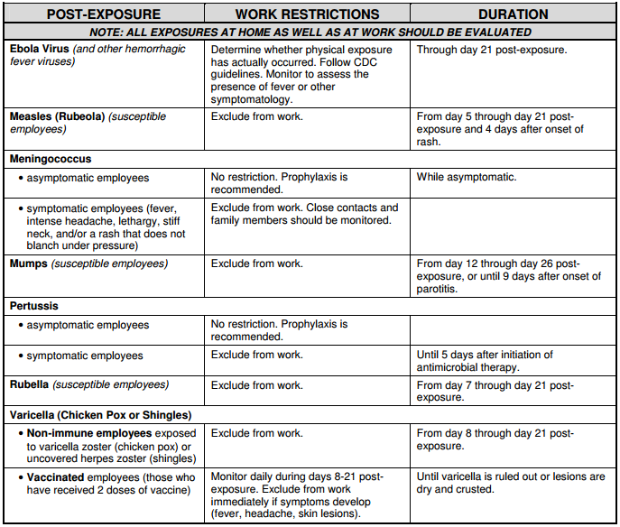

- Employees who have an infection or a communicable disease must call _________________ (indicate the name of responsible person) at the clinic to inform of active disease. Refer to table below for suggested responses.

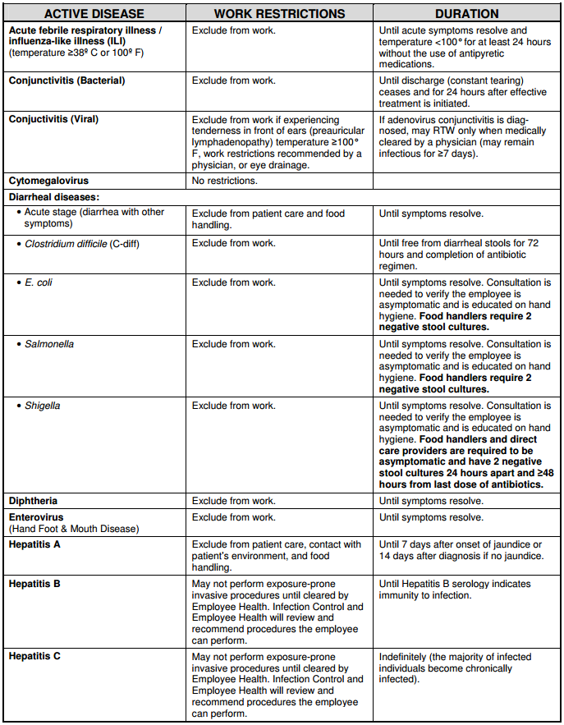
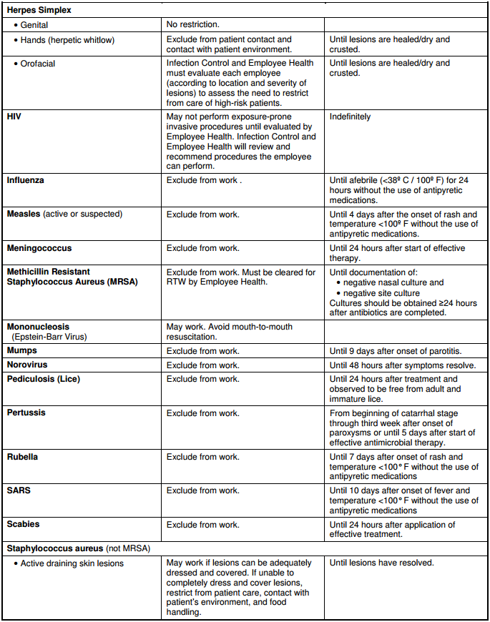

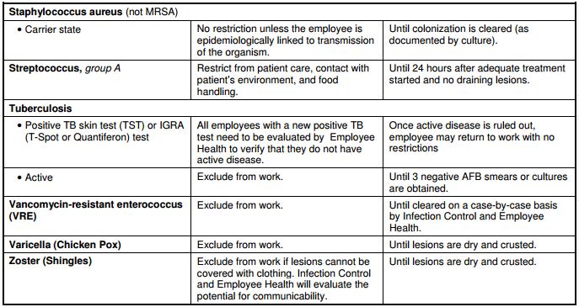

- All employees diagnosed with notifiable communicable disease must be reported to the Medical Officer of Health (MOH) as per the Alberta Health Notifiable Disease List¹.

- Diseases included in the Alberta Health Notifiable Disease List may prompt a Work Exclusion Order issued under the Public Health Act.

References:
- Alberta Health. 2015. Notifiable Disease and Diseases Under Surveillance List, 2015.
http://www.health.alberta.ca/documents/Notifiable-Disease-List-2015.pdf
- Association of Occupational Health Professionals in Healthcare. 2014. Recommended Work Restrictions for Communicable Diseases in Health Care Workers. http://aohp.org/aohp/Portals/0/Documents/MemberServices/templateandform/WR4CD-HCW.pdf
- College of Physicians & Surgeons of Alberta. 2016. General Infection Prevention & Control Assessment.
http://www.cpsa.ca/wp-content/uploads/2016/06/General-IPAC-Standards.pdf?x91570

POLICY & PROCEDURE: Cleaning and Disinfection of Toys
(Standard G.1.1.10)

Date: Approved by:

Purpose: Toys can be a reservoir for pathogenic microorganisms that can be present in saliva, respiratory secretions, feces, or other body fluids. For this reason, it is necessary to ensure that patients and families have access to clean toys that are supplied in clinic waiting rooms.

Policy:

Material and Design of Toys:

Toys that are shared shall be easily cleanable or dedicated to a single child. Toys shall be non-porous, smooth, minimally textured and able to withstand frequent and rigorous cleaning and disinfection. Water-retaining bath toys and stuffed toys shall not be used.

Frequency of Cleaning and Disinfecting Toys and Play Areas:

- Toys and utensils that go into the mouth or that have been in contact with saliva or other body fluids shall be cleaned and disinfected after each child’s use.
- Toys that are not contaminated by body fluids shall be cleaned and disinfected at least daily and when visibly soiled.
- Play areas should be cleaned and disinfected at least weekly and when visibly soiled.

Procedure:

Cleaning and Disinfecting Toys:

- Wash with detergent and warm water.
- Rinse with clean warm water.
- Wipe or immerse in one of the following freshly prepared disinfectant solutions for a minimum of 2 minutes:
- Chlorine solution (bleach) @ 100 ppm. Mix 10 ml (2 teaspoons) household bleach per 5 liters water.
- Quaternary ammonium solution @ 200 ppm. Follow manufacturer’s instructions for mixing correct dilution and contact time.
- Accelerated hydrogen peroxide solution @ 0.5%. Follow manufacturer’s instructions for mixing correct dilution and contact time.

Indicate name of solution, concentration, and contact time used:
_____________________________________________________________
- Rinse to remove disinfectant with clean warm water.
- Air dry.
- Store in a clean, labeled bin or area that is separate from used toys.

References:
- Alberta Health Services Environmental Public Health. 2014. Health and Safety Guidelines for Child Care Facilities. http://www.albertahealthservices.ca/assets/wf/eph/wf-eh-health-safety-guidlines-child-care-facilities.pdf
- College of Physicians & Surgeons of Alberta. 2016. General Infection Prevention & Control Assessment. http://www.cpsa.ca/wp-content/uploads/2016/06/General-IPAC-Standards.pdf?x91570
- Infection Prevention and Control Canada. 2011. IPAC Canada Practice Recommendations: Toys.
http://www.ipaccanada.org/pdf/Toys%20Practice%20Recommendations%202011%20-%20R2014.pdf

POLICY & PROCEDURE: Cold Chain Management of Vaccines
(Standard G.1.1.11)

The College of Physicians & Surgeons of Alberta IPAC Program collaborated with the Alberta College of Pharmacists and the College & Association of Registered Nurses of Alberta to standardize cold chain management of vaccines in community health care. Policies and procedures for cold chain management should align with the Guidelines for Medication and Vaccine Injection Safety published on the IPAC Program webpage for General IPAC: http://www.cpsa.ca/ipac/general-ipac/.

For assistance, contact the IPAC Program at 780-969-5004 or ipac@cpsa.ab.ca.

POLICY & PROCEDURE: Medical Device Reprocessing
(Standard G.1.1.12 and M.1.1)

Template policies & procedures for medical device reprocessing can be found in the MDR Toolkit available on the IPAC Program webpage:
http://www.cpsa.ca/ipac/

For assistance, contact the IPAC Program at 780-969-5004 or ipac@cpsa.ab.ca.

