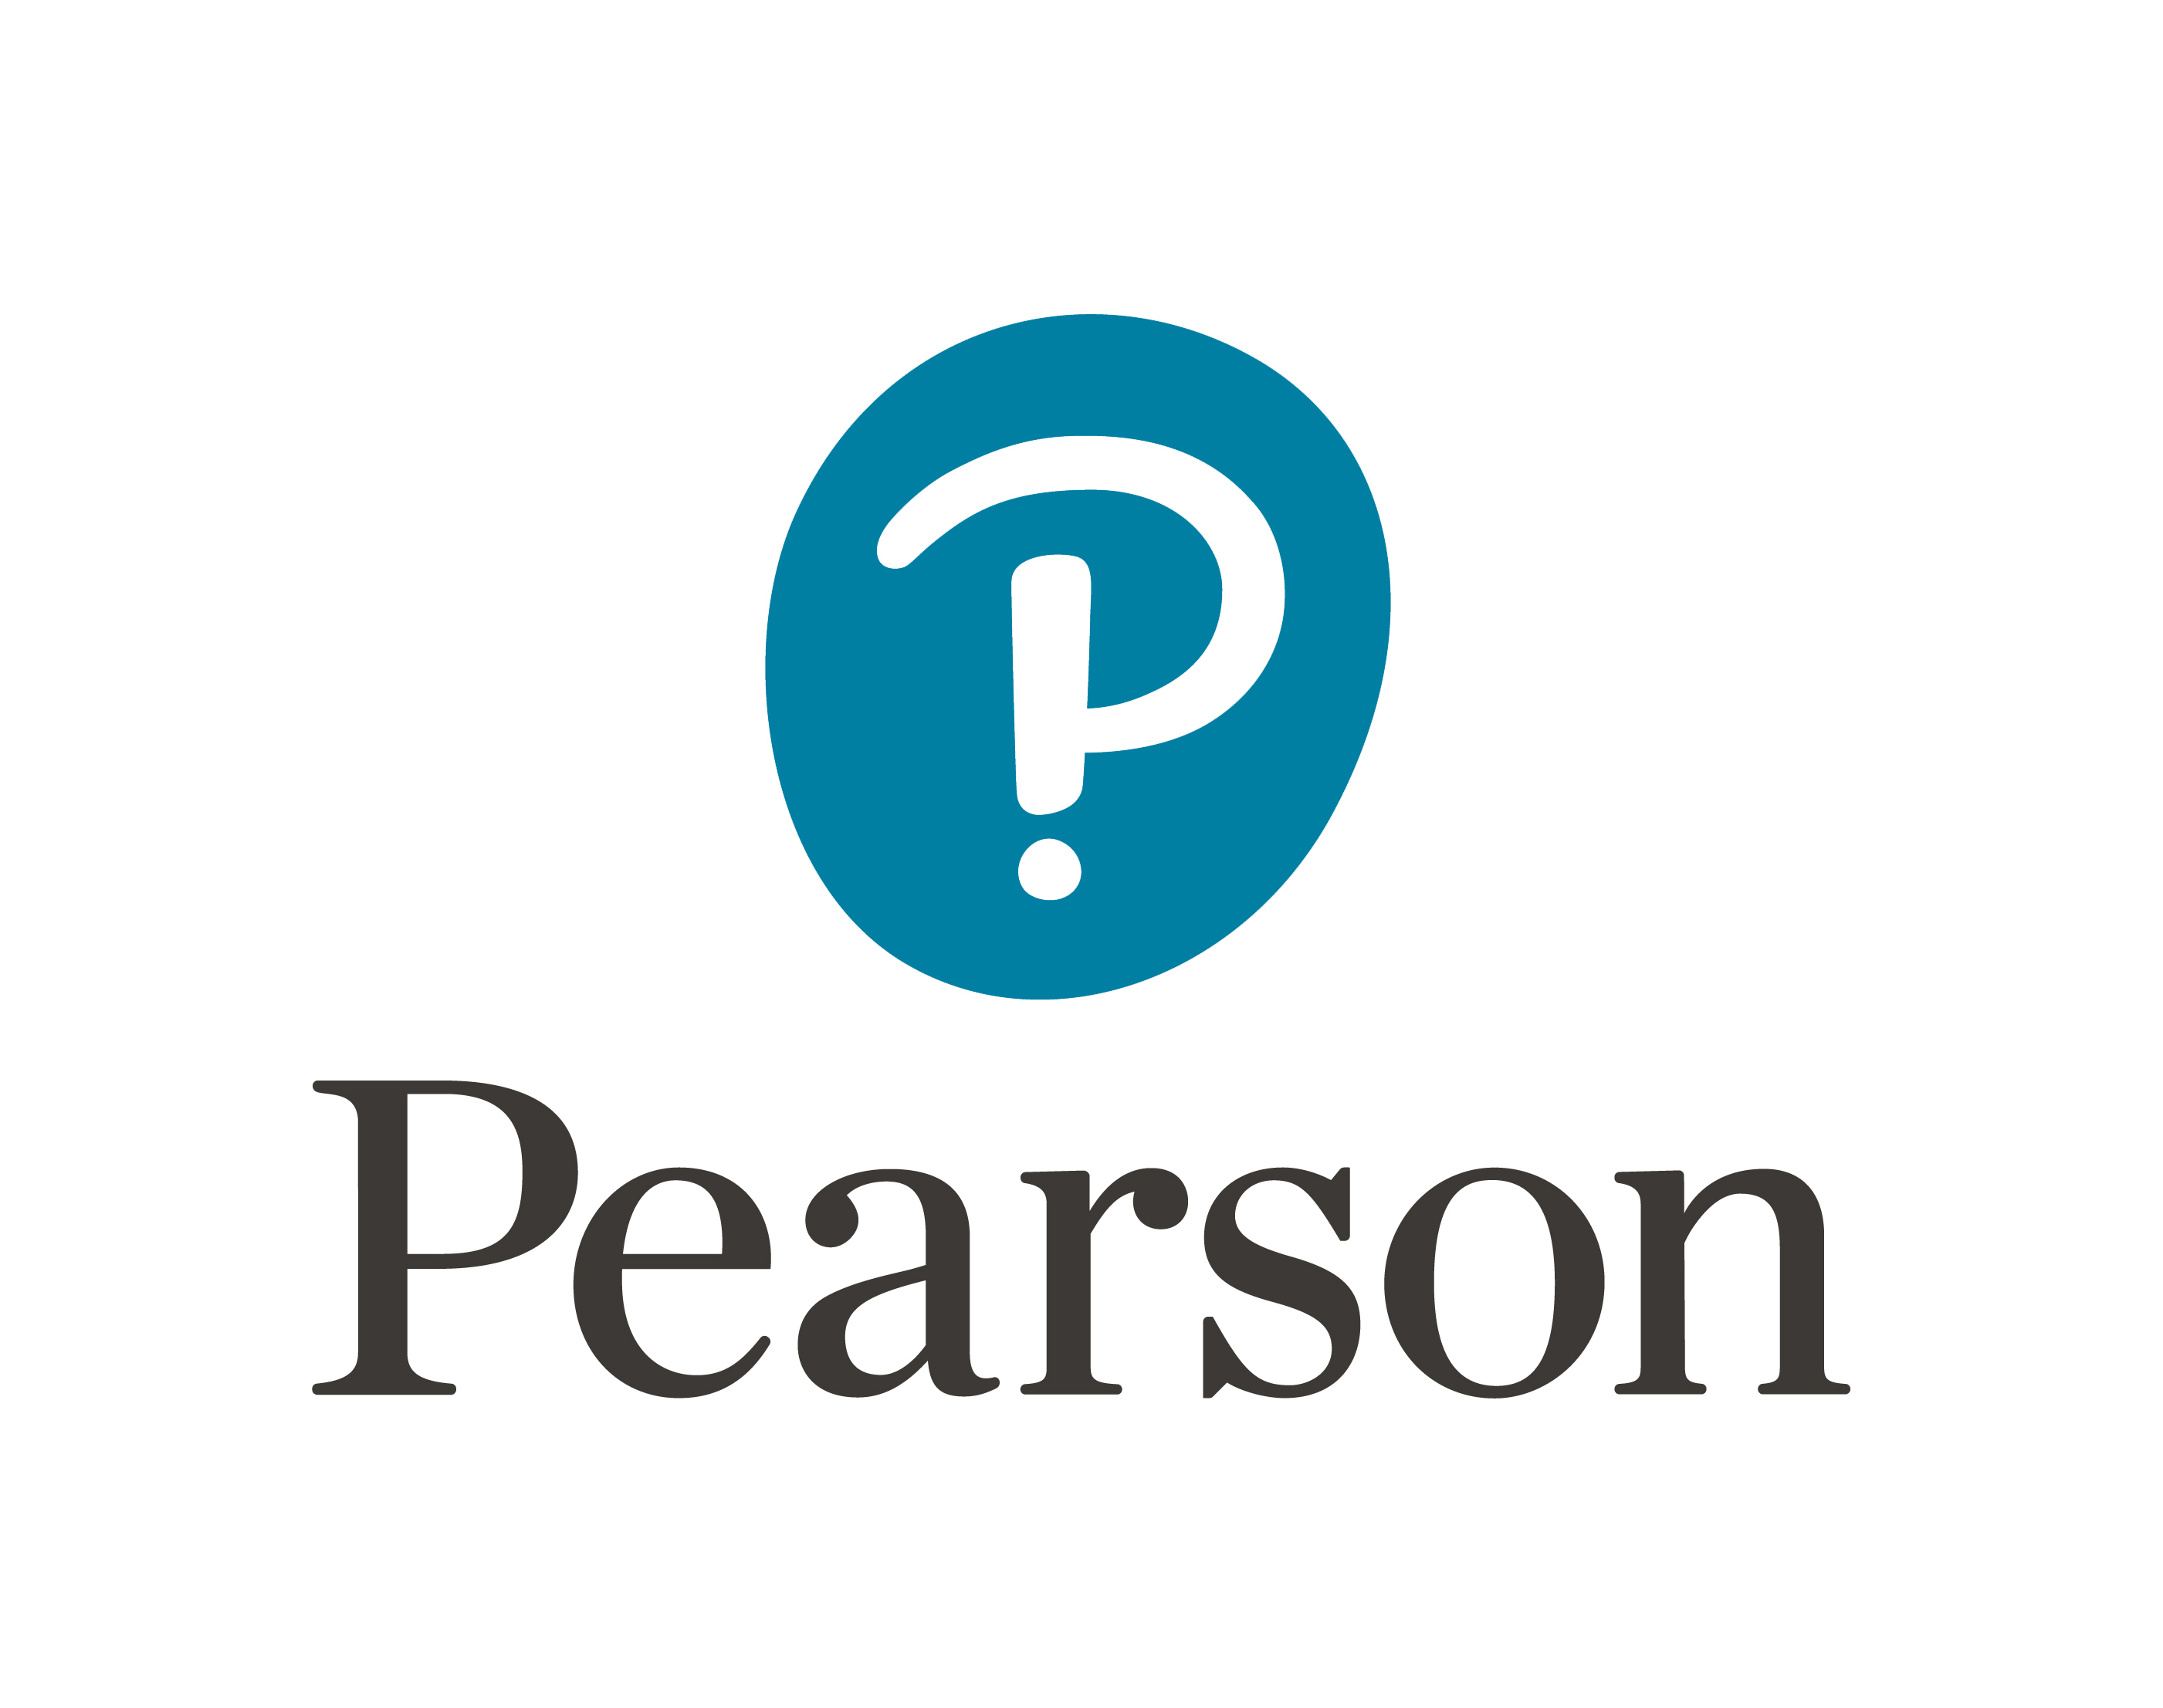

Pearson Quality Nominee Resource

Template for policy and procedure review log

This document is intended to provide a template that may be used to capture an overview of all policies and procedures within a centre

Th​is QN support resource is an example template and its use is not required by Pearson. It has been developed​ by the Pearson Vocational Quality Advisor​s in response to feedback from our Quality Nominee​ community​ to be used solely as support material

Template for policy and procedure review log

Name of Policy | Version No | Approved to Date | Planned Review Date

