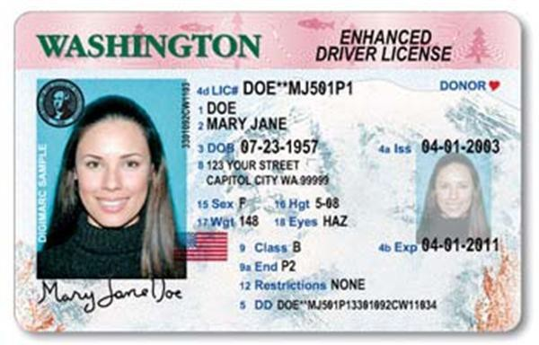

**Authorization of Temporary Guardianship:**

I, **(parent’s name)** the Parent of **(child’s name)** hereby grant temporary guardianship to **(guardian’s name)** for the period from the day of 20 and expiring

on the day of 20 .

I also approve of my Child participating in the **(event name)** on

**(date)**. I authorize the Temporary Guardian to act on my behalf in making all

decisions on a daily basis as to the Child's activities.

**SIGNATURE**

**DATE**

Please attach copy of PARENT ID with signature:

**PARENT INFORMATION**

**TEMPORARY GUARDIAN**

Full Name:

Full Name:

Phone:

Phone:

Email:

Email:

**CHILD INFORMATION**

Full Name:

Example of ID w/ Signature. Can be included in separate document.