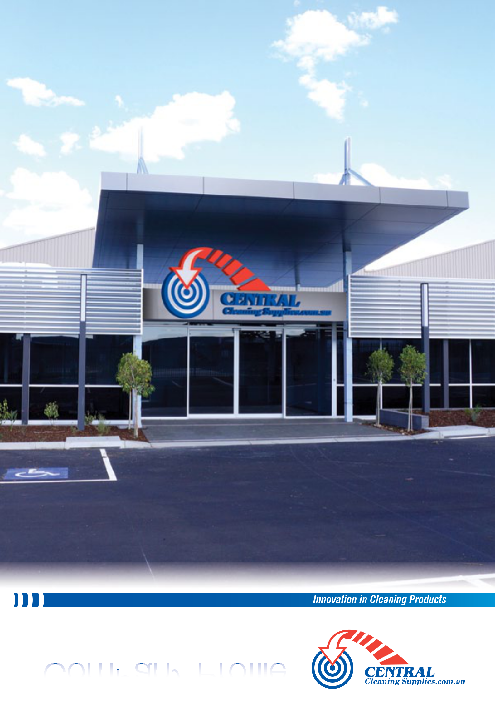

Company Profile
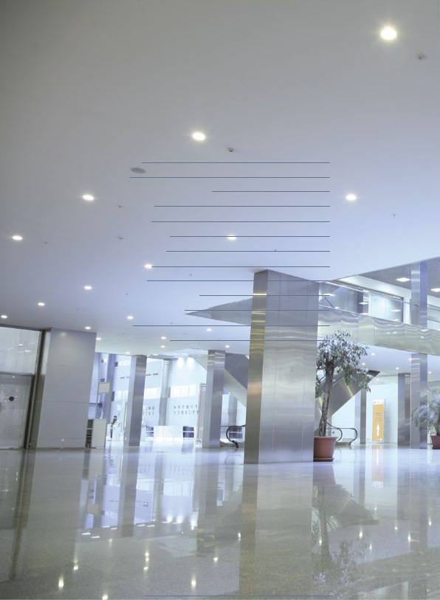

Index

Introduction | 3
Our Aim | 4
Corporate Social Responsibility | 5
Product Range | 6
Brand Names | 6
Support & Services | 7
Risk Management | 8
Environmental | 10
Sustainability | 11
Warehousing & Distribution | 12
Distribution Experience | 13
Contacts | 15
Further Information | 17

Central Cleaning Supplies Company Profile 2



Introduction

Central Cleaning Supplies (Aust) Pty. Ltd. (CCS) is one of the nations largest distributors of Cleaning Materials, Chemicals, Paper Products and Equipment.

For the past 28 years, CCS has provided an extensive range of innovative products and services catering for the Professional, Commercial, Industrial and the Domestic cleaning industry.

With over 60 staff, CCS has successfully established wholesale and retail outlets nationwide to accommodate small and medium sized cleaning companies.

Our long established client base reads as the industry who’s who.

Individual client expenditure with Central Cleaning Supplies (Aust) P/L. ranges from $1M+ per annum to $200 per month. This represents a diverse set of client requirements and service delivery processes.

Our success is primarily based on customising client requirements to create true commercial value for the client. This fundamental principal drives high client loyalty and in turn focuses our joint attention towards:

- Reducing Client Procurement Costs

- Reducing Client Transaction Costs

- Improving Client Labour Productivity

- Improving Client/End User Relationships

Central Cleaning Supplies Company Profile 3

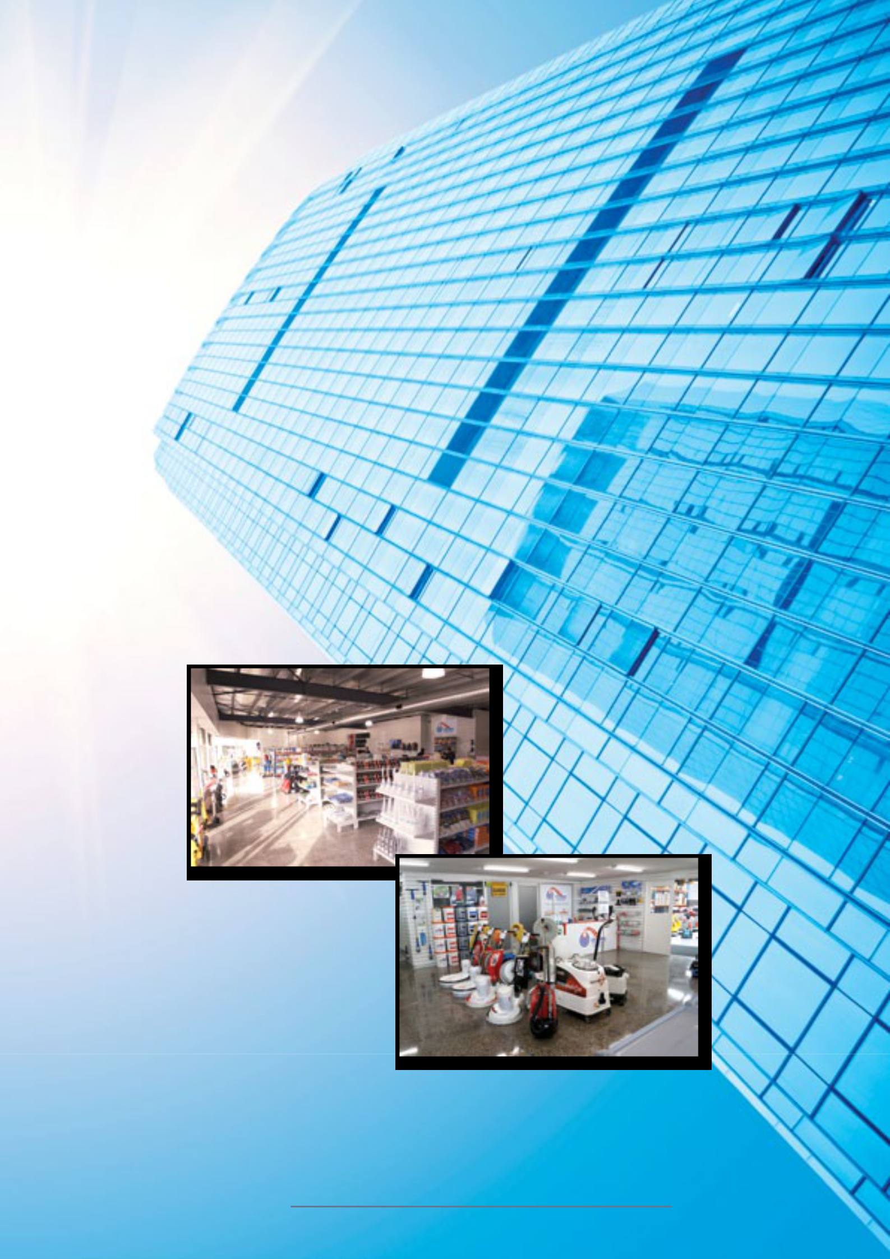

Our Aim

Our aim is to increase our overseas buying to provide you, the customer, with excellent products at great prices, keep growing and to open new distribution points around Australia and become the largest independent cleaning supplier in Australia.

Our goal is to simplify the lives of our customers.

We understand that our customers are judged by the highest standards of quality and service. The facilities they care for are expected to be hygienic and environmentally sound - an ever-changing, never-ending challenge. We, the people of Central Cleaning Supplies promise to be a full partner in helping our customers meet and exceed these expectations.

Central Cleaning Supplies Company Profile 4



Corporate Social Responsibility

Central Cleaning Supplies is a Melbourne Head Office Company that operates a Cleaning and Consumable Supply business servicing the cleaning, health, education, hospitality and government sectors and understands its role as a medium sized employer operating with its footprint in multiple states, that it must take an approach to business that is not only focussed on the delivery of a profit to its shareholders, but must incorporate, broad based economic, ecological and social factors.

Central Cleaning Supplies sees its role as being a contributor to the community on a scale that is possible from a company that has an extensive client base and a consequential capacity to influence people to make good choices for the country when selecting cleaning equipment and supplies. It has the financial and community ties to be able to assist groups who might otherwise remain hidden and isolated, unable to gain opportunities readily available to mainstream and establish members of society.

As major supporters of the cleaning and property services sector and are extremely interested in the promotion of good environmental choices by our customers. We offer alternative product that has a beneficial impact on the environment, low Volatile Organic Compounds, recycled and recyclable products, equipment that is supplied with the view that it lowers energy consumption in the usage cycle, extensively filters particles released into the air, etc.

Joe and Central is a member of the Building Services Contractors Association as a member and sponsor so that the company has the opportunity to influence the professionalization of the cleaning sector, supporting industry events that educate members and enhances competition, which in turn encourages industry participants to strive to be more professional and use more ecologically sustainable product. The social benefits have included the Managing Director, Joe Camilleri having facilitated many start up businesses in the cleaning sector, by offering interest free terms on capital equipment, personal mentoring to young people in the cleaning sector, arranged professional coaching for clients who could otherwise not afford such services and

Central Cleaning Supplies has grown over its 28 year history from humble beginnings in North Melbourne and in that time has continued to ensure that it complies with its legal and financial obligations to the community.

Central Cleaning Supplies Company Profile 5

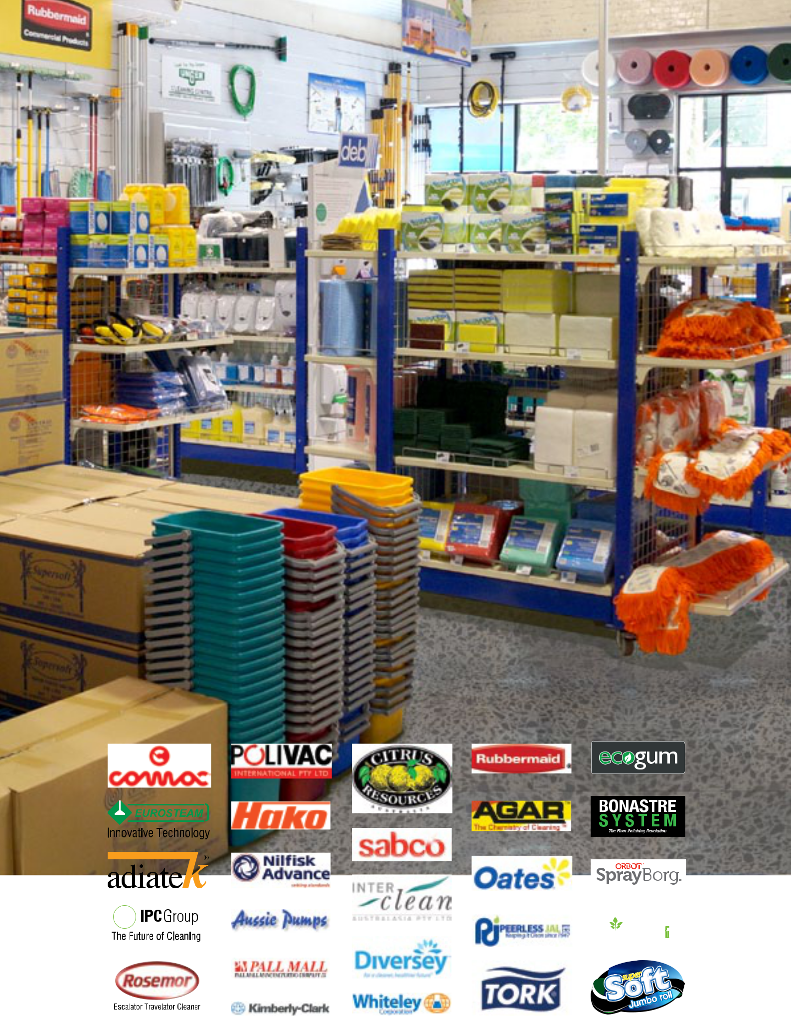

Product Range

We stock over 6,000 line items across 5 distinct product groups.

The groups are:

Materials | Equipment
• Cloths | •Vacuum Cleaners
• Wipes | • Scrubbers
• Brooms | • Polishers
• Mops | • Ride-On Units.
• Buckets | Sundries
• Bin Liners. | Sundries
Chemicals | • Brushware
Chemicals | • Accessories
• Concentrates | • Parts
• Hard & Soft Surface | • Applicators.
• Dispensers.

Paper

- Facial Tissue

- Toilet Rolls

- Towels

- Dispensers.

Brand Names

ULTIMATE 1.0
eco-mat

URINAL DEODORISER/CLEANER

Central Cleaning Supplies Company Profile 6

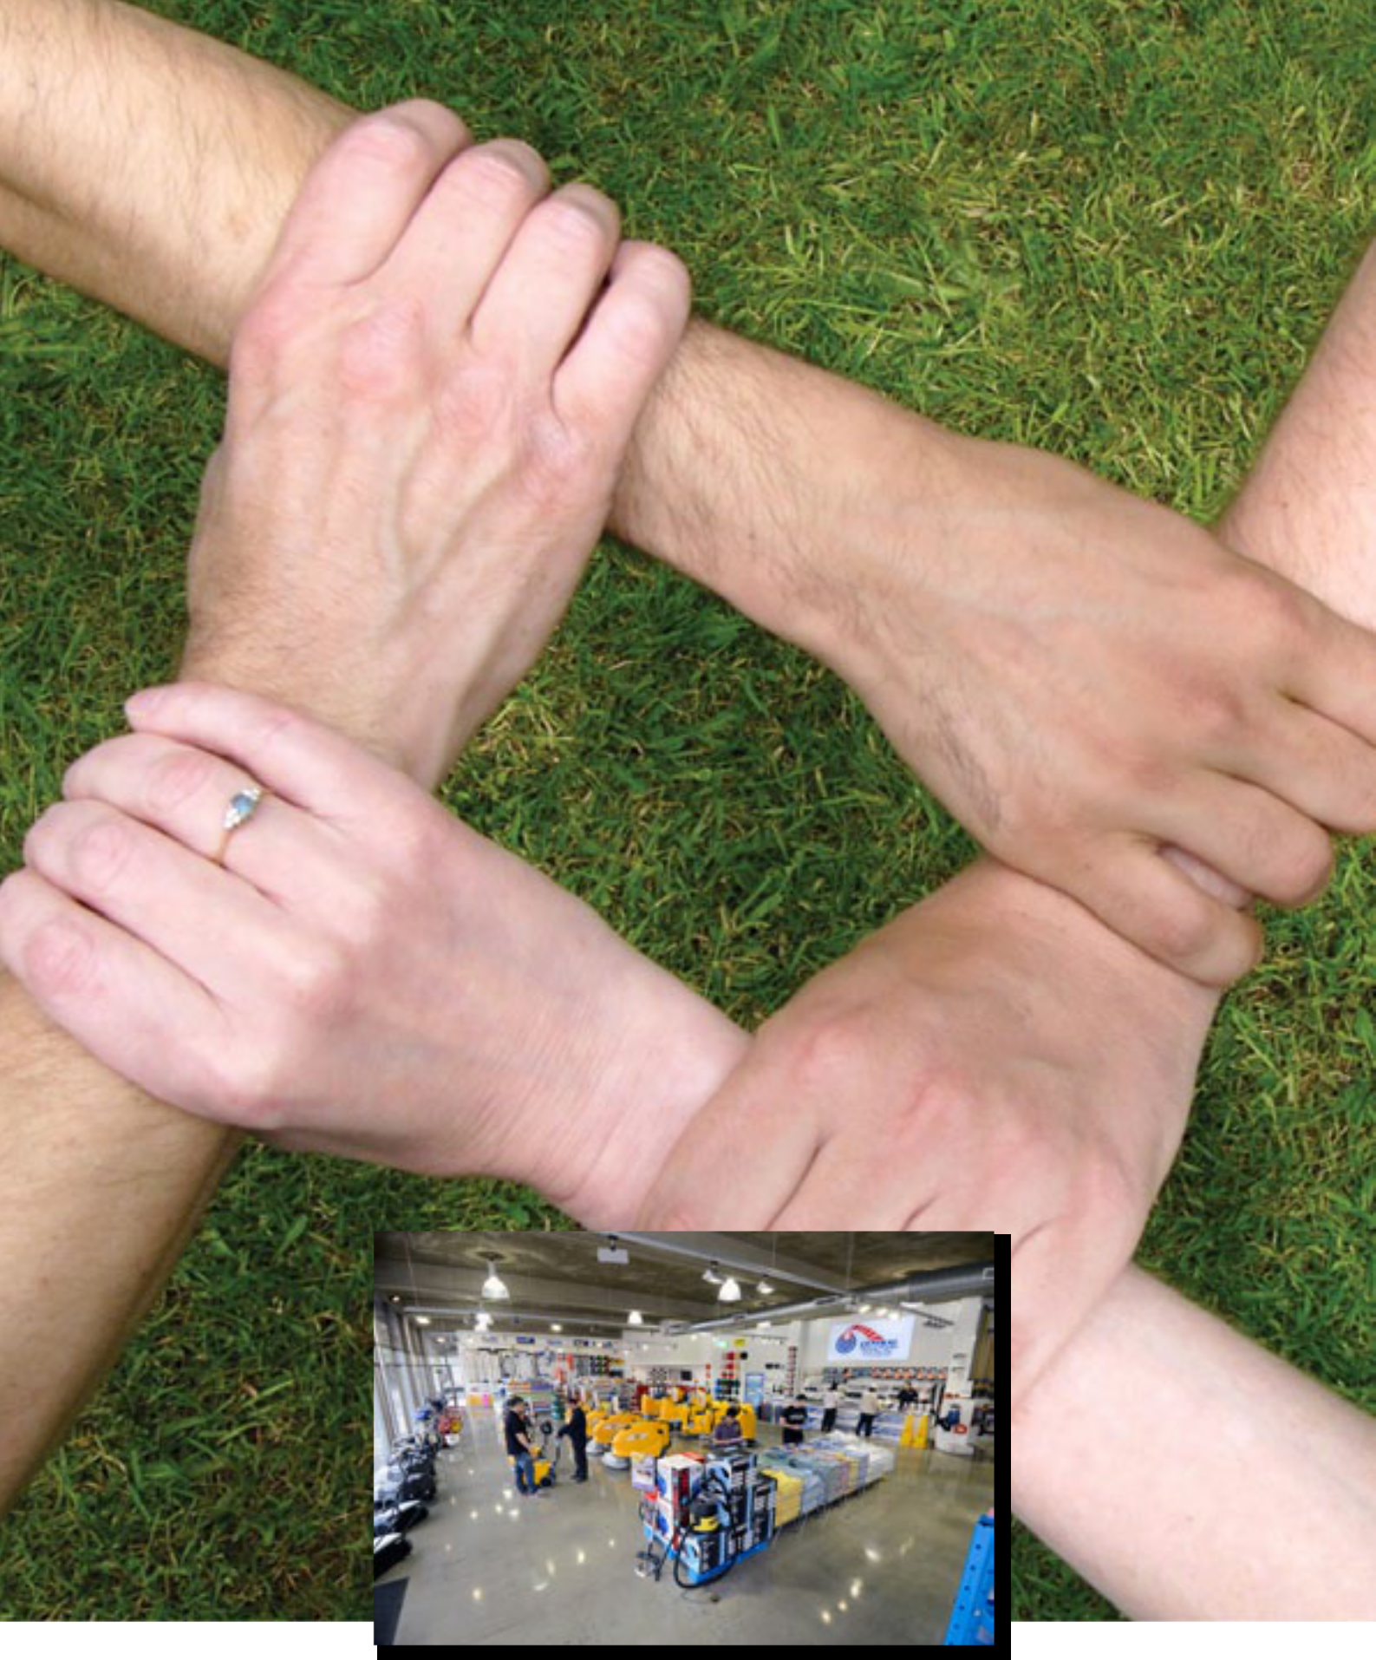

Support & Services

CCS boasts the ability to deliver the full set of pre and post sales support services required to make a true difference to your business and service delivery needs. We don’t just sell products. We support every sale with realistic advice and information aimed at improving labour productivity and reducing your overall cost base. Our Staff will assist your Staff in new innovations being released onto the market and provide information regarding these products.

Some of our more popular services include:

- Accredited Equipment Warranty Services

- Equipment Rental - short and long term

- Field and Workshop Equipment Remedial and

Preventative Maintenance 24 hours 7 days per week.

- Fully Comprehensive Maintenance Agreements.

- Asset Management Facilities

- Financing Arrangements

- Account Management

Central Cleaning Supplies Company Profile 7

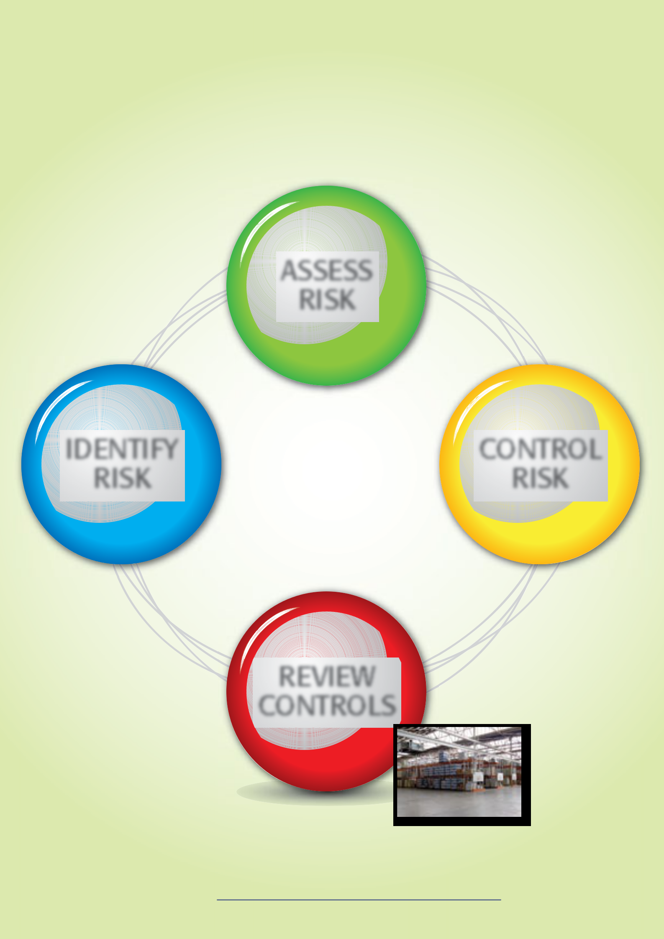

Risk Management

In today’s economicconditions, managing risk and compliances is becoming a greater burden on more and more cleaning contractors and providers. AtCCS, we_{ASSESS}understandthese issues and have, under construction, a series of systems designed to minimize your risks.

The types of information andRISKassistance we can provide includes:

- Access to Material Safety Data Sheets (MSDS) delivered with all chemicals.
- Splash resistant chemical dispensing units.

- Specialised equipment training and related OH&S compliance.

- Environmentally friendly cleaning agents and systems.

• Quality accredited supply chain infrastructure.

• Extensive procurement reporting and analysis from our IT system.

IDENTIFY | Quality Practices | CONTROL
Central Cleaning Supplies is a company committed to ensuring that
RISKall of the processes weRISK_{MANAGEMENT} |  | RISK
 | follow are designed to deliver a high quality

outcome for the clients and the industry in general.

The cleaning industry PROCESSisoftenconsideredtobe an industry that is unprofessional and that people who work within it are not well educated and fail to deliver on what they say.

Central Cleaning Supplies is committed to a professional cleaning and hygiene services sector that delivers on what it says it can.

That is why we operate the way we do. Every activity is focussed on the delivery of a quality outcome. Our processes are founded on the framework of ISO 9001 with a focus on excellence as the heart of it.
REVIEW

Our business is operated on the basis of our capacity to be able to accomplish our committed_{CONTROLS}activities.

- We buy from reputable manufacturers and agents that through their own quality control measures can assure us that what we sell will work.

- We seek external advice on Industry best practice.

Central Cleaning Supplies Company Profile 8

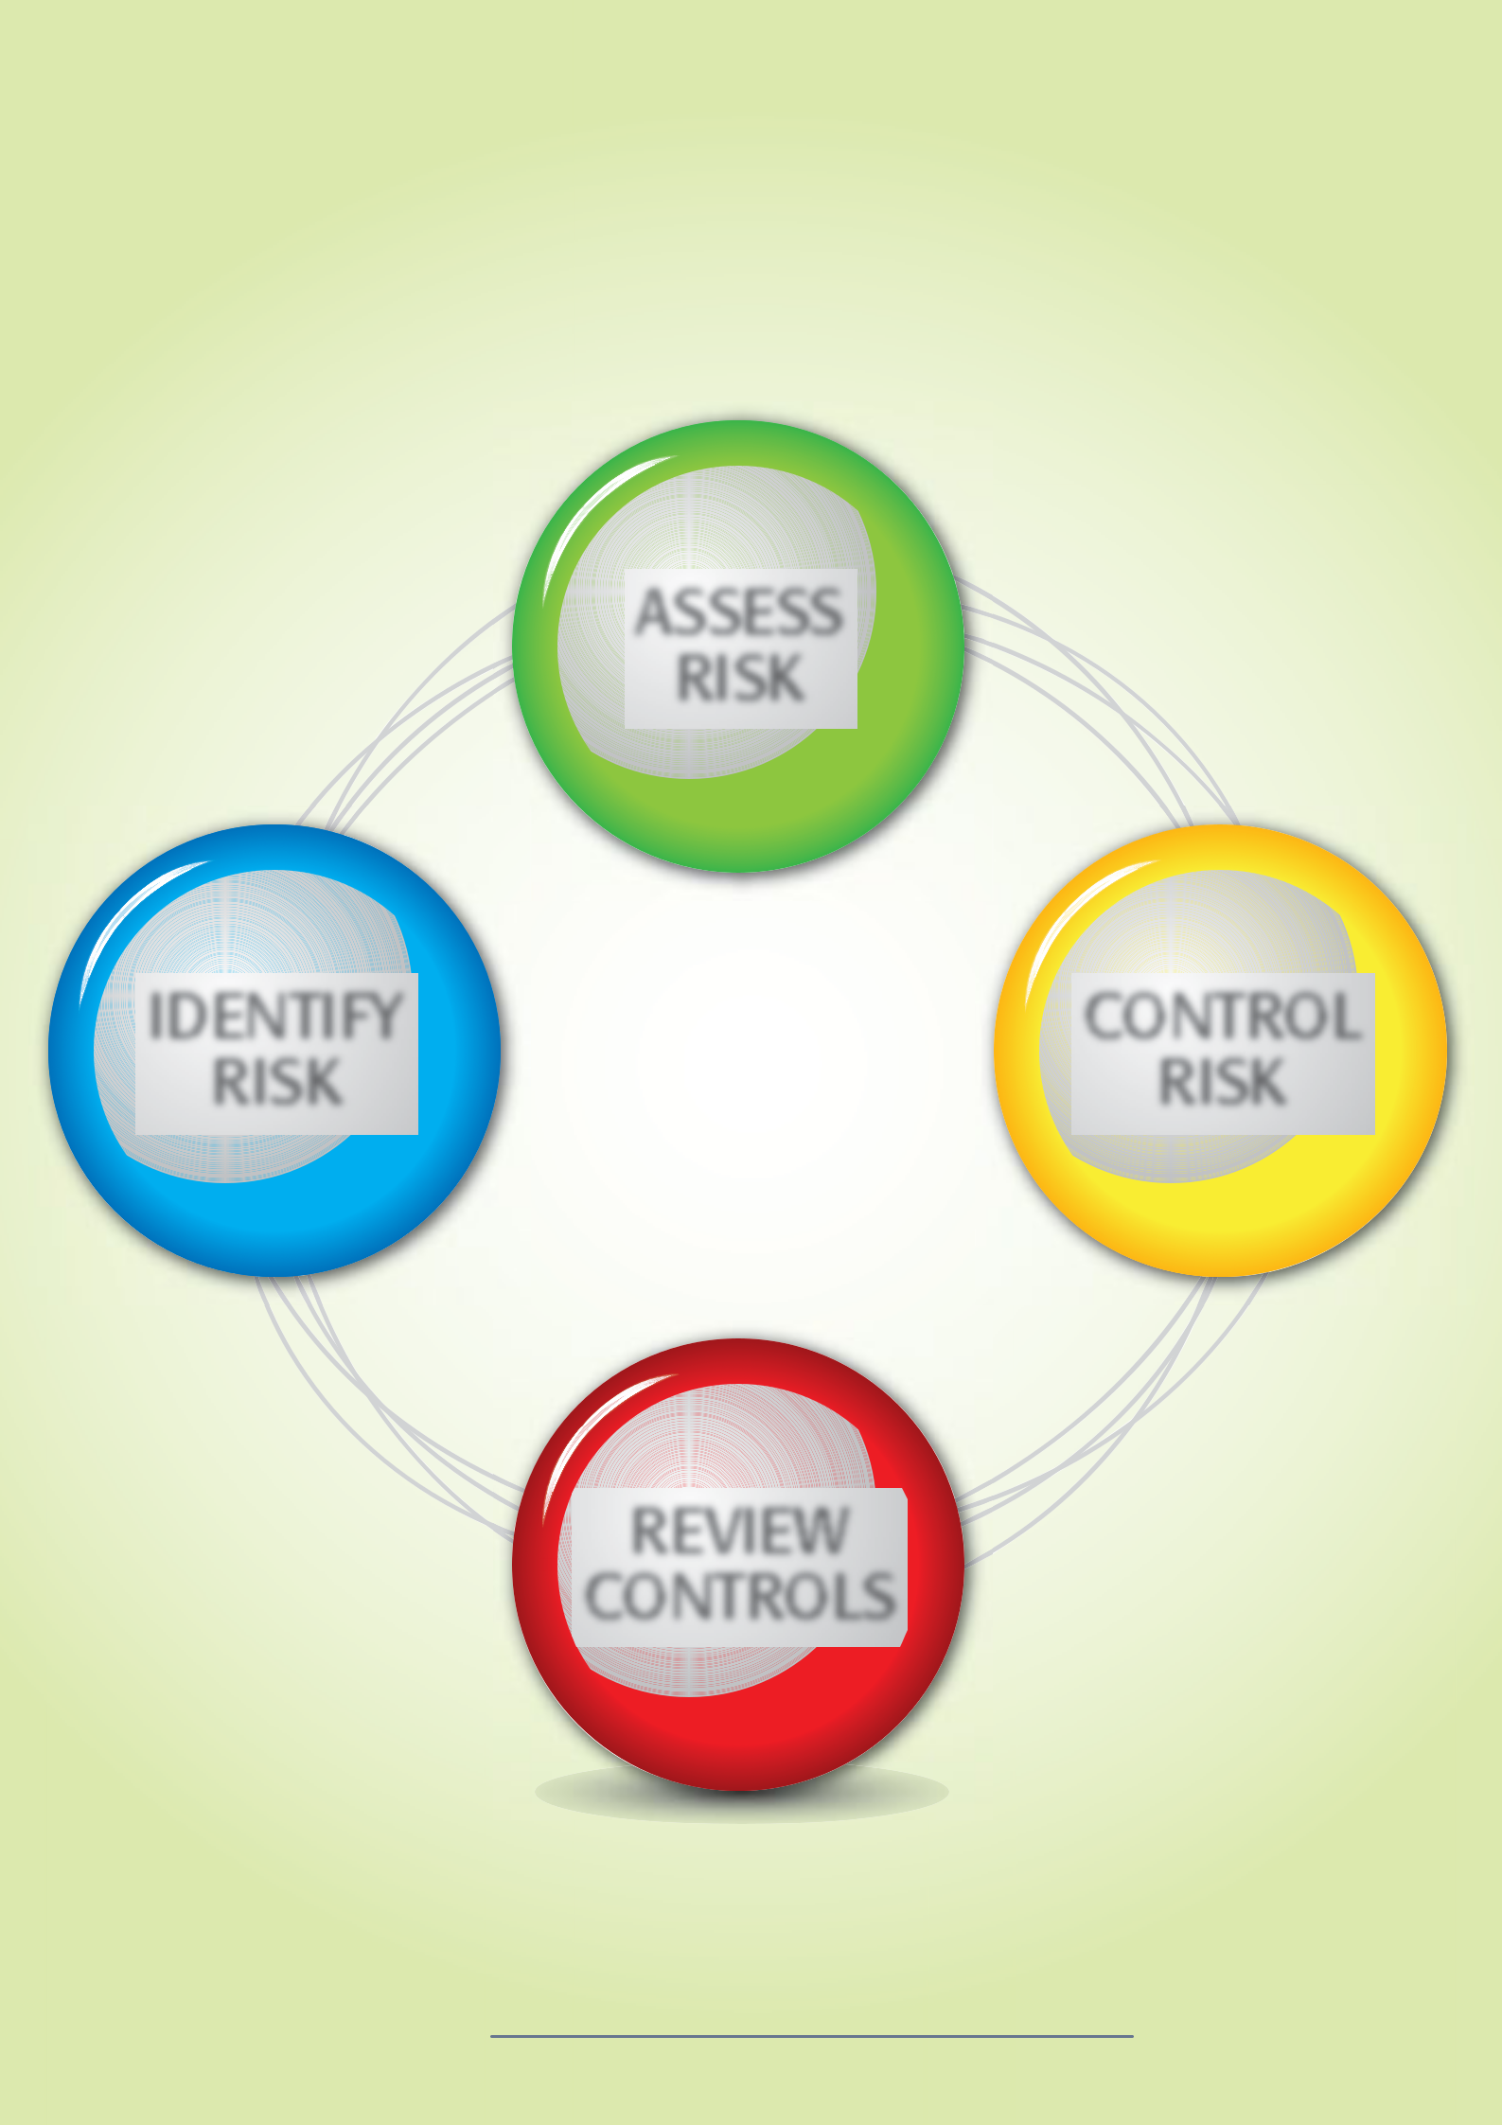

Risk Management

• We commit to achievable time frames for our clients that can be

met. We often meet _{ASSESS}theimpossibleand in 98.65% (FY 2011/12) of cases meet our committed targets. As soon as a service fault is identified it is investigatedRISKandaloop closed to as far as practicable.

• We engage our staff in training activities and encourage them to undertake a combination of professional and personal development and fund these activities upon successful completion

• We continually review the business with restless discontent, always striving for a marketable edge that is based on ensuring that quality is the most outcome our clients seek.

IDENTIFY | IT Support |  | CONTROL
Central Cleaning Supplies has developed websites that allow you
account balances and view invoice history.
RISKto place orders, viewRISK_{MANAGEMENT} |  |  | RISK

The website uses the latest security technology to safeguard your information. _{PROCESS}

We have two models available from the basic to the advanced this allows multi-level approval, the person who places and the person who has the right to approve. Depending on your structure, the website will email the supervisor of the site to approve, amend or delete.

- Our IT system can generate a recurring order for products ordered on a regular basis, either weekly, fortnightly, monthly or as required
- Multiple sales orders for a customer can optionally generate a

single invoice.

• Purchase Orders are received electronically through a database or direct into a file. REVIEW

• Comprehensive sales history and sales analysis reports on a ‘per site’ can be generatedCONTROLS.

• Customer Profile Order Entry displays up to 12 months of sales history (and more) for each product enabling more proactive order taking.

• Quotes are produced by an innovative sub-system that automatically generates a Sales Order once quote has been accepted.

Central Cleaning Supplies Company Profile 9

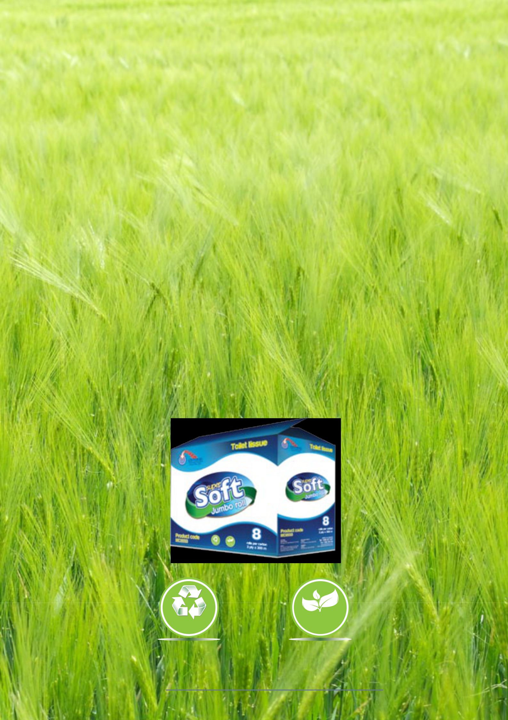

Environmental

Our goals are to provide services that are safe and environmentally sound, conduct our operations in an environmentally responsible manner and create health and safety practices and work environments that enable our employees and customers to work injury free.

Our company works with employees, suppliers and customers to protect and enhance the environment. We pride ourselves with being environmentally friendly with a variety of products which are biodegradable and carbon neutral etc. We uphold the principals and fully recycle all our packing materials and we also use minimal packaging when shipping our products.

In addition, we are constantly striving to research and work with renewable and biodegradable materials. Our Super Soft Toilet Tissue products are made from 100% Recycled paper. Our suppliers that provide us with chemicals and bin liners are constantly providing us with new environmental products to pass onto our customers, which is beneficial to all concerned that become partners with us. New GREEN products and BIODEGRADABLE products are stocked by us at all times.

Environmental
Recycle Friendly

Central Cleaning Supplies Company Profile 10

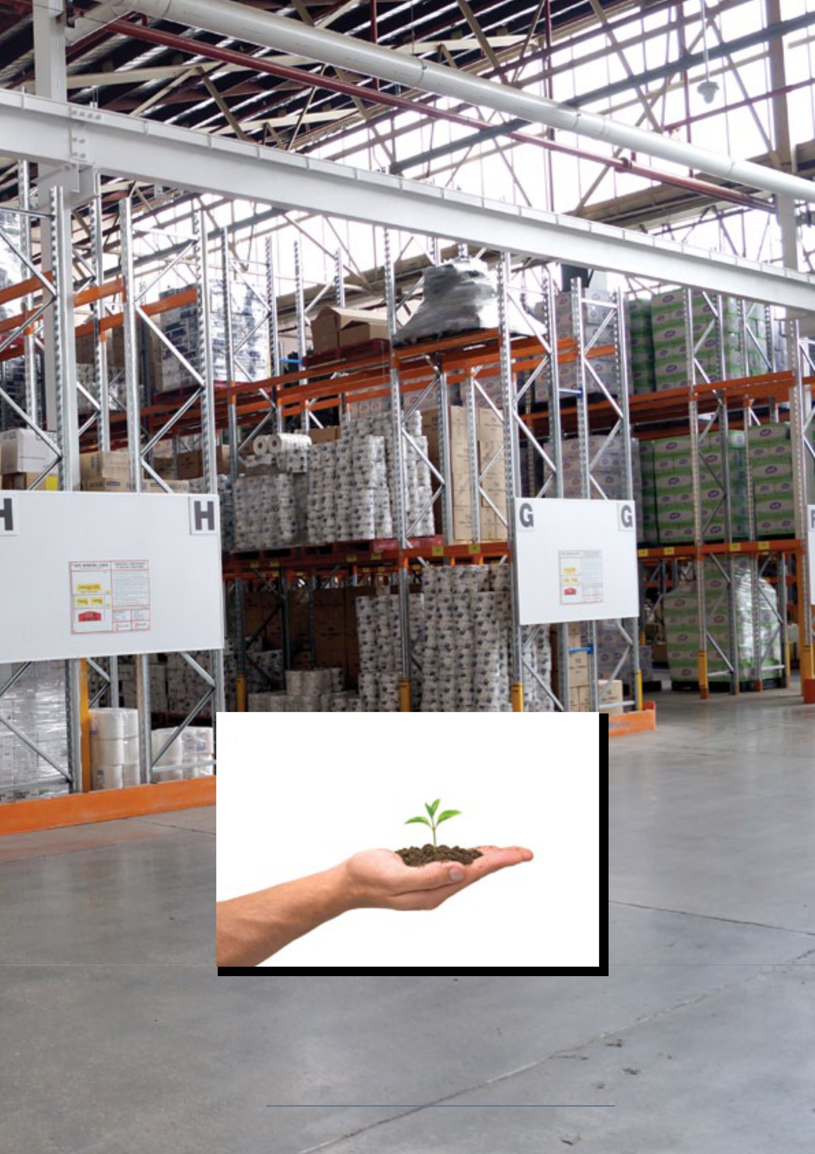

Sustainability

Central Cleaning Supplies is continually searching for ways to reduce the environmental footprint, without compromising service delivery. Our Environmental Policy provides a systematic approach for environmental management across the business, having regard to sustainability, preventing pollution and continual improvement in environmental performance.

Specifically, we aim to minimise any impact on the environment by:

- Promoting environmental awareness and providing the resources and information amongst suppliers, contractors and partners to improve environmental management resources

- Using our natural resources efficiently including minimising, reusing and recycling waste to the extent practicable

Central Cleaning Supplies Company Profile 11

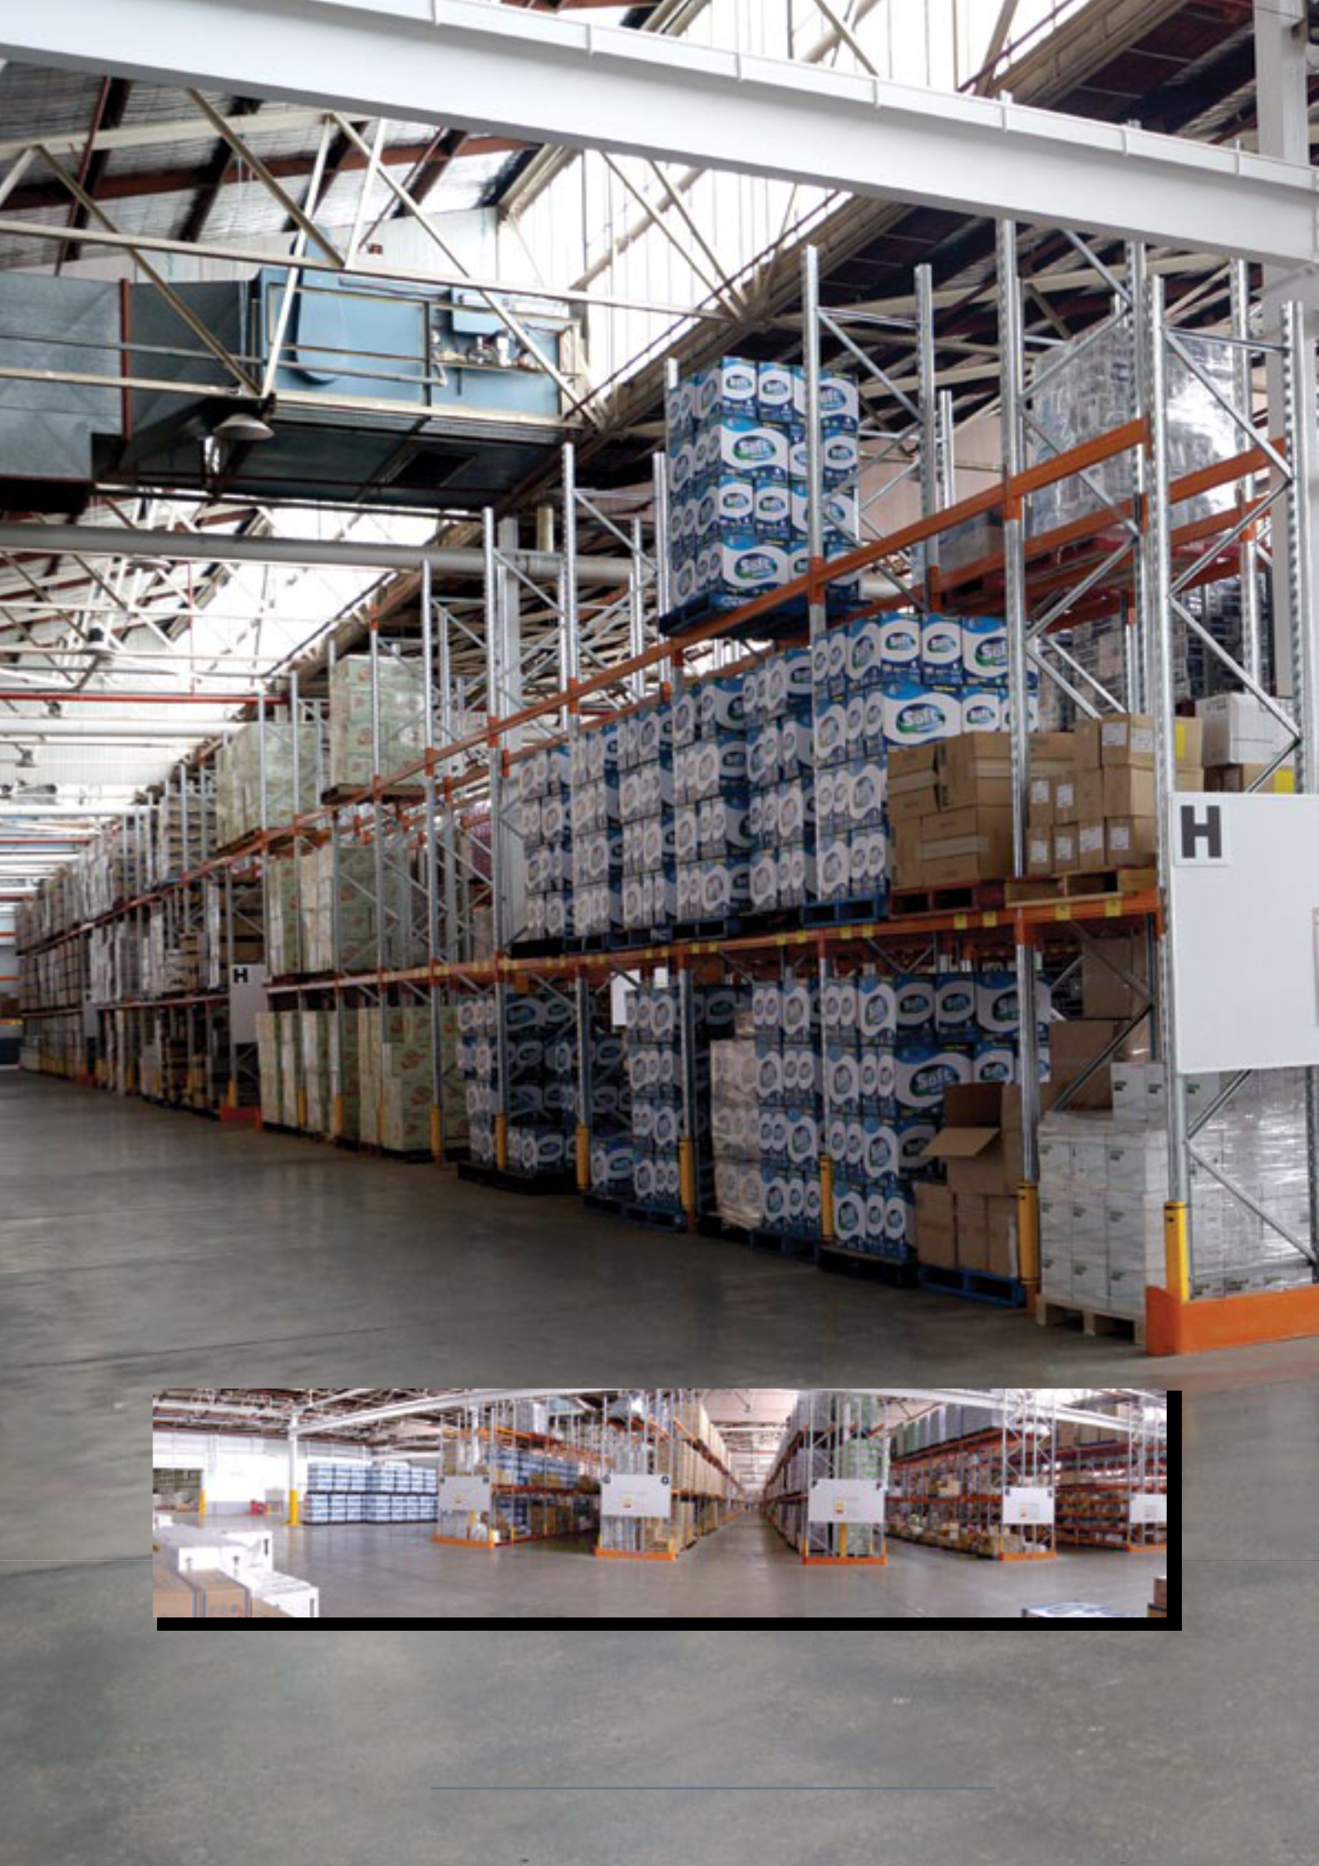

Warehousing & Distribution

Our distribution network is extensive and covers all areas of Australia. Distribution is facilitated through multiple warehousing and retail outlets.

We have warehouse facilities in Melbourne, Albury and Sydney. Using these geographical points we can guarantee goods will be delivered on time and reduce any unforseen back orders or down time.

The Freight Services we provide and/or use are TNT Transport, Fastway Couriers, Aussie Freight, WA Freight & Toll Ipec for all interstate and Country Deliveries. We use our own trucks for Metro Melbourne and Tasmania Deliveries. All deliveries from Albury use Fastway Couriers and Sydney use Toll Ipec.

The Albury facility is a state of the art 30,000 pallet warehouse. Using RF Barcode racks and the Paperless Warehouse Management System used by many multi- national companies.

Deliveries are carried FIS and expected delivery time frame is within 24 to 48 hours from when orders are placed for VIC, NSW, QLD,

- hours + for NT and WA. Urgent, unforseen orders will be dealt with fast and efficiently within the same time frame or sooner, Monday to Friday and if required, weekend deliveries can also be carried out.

All products and equipment are insured for delivery and are guaranteed to arrive on time and in perfect condition.

All stock items from initial order will be maintained on hand with the minimum two (2) months at all times.

Central Cleaning Supplies Company Profile 12



Distribution Experience

Our experience covers the following “Start-Ups” and “On-Going” delivery distribution.

- NSW Government Schools Cleaning Contract - 1998 -1999/2008 - Current

- Coles Myer, Target, Safeway/Woolworths, IGA, Action Supermarkets,

Foodworks - Australia Wide (cleaning contractor) - 2003 - Current

- Westfield Shopping Centres - Australia Wide - 2004 - Current

- Vincinity Centres - Australia Wide - 2004 - Current

- Sydney International Terminals 1 & 2 - 2012, Cairns International Terminal

Bldg. 2011, Adelaide Domestic Airport - 2005, Tullamarine Airport - 2012,

Qantas Terminals/Maintenance & Freight - WA, NT, TAS & VIC - Current &

Darwin Airport - Current

- Commonwealth Banks throughout VIC, SA, NT & NSW - 2006 - Current

- Myer Stores & Distribution Centres - Australia Wide - 2007 - Current

- Westpac Bank Branches throughout Victoria & NSW - 2007 - Current

- Etihad Stadium - Docklands 2007 - Current

- David Jones Stores & Distribution Centres - Australia Wide - 2008 - Current

- ANZ Banks Australia Wide 2009 - Current

- National Australia Bank throughout NSW, QLD, SA & VIC 2009 - Current

- Australian Federal Police/Customs Sites - Victoria 2009 - Current

- Energex Sites - QLD 2009 - Current

- Melbourne Cricket Ground (MCG) - Victoria 2010 - Current

- Crown Casino - Melbourne 2011 - Current

- Police Stations - Victoria wide 2011 & Western Australia- Current

- University of Western Sydney - 2012 - Current

- Medicare Offices throughout Victoria, QLD & NSW - Current

- Exxon/Mobil Head Office and Refineries - Victoria & SA. - Current

- Ford Motor Company - Victoria - Current

- Australian Red Cross - Current

- Treasury Department Buildings - Victoria - Current

- Sports Stadiums, Football Arenas, Aquatic/Leisure Centres - Australia Wide

  - Current

- Harvey Norman Stores - Australia Wide - Current

    - MetLink Transportation Melbourne Metro, Incorp. Flinders St. Station &

Southern Cross Station - Current

Central Cleaning Supplies Company Profile 13



Distribution Experience

- Melbourne & Victoria Universities, Kangan Tafe, RMIT, Monash, LaTrobe & Swinburne Universities - Current

- Australia Post - Australia Wide - Current

- Western, Melbourne & Barwon Health Services (Hospitals) - Victoria -

Current

- Centrelinks - Victorian Metro and Country - Current

- AUSGRID/STA - New South Wales - Current

- Railcorp - New South Wales - Current

- Defence sites - Victoria, Northern Territory, Western Australia, Nauru &

Manus Islands - Current

The above are only a few that CCS have been involved with and continue as a major distributor. We have the smaller Cleaning Contractors’ needs in delivering to sites, which range from Banks, Government Buildings, Public/ Private Schools, Retail/Business outlets down to Restaurant and Cafes.

Central Cleaning Supplies Company Profile 14

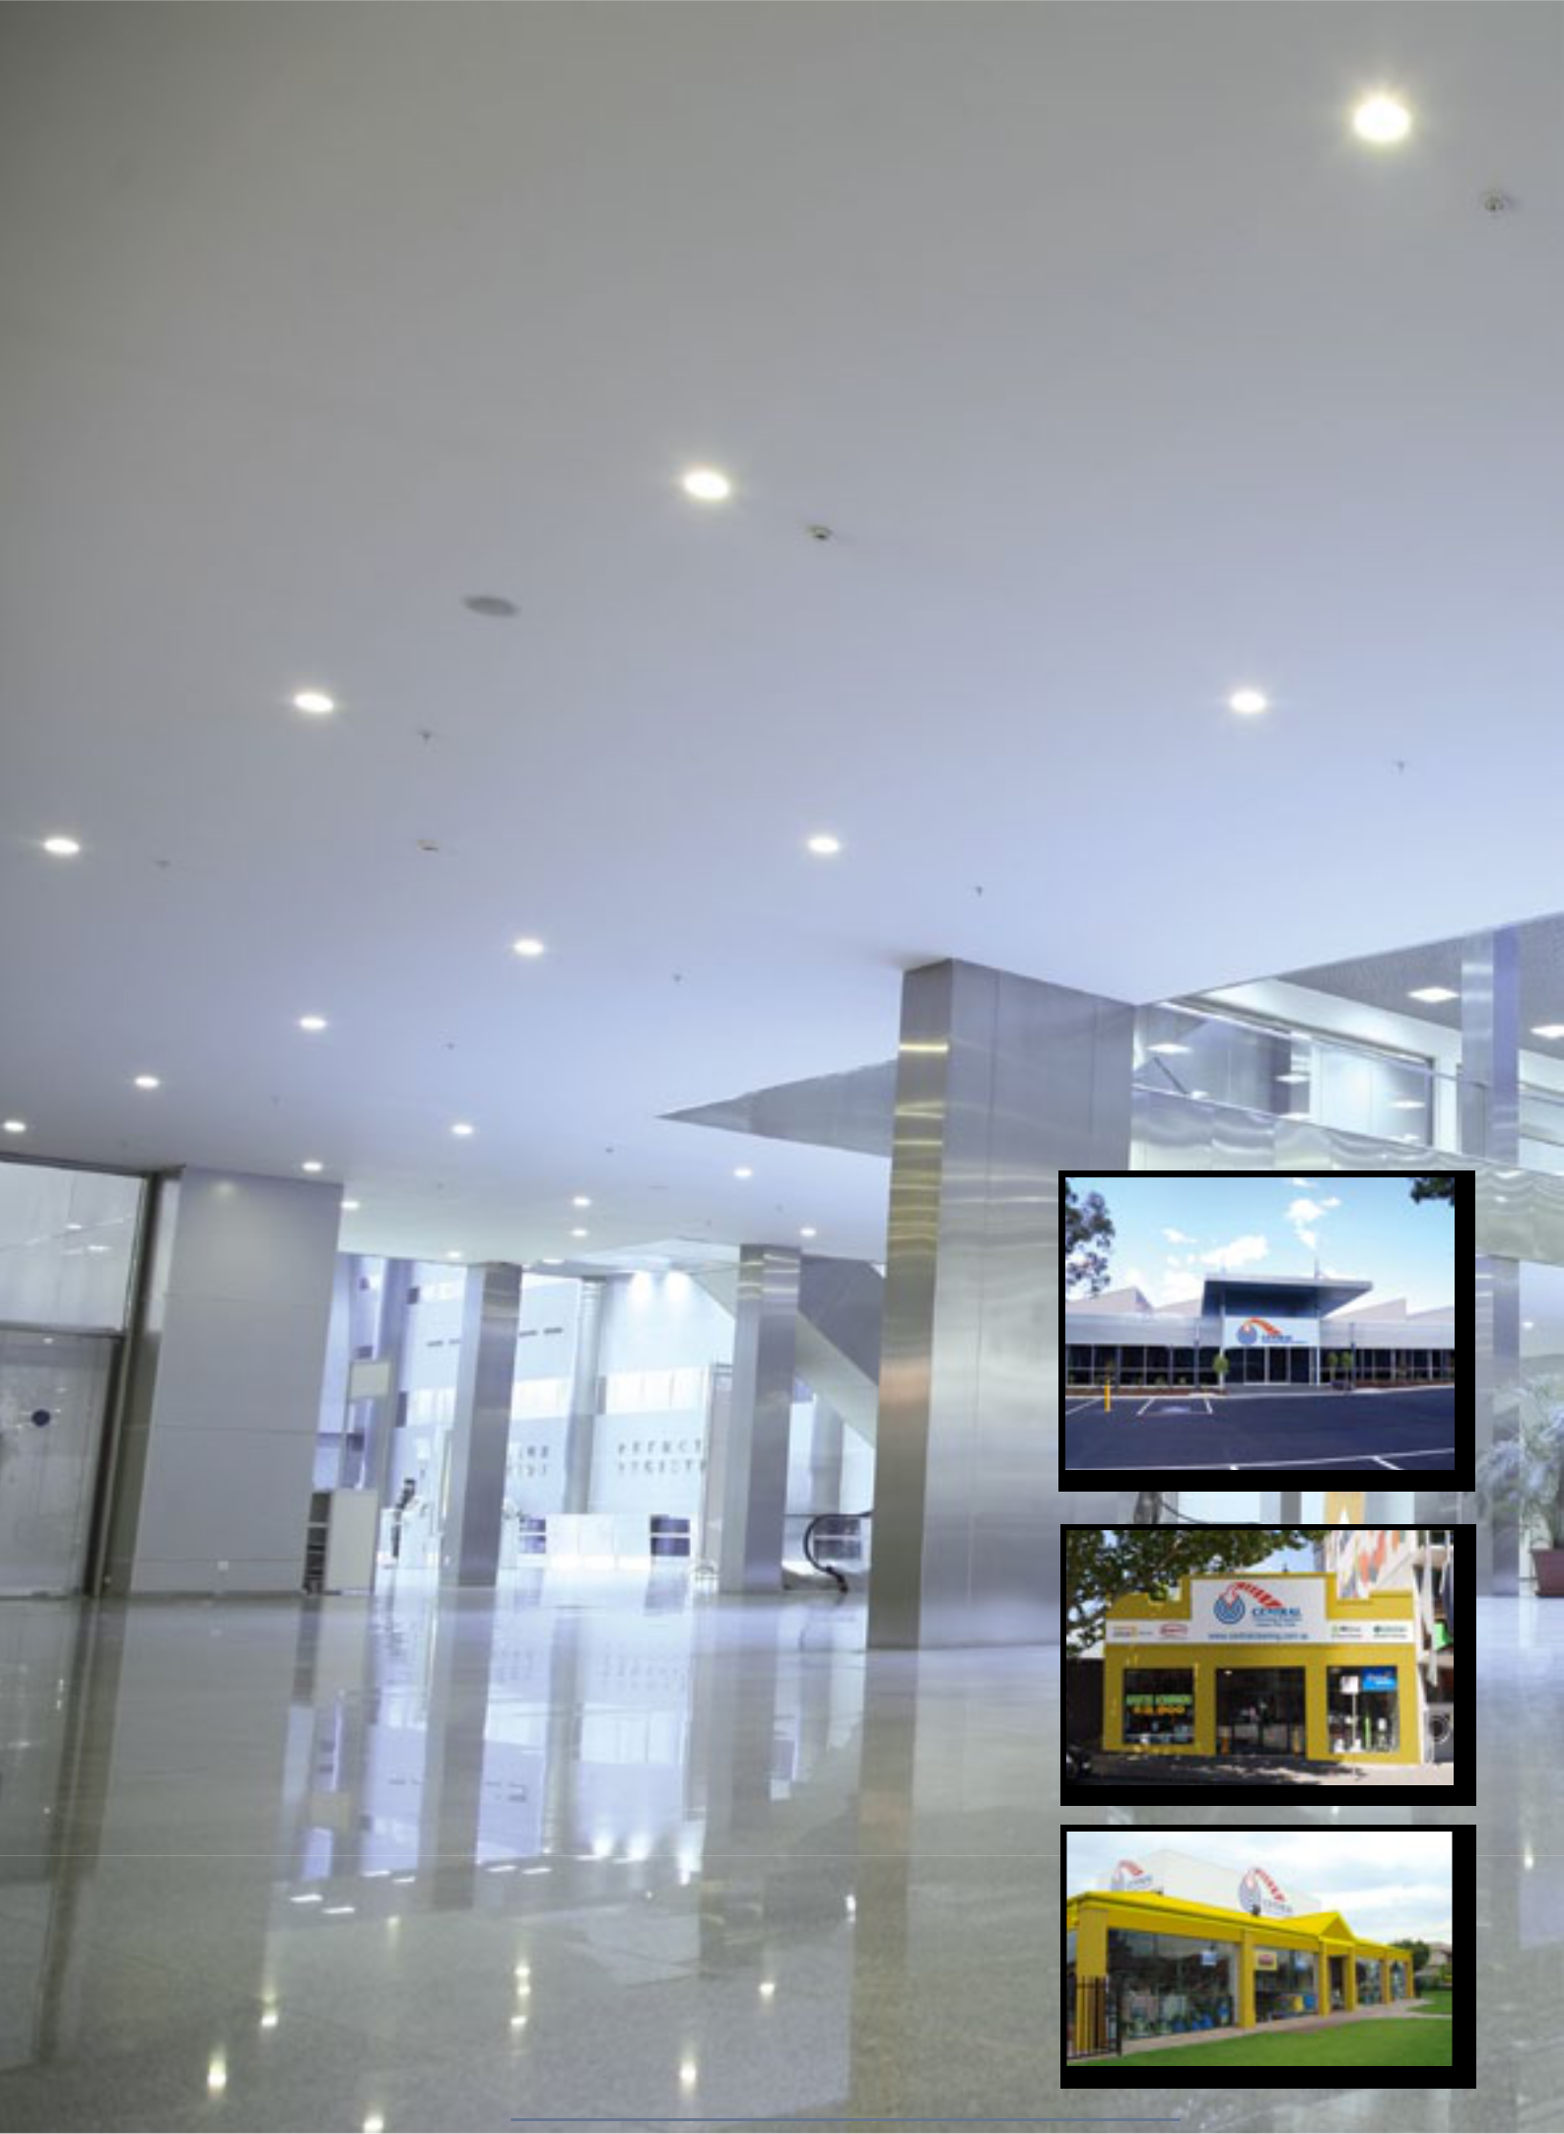
Contacts

VICTORIA

Head Office,

Main Warehouse, Sales, Accounts and Service

Managing Director: Mr. Joe Camilleri

email: joe@centralcleaning.com.au

General Manager: Mr. Daniel Pisaniello

email: Daniel@centralcleaning.com.au

Operations Manager: Ms Julia Spalding

email: julia@centralcleaning.com.au

National Business Develop Managers: Mr. Steven Kulper

email: steven@centralcleaning.com.au

Account Managers: Mr. Mat Spurr, Mr. Maurice Papaspiros, Mr. Andrew Serratore

mailto: sales@centralcleaning.com.au

IT Support: Ms Joanne Cavallaro

email: Joanne@centralcleaning.com.au

Customer Service Manager: Ms Noemi Gatica

email: noemi@centralcleaning.com.au

Customer Orders: Ms Lindita Shaptafaj

email: customerorders@centralcleaning.com.au

and Customer Service Support & Web Admin Mr. Jonathan Alaguna email: webadmin@centralcleaning.com.au

Accounts: Ms. Janet Rowe, Ms. Anne Polsen

email: ar@centralcleaning.com.au

& Ms. Anne Marie Camilleri

email: amc@centralcleaning.com.au

Service Co-Ordinator: Mr. Ronny Makkar

email: ronny@centralcleaning.com.au

25 - 29 Paramount Road, West Footscray Victoria 3012 8:00am to 6:00pm Monday to Friday Excl. Public Holidays Contact all Branches: Tel: 1300 347 347 Fax: 1300 348 348

Retail Outlets

Victorian Retail Manager: Mr. Danny Hamra

email: dannyh@centralcleaning.com.au

Carlton:

Store Manager: Mr. Ricardo Torres

email: carlton@centralcleaning.com.au

8:00am to 6:00pm Monday to Friday Excl. Public Holidays

8:30am to 12:00pm Saturday

201 Queensberry Street, Carlton Victoria 3053

Preston:

Store Manager: Mr. Jerry Yan

email: preston@centralcleaning.com.au

8:00am to 6:00pm Monday to Friday Excl. Public Holidays

8:30am to 5:00pm Saturday

439 Bell Street. Preston Victoria 3072

Central Cleaning Supplies Company Profile 15
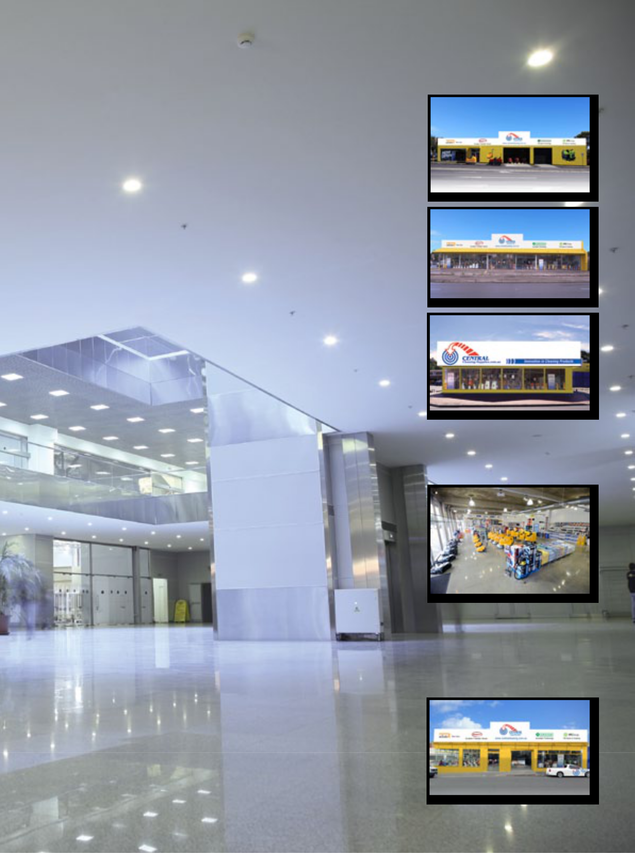
Contacts

Nth Melbourne:

Store Manager: Mr. Amit Kumar

email: george@centralcleaning.com.au

8:00am to 6:00pm Monday to Friday Excl. Public Holidays

161 Arden Street, Nth Melbourne Victoria 3051

Sunshine:

Store Manager: Mr. Jimmy Bhandal

email: jimmy@centralcleaning.com.au

8:00am to 6:00pm Monday to Friday Excl. Public Holidays

8:30am to 5:00pm Saturday

361 Ballarat Rd, Sunshine Victoria 3020

Ferntree Gully:

Store Manager: Mr. Anthony Littel

email: anthony@centralcleaning.com.au

8:00am to 6:00pm Monday to Friday Excl. Public Holidays

8:30am to 5:00pm Saturday

1029A Burwood Hwy, Ferntree Gully VIC 3156

New South Wales

Retail Outlet Distribution and Service

Branch Manager: Mr. Peter Stojanovski

email: peter@centralcleaning.com.au

Accounts Manager: Mr. Luke Perring

email: luke@centralcleaning.com.au

Store Ass: Mr. Diego Escobar

email: diego@centralcleaning.com.au

Service Co-Ordinator: Mr. Ian Soles

email: sydservice@centralcleaning.com.au

601- 607 Gardeners Road, Mascot NSW 2020

8:00am to 6:00pm Monday to Friday Excl. Public Holidays

Tel: 1300 347 347 Fax: 1300 348 348

TASMANIA

Retail Outlet Distribution and Service

State Manager: Mr. Scott Seabourne

Store Ass: Tim Watson

email: tas@centralcleaning.com.au

28 - 30 Brisbane Street, Hobart Tasmania 7000

8:00am to 5:00pm Monday to Friday Excl. Public Holidays

Tel: 1300 347 347 Fax: 1300 348 348

Toll Free: 1800 247 704

Central Cleaning Supplies Company Profile 16
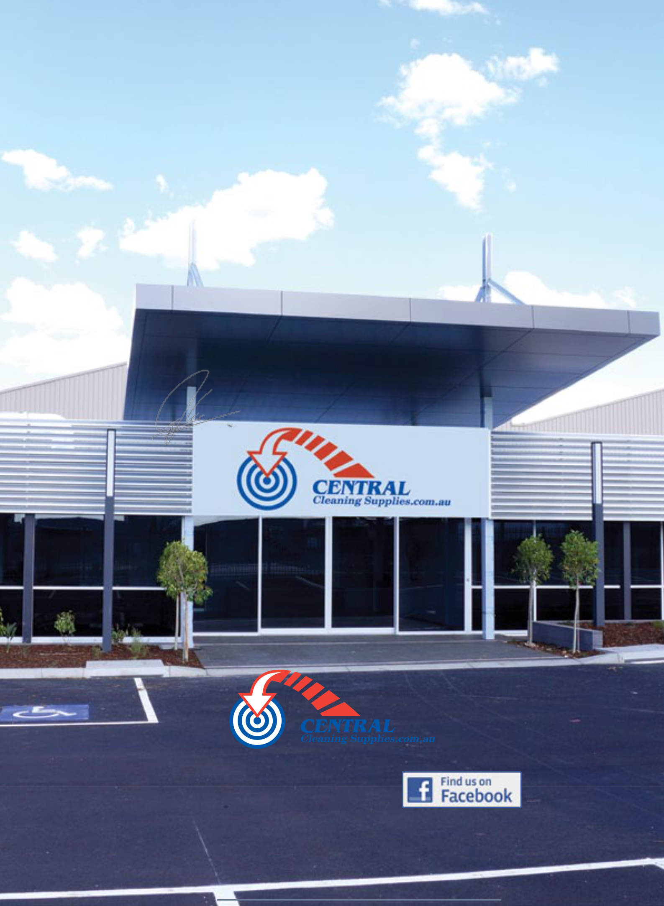

Further Information

Our entire firm is dedicated to providing the highest level of service that you, the customer, consider most appropriate for your needs. Please feel free to contact us and we would be only too pleased to arrange a site visit from one of our dedicated Sales Staff.

We thank you for this opportunity and should you require any further assistance, please do not hesitate in contacting the undersigned.

Yours faithfully,

Mr. Joe Camilleri

Managing Director

Visit our website

www.centralcleaning.com.au

Central Cleaning Supplies Company Profile 17

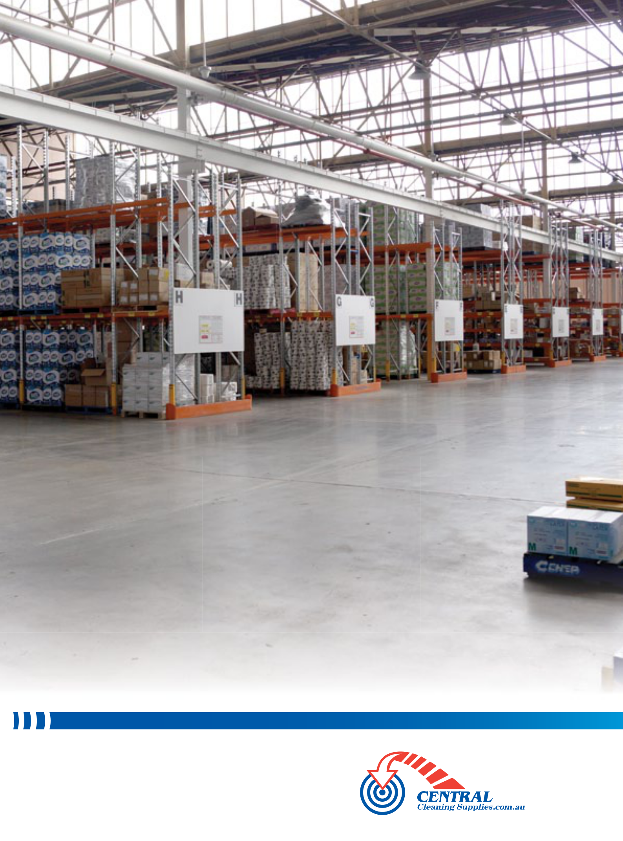

We are dedicated to provide the highest level of service

CONTACT ALL BRANCHES
Tel: 1300 347 347
Fax: 1300 348 348 VICTORIA - NEW SOUTH WALES - TASMANIA

Email: sales@centralcleaning.com.au SOUTH AUSTRALIA - QUEENSLAND - WESTERN AUSTRALIA

