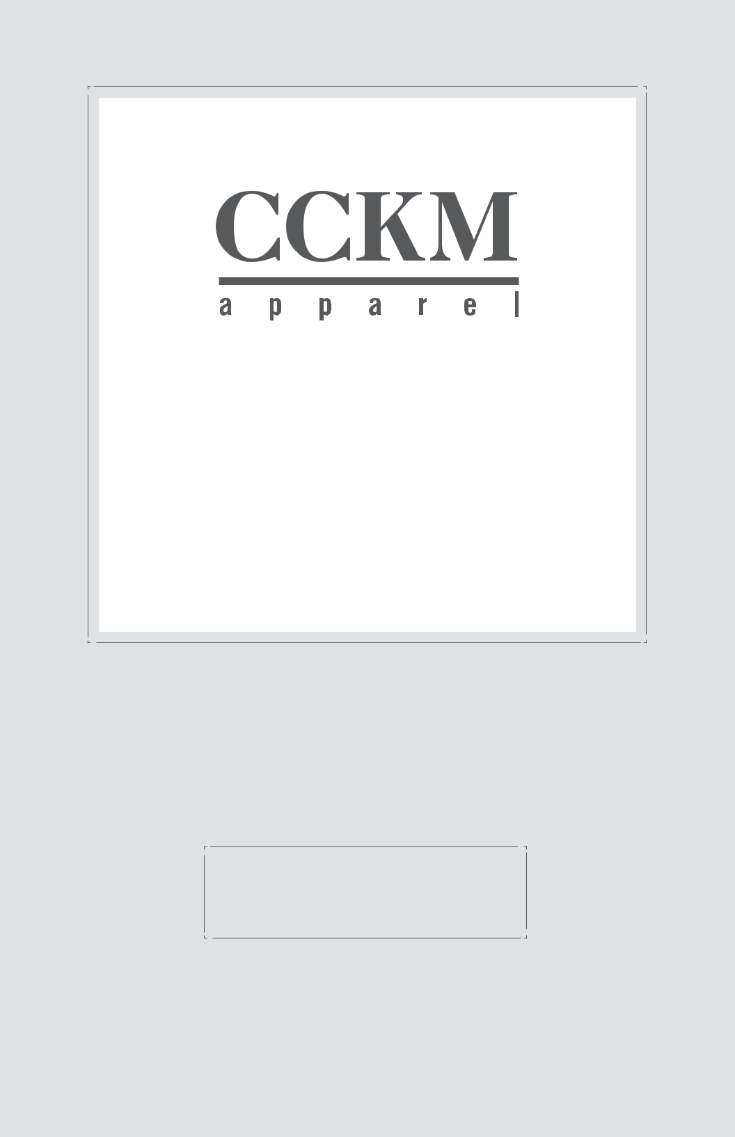

COMPANY PROFILE

Our mission is to supply our customers a “Full Package” program of knitted apparel products at the highest level of quality, service, compliance and value.

• • •

Cannon County Knitting Mills, Inc.

Brooklyn Manufacturing

CCKM CORPORATE

Office

237-F Castlewood Drive Murfreesboro, TN 37129

Phone: 615-890-2938

Fax: 615-890-2405

Chairman / CEO: Brad Gibens bradgibens@cckmapparel.com

Vice President / CFO: Bill Perkoski bperkoski@cckmapparel.com

CCKM SALES

Established 1959 | Vice President of Sales:
One Huntington Quadrangle | Jerry Eckstein
Suite 2N12 | jeckstein@cckmapparel.com
Melville, NY 10747 | Sales Associate: Eileen Purcell
Phone: 631-815-5025 | epurcell@cckmapparel.com
Website
www.CCKMapparel.com

CCKM MANUFACTURING

Brooklyn Manufacturing, LTDA de C.V. - Established 1990 Zona Franca San Marcos, Bodega #7 San Salvador, El Salvador, C.A.

Phone: 503-2213-3800

Fax: 503-2213-3838

Vice President / Operations:

Mike Rodgers

mike_rodgers@brooklyn.com.sv

Director of Manufacturing:

Francisco Davila

francisco_davila@brooklyn.com.sv

Manager of Production Planning:

Maria Godinez

maria_godinez@brooklyn.com.sv

Manager of Engineering:

Miguel Zabaneh

miguel_zabaneh@brooklyn.com.sv

Manager of Cutting & Fabric Purchasing: Carlos Escobar carlos_escobar@brooklyn.com.sv

CUSTOMERS

THE NORTH FACE

Polar Fleece Jackets Performance Training Tops Performance Sportswear Performance Baselayers

LACOSTE

Performance Placket Shirts Fashion Apparel

EASTERN MOUNTAIN SPORTS

Performance Apparel Performance Underwear Performance Base Layers Polar Fleece Jackets Yoga Apparel

UNDER ARMOUR

Performance Apparel

Performance Plackets

VINEYARD VINES
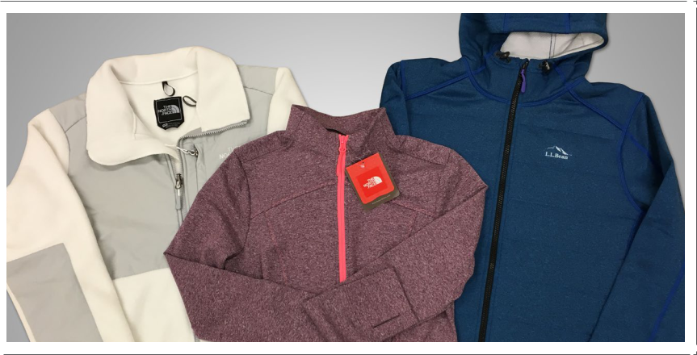

Power Stretch Jackets Polar Fleece Jackets

COLUMBIA SPORTSWEAR / MOUNTAIN HARDWEAR

Performance Apparel

Polar Fleece Jackets

Powerstretch Jackets

Accessories

PATAGONIA

Performance Base Layers Subliminated Apparel Polar Fleece Jackets

- BEAN

Performance Apparel Power Sport Jackets Power Dry Base Layers
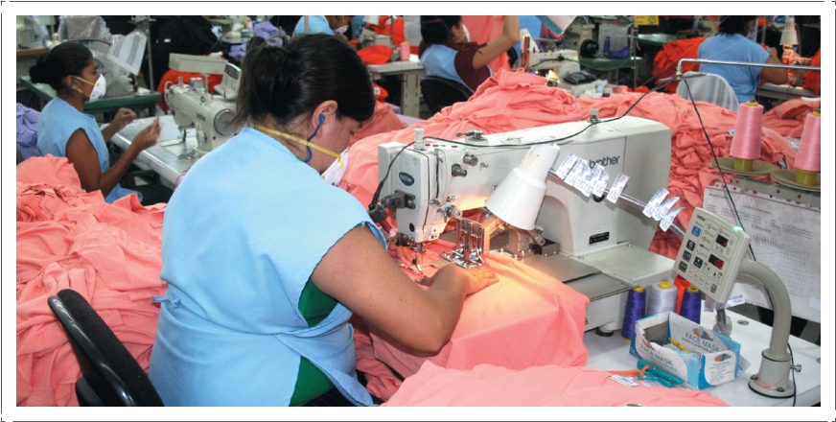

GARMENT CONSTRUCTION

Cutting

Embroidery

Sublimation

Pad Printing

Heat Transfer

Embossing

Screen Printing (Outside Contractors)

Laser Cutting and Glueing

Seam Sealing

Garment Washing

Sewing

Finishing
PLANT INFORMATION

Physical Plant

180,000 Sq. Feet

1,800 Employees

Production System Modular-Unit Production System Progressive Bundle Unit Piece Rate Compensation

Quality Data

Quality Manual Available Inspection Results Maintained

Areas of Quality Inspection FABRIC - Defects / Shade 10-100% FABRIC TESTING - Shrinkage, Crocking, Burst Strength, Skewing, Weight, Color Matching, Color Shade bands

TRIMS - Quantity / Quality / Correctness - 10%

CUTTING - Final audits before ship to sew - 10%

IN-LINE - Sewing Lines - 5 times a day - 2% AQL

FINAL EXAM - All Inspected - 100% FINAL AUDIT - All Styles audited before ship - 2.5% AQL

Sample Department

Patterns

Protos

Sales Samples

Final Approval

Information Systems

Computerized System Control

EDI

UPC Printing

LECTRA - Pattern Equipment

& Transmission
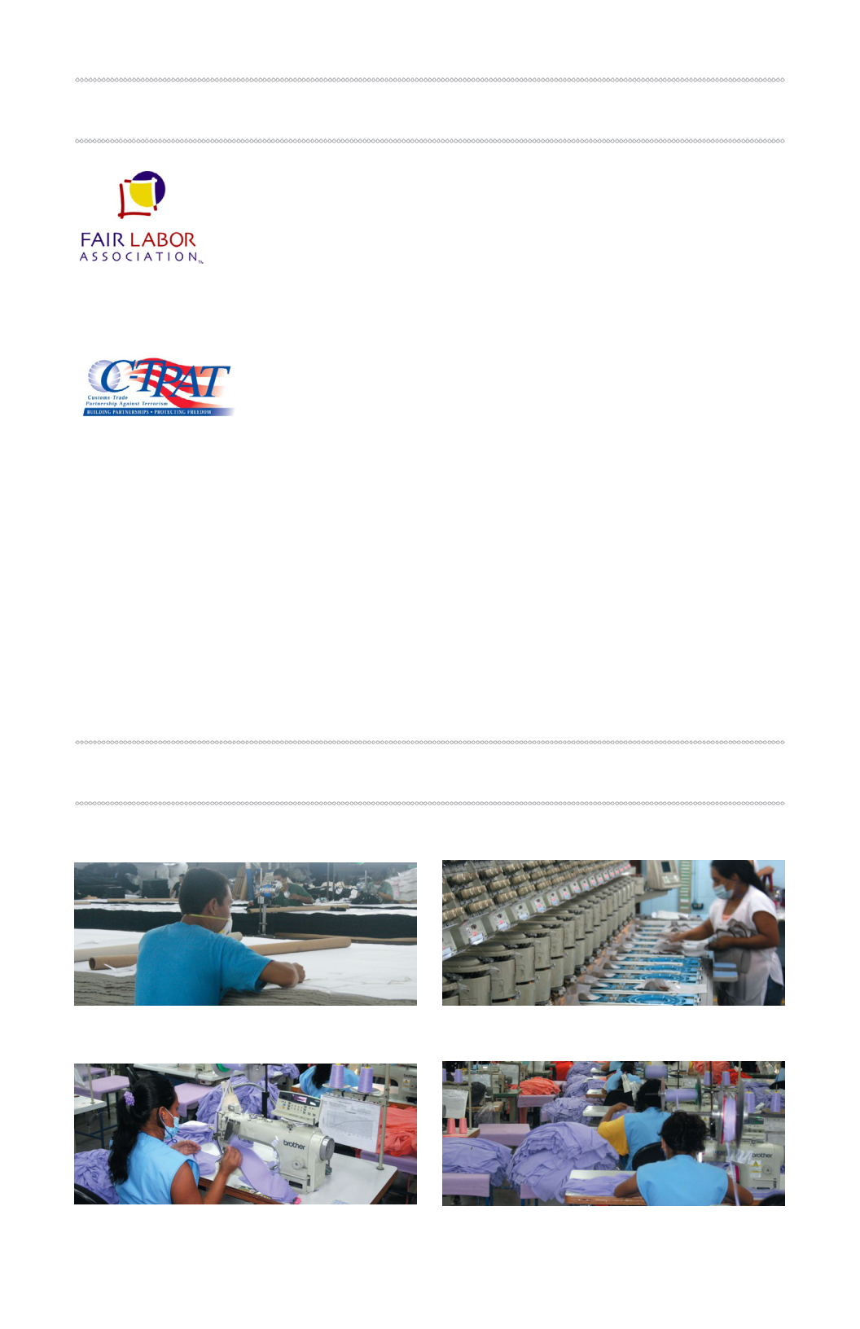
 COMPANY CERTIFICATIONS / MEMBERSHIPS

Accredited Member

Fair Labor Association, Code of Conduct

C-TPAT Certified Member

Customs - Trade Partnership

Against Terrorism

RESOURCES

Cutting Embroidery

Sewing

