

COMPANY PROFILE
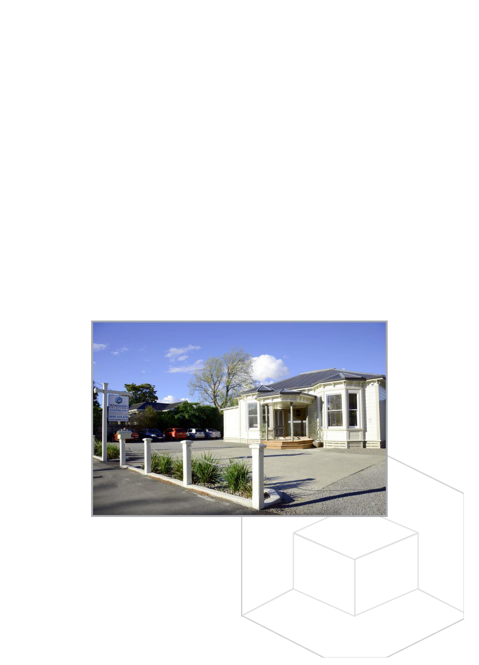
Why use Technology Solutions?

Technology Solutions has been a long-term trusted partner for clients in the Wairarapa region and beyond since 1976; working closely with our clients allows us to act in their best interest over the long term.

Our 15 dedicated staff (excluding the cats) have a combined experience of over 273 years.

OUR CLIENTS BENEFIT FROM:

- Established team of 15 staff – most 5+ years and many 10+ years

- A proven client service model: locally owned and operated

- Considerable range of combined technical knowledge and experience

- Timely response to any issues

- Cost efficient services

- Fixed costs for easier budgeting

CLIENT AND FUTURE FOCUSED:

We have recently appointed a Customer Service Manager to assist the technical team with enhancing client management and to provide a better level of service to our clients. Lloyd brings a wealth of operations and management experience to the company.

We are committed to ensuring that our often very busy technical team is resourced appropriately for the ultimate benefit of our clients.

Our new custom built premises in Victoria Street, Masterton

22 Victoria Street, Masterton, NZ 5810 | (06) 370-8093 | 0800-878-878 | info@techs.co.nz | www.techs.co.nz

Est. 1979 | On-Call & On-Site | Network Specialists | Wireless Networks | Mobile Device Gurus | Hardware & Software Sales Website Design | Application Development | Apple Mac Service | Database Design | Remote Support | Home & Office 237 Years Combined Experience | The #1 Provider for I.T. in the Wairarapa
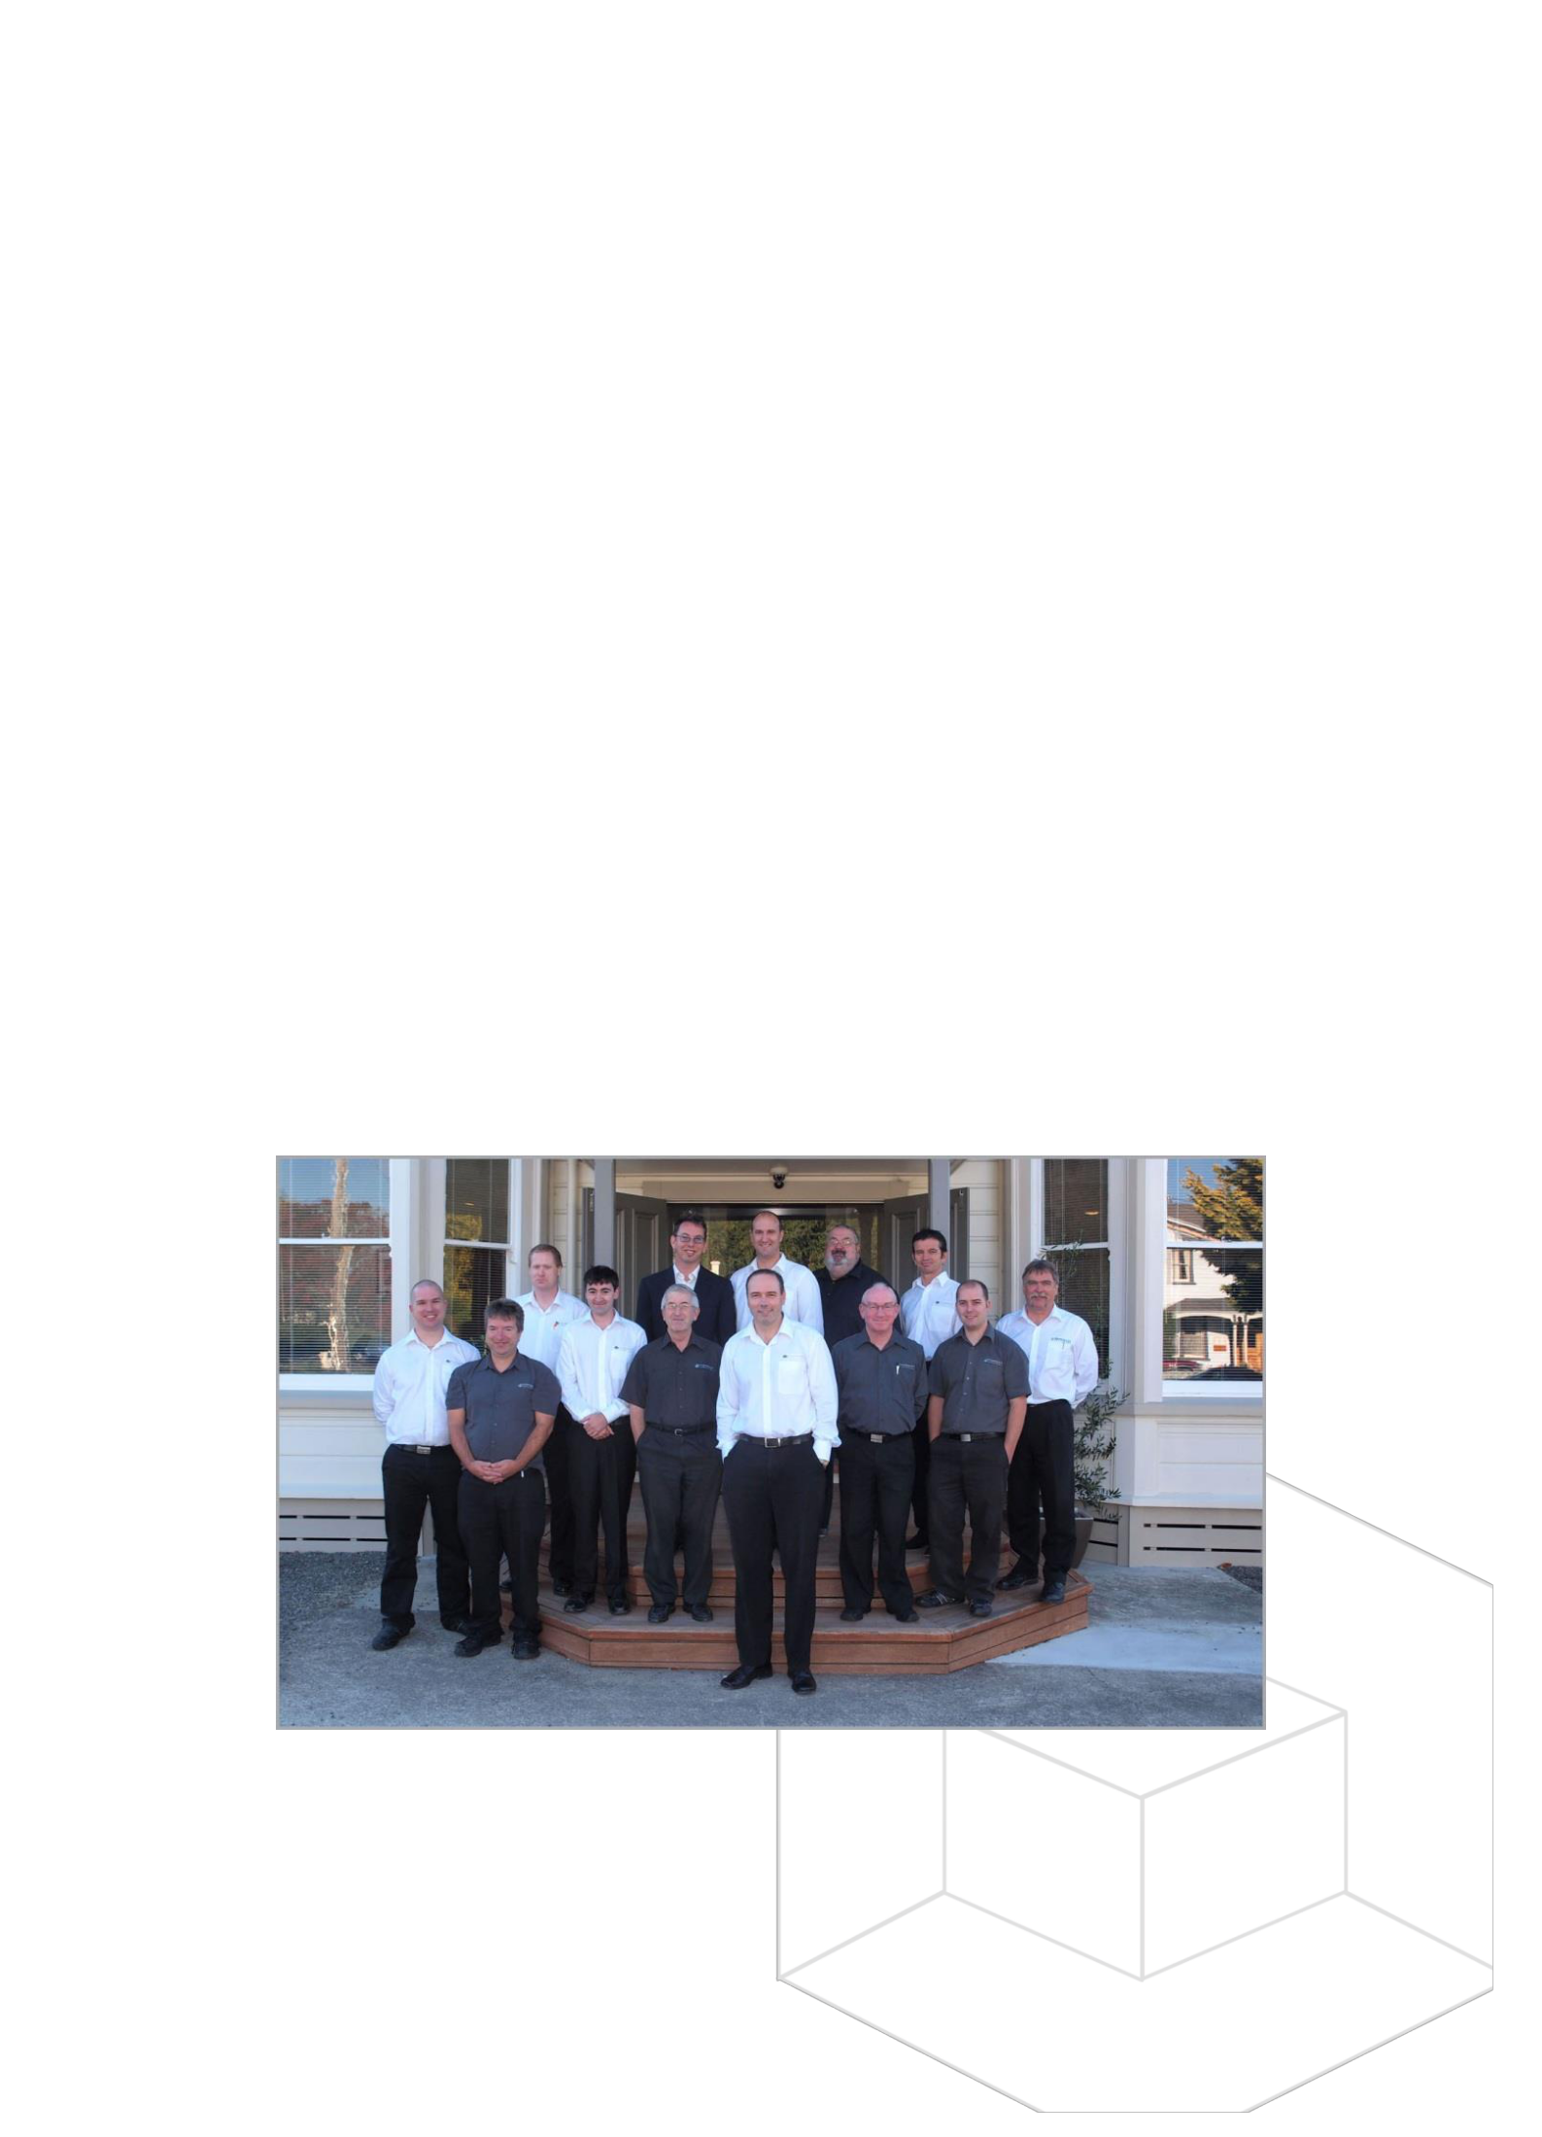
Company Profile

Technology Solutions is an Information Technology company located in Masterton, New Zealand, servicing clients nationwide.

Technology Solutions is the leading provider of business & education I.T. solutions in the Wairarapa. Partnering with the best of breed technologies such as Hewlett Packard, D-Link and Microsoft, we employ best practices developed over thirty years of service. We are extremely committed to delivering quality advice, sales and support to assist our clients to achieve the maximum from their I.T. investment.

Our key skill areas are:

- Total site I.T. management

- Web & Application Development

- Internet services/site hosting

- Network/Server Installation

- On-site Service

- Workshop Repair

OWNERSHIP & MANAGEMENT

Technology Solutions is a private company. Founded in the 1970s by Ted Paris, the company is registered as Wairarapa Computer Services Limited, trading as Technology Solutions. Simon Griffiths is Technology Solutions’ General Manager and owner.

The team at our offices in Victoria street

22 Victoria Street, Masterton, NZ 5810 | (06) 370-8093 | 0800-878-878 | info@techs.co.nz | www.techs.co.nz

Est. 1979 | On-Call & On-Site | Network Specialists | Wireless Networks | Mobile Device Gurus | Hardware & Software Sales Website Design | Application Development | Apple Mac Service | Database Design | Remote Support | Home & Office 237 Years Combined Experience | The #1 Provider for I.T. in the Wairarapa
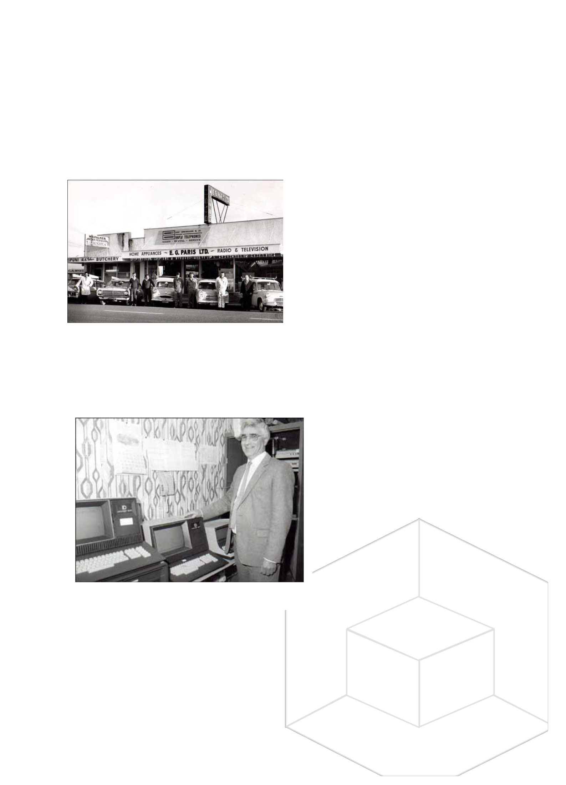
Company History

Established in 1965 by Ted Paris as a home appliance and electrical services store, the only constant thing between 1965 and present day has been the building, and now finally that has succumbed to progress with it now being the location of Pak n Save.

As the washing machine market changed Ted took a bold step and started Wairarapa's first computer bureau processing facility. This required a huge investment in computer equipment, equipment that took up a whole room, had hard disk drives the size of fridges and were a lovely brown colour.

The original location (now pac n save)

Initially called Wairarapa Computer Services, we provided a facility for clients to come and process their accounts with our magnificent Datapoint mini-computer. Who would predict computers would get smaller faster and progress to a point where clients would eventually own their own systems? Well, we did. Confronted with the evidence of components getting smaller and faster, and the decline in cost to acquire this equipment, we identified computer services as the technology revolution of the future.

In 1995 Wairarapa Computer Services purchased its local competitor - ComputerLand - and

inherited the ComputerLand franchise. However, we quickly learned that operating as a ComputerLand franchise wasn't for us. Most of the corporate business that ComputerLand's franchise model was based on was not in Masterton.

So in 1999 the ComputerLand franchise was dropped and under the new name of Technology Solutions we went it alone.

Through continued customer focus, quality sales and support that gamble has paid off.

We are now the largest company of our type in the Wairarapa, employing fourteen staff with the diversity and depth of skill to meet any computer technology requirement, from home and small office workstations through to wide area networks and Internet development.

Ted Paris with the Datapoint ‘mini’ computer system

In early 2005 we relocated to the historic Hessey house in Worksop road, Masterton and then again to our current location of 22 Victoria Street, Masterton.

22 Victoria Street, Masterton, NZ 5810 | (06) 370-8093 | 0800-878-878 | info@techs.co.nz | www.techs.co.nz

Est. 1979 | On-Call & On-Site | Network Specialists | Wireless Networks | Mobile Device Gurus | Hardware & Software Sales Website Design | Application Development | Apple Mac Service | Database Design | Remote Support | Home & Office 237 Years Combined Experience | The #1 Provider for I.T. in the Wairarapa


Conclusion

Technology Solutions’ focus is to provide a long term I.T. partnerships with our clients. Most of our client relationships have been for at least five years, many much longer. These long term relationships allow us to understand our clients’ unique needs and requirements and provide a high level of service.

We believe we can provide cost effective service & support allowing you to get the best from your I.T.

investment.

We can provide:

- access to an experienced and well-resourced specialist I.T. support and service team;

- prompt telephone and remote services;

- proven and established track record

If you are interested in knowing more as to how Tech Solutions can help you better manage and utilise your IT systems we would be delighted to discuss this with you.

CONTACT DETAILS

Lloyd Wilson

Customer Service Manager

Technology Solutions

22 Victoria Street

Masterton

Tel 06 370 8093

Fax 06 370 8091

Email lloyd@techs.co.nz

Web www.techs.co.nz

22 Victoria Street, Masterton, NZ 5810 | (06) 370-8093 | 0800-878-878 | info@techs.co.nz | www.techs.co.nz

Est. 1979 | On-Call & On-Site | Network Specialists | Wireless Networks | Mobile Device Gurus | Hardware & Software Sales Website Design | Application Development | Apple Mac Service | Database Design | Remote Support | Home & Office 237 Years Combined Experience | The #1 Provider for I.T. in the Wairarapa

