

2019 Business Profile

Investor Relations

DPDHL Group at a Glance (as of 1.1.2019)


Network Businesses – asset intensive Brokerage & Outsourcing – asset light



2018

Group revenues EUR 61.6bn

EBIT

EUR 3.162bn

>500k employees >220 countries/ territories

2020 EBIT targets:

Group: EUR >5bn;

P&P: EUR >1.6bn ;

DHL : EUR >3.7bn

Post & Paket
Deutschland

Products

USO Provider for

letter products in

Germany.

Parcel operations

in Germany

Geographies

Germany

Market Share

63% business

letters Germany

45% parcel

Germany

DHL
eCommerce
Solutions

Parcel operations

in Europe, US and

selected

international

markets

Europe

USA

Asia Pacific

#4 in USPS Parcel

Select

#1 in Indian B2B

Express

DHL Express

Core product TDI (Time Definite International): premium cross-border parcels and document delivery

>220 countries and territories

Global No 1 in TDI 38% market share

DHL Global Forwarding, Freight

Brokerage of transport services in Air, Ocean and Road freight

>150 countries and territories

#1 in air freight

#2 in ocean freight #2 in European road freight

DHL Supply
Chain

Customized, outsourced logistics solutions through full value chain

>50 countries and territories

#1 globally

6.0% market

share

INVESTOR RELATIONS | NOVEMBER 2019 PAGE 2

DPDHL Group: Products and Solutions Portfolio Covering Full Global Logistics Value Chain

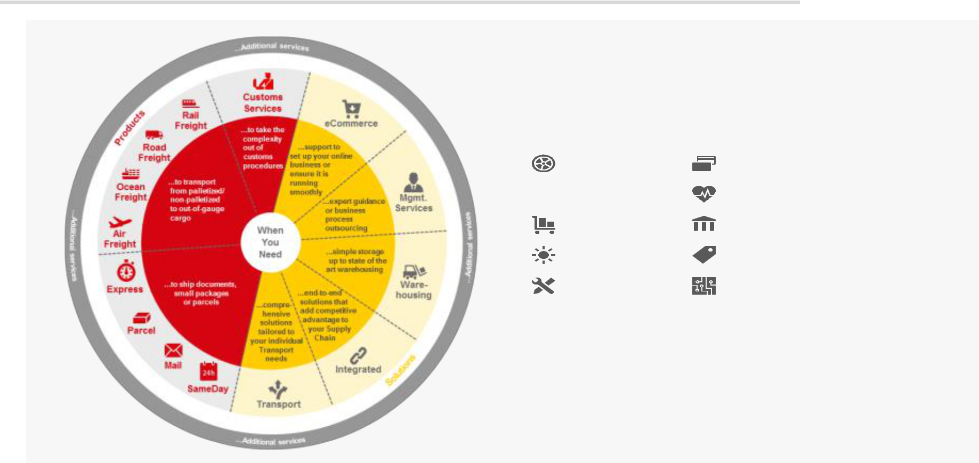

Our sector expertise

Our sector-specific expertise spans across multiple sectors and specialty areas, offering you tailored solutions that best match your industry’s logistics requirements. With dedicated teams of experts, we ensure that we remain at the forefront of sector developments and constantly adapt our portfolio to your needs

Automotive |  | Financial Services
Chemicals |  | Life Sciences
Chemicals |  | and Healthcare
Consumer |  | Public Sector
Energy |  | Retail
Engineering and |  | Technology
Manufacturing |  | Technology

Our green expertise

DHL’s GoGreen program helps you – and us – reduce the

environmental impact of doing business across the world. Our

GoGreen Solutions portfolio of transport efficient and environmentally optimized logistics solutions supports you to quantify and improve your carbon footprint. It reduces waste, meets producer responsibilities and helps you move to a more Circular Economy

INVESTOR RELATIONS | NOVEMBER 2019 PAGE 3

DPDHL Group: Divisional Overview

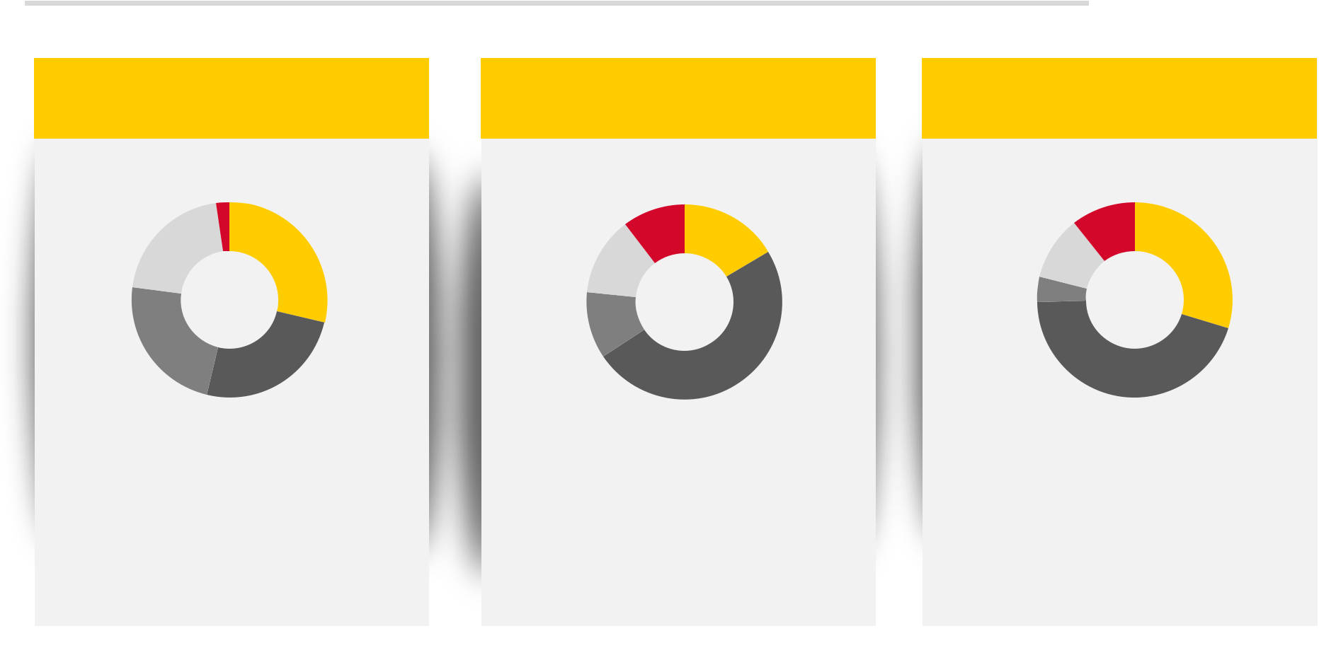

Revenue distribution,

DPDHL Group

-1,401

13,350 18,476

14,978

16,147

PeP

Express

DGFF

DSC

Corp. Functions & Consol.

EBIT distribution,

DPDHL Group

-413
656

520

442

1,957

PeP

Express

DGFF

DSC

Corporate Functions

Capex distribution,

DPDHL Group

280

786

282

110

1,190

PeP

Express

DGFF

DSC

Corp. Functions & Consol.

INVESTOR RELATIONS | NOVEMBER 2019

PAGE 4

DPDHL Group: Geographic Overview

In €m

Revenue by region

DPDHL Group

2,398

10,766

18,759

11,163

18,464

Germany

Europe Ex Germany

Americas

Asia Pacific

Other

Staff by region (FTE)
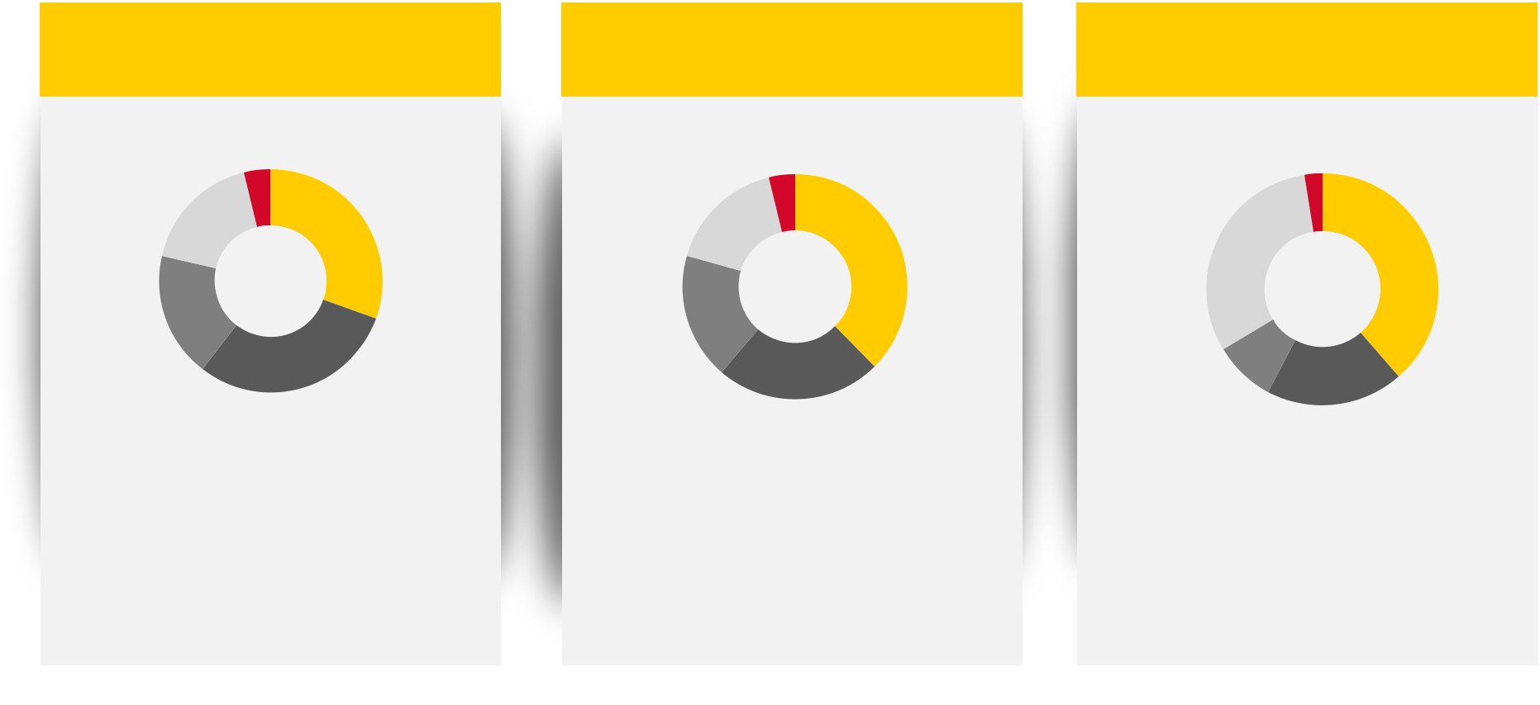
DPDHL Group

18,961

83,561

187,103

90,648

118,745

Germany

Europe ex Germany

Americas

Asia Pacific

Others

Staff by Division (FTE)

DPDHL Group

12,327

155,954 | 192,237

42,783

95,717

PeP

Express

DGFF

SC

Corporate Functions

INVESTOR RELATIONS | NOVEMBER 2019 PAGE 5

DPDHL Group: Board of Management

CFO DPDHL |  | CEO DPDHL
GROUP |  | GROUP
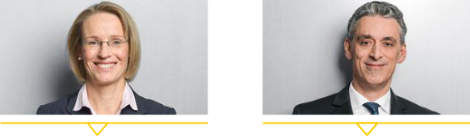

 | Melanie Kreis |  |  | Frank Appel
 | Member: Oct. 14 |  |  | Member since Nov.2002
Appointed until: June 2022 |  |  |  | CEO since Feb. 2008
 |  |  | Appointed until Oct. 2022

P&P Deutschland |  | Express |  | Forwarding,
P&P Deutschland |  | Express |  | Freight
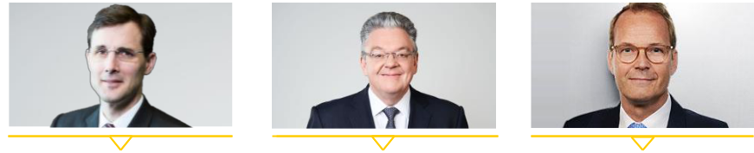

Tobias Meyer | John Pearson | Tim Scharwath
Member since Apr 2019 | Member since Jan 2019 | Member since Jun 2017
Appointed until Mar 2022 | Appointed until Dec 2021 | Appointed until May 2025

HR, Corporate

Incubations


Thomas Ogilvie

Member: Sept. 2017

Appointed until: Aug. 2020


Supply eCommerce
JohnChainGlbert Solutions



Oscar de Bok | Ken Allen
Member since Oct 2019 | Member since Feb 2009
Mandate until Sept 2022 | Appointed until Jul 2022

INVESTOR RELATIONS | NOVEMBER 2019 | PAGE 6

DPDHL Group: Structural Market Trends
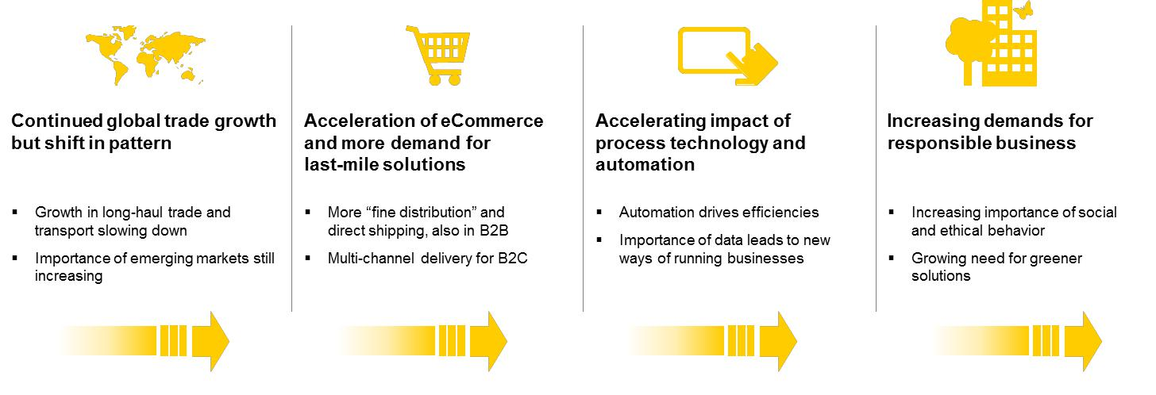
As shown at


2014 CMD

INVESTOR RELATIONS | NOVEMBER 2019 PAGE 7

Guidance 2019/2020 confirmed

in € bn | 2019 | 2020
Group EBIT | 4.0-4.3 | >5.0

P&P Germany 1.1-1.3 | >1.6

DHL | 3.4-3.5 | >3.7

Corporate _{-0.5 -0.35} Functions

2019

Free Cash Flow: >€0.5bn (incl. ~€1.1bn debt-financed Express intercontinental fleet renewal)

Tax rate: Between 19% and 22%

Gross Capex (excl. leases): ~€3.7bn (incl. ~€1.1bn for debt-financed Express intercontinental fleet renewal)

INVESTOR RELATIONS | NOVEMBER 2019 PAGE 8

Rolling 2022 financial targets, as introduced at 2019 CMD

in € bn | 2022


Group | >5.3
EBIT | >5.3
Capex (20-22) | 8.5 - 9.5
cumulative | 8.5 - 9.5
FCF (20-22) | 4.5 - 5.5
cumulative | 4.5 - 5.5

All targets to be rolled

forward annually

2022 minimum EBIT guidance

based on cautious macro scenario

Capex guidance includes ~€800m for Boeing 777 order in 2020/21

Divisional EBIT growth remains key driver of OCF and FCF growth

INVESTOR RELATIONS | NOVEMBER 2019 PAGE 9

DPDHL Shareholder Distribution

As per 31 Dec, 2018

„KfW |  | Institutional Investors | Institutional Investors by Region
Banken- |  |  | ▪ | USA | 15.8%
Gruppe“ | 20.5%
 |  |  | ▪ | Great Britain | 12.2%
 | 66.8% |  | ▪ | Great Britain | 12.2%
 |  |  | ▪ | Germany | 11.3%
 | 12.7% |  | ▪ | Others | 27.5%


Retail Investors

INVESTOR RELATIONS | NOVEMBER 2019 PAGE 10
POST & PAKET DEUTSCHLAND (P&P)

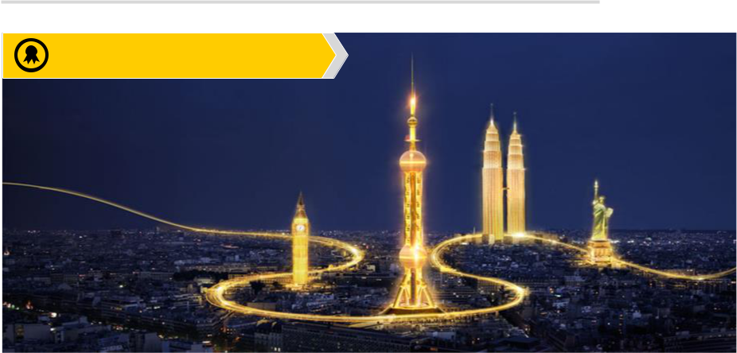

- #1 European post and parcel provider

INVESTOR RELATIONS | NOVEMBER 2019 PAGE 11
PeP: Revenue Mix and Main Assumptions

2018 PeP revenue:
EUR 18,476m
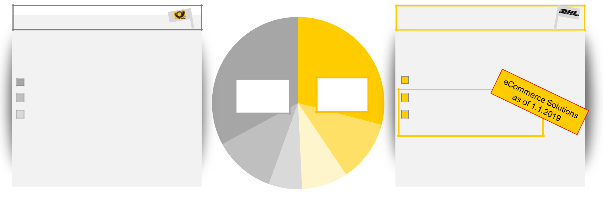

Post |  | Parcel and eCommerce

Brand: Deutsche Post Post product segments:

Brand: DHL

Parcel operations:

Mail Communication Dialogue Marketing

Other (incl. Press services, retail outlets)

Post | Parcel
51% | 49%
Parcel Germany

Parcel Europe

DHL eCommerce

(Parcel Outside

1)
Volume expectation:

- German letter decline: ~ -2-3%

1)
Volume expectation:

- German Parcel growth: +5 -7%

- International Parcel growth: >+8%

1) p.a. until 2020

INVESTOR RELATIONS | NOVEMBER 2019 PAGE 12

PeP: EBIT History and P&P Outlook

2018 PeP EBIT: EUR 1,050m (adjusted)*

PeP revenue & EBIT,

in EUR m

25,000 |  | Parcel Revenue |  |  | Post Revenue |  | PeP EBIT |  |  |  |  |  | 2,200
 |  |  |  |  |  |  |  |  |  |  | 2020 P&P EBIT |  | 2,000
20,000 |  |  |  |  |  |  |  |  |  |  | guidance: |  | 2,000
 |  |  |  |  |  |  |  |  |  |  | EUR >1.6bn |  | 1,800
15,000
 |  |  |  |  |  |  |  |  |  |  |  |  | 1,600
10,000
 |  |  |  |  |  |  |  |  |  |  |  |  | 1,400
5,000 |  |  |  |  |  |  |  |  |  |  |  |  | 1,200
0 |  |  |  |  |  |  |  |  |  |  |  |  | 1,000
2008 | 2009 | 2010 | 2011 | 2012 | 2013 | 2014 | 2015 | 2016 | 2017 | 2018 | 2019 | 2020
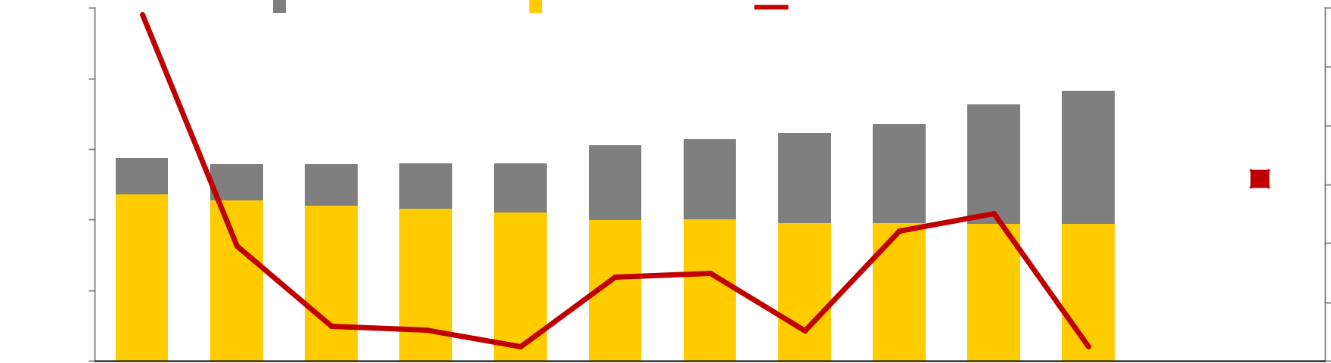

* Adjusted for €502m restructuring charge and €108m pension revaluation

Complex management of transition from postal to parcel player

INVESTOR RELATIONS | NOVEMBER 2019 PAGE 13
P&P Deutschland: German Post and Parcel Network

82 Mail sorting centers | 35 Parcel sorting centers
 |  | Rostock
 |  | Hamburg
 | Hannover
 | 1
 |  | Berlin
 | Köln
 | Frankfurt | 50,000 parcels/h
 |  | 40,000 parcels/h
 |  | 32,000 parcels/h
 | Stuttgart | Nürnberg
 |  | 28,000 parcels/h
 |  | München
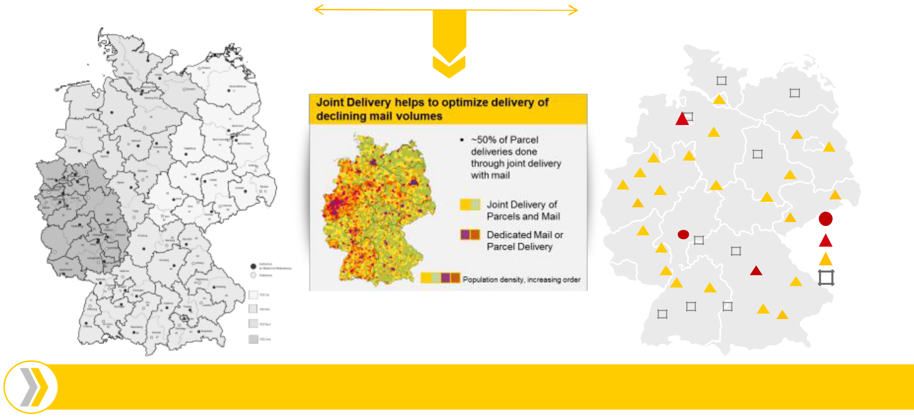

Highly efficient and automated sorting capability enables high quality Mail & Parcel delivery

INVESTOR RELATIONS | NOVEMBER 2019 PAGE 14
P&P: Post Products, Market Structures and Regulation
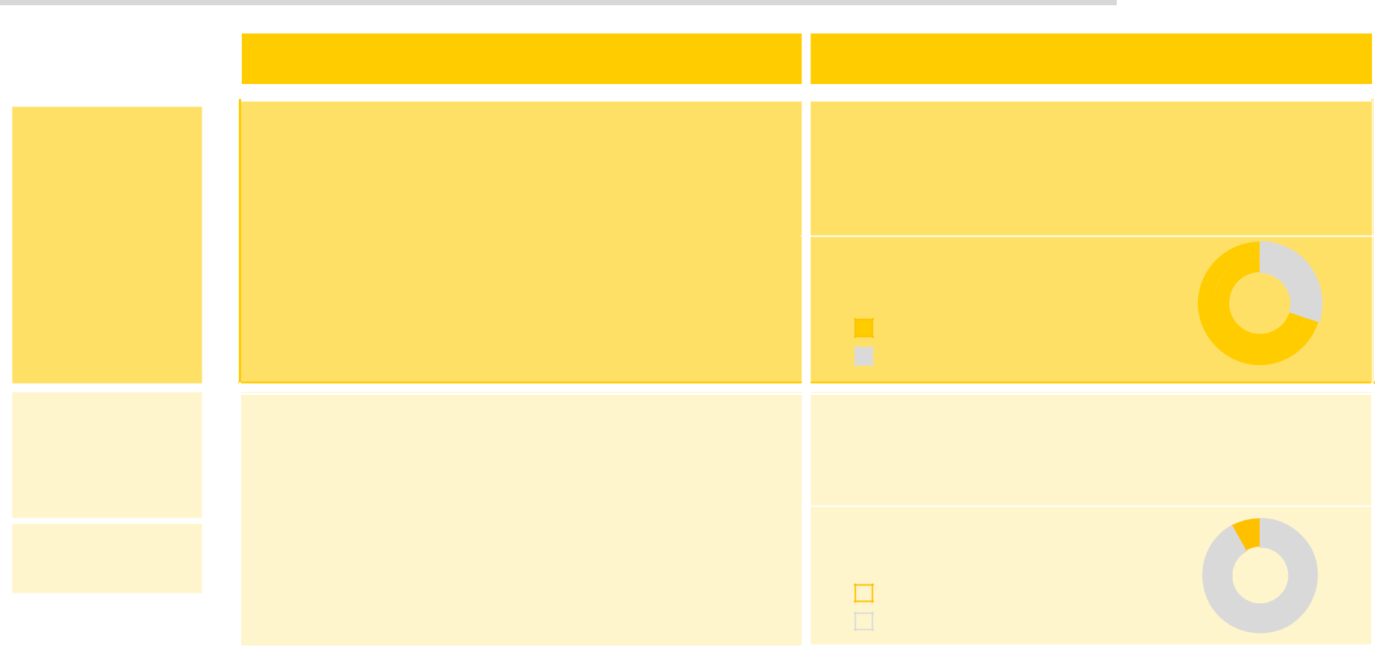

Post revenue | The Mail Company for Germany | Regulation & Pricing
FY18: EUR 9.7bn | The Mail Company for Germany | Regulation & Pricing
 | USO (Universal Service Offering) Provider | Mostly Regulated
 | in Germany | 2016-18 price cap = CPI +5.8%

Last regulated price increase: +7.5% in 2016
 | ▪ | Mail Communication (MC)
Mail | - | Standard letter products | Market structure, | 37%
Communication |  |  | Business customer mail | 37%
Communication | - Domestic and Out-/Inbound Germany |  | Business customer mail
EUR 6.3bn |  |  | Deutsche Post | 63%
EUR 6.3bn | - Includes digital letter product E-POST |  | Deutsche Post | 63%
 |  |  | Competition
Dialogue | ▪ | Dialogue Marketing (DM) | Mostly Unregulated

Marketing | - Advertisement mailings & campaigns |  | No formal price setting, potentially ex-post price
EUR 2.2bn |  |  | controls
EUR 2.2bn | - Digital & physical
 |  |  | Market structure, German
Other: | ▪ | Other: |  |  |  | 8%
EUR 1.2bn |  | Other: | advertising market
EUR 1.2bn | - Press & Pension Services, Retail Outlets
 |  |  |  |  | Deutsche Post | 92%
 |  |  |  |  | Competition | 92%
INVESTOR RELATIONS | NOVEMBER 2019 |  |  |  |  |  | PAGE 15

P&P: DHL Parcel Germany Maintains Sustainable Growth Momentum

DHL Parcel Germany, volume growth, yoy

9.8% |  | 9.8% |  |  |  |  |  | 8.7% |  | 9.3%
 |  |  |  |  |  |  |  |  |  |  |  | 7.8%
 |  |  |  | 7.4% |  | 7.0% |  |  |  |  |  |  |  | 7.5%
 |  |  |  |  |  |  | market growth expectation: 5-7%
2011 |  | 2012 |  | 2013 |  | 2014 |  | 2015 |  | 2016 |  | 2017 |  | 2018
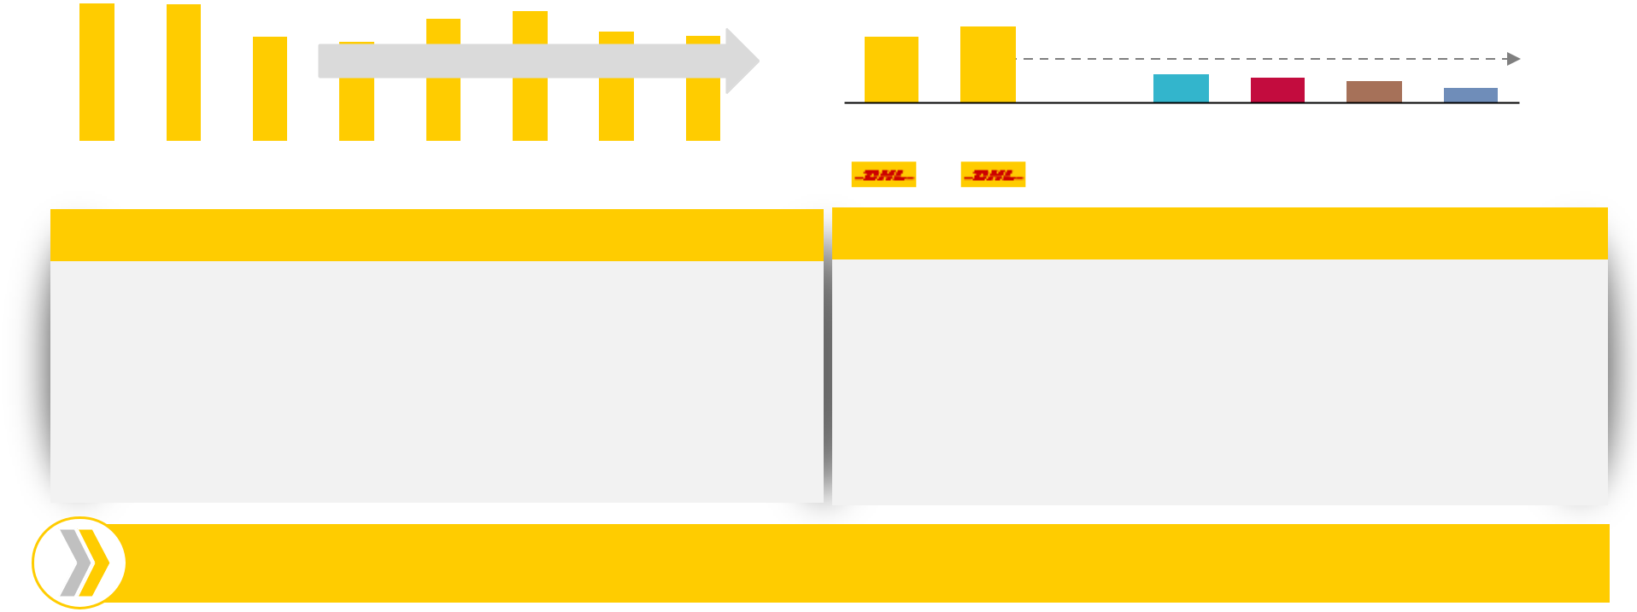

High delivery convenience…

- Broad choice of recipient services for consumers: doorstep delivery, Parcel lockers (Packstation), Click & Collect (Parcel shops)

- Highest density of customer access points for delivery & returns

- ~5m parcels delivered per working day in 2018

DHL Parcel Germany, market share development


+6pp
39% | 45%
 |  |  |  |  | 20%
2010 | 2017 | Comp 1 | Comp 2 | Comp 3 | Comp 4

…enabled by efficient, automated network

- ~82% next day delivery & ~97% second day delivery

- 35 fully automated parcel sorting centers, with average sorting capacity of ~30,000/hour

- >240 local delivery depots and >80 mechanized depots

- Capacity increased by >50% versus 2012

We aim for a balanced mix of volume growth and yield

INVESTOR RELATIONS | NOVEMBER 2019 PAGE 16

DHL EXPRESS

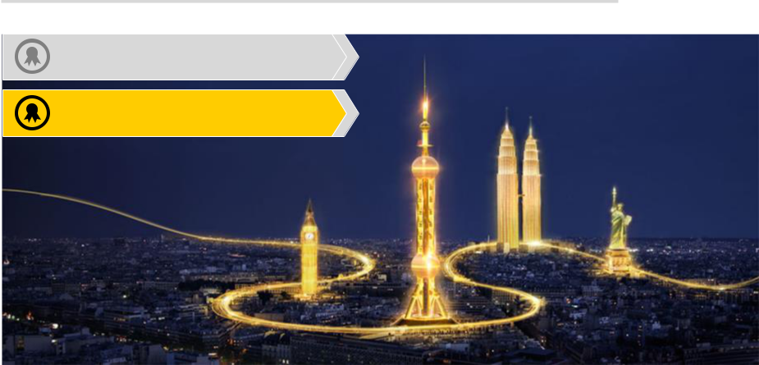

- #1 Europe´s largest post and parcel provider

- #1 International express delivery

INVESTOR RELATIONS | NOVEMBER 2019 PAGE 17
DHL Express: Focus on TDI


DHL Express Core Product | Continue successful FOCUS strategy

TDI (Time Definite International) - The premium segment

within Express Industry

Time Definite = Dedicated delivery at a scheduled time of day International = Cross-Border Shipment (intra- or between continents)

TDI: requires dense and broad international network

TDD: Time Definite Domestic

DDI: Day Definite International

- Day Definite Domestic

ACS: Air Capacity Sales (re-sale of spare capacity on dedicated fleet to optimize utilization, not sold by core Express sales teams)

Content examples:

Bank Docs, Contracts, Certificates, Invoices, Vaccines, Spare parts, Fashion, Passports, Shipping Docs

2009 Revenue distribution
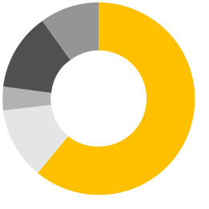

10%

13%


4%

12% ^{61%}

TDI |  | TDD |  | DDI

2018 Revenue distribution
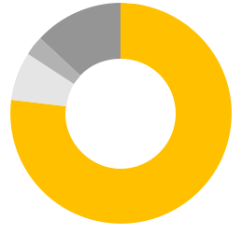

0%
3% 13%

7%

77%

DDD |  | ACS / Other

INVESTOR RELATIONS | NOVEMBER 2019 PAGE 18

DHL EXPRESS: For Our International Network, x-border B2C is a Profitable Growth Driver


Portion of B2C TDI shipments has increased over time
>10%¹⁾ _{>30%}¹⁾

We grow B2C profitably because 90% of the KPIs perfectly suit our network

SpD²⁾ | Volume growth drives better utilization
SpD²⁾ | of existing network
WpS³⁾ | Lower weight per shipment
RpK⁴⁾ | Higher RpK related to lower WpS

2013 2018

Our TDI product is attractive to e-tailers because we offer…
- Unparalleled global door-to-door network

- Fast customs clearance

- Flexible delivery options

- Highest service quality & customer service

  - Indications based on medium to large B2C customers of top 30 countries

  - Shipments per Day 3) Weight per Shipment 4) Revenue per Kilo

First mile

Hub sort 

Airlift

Last mile

More pieces per stop at pickup

Better utilization of existing infrastructure, with high degree of conveyables

Better utilization of existing capacity, with lower WpS being advantageous

Residential delivery to private households

X-Border e-commerce has developed into an important TDI vertical and profitable growth driver

INVESTOR RELATIONS | NOVEMBER 2019 PAGE 19

DHL EXPRESS: The Most International Company in the World

Global network covering 220 countries and territories

First-mover in International Express,
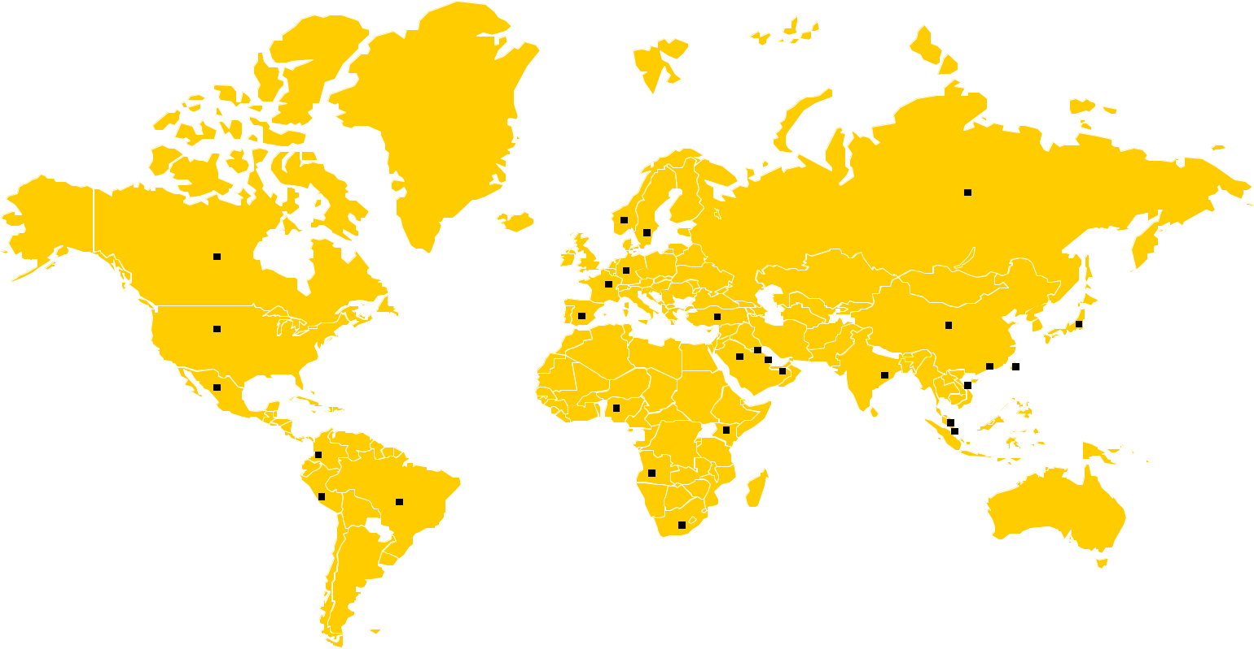

market entrance date by country (examples):

Russia 1984
 | Norway 1977
 | Sweden 1978
Canada 1977 | Germany 1977
 | France 1975
 | Turkey 1981
USA 1969 | Spain 1979 | Kuwait 1980 |  |  | China 1980 Japan 1972
 |  |  |  | Hong Kong 1973
 | Saudi Arabia 1976 | Bahrain 1976
 | Saudi Arabia 1976 |  |  |  | Taiwan 1973
Mexico 1976 |  | UAE 1977 | India 1980 |  | Vietnam 1988
 | Nigeria 1979 | UAE 1977
 | Nigeria 1979 |  |  |  | Malaysia 1973
 | Kenia 1980 |  |  |  | Malaysia 1973
Colombia 1978 | Angola 1984 |  |  | Singapore 1972
Peru 1981
Brazil 1978 | South Africa 1978

INVESTOR RELATIONS | NOVEMBER 2019 PAGE 20
DHL EXPRESS: Global TDI Market Leader

TDI leadership across all regions outside the Americas
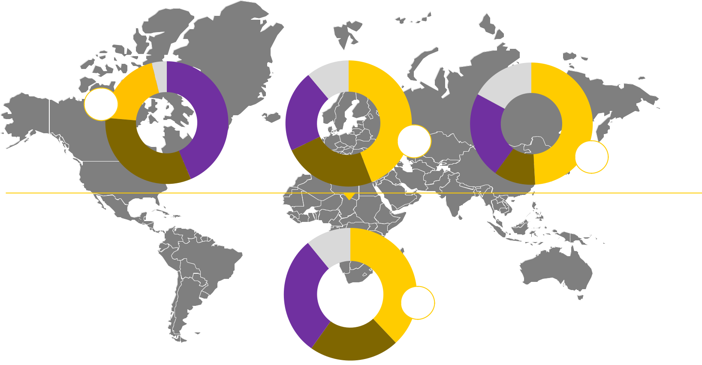

Americas [EUR 8.2bn ]

4%

20%
+2%
44%

Europe [EUR 7.1bn]

 | 11%
21% | 44%

Asia Pacific [EUR 8.0bn]

17%

49%

33%


+x% %pt change vs. 2014 MI study

DHL UPS FedEx, incl TNT Others

Country base:

EU: AT, CZ, DE, ES, FR, IT, NL, PL, RO, RU, SE, TR, UK

AM: AR, BR, CA, CL, CO, MX, PA, US;

AP: AU, CN, HK, IN, JP, KR, SG, TW

+3%

24%

Global [EUR 24.0bn]

11%

38%
^{29%} +4%

22%
23%

11%

+5%

GLOBAL: EU+AM+AP+(AE+SA+ZA)

INVESTOR RELATIONS | NOVEMBER 2019
Source: Market Intelligence 2017, annual reports and desk research

PAGE 21

DHL EXPRESS: Virtual Airline Model

Virtual Airline

Approx. 500 airports and 22 major hubs connected through

- Dedicated air: >250 aircraft with 17 owned and partner airlines on >600 daily flights

- Purchased air: >300 commercial airlines with >1,800 daily flights
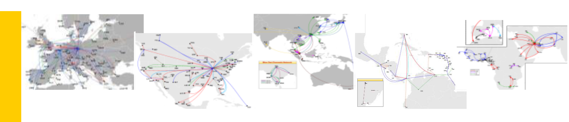

 | Europe |  | Asia Pacific
Networks |  | North America
Regional |  86 dedicated aircraft |  62 |  23

INVESTOR RELATIONS | NOVEMBER 2019

InterCon Network
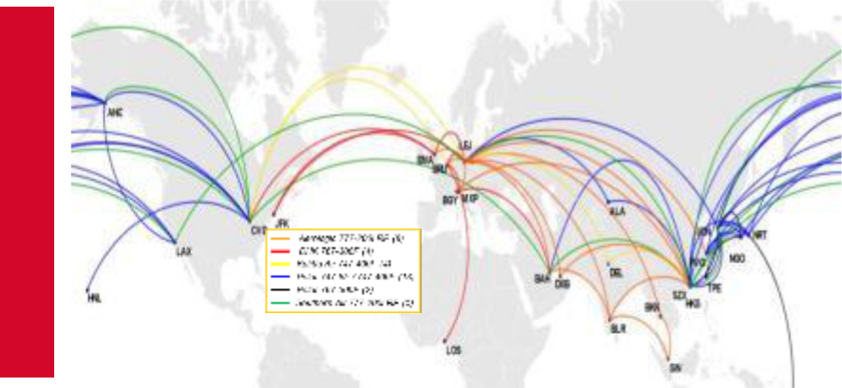

- 36 dedicated intercont aircraft

Middle East & Africa

Latin America

SSA Network

 18 |  19

PAGE 22
DHL EXPRESS: Financial Track Record
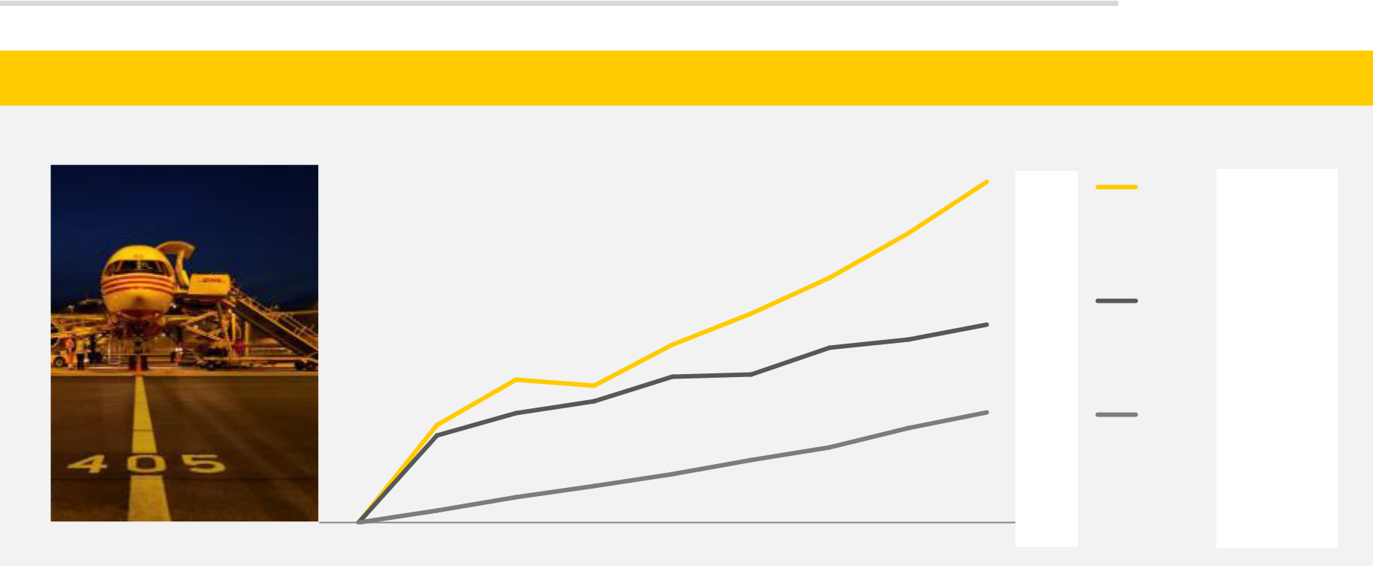

Indexed development of operating KPIs

Indexed to 100 CAGR

13%

8.7%

2010 2011 2012 2013 2014 2015 2016 2017 2018

Focus on TDI growth & yield is crucial to sustained profitability growth

INVESTOR RELATIONS | NOVEMBER 2019

KPI |  | FY 2018


EBIT | € 1,957m

EBIT
margin 12.1%

^{TDI} 955,000

SpD

PAGE 23
DHL GLOBAL FORWARDING, FREIGHT (DGFF)

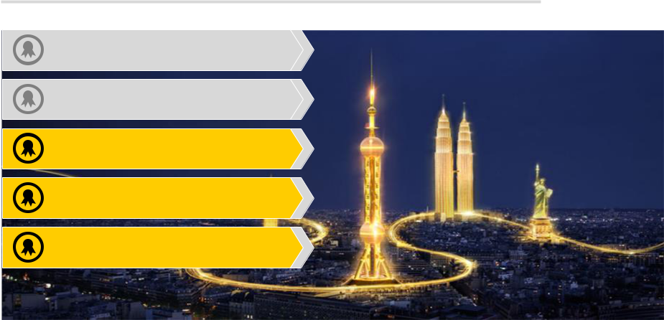

- #1 Europe´s largest postal provider

- #1 International express delivery

- #1Global air freight volumes

- #2 Global sea freight volumes

- #2 European road freight volumes

INVESTOR RELATIONS | NOVEMBER 2019 PAGE 24
DGFF: Products & Solutions Portfolio

DHL AIR PRIORITY

DHL AIR CONNECT

DHL AIR ECONOMY

DHL AIR CHARTER

DHL AIR THERMONET

CUSTOMS BROKERAGE

RAIL FREIGHT

SAME DAY

WAREHOUSING

INSURANCE

SECURITY

2018 Revenue EUR 14,978m
Split by Product Line
DHL ASIALINE
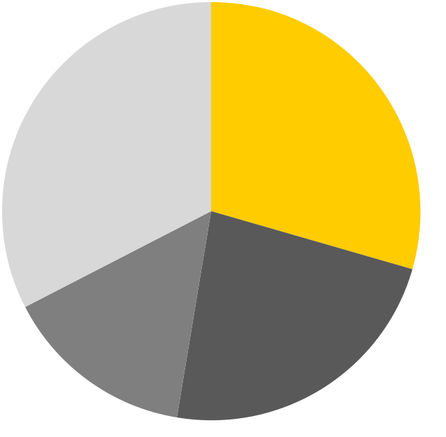

DHL ASIACONNECT

DHL AFRICALINE

DHL AFRICACONNECT

Air Freight Road Freight

DHL OCEAN DIRECT FCL

Others Ocean Freight DHL OCEAN CONNECT CONTAINER

MANAGEMENT

DHL OCEAN CHARTER

DHL OCEAN THERMONET

INVESTOR RELATIONS | NOVEMBER 2019 PAGE 25

DHL GLOBAL FORWARDING: Sector Mix

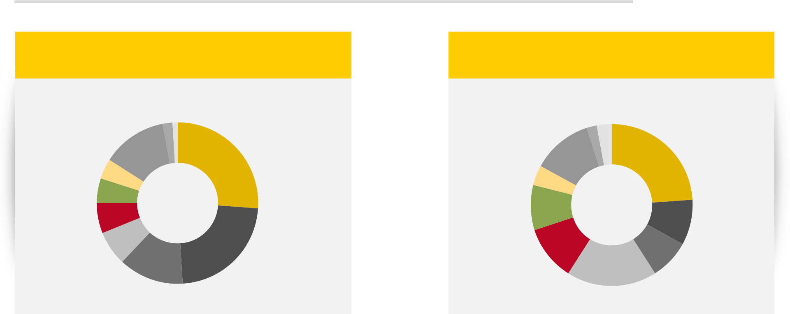

Air Freight volume 2018

(in k tons)

Share of total in %

1%
2%

Engineering &
Manufacturing
Technology

Life Science
Health Care

Ocean Freight volume 2018

(in k TEU)

Share of total in %

2%

13%

4%

5%

6%

26%

Consumer

Automotive

Retail

Chemicals

12% | 3%
12% | 24%

4%

9%
9%

7%
23%

13%

Others

Energy

Wine and Spirits
11% _{8%}

18%

INVESTOR RELATIONS | NOVEMBER 2019 PAGE 26

DHL GLOBAL FORWARDING, FREIGHT: MARKET POSITIONS

Strong market position in all three product segments
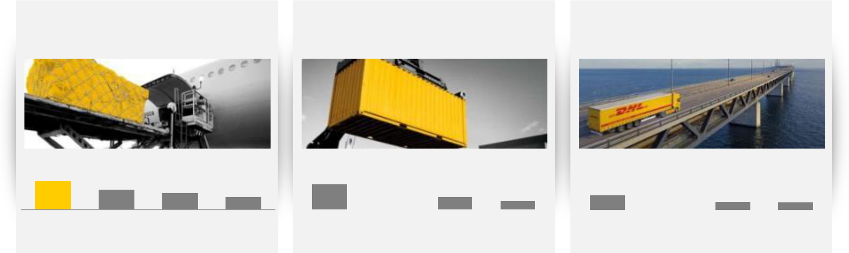

Air Freight volume 2017 |  | Ocean Freight |  | European Road Freight
(exports only) |  | volume 2017 |  | market share 2017
(in k tons) |  | (in k TEU) |  | (in %, based on revenue)

2,248 | 1,570 | 1,300 | 996

DGF Kuehne & DB Panalpina

Nagel Schenker

4,355 | 3,259 | 2,169 | 1,521 | 3.4 |  | 2.2 | 1.9 | 1.7
Kuehne & | DGF | DB | Panalpina |  | DB | DHL | DSV | Dachser
Nagel |  | Schenker |  |  | Schenker | Freight

Source: Company publications/ estimates; MI Freight 2017

INVESTOR RELATIONS | NOVEMBER 2019 PAGE 27

DGFF: We Are Market Leaders in Size and Scope

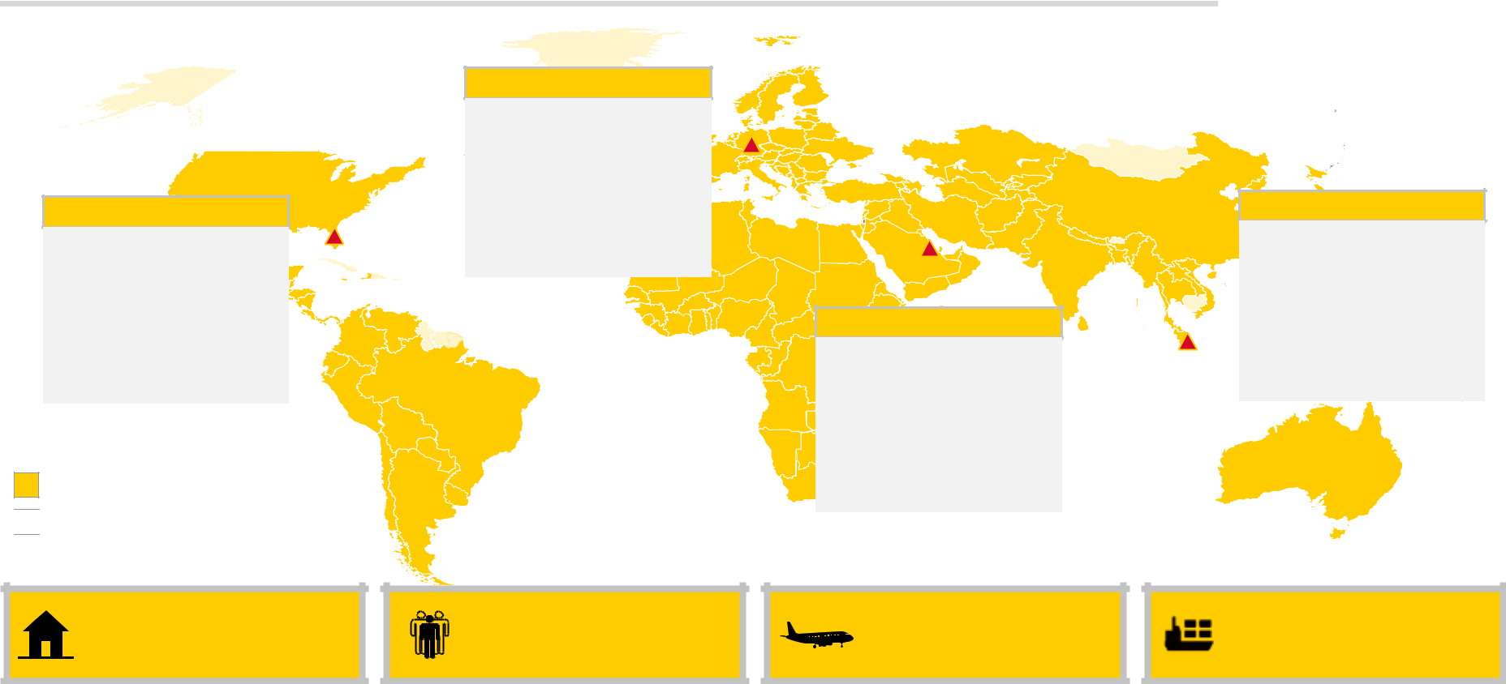

Americas

• ~8,200 Employees

• 36¹⁾ Countries
• 395²⁾ Locations
(offices +

operational sites)

DGF Present

Other DPDHL operations

Regional Head Office

Europe

• ~8,600 Employees

• 49¹⁾ Countries
• 203²⁾ Locations
(offices +

operational sites)

Middle East &Africa

• ~1,900 Employees

• 59¹⁾ Countries
• 47²⁾ Locations
(offices +

operational sites)

Asia Pacific

- ~8,800 Employees

• 37¹⁾ Countries
- 256²⁾ Locations (offices +

operational sites)

Present in more than^{Chile} | ^{Uruguay} ~30,000 highly | >2.2m AFR export | >3.2m TEUs
190 countries | qualified employees | tons transported³⁾ | _{transported}3)New Zealand
1) Including agent countries; 2) Estimate as of August 2016, this is subject to change depending on business operating needs and environment 3) As per FY 2017
INVESTOR RELATIONS | NOVEMBER 2019 |  |  | PAGE 28

The Lifecycle of a Shipment is a Complex Process

Forwarding is more than brokerage of transport, it is managing all the steps along the way
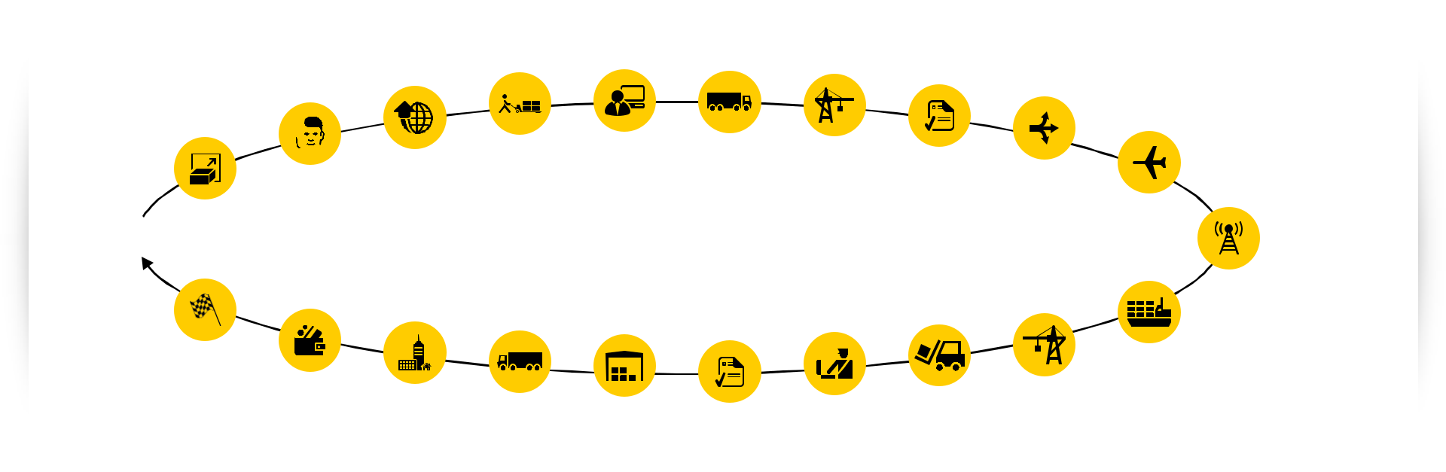

Goods

to be shipped

Quotation

Process

Plan route | Take control | Create documents
Plan route | of goods from | for export compliance | Manage transport
& organize | customer | & customs | to port/airport | Consolidation | Manage loading
shipment |  |  |  | Consolidation | Manage loading
shipment |  |  |  | Consolidation | & export process
Ensure goods

are shipped

Ensure

shipment

stays on track

Billing |  |  | Accept delivery
& payments | Transport to warehouse |  | Accept delivery
& payments | Transport to warehouse |  | at port/airport
 | or final destination | Manage documents for import | at port/airport
 |  | compliance & customs process

Success in Forwarding is built on experience, customer relationships, processes and in some aspects, such as consolidation, is also a function of scale

INVESTOR RELATIONS | NOVEMBER 2019 PAGE 29

DGFF: Gross Profit and Gross Profit/EBIT Conversion

 |  | FY
in EUR m |  | 2018
Total revenues |  | 14,978
Revenues Global Forwarding |  | 10,667
 | t/o Airfreight | 4,924
 | t/o Oceanfreight | 3,503
 | t/o others | 2,240
Revenues Freight |  | 4,454
Consolidation |  | -143
Total Gross Profit |  | 3,604
 | t/o Airfreight | 942
 | t/o Oceanfreight | 668
 | t/o others | 877
 | t/o Freight | 1,117
Reported EBIT |  | 442
 | t/o Forwarding | 362
 | t/o Freight | 80

DGF Gross Profit conversion and EBIT margin
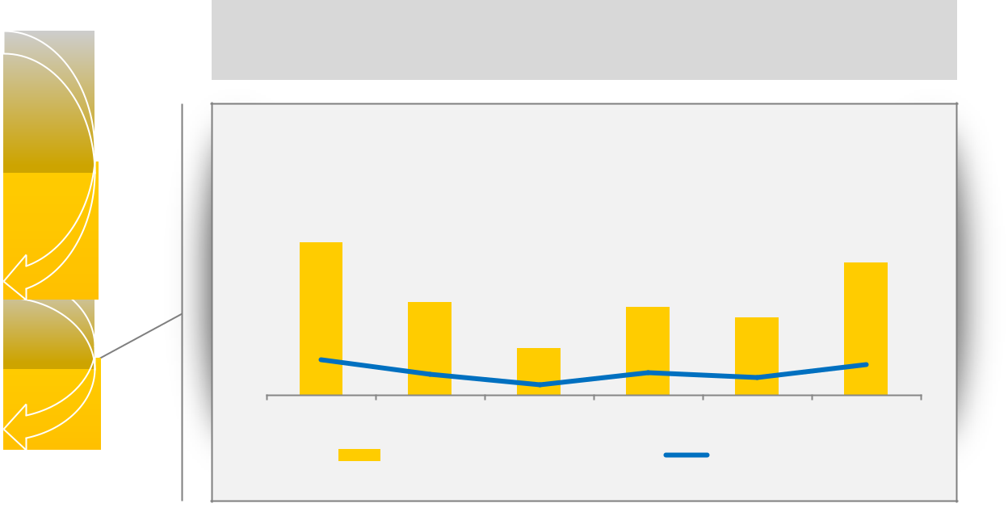

16.9% |  |  |  |  | 14.6%
 | 10.3% |  | 9.7% | 8.6%
3.9% |  | 5.1% |  |  | 3.4%
3.9% | 2.3% | 1.2% | 2.4% | 2.0% | 3.4%
2013 | 2014 | 2015* | 2016 | 2017 | 2018
 | GP-to-EBIT conversion |  |  | EBIT margin
*Adjusted for €353m one-offs

INVESTOR RELATIONS | NOVEMBER 2019 PAGE 30

DGFF: Financial Track Record

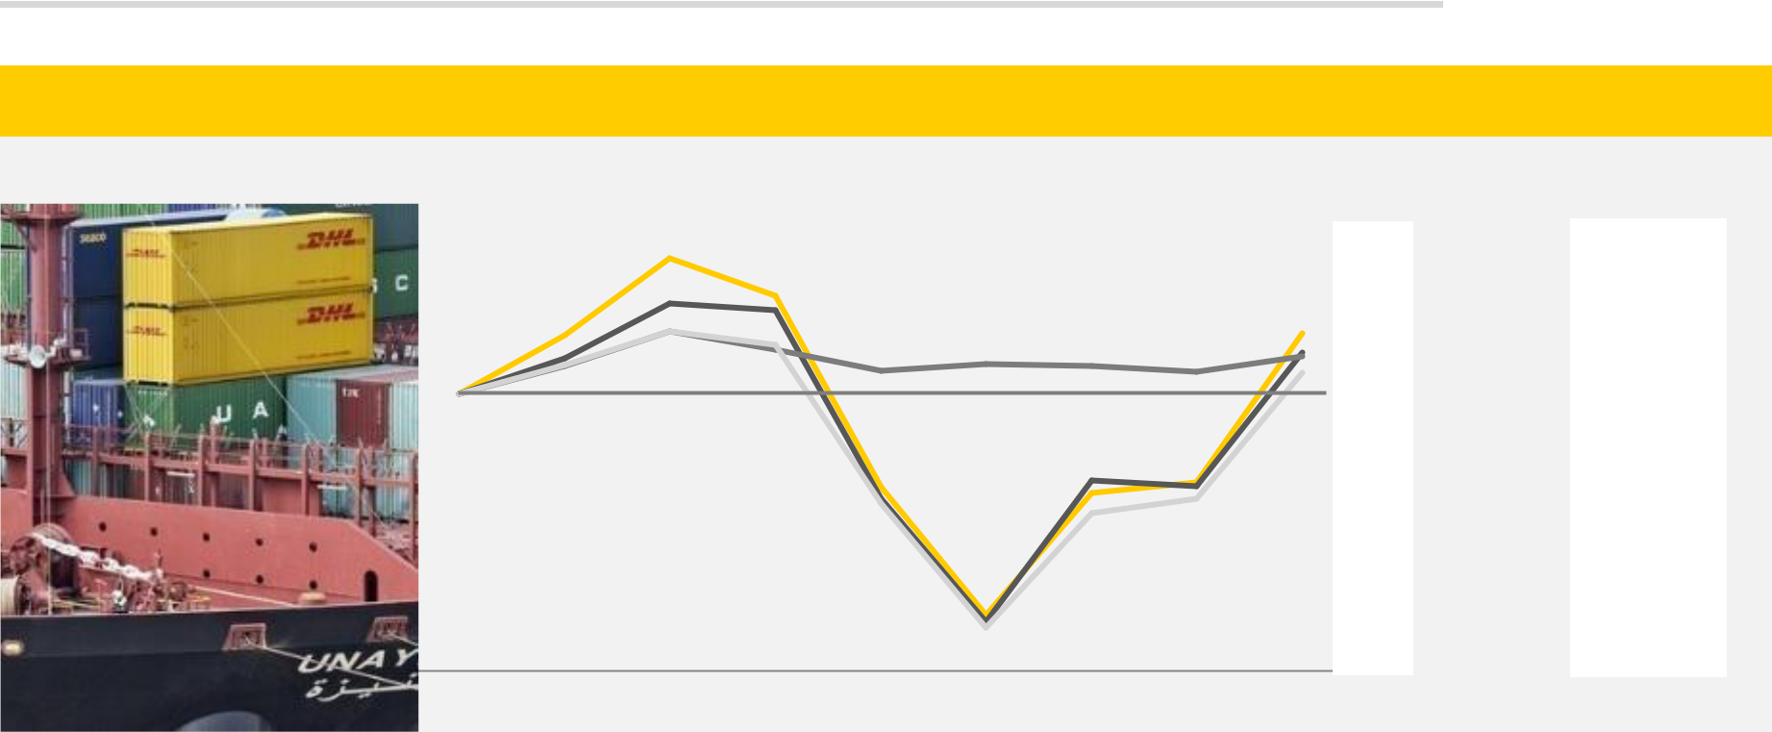

Indexed development of operating KPIs

Indexed to 100 _{CAGR}

2%

1%

2010 2011 2012 2013 2014 2015 2016 2017 2018

 | KPI |  |  | FY 2018
 |  | EBIT |  | EUR 442m
 |  | EBIT |  | 3.0%
 |  | Margin |  | 3.0%
 |  | Gross |  | EUR
 |  | Profit
 |  |  |  | 3,604m
 |  | GP |  | 12.3%
 |  | Conver |  | 12.3%
sion

Profitability KPIs are tightly correlated with GP conversion ratio

INVESTOR RELATIONS | NOVEMBER 2019 PAGE 31

SIMPLIFY: Strategic Framework and Priorities

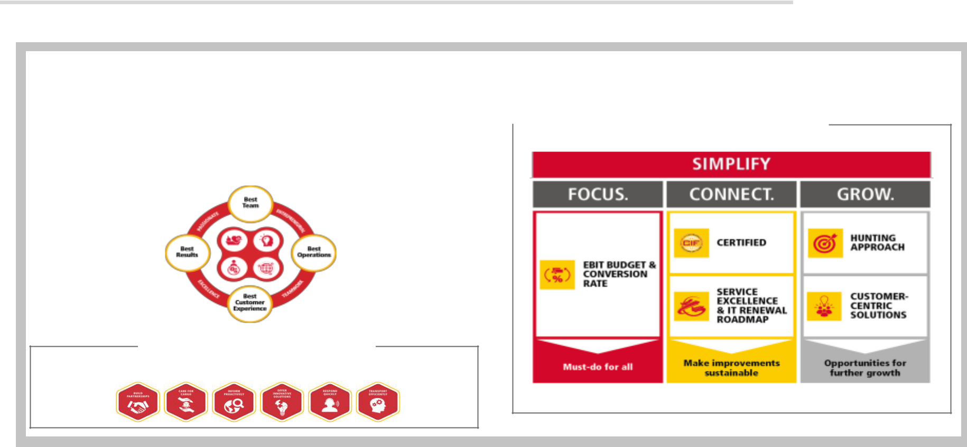

A strategic framework … |  |  |  |  |  | …and priorities
 |  | Our Aspiration
 |  |  |  |  |  |  |  | Priorities 2019
Undisputed Industry Leader |  |  |  |  |  |  |  | Priorities 2019
 |  | Our Goals & Values

Our Service Promise
The Freight Forwarding Experts. Since 1815.

INVESTOR RELATIONS | NOVEMBER 2019 PAGE 32
DHL SUPPLY CHAIN (DSC)

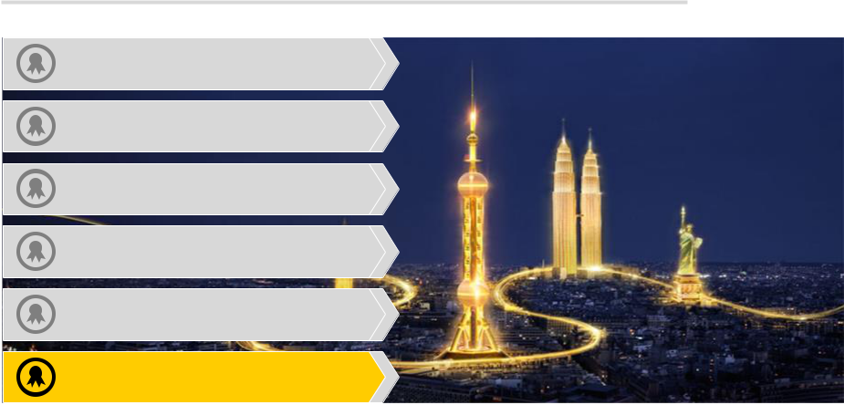

- #1 Europe´s largest postal provider

- #1 International express delivery

- #1 Global air freight volumes

- #2 Global sea freight volumes

- #2 European road freight volumes

- #1 Global leader in contract logistics

INVESTOR RELATIONS | NOVEMBER 2019 PAGE 33
DHL SUPPLY CHAIN: Outsourced Contract Logistics Market

Contract logistics market

Top 10 players 2017

Growth in total addressable market¹⁾ driven by
outsourcing trend

DSC | 6.0%
XPO Logistics | 2.3%
Kuehne & Nagel | 2.1%
Hitachi | 1.8%
CEVA | 1.5%
SNCF Geodis | 1.3%
DB Schenker | 1.2%
UPS SCS | 1.2%
Ryder | 0.8%
DSV | 0.7%

- Fragmented Market

Top 10 players

represent less

than 20% of total

estimated market

volume

Outsourced Contract Logistics |  |  | 2,311 | CAGR
In house logistics
1,907 |  |  | 263 | 5.1%
 |  |  | (13%) | 5.1%
204
(12%)
 |  |  | 2,050 | 3.8%
1,703


EUR bn

2017 2022

- DHL projection based on forecasts from IHS Global Insight and Transport Intelligence; suppliers with global footprint

INVESTOR RELATIONS | NOVEMBER 2019 PAGE 34

DHL SUPPLY CHAIN: #1 in Global Contract Logistics
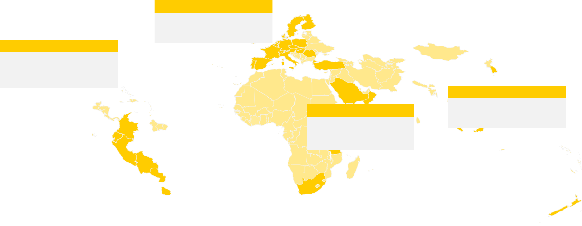

Americas
- ~50,000 Employees

- 13 Countries

DHL Supply Chain presence

Other DPDHL Group operations


Largest warehousing provider with >25m sqm*

- Including owned, leased and operated space

INVESTOR RELATIONS | NOVEMBER 2019

Europe
- ~66,000 Employees
▪ 20 Countries

 |  | Asia Pacific
Middle East &Africa |  | ▪ | ~25,000 Employees
 |  | ▪ | 16 Countries
▪ | ~6,000 Employees | ▪ | 16 Countries
▪ | 7 Countries

Present in more than | Global revenue leader | ~1,500 customers across
50 countries | with EUR 13bn in 2018 | the globe

PAGE 35

DHL SUPPLY CHAIN: Solutions Overview

Offering Customized Solutions Across the Entire Supply Chain
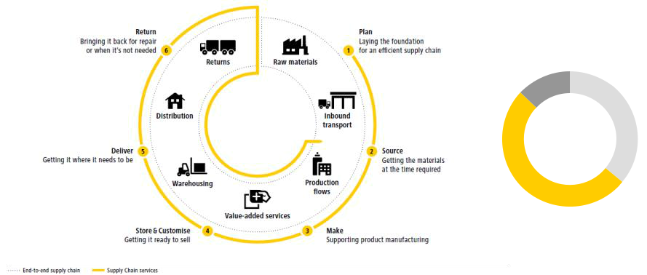

Revenue by Service Area

FY 2018

Value Added
Services
13% Transportation

36%

51%

Warehousing

INVESTOR RELATIONS | NOVEMBER 2019 PAGE 36
Automation & Digitalization at DHL SUPPLY CHAIN

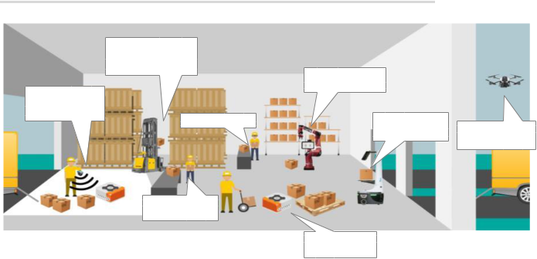

Automated Storage

and Retrieval

Systems

Location/
Tracking via
Internet of Things | Vision Picking

Smart Scanning/

Smart Watches

INVESTOR RELATIONS | NOVEMBER 2019

Collaborative

Stationary Robots

Automated | Surveillance with
Picking Robots | Surveillance with
 | Drones

Automated

Pallet/ Tugger

PAGE 37

DHL SUPPLY CHAIN: Sector Revenue Split and Added Value

Revenue by sector FY 2018

 | Engineering & |  | Others
 | Manufacturing |  | 7%
 | Life Sciences & |  | 5% | 27% | Retail
 | Healthcare | 10% |  | 27%
 |  | 12%
 | Technology
 |  |  | 16% | 23% | Consumer
Direct-to-Market |  |  | 16% | 23% | Consumer


Omnichannel & e-Fulfillment

Automotive

Service Logistics
Inbound to Manufacturing

INVESTOR RELATIONS | NOVEMBER 2019 PAGE 38

DHL Supply Chain: Financial Track Record

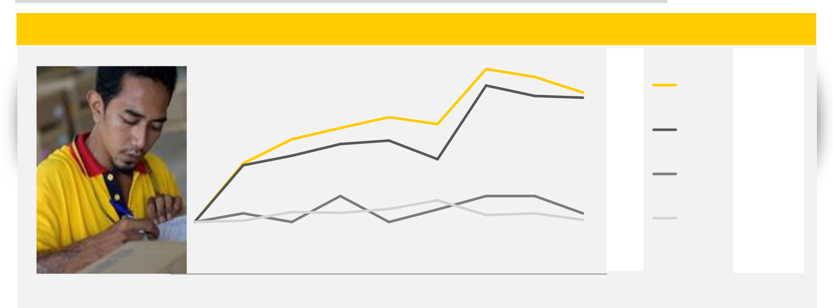

Indexed development of operating KPIs

Indexed to 100 CAGR FY 2018

 |  |  |  |  |  |  |  | 11% | EBIT | EUR 520m
 |  |  |  |  |  |  |  |  | EBIT | 3.9%
 |  |  |  |  |  |  |  |  | Margin
 |  |  |  |  |  |  |  |  | Biz Wins | EUR 1.3bn
 |  |  |  |  |  |  |  | 1%
 |  |  |  |  |  |  |  | 0% | Revenue | EUR 13bn
100
2010 | 2011 | 2012 | 2013 | 2014 | 2015 | 2016 | 2017 | 2018

Focus on selective business wins and contract lifecycles supported by operating standardization drive sustained growth in EBIT and EBIT margin

INVESTOR RELATIONS | NOVEMBER 2019 PAGE 39
INVESTOR RELATIONS CONTACT INFORMATION


Martin Robert Schneider Sebastian Slania Christian Rottler Agnes Putri

Ziegenbalg

+49 228 182 63000 | +49 228 182 63201 | +49 228 182 63203 | +49 228 182 63206 | +49 228 182 63207
m.ziegenbalg@dpdhl.com | +49 228 182 63201 | +49 228 182 63203 | christian.rottler@dpdhl.com | a.putri@dpdhl.com
m.ziegenbalg@dpdhl.com | robert.schneider1@dpdhl.com | sebastian.slania@dpdhl.com | christian.rottler@dpdhl.com | a.putri@dpdhl.com

INVESTOR RELATIONS | NOVEMBER 2019 PAGE 40

