BUSINESS PROFILE
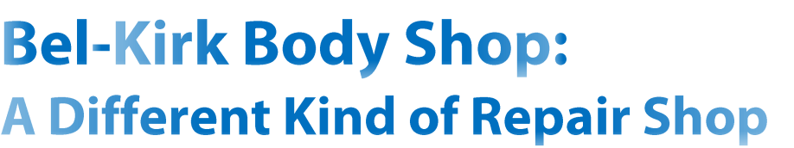

_{B}el-Kirk Body Shop might be small in size, but the family-owned business has left distinguished tread marks throughout the nearby community and beyond.

Just 15 minutes from Seattle, Wash., the full-service, third-generation auto body shop comes highly recommended not only by dealerships and insurance companies but by the locals.

“We have some customers who have been with us for 30 years, since the shop first opened its doors,” said office manager Tina Clark, who is also daughter-in-law to the shop’s owner, Diane Clark. “They have become friends. A lot of them just come by to say ‘hi.’”

Parts align in many ways inside the walls of Bel-Kirk Body Shop. The painting on the back wall is actually a visual replica of owner Diane Clark’s truck. To evoke that homey feel for its customers, the shop’s inner walls are decorated with vintage car parts and license plates. Clark also owns an alignment shop next door.

Parts manager Cecilio ’Cec’ Fines says the body shop boasts a staff count of about 10. “For a small body shop like us, we do a lot of business,” she commented. Fines noted they repair about 15 cars a week, which translates to roughly 80 cars per month.

The shop has not only built a following with the locals, but to contribute to its wide base, office manager Clark said the shop sees a lot of customers from the broader Northwest region.

Clark said customers have come from Spokane, Wash., which is four and a half to five hours away, for alignment work, while others have come up from

By Brittney Henton
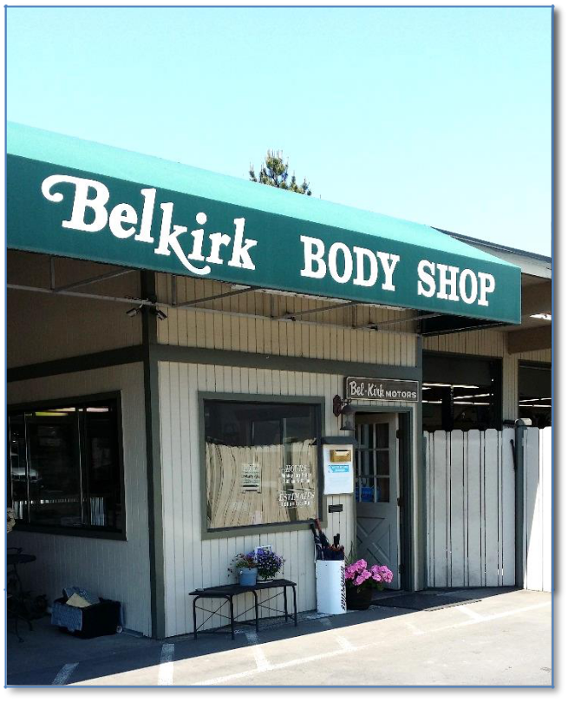

southern Washington or northern Oregon for fender rolling or body work.

“We see everything,” Clark continued, “we don’t specialize in just one car. The owner’s son has built a rapport with a lot of the younger generation,” Clark stated. “We get to see anything from classics to Evos and Subarus.” Clark said they even see lifted 4x4s, big trucks and small, tiny cars. “It’s pretty amazing the types of vehicles we get in here.”

Continued on next page…

JUNE 2015

BUSINESS PROFILE
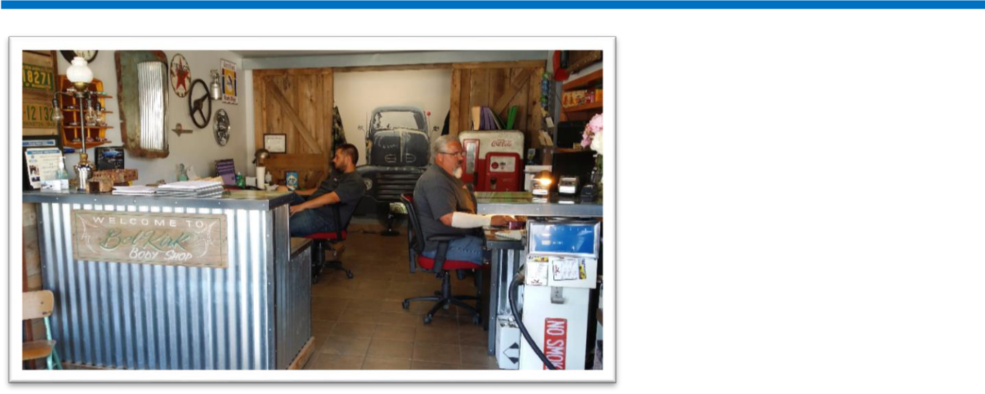

To evoke that homey feel for its customers, Bel Kirk Body Shop’s inner walls are decorated with vintage car parts and license plates.

And the shop is able to handle a large body of work with just one painter, one detail person, two estimators and two body techs.

Clark said one of the body technicians has been working at the shop basically since it opened.

“He’s one of the best out there,” Clark said. “He’s worked on a little bit of everything. He’s pretty amazing.”

Clark said another amazing thing: the shop has also been given the opportunity to sponsor some street car challenges. “It’s giving these kids with performance cars the opportunity to race safely and legally on tracks instead of on the streets,” Clark said.

Fines said he has been using PartsTrader for almost six months now. And since then, the parts (and stars) have moved even more into alignment for the business. “(PartsTrader) saves you time so you can do other things,” Fines said. Sometimes those “other things” include checking in parts. Then all Fines has to do is come back to his office to monitor his orders on his computer. PartsTrader provides an Estimated Time of Arrival for each order.

Fines said the size of the shop’s parts inventory varies, but the shop does order a lot of parts. He said he has used the parts ordering service more heavily the last three months.

The road wasn’t always smooth, though. He said at first, PartsTrader was hard to understand. But he got over that road block by keeping in contact with his area

representative, Zeke Villalobos, and by utilizing PartsTrader’s technical support hotline.

Fines said one reason the shop started using PartsTrader more was because the number of insurance companies accepting PartsTrader has grown.

Fines also said the parts service includes of lot of vendors that he has ordered parts from in the past, now a part of PartsTrader’s “preferred” vendors list. “It’s the same people that I worked with. I know them personally,” he said.

Another thing he enjoys about PartsTrader: the incentives. “There’s more rewards points,” Fines said. “You get so many points, you can get a reward for your store” – body shop equipment, for example.

Just as PartsTrader has made tweaks and upgrades to its system, Bel-Kirk Body Shop has been building its brand by acquiring a broad and loyal customer base, according to Clark.

PartsTrader’s simplicity has proved a valuable asset for Bel-Kirk Body Shop’s profound reach and increasing commitments.

“It’s fast and simple,” Fines said about ordering through PartsTrader. “And once you get to know it, it works good for you.”

This article courtesy of PartsTrader - www.partstrader.us.com © PartsTrader LLC All rights reserved.

JUNE 2015

