LFOUNDRY

COMPANY PROFILE



OVERVIEW |  | 3
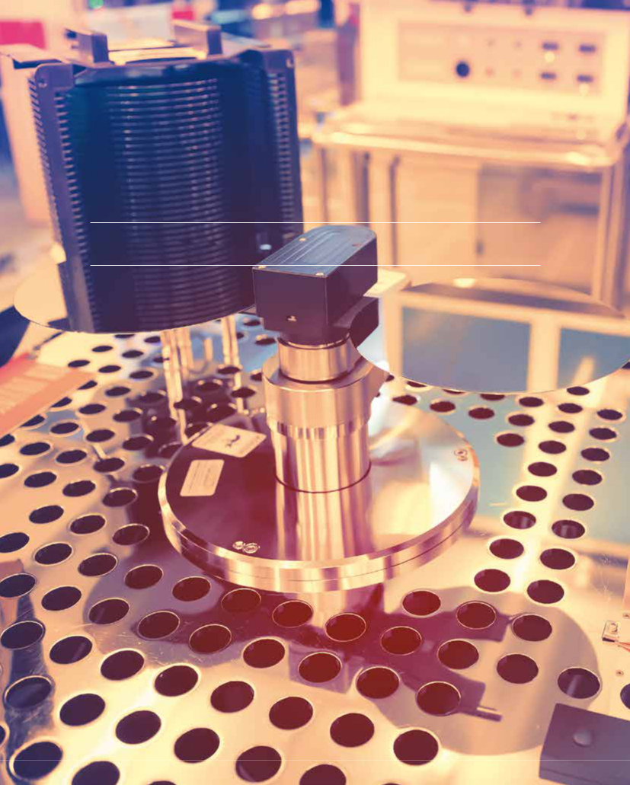

01

OVERVIEW
4 LFOUNDRY COMPANY PROFILE

LFoundry, a SMIC company, is a leading specialized foundry. From the heart of ancient Europe, with the Headquarter

in Avezzano (Italy), LFoundry is focused on providing access to most advanced analogue manufacturing service with a capacity of >40,000 wafers/month, innovative technology extensions, including volume 90nm and copper manufacturing, a strong emphasis on flexibility and customer partnership. LFoundry is supporting own technology IP for 150nm and 110nm with a large portfolio of process-proven libraries, IP, design tools and reference flows. LFoundry’s key focus is primarily
in automotive and industrial related applications including CIS, security, smart power, embedded memory, and others.

As a SMIC Company, LFoundry can leverage skills and capabilities of one of the leading semiconductor foundries in the world and the largest and most advanced foundry in mainland China.

OUR PLACE

In Avezzano (AQ - Italy), LFoundry is enabling innovation worldwide. We have a continuous commitment to guaranteeing a secure environment in which our customers can realise their ideas to the highest standard, relying on LFoundry as an indispensable partner to unleash their full potential.

DEDICATED FOUNDRY AT AVEZZANO

Since 2006, the 8” Avezzano site has been manufacturing imaging process technologies and products using 180nm to 90nm technologies, including a volume copper, Back End of Line (BEOL), Back Side Illumination processes (BSI) and extensive testing capabilities. The Fab provides automotive ISO-TS16949 certification as well as OHSAS 18001 and ISO 14001.

LFOUNDRY GLOBAL FOOTPRINT
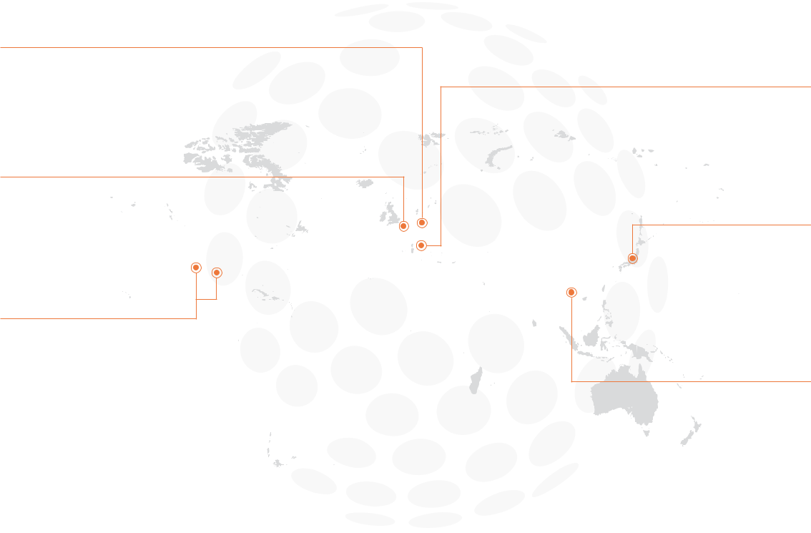

GERMAN HEAD OFFICE

Landshut, Germany:
- Management
- Sales & Marketing Head Office

- Design

SALES REPRESENTATION

Paris, France

SALES REPS AND BUSINESS

DEVELOPMENT OFFICE USA

Irvine, CA
Austin, TX

HEADQUARTER AND

MANUFACTURING

Avezzano, Italy

JAPAN OFFICE

Tokio, Yokohama, Japan

SALES REPRESENTATION

South Korea

OVERVIEW |  | 5

OUR WORDS

These are the words we choose to name our spirit and introduce LFoundry to the world.

This is what we are, where we go, what we do and how we do it.

Put simply, this is us.

MISSION

WE CREATE INNOVATIVE SOLUTIONS TO BRING OUR CUSTOMERS’ VISION TO LIFE, SHAPING STRONG PARTNERSHIPS IN A HIGHLY SECURE ENVIRONMENT

VALUES

RESILIENCE

Resilience expresses the ability to go up against significant change and come out victorious. Rooted in LFoundry’s history, this value lays a strong foundation for the company to overcome the technological and circumstantial challenges of the future.

INITIATIVE

LFoundry promotes a spirit of initiative to find high-performance solutions. Driven by creativity to create value for and with its customers, making the right decisions at the right time.

FAIRNESS

LFoundry works alongside its customers to create tailor-made solutions, establishing highly collaborative relationships founded on its dignity and integrity as a technology partner.

SECURITY

A continuous commitment to guaranteeing a secure environment in which customers can realise their ideas to the highest standard, trusting in LFoundry as a valued partner to unleash their full potential. Embodies the concept of protection,

both in terms of the products themselves and the intellectual property rights associated with them.

INTERDEPENDENCE

Conveys the ideas of interdependence and cooperation, specifically in the foundry-customer interrelationship, in individual work teams and between each member of LFoundry’s workforce. This value underlines the importance of the single parts of a larger system comprised of the foundry, its customers and its employees, simultaneously evoking their connection to the working process with a view to reaching a common goal.

6 LFOUNDRY COMPANY PROFILE
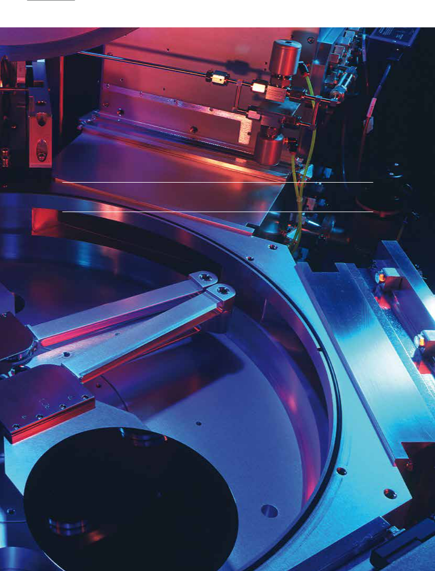

02

COMPANY BASE DATA
COMPANY BASE DATA |  | 7


REVENUE

MILLION $:

225

FAB CAPABILITY:

Smallest CD 65nm, 90nm volume production, Al and Cu metallization

AVAILABLE LOGIC PLATFORMS:

CMOS 150nm and 110nm

SPECIALIZED TECHNOLOGY SOLUTIONS:

110 nm Smart Card Platform with 90nm eFlash, 110nm CMOS Image Sensor Platform Incl. BSI

CAPACITY |  | TECHNOLOGY TEAM
WAFER PER MONTH: |  | R&D ENGINEERING:
40.000 | 90
 | PROCESS & EQUIPMENT ENGINEERING:
 | 110
 |  | DESIGN:
 | 14

TECHNOLOGY

SPECIALIZED SOLUTIONS ROADMAP:

110nm Touch Display, 150nm Smart Power (LDMOS), CMOS Integrated MEMS

SPECIALTIES:

Back Side illumination process, Back Side processing for thin wafer, wafer stacking

SPECIALITY FOUNDRIES

1.0µm ... 0.25µm

150 / 200mm

TECHNOLOGY NODE

ANALOG
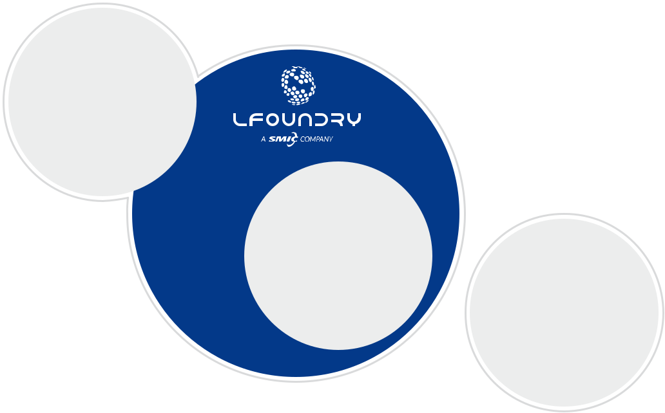

MIXED SIGNAL

- SPECIALIZED FOUNDRY

180 …90 / 80 ... 65nm

200mm ... 300mm

POSITION STRATEGY

Combining mainstream technologies for analog mixed signal:

- with specialty foundry offerings

- on moving forward technology nodes and wafer size requirements

DIGITAL FOUNDRY

≤ 45nm / 300mm

WAFER SIZE

8 LFOUNDRY COMPANY PROFILE

SERVICE MODEL

Innovative in technology, partnership-and supply-models in secure environment.


CUSTOMER TECHNOLOGY | QUALITY | JOINT TECHNOLOGY DEVELOPMENT
CUSTOMER TECHNOLOGY | INNOVATIVE
 | TECHNOLOGY
Adopting customer technology | COMMITMENT |  | Technology development
and customizing foundry technology | FLEXIBILITY |  | and production partnership

OPEN FOUNDRY

Design environments and wafer

fabrication based on advanced

analogue/mixed signals technology

JOINT TECHNOLOGY DEVELOPMENT


- Excellent network to leading institutes

- New integration e.g. for MEMS into CMOS

- Technology IP generation

- Setup of full solutions

OPEN FOUNDRY


- Flexible PDK platform (i-PDK) with accurate models

- Continuous mainstream technology enrichment with modules like Image Sensors/Pixel, Optical Sensors, High Voltage, RF devices, High density / low cost embedded memory, ...

- Specific qualifications like automotive and security


CUSTOMER TECHNOLOGY

- Special imaging technology know how and capabilities

- Engineering know how & IP for non-CMOS technologies such as Optical Sensors, Power MOS, …

OUR VALUE PROPOSITION

- Reliable, fast and flexible customer-specific manufacturing and development partner

- Providing volume leading-edge specialized technology capacity down to 90nm and copper metallization

- Advanced analog and mixed-signal process technologies down to 110nm including stacking capability

- CMOS Image Sensor optimized technology on 110nm and 90nm incl. Back Side Illumination

- Special competencies and technologies for, Imaging, Smart Cards Smart Power and Touch Integrated Display Drivers
TECHNOLOGY |  | 9
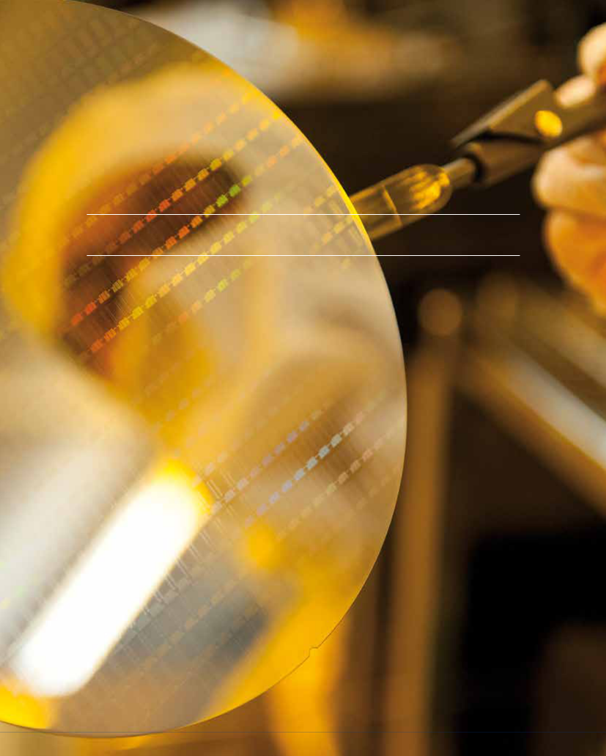

03

TECHNOLOGY
10 LFOUNDRY COMPANY PROFILE

TECHNOLOGY PORTFOLIO

Designing complete systems today for the worldwide markets of tomorrow requires the correct identification, the efficient incorporation and the absolute protection of critical, reusable and fundamental intellectual property building blocks. LFoundry demonstrates each day its flexibility. Company engineers are prepared to meet with customer counterparts

to decide whether to use customer IP exclusively, import third-party IP or to integrate LFoundry IP into a system-level design.

LFOUNDRY TECHNOLOGY 150nm

0.15μm high performance (automotive grade, radiation hard) analog, mixed-signal process for a wide field of different applications, including high voltage and various sensor (Opto, MEMS) SoC enabling technologies.


• | Temp. Sensor
• | Gas Sensor * | Process for
• | Energy Harvester * | Process for
• | Energy Harvester * | complex AMS
 |  | products | Memory
 |  | High Temp. | SRAM
 |  | High Temp. | e-fuse*
 |  | 150°C (T_{a}) | e-fuse*
 |  | 150°C (T_{a}) | EEPROM
 |  |  | OTP

- 4-6 Metal (Al.)

- 1.8V MOS high speed

- 1.8V MOS low leak

- 3.3V MOS

- 5V MOS

- high poly resistor

- MIM 1fF, 2fF

 | 150nm | High quality
C-MEMS |  | Digital Library
C-MEMS |  | Low leak
Sensors |  | Low leak
Sensors |  | High speed
Harvester |  | High speed
 |  | RF
High Voltage |  | Inductors
LDMOS |  | Varactors
Power metal | up to 10GHz
 | Opto
 | Photosensor
 | Filters
 |  | Step | Process

Integrated Power

- MT power metal

• LDMOS up to 60V

• LDMOS 2.0 & IGBT* >80V up to 800V

Isolation | STI with mini LOCOS
Channel | Retrograde Implants with HE
Gate Oxides | 1.8V, 3.3V, 5.0V
Gate | Salicided polysilicon (150nm)
Spacer | Oxide
Salicide | CoSi2 with salicide block
Contact & Vias | Tungsten
Metals | Up to 6 Aluminium + MT (Inductors)
Passivation | Polymide

*Under development

TECHNOLOGY |  | 11

LFOUNDRY TECHNOLOGY 110nm

The focus of the 0,11µm technology is in the low power and high speed area for analog, mixed-signal products with higher digital rate based on its 1.2V core.


Process for

high density

digital
products
HV MOS

High Temp. 6V MOS

125°C (T_{a}) 32V MOS
LDMOS*

- 4-6 Metal (Al./Cu.)

- 1.2V MOS (low, regular, high)

- 1.8V MOS (inside Flash)

- 3.3V MOS

- 5/6V MOS

- 32V MOS

- high poly resistor

- MIM 1fF, 2fF, >4fF*

RF* | 110nm | Digital Library
Inductors | 110nm | Digital Library
Inductors | 110nm | High density
Varactors | 110nm | High density
... |  | Low power

 | Memory
CMOS imager | Flash (90nm)
CMOS imager | OTP
Advanced | OTP
Advanced | SRAM
Opto | SRAM
Opto | ROM (m/dif)
 | e-Fuse*

Step | Process | Advanced Memory
Isolation | STI | • | High quality Flash
Channel | Retrograde Implants with HE |  | SST ESF-3 (500k W/E)
Gate Oxides | 1.2V, 3.3V, 5/6V, 32V | • | Low mask count Flash*
Gate | Salicided polysilicon (110nm) | • | Low mask count Flash*
Gate | Salicided polysilicon (110nm) |  | based on SST ESF-1
Spacer | Oxide L-shape |  | based on SST ESF-1
Salicide | CoSi2 with salicide block
Contact & Vias | Tungsten
Metals | Up to 6 Alu/Copper
Litho | Down to 193nm ArF

*Under development

12 LFOUNDRY COMPANY PROFILE
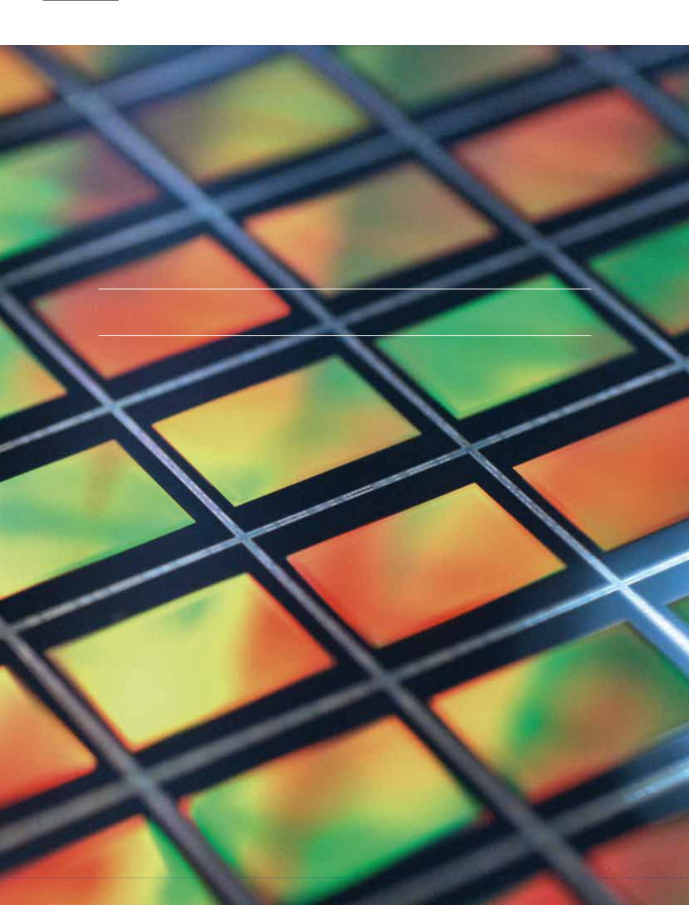

04

LFOUNDRY’S CODE OF ETHICS
LFOUNDRY’S CODE OF ETHICS |  | 13

LFOUNDRY’S CODE OF ETHICS

Ethical principles are crucial drivers on our path toward a sustainable future.

The Code of Ethics represents an unavoidable management tool for ethical conduct in business affairs, together with the rules and agreements in force in the countries where LFoundry is operating, both directly and indirectly,

or through its subsidiaries and / or affiliates. The Code is also an effective element of corporate strategy and organization and is an integral part of the Organisational, Management and Control Model pursuant to Legislative Decree
no. 231/01 (hereinafter the “Model”).

The ethical principles inspiring LFoundry, and from which its models of conduct derive, in order to effectively and fairly compete in the market, improve the satisfaction of its customers, increase the value and develop people’s skills and the professional growth are following:

- compliance with the laws

- ethics, fairness, professionalism

- impartiality

- people’s honesty

- transparency and completeness of the information

All people at LFoundry, without any distinction and exception, undertake therefore to observe and enforce these principles, as part of their duties and responsibilities. This commitment requires that the persons, with whom the company is in relationship for whatever reason, act towards it according to the rules and methods based on the same

values. In particular, the belief of acting to the benefit of the company shall not justify in any way behaviors that conflict with these principles.

In this scenario, LFoundry is responsible for:

- promoting propagation of the Code among the recipients so that they can contribute to improve its principles
- and contents

- taking into account recipients possible suggestions and observations, in order to confirm or integrate the Code
- controlling the compliance with the Code by providing suitable information, prevention and control tools
- and procedures, and ensuring the transparency of operations and behaviors, implementing corrective actions, if necessary

The verification of compliance with the Code is performed by the Supervisory Body pursuant to Legislative Decree. 231/01 of the Company (hereinafter “OdV”).

Bringing such principles and conduct to life is the essential element for the responsible growth of our company, whose aim is to be one of the best examples of business ethics
at international level.

LFoundry Code of Ethics was approved by the Board of Directors of LFoundry S.r.l. on April 29, 2014.

14 LFOUNDRY COMPANY PROFILE


Bringing THE CODE OF ETHICS principles and conduct to life is the essential element for the responsible growth of our Company, whose aim is to

be one of the best examples of business ethics at international level.
CORPORATE SOCIAL RESPONSIBILITY |  | 15
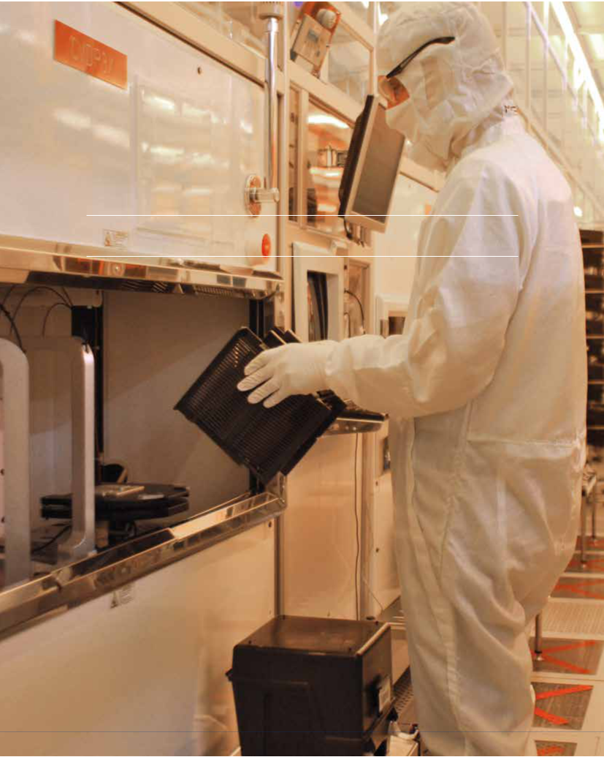

05

CORPORATE SOCIAL RESPONSIBILITY
16 LFOUNDRY COMPANY PROFILE

CORPORATE SOCIAL RESPONSIBILITY

Being a leading company means being an example to the world we lead.

HEALTH AND SAFETY

The Occupational Health and Safety (OHS) Management System, established at LFoundry according to OHSAS 18001:2007 standard is periodically assessed and recertified by a Third Party. The company’s performance on these disciplines exhibits the effectiveness of preventative and protective measures we adopt to safeguards and protect employees, visitors and contractors from the occupational risks as well as those risks associated with eventual emergencies.

SECURITY

The Security Management System in LFoundry, according to intents of its security policy, is intended to “safeguard people, information, goods and business continuity, guaranteeing an environment that infuses trust to investors, suppliers and customers.”

LFoundry is deeply committed in the protection of the Confidentiality, Integrity and Availability of Information, Goods, Process, Material and Product. Its aim is to reach this goal through the suitable use of technologies, methods, and trained personnel.

In order to catch and keep this goal LFoundry is involved in a Site Security Certification process, in accordance with the ISO 15408 standard.

This certification path is under control of the Italian Body for Security Certification (OCSI: Organismo di Certificazione della Sicurezza Informatica: depending from MISE (italian Ministry for Economic Development).

The plan for LFoundry is to reach an EAL5+ level certification.

In case of success this will be the first time that in Italy a company reaches such certification level.

ENVIRONMENT

The Environmental Management System established

at LFoundry according to DIN ISO 14001:2004 standard is periodically assessed and recertified by a Third Party; this exhibits the effectiveness of systems and methods we adopt as well as the continuous commitment for the environment as proof of consistent compliance to regulations and achievement of significant results in reducing the use

of natural resources, energy consumption, raw materials and chemicals, disposal of wastes and employees transportation.

ENERGY

Energy Management plays a key role in support of our plans to maximize profitability, strengthen our competitive position, and provide customers with the highest quality products through Best Key Methods implementation (BKM) which allow LFoundry to be a benchmark company in terms of rational use of energy, increasing the efficiency of energy production and utilization process management of the main sources of energy through a solid management of conventional and innovative activities and projects, while maintaining the conformity with law and code.

The energetic screening arranged in compliance with the guide UNI CEI 16247, LFoundry strives to:

- maximize its energy performance, reducing operating

CORPORATE SOCIAL RESPONSIBILITY |  | 17

expenses and increase shareholder value by actively and responsibly managing energy consumption

- demonstrate commitment to our community and leadership in our industry, by reducing environmental impacts associated with energy use

- identify strategic project to achieve energy management mission

Based on the energy audit below the major activities and project accomplished during the 2015:

- site relamping of more than 30.000 sqm of parking area allow us to save more than 60% of energy saving, improve the performance and reduce the impact
to the envoronmental

- free cooling based on the well water temperature we recovery cooling to supply fab tools and reducing electrical chiller usage

- compressed air system efficiency improvement

as a revamping of the system based on the replacement of 3 old compressors with 2 new high efficiency compressors allow us to save 30% of energy consumption

Invested more than 400.000 euro in energy efficiency project and approved strategic investment on cogeneration revamping which will allow us to improve site energy efficiency of the 25% and reducing environmental impact of the 30%.

Last but not least, started an internal program of energy efficiency with internal resources (site energy conservation team) with the object to reduce fab tool consumption.

Waste management

Waste is one of the area of focus of LFoundry environmental policy. Semiconductor realization end up with generation of large amount of hazardous and not hazardous waste which contribute to enviromental pollution, other than resulting in cost for a correct disposal. In order to effectively address this environmental aspect, LFoundry actively joined SILVER project within ENIAC JU so to identify a viable industrial solution to reduce waste from Photolitography process. Results of experimentation conducted with L’Aquila University have demonstrated good possibility to degrade one of the most environmental hazardous substance (TMAH) though a specific biological purifier treatment.

Water management

Water is a key resource for semiconductor production.

A large amount of ultrapure water is needed to run

a production Fab, and same quantity is released as waste water at the end of the production cycle. LFoundry is actively investigating in solution to improve water usage efficiency, so to reduce needs at facility incoming, as well as is focused in releasing less polluted water at final discharge for the benefit of the environment. In 2015 a small water recycle plant was installed in the facility so to eliminate suspended solid from polishing process ( CMP ) waste stream.

The plant has a nominal capacity of 5m3/h and is confirming its effectiveness in providing a good recycled water for industrial purposes.

18 LFOUNDRY COMPANY PROFILE
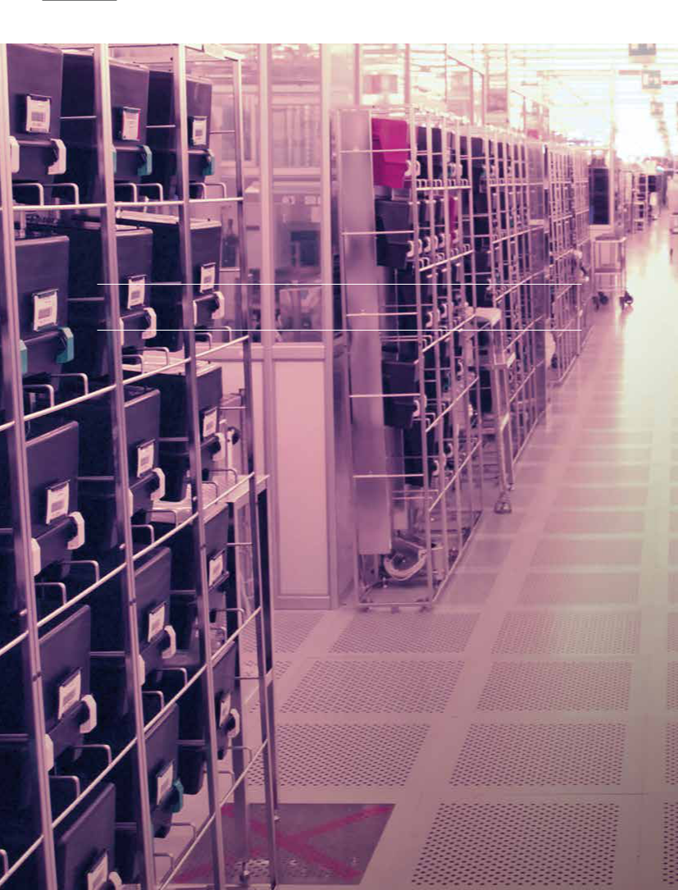

06

QUALITY POLICY
QUALITY POLICY |  | 19

WE CALL IT “QUALITY CULTURE”

LFoundry’s approach to quality.

The ability to bring our customers’ ideas to life, the spirit

of interdependence, partnership, and fairness we instill, and the attention to a global concept of security all lead to a quality culture at LFoundry that protects our customers’ projects from the moment of their inception. Our competitiveness

is grounded in the ability to satisfy our customers’ needs, and quality is the key which enables us to facilitate their success and guarantee its continuity.

The quality of our production is underpinned by a tightly structured and highly integrated process oriented management system, designed to ensure the safe transition from a flexible and innovative habitat in developmental stages to a mindful and controlled environment during series production. A profound application of risk management and LFoundry’s deployment of the best known methods

of quality management are complemented by advanced, highly customised solutions for error prevention and process control to create the right environment for any project. Through
our commitment to continuous improvement we ensure that the quality of our customers’ products undergoes constant enhancement, plotting a detailed roadmap to zero defects with our partners.

As a consequence of this steadfast management system, LFoundry is able to fulfill our customers’ most stringent requirements, even meeting the exacting standards of the automotive industry. Our quality management system has been certified in compliance with ISO TS 16949 specifications since 2009, making us the perfect partner to satisfy

the standards of a wide array of challenging market segments.

The most rewarding recognition of our efforts toward

global quality is the appreciation our customers voice

to us regarding the tangible improvements they see in the

performance and yield of their products. This builds strong

and cohesive partnerships with mutual trust, conceived in the earliest developmental stages of our collaborations and then consolidated in the management of mature products.

QUALITY POLICY

We are committed to partner with our customers to exceed their expectations.

Our competent and motivated team is engaged in providing the best innovative and reliable foundry solution,

in a continuous effort to achieve zero defect and quality excellence.

KEY QUALITY ELEMENTS

PARTNER WITH OUR CUSTOMER

TO EXCEED THEIR EXPECTATION

 WE STRONGLY BELIEVE THAT QUALITY EXCELLENCE MAY BE ACHIEVED ONLY PARTNERING WITH OUR CUSTOMERS.

PARTNERSHIP STARTS SINCE THE ANALYSIS

OF CUSTOMERS IDEA IN ORDER TO FIND THE RIGHT SOLUTION TO ENABLE THE ACHIEVEMENT OF THE MOST CHALLENGING TARGETS, TO PREVENT ISSUES AND TO ENHANCE FURTHER IMPROVEMENTS.

DEVELOPMENT STAGES ARE MANAGED SIDE BY SIDE WITH OUR CUSTOMERS TO ENSURE A SAFE LAUNCH OF THE PRODUCTS AS A PREREQUISITE OF FUTURE CONSTANT DELIVERY OF QUALITY PRODUCTS.

20 LFOUNDRY COMPANY PROFILE

BEST AND INNOVATIVE AND RELIABLE QUALITY EXCELLENCE: MANAGEMENT BY

FOUNDRY SOLUTION PROCESS

WE BRING CUSTOMER PRODUCTS TO LIFE THANKS TO OUR INNOVATIVE AND RELIABLE FOUNDRY SOLUTIONS.

WE FOLLOW A STAGE AND GATE APPROACH TO INTRODUCE NEW TECHNOLOGIES AND NEW PRODUCTS.

OUR PRODUCT LIFECYCLE MANAGEMENT FOLLOWS THE INDUSTRY STANDARD APQP (ADVANCED PRODUCT QUALITY PLANNING) PRINCIPLES.

IT GUARANTEES A FAST AND RELIABLE PROCESS DEVELOPMENT AS WELL AS A SAFE LAUNCH IN SERIES PRODUCTION. THE COMPLIANCE WITH CUSTOMER REQUIREMENTS IS CONSTANTLY VERIFIED IN EVERY PROJECT PHASE.

COMPREHENSIVE RELIABILITY PROGRAM FOR PROCESS AND TECHNOLOGY QUALIFICATION ACCORDING INTERNATIONAL STANDARDS LIKE JEDEC JP001 ARE APPLIED.

CONTINUOUS EFFORT TO ACHIEVE ZERO DEFECT

OUR STRUCTURED APPROACH TO DEFECT AND VARIABILITY REDUCTION ENSURES CONSTANT IMPROVEMENT OF PROCESSES AND PRODUCTS.

 FEEDBACK FROM CUSTOMERS AND FROM THE FIELD ARE PART OF THE INPUTS TO OUR CONTINUOUS IMPROVEMENT AND ROADMAP TO ZERO DEFECT

 QUALITYEXCELLENCEANDSUPERIORCUSTOMER SATISFACTIONISENSUREDTHANKSTOAMANAGEMENT BYPROCESSOFTHEWHOLEVALUECHAIN.

–– from customer requirements to product development –– from selection and management of suppliers to product
fabrication

–– from monitor of processes to management review

–– from opportunity of improvement to change management

OUR QUALITY MANAGEMENT SYSTEM HAS BEEN DESIGNED TO SATISFY CUSTOMERS NEEDS AND EXPECTATIONS, MEET STATUTORY AND REGULATORY REQUIREMENTS AND CONTINUALLY IMPROVE PROCESSES AND PRODUCTS.

OUR MANAGEMENT SYSTEM IS CERTIFIED FOR COMPLIANCE TO ISO 9001:2008 AND ISO TS 16949 INTERNATIONAL STANDARD.

QUALITY EXCELLENCE: PROCESS CONTROL

WE HAVE FULLY AUTOMATED PRODUCTION ENVIRONMENT TO PREVENT PROCESS DEVIATION AND DETECT PRODUCT ANOMALIES:

–– Electronic Control Plan (paperless)

–– Automated Process Control Architecture

–– Real time SPC system for control of critical inline parameters

–– FDC (Fault Detection and Classification) tools to detect process variations

–– APC (Advanced Process Control and automatic adjustments) to reduce process variations
–– OCAP treatment and documentation, including non

Conformity product segregation

–– Quality checks for production equipment automatically controlled by structured QC models

–– Safe process recipe management

–– Fully automated poka yoke tools to prevent misprocesses and mis-operation

LFOUNDRY IS A SMIC COMPANY |  | 21
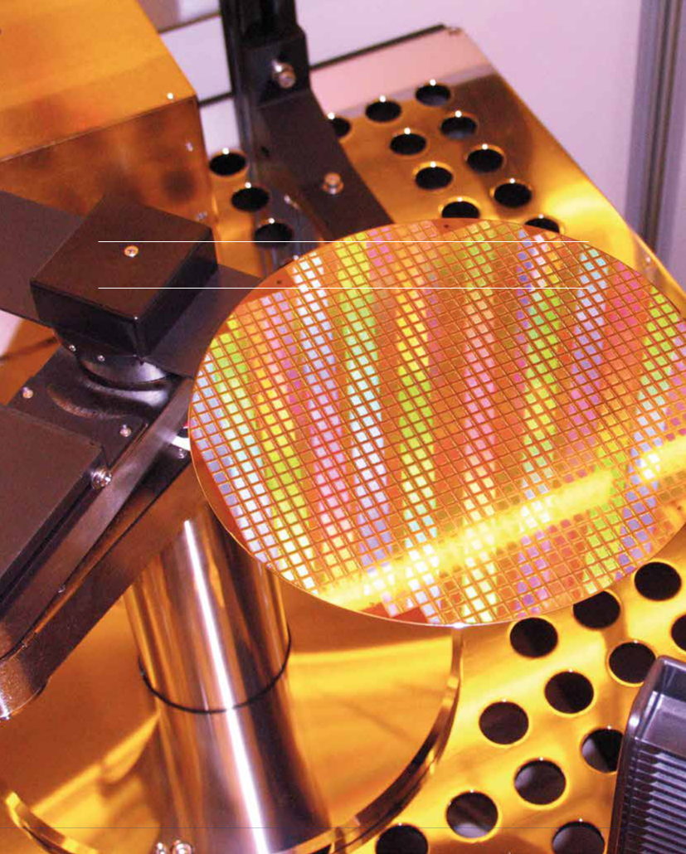

07

LFOUNDRY IS A SMIC COMPANY
22 LFOUNDRY COMPANY PROFILE

ABOUT SMIC

Semiconductor Manufacturing International Corporation

(“SMIC”; NYSE: SMI; SEHK: 981) is one of the leading

semiconductor foundries in the world and the largest and

most advanced foundry in mainland China. SMIC provides

integrated circuit (IC) foundry and technology services

on process nodes from 0.35 micron to 28 nanometer.

Headquartered in Shanghai, China, SMIC has an international

manufacturing and service base. In China, SMIC has a 300mm

wafer fabrication facility (fab) and a 200mm mega-fab

in Shanghai; a 300mm mega-fab and a majority-owned

300mm fab for advanced nodes in Beijing; 200mm fabs in

Tianjin and Shenzhen; and a majority-owned joint-venture

300mm bumping facility in Jiangyin; additionally, in Italy

SMIC has a majority-owned 200mm fab. SMIC also has

marketing and customer service offices in the U.S., Europe,

Japan, and Taiwan, and a representative office in Hong Kong.

For more information, please visit www.smics.com.

