

Passion
first

COMPANY PROFILE
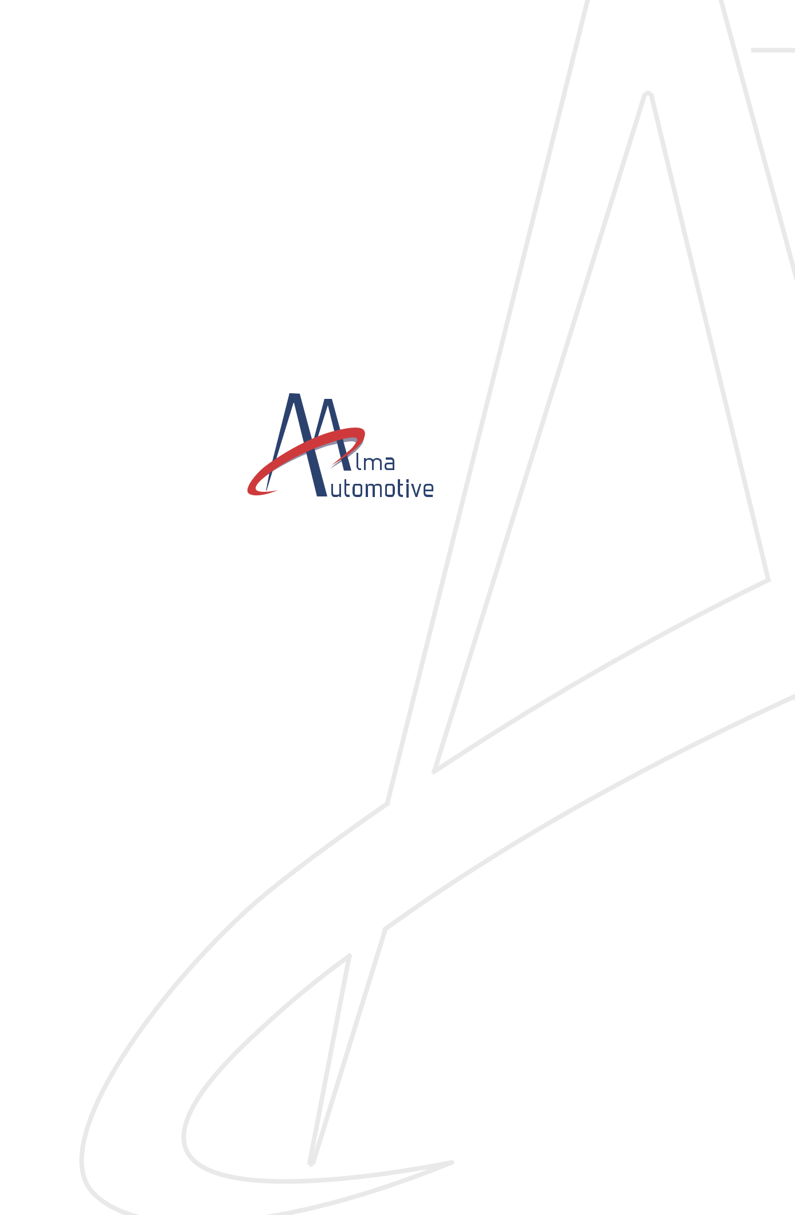

w w w. a l m a - a u t o m o t i v e . i t


Originally established as a spin-off of University of Bologna, Alma Automotive represents the synergy between knowledge acquired in academic research activities and years of experience in developing applied solutions. The company has now evolved to offer both ready-to-use products and technical consulting services supported by bespoke hardware and software solutions.

Our company was born in the so called Italian Motor Valley in the Emilia-Romagna region, where some of the most exclusive car and motorbike makers in the world come from. We have grown in this environment surrounded by racing cars, supercars and motorbikes and turned our passion for engines and cars into our job.

Highly oriented towards new challenges, Alma Automotive’s mission is to provide innovative solutions and tools to help customers in the development of ever more efficient engines and powertrains.

The strong relationship we have with top-tier automotive companies is testimonial to the high level of skill and quality of services offered to our clients.

Delivering excellence through our people

When we select our new employees, we seek passionate and talented people, with excellent hard and soft skills. Essentially we look for people who are creative, constructive and ready to experiment new things.

Our team is characterized by three levels of experience:

Senior, Experienced and Junior engineers.

Senior

- Professors and highly experienced professionals

- Key account management

- Sharing technical knowledge and experience with the team

Experienced

- PhD graduates or at least 4 years’ experience

- Leading projects

- Sharing solutions with Senior members

- Developing project management skills

Junior

- Master’s degree graduate

- Often with previous experience in industry

- Developing skills working on projects

- Learning from more experienced members of the team

We value our Team

Passion first

To face every day challenges knowledge and expertise are essential, but not enough if you are not driven by passion. This passion is what we share in our team, and what keeps us striving for excellence in everything we do.

Employee empowerment

We don’t think of empowerment only as a business strategy to improve efficiency, but as a natural way to develop a sense of ownership and responsibility among our team. We want our employees to openly share suggestions about their work and the company as a whole. We want them to feel part of the company, as they are the ambassadors of our organization.

Proactive teamwork

One of the keys to Alma Automotive’s success is our ability to work together as a team, and support each other in finding the best solutions for different projects.

Sharing know-how and experience enables us to maximize the performance of our products and services, adding value to clients.

Training program

To deliver excellent services and design innovative products our team skills and competences are of crucial importance. We pursue a continuous training program both internally by sharing technical knowledge and organizing specific training sessions, and also externally through different certification programs. We also sponsor several PhD programs, as we truly want the best preparation for our team, turned into first-class service for our customers.

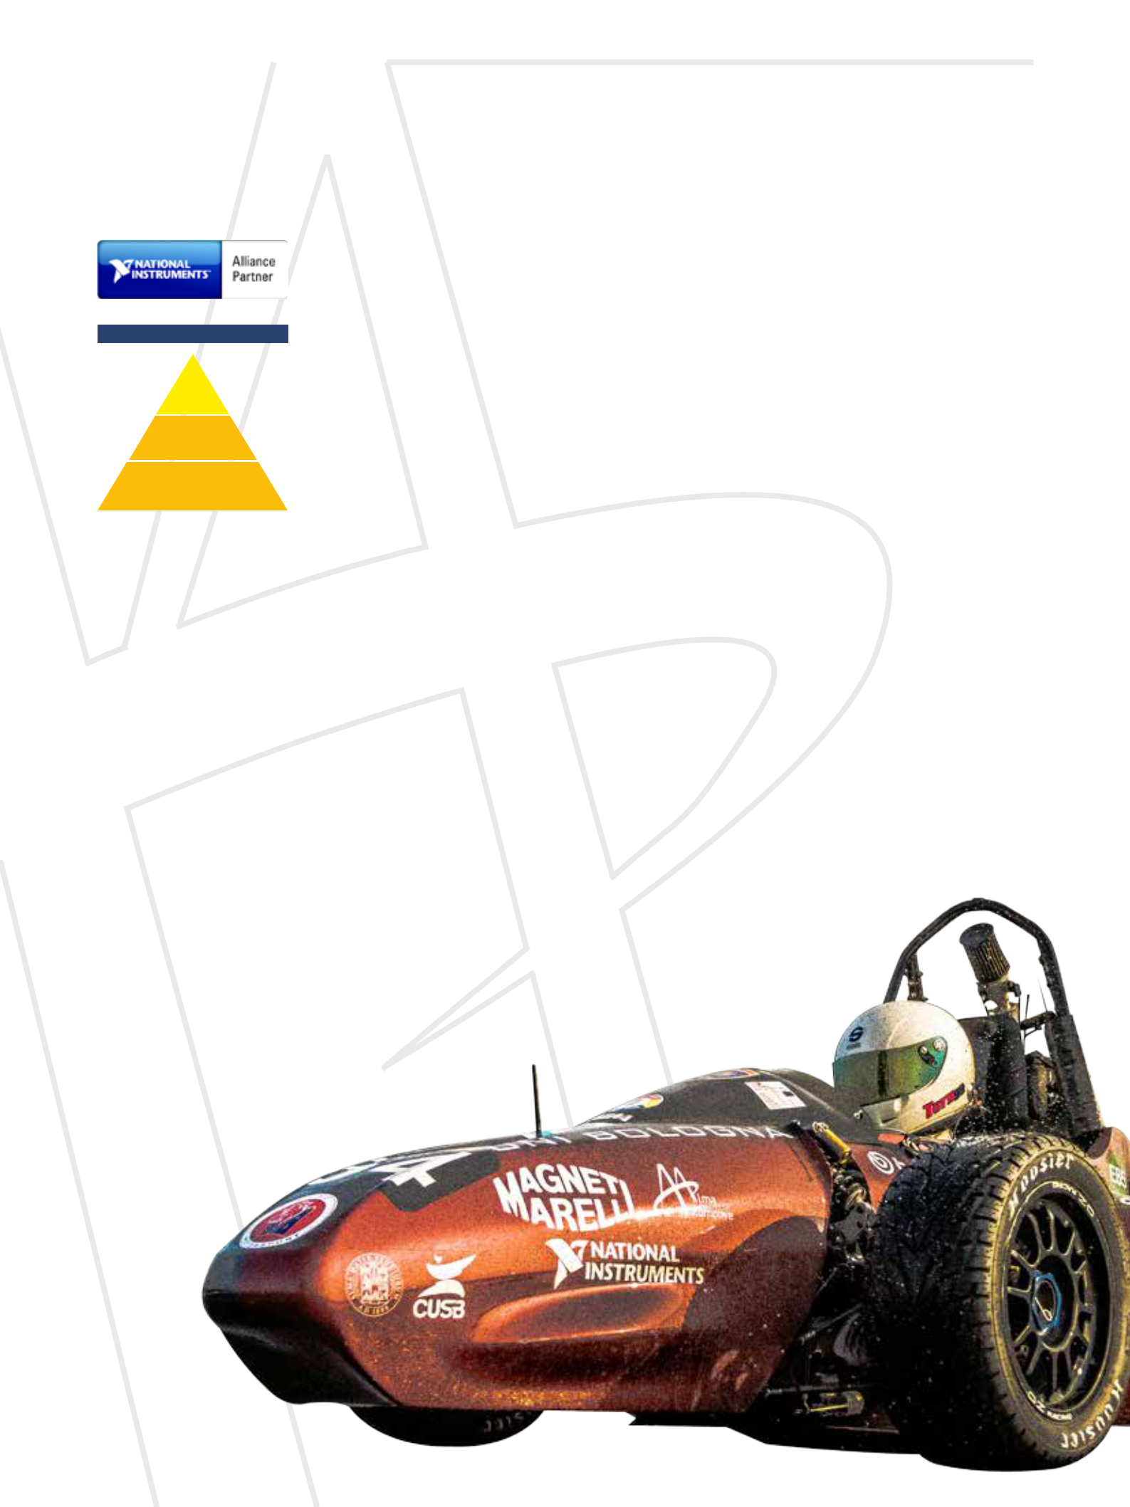
5

Our partnerships

NI LabVIEW Certifications

Certified
LabVIEW
Architect

Certified
LabVIEW
Developer

Certified LabVIEW
Associate Developer

Since 2012, we have been National Instruments’ alliance partner and in 2013 we won the 1st prize at the Engineering Impact Awards 2013 as the best measurement and automation application in Italy.

Alma Automotive has been pursuing a long term LabVIEW certification program, by covering all three levels of expertise, from the entry level LabVIEW Associate Developer to the more experienced LabVIEW Architect.

Sponsor of UniBo Motorsport

UniBo Motorsport is the Formula SAE Team of University of Bologna. The Formula SAE® is an innovative racing competition where university students from all over the world challenge each other in the design, production and put on track of a formula-style car.

Our collaboration started in 2010, when UniBo Motorsport took its first step in the Formula SAE® series, with something that no team had ever done before: an engine control system designed from scratch and implemented on a NI Compact RIO. From 2011, on UniBo Motorsport, supported by Alma Automotive, has developed its ECU year after year, until 2014, when the team developed

a new ECU based on NI Single-Board RIO platforms, a reliable product with excellent performance. Thanks to this new ECU, impressive results in the most challenging Formula SAE competitions have been achieved, receiving remarkable feedback from technical judges from all over the world.



Real-Time control
& measurement systems

Powertrain analysis and modeling for calibration and control

Racing performance
analysis
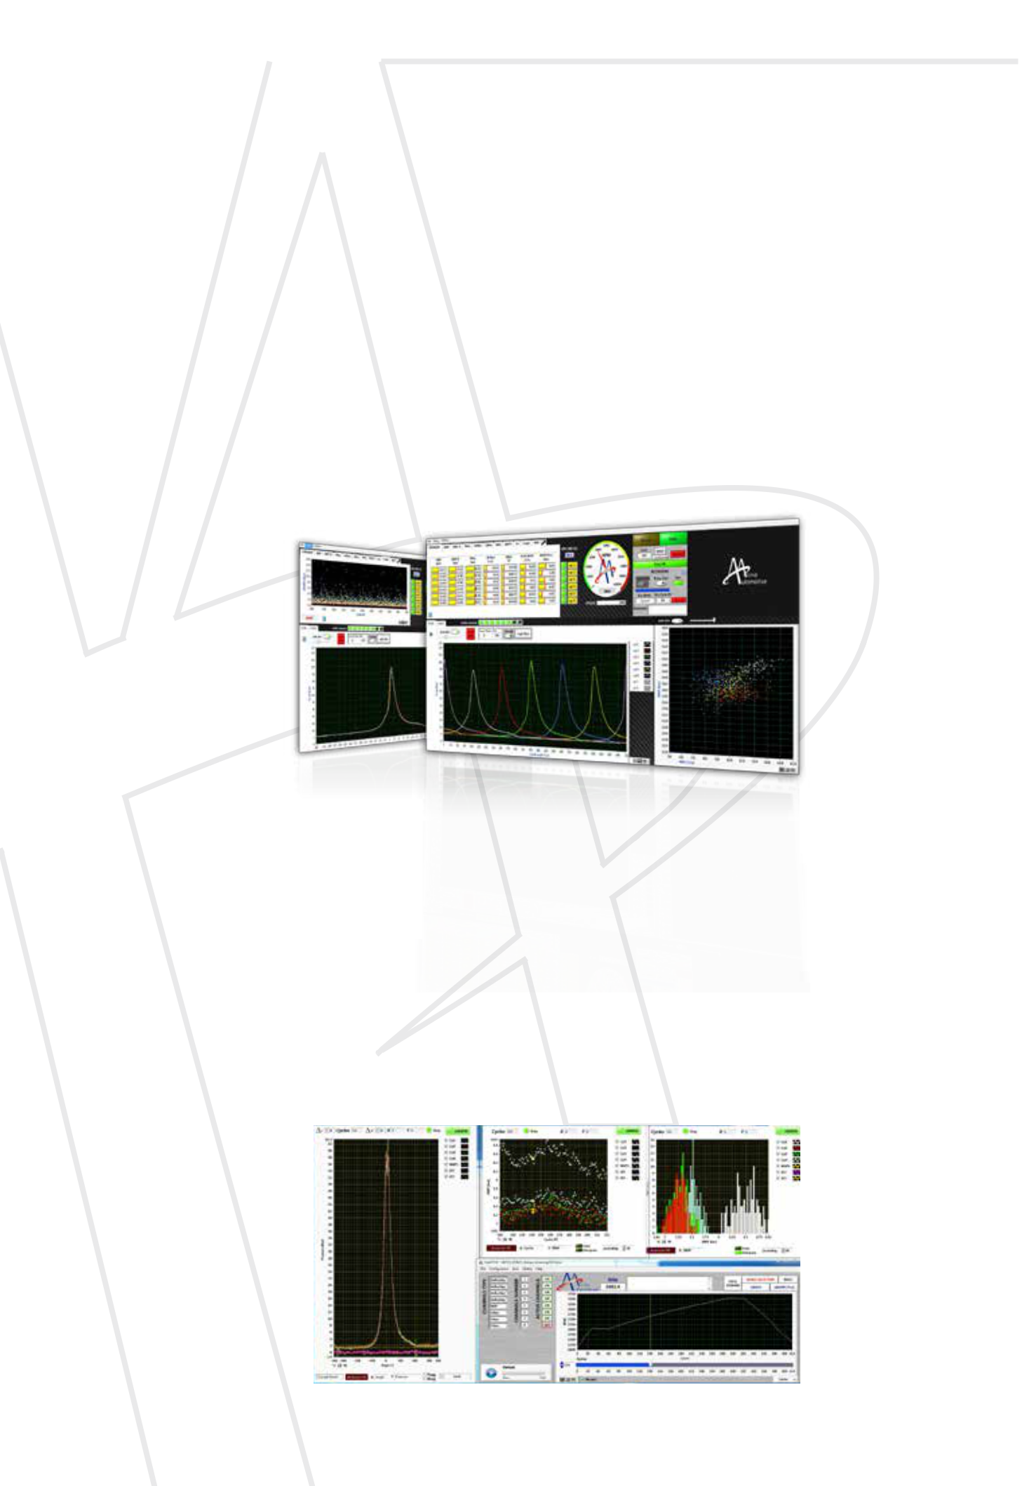
7

Combustion analysis systems

Distinctive features at a glance

- Direct connection to standard crankshaft position sensors, without any crank angle adapter needed

- Time-based combustion analysis system

- Time-to-Angle conversion performed with the interpolation approach for the highest precision
- Real-time, cycle-by-cycle and cylinder-by-cylinder evaluation of combustion parameters

- Combustion parameters published on CAN cycle-by-cycle

- User interface for in-cylinder pressure and combustion data monitoring

- Data acquisition based on analog trigger or event-based (limit value violations)

Real-Time combustion analysis

The combustion analysis system evaluates in Real-Time and publishes on the CAN network:

- IMEP, IMEPH

- Pmax, APmax

- Cumulative Heat Release

- MFBxx angles (xx defined by user, for example:

MFB10, MFB50, MFB90)

- Knock indexes (MAPO and integral)

Configuration of the algorithms includes (but is not limited to):

- Engine geometry

- Low-pass and high-pass digital filtering of pressure data (IIR, 2nd order)

- Angular window for knock analysis

- Crankshaft reference sensor and analog input filter delays (delay compensations)

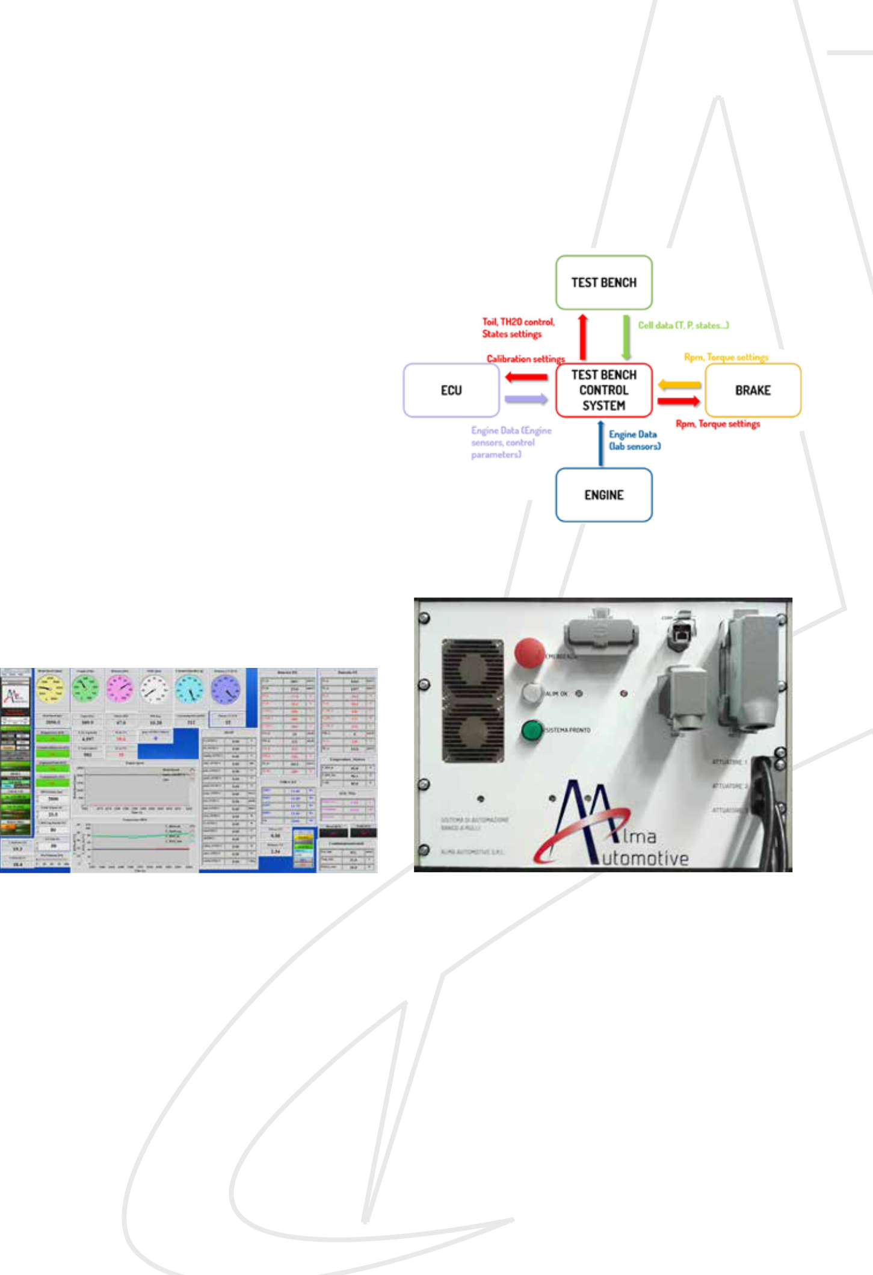
Test bench control systems

Our long term experience in engine testing, we are able to offer solutions that are individually tailored to our customers needs.

Layout hardware:

- Real-Time OS

- FPGA: fast digital and analog signals management

- I/O signals

  - Analog Input/Output

  - Thermocouples

  - Thermistors

  - Relay

  - Digital Input/Output

  - Counters

  - CAN

  - RS232

Layout software: |  | - | User defined variables, based on algebraic
• Easy-to-use and easy-to-configure host interface |  |  | operations on input/costants
• Standard functionalities |  | - | Automatic test management
- | Data acquisition | - Graphical representation of acquired variables
- | Configurable logger functions (MEMO, post- | - | Signals plausibility assessment
 | mortem, etc.) | - Interface support with external measurement
- Actuators management and feedback control |  |  | devices
- | Limit values monitoring and alarms management | • Possibility of developing ad hoc functionalities, even
 |  | if not defined in the initial specification requirements

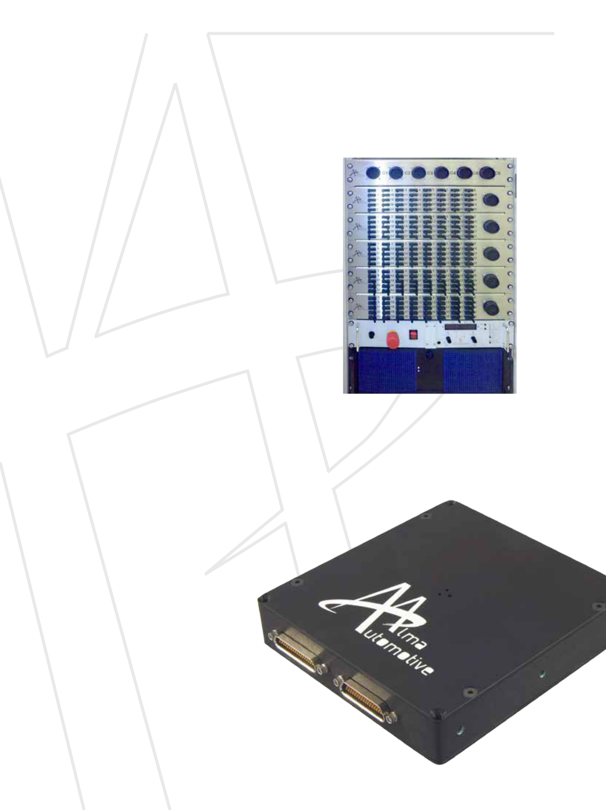
9

Hardware in the loop systems

Thanks to our strong know-how about modeling internal combustion engine systems, we are capable of developing HIL systems featuring complete engine and vehicle models.

Common features at a glance:

- Based on National Instruments software (VeriStand) and hardware (PXI, CompactRIO fpr simpler applications)

- Model-based (Simulink)/data replier: engine-vehicle models available

- Custom signal conditioning (Fault Insertion Units, conditioning for high voltage generation/acquisition)

- Custom exchangeable Load boards

Rapid Control Prototyping systems

Over the years we have matured insightful experience in ECU simulation and prototyping. In particular we offer our customers the possibility to implement a V-ECU (Virtual Engine Control Unit) in a short time scale.

We are capable of developing RCP systems and implementing them on MIRACLE, our in-house designed Micro Rapid Controller & Logging Environment.
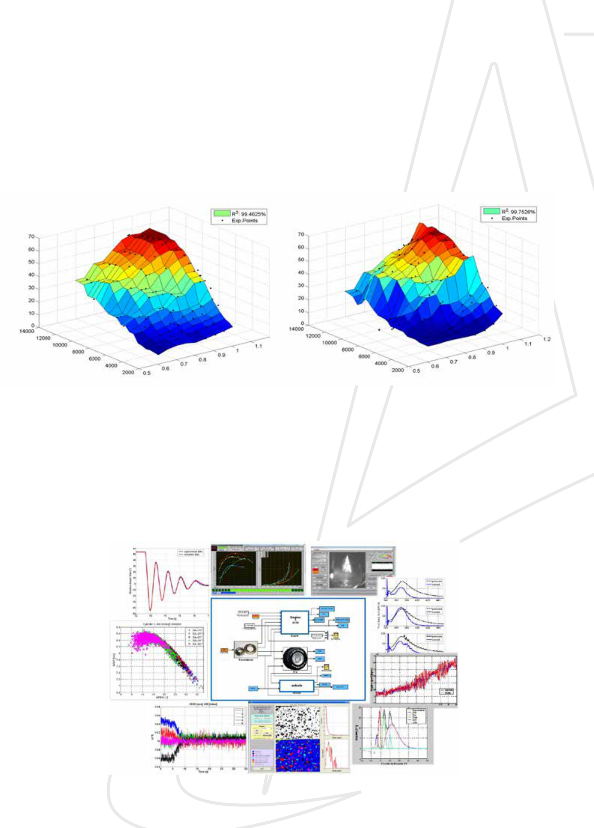
Powertrain analysis and modeling for calibration and control

A few examples of activities that we have carried out for

our customers:

• Engine calibration and control algorithms

development

• Turbocharger speed estimation based on acoustic

emissions

• On-board stereoscopic image acquisition of tyres for

deformation evaluation

•

•

•

•

•

Torque-meter based on shafts torsion

Simplified models for HIL systems, integrating

engine, clutch, gearbox and driveline simulations

Detailed vehicle dynamics models

Detailed model of engine components to define

control or diagnostic algorithms

Dual Mass Flywheel, tank/canister circuits, driveline

dumpers, internal EGR, combustion

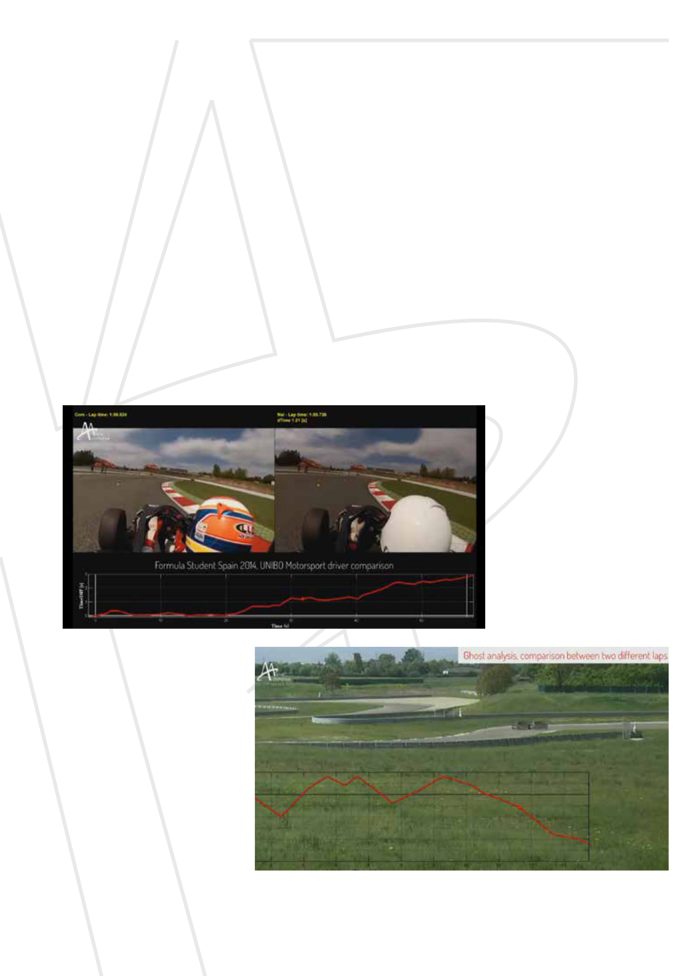
11

Racing performance analysis

With more than 10 years’ strong experience in motorsport, we have matured our insightful expertise in developing solutions and tools for racing performance analysis. Our target customers are motorsport teams, aiming to get a deeper understanding of their vehicles’ behavior and drivers’ performance during test sessions and races. Our tools can be applied to both cars and motorbikes with different levels of analysis depending on customer needs. An example of some valuable analysis we usually carry out is the “side-by-side video compare”, a simple but

powerful tool especially designed for drivers looking to get the most out of their vehicles. Thanks to the space-based analysis of laps with respect to the competitor’s best lap, the driver gets to know where he should improve through the time differential plotted below. In order to get even more detailed information, a further tool is the “Ghost analysis”, which allows the comparison of different laps with the vehicle covering different trajectories, and enables the driver and the team to understand the best way to face the most crucial sections of the track.


Automotive reserves the right to make technicalAlmaAutomotiveproductsisexcluded.
Alma
 | of
knowledge.
owners | from theuse
state ofresulting
respective | damage
their | damage
current
the
theproperty | forconsequential
of
to
Trademarks areTheinformationcorrespondschanges.Liability

Alma Automotive s.r.l.
Via Terracini 2/c - 40131 Bologna - Italy
Tel. +39 051 9923806 / +39 051 0548470 / Fax +39 051 0544839 | www.alma-automotive.it
info@alma-automotive.it - www.alma-automotive.it | www.alma-automotive.it

