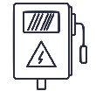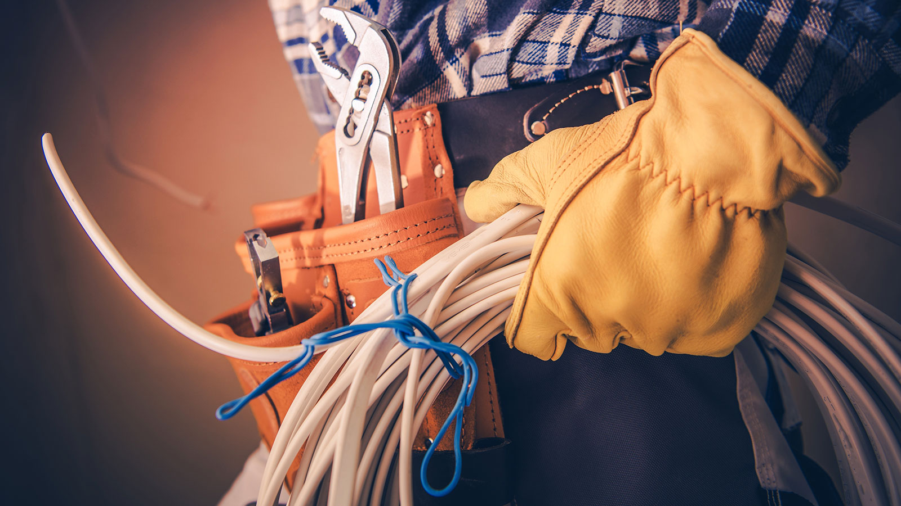[](https://templatelab.com/)

Donec laoreet nonummy augue. Suspendisse dui purus, scelerisque at, vulputate vitae, pretium mattis, nunc. Mauris eget neque at sem venenatis eleifend. Ut nonummy. Fusce aliquet pede non pede. Suspendisse dapibus lorem pellentesque magna. Integer nulla. Donec blandit feugiat ligula. Donec hendrerit, felis et imperdiet euismod, purus ipsum pretium metus, in lacinia nulla nisl eget sapien. Donec ut est in lectus consequat consequat. Etiam eget dui. Aliquam erat volutpat. Sed at lorem in nunc porta tristique.

LOREM IPSUM

Donec laoreet nonummy augue. Suspendisse dui purus, scelerisque at, vulputate vitae, pretium mattis, nunc. Mauris eget neque at sem venenatis eleifend. Ut nonummy. Fusce aliquet pede non pede. Suspendisse dapibus lorem pellentesque magna. Integer nulla. Donec blandit feugiat ligula. Donec hendrerit, felis et imperdiet euismod, purus ipsum pretium metus, in lacinia nulla nisl eget sapien. Donec ut est in lectus consequat consequat. Etiam eget dui. Aliquam erat volutpat. Sed at lorem in nunc porta tristique.

LOREM IPSUM

Donec laoreet nonummy augue. Suspendisse dui purus, scelerisque at, vulputate vitae, pretium mattis, nunc. Mauris eget neque at sem venenatis eleifend. Ut nonummy. Fusce aliquet pede non pede. Suspendisse dapibus lorem pellentesque magna. Integer nulla. Donec blandit feugiat ligula. Donec hendrerit, felis et imperdiet euismod, purus ipsum pretium metus, in lacinia nulla nisl eget sapien. Donec ut est in lectus consequat consequat. Etiam eget dui. Aliquam erat volutpat. Sed at lorem in nunc porta tristique.

LOREM IPSUM

YOUR SLOGAN GOES HERE!

EMERGENCY ELECTRICIAN

Call **„E“ Electrical Services** on 555 588 2175 145 and we will arrange an on site visit as soon as possible.

LIGHTING

No matter if it’s in a room, office or outdoor area. We have experience in lighting design as well as installation.

SWITCHBOARD UPGRADE

Your expensive electronic equipment and gadgets may be at risk to an unexpected power surge.

ALARM SYSTEMS

We provide installation and maintenance on a range of alarm systems, security systems, and CCTV systems.

INSTALLATIONS DESIGN

We complete the design of electrical installations and provide electrical engineering in HV and LV.

SMART HOME

Some smart home devices allow you to protect your home but also to save energy and money.

HOT WATER SYSTEMS

We can install, maintain, and repair how water systems. We will find spare parts in no time and make system run again.

ELECTRICAL TESTING

We diagnose electrical faults fast. If you have problems relating to electrical wiring or lighting we can help.

ABOUT „E“ ELECTRICAL SERVICES

Lorem ipsum dolor sit amet, consectetuer adipiscing elit. Maecenas porttitor congue massa. Fusce posuere, magna sed pulvinar ultricies, purus lectus malesuada libero, sit amet commodo magna eros quis urna. Nunc viverra imperdiet enim. Fusce est. Vivamus a tellus. Pellentesque.

211 Thunder Road, Middletown, 22100 Texas I (555) 123 4568 0000 I www.e-electricalservicesonline.com

[**©** TemplateLab.com](https://templatelab.com/)