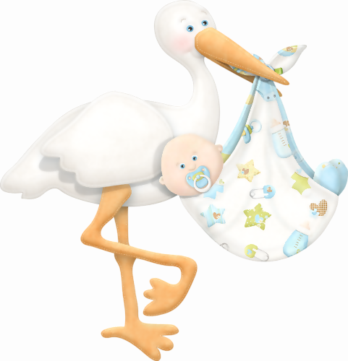 |  |  |  |  |  | BABY SHOWER SIGN IN SHEET
 | NAME OF BABY |  |  |  |  |  |  |  |  | GENDER |  | PARENTS NAME
 | <Name of Baby> |  |  |  |  |  |  |  |  | <Gender> |  | <Parents Name>
 | DATE |  | TIME |  | VENUE
 | mm/dd/yyyy |  | hh:mm PM |  | <Venue>
 | GIFT SUGGESTIONS |  |  |  |  |  |  |  | Name |  |  |  | No. of Guess |  | Contact Number
 |  |  |  |  |  |  |  |  |  |  |  |  | Adult | Kid
 | ⃝ | Feeding Bottles |  |  |  |  |  |  | John Smith |  |  |  | 2 | 0 | 1 47-8335-3466
 | ⃝ | Bath Tub & Bathtub Net
 | ⃝ | Bodysuit Baby Outfits
 | ⃝ | Cute Plush Stuff Toy
 | ⃝ | Milk Bottle Sterilizing Box
 | ⃝ | Infrared Baby Thermometer
 | ⃝ | Baby Care Lotion
 | ⃝ | Bibs & Burp Cloths
 | ⃝ | Shake Flexible Rattle Ball
 | ⃝ | Hypoallergenic Toddler Pillow
 | ⃝ | Muslin Blanket
 | ⃝ | Front Ergonomic Carrier
 | ⃝ | Baby Oral Syringe
 | ⃝ | Water Wipes
 | ⃝ | Air Purifier Device
 | ⃝ | Chicco Brush & Comb
 | ⃝ | Silicone Breast Pump
 | ⃝ | Playmat
 | ⃝ | Baby Toothwipes
 | ⃝ | Playroom Disinfectant Spray
 | ⃝ | Drying Rack & Bottle Brush

