 | 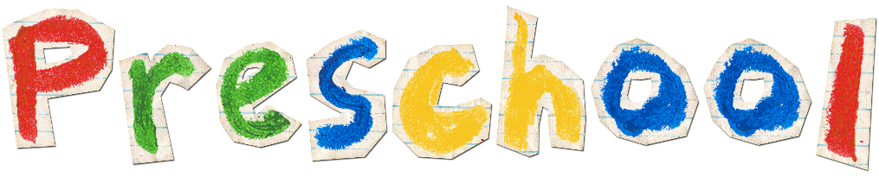 |  |  |  |  | Sign Up Sheet
 |  | SCHOOL NAME |  |  |  |  |  | DATE
 |  | <School Name> |  |  |  |  |  | Mm/dd/yyyy
 |  | ADDRESS |  |  |  |  |  | CONTACT NUMBER
 |  | <School Address> |  |  |  |  |  | <Contact Number
 |  | Child Name | Parent/Guardian Name | Contact Number | Address
 |  | John Smith | Linda Smith | 1 47-8335-3466 | Columbia Heights, Washington DC

