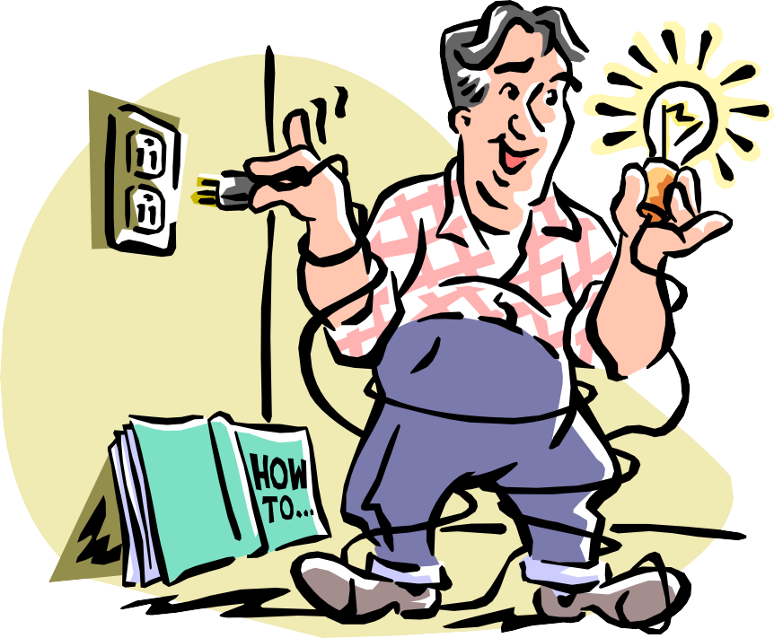

**Introduction**

**To Technical Writing**

Park High School Winter Intensive Phila Hoopes, Instructor

1991

***WHAT IS TECHNICAL WRITING?***

**Introduction**

Picture a typical technical manual. It’s a huge, incomprehensible volume, usually used as a doorstop, and only opened when all else fails, right?

Not necessarily. Take a look at *these* technical manuals:

•

•

•

•

*The Moosewood Cookbook*

*Reader’s Digest Do-It-Yourself Manual Juggling for the Complete Klutz*

*How to Keep Your Volkswagen Alive*

What do they have in common? They’re all books that:

1.

2.

3.

Break a thing or action down into its basic elements Describe the basic elements

Tell the reader how to use or perform them.

**How Does Technical Writing Differ from Creative Writing?**

Technical manuals are designed to function as *tools*, not as works of art. So technical writers use a different set of rules when they build a manual:

•

•

•

*Usability* – how easily can the reader find information?

*Clarity* – how easily can the reader understand the information?

*Maintainability* – how easily can the information be updated?

In all cases, *the reader’s needs come first.*

**Analyzing the Audience**

Before technical writers can decide what type of manual fits the reader’s needs, they must perform an *audience analysis* to find out what the reader needs:

•

•

•

•

*What is the reader’s average educational level? Why will the reader be using this product?*

*Why will the reader be using this manual?*

*What is the reader’s attitude toward the product and the manual?*

*(continued)*

*Introduction to Technical Writing*

*2*

***WHAT IS TECHNICAL WRITING? - continued***

**How Do You Construct a Technical Manual?**

A technical manual is often constructed through a process called *structured writing*. This involves creating four separate versions, each one adding more detail to the one before it.

1.

*2.*

3.

4.

*Topic List:* shows major sections *(maps)* of the manual

*Structured Outline:* shows sub-topics *(blocks)* that each map will contain *Storyboard:* summarizes the information that each block will contain *Complete Document:* replaces the summaries with actual information

**How is the Manual Checked for Accuracy?**

As the writer produces each version, from the topic list to the complete document, it’s reviewed by a team of experts who are involved with the product that’s being documented. They check to be sure that all the necessary information is included, that it’s well-organized and correct.

Eventually, the whole team meets to *walk through* the storyboard. This meeting allows everybody to raise questions or suggest changes before the writer spends time creating the complete manual.

After the manual is written, it goes through additional technical reviews. When everybody is sure that the facts are correct and clear, the manual is edited for grammar and style.

Only after everybody signs off, saying that the manual has no errors, is it published.

*Introduction to Technical Writing*

*3*

***BUILDING A TOPIC LIST***

**What is a Topic List?**

Basically, it’s the result of a brainstorming session. The topic list shows the main subjects that you intend to cover in your document. It is not an outline; it does not give any detailed information about *how* you plan to deal with those subjects. It just lists them.

***Note:*** In the style of technical writing that we’ll be discussing, the divisions shown in a topic list are called *maps*. “What is Technical Writing?” is an example of a map.

**Elements of a Technical Topic List**

Most technical manuals have six types of maps.

***Introduction: “Before You Begin”***

The introduction gives an overview of the section: what will you be telling the reader?

***Definition: “What is…?”***

The definition gives a general description of the thing or process you’re writing about.

***Analysis: “Elements of…”***

The analysis breaks down the thing or process into its separate elements.

***Procedure: “How to…”***

The procedure section gets down to the nitty-gritty: how does the reader perform an actual procedure?

***Note:*** Your topic might have more than one procedure: each procedure would be described in a separate map.

***Troubleshooting: “What If..?”***

The troubleshooting section tells the reader what to do if something goes wrong. Not all technical documents need this type of section: often the information can just be included in the procedure as a note or warning.

*(continued)*

*Introduction to Technical Writing*

*4*

***BUILDING A TOPIC LIST - continued***

**Researching a Topic List**

Research for a topic list doesn’t need to be detailed; you just need to get an idea of the information that the document should include. At the same time, however, this can be a helpful way to discover potential problems and obstacles before they stop you cold.

***Example:*** You’re assigned to document a word-processing program. While building your topic list, however, you discover that the text-copy function not only *has not* been coded for this release – it’s *not going to be* coded until the next release! Oops – there go the Definition, Analysis, and Procedure maps! Instead, you insert a Troubleshooting map.

*Introduction to Technical Writing*

*5*

***BUILDING A STRUCTURED OUTLINE***

**What is a Structured Outline?**

A structured outline adds a new level of detail to the topic list. In this way, it serves two purposes:

***Tool for checking your research***

Building on the topic list demands a new level of research…and frequently uncovers things you’d missed, or areas where you’d gone off track.

***Tool for checking your organization***

When you are dissecting and analyzing something, it’s easy to arrange the pieces in an inappropriate order. Building the structured outline forces you to check the logic you used in constructing the topic list.

**Elements of a Structured Outline**

The structured outline lists the topics that you intend to discuss within each map. These are organized in groups of *blocks* (for example, “What is a Structured Outline?”) and *subblocks* (for example, “Tool for checking your research”). They may be identified by indentation, font and type size, or numbers.

***Example:*** Blocks within Map 1 would be numbered 1.1, 1.2, etc. Subblocks within Block 1.1 would be numbered 1.1.1, 1.1.2, and so forth.

*(continued)*

*Introduction to Technical Writing*

*6*

***BUILDING A STRUCTURED OUTLINE - continued***

**How to Create a Structured Outline**

Here are some of the topics you’ll need to include in a structured outline:

***This section…***

***Includes this content…***

Introduction

Tells the reader what you’ll be covering in the document. Usually includes an *internal index* listing the maps and summarizing their contents.

Definition

Gives the reader some general information about the thing or process: what is its purpose? What does it do? Why does the reader need it?

Analysis

Lists and describes the individual parts or procedures that make up the thing or process: what are they? How do they affect each other? How does the whole thing fit together?

Procedure

In as much detail as possible, list and explain the steps of an individual procedure. If the reader will need to perform more than one procedure, describe them in separate maps.

Troubleshooting

If this section is necessary – and it isn’t always – list the possible problems that the reader will encounter, and what can be done about them.

*Introduction to Technical Writing*

*7*

***BUILDING A STORYBOARD***

**What is a Storyboard?**

A storyboard adds a summary sentence to each block or subblock of the structured outline. In this way, it serves three purposes:

***Tool for checking your research***

Building on the structured outline demands a new level of research. No matter how good your structured outline was, you can expect to find ways of improving it when you build the storyboard.

***Tool for checking the organization of the structured outline***

Again, no matter how good your structured outline was, you’ll find it’s much easier to sense the logical flow of the document when you build the storyboard.

***Model of the finished document***

When you’ve completed your storyboard, the design phase of your document is finished. You have the skeleton of your document in your hands; all you need to do now is to flesh it out.

**Why Construct a Storyboard?**

If you’ve done your research well, you might feel that the storyboard is an unnecessary step: you have all the information, you know how you want to organize it – why spend time writing summaries for each block? Why not just write the actual text?

Remember, though, that in technical writing you are not the only person responsible for the accuracy of the document. Your team of technical experts has been checking your previous versions, but – if they’re like most programmers and engineers – they have a hard time visualizing a complete document from the topic list and structured outline. If they don’t see a storyboard before you hand them the complete document, it’s entirely likely that they will suggest major changes…and you will have wasted a great deal of time.

*(continued)*

*Introduction to Technical Writing*

*8*

***BUILDING A STORYBOARD - continued***

**Elements of a Storyboard**

As you build your storyboard, you’ll be adding a number of elements to your structured outline. The important thing to remember is this: *you are not adding the actual text*.

You’re just indicating that these elements will be present. Some of the elements are:

•

•

•

Bulleted or numbered lists Charts or tables

Graphics (diagrams, screens, or illustrations)

**How to Construct a Storyboard**

In building a storyboard, you’ll be looking at each block, asking yourself: *What information should I put here? What is the easiest way for the reader to understand the information?*

Some people think verbally; other people think visually. To communicate to both, you’ll need to add graphics (charts, tables, diagrams, and illustrations) to convey particularly complex information. It’s a good idea to include preliminary versions of these graphics in your storyboard.

*Introduction to Technical Writing*

*9*

***HOLDING A WALKTHROUGH***

**What is a Walkthrough?**

In the walkthrough, you meet with your team of experts to review your storyboard, page by page. This lets the team see a model of the document as it will appear in its final form.

You will probably need to remind the team that a walkthrough is *not* a time to review your writing or technical details (for example, which key to press to achieve X result). It is strictly a means of checking the *completeness, organization, and logical flow* of the document.

**What Happens in a Walkthrough?**

Usually – *unless you lead the meeting firmly* – your team ends up arguing over the product!

To keep the meeting on track, you need to give each team member a copy of the revised structured outline and storyboard. Then, you lead them through the packet page by page. For each page, ask:

•

•

•

Is the information logically organized? Are all the necessary elements included?

Are any elements absolutely unnecessary?

If you have any questions of your own about the document, mark them in the appropriate place on your copy. As you reach that page, ask your question.

When you’ve finished presenting the storyboard, ask the team whether they have any additional questions to ask or changes to suggest.

**After the Walkthrough**

After the team has made their suggestions, you revise the document. Then, you start to replace the storyboard’s summary sentences with actual text.

When you have completed your first draft, send it to the team for technical review. When they return it with their corrections, revise the document6 and toss it back to the team.

The document will probably travel between you and the team several times before it satisfies everybody.

After all of the technical corrections are made, you take the document to your editor for stylistic review. When the grammar and style are correct, the document finally goes to publishing.

*Introduction to Technical Writing*

*10*