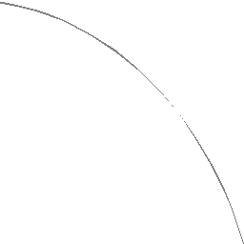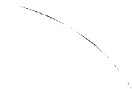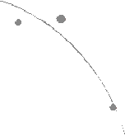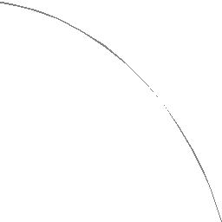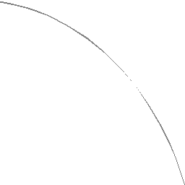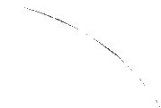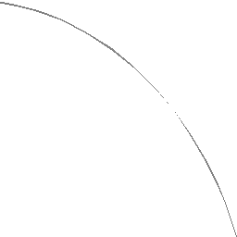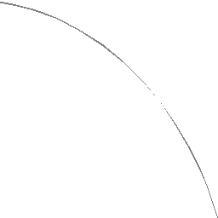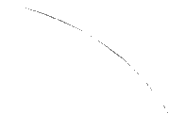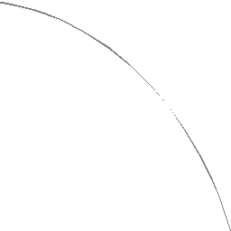

1

Good Technical Writing is:

* Technically accurate
* Useful
* Concise
* Complete
* Clear
* Consistent

Purpose of technical writing

* Transmit technical information accurately
* Different from
  + Popular non-fiction (entertainment)
  + Advertising (sell)
* Sacrifice style, grace, and technique
  + For clarity, precision, and organization

Technical Writing

* Deals with topics of a technical nature
  + Science, engineering, and technology
* Deals with an object, process, system, or abstract idea
* Utilitarian
  + Stressing accuracy rather than style
* Objective tone
* Technical content
  + Not the author’s feelings about it

What is technical writing?

“Newspaper reporters and technical writers are trained to reveal almost nothing about themselves in their writing. This makes them freaks in the world of writers, since almost all of the other ink-stained wretches in the world reveal a lot about themselves to the reader.”

Kurt Vonnegut, Jr.

Reference

* Gary Blake, Robert W. Bly, *The Elements of Technical Writing,* Macmillan, 1993.

Technical Writing

CE/CSE/EE/IE/MAE 1104

Jim Williams

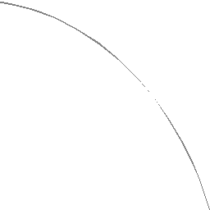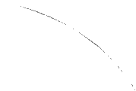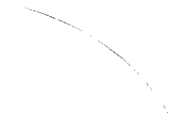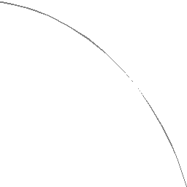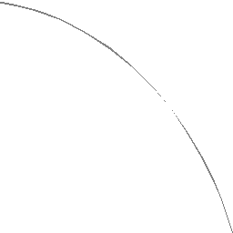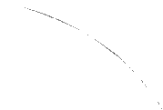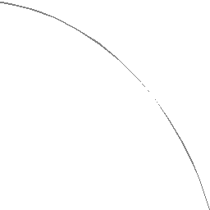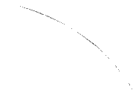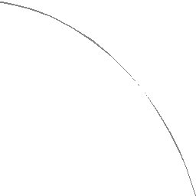

2

Principles of Technical Writing

* Know your reader.
  + How much do you have to explain?
  + Can you say “operating system” or do you need to define it?
* Break your writing into short sections.

Principles of Technical Writing

* Use specific and concrete terms rather than vague generalities.
  + Aircom’s new scrubbing system saves the Samson Company a fortune in fuel every day.
* Use past tense to describe your experimental work and results.
* Use present tense in most other writing.

Principles of Technical Writing

* Delete words, sentences, and phrases that do not add to your meaning.
  + Wordy: It is most useful to keep in mind that the term *diabetes mellitus* refers to a whole spectrum of disorders.
  + Concise: *Diabetes mellitus* refers to a whole spectrum of disorders.

Principles of Technical Writing

* Use plain rather than elegant or complex language.
  + Elegant: The corporation deemed it necessary to terminate Joseph Smith.
  + Plain: Joseph Smith was fired.

Principles of Technical Writing

* Use the active voice.
  + Passive: Dolphins were taught by researchers in Hawaii to learn new behavior.
  + Active: Researchers in Hawaii taught dolphins to learn new behavior.

Good Technical Writing is (con’t)

* Correct in spelling, punctuation, and grammar
* Targeted
* Well organized
* Interesting

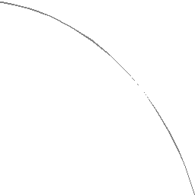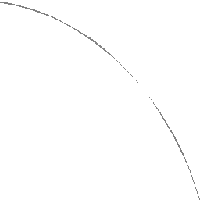

3

Principles of Technical Writing

* Redundancies
  + New innovations
  + First and foremost
  + Current status
  + An honor and a privilege
  + Consensus of opinion
  + Past history
  + Personal opinion

Principles of Technical Writing

* Wordy Phrases
  + *Many* for *a large number of*
  + *Generally* for *as a general rule*
  + *At the time* or *now* for *at this point in time*

Principles of Technical Writing

* Big Words
  + Avoid if possible
  + Use only if commonly used in technical conversation
  + Try to use a shorter word that means the same
    - *Use* for *utilize*
    - *Idea* for *concept*
    - *Ease* or *simplify* or *help* for *facilitate*

Principles of Technical Writing

* Jargon
  + Know your audience
  + A hospital administrator’s definition of *catchment area* is probably different from a civil engineer’s definition
  + Do not invent words
    - Signage for signs

Principles of Technical Writing

* Opt for an informal rather than a formal style.
  + Formal: It is unfortunate that I was not available when you visited our facilities the other day.
  + Informal: I am sorry I missed you the other day.
  + Avoid terms like
    - Whereof, Thereby, Inasmuch as, enclosed herewith

Principles of Technical Writing

* Keep ideas and sentence structure parallel.
  + Nonparallel: Please sign the proposal, date it, and it must be sent to me.
  + Parallel: Please sign the proposal, date it, and send it to me.

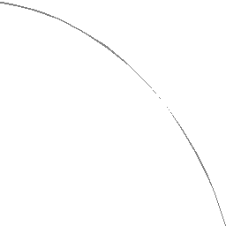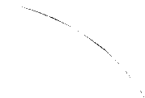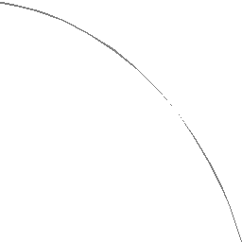

4

Letters

* Format issues (continued)
  + Body
  + Signature block
    - Closing
      * Usually “Sincerely” or “Sincerely yours”
      * Others acceptable, but KISS
    - Sender’s name
      * Typically your professional name, unless you are well- acquainted with the recipient
      * Include your title
  + Sign the letter

Letters

* Format issues
  + Return address
    - Only necessary if not using letterhead
  + Date
    - ALWAYS use
  + Recipient’s address
  + Subject
  + Greeting
    - Depends on your familiarity with recipient

Letters, Memos, and E-mails

* Body
  + Put what you are asking for as close to the top as possible
  + Add necessary descriptive info below
  + Ideally, multiple paragraphs
    - Typically more than one sentence per paragraph
  + Try to limit to one page
  + Use an easy-going, conversational tone
    - Not easy
* See format slides (pdf files)

Types of Technical Writing

* Letters, memos, e-mails
* Reports and journal articles

Principles of Technical Writing

* Overblown phrases
  + I’m sure you can appreciate
  + Note how this matter will be handled
  + When time permits
  + By virtue of
  + Deemed it necessary
  + Under separate cover

Principles of Technical Writing

* Clichés
  + Acid test
  + Back to square one
  + Beyond a shadow of a doubt
  + Grind to a halt
  + Light of day

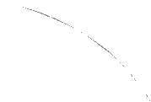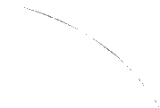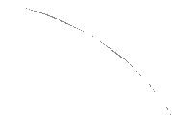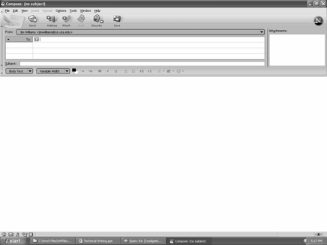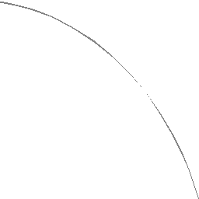

5

E-mails

* E-mail names
  + Use a professional sounding one for your professional work
  + Bad examples
    - slobwatson
    - swiftfeet
    - ezmow
    - kookers
  + Try to use your name as your e-mail name

E-mails

* Always include subject
* Be careful when you click on “reply”
  + E-mails can be very widely distributed
  + Keep this in mind when you write and send them

E-mails

* Date, To, From, and Subject handled automatically
* Always include
  + Greeting
  + Body
  + Signature (your name printed at the bottom)
* Body should be written with same level of care as for a letter or memo

Memos

* More often used within an office
* MEMORANDUM, Date
* To, From, Subject lines
* Body can be very similar to letter
* Sign or initial memo
  + Next to “From” at the top or
  + Below the body

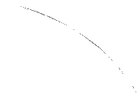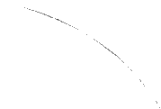

6

Technical Reports and Journal Articles

* Journal article
  + Peer reviewed
  + Edited
  + Widely available
* Technical reports
  + Typically reviewed by client only
  + Often not distributed beyond client
  + Can be much longer than journal article

Technical Reports and Journal Articles

* Abstract
  + Almost always needed
  + Appears at front of report or article
  + Summary
    - Allows someone to understand what you did and your conclusions
  + Typically not longer than 300 to 500 words
    - Often shorter
  + Long abstract often called
    - Executive Summary

Technical Reports and Journal Articles

* Longer reports also have the following
  + At the front
    - Cover page and title page
    - Table of contents
  + At the back
    - appendices

Technical Reports and Journal Articles

* Required elements
  + Introduction
  + Body
    - Theory
    - Experimental process
  + Results
  + Conclusions
  + References

Check it out

Eye halve a spelling chequer, it came with my pee sea

It plainly marques four my revue, miss steaks eye kin knot sea Eye strike a key and type a word and weight four it two say Weather eye am wrong oar write and it shows me strait aweigh. As soon as a mist ache is maid, it nose bee fore two long,

And eye can put the error rite; its rare lea ever wrong.

Eye have run this poem threw it, and I am shore your pleased to know,

Its letter perfect awl the weigh! My chequer tolled me so.

-*Sauce Un none*

Letters, Memos, and E-mails

* Always use spell check
* Always proof read your document before sending

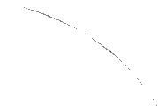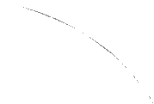

7

Formatting Issues

* Margins
  + Minimum 1 inch all around
  + Wider on the left (or right) if report is bound
  + All headers, page numbers, etc., are within the margins

Formatting Issues

* Page Formatting
  + Portrait vs. landscape
    - Almost all text is in portrait orientation
    - Landscape used for figures and tables that are wider than they are high
  + Orient landscape pages so that bound document is rotated 90 degrees clockwise

Formatting Issues

* Font Sizes
  + For monospaced fonts
    - 12 point corresponds to 10 chars./inch
    - 10 point corresponds to 12 chars./inch
  + Be careful when mixing font sizes
    - Section headings are often in a larger font
    - Text on a title page will often vary in size
    - Footnotes are often smaller
    - Use “Relative Font Size” features that some word processing software provides

Formatting Issues

* Font Sizes
  + 72 points/inch
    - Measured from the lowest extension down to the highest extension up
    - Typically no one letter is the full height
  + Common sizes
    - 10 point
    - 12 point

Formatting Issues

* Fonts
  + Use them as designed
    - For example, some fonts not designed to be used as all capitals

Formatting Issues

* Fonts
  + Serif vs. sans serif
    - Serif usually used for text
    - Sans serif usually used for numbers (tables)
  + Serif – Times Roman
  + Sans-Serif – Arial (Helvetica)
  + Proportionally spaced vs. monospaced
  + Mix fonts carefully in a single report or article
  + Can often be used to set a tone or mood

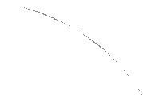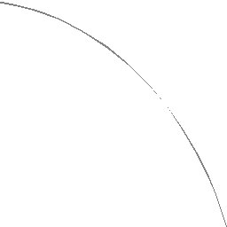

8

Formatting

* Page Numbering
  + Always on multipage documents
  + Make sure font matches text font
  + If printing on both sides
    - Make sure right page is odd

Formatting

* Justification
  + Almost always: full
  + Single page documents: left can be used
    - Results in ragged right edge
    - Makes more sense with monospaced fonts
  + Narrow columns may need left justification
    - Avoids awkward word spacing
  + Titles are often center justified
  + Right justify is seldom used

Formatting

* Paragraphs
  + Indent or not?
    - Your choice, but be consistent
  + Skip a line between paragraphs if not indenting
  + In any case
    - Indent or not indent
    - Space between paragraphs or not
  + BE CONSISTENT

Formatting Issues

* Line Spacing
  + Single, 1½ spacing, double spacing
  + Use single spacing for letters & memos
    - Typically one or two pages
  + Use 1½ spacing for longer documents
    - Easier to read
  + If single spacing is used
    - Use two columns on the page
  + The narrower the column, the smaller the line spacing