**Technical writing tutorial**

**Purpose:**

To learn how to communicate technical information in writing.

**Importance:**

The main modes of communication are written, verbal, and visual. As a scientist or engineer, you will want to share your work. This is commonly done through thesis, journal papers, and books. This type of writing has a different purpose than creative story telling or other types of writing you may have done. There are rules, standards, and formats which are commonly used. You should know these before you embark on publishing your work.

**Goals:**

After this activity, you will be able to:

•

•

•

•

Structure a technical paper

Properly integrate charts and plots into a technical paper Properly integrate figures into your technical papers Properly integrate equations into your technical paper

Word processing, we will use Microsoft WordTM

**Software:**

**Links:**

[Online: A reference guide to using internet sources](http://www.bedfordstmartins.com/online/index.html)

[***averma***](http://www.bedfordstmartins.com/online/index.html)

*2003-08-05 06:27:25*

--------------------------------------------

Online: A reference guide to using internet sources

**SECTION 1: INTRODUCTION TO TECHNICAL WRITING**

**What and Why:**

Technical writing is used to report information. This is different from creative and other types of writing styles in many ways. We will discuss these later. Why is this important? As a scientist/engineer, it is important for you to be able to be able to communicate your work to others in writing.

**Voice:**

Technical writing needs to be objective. Why? The purpose of the document is to relay information. This is most easily accomplished by reporting "just the facts ma'am". Adding opinions, personal observations, and other extraneous material can cloud the communication between the author and reader. In addition, technical documents are often "serious documents", meaning that much depends on them. They need to be concise and specific. Let us say you are the CEO of a company who is looking to fund academic research contracts. These contracts are typically between $50,000 and $100,000 dollars per year. There are several candidates for funding. To become familiar with their work, you decide to read one or two of their publications. How likely are you to give $100,000 to someone who's representation of their work comes off like a commercial or rambles on? Not likely.....

**Opinions:**

The author uses her words to relay information about facts and events that have happened. The author typically does not relay opinions, except in the cases where an unexplained event or phenomena has occurred. In this case, it is OK for the author to render an opinion (educated, of course) about the situation. If this is done, it is important that the author make clear that he or she is offering an opinion and not a fact. In a technical paper, the author remains independent from the subject of the article. Technical documents usually do not contain the following words:

I, you, we.....

**Tense:**

As the writer is usually writing about events which have already happened, the tense of the paper is mainly past tense. However, in some parts of the document, it may be appropriate to use present or future tense. For instance, if the author is covering facts that were, are, and forever shall be true, the facts may be referred to in present tense. If the author is writing about experiments or activities yet to come, future tense is appropriate.

**SECTION 2: COMMON COMPONENTS OF A TECHNICAL REPORT**

**Title Page**

The title page is used to convey the following:

Title Authors

Author affiliation Date published

Other... Depending on required format, more information may be placed on this page

•

•

•

•

•

**Abstract**

The abstract is a concise report on the important contents of the document. Abstracts are usually one or two paragraphs. The purpose of the abstract is to provide a quick review of the important contents of the document so that others can determine if they should invest time reading the rest of the document.

**Table of Contents (Usually for books and thesis, articles typically do not have this)**

The table of contents is a listing of the main headings of the document. This includes the abstract, nomenclature, chapters, chapter sections, references, and appendices.

**Nomenclature**

The nomenclature is a tabulated listing of the variables (and their units) that will be used in the document.

**Chapters/Sections**

The chapters/sections make up the body of the document. They include the detailed information the author wants to convey.

**References**

This section lists the books, magazines, conversations, websites, and other sources of information you used in writing your document.

**Appendices**

Appendices contain information which is important, though in most cases secondary to the purpose of the document. For instance tabulations of scientific data, detailed calculations, and similar material are often good candidates for appendices.

**SECTION 3: HOW TO WRITE A TECHNICAL REPORT**

**Purpose:**

First, make sure you are clear about what you are going to write and why you are writing it.

**Audience:**

Determine who you are writing for. This is important as it helps you choose the right language and level of detail. Customize your document's content to the knowledge and interest levels of the reader.

**Outline:**

I find the fastest way to write is to start with a moderately detailed outline. Moderate implies that the topics in the outline extend into what will become the main points of paragraphs. It is important and usually easy to establish a logical procession in a document via a well organized outline. In addition, it is much easier to re-organize a document at the outline stage by moving phrases around, rather than move entire chapters and sections around after the document is finished.

**References:**

Write the references to your paper. This allows you to put references into the text as you type your document. This may sound silly, but it will save you time as you will eliminate the extra step of reading the paper once or twice to insert and correct references.

**Non-text components:**

At this point, I review the outline and determine the figures, tables, and other non-text mediums that can or should be used to convey information. I then make these and insert them into the appropriate spots in the outline. The old saying, "A picture is worth a thousand words" is true!!! If you have your figures, charts, and tables ready, it is much easier to 'let them do the talking" and write around them. You could try to create these mediums as you wrote the document, but this requires interrupting the writing process, switching gears to make the figure/table, then trying to pick up your train of though where you left off.

**The body. Just do it:**

Do not start with the title page! It is best to save this for last as it is often difficult to develop a proper title. Start with the first or second chapter/section. Once you start to write, keep going! Do not stop unless you have to (i.e. dehydration, starvation, sleep depravation, etc...).

I find it easier to write without worrying about corrections during the first draft of a paper. This again helps the writer maintain focus and avoid writers block.

**Proofing:**

Always have someone else proof your work. This is important as you may be so involved in the subject that every sentence, figure, and table seems absolutely clear. By having someone else (preferable someone in or close to your target audience) read the document, mistakes and sections requiring clarification can be identified.

**SECTION 4: EQUATIONS**

Equations are typically formatted with the equation indented from the text and the equation number posted to the right (against the right margin of the text). Some times it is necessary for the author to provide details on the variables after the equation is posted. For instance, if your document does not have a nomenclature and you have not explained the variables in your equation, how can the reader supposed to know what the variables mean? In this case, you should present a list which matches the variables to their names and units as seen below.

⬧ = F (L - x) c / I

**Equation (1)**

Where,

F = Force at end of beam L = Length of beam

I = 2nd Area moment of inertia

x = Distance from the base of the beam to the point of interest t = Thickness of beam

Your text then continues......

If your paper contains a nomenclature, it is not necessary to provide the names and units of the variables in an equation unless you think it helps to make a point.

⬧ = 0.5 F (L - x) t / I

**Equation (1)**

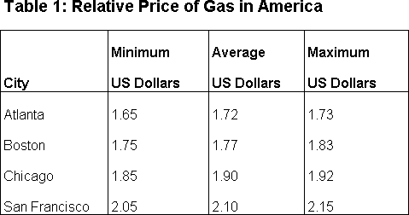

**SECTION 5: TABLES**

Tables are used as a means to quickly compare information side-by-side. Tables have a heading which precedes the table, usually in a font that is bold and larger than the text of the table. The headings of the table should be bold and contain information about the units for the data.

**SECTION 6: FIGURES**

Figures can contain many different types of visual information. Typically figures contain either:

•

•

•

•

Photographs (may or may not be annotated) Charts or data plots

Drawings or schematics

Other visual information types can be displayed...

The text in the figure appears after the subject of the figure. The font of the figure title should be bold and larger than the font of the document text. The figure and title should be centered across the page or column of text. When referring to the figure in the text, one may use one of the following formats (as long as one is consistent in the use, i.e. do not mix and match Fig. and Figure formats in the same document):

**Fig.:** matches the experimental data as seen in Fig. 13, we can not ...

**Figure**

matches the experimental data as seen in Figure 13, we can not...

**#:**

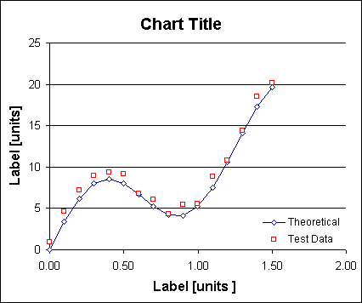

Some examples of Figures are shown below:

**Figure 1: Example Photograph With Annotations**

**Figure 2: Example Plot**

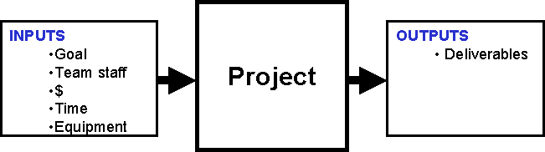

**Figure 3: Example Chart/Drawing**