TECHNICAL WRITING

FOR ENGINEERS

Presented by

Prof. Karim El-Dash

18-21/05/2014

1

Planning for the Document

**Introduction**

The key concept in technical communication is that audience and purpose determine everything about how you communicate on the job. As a nurse, for example, you would need to communicate information to both doctors and patients. You’d likely use different language with these two audiences and have different goals in relaying the information to each party. As a sales manager, you would communicate information about your products to potential clients; you’d communicate that same information differently to other sales representatives that you’re training to work

with you.

**Using an Audience Profile Sheet**

As you read the discussions in this chapter about audience characteristics and techniques for learning about your audience, you might think about using an audience profile sheet. This sheet is a form that prompts you to consider various audience characteristics as you plan your document. For example, the sheet can help you realize that you do not know much about your primary reader’s work history

and what that history can tell you about how to shape your document.

**Why Is Your Audience Reading Your Document?**

For each of your most important readers, consider why he or she is reading your document. Some writers find it helpful to classify readers into categories — such as primary, secondary, and tertiary — each of which identifies a reader’s distance from

the writer.

2

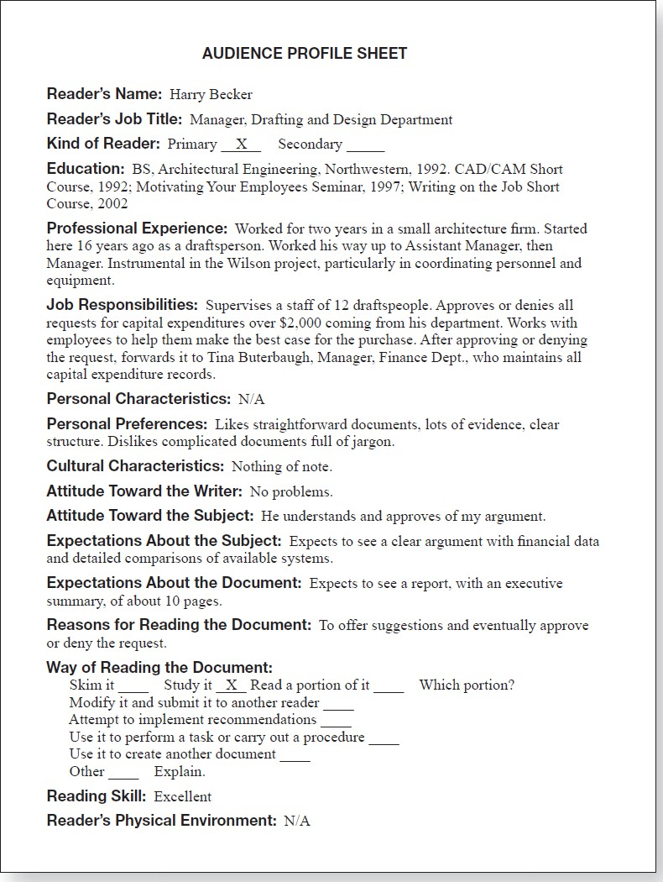

3

**How Will Your Readers Use Your Document?**

In thinking about how your reader will use your document, consider the following

three factors:

1. The way your reader will read your document. Will he or she

— file it?

— skim it?

— read only a portion of it?

— study it carefully?

— modify it and submit it to another reader?

— try to implement recommendations?

— use it to perform a test or carry out a procedure?

— use it as a source document for another document?

Therefore, put this information in an appendix. If you know that your reader wants to use your status report as raw material for a report to a higher-level reader, try to write it so that it requires little rewriting. Use the reader’s own writing style and make sure the reader has access to the electronic file so that your report can be

merged with the new document without needing to be retyped.

2. Your reader’s reading skill. Consider whether you should be writing at all, or

whether it would be better to do an oral presentation or use computer based training.

4

3. The physical environment in which your reader will read your document. Often,

technical documents are formatted in a special way or constructed of special materials to improve their effectiveness.

**Communicating Across Cultures**

Our society and our workforce are becoming increasingly diverse, both culturally and linguistically, and businesses are exporting more and more goods and services. As a result, technical communicators and technical professionals often communicate with nonnative speakers of English in the United States and abroad and with speakers of other languages who read texts translated from English into their own

languages.

**Understanding the Cultural Variables “on the Surface”**

Communicating effectively with people from another culture requires understanding a number of cultural variables that lie on the surface. You need to know, first, what language or languages to use. You also need to be aware of political, social, religious, and economic factors that can affect how readers will interpret your documents. Understanding these factors is not an exact science, but it does require

that you learn as much as you can about the culture of those you are addressing.

In International Technical Communication, Nancy L. Hoft (1995) describes seven

major categories of cultural variables that lie on the surface:

1.

2.

3.

4.

5.

Political. Economic. Social.

Religious.

Educational.

5

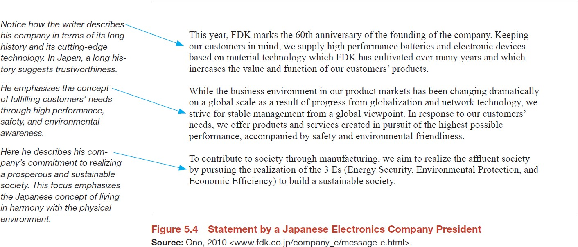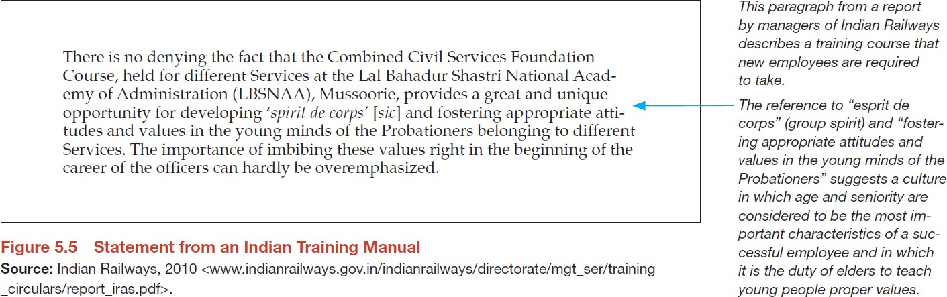

6.

7.

Technological.

Linguistic.

6

**Guidelines for writing for readers from other cultures**

The following eight suggestions will help you communicate more effectively with

multicultural readers.

•

Limit your vocabulary. Every word should have only one meaning, as called for in Simplified English and in other basic-English languages.

Keep sentences short. There is no magic number, but try for an average length of no more than 20 words.

Define abbreviations and acronyms in a glossary. Don’t assume that your readers know what a GFI (ground fault interrupter) is, because the abbreviation is derived from English vocabulary and word order.

Avoid jargon unless you know your readers are familiar with it. For instance, your readers might not know what a graphical user interface is.

Avoid idioms and slang. These terms are culture specific. If you tell your Japanese readers that your company plans to put on a “full-court press,” most likely they will be confused.

Use the active voice whenever possible. The active voice is easier for nonnative speakers of English to understand than the passive voice.

Be careful with graphics. The garbage-can icon on the Macintosh computer does not translate well, because garbage cans have different shapes and can be made of different materials in other countries.

Be sure someone from the culture reviews your document. Even if you have

had help in planning the document, have it reviewed before you publish and distribute it.

•

•

•

•

•

•

•

7

**Determining Your Purpose**

Once you have identified and analyzed your audience, it is time to examine your purpose. Ask yourself this: “What do I want this document to accomplish?” When your readers have finished reading what you have written, what do you want them to know or believe? What do you want them to do? Your writing should help your

readers understand a concept, hold a particular belief, or carry out a task.

**Communicating verbs**

authorize define describe explain illustrate inform outline present review

summarize

**Convincing verbs** assess evaluate forecast propose recommend

request

This classification is not absolute. For example, review could in some cases be a convincing verb rather than a communicating verb: one writer’s review of a

complicated situation might be very different from another’s.

Here are a few examples of how you can use these verbs to clarify the purpose of

your document (the verbs are italicized).

•

This wiki *presents* the draft of our policies on professional use of social media within the organization.

This letter *authorizes* the purchase of six new laptops for the Jenkintown facility.

This memo *recommends* that we revise the Web site as soon as possible.

•

•

8

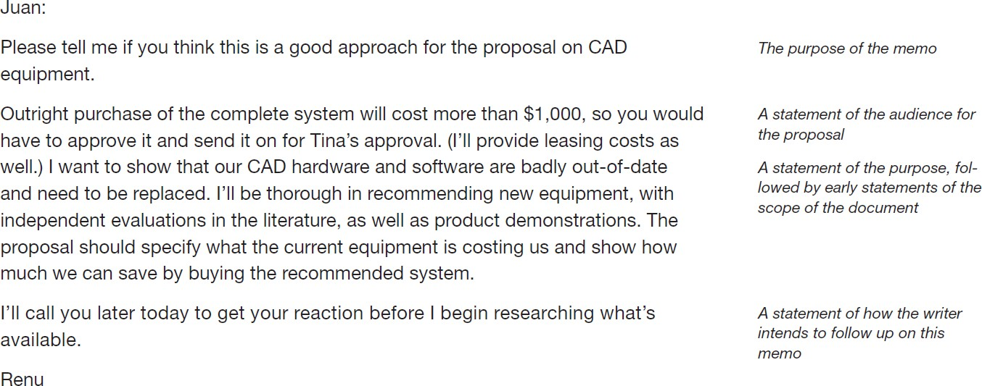

**Gaining Management’s Approval**

9

**Displaying Your Organizational Pattern Prominently**

Make it easy for your readers to understand your organizational pattern. Displaying your pattern prominently involves three main steps:

•

*Create a detailed table of contents.* If your document has a table of contents,

including at least two levels of headings helps readers find the information they seek.

•

*Use headings liberally.* Headings break up the text, making your page more

interesting visually. They also communicate the subject of the section and improve readers’ understanding.

•

*Use topic sentences at the beginnings of your paragraphs.* The topic sentence

announces the main point of a paragraph and helps the reader understand the details that follow.

10

**Organizational Patterns and the Kinds of Information You Want to Present**

11

**If you want to ……**

**Consider using this organizational pattern**

**For example …….**

Explain events that occurred or might occur or tasks the reader is to carry out

**Chronological**. Most of the time, you present information in chronological order.

Sometimes, however, you use reverse chronology.

You describe the process used to diagnose the problem with the accounting software. Or, in a résumé, you describe your more-recent jobs before your less-recent ones.

Describe a physical object or scene, such as a device or a location

**Spatial**. You choose an organizing principle such as top-to-bottom, east-to- west, or inside-to- outside.

You describe the three buildings that will make up the new production facility.

Explain a complex situation, such as the factors that led to a problem or the theory that underlies a process

**General to specific**. You present general information first, then specific information.

Understanding the big picture helps readers understand the details.

You explain the major changes and details of a law mandating the use of a new refrigerant in cooling systems.

Present a set of factors

**More important to less important**

You discuss the most- important issue first, then the next most-important issue, and so forth.

In technical communication, you don’t want to create suspense. You want to present the most important information first.

When you launch a new product, you discuss market niche, competition, and then pricing.

**Organizational Patterns and the Kinds of Information You Want to Present**

12

**If you want to ……**

**Consider using this organizational pattern**

**For example …….**

Present similarities and differences between two or more items

**Comparison and contrast**. You choose from one of two patterns:

1. discuss all the factors related to one item, then all the factors related to the next item, and so forth;
2. discuss one factor as it relates to all the items, then another factor as it relates to all the items, and so forth.

You discuss the strengths and

weaknesses of three companies bidding on a contract your company is offering

Assign items to logical categories or discuss the elements that make up a single item

**Classification and partition**. Classification involves placing items into categories according to some basis. Partition involves breaking a single item into its major elements.

You group the motors your company manufactures according to the fuel they burn: gasoline or diesel. Or you explain the operation of each major component of one of your motors.

Discuss a problem you encountered, the steps you took to address the problem, and the outcome or solution

**Problem-methods- solution**. You can use this pattern in discussing the past, the present, or the future. Readers understand this organizational pattern because they use it in their everyday lives.

In describing how your company is responding to a new competitor, you discuss the problem (the recent loss in sales), the methods (how you plan to examine your product line and business practices), and the solution (which changes will help your company remain competitive).

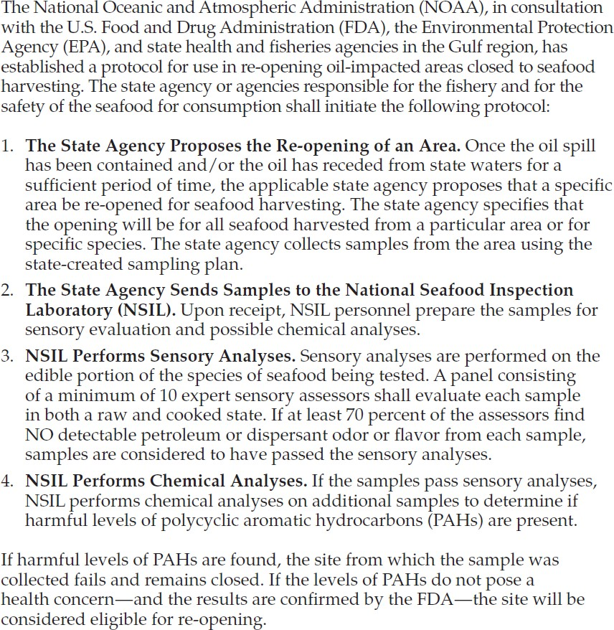

Information Organized Chronologically

13

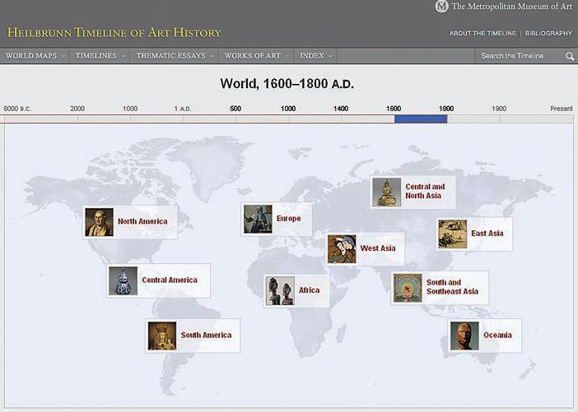

**Organizing Information Spatially**

These three suggestions can help you write an effective spatial passage.

•

Provide signposts. Help your readers follow the argument by using words and

phrases that indicate location (*to the left*, *above*, *in the center*) in headings, topic sentences, and support sentences.

•

Consider using graphics to complement the text. Diagrams, drawings,

photographs, and maps clarify spatial relationships.

•

Analyze events where appropriate. A spatial arrangement doesn’t explain itself; you have to do the analysis. A diagram of a floor plan cannot explain

why the floor plan is effective or ineffective.

This screen, from the Metropolitan Museum of Art’s “Heilbrunn Timeline of Art

History” Web feature, uses spatial organization to show the different styles of art that originated in various regions from 1600 to 1800 c.e.

14

**Organizing Information from General to Specific**

These two suggestions can help you use the general-to-specific pattern effectively.

•

Provide signposts. Explain that you will address general issues first and then move on to specific concerns. If appropriate, incorporate the words general and specific or other relevant terms in the major headings or at the start of the

text for each item you describe.

•

Consider using graphics to complement the text. Diagrams, drawings,

photographs, and maps help your reader understand the general or fine points of the information.

15

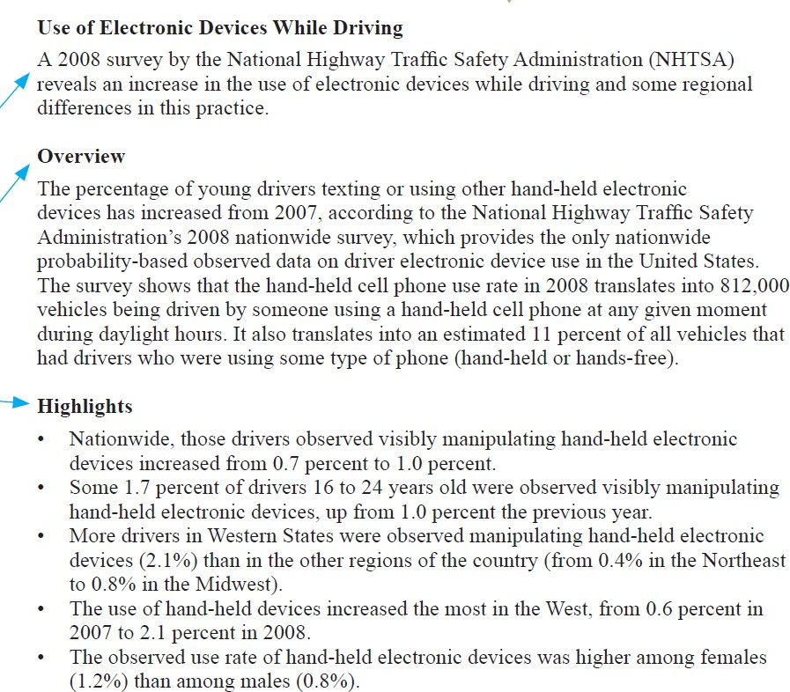

**Information Organized from General to Specific**

16

**Organizing Information from More Important to Less Important**

These three suggestions can help you write a passage organized from more

important to less important.

•

Provide signposts. Tell your readers how you are organizing the passage. For instance, in the introduction of a proposal to design a new microchip, you might write, “The three applications for the new chip, each of which is

discussed below, are arranged from most important to least important.”

In assigning signposts, be straightforward. If you have two very important points and three less-important points, present them that way: group the two important points and label them, as in “Major Reasons to Retain Our Current

Management Structure.” Then present the less-important factors as “Other

Reasons

to

Retain Our

Current

Management Structure.”

Being

straightforward makes the material easier to follow and enhances your

credibility.

•

Explain why one point is more important than another. Don’t just say that you will be arranging the items from more important to less important. Explain why the more-important point is more important.

Consider using graphics to complement the text. Diagrams and numbered lists

often help to suggest levels of importance.

•

17



**Information Organized from More Important to Less Important**

18

**Organizing Information by Comparison and Contrast**

These four suggestions can help you compare and contrast items effectively.

•

Establish criteria for the comparison and contrast. Choose criteria that are

consistent with the needs of your audience.

•

Evaluate each item according to the criteria you have established. Draw your

conclusions.

•

Organize the discussion. Choose either the whole-by-whole or part-by-part

pattern or some combination of the two. Then organize the second-level items.

•

Consider using graphics to complement the text. Graphics can clarify emphasize comparison-and-contrast passages. Diagrams, drawings,

tables are common ways to provide such clarification and emphasis.

and

and

19

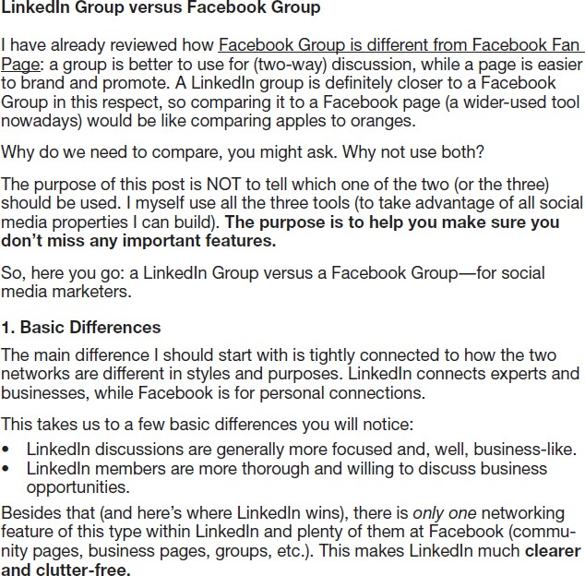

**Information Organized by Comparison and Contrast**

20

**Organizing Information by Classification or Partition**

These six suggestions can help you write an effective classification or partition

passage.

•

Choose a basis of classification or partition that fits your audience and purpose. If you are writing a warning about snakes for hikers in a particular state park, your basis of classification will probably be whether the snakes are poisonous. You will describe all the poisonous snakes, then all the nonpoisonous ones.

Use only one basis of classification or partition at a time. If you are classifying graphics programs according to their technology — paint programs and draw programs — do not include another basis of classification, such as cost.

Avoid overlap. In classifying, make sure that no single item could logically be placed in more than one category. In partitioning, make sure that no listed component includes another listed component. Overlapping generally occurs when you change the basis of classification or the level at which you are partitioning a unit. In the following classification of bicycles, for instance, the writer introduces a new basis of classification that results in overlapping

categories:

•

•

— mountain bikes

— racing bikes

— comfort bikes

— ten-speed bikes

The first three items share a basis of classification: the general category of

bicycle. The fourth item has a different basis of classification: number of

21

speeds. Adding the fourth item is illogical because a particular ten-speed bike

could be a mountain bike, a racing bike, or a comfort bike.

•

Be inclusive. Include all the categories necessary to complete your basis of classification. For example, a partition of an automobile by major systems would be incomplete if it included the electrical, fuel, and drive systems but not the cooling system. If you decide to omit a category, explain why.

Arrange the categories in a logical sequence. Use a reasonable plan: chronology (first to last), spatial development (top to bottom), importance (most important to least important), and so on.

Consider using graphics to complement the text. Organization charts are

commonly used in classification passages; drawings and diagrams are often used in partition passages.

•

•

22

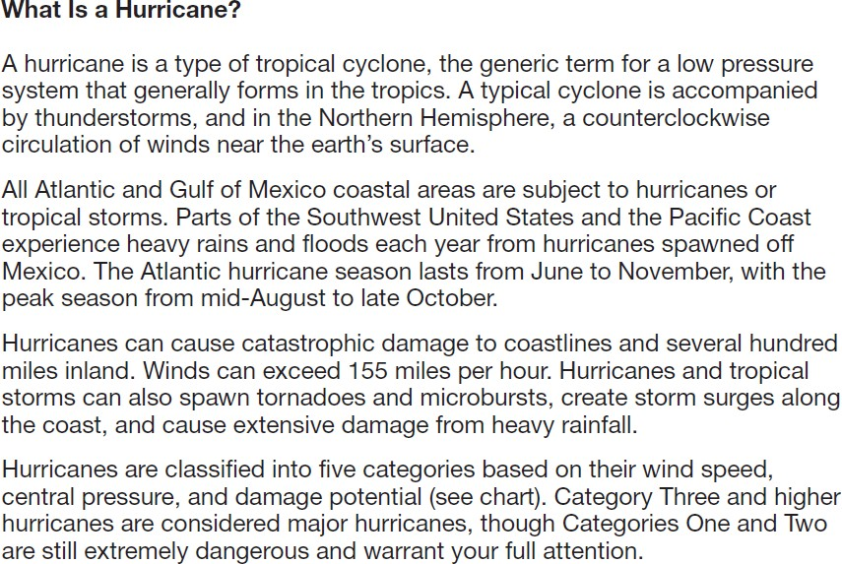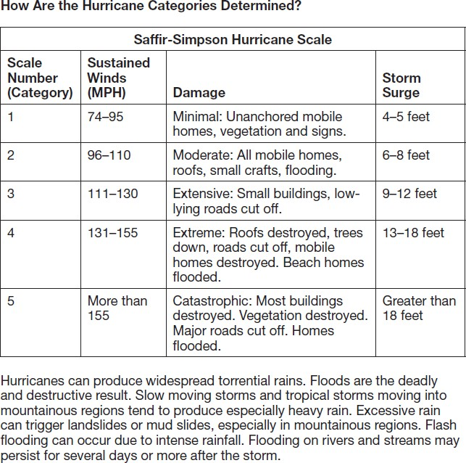

**Information Organized by Classification**

23

**Organizing Information by Problem-Methods-Solution**

These five suggestions can help you write an effective problem-methods-solution

passage.

•

In describing the problem, be clear and specific. Don’t write, “Our energy expenditures are getting out of hand.” Instead, write, “Our energy usage has increased 7 percent in the last year, while utility rates have risen 11 percent.” Then calculate the total increase in energy costs.

In describing your methods, help your readers understand what you did and why you did it that way. You might need to justify your choices. Why, for example, did you use a t-test in calculating the statistics in an experiment? If you can’t defend your choice, you lose credibility.

In describing the solution, don’t overstate. Avoid overly optimistic claims, such as, “This project will increase our market share from 7 percent to 10 percent within 12 months.” Instead, be cautious: “This project could increase our market share from 7 percent to 10 percent.” This way, you won’t be embarrassed if things don’t turn out as well as you had hoped.

Choose a logical sequence. The most common sequence is to start with the problem and conclude with the solution. However, different sequences work equally well as long as you provide a preliminary summary to give readers an overview and provide headings or some other design elements to help readers find the information they want. For instance, you might want to put the methods last if you think your readers already know them or are more interested in the solution.

Consider using graphics to complement the text. Graphics, such as flowcharts,

diagrams, and drawings, can clarify problem-methods-solution passages.

•

•

•

•

24

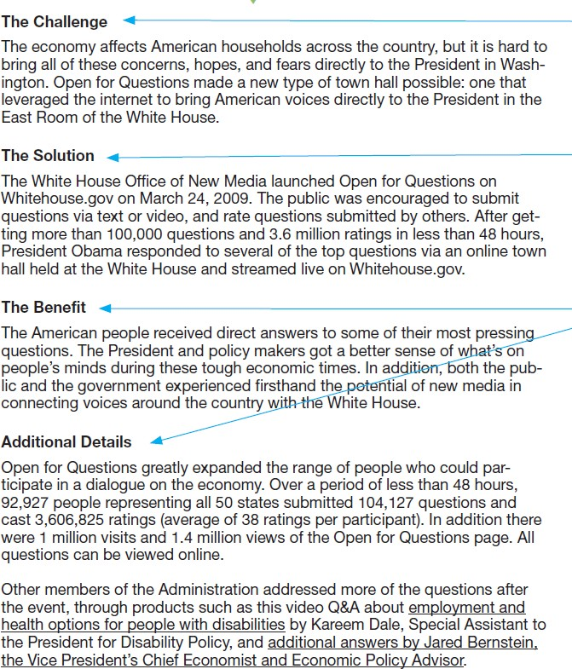

**Information Organized by the Problem-Methods-Solution Pattern**

25

**Exercise**

For each of the lettered topics that follow, identify the best organizational pattern for

a discussion of the subject.

For example, a discussion of distance education and on-campus courses could be organized using the comparison-and-contrast pattern. Write a brief explanation about why this would be the best organizational pattern to use. (Use each of the

organizational patterns discussed in this chapter at least once.)

a.

b.

how to register for courses at your college or university how you propose to reduce the time required to register change your schedule

your car’s dashboard

the current price of gasoline

advances in manufacturing technology

the reasons you chose your college or major a student organization on your campus

two music-streaming services

MP3 players

for classes or to

c.

d.

e.

f.

g.

h.

i.

j.

how you propose to increase the ties between your college or university and local business and industry

college courses

increased security in airports

k.

**l.**

26

Developing the Document

**Working within Constraints**

In planning a persuasive document, you need to work within the constraints that shape your environment on the job. As an engineer, you routinely work within constraints: the amount of information you can gather for a paper, the required length and format, the due date, and so forth. On the job, you will face similar constraints that fall into eight categories: ethical, legal, political, informational, personnel,

financial, time, and format and tone.

**Ethical Constraints** Your greatest responsibility is to your own sense of what constitutes ethical behavior. Being asked to lie or mislead directly challenges your ethical standards, but in most cases, you have options. Some organizations and

professional communities have a published code of conduct.

**Legal Constraints** You must abide by all applicable laws on labor practices, environmental issues, fair trade, consumer rights, and so forth. If you think you have been asked to do something that might be illegal, meet with your organization’s legal

counsel and, if necessary, with attorneys outside the organization.

**Political Constraints** Don’t spend all your energy and credibility on a losing cause. If you know that your proposal would help the company but that management disagrees with you or that the company can’t afford to approve it, consider what you might achieve through some other means, or scale back the idea. Two big exceptions

to this rule are matters of ethics and matters of safety.

**Informational Constraints.** The most common informational constraint you might face is that you cannot get the information you need. You might want your organization to buy a piece of equipment, for example, but you can’t find unbiased evidence that would convince a skeptical reader. What do you do? You tell the truth.

Explain the situation, weighing the available evidence and carefully noting what is

27

missing. If you unintentionally suggest that your evidence is better than it really is,

you will lose your most important credential: your credibility.

**Personnel Constraints** The most typical personnel constraint you might face is a lack of access to as many collaborators as you need. In such cases, present a persuasive proposal to hire the personnel you need. However, don’t be surprised if

you have to make do with fewer people than you want.

**Financial Constraints** Financial constraints are related to personnel constraints:

If you had unlimited funds, you could hire all the personnel you need. But financial constraints can also affect other kinds of resources: you might not be able to print as many copies of a document as you want, or you might need to settle for black and

white instead of full color.

**Time Constraints** Start by determining the document’s deadline. (Sometimes a document will have several intermediate deadlines.) Then create a schedule. Keep in mind that tasks almost always take longer than estimated. And when you collaborate, the number of potential problems increases, because when one person

is delayed, others may lack the necessary information to proceed, causing a logjam.

**Format and Tone Constraints** You will be expected to work within one additional

set of constraints:

•

**Format**. Format constraints are limitations on the size, shape, or style of a document. For example, your reader might like to see all tables and figures presented at the end of the report. If you are writing to someone in your own organization, follow the format constraints described in the company style guide, if there is one, or check similar documents to see what other writers have done.

**Tone**. When addressing superiors, use a formal, polite tone. When addressing

peers or subordinates, use a less formal tone but be equally polite.

•

28

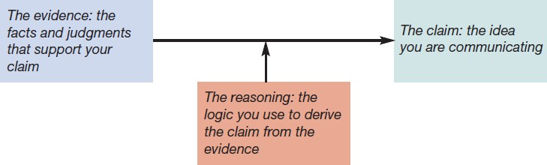

**Crafting a Persuasive Argument**

Persuasion is important, whether you wish to affect a reader’s attitude or merely present information clearly. To make a persuasive case, you must identify the elements of your argument, use the right kinds of evidence, consider opposing viewpoints, appeal to emotions responsibly, decide where to state your claim, and understand the role of culture in persuasion.

**Using the Right Kinds of Evidence**

People most often react favorably to four kinds of evidence: “commonsense”

arguments, numerical data, examples, and expert testimony.

•

**“Commonsense” arguments.** Here, commonsense means, “Most people

would think that . . .” The following sentence presents a commonsense argument that flextime is a good idea:

Flextime makes sense because it gives people more control over how they plan their schedules. A commonsense argument says, “I don’t have hard evidence to support my conclusion, but it stands to reason that . . .” In this case, the argument is that people like to have as much control over their time as possible. If your audience’s commonsense arguments match yours, your

argument is likely to be persuasive.

29

•

**Numerical data.** Numerical data — statistics — are generally more persuasive than commonsense arguments. Statistics drawn from the personnel literature show that, among Fortune 500 companies, flextime decreases turnover by 25 to 35 percent among female employees younger than 38.

**Expert testimony.** A message from an expert is more persuasive than the same message from someone without credentials. A well-researched article on flextime written by a respected business scholar in a reputable business

journal is likely to be persuasive.

•

**Considering Opposing Viewpoints**

When you present an argument, you need to address opposing points of view. If you don’t, your opponents will simply conclude that your proposal is flawed because it doesn’t address problems that they think are important. In meeting the skeptical or

hostile reader’s possible objections to your case, you can use one of several tactics:

•

The opposing argument is based on illogical reasoning or on inaccurate or incomplete facts. You can counter the argument that flextime increases utility bills by citing unbiased research studies showing that it does not.

The opposing argument is valid but less powerful than your own. If you can show that the opposing argument makes sense but is outweighed by your own argument, you will appear to be a fair-minded person who understands that reality is complicated.

The two arguments can be reconciled. If an opposing argument is not invalid

or clearly inferior to your own, you can offer to study the situation thoroughly to find a solution that incorporates the best from each argument.

•

•

For example, if flextime might cause serious problems for your company’s many

carpoolers, you could propose a trial period during which you would study several

30

ways to help employees find other carpooling opportunities. If the company cannot

solve the problem, or if most of the employees prefer the old system, you will switch back to it. This proposal can remove much of the threat posed by your ideas.

**Understanding the Role of Culture in Persuasion**

If you are making a persuasive argument to readers from another culture, keep in mind that cultures differ significantly not only in matters such as business customs but also in their most fundamental values. These differences can affect persuasive writing. Culture determines both what makes an argument persuasive and how

arguments are structured:

•

What makes an argument persuasive? Statistics and experimental data are fundamental kinds of evidence in the West, but testimony from respected authority figures can be much more persuasive in the East.

How to structure an argument. In a Western culture, the claim is usually presented up front. In an Eastern culture, it is likely to be delayed or to remain unstated but implied. When you write for an audience from another culture, use two techniques:

* Study that culture, and adjust the content, structure, and style of your arguments to fit.
* Include in your budget the cost of having your important documents

reviewed and edited by a person from the target culture. Few people are experts on cultures other than their own.

•

31

**Common Logical Fallacies**

32

Fallacy

Explanation

Example and comment

Ad hominem argument; also called *argument against the speaker*

An argument against the writer, not against the writer’s argument

“Of course Matthew wants us to buy more computers—he’s a computer geek.”

The fact that Matthew is a computer geek” doesn’t necessarily mean that his argument for buying more computers is unwise.

Argument from ignorance

An argument that a claim is true because it has never been proven false, or false because it has never been proven true

“Nobody has ever proven that global warming is occurring. Therefore, global warming is a myth.”

The fact that a concept has not yet been proven does not necessarily mean that it is false. Perhaps the measurement techniques are insufficiently precise or not yet available.

Appeal to pity

An argument based on emotion, not reason

“We shouldn’t sell the Ridgeway division. It’s been part of the company for over 40 years.”

The fact that the division has long been a part of the company is not in itself a good reason to retain it.

Argument from authority

An argument that a claim is valid because the person making the claim is an authority

“According to world- renowned climatologist Dr. William Smith, global warming is definitely a fact.” Even if Dr. Smith is a recognized authority in this field, saying that global warming is a fact is not valid unless you present a valid argument to support it.

**Common Logical Fallacies**

33

Fallacy

Explanation

Example and comment

Circular argument; also called

*begging the question*

An argument that assumes what it is attempting to prove

“HP is more successful than its competitors because of its consistently high sales.” Because “more successful” means roughly the same thing as achieving “consistently high sales,” this statement says only that HP outsells its competitors. The writer needs to explain *why* HP outsells its competitors and is therefore more successful.

Either-or argument

An argument that poses only two alternatives when in fact there might be more

“If we don’t start selling our products online, we’re going to be out of business within a year.”

This statement does not explain why these are the only two alternatives. The company might improve its sales by taking measures other than selling online.

*Ad populum* argument; also called *bandwagon argument*

An argument that a claim is valid because many people think it is or act as if it is

“Our four major competitors have started selling online. We should, too.”

The fact that our competitors are selling online is not in itself an argument that we should sell online, too.

Hasty generalization; sometimes called *inadequate sampling*

An argument that draws conclusions based on an insufficient number of cases

“The new Tata is an unreliable car. Two of my friends own Tatas, and both have had reliability problems.”

Before reaching any valid conclusions, you would have to study a much larger sample and compare your findings with those for other cars in the Tata’s class.

**Common Logical Fallacies**

34

Fallacy

Explanation

Example and comment

Post hoc reasoning (the complete phrase is *post hoc, ergo propter hoc*)

An argument that claims that because A precedes B, A caused B

“There must be something wrong with the new circuit breaker in the office. Ever since we had it installed, the air conditioners haven’t worked right.”

Maybe the air conditioners are malfunctioning because of the circuit breaker, but the malfunctioning might have other causes.

Oversimplifying

An argument that omits important information in establishing a causal link

“The way to solve the balance-of-trade problem is to improve the quality of the products we produce.” Although improving quality is important, international trade balances are determined by many factors, including tariffs and currency rates, and therefore cannot be explained by simple cause-and-effect reasoning.

**Creating a Professional Persona**

Your persona is how you appear to your readers. Demonstrating the following four characteristics will help you establish an attractive professional persona.

•

**Cooperativeness**. Make clear that your goal is to solve a problem, not advance your own interests.

**Moderation**. Be moderate in your judgments. The problem you are describing will not likely spell doom for your organization, and the solution you propose will not solve all the company’s problems.

**Fair-mindedness**. Acknowledge the strengths of opposing points of view,

even as you offer counterarguments.

•

•

•

**Modesty**. If you fail to acknowledge that you

someone else will be sure to volunteer that insight.

don’t

know

everything,

35

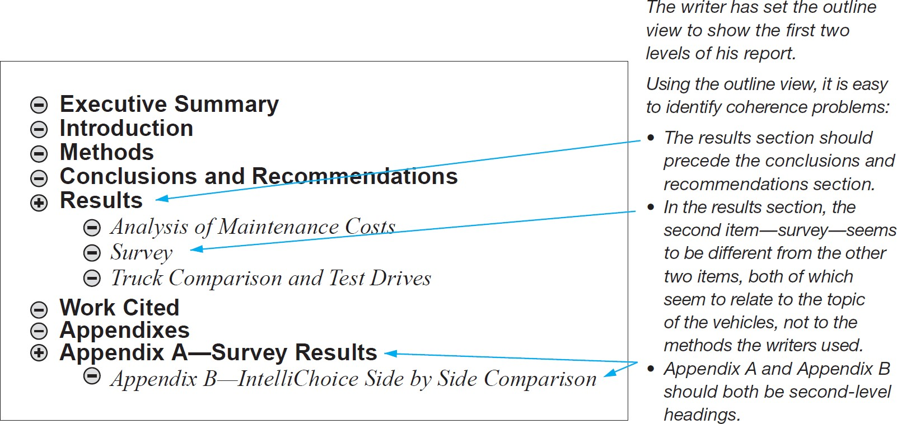

Writing Coherent Documents

**Reviewing the Whole Document for Coherence**

In looking for problems that need fixing, most writers look for the largest, most important problems first, then work on the smaller, less important ones. That way, they don’t waste time on awkward paragraphs they might eventually decide to

delete.

They begin by reviewing the document as a whole (for organization, development,

and content), saving the sentence level concerns (such as grammar, punctuation, and spelling) for later.

**Studying the Coherence of a Document Using the Outline View**

36

**Writing Coherent Titles**

The title of a document is crucial because it is your first chance to define your subject and purpose for your readers, giving them their first clue in deciding if the document contains the information they need. The title is an implicit promise to readers: “This document is about Subject A, and it was written to achieve Purpose B.” Everything that follows has to relate clearly to the subject and purpose defined in the title; if it doesn’t, then either the title is misleading or the document has failed to make good

on the title’s promise.

**Writing Coherent Headings**

Headings, which are lower-level titles for the sections and subsections in a document, do more than announce the subject that will be discussed in the document. Collectively, they create a hierarchy of information, dividing the document into

major sections and subdividing those sections into subsections.

In this way, coherent headings communicate the relative importance and generality of the information that follows, helping readers recognize major sections as primary (likely to contain more-important and more-general information) and subsections as secondary or subordinate (likely to contain less important and more-specific

information).

**Revising Headings**

Follow these four suggestions to make your headings more effective.

•

**Avoid long noun strings.** The following example is ambiguous and hard to

understand:

*Proposed Production Enhancement Strategies Analysis Techniques*

37

Is the heading introducing a discussion of techniques for analyzing strategies that have been proposed? Or is it introducing a discussion that proposes using certain techniques to analyze strategies? Readers shouldn’t have to ask such

questions. Adding prepositions makes the heading clearer:

*Techniques for Analyzing the Proposed Strategies for Enhancing Production*

This heading announces more clearly that the discussion describes techniques for analyzing strategies, that those strategies have been proposed, and that the strategies are aimed at enhancing production. It’s a longer heading than the

original, but that’s okay. It’s also much clearer.

•

**Be informative.** In the preceding example, you could add information about

how many techniques will be described:

*Three Techniques for Analyzing the Proposed Strategies for Enhancing*

*Production*

You can go one step further by indicating what you wish to say about the three

techniques:

*Advantages and Disadvantages of the Three Techniques for Analyzing the*

*Proposed Strategies for Enhancing Production*

Again, don’t worry if the heading seems too long; clarity is more important

than conciseness.

•

**Use a grammatical form appropriate to your audience**. The question form

works well for less-knowledgeable readers or for nonnative speakers:

*What Are the Three Techniques for Analyzing the Proposed Strategies for*

*Enhancing Production?*

38

The “how-to” form is best for instructional material, such as manuals:

*How to Analyze the Proposed Strategies for Enhancing Production*

The gerund form (-ing) works well for discussions and descriptions of

processes:

*Analyzing the Proposed Strategies for Enhancing Production*

•

Avoid back-to-back headings. Use advance organizers to separate the

headings.

**Writing Coherent Paragraphs**

There are two kinds of paragraphs: body paragraphs and transitional paragraphs.

A body paragraph, the basic unit for communicating information, is a group of sentences (or sometimes a single sentence) that is complete and self-sufficient and that contributes to a larger discussion. In an effective paragraph, all the sentences clearly and directly articulate one main point, either by introducing the point or by providing support for it. In addition, the whole paragraph follows logically from the

material that precedes it.

A transitional paragraph helps readers move from one major point to another. Like a body paragraph, it can consist of a group of sentences or be a single sentence. Usually it summarizes the previous point, introduces the next point, and helps

readers understand how the two are related.

39

**Structure Paragraphs Clearly**

Most paragraphs consist of a topic sentence and supporting information.

**The Topic Sentence** Because a topic sentence states, summarizes, or forecasts the main point of the paragraph, put it up front. Technical communication should be clear and easy to read, not suspenseful. If a paragraph describes a test you performed,

include the result of the test in your first sentence:

*The point-to-point continuity test on Cabinet 3 revealed an intermittent open circuit*

*in the Phase 1 wiring.*

Then go on to explain the details.

**The Supporting Information**

The supporting information makes the topic sentence clear and convincing. Sometimes a few explanatory details provide all the support you need. At other times, however, you need a lot of information to clarify a difficult thought or defend a controversial idea. How much supporting information to provide also depends on

your audience and purpose?

**Paragraph Length** How long should a paragraph be? In general, 75 to 125 words are enough for a topic sentence and four or five supporting sentences. Long paragraphs are more difficult to read than short paragraphs because they require more focused concentration. They can also intimidate some readers, who skip over

them.

40

**Dividing Long Paragraphs**

41

**Technique**

**Example**

**Break the discussion at a logical place.**

The most logical place to divide this paragraph is at the introduction of the second factor. Because the paragraphs are still relatively long, this strategy works best for skilled readers.

High-tech companies have been moving their operations to the suburbs for two main reasons: cheaper, more modern space and a better labor pool. A new office complex in the suburbs will charge from one-half to two thirds of the rent charged for the same square footage in the city. And that money goes a lot further, too. The new office complexes are bright and airy; new office space is already wired for computers; and exercise clubs, shopping centers, and even libraries are often on-site.

The second major factor attracting high-tech companies to the suburbs is the availability of experienced labor. Office workers and middle managers are abundant.

In addition, the engineers and executives, who tend to live in the suburbs anyway, are happy to forgo the commuting, the city wage taxes, and the noise and stress of city life.

**Make the topic sentence a separate paragraph and break up the supporting information.**

This revision is easier for all readers to understand because the brief paragraph at the start clearly introduces the information. In addition, each of the two main paragraphs now has a clear topic sentence.

High-tech companies have been moving their operations to the suburbs for two main reasons: cheaper, more modern space and a better labor pool.

First, office space is a bargain in the suburbs. A new office complex in the suburbs will charge from one-half to two-thirds of the rent charged for the same square footage in the city. And that money goes a lot further, too. The new office complexes are bright and airy; new office space is already wired for computers; and exercise clubs, shopping centers, and even libraries are often on-site.

Second, experienced labor is plentiful. Office workers and middle managers are abundant. In addition, the engineers and executives, who tend to live in the suburbs anyway, are happy to forgo the commuting, the city wage taxes, and the noise and stress of city life.

**Dividing Long Paragraphs**

42

**Technique**

**Example**

**Use a list.**

This is the easiest of the three versions for all readers because of the extra visual cues provided by the list format.

High-tech companies have been moving their operations to the suburbs for two main reasons:

* *Cheaper, more modern space.* Office space is a bargain in the suburbs. A new office complex in the suburbs will charge anywhere from one- half to two-thirds of the rent charged for the same square footage in the city. And that money goes a lot further, too. The new office complexes are bright and airy; new office space is already wired for computers; and exercise clubs, shopping centers, and even libraries are often on-site.
* *A better labor pool.* Office workers and middle managers are abundant. In addition, the engineers and executives, who tend to live in the suburbs anyway, are happy to forgo the commuting, the city wage taxes, and the noise and stress of city life.

**Adding Transitional Words and Phrases**

Transitional words and phrases help the reader understand a discussion by explicitly

stating the logical relationship between two ideas. The following Table lists the most

common logical relationships between two

transitions that express those relationships.

ideas

and

some

of

the

common

43

**Relationship**

**Transition**

addition

also, and, finally, first (second, etc.), furthermore, in addition, likewise, moreover, similarly

comparison

in the same way, likewise, similarly

contrast

although, but, however, in contrast, nevertheless, on the other hand, yet

illustration

for example, for instance, in other words, to illustrate

cause-effect

as a result, because, consequently, hence, so, therefore, thus

time or space

above, around, earlier, later, next, to the right (left, west, etc.), soon, then

summary or conclusion

at last, finally, in conclusion, to conclude, to summarize

**Weak**

The project was originally expected to cost $300,000. The final cost was

$450,000.

**Improved**

The project was originally expected to cost $300,000. However, the final

cost was $450,000.

This next sentence pair differs from the others in that the weak example does contain

a transitional word, but it’s a weak transitional word:

**Weak**

According to the report from Human Resources, the employee spoke rudely to a group of customers waiting to enter the store, and he repeatedly ignored

requests from co-workers to unlock the door so the customers could enter.

**Improved**

According to the report from Human Resources, the employee spoke rudely to a group of customers waiting to enter the store; moreover, he repeatedly ignored requests from co-workers to unlock the door so the customers could

enter.

44

**Repeating Key Words**

Repeating key words — usually nouns — helps readers follow the discussion. In the

following example, the first version could be confusing:

**Unclear**

For months the project leaders carefully planned their research. The cost of the work

was estimated to be over $200,000.

What is the work: the planning or the research?

**Clear**

For months the project leaders carefully planned their research. The cost of the

research was estimated to be over $200,000.

From a misguided desire to be interesting, some writers keep changing their important terms. Plankton becomes miniature seaweed, then the ocean’s fast food. Avoid this kind of word game; it can confuse readers. Of course, too much repetition

can be boring. You can vary nonessential terms as long as you don’t sacrifice clarity.

**Sluggish**

The purpose of the new plan is to reduce the problems we are seeing in our

accounting operations. We hope to see a reduction in the problems by early next quarter.

**Better**

The purpose of the new plan is to reduce the problems we are seeing in our

accounting operations. We hope to see an improvement by early next quarter.

45

**Using Demonstrative Pronouns Followed by Nouns**

Demonstrative pronouns — this, that, these, and those — can help you maintain the coherence of a discussion by linking ideas securely. In almost all cases, demonstrative pronouns should be followed by nouns, rather than stand alone in the

sentence.

In the following examples, notice that a demonstrative pronoun by itself can be

vague and confusing.

**Unclear**

New screening techniques are being developed to combat viral infections. These are

the subject of a new research effort in California.

What is being studied in California: new screening techniques or viral infections?

**Clear**

New screening techniques are being developed to combat viral infections.

These techniques are the subject of a new research effort in California.

**Unclear**

The task force could not complete its study of the mine accident.

This was the subject of a scathing editorial in the union newsletter.

What was the subject of the editorial: the mine accident or the task force’s inability

to complete its study of the accident?

**Clear**

The task force failed to complete its study of the mine accident. This failure was the

subject of a scathing editorial in the union newsletter.

46

Writing Effective Sentences

**Structuring Effective Sentences**

Good technical communication consists of clear, correct, and graceful sentences that

convey information economically. This section describes seven principles for structuring effective sentences:

**Emphasize New and Important Information**

Sentences are often easier to understand and more emphatic if new information

appears at the end. For instance, if your company has labor problems and you want to describe the possible results, structure the sentence like this:

Because of labor problems, we anticipate a three-week delay.

In this case, the “three-week delay” is the new information.

If your readers already expect a three-week delay but don’t know the reason for it,

reverse the structure:

We anticipate the three-week delay in production because of labor problems.

Here, “labor problems” is the new and important information.

Try not to end the sentence with qualifying information that blunts the impact of the

new information.

**Weak**

The joint could fail under special circumstances.

**Improved**

Under special circumstances, the joint could fail.

47

**Choose an Appropriate Sentence Length**

Sometimes sentence length affects the quality of the writing. In general, an average of 15 to 20 words is effective for most technical communication. A series of 10- word sentences would be choppy. A series of 35-word sentences would probably be too demanding. And a succession of sentences of approximately the same length

would be monotonous.

In revising a draft, use your software to compute the average sentence length of a

representative passage.

**Avoid Overly Long Sentences**

How long is too long? There is no simple answer, because ease of reading depends on the vocabulary, sentence structure, and sentence length; the reader’s motivation and knowledge of the topic; the purpose of the communication; and the conventions of the application you are using. For instance, you use shorter sentences in tweets

and text messages than in reports.

Often a draft will include sentences such as the following:

The construction of the new facility is scheduled to begin in March, but it might be

delayed by one or even two months by winter weather conditions, which can make it impossible or nearly impossible to begin excavating the foundation.

To avoid creating such long sentences, say one thing clearly and simply before

moving on to the next idea. For instance, to make this difficult 40-word sentence easier to read, divide it into two sentences:

The construction of the new facility is scheduled to begin in March. However,

construction might be delayed until April or even May by winter weather conditions,

48

which can make it impossible or nearly impossible to begin excavating the

foundation.

**Avoid Overly Short Sentences**

Just as sentences can be too long, they can also be too short and choppy, as in the

following example:

*Customarily, environmental cleanups are conducted on a “time-and-materials” (T&M) basis. Using the T&M basis, the contractor performs the work. Then the contractor bills for the hours worked and the cost of equipment and materials used during the work. With the T&M approach, spending for environmental cleanups by private and government entities has been difficult to contain. Also, actual*

*contamination reduction has been slow.*

The problem here is that some of the sentences are choppy and contain too little information, calling readers’ attention to how the sentences are constructed rather than to what the sentences say. In cases like this, the best way to revise is to combine

sentences:

*Customarily, environmental cleanups are conducted on a “time-and-materials” (T&M) basis: the contractor performs the work, then bills for the hours worked and the cost of equipment and materials. With the T&M approach, spending for environmental cleanups by private and government entities has been difficult to*

*contain, and contamination reduction has been slow.*

49

**Focus on the “Real” Subject**

The conceptual or “real” subject of the sentence should also be the grammatical subject. Don’t disguise or bury the real subject in a prepositional phrase following a weak grammatical subject. In the following examples, the weak subjects obscure the

real subjects. (The grammatical subjects are italicized.)

**Weak**

The use of this method would eliminate the problem of motor

damage.

**Strong**

This method would eliminate the problem of motor damage.

**Weak**

The presence of a six-membered lactone ring was detected.

**Strong**

A six-membered lactone ring was detected.

Another way to make the subject of the sentence prominent is to reduce the number of grammatical expletives. Expletives are words that serve a grammatical function in a sentence but have no meaning. The most common expletives are it is, there is,

there are, and related phrases.

**Weak**

There is no alternative for us except to withdraw the product.

**Strong**

We have no alternative except to withdraw the product.

**Weak**

It is hoped that testing the evaluation copies of the software will help

us make this decision.

**Strong**

We hope that testing the evaluation copies of the software will help

us make this decision.

50

**Focus on the “Real” Verb**

A “real” verb, like a “real” subject, should stand out in every sentence. A common problem in technical communication is the inappropriate use of a nominalized verb

— a verb that has been changed into a noun, then coupled with a weaker verb. To install becomes to effect an installation; to analyze becomes to conduct an analysis. Notice how nominalizing the verbs makes the following sentences both awkward

and unnecessarily long (the nominalized verbs are italicized).

**Weak**

Each preparation of the solution is done twice.

**Strong**

Each solution is prepared twice.

**Weak**

Consideration should be given to an acquisition of the properties.

**Strong**

We should consider acquiring the properties.

**Use Parallel Structure**

A sentence is parallel if its coordinate elements follow the same grammatical form: for example, all the clauses are either passive or active, all the verbs are either infinitives or participles, and so on. Parallel structure creates a recognizable pattern, making a sentence easier for the reader to follow. Nonparallel structure creates no such pattern, distracting and possibly confusing readers. For example, the verbs in the following examples are nonparallel because they do not use the same verb form

(verbs are italicized).

**Nonparallel**

Our present system is costing us profits and reduces our productivity.

**Parallel**

Our present system is costing us profits and reducing our

productivity.

51

**Nonparallel**

The compositor should follow the printed directions; do not change

the originator’s work.

**Parallel**

The compositor should follow the printed directions and should not

change the originator’s work.

When using parallel constructions, make sure that parallel items in a series do not

overlap, causing confusion or even changing the meaning of the sentence:

**Confusing**

The speakers will include partners of law firms, businesspeople, and civic leaders. “Partners of” appears to apply to “businesspeople” and “civic leaders,” as well as to “law firms.” That is, “partners of” carries over to the other items in the series. The following revision solves the problem by rearranging the items so that “partners” can

apply only to “law firms.”

**Clear**

The speakers will include businesspeople, civic leaders, and partners

of law firms.

**Confusing**

We need to buy more lumber, hardware, tools, and hire the subcontractors. The writer has linked two ideas inappropriately. The first idea is that we need to buy three things: lumber, hardware, and tools. The second is that we need to hire the subcontractors. Hiring is not in the same category as the items to buy. In other words, the writer has structured and punctuated the sentence as if it contains a four-item series, when in fact it should contain a three-item series

followed by a second verb phrase.

**Clear**

We need to buy more lumber, hardware, and tools, and we need to

hire the subcontractors.

52

**Choosing the Right Words and Phrases**

This section discusses four principles that will help you use the right words and

phrases in the right places: select an appropriate level of formality, be clear and specific, be concise, and use inoffensive language.

Select an Appropriate Level of Formality

Although no standard definition of levels of formality exists, most experts would

agree that there are three levels:

Informal

The Acorn 560 is a real screamer. With 3.8 GHz of pure computing power, it slashes through even the thickest

spreadsheets before you can say 2 + 2 = 4.

Moderately formal

With its 3.8 GHz microprocessor, the Acorn 560 can

handle even the most complicated spreadsheets quickly.

Highly formal

With a 3.8 GHz microprocessor, the Acorn 560 is a high-

speed personal computer

appropriate

for computation-

intensive

applications

such

as

large,

complex

spreadsheets.

53

**Be Clear and Specific**

Follow these seven guidelines to make your writing clear and specific:

•

Use active and passive voice appropriately.

•

Be specific.

•

Avoid unnecessary jargon.

•

Use positive constructions.

•

Avoid long noun strings.

•

Avoid clichés.

•

Avoid euphemisms.

54

**Use Active and Passive Voice Appropriately**

In a sentence using the active voice, the subject performs the action expressed by the verb: the “doer” of the action is the grammatical subject. By contrast, in a sentence using the passive voice, the recipient of the action is the grammatical subject.

Compare the following examples (the subjects are italicized):

**Active**

Dave Brushaw drove the launch vehicle.

The doer of the action is the subject of the sentence.

**Passive**

The launch vehicle was driven by Dave Brushaw.

The recipient of the action is the subject of the sentence.

In most

cases, the active voice works better than the passive voice because it

emphasizes the agent (the doer of the action). An active-voice sentence also is shorter because it does not require a form of the verb to be and the past participle, as a passive-voice sentence does. In the active version of the example sentence, the

verb is “drove” rather than “was driven,” and the word “by” does not appear.

* When the agent is clear from the context:

*Students are required to take both writing courses.*

Here, the context makes it clear that the college sets the requirements.

* When the agent is unknown:

*The comet was first referred to in an ancient Egyptian text.*

We don’t know who wrote this text.

* When the agent is less important than the action:

*The blueprints were hand-delivered this morning.*

It doesn’t matter who the messenger was.

55

* When a reference to the agent is embarrassing, dangerous, or in some other way

inappropriate:

*Incorrect figures were recorded for the flow rate.*

It might be unwise or tactless to specify who recorded the incorrect figures.

Perhaps it was your boss. However, it is unethical to use the passive voice to

avoid responsibility for an action.

56

**Be Specific**

Being specific involves using precise words, providing adequate detail, and avoiding

ambiguity.

•

**Use precise words.** A Ford Focus is an automobile, but it is also a vehicle, a machine, and a thing. In describing the Focus, automobile is better than the less- specific vehicle, because vehicle can also refer to pickup trucks, trains, hot-air balloons, and other means of transport. As words become more abstract — from machine to thing, for instance — chances for misunderstanding increase.

**Provide adequate detail.** Readers probably know less about your subject than

you do. What might be perfectly clear to you might be too vague for them.

•

**Vague**

An engine on the plane experienced some difficulties.

Which engine? What plane? What kinds of difficulties?

**Clear**

The left engine on the Cessna 310 temporarily lost power during

flight.

•

**Avoid**

**ambiguity.** Don’t let readers wonder which of two meanings you are

trying to convey.

**Ambiguous**

After stirring by hand for 10 seconds, add three drops of the iodine

mixture to the solution.

After stirring the iodine mixture or the solution?

**Clear**

Stir the iodine mixture by hand for 10 seconds. Then add three

drops to the solution.

**Clear**

Stir the solution by hand for 10 seconds. Then add three drops of

the iodine mixture.

57

**Use Positive Constructions**

The term positive construction has nothing to do with being cheerful. It indicates that the writer is describing what something is instead of what it is not. In the sentence “I was sad to see this project completed,” “sad” is a positive construction.

The negative construction would be “not happy.”

Here are a few more examples of positive and negative constructions:

58

**Positive Construction**

**Negative Construction**

Most

not all

Few

not many

on time

not late, not delayed

positive

not negative

inefficient

not efficient

reject

cannot accept

impossible

not possible

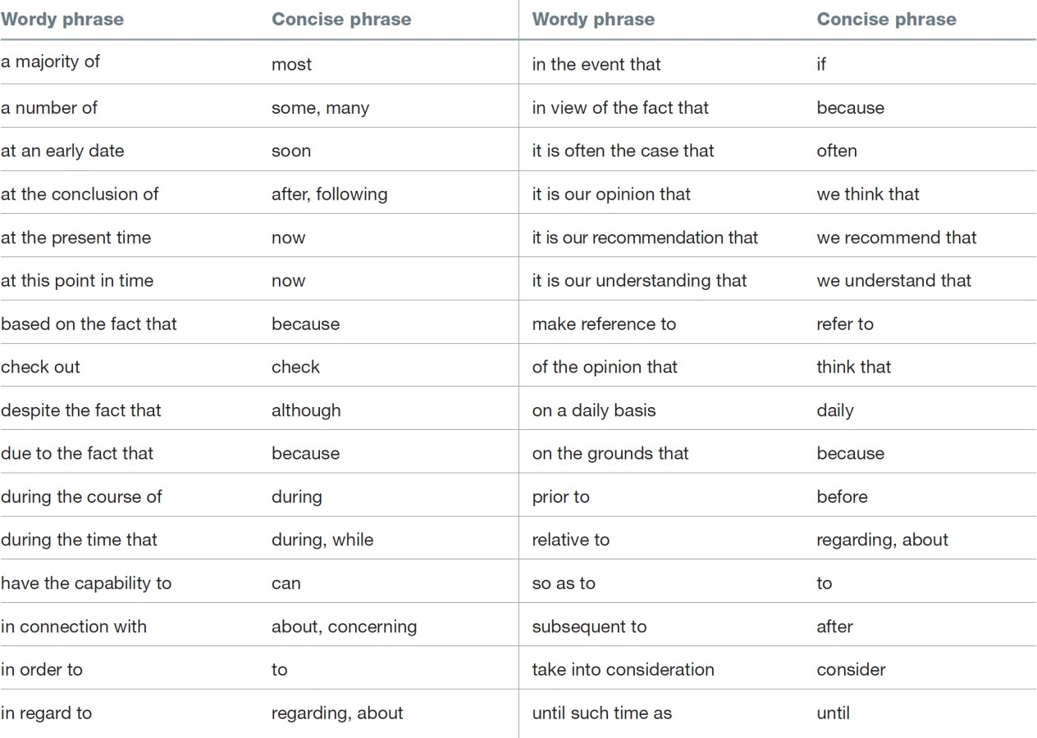

**Avoid Wordy Phrases**

Wordy phrases also make writing long and boring. For example, some people write on a daily basis rather than daily. The long phrase may sound more important, but

daily says the same thing more concisely.

59

**Exercise #2**

This exercise requires that you create the headings and subheadings for a report on the following research on the loss of life in the sinking of the *Titanic.*

The *R.M.S. Titanic* sideswiped an iceberg at 11:40 p.m. on April 14, 1912. Estimated to be able to stay afloat for 2 days under the worst scenario, the ship sank in less than 3 hours [Gannon, 1995]. The iceberg created a 300-foot gash in the *Titanic's* hull above and below the waterline.

Tests on *Titanic's* steel showed that the steel had high sulfur content, which increases the brittleness of steel by disrupting the grain structure [Hill, 1996]. This increase in brittleness contributed to the severity of the hull's damage.

Captain E. J. Smith had not slowed the ship's speed that night, although the ship's wireless operators had received several ice warnings. The ship was moving at more than 22 knots.

The sea was a "flat calm," a rarity for these waters. Under such conditions, there was no "tell-tale phosphorescent ripple" against the iceberg [Gardiner and Van der Vat, 1995]. Lookouts in the crow's nest on the Titanic did not spot the massive iceberg until only 5 minutes before the collision. That night, the lookouts had misplaced their binoculars.

Even before the iceberg was spotted, Quartermaster Hitchens at the helm had begun to turn to port. When the alarm sounded, he turned full to port. His turning caused the *Titanic* to sideswipe the iceberg, rather than hit it head-on. Experts believe that the ship would not have sunk so quickly had it hit the iceberg head-on [Gardiner and Van der Vat, 1995].

The lower section of the *Titanic* was divided into sixteen major watertight compartments. Actually, the compartments were watertight only in the horizontal direction--their tops were open. After the collision, six watertight compartments began filling with water. Soon, water spilled over the tops.

Scientists have concluded that the watertight compartments contributed to the disaster by keeping the flood waters in the bow of the ship [Gannon, 1995]. If there had been no compartments, the incoming water would have spread out, and the *Titanic* would have likely remained afloat for another six hours.

60

Flares were fired and *Titanic's* wireless operators sent out an SOS, but the wireless operator of the nearest ship, the *California,* had gone to bed at 11:30. Controversy exists on whether the *California* had seen the *Titanic's* signal flares. If so, why had its captain, Stanley Lord, not responded?

*Titanic's* steel showed high levels of oxygen, which leads to an increased ductile-to- brittle transition temperature. For *Titanic's* steel, that temperature was determined to be 25 to 35 degrees F [Hill, 1996]. The water temperature that night was below freezing.

The wrought iron rivets that fastened the hull plates to the *Titanic's* main structure also failed because of brittle fracture during the collision with the iceberg. Low water temperatures contributed to this failure [Garzke and others, 1994].

As it filled with water, the bow submerged, raising the stern out of water. When the stern reached an angle of about 45 degrees, the stresses in the ship's midsection (15 tons per square inch) caused the steel to fail and the bow to rip loose and sink [Gannon, 1995]. Contributing to this failure in the midsection was the design of *Titanic's* huge spiral staircase. The staircase not only weakened the midsection's structure, but served as a means for water to pass up through the ship.

The *Titanic* carried lifeboats for 1,178 people, a number that exceeded regulations of that time. However, the crew, which had never been drilled on the use of the lifeboats, was inexperienced at filling and lowering them. The first lifeboats into the water were not even half full. In all, only 705 were saved by the lifeboats.

Those on *Titanic* who went into the icy waters when the ship foundered died within minutes-hours before the *Carpathia,* the first rescue ship on the scene, was able to arrive.

61

**Exercise #3**

This exercise requires that you identify the main stylistic problem in each excerpt.

1:

Discharges of these hazardous substances occur through spills when loading vehicles, spills and over-spills when filling the tanks, leaks from supply pipes and pipe joints, rust holes and cracks in the seams of the tanks themselves.

2:

The design of the circuit is shown in Appendix A. The first schematic of the Appendix shows the interface of the EEPROM with the HC11. The decoder and the bit latch were also needed for this circuit. The decoder made sure that the EEPROM responded to address locations $6000 to $7FFF. The latch stored the address lines for the EEPROM when Port C on the EVBU switched from output address lines to input data lines. These integrated chips worked together to give the HC11 the expanded memory.

3:

Report Title: Loading Dock Boxcar Stop Viscous Damping Values

4:

Standalone Operation. This involved both hardware and software...

5:

The objective of this endeavor is to develop a commercialization strategy for solar energy systems by analyzing factors impeding early commercial projects (i.e., SOLAR ONE) and by identifying the potential actions that can facilitate the viability of the projects.

6:

It has come to my attention that your sport utility vehicles are not as technologically advanced as they could be! Microprocessors are more than just a booming technological buzzword; they are something that can be seamlessly implemented into existing vehicles and will add countless dimensions to their capabilities...These are of course tiny examples in a grander scheme of things that can be accomplished with microprocessors. There are much more useful and innovative things that could be done to improve both the mechanical and ergonomic aspects, which would put you light-years ahead of your closest competitors, all the while fattening your pockets...I enthusiastically look forward to meeting with you!

62

7:

Enormous mining companies are both continuing operations at old gold mines, such as the case of the Homestake Mine in Lead, South Dakota, which has operated continuously since 1877 and is continuing to increase its operations [Hinds and Trautman, 1983], and opening new gold mines, often in very disturbing locations, such as the proposed, and for now, postponed, New World Mine, whose proposed location was about 2.5 miles from the border of Yellowstone National Park, near Cooke City, Montana.

8:

Most people are diagnosed with phenylketonuria at birth.

9:

Since the invention of the catalytic converter, one problem that has baffled people involved with emission control is their lack of effectiveness in oxidizing CO and HC until the engine is warm.

10:

Procedures for Design. The procedures for this part of the laboratory began with the ASM command. This command was used to disassemble code. This disassembly began at the specified memory address. This command was useful in examining the code predefined by the Buffalo Disassembler. The "ASM" command was used at the start of address $E000. It listed the first three instructions at location $E000. Table 1 shows both the machine code and the disassembled code for these instructions.

11:

To provide spill protection all tanks were to include catchment basins and automatic shutoff devices or overfill alarms or ball float valves.

12:

Introduction Background

Origin of Computer Viruses Destruction by Computer Viruses Example (Burleson Virus) Barriers to Computer Viruses Physical

Antiviral Barriers Conclusions Recommendations

63

13:

Each time we wired the hex display, we placed it in a different location on the bread board. Unfortunately, each time the hex display would show a different reading. The third time proved to be the charm as the hex display read all of the numbers correctly.

14:

Interfacing the Matrix Keyboard. Here, a 4x4 matrix keypad and TIL-311 hex display to be added to the hardware wired in the previous section.

15:

Report Title: Vertical Linear Actuators Position Measurement and Repeatability NIF Bottom Loading Insertion System Test Procedure.

64

**Exercise #4**

Each of the following excerpts has an ambiguity, which is a word or phrase with more than one meaning. While poets make their living off ambiguities, engineers and scientists are often sued for ambiguities. For each excerpt, identify the source of the ambiguity:

1. improper syntax (word order),
2. missing comma,
3. unclear pronoun reference, or
4. grouping of conflicting words.

1. With the lid off the reactor core was exposed, allowing radioactive isotopes to escape.

2. We propose to provide the above engineering services hourly based on the following estimates.

3. Compared with the pollution of the average coal-fired plant, the thermal pollution of a nuclear power plant is less than 2 percent more.

4. Reductions up to 80% in heat and mass transfer coefficients were measured due to outgassing.

5. As airplane designs change the anti-ice systems also have to change.

6. Most people are diagnosed with phenylketonuria at birth.

7. The use of the thermal storage unit is limited to supplying low-pressure auxiliary steam because of insufficient excess energy from the undersized collector.

8. At this time, the Department of Energy is only considering Yucca Mountain as a possible storage site for nuclear waste. Other possible sites are excluded from discussion.

9. If the airplane waits too long to take off the de-ice fluid can dissipate.

10. The Lunar Module was only designed to hold two astronauts and to have a life time of forty-five hours.

11. The beams are positioned with respect to the chopper blade so that while one beam passes the output of the opposite beam is completely blocked.

65

12. The Hindenburg was filled with hydrogen because it is lighter than air...The report claimed that a hull wire could have ruptured a gas cell if it fractured.

13. Avoiding complicated multi-ordered calculations, the equations come from fundamental definitions of mass flow, work, and efficiency.

14. To provide spill protection, all tanks were equipped with basins and automatic shutoff devices or overfill alarms or ball float valves.

15. Being the first step in introducing CFD, Jones had to set up conservative assumptions.

16. As with any system errors occur in localization.

17. Having a model would help designers predict the effects of engine operation over all speeds.

66

**Style requirements of good technical writing:**

•

•

•

•

•

•

•

•

•

•

Use an accepted report format. Choose concise words.

Be unbiased and maintain a neutral, objective tone. Construct clear sentences of mixed length.

Develop a balanced flow of paragraphs with clear and concise topic sentences. Avoid the use of unfamiliar technical words.

Avoid acronyms. Many readers may not know what they mean. Use an impersonal style, especially for formal reports or papers. Adopt a positive style of writing, and write in the active voice.

Avoid rewordings and words with contemporary meanings that are different from dictionary meanings.

Write with credibility; avoid the use of superlatives like superior, fastest, and so forth that are often just unsupported exaggerations.

Avoid conversational writing in technical reports.

Adopt the concept of parallel construction when listing items or shaping the length and content of many paragraphs

Use topic headings to help organize and prioritize the flow of para- graphs.

•

•

•

•

67

**Points to keep in mind when writing the introduction are the following:**

•

Write to the reader with the least technical background, but do not state that you are writing “down.” This insults the reader.

Put in enough history, but do not sacrifice concision. Cite references when appropriate.

An introduction should be written so it can stand by itself. State the scope of your work in the introduction.

The purpose of an investigation report is simply to present its results. It is adequate to state this.

The objective of a study is the same as the goal of the work. It is the final outcome and value of the work.

The objective of a report may be different than the objective of the study. If it is, state this.

The purpose of the report may be different from the purpose of the study. If it is, state it.

Choose a title very carefully. It is the ultimate abstract of the report. Decide on distribution (readership) before writing anything.

Informal reports need background, purpose, and objective. Sometimes these can be put in one sentence.

Always tell the reader what is coming in the report. State the format at the end of the introduction.

Purpose is the same as intention.

The introduction and conclusions/recommendations may be the only part of a report that is read by managers. Write with this in mind.

•

•

•

•

•

•

•

•

•

•

•

•

•

68

**The following are some comments on the body of a technical report:**

•

If you use standard tests in a study, reference them by number in the procedure section but still describe them.

Make the procedure repeatable; ask a coworker or general acquaintance if they could repeat this test. Find out if you omitted key details.

The body must include procedure, results, and discussion.

A result is not a conclusion. It is a statement of the outcome of a test, study, design, or experiment.

Never mix procedure with results or results with discussion.

List all the parameters that could affect the results of your work. Check that you state test conditions for all these parameters in your procedure.

Result sections contain only results—no interpretation. Just present results in a form that makes interpretation easy. Describe your results in words, too.

Interpretation and explanation of results is done in the discussion section of a report.

If you are reporting on an investigation, the purpose of the report is to present the results of the investigation and no more.

The discussion is the place to compare your results with the work of others. Results usually require graphics to assist the reader.

Try to avoid the presentation of data in tabular form only. In some cases, readers appreciate data presented in both tabular and graphical form.

Keep the procedure and results sections free of opinions. These belong in the discussion.

•

•

•

•

•

•

•

•

•

•

•

•

69

**Negative words**

A mistake is almost always undesirable. An “oversight” and similar to a “mistake”; all imply a negative connotation.

Many English words almost always evoke negative reactions:

an

“accident”

are

•

•

•

•

•

•

•

•

•

•

•

•

Lazy Loud Indolent Fat Shiftless Boisterous Ignorant Impolite Rude Terse Crazy

Dumb

70

71

**Big word**

**Concise replacement**

Facilitate

Help

Contact

Call

Attempt

Try

Additionally

Also

Congregate

Gather

Significantly

Greatly

Springtime

Spring

Therefore

So

Utilization

Use

**Wordy phrase**

**Concise replacement**

And so as a result

Hence

Day to day routine

Routine

On the rise

Growing

On the basis of

Based on

Not withholding the fact that

But

Is knowledgeable about

Knows

It is evident that

Clearly

It is important to note

Note

**Meaningless or very misleading words:**

•

•

•

•

•

•

•

•

•

•

•

•

outstanding biggest ultimate optimize maximize cheapest farthest robust highest friendliest fastest

lowest

72

**Same-Sounding Word and Wrong Usage**

A significant number of English different meanings, such as:

* Two, to, and too
* Coarse and course
* Principal and principle
* Loose and lose
* Plane and plain
* Their and there
* See and sea
* Affect and effect
* Brake and break

words

have

the

same

pronunciation

but

very

73

**The following are examples of action verbs to use in recommendations:**

•

•

•

•

•

•

•

•

•

•

•

•

•

•

•

•

improve study expand continue create reduce develop purchase close design move install build delay enforce

adopt

74

**The following are some guidelines for omitting items that should be left out of the report background:**

•

Never use personal names (in fact, never use personal names in a re- port except in referring to listed references or in an acknowledgment).

Never whine (We have been asking for this repair for three years, etc.); state only facts.

Never use trade names unless the purpose of the report is to evaluate trade name products. A copy of your report may end up in anybody’s hands.

Never blame a person for a problem.

Never include anything that could in any way cause litigation against you or your company (write as if your report is to be published in a newspaper).

Never express prejudice.

•

•

•

•

•

75

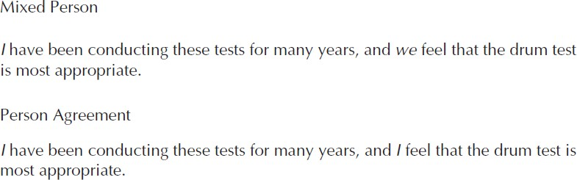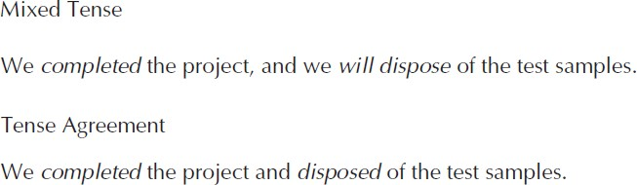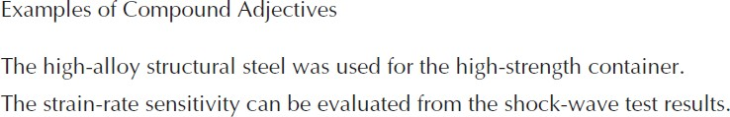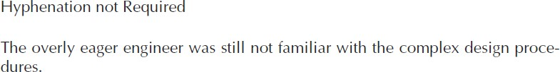

**General Notes:**

76

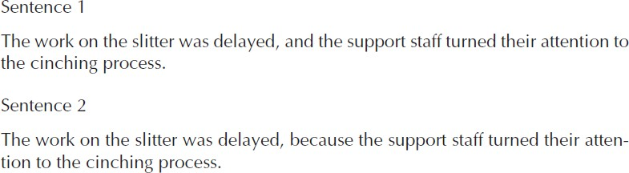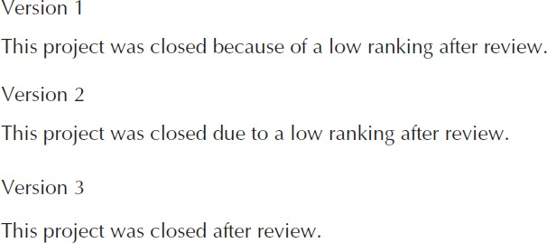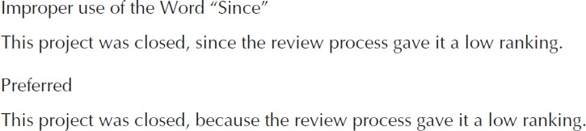

Conjunction

Preposition

77

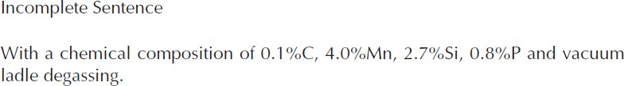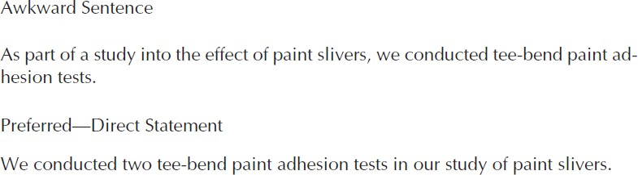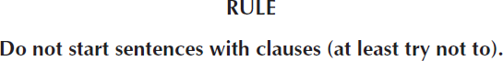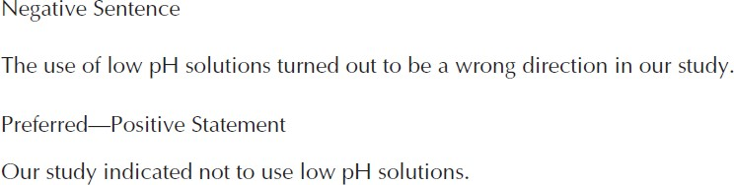

Sentence Construction

78

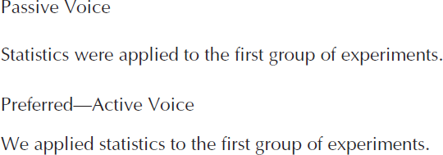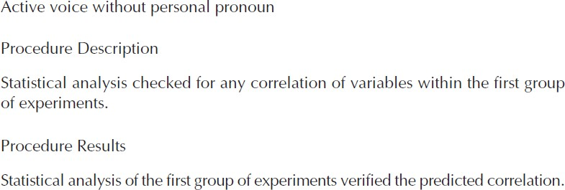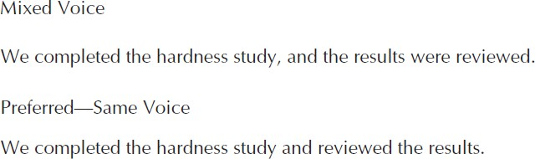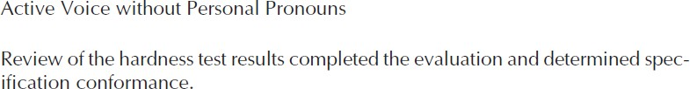

Active and Passive

79

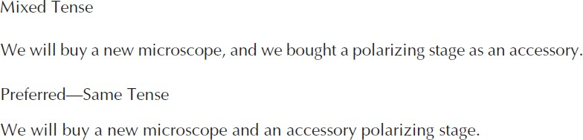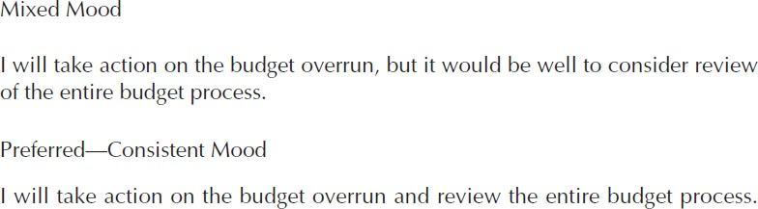

80

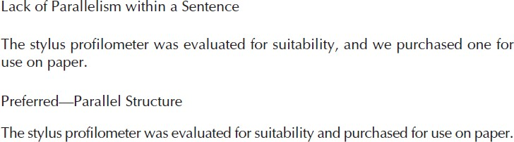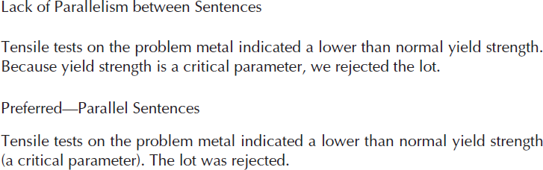

Parallelism in Sentence

81

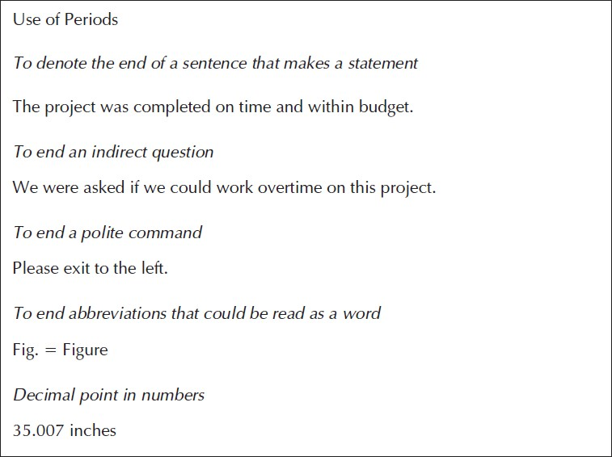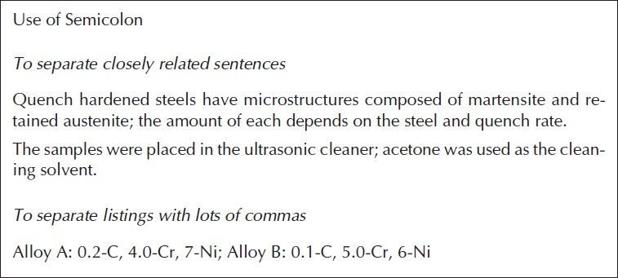

82

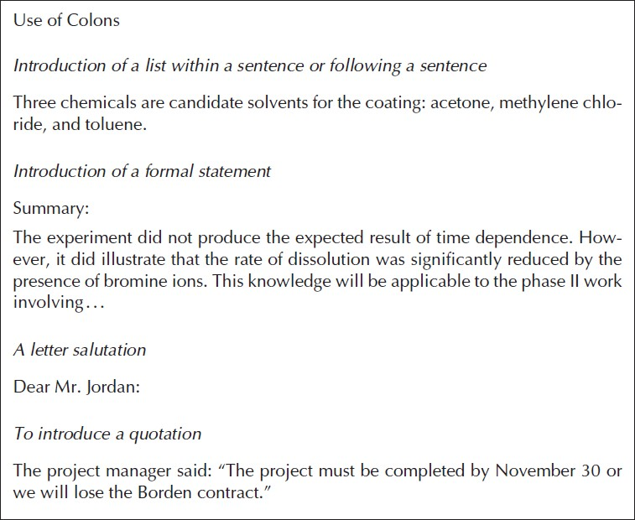

83

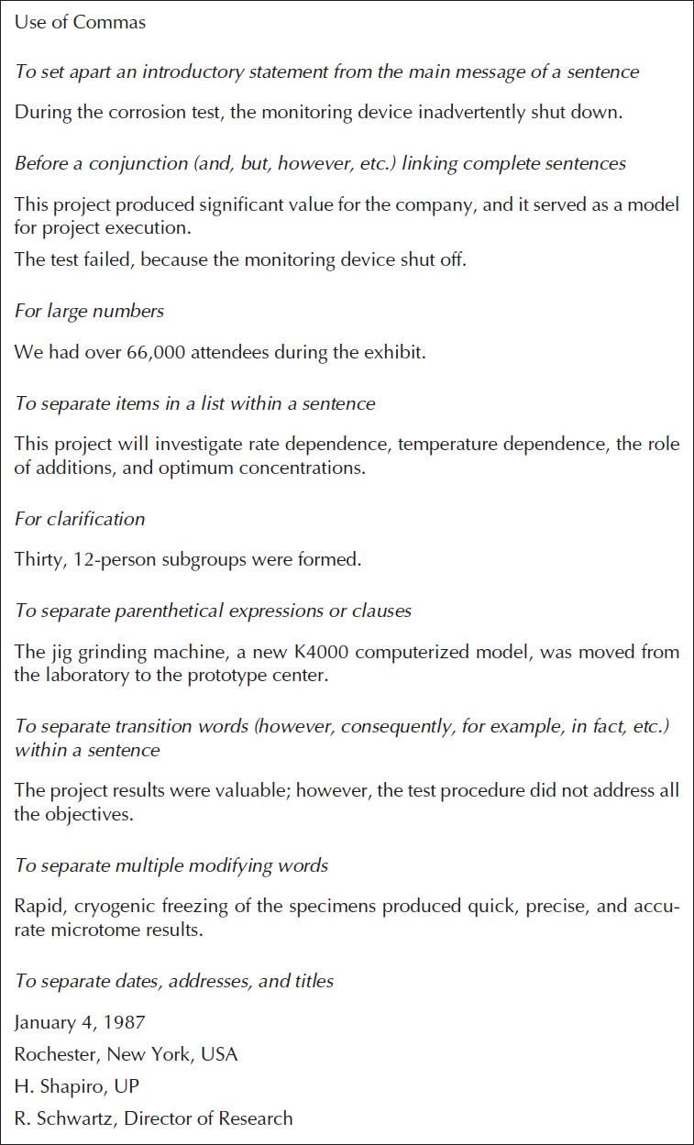

84

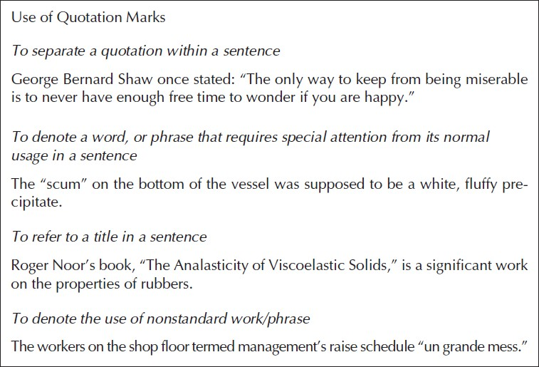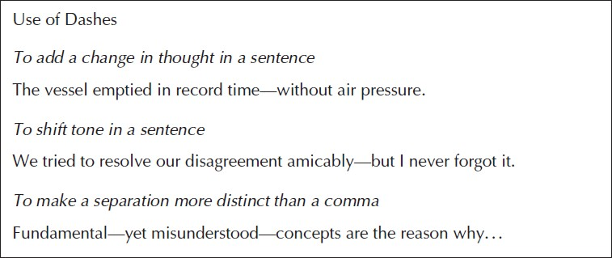

85

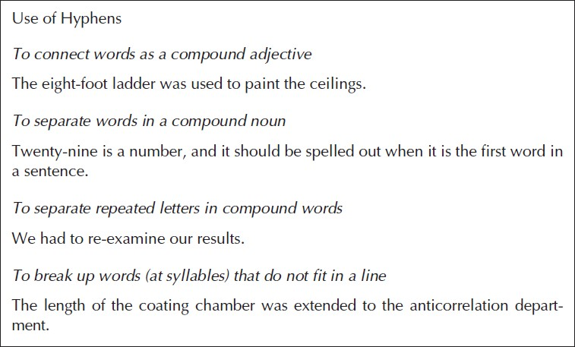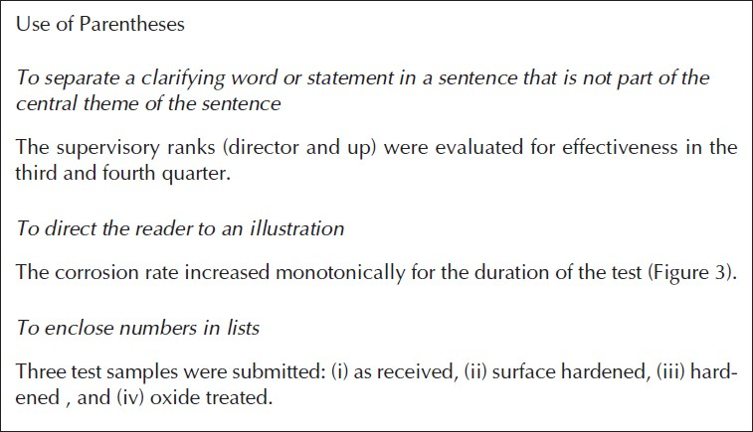

86

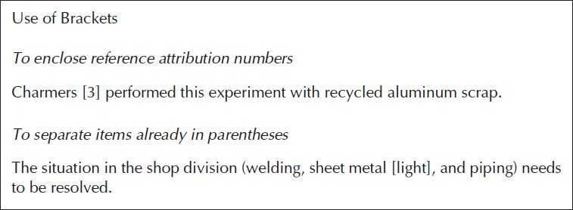

87