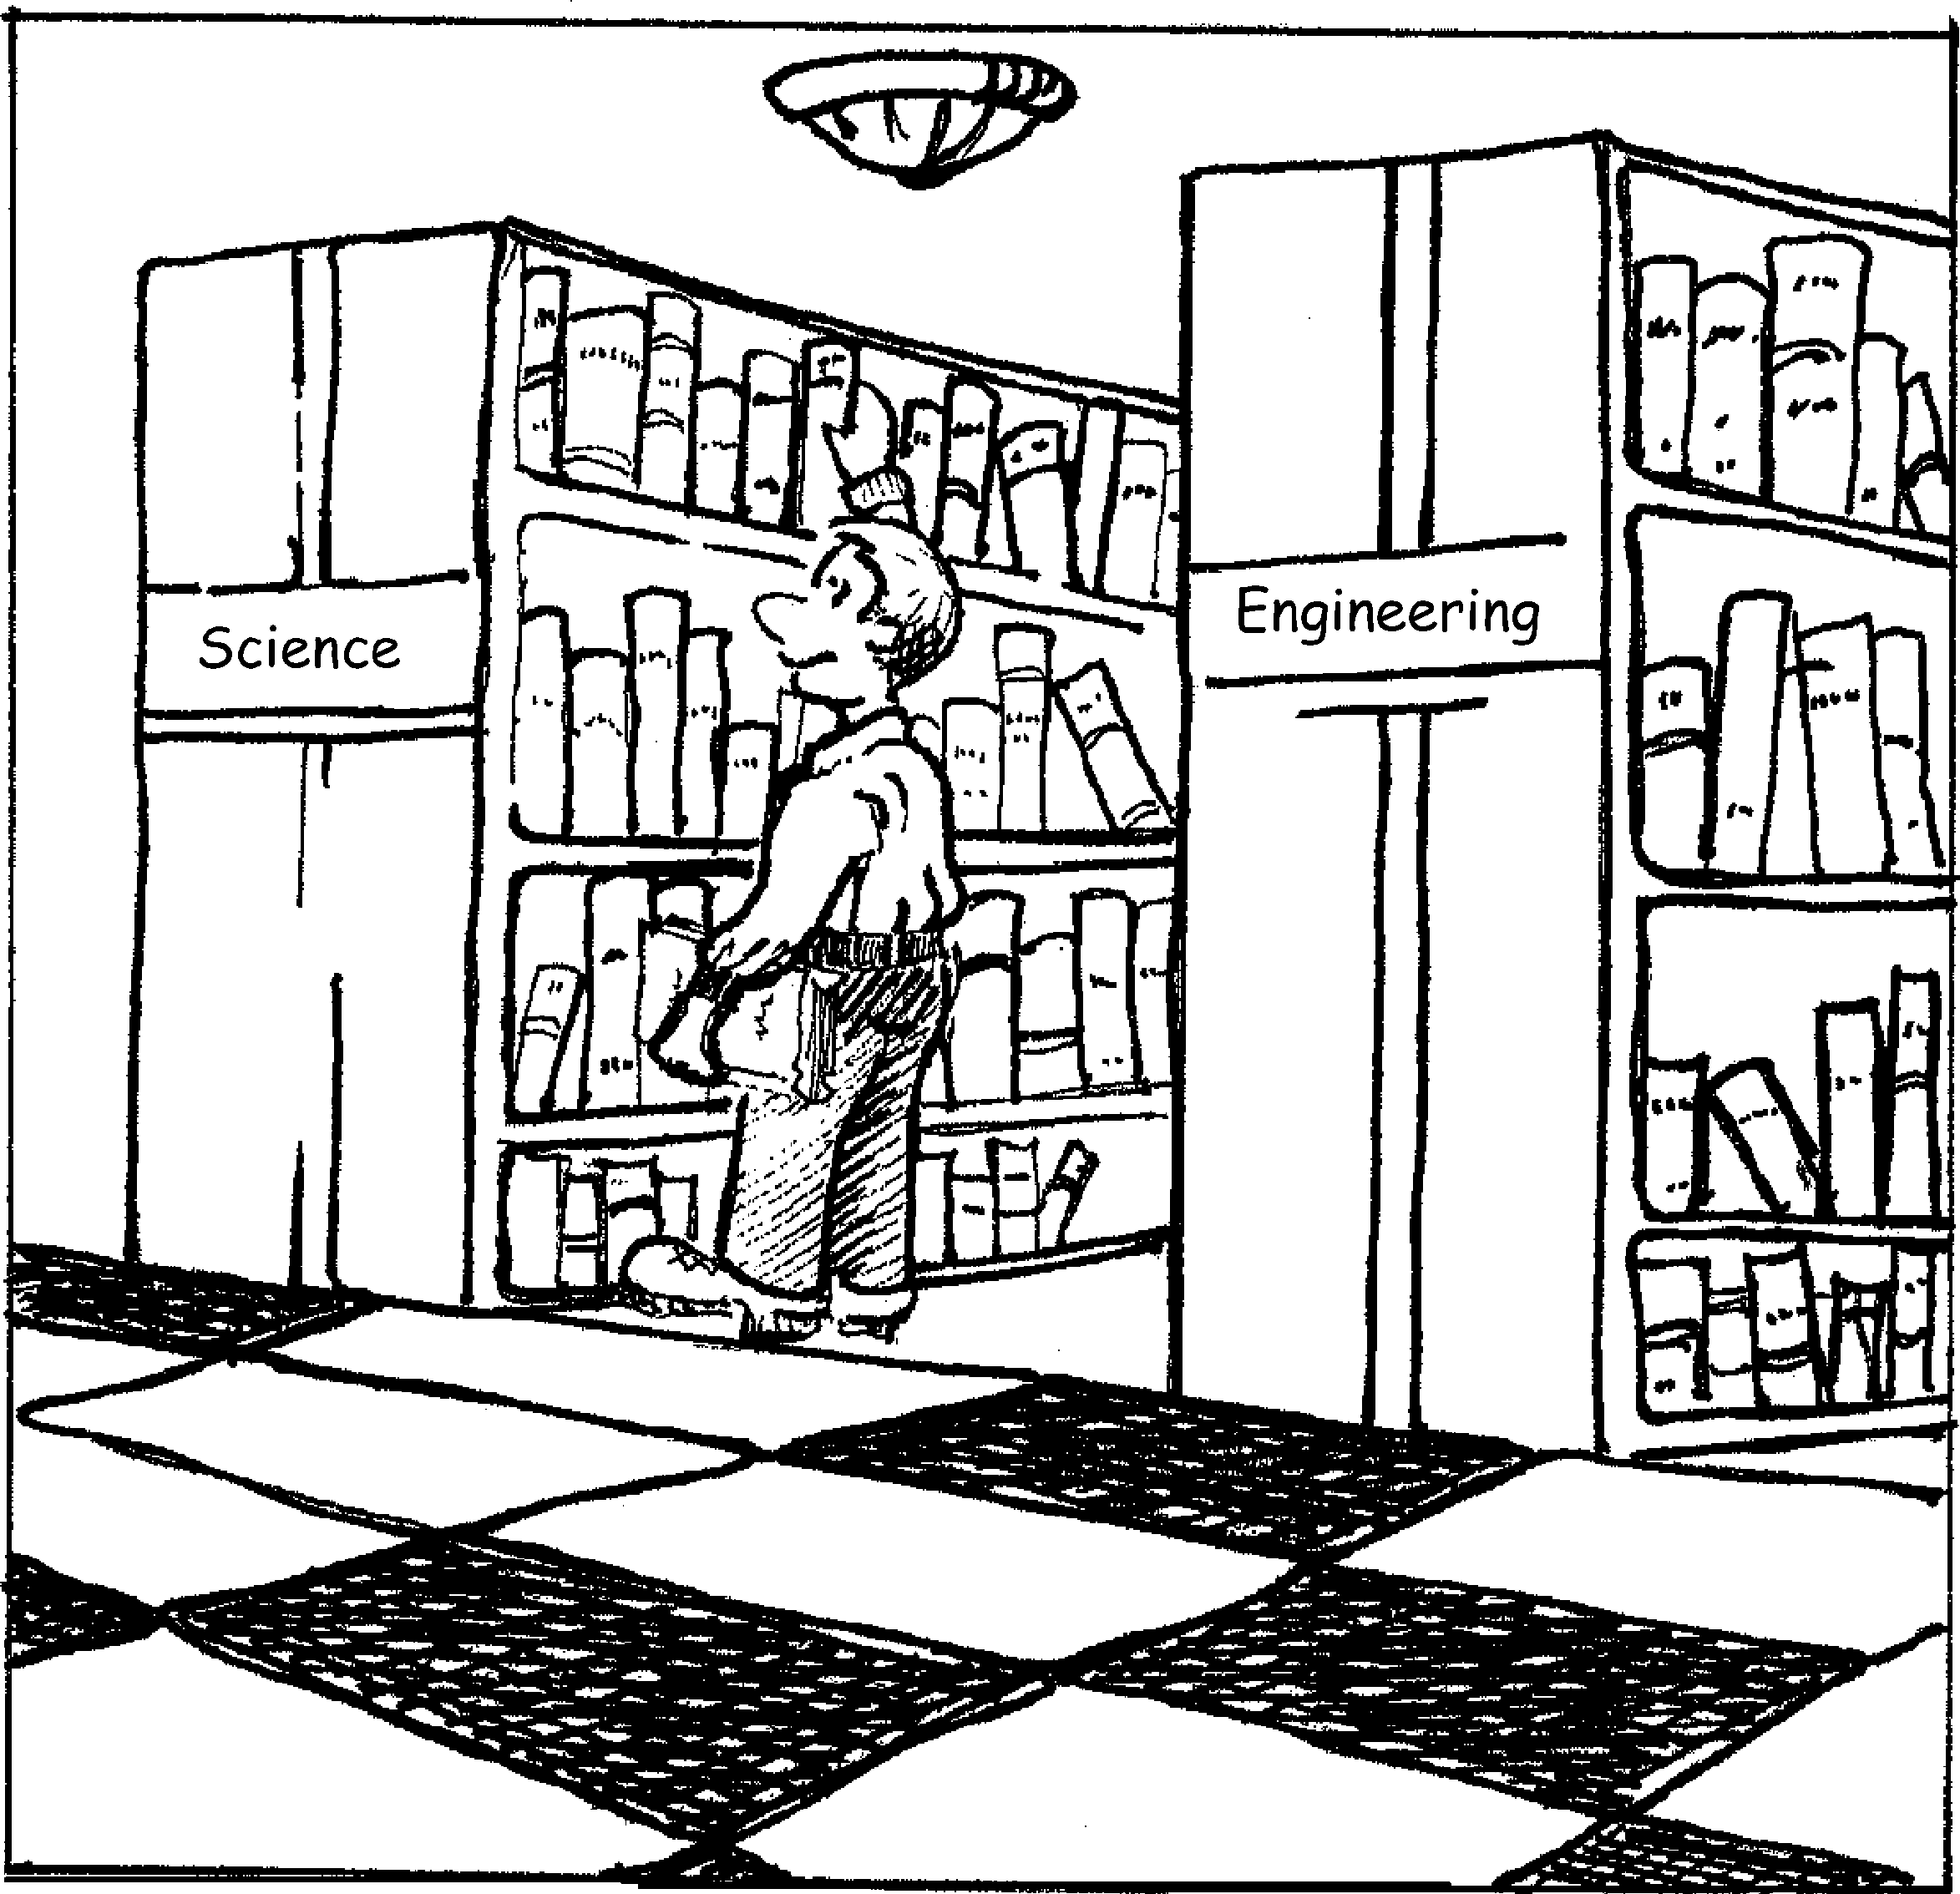

© 2001 ASM International. All Rights Reserved. Engineers’ Guide to Technical Writing (#06218G)

[www.asminternational.org](http://www.asminternational.org/)

CHAPTER **1**

What Is Technical Writing?

*CHAPTER GOALS*

*Show where technical writing fits into the spectrum of interpersonal communications*

*Illustrate how technical writing differs from other forms of writing*

*1.*

*2.*

TECHNICAL WRITING is a broad term that encompasses a wide vari- ety of documents in science, engineering, and the skilled trades. The ma- jor types of documents in technical writing can be grouped into four major categories (Fig. 1.1):

•

•

Reports and communications in day-to-day business

Technical papers, magazine articles, books, and theses for purposes of education, teaching, and the sharing of information and knowledge Patents

Operational manuals, instructions, or procedures

•

•

Most technical writing in day-to-day business involves the preparation of various “reports” (Fig. 1.1). Writing reports is common for many techni- cal people because reports are a major part of the development and appli- cation of technology. Very few companies pay technical professionals a salary without written words to implement and evaluate what has been worked on or developed. For example, if an engineer spends a year de- veloping a new transmission for a car, several types of reports are needed for the design, evaluation, and implementation of the new component. En- gineering must also report to management on the viability of design, costs,



© 2001 ASM International. All Rights Reserved. Engineers’ Guide to Technical Writing (#06218G)

**2 / Engineers’ Guide to Technical Writing**

[www.asminternational.org](http://www.asminternational.org/)

Technical writers specialize in these

Instructions

Manuals

Procedures

Attorneys, engineers, researchers need these

Process or Machine Descriptions

Patents

Technical Writing

Scripts

For day-to-day business in many technical fields

Reports

Letters, memos,

e-mail/notes, informal reports, formal reports, status reports, surveys, benchmarking, marketing, quality control

Magazine Articles

Books

Papers

Theses

For teaching and education

**Fig. 1.1**

Spectrum of technical writing

and work objectives. This usually requires a written document and related engineering drawings—a report.

A second category of technical writing includes documents for teaching and education (Fig. 1.1) in the form of scripts, magazine articles, books, papers, and degree theses. Scripts for videos, movies, magazine articles, or multimedia presentations are most often written and edited by profession- als in these fields.

Books on technical topics are most often written by academicians, al- though technical professionals occasionally may write an entire book in their area of experience and knowledge. Writing a book obviously requires much more discipline than the writing of reports, but it still requires the clarity of presentation and purpose as in the reports and papers of day-to- day business. Chapter 4, “Writing Strategy,” also has relevance for book authors. The key difference is that books are intended for a larger audience and should have unique and compelling features for the readers.

Papers and theses are more common forms of educational or informa- tional documents written by technical professionals. Of course, many peo- ple in science and engineering write theses. However, they usually only do one per degree, and the formal writing style and related details are almost always rigorously dictated by the school involved. Papers are the other cat- egory in the grouping of types of technical writing that could be consid- ered to be teaching or educational. This book includes information on writ-

© 2001 ASM International. All Rights Reserved. Engineers’ Guide to Technical Writing (#06218G)

[www.asminternational.org](http://www.asminternational.org/)

**What Is Technical Writing? / 3**

ing a paper, because it is very possible that a technical person will write pa- pers throughout his or her career.

Another category of technical writing is for manuals, instructions, and procedures (Fig. 1.1). This form of specialized writing is not addressed in this book because these kinds of documents often have legal/liability im- plications and are best left to trained technical writers. For example, if you invent a novel type of bicycle seat, a user who got hurt because he installed the seat pointing aft could sue you if you did not include in the installation and use manual a statement like the following:

Similar liability could be incurred by overlooking a safety or environmen- tal concern in writing a heat treating procedure for a gear. If a particular career situation requires that you write these kinds of documents, appro- priate references on technical writing are listed at the end of this Chapter. Finally, patents require another key type of document in technical writ- ing. Lawyers usually write patents, but not without lots of writing and search- ing on the part of the applicant. Thus, this book addresses the inventor’s part

of a patent application and the general criteria for patentability.

**1.1 Purpose of This Book**

With an understanding of what technical writing is and what aspects of technical writing are covered in this book, the reader can appreciate the pur- pose of this book. It is to give students and working technical people usable, easy to follow guidelines on how to write effective reports pertaining to all types of engineering, the skilled trades, and the sciences. The main empha- sis is on engineering because of author bias [*that is what I know and do*]. There are many books and publications on technical writing; why is an- other needed? Forty years of personal experience in the engineering field have shown that in spite of availability of writing texts and courses, most engineers are poor and/or infrequent writers. In fact, some engineers never write any reports [*I used to monitor department reports and publish a list- ing in our newsletter. Some of our staff wrote 50 reports per year. Others had records as bad as zero for eight years*]. This aversion to written doc- umentation undoubtedly happens in other fields. Chapter 2 cites some rea- sons why such behavior may not be in the interest of career progress or in your employer’s interest. It is felt that a root cause of writing aversion is lack of writing skills. Some people were never required to take a writing course in college; others never practiced writing after college. Most writ- ing texts are too detailed for self-study by working people in technical fields. This book provides a concise guide for self-study or classroom use

“The prow of the seat (point A in Fig. 6) should be positioned pointing at the han- dlebars (Fig. 7).”

© 2001 ASM International. All Rights Reserved. Engineers’ Guide to Technical Writing (#06218G)

**4 / Engineers’ Guide to Technical Writing**

[www.asminternational.org](http://www.asminternational.org/)

that eliminates barriers to writing and addresses report writing in particular. The objective of the book is to promote the development of technical peo- ple with good writing skills and the benefits that this brings to the employer.

**1.2 Attributes of Technical Writing**

The remainder of this Chapter describes the specific attributes of techni- cal writing and shows examples of how technical writing differs from other types of writing. In general, technical writing has a degree of formality, and it generally focuses on a specific subject with the purpose of making some- thing happen or sharing useful information or knowledge.

Ten general attributes of technical writing are listed and described in the following sections:

•

•

•

•

•

•

•

•

•

•

It pertains to a technical subject. It has a purpose.

It has an objective.

It conveys information/facts/data. It is impersonal.

It is concise.

It is directed.

It is performed with a particular style and in a particular format. It is archival.

It cites contributions of others.

There are probably more attributes, but the attributes in the above list de- fine some key characteristics that distinguish technical writing from other types of writing.

***Pertains to a Technical Subject***

Technical writing must pertain to some aspect of engineering or the sci- ences in a given subject area such as the following:

•

•

•

•

•

•

•

•

•

•

•

Philosophy, psychology, and religion History

Geography and anthropology Social sciences

Political science Law

Education Fine arts

Language and literature Science

Agriculture

© 2001 ASM International. All Rights Reserved. Engineers’ Guide to Technical Writing (#06218G)

[www.asminternational.org](http://www.asminternational.org/)

**What Is Technical Writing? / 5**

•

•

Technology Health/medicine

Libraries usually categorize books into these subject categories, and tech- nical writing may apply to any of these categories if the work contains en- gineering or science as the focus. For example, a paper on the acoustic/sound aspects of a piano could be very technical and end up in the music category. Similarly, a book on restoration techniques for antiques could be rife with chemistry and metallurgy, but it may end up in the fine arts category. The point is that technical writing can be on one of many different subjects if the subject is being described or evaluated in an objective fashion.

***Has a Purpose***

A technical document always is written for a reason, and the purpose of reports may be to explain what was done, why it was done, and/or the re- sults of a study. The purpose of reports on investigations is usually to pre- sent the results of the study.

The purpose of reports and papers should also be clearly stated, as in the following example:

This excerpt identifies the purpose of the report as the presentation of re- sults from a statistical study. Readers are also informed why the author(s) did the work. If the report is done correctly, it will also close with recom- mendations on what should happen next.

***Has an Objective***

The objective of a technical report is the overall reason for doing the work. In an industrial situation, the objective of any work is usually to make or increase profits. In the preceding example, the objective was to reduce failure rates to a level of less than three ppm. This will save money and in- crease profits. Discriminating between purpose and objective requires some practice, and this distinction is discussed in more detail again in the Chap- ters on strategies and introductions.

***Conveys Information/Facts/Data***

Technical writing should have substance in every statement. If a sentence does not convey information pertinent to a study, leave it out. Technical writing is focused on the technology under discussion.

It is the purpose of this report to present the results of a statistical study on the fail- ure rate of spring latches on a type D cardiology cassette. There have been a num- ber of latch failures uncovered in the inspection cycle, and this work is the first step in reducing the latch failure rate to less than three ppm failure rate.

© 2001 ASM International. All Rights Reserved. Engineers’ Guide to Technical Writing (#06218G)

**6 / Engineers’ Guide to Technical Writing**

[www.asminternational.org](http://www.asminternational.org/)

A report without facts or scientific evidence to support an opinion also usually lacks credibility, and it is likely to be unsuccessful in achieving its purpose and objective. The following report excerpt illustrates reports with and without data. Which would persuade you?

The use of data and factual information makes the work a technical report. The communication without the data is not much different than a water cooler discussion between coworkers. If the author is the leading expert of the world on grinding, his or her opinions may make the report persuasive, but most people are not infallible authorities on subjects.

Most reports need facts or data to support conclusions and recommen- dations, and the verbs listed here are probably associated with factual state- ments:

•

•

•

•

•

•

•

•

•

•

•

•

•

•

•

•

•

•

Determined Solved Built Accepted Rejected Completed Passed Failed Broke Approved Cancelled Invented Designed Developed Discovered Uncovered Deduced Studied

No Data

A decision has been made to convert the machine shop grinding operations into a three-shift operation to increase efficiency and machine utilization.

Preferred—with Data

A study was conducted to improve the elapsed time required to grind a set of slit- ting knives. The average elapsed time for a regrind for the 1997 fiscal year was 11 days. A second study indicated that the largest time allotment in the 11 day re- grind time was 3.4 days waiting for grinder availability. These studies were based on one shift (day). A three-week test with three-shift operation reduced the wait- ing for machine availability time to zero. The elapsed time for thirty knife sets that were ground in the three-week test time was less than one day. These test results suggest that three-shift operations should be implemented.

© 2001 ASM International. All Rights Reserved. Engineers’ Guide to Technical Writing (#06218G)

[www.asminternational.org](http://www.asminternational.org/)

**What Is Technical Writing? / 7**

Verbs that are often not associated with factual statements include words like the following:

•

•

•

•

•

Think May be Suggest Appear Suppose

***Impersonal (Third Person) Voice***

The use of first person pronouns is usually discouraged in technical writ- ing. The intrusion of “I” makes the work less authoritative. Similarly, it is inappropriate to use names of people and/or trade names unless there is no other way to describe the item.

The preceding excerpt from a report on metal hardness problems illustrates how not to write a technical report. Judicious use of personal pronouns is acceptable, but because a novice in technical writing may not know when it is acceptable, it is probably advisable to avoid the use of personal pro- nouns (I, you, me, we, mine) in formal reports and published papers. Writ- ing in the third person is the style adopted in many journals and organiza- tions. [*The text contains personal anecdotes that may use personal pronouns. I placed them within brackets so that I can follow the rule of no- personal pronouns in the remainder of the text. Consider these bracketed sections like the sidebars used in some texts to interject interesting facts, like biographical sketches, to keep the reader’s interest. In my case, the first draft of this book was deemed “boring” by several reviewers. The sec- ond draft with personal anecdotes was not labeled boring by the second set of reviewers, just “rough.” This third rewrite addresses the dislikes of all ten reviewers, and I left anecdotes like this in because, let us face it—Eng- lish grammar and writing techniques are not the most titillating subjects.*] With regard to using people’s names in reports, it is not necessary and it reads “unprofessional.” In addition, it adds length, and anything that adds unnecessary length to a document should not be done. If the intent of in- cluding names is to give credit, the correct placement of credits is not in the body of a report. Credits belong in end-of-document acknowledgments, which will be covered in a subsequent Chapter. Personal pronouns and names should be omitted because they are unnecessary. Trade names should

Discouraged

I ran a series of hardness tests on the valve seals for Bob MacArther from the shops division, and I found that three of the seals were below normal. I also notified Harry Randall and Phylis Carter so that the two of them could do Rockwell mea- surements on future value seals.

© 2001 ASM International. All Rights Reserved. Engineers’ Guide to Technical Writing (#06218G)

**8 / Engineers’ Guide to Technical Writing**

[www.asminternational.org](http://www.asminternational.org/)

be avoided because of liability considerations. The message can usually be conveyed fully without their use:

***Be Concise***

Technical reports are usually written for business reasons. They are not intended to entertain; they communicate information to an identified per- son or group. Say what you want to say and get out! Wandering sentences and extra words reflect badly on the author and often have a negative ef- fect on the readership that you are trying to reach.

Concision can become an acquired writing trait. There are text books on the subject, but a major source of extra words are phrases such as “it fol- lows that,” “in any case,” and “nonetheless.” It is often possible to replace these phrases with a punctuation mark.

Not Concise

The biopsy results were negative. Nonetheless, the nurse-practitioner sent a sam- ple for retest to be sure.

Preferred

The biopsy results were negative, but the nurse-practitioner sent a sample for retest to be sure.

Wordy

Polymer surfaces were studied to determine if physical surface changes occur with continued UV exposure. This program was necessitated to meet customer expec- tations for a longtime company with world-class name recognition. If surface degradation is in fact occurring, we need to ascertain and assess the severity of this degradation. Moreover, it is imperative that we address any product defi- ciencies so that the company image as a supplier of robust products is not deni- grated.

Preferred

A study was conducted to quantify UV damage to polymer surfaces. This work was done to satisfy customer concerns about the weatherability of sun shields made from our outdoor grade of polypropylene.

Preferred

A series of hardness tests were conducted on valve seals at the request of the Shops Division, and it was determined that three parts had abnormally low hardnesses. The appropriate individuals were notified so that they can request hardness test- ing on future valve-seal shipments.

© 2001 ASM International. All Rights Reserved. Engineers’ Guide to Technical Writing (#06218G)

[www.asminternational.org](http://www.asminternational.org/)

**What Is Technical Writing? / 9**

Concise writing is described further in subsequent Chapters, but every writer should strive to state his or her message with the fewest words. Invariably, the people who read technical documents are busy. Extra words mean extra work for them and that they like your document (plan, proposal, etc.) less.

***Directed to Readers***

Chapter 4 “Writing Strategy” discusses readership of reports, but at this point it is sufficient to say that technical reports must be directed to a par- ticular readership. The author is responsible for determining the specific individuals or parties who will receive a technical document. Writing should be aimed at the readership. Directing a report determines the tech- nical level of the writing. If you direct a report to your coworkers, you do not have to bring them up to speed on the organization of your department. They already know it.

The readers know what an infrared camera is, where it goes on the instru- ment, what an SEM (scanning electron microscope) is, and about the im- pingement problem, or they should know, if the document is correctly di- rected. If this report was to be circulated outside the department or to upper level management, it would be necessary to give background information and define terms.

***Style and Format***

The attributes of technical writing also include style and format. Style is the way that you write; format is the ordering and physical layout of a document. **The appropriate style** for technical writing is objective. Technical doc- uments present data, facts, calculations, test results, and theories, and these must be presented in an accurate manner that is not opinionated. Conclu- sions are inferred from test results; recommendations are the logical out-

come of the conclusions.

Not Objective

The damaged gear train was removed in a bushel basket. Only a miracle worker could put this puppy back together. The operators must have fallen asleep at the controls.

Parochial Report

The attached procedure covers the operation of an infrared camera on the de- partment’s SEM. This equipment upgrade addresses the problem that exists in de- termining the exact location of beam impingement within the sample holder area.

© 2001 ASM International. All Rights Reserved. Engineers’ Guide to Technical Writing (#06218G)

**10 / Engineers’ Guide to Technical Writing**

[www.asminternational.org](http://www.asminternational.org/)

**The format** (the basic elements and their placement) of technical papers and reports is a more structured one than that used for other forms of writ- ing. Formal technical reports have basic elements and a structure as follows:

•

•

•

•

•

•

Introduction (why you are doing the work) Procedure (what you did)

Results (what happened) Discussion (what it means) Conclusions (what was learned)

Recommendations (what is to be done with the new information or knowledge)

This style and format have been agreed to by international technical journals, most educational institutions that teach in English, and most industries or or- ganizations that employ engineers and scientists. As shown in subsequent Chapters, all of these report elements may sometimes be put on one page. [*I recently acquired a new supervisor who is not familiar with engineer- ing or laboratory testing. He receives a copy of all my reports. He recently annotated one of my reports with “seems rather segregated.” He is right; technical reports are segregated. The problem statement goes in the intro- duction; what you did goes in the investigation section. The results go in the*

*results section, and so forth. Technical reports have a definite order.*]

In summary, technical reports have a standard style and format, and, as this book shows, this makes writing technical reports easy.

***Archival***

An intrinsic part of the value of technical writing is that it is written in such a manner that it can be archived and produce valuable and usable in- formation in the future. Conversely, technical documents should not be gen- erated on transient issues or subjects that will not be pertinent in the future.

Not Archival

The BCH perforators were shut down last Thursday because of a power interrup- tion. The shutdown caused the loss of three master rolls of product. The root cause of the shutdown was determined to be a faulty relay in the control point of the perforating center. The specific details of the product loss are:

.

Preferred

The damaged gear train was removed for inspection to determine the root cause of failure. At this point in the failure analysis, it appears that the unit cannot be re- turned to service. Testing will be completed by Wednesday.



**ASM International** is the society for materials engineers and scientists, a worldwide network dedicated to advancing industry, technology, and applications of metals and materials.

ASM International, Materials Park, Ohio, USA [www.asminternational.org](http://www.asminternational.org/)

This publication is copyright © ASM International®. All rights reserved.

**To order products from ASM International:**

**Online**

Visit [www.asminternational.org/bookstore](http://www.asminternational.org/bookstore)

1-800-336-5152 (US) or 1-440-338-5151 (Outside US)

1-440-338-4634

Customer Service, ASM International

9639 Kinsman Rd, Materials Park, Ohio 44073-0002, USA [CustomerService@asminternational.org](mailto:CustomerService@asminternational.org)

American Technical Publishers Ltd.

27-29 Knowl Piece, Wilbury Way, Hitchin Hertfordshire SG4 0SX, United Kingdom

Telephone: 01462 437933 (account holders), 01462 431525 (credit card)

[www.ameritech.co.uk](http://www.ameritech.co.uk/)

Neutrino Inc.

Takahashi Bldg., 44-3 Fuda 1-chome, Chofu-Shi, Tokyo 182 Japan Telephone: 81 (0) 424 84 5550

**Telephone**

**Fax**

**Mail**

**Email**

**In Europe**

**In Japan**

**Terms of Use.** This publication is being made available in PDF format as a benefit to members and customers of ASM International. You may download and print a copy of this publication for your personal use only. Other use and distribution is prohibited without the express written permission of ASM International.

No warranties, express or implied, including, without limitation, warranties of merchantability or fitness for a particular purpose, are given in connection with this publication. Although this information is believed to be accurate by ASM, ASM cannot guarantee that favorable results will be obtained from the use of this publication alone. This publication is intended for use by persons having technical skill, at their sole discretion and risk. Since the conditions of product or material use are outside of ASM's control, ASM assumes no liability or obligation in connection with any use of this information. As with any material, evaluation of the material under end-use conditions prior to specification is essential. Therefore, specific testing under actual conditions is recommended.

Nothing contained in this publication shall be construed as a grant of any right of manufacture, sale, use, or reproduction, in connection with any method, process, apparatus, product, composition, or system, whether or not covered by letters patent, copyright, or trademark, and nothing contained in this publication shall be construed as a defense against any alleged infringement of letters patent, copyright, or trademark, or as a defense against liability for such infringement.

**Publication title**

**Product code**

**Engineers’ Guide to Technical Writing**

**#06218G**