Writing That Works

A Teacher’s Guide to
Technical Writing

by
Dr. Steven M. Gerson
Johnson County Community College

Developed and Published by: Kansas Curriculum Center Washburn University Topeka, KS

Writing That Works

A Teacher’s Guide to Technical Writing

by
Dr. Steven M. Gerson
Johnson County Community College

Project Advisor:
Dr. Craig Haugsness
Program Consultant: Technology Initiative KS State Dept. of Education
Designed and Edited by:
Ben Clay
Kansas Curriculum Center

Text Processing by:
Esperanza Root

PREFACE

Welcome to Technical Writing

by Dr. Steven Gerson

I hope this Teacher’s Guide will help you find new and interesting ways to incorporate technical writing in your classroom. The Teacher’s Guide seeks to accomplish the following:

Chapter One not only provides a rationale for teaching technical writing, but also defines technical writing and compares/contrasts it to other types of written communication. This puts technical writing into context, for you and your students. In addition, the chapter gives you several teaching tools. These include tables, which you can make into overheads, and a wide range of end-of-chapter activities. These teaching tools lend themselves to classroom discussions, assignments, and tests.

Chapter Two provides exact criteria for teaching technical writing. The technical writing criteria is expressed in 5 Traits, comparable to the 6 Traits rubric with which you may be familiar. These 5 Traits include clarity, conciseness, accessibility, audience, and accuracy. This chapter gives you a 5 Traits grading rubric and many end-of- chapter activities.

Chapter Three discusses the different types of technical writing. These include letters, memos, e-mail, reports, instructions, resumés, bro- chures, newsletters, fliers, web pages, PowerPoint presentations, and graphics. This chapter provides numerous samples for each type of technical writing, as well as peer evaluation checklists, ready for
duplication and use in your classes.

Chapter Four focuses on technical writing assignments. Whether you teach elementary school, English, Spanish, math, physical education, business, history, psychology, or art, you will find assignments geared toward your classes . . . and they all work. They are interesting, diverse, and proven effective in classroom settings.

(Continued on next page…)

This revised teachers’ guide to technical writing includes the following
New and Updated information:
- Updated information and New samples (screen captures) for websites. This includes revised criteria and explanations of the importance of websites, as well as the ways in which on-line text differs from hard copy.
- Updated information and New samples (screen captures) for e-mail. This includes revised criteria and explanations of the increased importance of electronic communication in the workplace.
- Updated information and New samples of instructions, appropriate for elementary as well as middle/high school students.
- Updated information and New samples of brochures and newsletters.
- New information and samples of fliers.
- New information on the use of online wizards and templates for memos, letters, resumes, brochures, newsletters, and fliers. This includes not only the benefits of wizards/templates but also problems encountered.
- New information on the importance of graphics in technical writing. This includes samples, criteria, and the reasons why graphics (tables and figures) are important in technical writing.
- New and revised assignments for technical writing, including
—Assignments for elementary school students as well as middle/high schools.
—Focus on different subject matters/disciplines, including agricultural education, family and consumer sciences, industrial technology, business/computer classes, etc.

I am available for on-line assistance via e-mail. I am always happy to talk about technical writing. If you have questions regarding assign- ments or curriculum, just contact me at:
sgerson@jccc.net
or you could use the two, old-fashioned approaches: phone
(913-469-8500, ext. 3625) or mail (12345 College Blvd., Johnson County Community College, Overland Park, KS 66210).

I want to thank several people for helping me prepare this Teacher’s Guide. Carol Hailey, Shawnee Mission North High School, gave me many ideas for assignments and curriculum options; Carmen Shelly, DeSoto High School, created the 5 Traits rubric that I have adapted. My office mate, Professor James McWard, reviewed early copies of this text and offered valuable suggestions for revision. Finally, my wife, Professor Sharon Gerson (DeVry Institute of Technology, Kansas City), was a constant source of assistance, helping me develop ideas, draft text, revise, and proofread.

Table of Contents

Preface i-ii
Chapter One: Why Teach Technical Writing 1-9
Definition 1
Rationale 2-3
Communication Continuum 4-5
Technical Writing vs. Essays 6
Five Components of Technical Writing 7-8
End of Chapter Activities 9
Chapter Two: Five Traits of Technical Writing 10-25
Clarity 10-12
Conciseness 13-16
Accessibility 16-17
Audience Recognition 18-19
Accuracy 20
Five Trait Rubric 21
End of Chapter Activities 22-25
Chapter Three: Applications of Technical Writing 26-80
Letters 26-33
Memos 34-38
E-Mail 39-42
Reports 43-45
The Job Search 46-54
Instructions 54-57
Web Pages 58-62
PowerPoint Presentations 63-65
Brochures 66-69
Newsletters 70-74
Fliers 75-78
Graphics 79-80
Chapter Four: Technical Writing Assignments 81-96
Sales Letters 81
Letters of Inquiry 82
Memos 82-83
E-Mail 83-84
Reports 84-85
The Job Search 85
Instructions 86
Web Pages and PowerPoint 86-87
Brochures/Newsletters 87-88
Fliers 88
Grouped Assignments 89-90
Conclusion 91
Sample Technical Writing I 91
Sample Course Scope and Sequence 92-96

Technical Writing: A Definition
Technical writing is commu- nication written for and about business and industry, focusing on products and services: how to manufac- ture them, market them, manage them, deliver them, and use them.
Technical writing is written:
- in the work environment (in the office, from 8:00 to 5:00, not counting overtime)
- for supervisors, col- leagues, subordinates, vendors, and customers
Technical writing, which must be understood easily and quickly, includes:
- memos and e-mail
- letters
- reports
- instructions
- brochures and newsletters
- the job search
- web pages
- fliers
- PowerPoint presentations
- graphics

Technical writing is the resumé that helps get a job and the web page that promotes a company.

In each case, the technical document must be quantifiable, precise, and easily understood.

Why is technical writing so important?
Why would I want to teach technical writing?
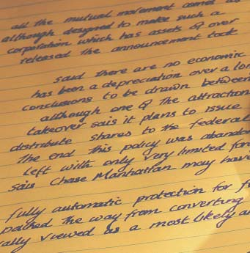

Chapter One
Why Teach Technical Writing?

Don’t I have enough to teach now without adding one more assignment or series of assignments to my curriculum?
What’s the point?

- Technical writing is not literature; it’s neither prose which recounts the fictional tales of characters nor poetry which expresses deeply felt, universal emotions through similes and metaphors.
- Technical writing is neither an expressive essay narrating an occurrence nor an expository essay analyzing a topic.
- Technical writing is not journalism, written to report the news.
- Technical writing does not focus on poetic images, describe personal experiences, or report who won the basketball game.
Instead, technical writing is:
—an instructional manual for repairing machinery
—a memo listing meeting agendas
—a letter from a vendor to a client
—a recommendation report proposing a new computer system

Once students are employed, will they have to write on the job? The answer is a resounding YES!

One reason for teaching technical writing is so students will know the types of documents they
will write on the job.

When our students are employed and have to write on the job, will they write essays?

Students often do not believe they will have to write at work; they assume that once their education is completed, writing will be a distant memory. They are wrong.
The answer is no. Our students, when employed, will not write essays at work. They will write essays while working on their college degrees; they might even be asked to write an essay on their job application when applying for work. However, once the job begins, essays end.

What takes the place of the essay?
The answer is technical writing—memos, letters, reports, e-mail, proposals, instructions, even web pages. That’s why technical writing is important. Technical writing is the type of written communication that our students will be responsible for on the job.

Is technical writing a necessary component of every employee’s professional skill?

Daily, newspapers tell us that employers want to hire people who can communicate effectively, both in writing and orally. Career counselors reiterate this.
  - In fact, we are told that on the job, an employee will spend at least 20 percent of his or her time writing.
  - This number increases as an employee’s responsibilities increase.
  - Managers spend up to 50 percent of their time writing.
  - CEOs spend between 80 and 100 percent of their work week communicating.

How does technical writing compare/contrast to traditional essays?

Technical writing is different from other types of written communication. Does that mean, therefore, that you must relearn all your teaching skills to accommodate this new communication beast?
Absolutely not. Many of the writing skills you already teach are applicable to technical writing. Others are less valid.

“Technical writing would come in handy for some students, such as our vo-tech kids. When they enter the job market, they could benefit by knowing
how to write at work.
But what about our college-bound students? Why would they need technical writing?”

On the next page is a Communication
College lasts only four to six years. In K-12, we should continue to prepare our students for college by teaching essays. In addition, we should prepare them for what comes next—their jobs. After they graduate with their AA or BA or BS, they go to work where they will write memos, letters, and reports.

The career and technical education students—the students who will work as mechanics, welders, office help, or daycare center assistants—can benefit by learning how to write technical documents.

However, our students who acquire associate degrees and bachelor degrees—the students who go on to become computer programmers, CAD/CAM operators, dental hygienists, fashion merchandising specialists, graphic artists, engineers, architects, accountants, doctors, and lawyers—also will need to write memos, letters, and reports.
Here is a reminder…
Continuum including traits and examples of five types of writing, ranging
from the
connotative

to the
denotative.

Connotative/Expressive
Communication Continuum

Type of Writing | Examples | Traits
Creative Writing | Poems, plays, stories | Connotative and expressive words, fictional characters, imagery, and plots
Expressive Writing | Narratives, descriptions | Subjective, based on personal experience, connotative and expressive words
Expository Writing | Comparison/contrast, analysis, cause/effect, argument/persuasion | Objective, connotative and denotative words
Journalism | News stories, features, editorials | Objective, written from factual observation, short sentences and paragraphs, some connotative but more denotative words
Technical Writing | Memos, letters, reports, instructions, resumés, web pages | Objective, written about products or services, short sentences and paragraphs, denotative words

Denotative/Objective
Legend:
Connotative
Denotative

Of course, there are exceptions… Newsletters, sales letters, websites, and fliers might include promotional information. Such sales details
On the next page is a poem about a tennis shoe as well as technical specifications for manufacturing
the same shoe.
These two writing samples further illustrate the difference between technical writing and other types of writing.
could depend on expressive words—maybe even fictional characters. However, generally speaking, most technical writing is denotative
versus connotative.

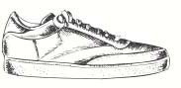
Ode to a Shoe
Technical Specifications for Manufacturing Tennis Shoes

My son’s tennis shoes rest temporarily in a heap against the kitchen door,
their laces soiled, their tongues hanging out like exhausted terriers.
The soles, worn down on the insides from sliding into second,
are green, the shades of summer.
Canvas exteriors, once pristine white, are the colors of the rainbow—
sun bleached, mud splattered, rained on, ketchup and mustard adorned,
each shoe shouting a child’s joyous exuberance: “I’m alive!”

The D40 Slammer Tennis Shoe will be manufactured to the following specifications:

Sole: Neoprene rubber #345 white enameled paint 1.589" high
Slammer waffle-textured©
Uppers: Blue canvas
Tongue: White canvas
Oval Slammer© logo heat- pressure sealed, centered .50" from all sides
Laces: 15" long
100% cotton
Aglets: Clear polyacetate plastic #290
Weight: 1 lb. 6 oz.

“Unclear writing costs American businesses real money—over one billion

The graphic appearing on the next page examines how
technical writing compares and
contrasts to essays.
dollars a year, according to one estimate…Did you know the Three Mile Island nuclear power plant meltdown was partly attributed to poorly written procedures?”
(“Why Dick and Jane Can’t Write on the Job…and How to Help Them,” Janet Van Wicklen,
American Society of Training and Development, 2000).

“The ability to communicate effectively is the most important skill you can have, whether you’re giving speeches, pitching ideas to your boss, or simply sending off an e-mail or leaving a voice message.”

(“What You Need to Know About Career Planning,”
< http://careerplanning.about.com/cs/importantskills/ > 2002.)

Comparison/Contrast: Technical Writing vs. Essays

Components | Technical Writing | Essays | Summary
Development | - Uses examples, anecdotes, testimony, data, research | - Uses examples, anecdotes, testimony, data, research | Same for both
Grammar | - It is important! | - It is important! | Same for both
Organization | - Provides an introduction, body, and conclusion  - Uses a subject line vs. a thesis and itemization of points vs. transitional words  - Uses topic sentences only when needed, dependent upon the type and length of correspondence | - Provides an introduction, thesis statement, body paragraphs, transitional words, and topic sentences | Similar in some ways, different in others
Style | - Uses short, denotative words; short sentences; and short paragraphs | - Uses longer, connotative words; longer sentences; and longer paragraphs | Different
Document Design | - Uses highlighting techniques, such as graphics, headings, subheadings, various fonts, white space, bullets, etc. | - Not usually a factor | Different

People read literature for pleasure, essays for enlightenment, and journalism for news. People

The five components listed above are discussed in greater
detail on the following pages.
read technical writing to accomplish a job.

Five Components of Writing

Development
If you have been teaching your students to develop their essays using such traditional means as examples, anecdotes, testimony, data, and research, then teaching technical writing will not be a strain. The same development techniques are applicable when the students write memos, letters, and reports.

Grammar
Grammar is important in essays. It might be more important in technical writing. Whereas errors often can hide in longer essays, those same errors loom large in one page memos or letters.

In a survey (Gerson) of over 700 technical writers (coast to coast) asked to list important aspects of correspondence, 98% ranked correct gram- mar as an essential component of successful writing.

Grammar is not merely the concern of English teachers. Professional writers and business people perceive it as essential.

Organization
Essays employ topic sentences, transition between and within paragraphs, and a thesis statement. Technical writing usually does not.
In a memo, letter, or report, the thesis would be replaced by a subject line. The different aspects of organization help distinguish technical writing from essays.

Since paragraphs are shorter in technical writing (often between one to three sentences) than in many essays, topic sentences are less important. Transitional words and phrases in an essay can be replaced by an enumerated list, by a list of bullets ( •♦□, etc.), and/or by headings and subheadings.

Style
Of greater importance is the different style (word usage, sentence structure, and paragraph length) used in essays versus technical writing. Essays rely on longer, more connotative words; longer, more complex syntax; longer, more detailed paragraphs. Technical writing, in contrast, demands short, denotative words; short, simple sentences; short
(Continued on next page…)

Style (continued)
paragraphs with information clarified through graphics (pie charts, line graphs, etc.). It has everything to do with audience and purpose.

The reader of technical writing does not have time, nor necessarily an interest in the subject matter. Envision this scenario. It is the night before Christmas, your children are asleep, and you are trying to put together a Christmas present—a doll house, a train set, etc.

To assemble this present, you are sitting on the floor (you have been sitting there for two hours, as your aching back attests). You are trying to read the complicated instructions which accompanied the toy (those instructions are a type of technical writing). You do not enjoy the activity. In fact, you just want to end the task and go to sleep. That is a typical technical writing situation.

The same holds true when you read an instruction to install software, build a cabinet, lay tile, or any other task. People do not read technical writing, such as instructions, for pleasure. The writing is a means to an end. Thus, to help people accomplish the task as quickly and as efficiently as possible, the writing style should be concise—short words, short sentences, and short paragraphs.

Document Design
Document design refers to the physical layout of the correspondence. Essays consist of words, words, and more words, separated by indentations to create paragraphs. Technical writing, in contrast, uses highlighting techniques and graphics for visual appeal to help the reader access and understand the data.

Technical writing is written to a different audience for a different purpose than essays.
The reader of technical writing does not have time, nor necessarily the interest in the subject matter.

Conclusion:
If we want students to write technical documents, we need to define what technical writing is and provide a context for writing such documentation.
This first chapter may be used to accomplish those goals.
Read, Lecture, Invite, and Test
End-of-Chapter Activities

Read this chapter for your own knowledge. Use this information to acquire a better understanding of technical writing or as a reminder of what you’ve always known. Lecture from the chapter.
Teach from this information to clarify for your students why technical writing is important, what technical writing entails, and how it differs from the type of writing they are used to. Invite people from business and industry to your classroom to discuss how technical writing is important to them. Test students on the information in this chapter. A short test could include the following:
- What percentage of time does a manager spend writing? Or a new employee, or a CEO?
- How does technical writing differ from essays? List at least three ways.
- Define technical writing. List five types of technical writing.
- Explain the writing continuum, giving examples to prove your points.

Have students create their own definition of technical writing
- Students could gather examples of technical writing (such as memos, letters, reports, brochures, or instructions), or you could bring in examples (this Teachers’ Guide provides you several examples). The students can get examples from their parents, from businesses, or in your school’s office.
- Once they have examples, break the students into groups and have them review the examples.
- Ask them to brainstorm the examples’ unique characteristics (page layout, length, tone, content, word usage).
- Next, give them essays—or poetry, or drama, or a short story, or a newspaper. Ask them to compare the technical writing to the other types of correspondence.
- Based on these discussions, ask the students to create their own list of technical writing criteria.
- Finally, ask the students to create a technical writing rubric, perhaps comparing it to Six Traits.

Write and Rewrite
Have the students write a poem (or an expressive essay or an expository essay) about a classroom object (a stapler, an eraser, etc.). Then have the students take the same subject and write a technical memo, complaint letter, recommendation report, instructions for using the object, or a manufacturing specification. Compare and contrast the results.

Chapter Two

In this Chapter...
Five Traits of Technical Writing
Students are not familiar with technical writing. Unless we teach them what this different type of communication en- tails, they will continue to write essays (the writing skill they have practiced since grade school).
1. Clarity

This chapter provides specific criteria to give students before asking them to write techni- cal documents. The five traits of technical writing are:
- clarity
- conciseness
- accessible document design
- audience recognition
- accuracy

Clarity in technical writing is mandatory

If a student fails to clearly understand a poem, a short story, a play, or a novel, that is unfortunate; however, equipment is not damaged, no one
is physically hurt, and no one is sued.
The most important criteria for effective technical writing is clarity. If the audience responds to a memo, letter, report, or manual with, “Huh?” what has the writer accomplished? If the correspondence is not clearly understood, the reader will either call the writer for further clarification, or just ignore the information. In either case, the writer’s time is wasted; the reader’s time is wasted; the message is lost.

Clarity, however, is not just a time concern. Think of it from this perspective: your company has written an installation manual for a product. The manual, unfortunately, is not clear. When the reader fails to understand the content, three negatives can occur:
- BAD—The equipment is damaged. This requires the owner to ship the equipment back. The company will replace the equipment, costs accrue, and public relations have been frayed.
- WORSE—The owner is hurt, leading to pain, anxiety, doctor’s bills, and bad public relations.
- EVEN WORSE—The company is sued. The company loses money, the writer of the manual loses a job, and public relations are severed.

Clarity achieved through reporter’s questions
This flawed memo, written by a manager to a newly hired employee, highlights the importance of clarity.

Nothing is Date: March 5, 2004

Ask your students:
  - What don’t you know in this memo?
  - What additional information should the
writer have included for

clear in this memo, and
the reasons are obvious. The manager has failed to answer Reporter’s Questions: who, what, when, where, why, how.
To: Michelle Fields From: Earl Eddings
Subject: Meeting

Please plan to prepare a presentation on sales.
M ake sure the information is very detailed.
Thanks.

Reporter’s Questions Checklist
clarity?

Obvious responses:
- When’s the meeting?
- Where’s the meeting?
- Who’s the meeting for?
- How much information is “very detailed”?
- How will the presentation be made?
- Why is this meeting being held?
- What does the manager want to be conveyed about sales?

Who
is the audience? Who will know what? Will the

audience know a great deal (High Tech)? Will the audience know a little about the topic (Low Tech)? Will the audience know nothing about the topic (Lay)?

What
do you plan to do? What do you want the audience to

do? What do you want to know?

When
should the job be completed? What’s the turnaround

time? What’s the timetable? What’s the desired schedule? When do you need an answer?

Where will the work take place?

Why
is the task being undertaken (the rationale, motivation,

goal)? Why is the desired date important?

How
should the task be performed? What’s the preferred

procedure?

Using the Reporter’s Questions Checklist as a prewriting tool, the previous memo could be revised to achieve greater clarity. Here is an example of a revised memo.

Date: March 5, 2004 To: Michelle Fields
From: Earl Eddings Subject: Sales Staff Meeting

Please make a presentation on improved sales techniques for our sales staff. This meeting is planned for March 18, 2004, in Conference Room C, from 8:00 a.m. - 5:00 p.m.

Our quarterly sales are down 27%. Thus, we need to help our staff accomplish the following:
- Make new contacts.
- Close deals more effectively.
- Earn a 40% profit margin on all sales.

Use our new multimedia presentation system to make your presentation. With your help, I know our company can get back on track.

Thanks.

In contrast to mystery stories which seek to create suspense, technical writing must be clear.

The ultimate goal of effective technical writing is to say the same thing to multiple readers!
Clarity achieved through specificity
When a student answers reporter’s questions, he or she has filled a page with words. But all words are not equal. Words like some, several, many, few, frequently, often, substantial, or recently will take up space on the page and convey an impression. These connotative words will not mean the same thing to everyone.

If a memo sent to six employees states that the company has lost a substantial amount of business, will all employees acquire the same knowledge? One might assume that a substantial loss equals $1,000; another might assume that a substantial loss equals twelve clients. In each case, the employees are guessing, and that is not the goal of successful technical writing.

(The previous memo using the phrase very detailed would be more clear if the writer had said he needed an eight hour presentation. Everyone receiving the memo then would know exactly how much time they needed to set aside to attend the meeting.)

Read the following paragraph, taken from an actual business correspondence:
2. Conciseness

“In order to facilitate an efficient meeting and fuel thought processes prior to June 25, I want to provide you with a brief overview of discussions recently carried out at the director and manager level within the process. These discussions involved personnel from Accounts Payable, Information Services, Procurement/ Materials Management, Financial Systems, and Property Accounting, centering on a proposed framework for managing process improvement moving forward.”

Do you understand this letter? Do you remember what you read? Did you even finish reading it?

Successful technical writing should help the reader understand the text, not present challenges to understanding

No one curls up in bed at night and for pleasure reads manuals about installing computer printers.
The above paragraph is not successful writing. It fails to communicate clearly because it is too long-winded. In this case, conciseness actually would aid clarity.

Isn’t it the responsibility of the reader to figure it out? No. The responsi- bility is with the writer. Here is why.

If an individual reads literature, it is his or her responsibility to under- stand the writing. Creative writers seek to challenge us. However, technical writing, as noted in Chapter 1, is not literature. We read technical writing because it is a job requirement.

Good technical writing is concise. It is a tool for the readers to use to accomplish whatever job they are doing. In contrast to traditional essays, effective technical writing uses short words and short sentences.

Conciseness has unique importance in technical writing

Technical Writing Must
Fit in the Box
Where’s the user manual for your car? It’s inside the glove compartment. In other words, that piece of very complex technical writing had to be written concisely enough to fit inside a specific-sized box. The content took a backseat, so to speak, to the user manual’s predetermined location within the car.

Here’s another example: what’s the perfect length of a resumé? One page, of course! Guess what? That’s a box. We have decided that a great resumé should fit inside a typical, 8” X 11” piece of paper.

Now, think about the size of an e-mail screen. Yes, the “box” is shrinking. A typical e-mail screen measures about 3” X 6”. A Palm Pilot monitor is about 2” X 2”. Your cell phone monitor is about 1” X 1”, and a pager’s monitor is closer to ¼” X 1½”. In each instance, the writer has less and less room to write.

Successful technical writing tries to avoid multisyllabic
words such as “mul-ti-syl-lab-ic.”

Conciseness achieved through short words

Teach students to use one and two syllable words. Of course, some multisyllabic words can not be changed. We can not replace engineer, telecommunications, or Internet. Other words, however, can be avoided. Look at these, for example.

Changing Long Words to Short Words
Long Words | Short Words
cognizant | know
endeavor | try
domicile | home
morbidity | death
terminate | end

Conciseness achieved through short sentences

You can shorten a sentence by avoiding:
- redundancy
- prepositional phrases
- passive voice
Here is an unsuccessful example of technical writing:
“In order to successfully accomplish their job functions, the team has been needing more work space for some time now.”
An improved sentence would read,
“The team needs more work space to do its jobs.”
The first sentence contains 20 words and 28 syllables; the second sen- tence contains ten words and ten syllables.

Avoiding redundancy

Why say, “The used car will cost the sum of $1,000.00”? It is more concise to say, “The used car will cost $1,000.00.” In this instance, “the sum of” is redundant. The following examples replace redun- dancy with concise revisions:

Wordy Sentence | Less Wordy Sentence
We collaborated to- gether on the projects. | We collaborated on the project.
This is a brand new  innovation. | This is an innovation.
The other alternative is to eat soup. | The alternative is to eat soup.

Avoiding prepositional phrases

Prepositional phrases create wordy sentences. Consider the following examples (note that the prepositional phrase is in bold type):

Wordy Sentence | Concise Sentence
He drove at a rapid rate. | He drove rapidly.
I will see you in the near future. | I will see you soon.
I am in receipt of your e-mail message re- questing an increase  in pay. | I received your e-mail message requesting a pay raise.

Passive Voice | Active Voice
It is my decision to run for office. | I decided to run for office.
There are sixteen people who tried out for the basketball team. | Sixteen people tried out for the basketball team.
The computer was purchased by Tom. | Tom purchased the computer.

In addition to clarity and conciseness, a third trait of effec- tive technical writing is accessibility (page layout—
Avoiding passive voice
Passive voice constructions are weak for at least two reasons. They are wordy, and they replace strong verbs with weak verbs. Example:
“The window was broken by the boys.”
versus
“The boys broke the window.”

The first sentence contains seven words and the weak verb was. In contrast, the second sentence contains five words and the strong verb broke. The emphasis is placed on the individuals (boys) rather than on an inanimate object (window). Other examples follow:
3. Accessible Document Design
the way the text looks on the page). Look at the following paragraph:
Regarding part number 315564-000, we received 541 units of wafer #3206-2. These were rejected. For the same part number, we received 643 units of wafer #3206-4. These were accepted. Three hundred and twenty- nine units of wafer #3206-5 from the same part number. These were accepted. Next, 344 of part number 315564-000’s wafer #3206-6 were accepted. However, the 143 units of wafer #3206-7 (same part number) were rejected. Finally, all 906 units of wafer #3206-8 were rejected. These also were from part number 315564-00.

Wall-to-wall words turn off readers.
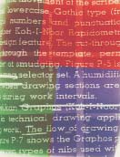
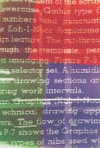
Highlighting techniques make the text open, airy, and inviting!

Students can make information leap off the page by making content accessible through the following highlighting techniques:

The paragraph on the bottom of page 16 consists of 84 words and ten sentences. The average number of words per sentence is only 8.4.
  - Graphics (table and figures)
  - White space

Because the sentences are not too long, the writing is concise. Next, the text is clear, due to specificity of detail. However, despite the clarity and conciseness, this writing fails. Why? Essentially, this paragraph is unintelligible. The page layout makes it nearly impos- sible for the reader to understand the text.

Using highlighting techniques (tables, headings and subheadings, different font sizes, column lines, and white space), below is a revised copy of the information presented on page 16.
Part Number 315564-00
Wafer # | Quantity Received | Accepted | Rejected
3206-2 | 541 |  | X
3206-4 | 643 |  
3206-5 | 329 |  
3206-6 | 344 |  
3206-7 | 143 |  | X
3206-8 | 906 |  | X

  - Boldface text
  - Headings and subheadings
  - Italics
  - Underlining
  - Varied Font sizes
• Bullets (•  �•)
  - Numbered lists
  - Varied Fo nt types
(computers offer
many options)

4. Audience Recognition

Who is writing to whom? What does the audience know, need to know, and want to know?

When your audience fails to understand the text, you have failed
to communicate!

Recognizing your audiences

Successful technical writers know that they can only achieve clarity by recognizing their audiences. Basically, our students will write to either High Tech Peers, Low Tech Peers, or Lay Readers. These three audi- ence levels have the following traits.

High Tech Peers know as much about a subject matter as you. They have the same job title, same education, same years of experience, and the same level of expertise. For example, a medical doctor writing to another medical doctor would be writing High Tech to High Tech.

Low Tech Peers who work in your company know something about the subject matter. They may not have the same job title, education, years of experience, or level of expertise. For example, a medical doctor writing to a staff nurse would be writing High Tech to Low Tech.

Lay Readers are your customers. They are completely out of the loop. For example, a medical doctor communicating with a patient.

Writing successfully to these three types of audiences requires different techniques.

High Tech Peers Communicating
High Tech and Low Tech Peer
High Tech and Lay Reader

Writing to High Tech Peers

Use pronouns in technical writing.
After all, companies do not write to companies. People write to people!

Readers want to be spoken to, not spoken at. Pronouns are effective in technical writing. You, your, us, we, our, I, me, and my create a personalized tone.
When writing to a high tech peer, one can use acronyms and abbrevia- tions, usually without any definition. Educators are familiar with QPA, NEA, and KPERS. But individuals in other fields would assume that NEA meant National Endowment for the Arts, not National
Education Association.

Writing to Low Tech Peers
Accountants do not need their high tech peers to define FIFO or CPR. If these accountants write to one of their fellow employees in sales, computer technology, or human resources (low tech peers), however, these high-tech terms must be explained. FIFO could be parentheti- cally defined as First In, First Out. CPR, which everyone assumes means Cardiopulmonary Resuscitation, in fact means Continuing Property Records, something accountants understand.

Writing to the Lay Reader
Whereas high tech readers do not need acronyms or abbreviations defined, and low tech readers need a parenthetical definition, lay readers want to avoid the confusion completely. All they want is the definition—no abbreviations or acronyms. In fact, they might also need follow-up explanations. Why would a homeowner in a residen- tial area want to be told by local health authorities, “You are in danger of DBPs”? What’s a DBP? These lay readers do not even want to be told, “You are in danger of DBPs (disinfection by-products).” What’s a disinfection by-product? Instead, the lay reader wants to be told that their nearby streams contain high-acid, chlorine, and ammonia levels.

Achieving Audience Recognition
Audience | Style | Example
High Tech Peers | Abbreviations/ Acronyms OK | Please review the enclosed  OP and EN.
Low Tech Peers | Abbreviations/ Acronyms need parenthetical definitions. | Please review the enclosed OP (Operating Procedure) and EN (Engineering Notice).
Lay Readers | No abbreviations/ acronyms.  Explanations instead. | By following the enclosed operating procedure, you can ensure that your printer will run to our engineers’ desired performance levels.

5. Accuracy

Effective technical writing must be correct, whether grammatically, mathematically, electronically, etc. Errors in technical writing make the company and the employee look bad. More importantly, errors can lead to damages, injuries, lawsuits, or just embarrassment and misunderstandings.

Students must understand the importance of proofeading

Ask your students to try these proofreading techniques:

Ode to Spell Check...
I have a spelling checker. It came with my PC.
It plainly marks four my revue Mistakes I cannot sea.
I’ve run this poem threw it. I’m sure your pleased to no, Its letter perfect in it’s weigh My checker tolled me sew.
—Unknown
- Use the computer’s spell check—remember, however, that a spell check will not catch form if you mean from, to if you mean too, or except if you mean accept.

- Let it sit—for a day or a weekend. When the document is cold, students are more objective about their own writing.

- Use peer evaluations—others will see the errors we miss.

- Read it aloud—sometimes we can hear errors.

- Read it backwards—then you read words out of context. You cannot anticipate the next word.

Conclusion:
Until we tell students what we want in a technical document, they will not give it to us. Once they know the criteria for successful technical writing, then you can hold them account- able for these skills.

5-Trait Rubric
This five-trait rubric can help
in assessing student work.

Trait | 0 1 | 2 3 | 4 5
CLARITY  Organization | - Important points are delayed or absent  - Some Reporter's Questions never answered  - Many vague, connotative words used | - Some important points are delayed  - Some Reporter's Ques- tions assumed understood  - Some vague, connotative | - Important points come first  - Reporter's Questions answered  - Specific, denotative words used
CONCISENESS  Sentence fluency/ word choice | - Longer words are commonplace  - Sentences average over 20 words  - Paragraphs often exceed six typed lines | - Longer words used when shorter words exist  - Sentences average 15-20 words  - Some paragraphs exceed six typed lines | - Words are generally one or two syllables  - Sentences average 10-12 words  - Paragraphs do not exceed six typed lines
ACCESSIBLE DOCUMENT DESIGN  Ideas and Content | - Highlighting is not used  - Information is not accessible  - Highlighting is overused | - Some main points are highlighted  - Information is usually accessible | - Highlighting techniques emphasize main points to help access  - Highlighting techniques not overused
AUDIENCE RECOGNITION  Voice | - Writer does not define high-tech terms  - Writer does not consider audience needs  - Writer never uses pronouns to involve audience | - Writer usually defines high-tech terms  - Writer usually considers audience needs  - Writer often involves audience through pronouns | - Writer defines all high-tech terms  - Writer considers audience needs  - Writer uses pronouns to involve audience
ACCURACY  Writing Conventions | - Punctuation often incorrect  - Spelling often incorrect  - Excessive grammar & usage errors distort the message | - Punctuation is usually correct  - Spelling is usually correct  - Grammar & usage somewhat flawed | - Correct punctuation  - Correct spelling  - Correct grammar & usage
Original source: Carmen Shelly at DeSoto High School, DeSoto, KS

End-of-Chapter Activities

Clarity and Conciseness

Revise the italicized vague words and phrases, specifying exact information. (Students are allowed to invent numbers.)

Specificity
Vague Word(s) | Specified
I have a low GPA.
The b-ball player was
really tall.
I’ll be home as soon as possible.
The team has a losing record.
The computer has lots of memory.

Change the following long words to shorter words.

Changing Long Words to Short Words
Long Word | Short Word
utilize
anticipate
cooperate
indicate
initially
presently
prohibit
inconvenience

More student activities for clarity and conciseness continued on next page...

Clarity and Conciseness (continued)

Change the following long phrases to one word.

Changing Long Phrases to One Word
Long Phrase | One Word
In the event that
At this point in time
With regard to
In the first place
Is of the opinion that
Due to the fact that
Make revisions
Take into consideration
With the exception of
Make an adjustment of

Revise the following long sentences, making them shorter.
  - I will be calling you on May 31 to see if you have any questions at that time.
  - If I can be of any assistance to you in the evaluation of this proposal, please feel free to give me a call.
  - The company is in the process of trying to cut the cost of expen- ditures relating to the waste of unused office supplies.
  - I am of the opinion that Acme employees have too much work to do.
  - In the month of July, my family will make a visit to the state of Arkansas.
  - It is the company’s plan to take action to avoid problems with hazardous waste.
  - On two different occasions, the manager of personnel met with at least several different employees to ascertain whether or not they were in agreement with the company’s policies regarding overtime.

Accessible Document Design

Ask your students to reformat the following text by using highlighting techniques. Consider using bullets or numbers, headings, boldface or underlining, and white space.

Student Activity
To make a pie chart using your word processing package’s graphic components, turn on the machine. Once it has booted up, double click on the word processing icon. After the system is open, click on “graphic,” scroll down to “chart,” and double click. Next, click on “data chart types” and select “pie.” Once you have done this, input your new data in the “data sheet.” After this has been completed, click anywhere on the page to import your new pie chart. If you want to make changes, just double click again inside the pie chart; then you can revise according to your desires.
- Bring a document to class. (This could be a textbook, technical manuals, popular magazines, brochures, etc.)

- In a small group, determine which documents are successfully accessible and which documents are not.

- Reformat any of the flawed documents to improve the document design.

Acronyms & Abbreviations
- Make a list of 4-6 acronyms or abbreviations from an area of interest. (Students interested in computers could list computer terms, students in art could list art terms, etc.)

- Read these terms to see how many of your peers understand the high tech language.

- Define the terms for a low tech reader and/or explain the terms for a lay reader.

Audience Recognition
- Bring a document to class. (This could be a textbook from your class or other classes, manuals found at home, popu- lar magazines, brochures, etc.)

- In a small group, determine whether high tech terminology, abbreviations, and/or acronyms are used successfully and defined when necessary?

- Define the terminology and/or explain the terminology to improve the document’s clarity.

(On the next page is an answer key for student activities on pages 22 and 23.)

Answer Key
- Specificity: 1.6; six foot seven; by midnight; 3 and 12; and
16 megs.

- Changing Long Words to Short Words: use; await; help; show; first; now; stop; problem.

- Changing Long Phrases to One Word: if; now; regarding or about; first; thinks; because; revise; consider; except; adjust or fix.

- Revising Long Sentences:
  - I will call on May 31, 1998, to answer questions.

  - If I can help you assess this proposal, please call.

  - The company is trying to cut costs of unused office supplies.

  - I think Acme employees are overworked.

  - In July, my family will visit Arkansas.

  - The company plans to avoid hazardous waste problems.

  - Twice, the personnel manager met with six employees to learn if they agreed with the com- pany’s overtime policies.

No one type of correspon- dence defines technical writing. Instead, technical writing consists of many dif- ferent types of documenta- tion. As teachers, we can help our students by famil- iarizing them with these various types of technical writing. This chapter in- cludes criteria, samples, and peer evaluation check- lists for the following:

In This Chapter...
Chapter Three
Applications in Technical Writing
- Letters
- Memos
- Reports
- The Job Search
- Brochures
- Newsletters
- Fliers
- Graphics
- PowerPoint Presentations

A successful letter will abide by all the criteria discussed in Chapter 2.

An effective letter will be:
- clear
- concise

Letters

Letters, which rarely should exceed one page, are a basic form of technical writing
A corporate environment will send letters (external correspondence) to and receive letters from potential employees, vendors, clients, lawyers, colleagues in other companies, and city, state, national, and interna- tional governments.

No matter who the reader is or why the letter has been written, a letter should have the following eight Essential Components:
- Writer’s address

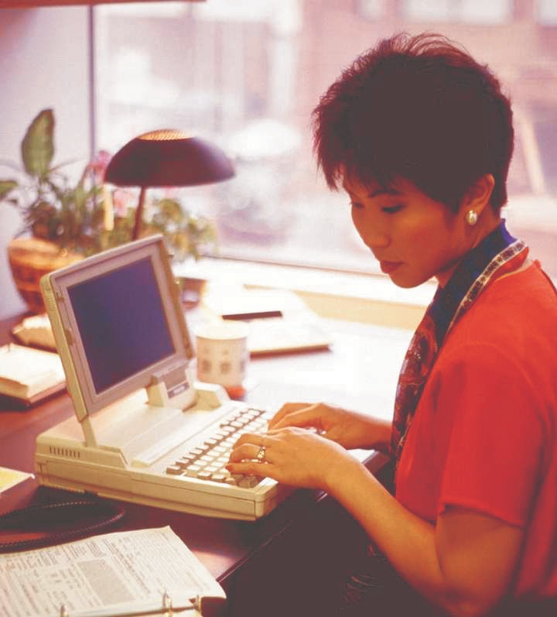
  - accessible
  - accurate and
  - recognize audience*
*By defining high-tech terms and by achieving a personalized tone.
- Date
- Reader’s address
- Salutation
- Text
- Complimentary close
- Signature
- Typed name
On the next page is a sample letter with each of the essential components noted.

Writer’s Address

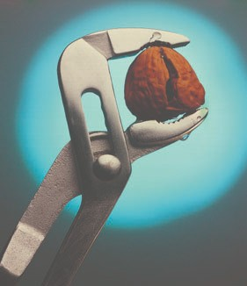
ACME NutZ & BoltZ
1800 West Hardware, Wheelbarrow, KS 66244

Date Reader’s Address
Salutation

Text

Complimentary Close
Signature
January 15, 2004 Julie Boyle
5982 Elm
Hastings, KS 62331 Dear Ms. Boyle:
Thank you for your letter requesting information about our Acme Nutz & Boltz service contract. The following clarifies what we cover and the duration of that coverage.

- Machinery maintenance: Free for 60 days after purchase. After the first two months, we will provide complete maintenance (parts and labor) for $24.00 a year up to five years. This main- tenance contract requires you to bring the machinery to our shop.

- On-site maintenance: Free for 60 days after purchase. After the first two months, we will service your machinery at your site for an additional $12.00 a year up to five years.

- Exclusions: We will maintain your machinery parts free for 60 days or for five years at $24.00 a year. This does not include lubricants. You should lubricate your machinery quarterly with 2 oz. of silicon gel. You can purchase this at our parts counter.

With our expert maintenance, your machinery can last a lifetime. If you purchase our five-year plan by the end of this month, Ms.
Boyle, we will offer you a 10% discount. Please contact our service representative at 441-9026, ext. 1313.

Sincerely,
Becky Sandhaus
Becky Sandhaus

Typed Name

All-Purpose Template
In addition to the eight essential letter components, an effective letter will also contain an Introduction, a Body, and a Conclusion (the text of the letter). To help students understand what these three parts of a letter should include, use the following all-purpose template:
- Tell the reader what’s next
- Include when you plan a follow-up action and
- Why that date or time is important
- What exactly you plan to do
- What you are writing about
- Itemize what exactly you want the reader to do or
- Tell the reader why you are writing and
Conclusion
Body
Introduction

This is called the All-Purpose Template because students can use this organizational approach for every type of letter they might write. Whether writing a cover letter for a resumé, a sales letter, or a letter of inquiry, the student will respond to the same questions.

Type of Letter | Introduction | Body | Conclusion
Cover Letter | Question:  Why are you writing?  Answer:  In response to a job advertisement.  Question:  What are you writing about?  Answer:  Name the specific job opening. (Many companies list numerous job openings.) | Question:  What exactly do you want to say?  Answer:  The reasons why you are quali- fied for the job. | Question:  What is next?  Answer:  When can you meet with the personnel director to discuss this job opening?
Sales Letter | Question:  Why are you writing?  Answer:  To solve a reader’s problem or ful- fill a reader’s need.  Question:  What are you writing about?  Answer:  The product or service you are at- tempting to sell. | Question:  What exactly do you want to say?  Answer:  The reasons why your product or service will benefit the reader. | Question:  What is next?  Answer:  When the reader should pur- chase this product or service and why that date is impor- tant (a discount, an extended warranty, or a discontinued item date).
Letter of Inquiry | Question:  Why are you writing?  Answer:  To ask your reader a question.  Question:  What are you writing about?  Answer:  The specific topic of your inquiry. | Question:  What exactly do you want to say?  Answer:  List your specific questions. | Question:  What is next?  Answer:  When do you want an answer and why is that date important.

Letter Wizards/Templates

Microsoft Word’s Wizards/Templates might help your students more easily write letters (and memos, fliers, resumés, etc.). Students can access Wizards/Templates by clicking on File, scrolling to New, and then clicking on the Letters & Faxes tab. Inside this file, they will find templates for contemporary, professional, and elegant letters.

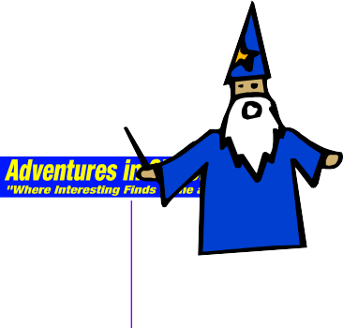
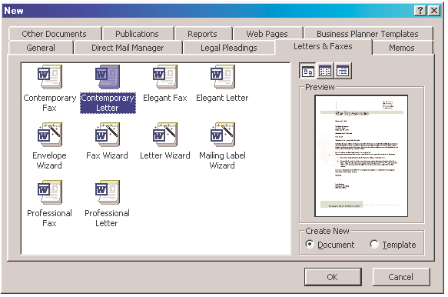
Wizards/Templates are good and bad. On the good side, these templates help students format letters and provide the standard letter components. On the bad side, however, templates can be restrictive, limiting the students’ options.

For example, I would NEVER teach students to begin a letter with Dear Sir or Madam. It is too impersonal and old-fashioned. Yet, the letter wizard provides this salutation in their template. Students should be informed of both the pluses and minuses of wizards.

Screen shot reprinted courtesy of Microsoft Corporation.

Wizards provide your students optional layouts for letters. On the next page is an example of what the Contemporary Letter template looks like.

Here is what the Contemporary Letter template looks like.
Company Name Here

August 20, 2004

[Click here and type recipient’s address]

Dear Sir or Madam

Type your letter here. For more details on modifying this letter template, double- click �. To return to this letter, use the Window menu.

Sincerely,

[Click here and type your name] [Click here and type job title]

On the following
Student Activity…
After the criteria on the all-pur- pose template have been shared and discussed with the students, have them write rough drafts of a Cover Letter, Sales Letter, or Letter of Inquiry.

(Samples of a Sales Letter and Letter of Inquiry follow the Peer Evaluation Checklist.)
page is a Peer Evaluation Checklist for
a LETTER.

This checklist may be
customized, depending on the type of letter the student is writing.

PEER EVALUATION CHECKLIST

LETTER

Writer’s Name

Reader’s Name Reader’s Name

QUESTIONS |  | YES | NO*
1 | Has the student provided the eight letter essentials?
2 | Does the student’s Introduction explain why he or she is writing and what he or she is writing about?
3 | Does the student’s Body explain what exactly he or she wants or plans to do?
4 | Does the student’s Conclusion explain what’s next, specifying when there should be a follow-up action and why that date/time is important?
5 | Is the letter Clear, answering reporter’s questions and specifying?
6 | Is the letter Concise, limiting word length, sentence length, and paragraph length?
7 | Does the letter provide an Accessible Document Design, using highlighting techniques effectively?
8 | Does the letter achieve Audience Recognition by defining high-tech terms?
9 | Does the letter achieve Audience Involvement by personalizing through pro- noun usage?
10 | Is the letter Accurate, abiding by all grammatical conventions?

*If the answer is no, specify what is missing and suggest a solution.

Sample Sales Letter

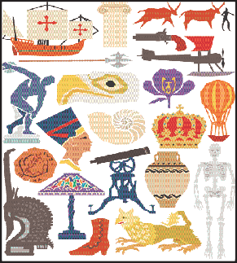
Teaching Tools
1423 Excel
Collegetown, KS 65551

July 12, 2004

Flint Lake Hills USD 6590 Lakeside Dr. Flint Lake, KS 68621

Subject: INTERACTIVE TEACHING EQUIPMENT

Do your teachers want more hands-on activities in class? Could your students profit from more personal involvement in their education? Now, you can use our proven Interactive Teaching Tools (ITT) to achieve these goals. Here is how we can help:

- ITT computer-generated presentations encourage creative teaching. The animated graphics packages (complete with 1200 images) help teachers enliven their lectures.

- ITT palm-top computers encourage student involvement. When each student has his or her own palm-top, that student can move from lecture to hands-on application instantaneously! Quick turnaround equals quick understanding.

- ITT software encourages shared learning. Our team-tested software helps students learn together. When students work in teams, they increase their knowledge, a fact proven by 2003 MIT studies in inter- personal effectiveness. This software then lets the teacher become a facilitator rather than a lecturer.

Ask for a free demonstration and free software package today! If you act before the next semester, we will offer you a USD 10% discount. ITT can help your teachers to help your students.

Sincerely,

Wilkes Barry, Ed.D.

Sample Letter of Inquiry

Flint Lake Hills USD

July 15, 2004

Teaching Tools 1423 Excel
Collegetown, KS 65551 Dear Dr. Barry:

6590 Lakeside Dr. Flint Lake, KS 68621

Your Interactive Teaching Tools (ITT) might be what we are looking for to increase student involvement and encourage hands-on instruc- tion. Before we place an order, however, we need more information. Please answer the following questions:

    - Do your ITT computer-generated presentation packages come with user manuals, and will you provide free training at our USD site?

    - Do you offer quantity discounts on your ITT palm-top comput- ers? We would like to purchase 500 palm-tops. However, we can only do this if you give us a cost break. This is required by our USD Purchasing Office.

    - What 1997 MIT study are you referring to? We would like a copy of that study for our USD board. This would substantiate your claims and help us recommend purchase.

Our Fall semester begins August 13, 2004. If you respond to our ques- tions by July 30, 2004, we will have time to meet with our board and consider a purchase.

Sincerely,

Walt D. McDonald, Ed.D. Superintendent, Flint Lake USD

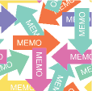
Memos differ from letters in two significant ways
First, memos are internal correspondence, written by employees in a company to employees in the same com- pany. Letters, in contrast, are external correspondence, written from within a company to outside vendors, clients, or colleagues. Secondly, memos have a different format than the letter essential components.

Memo components
Memos replace the eight letter essential components with the following memo identification lines:
Memos

Teaching Suggestion
- When teaching about writing letters, the focus is usually on types (such as cover letters, sales letters, and letters of inquiry).

- It is suggested that the instructor use modes to teach memos.

- Students could write a problem/solution, com- parison/contrast, argu- ment/persuasion, a cause/ effect, a classification or analysis memo, etc.

- This, of course, is not mandatory. Using modes is an easy tool since both teachers and students are familiar with this organiza- tional technique.

      - Date is the month, day, and year in which you are writing
Date:
To: From:
Subject:
      - To names your reader
      - From is your name
      - Subject (typed in all capitals) provides your audience two things: a topic and a
focus. For example, a successful subject line would read as follows:
Subject: VACATION SCHEDULE FOR ACCOUNTANTS
Accountants is the topic of the memo; vacation schedule is the focus. The focus aids communication more than the topic. The topic of a memo, for instance, can stay the same, while the focus changes. Look at the following examples:
Subject: SALARY INCREASE FOR ACCOUNTANTS
Subject: TERMINATION OF ACCOUNTANTS
In each of these instances, the topic stays the same: Accountants. Notice, then, how important the focus comments are. We see a huge difference between salary increases, vacation schedules, and termination.

In addition to the identification lines, memos differ from letters in one other subtle way. Whereas letters are signed (essential component #7), memos are initialed next to the From line.

Though memos and letters differ as noted, they are similar in all other ways. Successful memos, like letters, have an introduction, body, and conclusion. Like letters, successful memos are clear, concise, accessible, accurate, and achieve audience recognition.
The next two pages contain sample memos focusing on problem/solution and comparison/contrast modes.

Sample Problem/Solution Memo

Date: March 15, 2004
To: Candice Millard
From: Larry Massin LMM
Subject: SOLVING PROBLEM WITH E-MAIL

Candice, as you noted in your March 13 memo, we are having prob- lems with our e-mail. Intranet correspondence has evinced the wrong tone, contained unnecessary spacing, and forced readers to scroll end- lessly. Here are suggestions to correct these problems.

- Improving Tone—Studies tell us that typing in all caps creates a negative tone, called flaming. For example, when one writes, TELL YOUR SUBORDINATES TO IMPROVE THEIR TONE IN E-MAIL, readers feel they are being shouted at. Please ask your colleagues to avoid typing in all capitals.

- Omitting Unneeded Spaces—E-mail arrives looking as follows: “Can you help us solve problems with odd spacing. We can not seem to figure out why this is happening.” This odd spacing is caused by the different sizes of monitors. We commonly use word wrap when writing memos and letters because all text will exist on an 8½ X 11 inch page. Such is not the case with e-mail. E-mail on a 12” monitor will look differ- ently than e-mail on a 16” monitor. To avoid the problem of odd spacing caused by different monitor sizes, do not use word wrap. Instead, use a hard return at the end of each line, and limit your line length to approximately 60 characters.

- Avoiding Endless Scrolling—A memo or letter follows the WYSIWYG factor. When we get an 8½ X 11 inch memo or letter, What We See Is What We Get. In contrast, e-mail screens are smaller. Readers are often forced to scroll for several screens. This is disconcerting. To avoid this problem, limit your e-mail to approximately 14 lines (one screen).

By using these techniques, Candice, your department’s e-mail will improve. Please e-mail my suggestions to your colleagues by today’s end-of-business. If I can answer other questions, just call ext. 3625.

Date: December 2, 2004
Sample Comparison/Contrast Memo
To: Lupe Salinas
From: Larry Massin LMM
Subject: INCREASING PRINTER CAPABILITIES

Lupe, currently our printers are backing up. This is due to increased demands placed on the printers. Now that we have 20 new em- ployees and 15 new accounts, our printers cannot keep up with the demand. To solve this problem, you might want to consider the following two options presented in Table 1:

Table 1: Printer Options
Options | 5 B/W, Dot Matrix Printers | 1 Color Laser Printer
Cost | 5 x $350=$1,750 | $2,500
Capability | Printing text | Print text/graphics in color
Capacity | Printing 1 page per 2 min. | Printing 5 pages per 2 min.
Control | Only 5 users can be linked | All 35 users can be linked

Both these options will meet our demands, Lupe. However, the color laser printer, though more expensive, will save us time and provide more quality. Let me know which option you prefer. If we place an order before month end, we can buy this year’s model (next year’s models will cost more).

Memo Wizards/Templates
Microsoft Word’s Wizards/Templates might help your students more easily write memos (and letters, fliers, resumés, etc.). Students can access Wizards/Templates by clicking on File, scrolling to New, and then clicking on the Memos tab. Inside this file, they’ll find templates for contemporary, professional, and elegant memos.

Wizards/Templates are good and bad. On the good side, these templates help students format memos and provide the standard memo components. On the bad side, however, templates are restrictive, limiting the students’ options.

(See example screen shots of Memo Wizards on next page.)

Wizards provide your students optional layouts for memos.

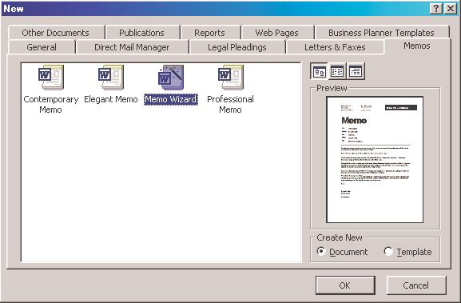

n shot reprinted courtesy of Microsoft Corporation.

Following is a Peer Evaluation Checklist for MEMOS.
Below is an example of what the  Contemporary Memo  template looks like. | Scree
interoffice memo
Date: 11/05/02
To: [Click here and type names] cc: [Click here and type names] From: Network Services
RE: [Click here and type subject]
[Click here and type your memo text]

PEER EVALUATION CHECKLIST

MEMO

Writer’s Name

Reader’s Name Reader’s Name

QUESTIONS |  | YES | NO*
1 | Does the student provide the memo identification lines (Date, To, From, Subject)?
2 | Does the student’s Subject line provide a topic and a focus; is the memo Initialed by “From”?
3 | Does the student’s Introduction explain why he or she is writing and what he or she is writing about?
4 | Does the student’s Body explain what exactly he or she wants or plans to do, using appropriate modes (problem/solution, comparison/contrast, argument/ persuasion, cause/effect, classification, analysis, etc.)?
5 | Does the student’s Conclusion explain what’s next, specifying when there should be a follow-up action and why that date/time is important?
6 | Is the memo Clear, answering reporter’s questions and specifying?
7 | Is the memo Concise, limiting word length, sentence length, and paragraph length?
8 | Does the memo provide an Accessible Document Design, using highlighting techniques effectively?
9 | Does the memo achieve Audience Recognition by defining high-tech terms and Audience Involvement by personalizing through pronouns?
10 | Is the memo Accurate, abiding by all grammatical conventions?

*If the answer is no, specify what is missing and suggest a solution.

E-mail is rapidly becoming one of the world’s most important means of communicating in the business place.
E-mail

Why is E-mail important?
Just look at these numbers:

- 140 million people will use e-mail in 2003.
- E-mail messages outnumber first-class letters 30-1.
- 80 percent of business employees say that e-mail has replaced most of their written business communication.
- 45 percent of business employees say that e-mail has replaced most of their business-related phone calls.
- 66 percent of business employees say that they are e-mail only communicators.

E-mail is similar to and different from memos and letters
Letters are external correspondence; memos are internal correspondence. E-mail (electronic mail), in contrast, can be both internal and/or external. Employees can e-mail each other within a company and/or e-mail vendors, clients, and colleagues outside a company.

E-mail is similar to memos in that both use identification lines
(Date, To, From, and Subject), in contrast to a letter’s eight essential components. Like letters and memos, e-mail must be clear, concise, accessible, accurate, and achieve audience recognition.

A successful e-mail contains a subject line with a topic and a focus, an introduction, a body, and a conclusion.
To succeed on their jobs, our students need to learn how to write successful
e-mail.

E-mail Benefits
- E-mail allows a writer to instantly communicate with a reader.

- E-mail can be sent to numerous readers at the same time.

- E-mail allows the writer and reader(s) to chat with each other online. A real-time dialogue is possible, whereas memos and letters may require days or weeks for dia- logue to occur.

- E-mail means no telephone tag.

However...
A wonderful value to the slowness of memos and letters is that time lets us correct errors.

While the benefits of e-mail help companies save time and money, things can and do go wrong.

E-mail problems

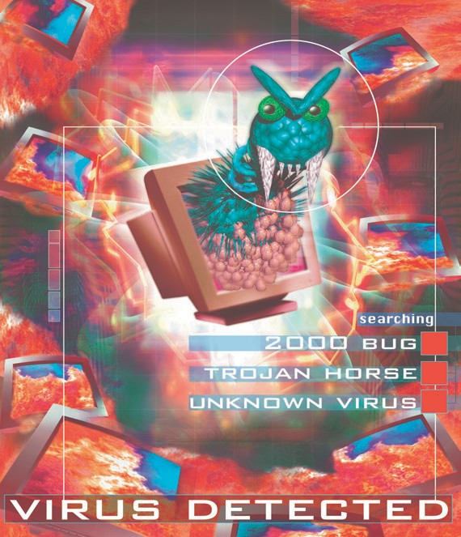

Highlighting techniques,
such as boldface, underlining, italics, color,
and fonts, are not possible for all
  - ail packages.

Some can use highlighting techniques; other e-mail packages cannot. If a system can use highlighting but another system cannot, the codes used to highlight will garble the e-mail message. E-mail writers should limit themselves to:
    - numbering,
    - asterisks
    - indenting (by using the tab key or the space bar)
Specifically, e-mail causes the following problems:
      - Instantaneous communication hinders the writer’s ability to double-check facts, effectively proofread text, and achieve the correct tone.
—If we write something that has grammatical or math- ematical errors, we can check these for correctness.
—If we write something that might be offensive, we can set the memo or letter aside for awhile. Then, at a later date, we could review the original and revise accordingly.
—E-mail, in contrast, can be sent at the push of a button. This speed may hinder our revision.
- People don’t like scrolling endlessly. Instead, e-mail should abide by the WYSIWYG factor (What You See Is What You Get). One, view- able screen of text is better than text that only can be read when you scroll . . . and scroll and scroll.

E-mail and computer viruses

Computer viruses, easily spread via e-mail, make readers cautious about opening e-mail from unknown sources. To avoid this problem, you should use Sig. Lines in your e-mail.

These signature lines tell readers who you are (since e-mail addresses like BigDaddy@aol.com or SweetBaby@hotmail.com don’t communicate clearly).

Ideal signature lines include your name, your organization/company, contact information (phone and fax numbers), and your URL and e-mail address.

The biggest problem in e-mail is lack of professionalism

Students are used to writing IMs—Instant Messages—to their friends. That’s not what we’re talking about in this chapter. We’re discussing e-mail written in the work- place, to bosses, co-workers, vendors, and clients. In instant messages, our students can get away with poor punctuation and spelling.

As Diane Stafford, editoralist for the Kansas City Star,
says, “One could argue that the casual nature of instant messaging has created a different mind-set among young e-mail users. Perhaps the medium dictates the style, and [students] don’t think it requires the same attention as, say, a school essay.”

But for business e-mail, those errors create the wrong image, making employees and companies look unprofessional. Stafford continues by stating, “job readiness education is a good thing in middle schools and high schools…Teach [students] that what’s acceptable in instant messag- ing isn’t appropriate for job hunting” (C1: May 2, 2002).

Sample Business E-Mail
From: spcsupport@nuvocom.net Date: December 30, 2003
To: Christy McWard
Subject: CREATING A NEW PROFILE

Thank you for contacting our 800-hotline. Recent online nuvocom.net updates have modified existing customer profiles. These changes can affect your e-mail. To solve the problems you encountered, create a new customer profile as follows:
- Click on the nuvocom.net icon to open your account.
- Double click “Configure.”
- Right click on “Manage Profiles.”
- Scroll down to “New Profile.”
- Type in your password and 6-digit PIN.
- Click “Next.”
- Click “Finish.”
This will allow you to access your e-mail. If you have any more questions, you can contact us either by e-mail, at our 800-hotline, or online at http://www.nuvocom.net/support.

On the next page is a
Peer Evaluation Checklist for E-mail.

PEER EVALUATION CHECKLIST

E-MAIL

Writer’s Name

Reader’s Name Reader’s Name

QUESTIONS |  | YES | NO*
1 | Does the student provide the e-mail identification lines (Date, To, From, Subject)?
2 | Does the student’s Subject line provide a topic and a focus; is the Address to the e-mail’s reader correct?
3 | Does the student’s Introduction explain why he or she is writing and what he or she is writing about?
4 | Does the student’s Body explain what exactly he or she wants or plans to do?
5 | Does the student’s Conclusion explain what’s next, specifying when there should be a follow-up action and why that date/time is important?
6 | Is the e-mail Clear, answering reporter’s questions and specifying?
7 | Is the e-mail Concise, limiting word length, sentence length, paragraph length, line length (to no more than 60 characters), and screen length (no more than 22 lines)?
8 | Does the e-mail provide an Accessible Document Design, using only such high- lighting techniques as numbers or asterisks?
9 | Does the e-mail achieve Audience Recognition by defining high-tech terms and Audience Involvement by creating a positive tone (versus “Flaming”- a negative tone)?
10 | Is the e-mail Accurate, abiding by all grammatical conventions?

*If the answer is no, specify what is missing and suggest a solution.

Reports | Reports come in all types and sizes
Students could write long reports (over three pages) or short reports (under three pages). They could write:
- proposals to recommend the solution to a problem or to assess the feasibility of a project
- trip reports about an off-site visit
- laboratory reports about the results of a procedure
- status reports about their progress on a project

Whichever type of report a student writes, whether it is long or short, it should have the following components:

Identification lines

Date, To, From, Subject (just as with memos and e-mail). The subject line would be typed in all caps and contain a topic and a focus.

Introduction
The introduction tells the readers what you are writing about and why you are reporting on this topic. This and the following comments about body and conclusion abide by the same all-purpose template discussed earlier in the chapter.

Body
The body of the report explains what exactly you accomplished and what problems you encountered (status report); what you saw and did (trip report); what procedure you followed and what you learned from the task (laboratory report); what options exist as feasible solutions to a problem (proposal).

Conclusion
The conclusion informs the reader what’s next. This could include what you plan to do during the next reporting period (status report), your suggestions for the next site visit (trip report), follow-up procedures and/or lessons learned (laboratory report), and your recommendations to solve the problem (proposal).

Remember the Five Traits of Technical Writing When Preparing Reports
Clarity--answering reporter’s questions.
Conciseness--using short words, short sentences, and short paragraphs.
Document Design-- employing highlighting techniques to make information accessible.
Audience Recognition- defining high tech terms. Throughout this chapter, it has been suggested that letters, memos, and e-mail use pronouns to achieve a personalized tone. Most reports, in contrast, are more objective, less personal.
Accuracy--abiding by grammatical conventions.

Sample Report Reports, unlike memos and e-mail, contain first, second,
and third level headings, as you can see in this sample report. The headings help the reader navigate text.

(A first level heading would be more emphatic than a second level, a second level more emphatic than a third, etc.)

A first level heading might be 11 POINT, ALL CAPS, ARIAL, BOLDFACE.

A second level, to be less emphatic, could be 10 POINT, INITIAL CAPS, OMEGA, BOLD- FACE.

A third level heading might be 9 point, no caps, Omega, Italics.
Date: October 3, 2004
To: Mr. Perry Michelson
From: Steve Janasz
Subject: LAB REPORT ON BACTERIA GROWTH

INTRODUCTION
Purpose
To determine the effects of antiseptics on the growth of bacteria. My hypothesis is that Sodium Hyperchlorite (Clorox) will reduce bacteria growth.
Materials/Equipment
- 2 petri dishes • pencil
- 5% Clorox • water
- soap • paper
- magnifying lens • agar
DISCUSSION
Procedure
- Obtain the petri dishes, then label one “control” and the other “5% Clorox.”
- Touch my unwashed hands to the petri dish labeled “control.” Close the lid after touching the dish.
- Wash my fingers in the 5% Clorox solution for 15 seconds.
- Air dry my fingers for about 2 minutes.
- Touch my washed fingers to the petri dish labeled “5% Clorox.” Close the lid after touching the dish.
- Wash my hands with soap to remove the Clorox.
- Incubate the dishes at room temperature.
- Record the day, date, number of colonies, and their color for days 0 through 4.
Results
colony count color of colonies
Day Control 5% Control 5%
- 0 0 off-white none
- 8 0 off-white none
- 285 0 off-white none
- 570 0 off-white none
- 411 1 off-white off-white
CONCLUSION
From the information gathered, I conclude that antiseptics kill most bacteria. My hypothesis is true, even though the 5% dish had one colony on day 4.

Note how the differences create a hierarchy, much like an outline, to lead the reader from point to point.

On the next page is a
Peer Evaluation Checklist
for REPORTS.

PEER EVALUATION CHECKLIST

REPORT

Writer’s Name

Reader’s Name Reader’s Name

 | QUESTIONS | YES | NO*
1 | Does the student provide Identification lines (Date, To, From, Subject), and does the Subject line provide a topic and a focus?
2 | Does the student’s Introduction explain why he or she is writing and what he or she is writing about?
3 | Does the student’s Body explain exactly what options he or she has considered (proposal), what has been accomplished (status report), what procedures have been followed (laboratory report), or what has been seen and done on the site visit (trip report)?
4 | Does the student’s Conclusion explain what’s next, specifying when there should be a follow-up action and why that date/time is important?
5 | Does the report include First level, Second level, and/or Third level Headings to help the reader navigate the text?
6 | Is the report Clear, answering reporter’s questions and specifying?
7 | Is the report Concise, limiting word length, sentence length, and paragraph length?
8 | Does the report have an Accessible Document Design, including bulleted lists and graphics, such as a table and/or chart?
9 | Does the report achieve Audience Recognition by defining high-tech terms?
10 | Is the report Accurate, abiding by all grammatical conventions?

*If the answer is no, specify what is missing and suggest a solution.

The Job Search Includes. . .
The Job Search
  - Finding job opportunities
  - Creating a resumé
  - Writing a cover letter/e-mail
  - Interviewing
  - Writing a follow-up letter/e-mail

Not many things are more important than getting a job. After all, income is paramount. Our students will need to find employment once they graduate from high school, the community college, a college, or a university. You know who might be best suited to help them find employment?
That’s right—their teachers, in all disciplines. We spend more time with our students than anyone else, and we know the students better than most people.

Online
Job Search Sites
- CareerLab.com
- Career City Jobs
- Job Options Job Search
- NetTemps
- Internet Job Locator
- Career Shop Job Search
- Career Builder Search
- HelpWanted USA
- Career Magazine Jobline Database

What other possibilities exist? Ask your students for their suggestions.
Whether you teach physical education, industrial technology, family and consumer sciences, agricultural education, business/computer classes, English, or any other discipline, you are the person who can help prepare students for their job search.

Finding job opportunities

Where should students look for jobs? They should try the following:

Networking. That can start with you, your school’s counselors, and, of course, their families and friends.

Career placement centers. Does your school’s counseling area list job opportunities? Many do, and that’s a great place for students to look. Area community colleges or local universities offer other possibilities.

Online searches. Our students are very computer/Internet savvy. Today, a wonderful site for job opportunities is the Internet. Some career placement experts suggest that within a few years, 95% of all jobs will be found online (L. A. Lorek, “Searching On-line.” The Kansas City Star. August 23, 1998: D1).

Monster.com, Headhunter.net, and Google.com, for example, let you search for jobs by title and location. Google.com provides a link to their cool jobs. All of these sites, and more, offer help with resumés, interview tips, job search tips, and samples of cover and
thank-you letters.

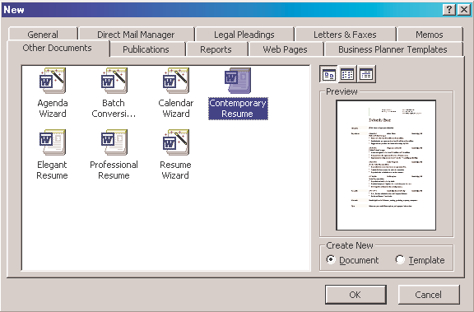

Don’t forget newspapers for your job search. Times have changed, and jobs can be found online, but local newspapers are still a solid standby.

Creating a resumé

Microsoft Word’s Wizards/Templates might help your students more easily write resumés (and letters, fliers, memos, etc.). Students can access Wizards/Templates by clicking on File, scrolling to New, and then clicking on the Other Documents tab. Inside this file, they’ll find templates for contemporary, professional, and elegant resumés.

Wizards/Templates are good and bad. On the good side, these templates help students format resumés and provide the standard resumé components. On the bad side, however, templates are restrictive, limiting the students’ options.

Screen shot reprinted courtesy of Microsoft Corporation.

Different types of resumés

Not that long ago, if one talked about different types of resumés, that would have just meant reverse chronological vs. functional. A reverse chronological resumé would work for most of our students, since these types of resumés are geared toward the traditional job applicant (recent high school or college graduates) hoping to enter a profession for the first time.
resu
ME!
Functional resumés are more common for older individuals who are changing jobs or career fields.

However, nowadays, different types of resumés refers to the format of the text versus the content. Today, you can send three types of resumés to prospective employers:

  - Traditional mail versions. This is when you mail an 8 ½” X 11" piece of paper to an
employer. In such a resumé, the student can use boldface headings, colored paper, italicized subheadings, bullets, etc.

Many people consider a resumé the perfect form of technical writing.

Whether you write a traditional resumé, e-mail version, or Internet resumé, they will all have many of the same components.
- An e-mail resumé. E-mail programs are different (AOL, Microsoft Outlook, Hotmail, and Juno, for example). They use different ASCII coding. So, what you see on your e-mail might not be what your reader sees. Thus, e-mail resumés cannot use boldface headings, color, italicization, or bullets.

The coding required for these highlighting techniques might create garbled text. An e-mail resumé, on the other hand, must limit highlighting techniques to simple tools like the use of asterisks, all caps, and double spacing.

- An Internet resumé. This resumé will be delivered online, using HTML coding. Internet resumés are very unique, rarely following any set pattern.

A resumé requires the writer to use each of the technical writing techniques already discussed. A resumé must be clear, concise (since most resumés are limited to one page), accessible, and correct.

In addition to the above concerns, a resumé would include identification information of the writer, employment objectives, the writer’s education, work experience, and references. (These components are further dis- cussed on the next page.)

Component | Description
Identification | The writer’s name, address, phone number, and e-mail address.
Objectives | This is optional: telling what kind of employment the applicant is seeking.
Education | List in reverse chronological order the writer’s degree (possibly at the anticipated graduation), school, city, state, and date of graduation (or anticipated date of graduation). The writer also could list achieve- ments, such as GPA, honors, and/or special classes taken. (Education does not have to come before Work Experience.)
Work Experience | List in reverse chronological order the writer’s job title, company, city, state, and dates of employment. The writer also could list achieve- ments, such as special tasks accomplished (open and shut store, train new employees, etc.), rapid promotions, number of hours worked while in school, and special skills acquired (use ten key calculator, computerized cash register, customer service, problem/solving skills).
References | Often noting References Supplied Upon Request is sufficient.

Incorrect information on a resumé is tantamount to lying, which would destroy an applicant’s chances
at getting or keeping a job.

Activities
- Direct your students to go online (Internet Explorer or Netscape) and type in individual resumés in the search box. Then, look at the different ways in which Internet resumés can appear.

—Which are good? Which are bad?

On the next page is an example document exemplifying the five components necessary for
an effective
resumé.
—Ask your students to make value judgments and then explain their
reasoning.
—Compare these online resumés to traditional, hard copy resumés.
What are the differences?

- Ask your students to find online sites giving tips for resumé writing. Then, in small groups, report their findings.
—What sites have they found?
—What tips are provided?

Sample Resumé

Leonard J. Liss
55122 Chico Mighty Oak, KS 66312
913-455-5555

OBJECTIVE
Seeking sales employment in the computer field, using my technical knowledge, problem solving skills, and interpersonal communication talents

WORK EXPERIENCE
Computer Salesperson, OmniTec Computers, 1997 to present
108 South Rd., Clayton, KS
  - Provided computer training for new customers
  - Exceeded my 15% sales quota each month
  - Installed and repaired customer computers

Computer Technician, U-Bet-Your-Byte, 1996-1997 2111 Elm St., Mighty Oak, KS
  - Repaired all computer makes and models
  - Received a letter of commendation from my boss

Stocker/Checker, USack Groceries, 1994-1996 786 Summer Rd., Mighty Oak, KS
  - Worked second shift (4:00p.m.-11:00p.m.) while going to high school full time
  - Earned enough money to pay for my own car and insurance
  - Promoted to Head Stocker within three months

EDUCATION
GED, Mighty Oak Alternative Education High School, 1997
  - Completed my degree while working 30 hours a week

Clayton High School, Clayton, KS, 1994-1996
  - Member of the Computer Club
  - Built own computer
  - Maintained a 3.0 GPA while working over 20 hrs./wk.

References supplied upon request
On the following page is a Peer Evaluation Checklist for the

RESUMÉ.

PEER EVALUATION CHECKLIST

RESUMÉ

Writer’s Name

Reader’s Name Reader’s Name

QUESTIONS |  | YES | NO*
1 | Does the student provide Identification lines (Name, Address—Street, City, State, ZIP Code—and Phone Number)?
2 | Does the student’s Objective section explain what kind of job he or she hopes to find?
3 | Does the student’s Education section explain in reverse chronological order exactly what degree he or she has, which school has been attended, where that school is located, and when the student graduated (or plans to graduate)? This section also can list educational achievements.
4 | Does the student’s Work Experience section explain in reverse chronological order exactly what his or her job title is, which company the student worked at, where this company was located, and the dates of employment? This section also can list achievements on the job.
5 | Does the resumé include a References section?
6 | Does the resumé include First level, Second level, and/or Third level Headings to help the reader navigate the text? For example, the student’s name would be a first level heading, and “Objectives,” “Work Experience,” and “References” would be a second level heading.
7 | Is the resumé Clear, answering reporter’s questions and specifying?
8 | Is the resumé Concise, limiting word length and omitting sentences?
9 | Does the resumé have an Accessible Document Design, including bulleted lists and white space?
10 | Is the resumé Accurate, abiding by all grammatical conventions and making sure that all dates, degrees, job titles, addresses, and phone numbers are correct?

*If the answer is no, specify what is missing and suggest a solution.

Writing a cover letter/e-mail
The Cover Letter Customizes the Job Search
Every resumé, whether traditional, e-mail, or Internet, should be prefaced by a cover letter.
This is important for two reasons: the cover letter or cover e-mail customizes the job search, and the cover letter highlights the student’s value.
Students will use the same resumé regardless of which job they are applying for.

The cover letter, in contrast, should be written for a specific job opportunity. Thus, whereas the resumé is generic, the cover letter or e-mail will highlight how the student is truly the best hire for that specific job.

To accomplish this goal, the student will use the cover letter to focus on how he or she can fulfill the requirements of the job as it has specifically been advertised.

Activity
—Ask your students to find online sites giving tips for cover letters.

—Then, in small groups, report their findings.

—What sites have they found? What tips are provided?

What a cover letter should accomplish
The cover letter should accomplish the following (see pages 26-33 for more information on letters):

- Essential components of a letter (writer’s address, date, reader’s address, salutation, text, complimentary close, signature, and typed name.) If the student is sending the resumé via e-mail, then these components will change—no address, salutation, or signature
will be required.

- Introduction. Tell why you are writing and what you are writing about. This will tell the reader that you are applying for a job (that’s the “why”) and which job you are applying for (that’s the “what”).

- Body. Tell what exactly makes you the best candidate for the job. List the ways in which you specifically meet the advertised criteria.

- Conclusion. Tell what’s next. When would you like to set up an interview to discuss your credentials?

On the next page is the text of a Sample
Cover Letter

Sample Cover Letter Text

Dr. John Smith, my physical education teacher at Bluff High School, informed me of an opening for an umpire in the Bluff City Parks and Recreation Summer 3-2 Baseball League. Please consider me for this position.

Though I have attached a resumé, let me highlight my skills:

- I played varsity baseball for Bluff High School, lettering for three years.
- I was all-city second team catcher.
- I have two years experience as a referee for youth soccer.
- I was the assistant coach for my brother’s little league baseball team for two years.

Eventually, I hope to get my teacher’s certification and coach high school baseball. I am positive that my background and motivation will be an asset to your Summer League. Could we meet to discuss my credentials and interest?

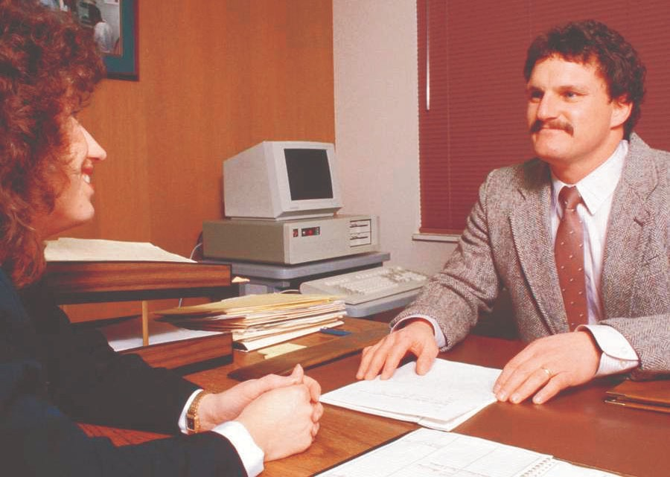
Interviewing

With luck, your student will write a cover letter/e-mail and resumé effective enough to get an interview. Then the next challenge occurs—landing the job. You can help by working with your students on interview/oral presentation skills. Basically, interviewing requires common sense:
  - Arriving on time
  - Dressing appropriately
  - Looking people in the eye when speaking
  - Sitting and standing straight
Activities
—Ask your students to find online sites giving tips for interviewing. In small groups report: what sites have they found? What tips are provided?

—Ask your students what questions they might be asked on a job interview.

—Try mock interviews in the classroom.
  - Not smoking or chewing gum during an interview

Be Prepared. . .
- Be prepared to answer questions (“Why do you want this job?” “What skills can you provide us?” “Why did you leave your last employment?” “What makes you right for this job?”)

- Be prepared to ask the right questions (salary range, hours, tasks, chains of authority, etc.)

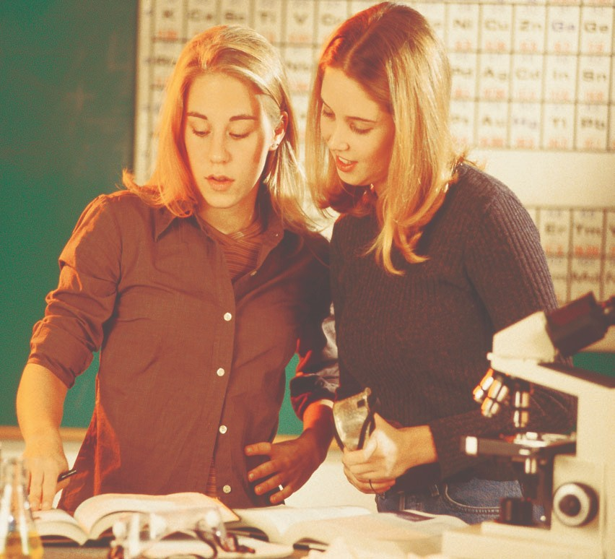

Writing a follow-up letter/e-mail
Instructions
Activity
- Ask your students to find online sites giving tips for follow-up letters.

- In small groups report: what sites have they found? What tips are provided?
A follow-up letter serves several purposes:
- Reminds the reader of your continued interest
- Politely thanks the reader for his or her time
- Allows you to highlight additional reasons why you are the best person for the job

These letters or e-mail do not have to be long. In fact, just a few sentences will suffice.

The only people who read instructions are those who need help performing the task

In a recent survey (Gerson & Gerson), 454 professional technical writers nationwide were asked which type of documentation they most often wrote. The writing of instructions was named by 90.1% of them.

Instructions (or procedures) tell the reader how to do some- thing. This could include programming a VCR, repairing a broken bicycle, installing speakers in a car, making a clock in industrial technology, performing a science experiment, or throwing a pot in a ceramics class.

To write effective instructions, students again must create
clear, concise, accessible, and accurate text which achieves audience recognition. The latter point, audience recognition, is espe- cially important in instructions. If we knew how to do it, we would not need to read the text.

Successful instructions often are much more detailed than the ones presented here.

The following pages illustrate the components and attributes generally found in successful instructions.

- Obtain the petri dishes, then label one control and the other 5% Clorox.
- Touch my unwashed hands to the petri dish labeled control. Close the lid after touching the dish.
- Wash my fingers in the 5% Clorox solution for 15 seconds.
- Air dry my fingers for about 2 minutes.
- Touch my washed fingers to the petri dish labeled 5% Clorox. Close the lid after touching the dish.
- Wash my hands with soap to remove the Clorox.
- Incubate the dishes at room temperature.
- Record the day, date, number of colonies, and their color for days 0-4.

Components of Instructions

Title

Graphic to Represent Topic

Introduction

Tools & Equipment

Numbered Steps Begin with a Verb

Cautions
Plant Cuttings Instructions
With a cutting from a favorite plant, you will be able to grow that plant forever!
Required Tools
- Propagation Pot • Potting Soil • Cloning Gel
  - Razor Blade • Water

Instructions
- Cover the bottom of your propagation pot with at least 3" of potting soil.
- Select your plant for the cutting. NOTE: Pick the healthiest plant you can find.
- Choose a branch or stem with 2 or 3 sets of leaves.
- Using your razor blade, make a 45-degree angle cut next to a leaf node (that’s where the branches leave the stem).
- Immediately dip the cutting in your cloning gel to prevent an air bubble from entering the stem.
- Place the cutting in the propagation pot, inserting the cutting at least 2" into the potting soil.
- Moisten the soil. Do Not over water.

Enjoy your plants for years to come

Conclusion

The steps of procedure are the most
important aspect of any instructions.

- Each step should be numbered.
- An action verb should be used to begin each step.
- Each step should have specificity of detail for clarity.
- Short words and sentences help achieve conciseness.
- The use of graphics helps the reader understand each step.

Previously discussed attributes of accessibility, audience recognition, and accuracy are important in writing successful instructions.

Accurate and correct information when writing instructions can mean the difference between life and death. Just ask any health practitioner.
Sample Instructions

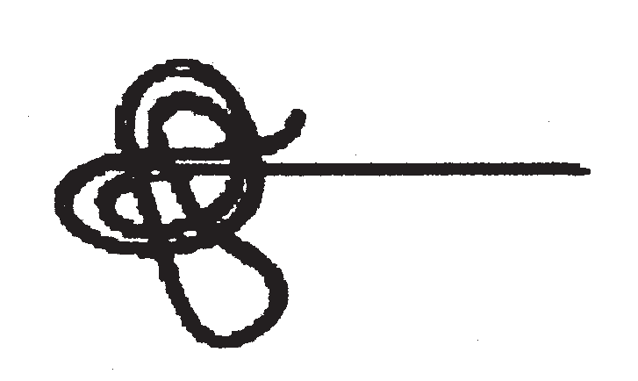
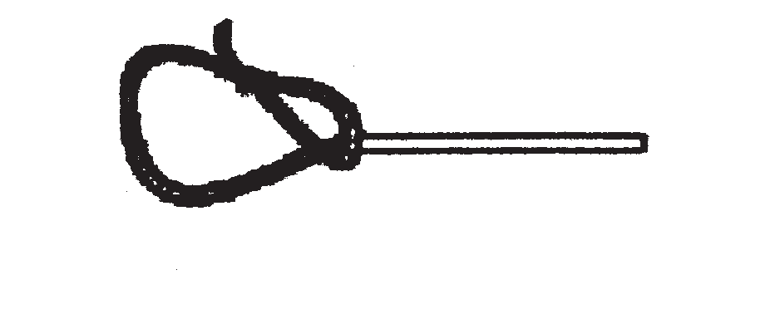
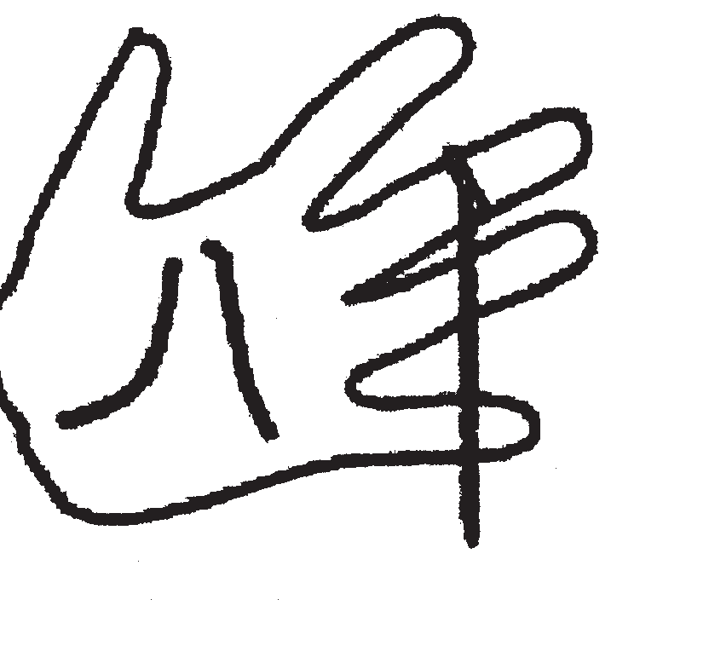
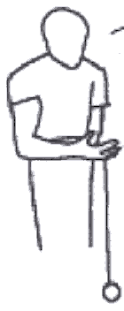
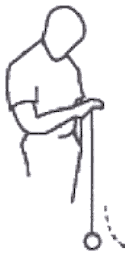
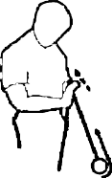
How to Yo-Yo
Yo-yoing is FUN! But it takes practice. Learn how to yo-yo by following these steps.

What Do You Need?
Any yo-yo will do. Be sure to buy one that will sleep (stay down) when you try to “walk the dog.” So the string can’t be tied or glued at the bottom. It must be loose enough to spin.
Steps for Yo-yoing Successfully
- Make about a ½ inch loop with the string, and then tie a knot. Pull about 2 inches of the string through the loop.

- Put your middle finger through the loop (between your first and second knuckle) and pull the string tight.

- Holding the yo-yo in your palm (with the palm facing up), throw your hand down, letting the yo-yo drop from your hand.

- When the yo-yo reaches the bottom, twist your hand counterclockwise so the palm is now facing down.

- To return the yo-yo to your hand, jerk your palm up.

On the next page is the Peer Evaluation Checklist for INSTRUCTIONS.

PEER EVALUATION CHECKLIST

Writer’s Name

Reader’s Name Reader’s Name

INSTRUCTIONS

Questions |  | YES | NO*
1 | Does the instruction include a Title, mentioning the topic to be discussed?
2 | Does the Title Page include a Graphic representing the topic?
3 | Has an Introduction been included, explaining why the instruction will be performed?
4 | Have required Tools and/or Equipment been listed?
5 | Has the writer provided Numbered Steps?
6 | Do steps begin with Action Verbs?
7 | Is each step clearly developed with Specific Details?
8 | Are Hazards (warnings, dangers, cautions, notes) provided?
9 | Are Graphics used to help the readers understand the steps?
10 | Is a Conclusion provided to sum up the instruction?

*If the answer is no, specify what is missing and suggest a solution.

Technical writing is no longer bound to hard copy
Web Pages
More and more, technical writing is online. One component of this growth is the Internet, which has generated a variety of occupations related to design, development, and maintenance of websites.

“I have been teaching composition and technical writing for about twenty-five years. In that time, I rarely have heard students gasp with joy upon writing an essay, memo, or letter. Students actually gasp when they see their hypertext go online.”
How rapidly are such jobs growing? Computer and data processing services are projected to be the fastest growing industry in the U.S. economy. In fact, web design, responsible for the creation of websites, is among the 10 fastest growing occupations. (Occupational Outlook Handbook, 2002.)
There is another reason to teach web pages, in addition to good job training: IT’S FUN!
With Wizards, teaching web design has never been easier

If your students are using Microsoft Word, they can access a web pages template. The students just open Microsoft Word, click on File, scroll to New, select the Web Pages tab, and they’re there. Wizards will allow students to create various types of websites and easily save their work as an HTML document.

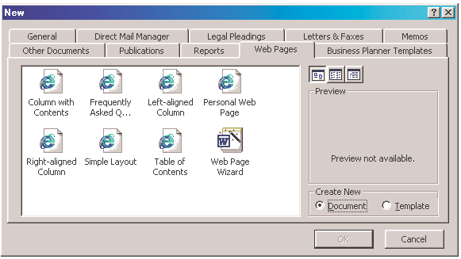

Screen shot reprinted courtesy of Microsoft Corporation.

On-line vs. hard copy
The Internet is very different from traditional means of commun- ication, such as books, magazines, and journals. Books, for example, require that we read chronologically and linearly. That is, we must read a book from beginning to end (chronologically) and line by line (linearly). That’s the way it is; that’s the way it’s always been.

The Internet, however, allows us to read differently: randomly. With hypertext links, you can jump to any page within a website, in any order you prefer.

There is no page 1 or page 2, nor is there a beginning or an end. Then, once within a web page, you should be able to scan the text (reading it at a glance) rather than read it line by line. The Internet is a paradigm shift in communication.

Start at the top left and end at the bottom right.

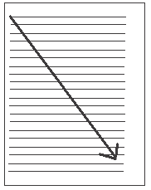

Think of it this way: the Internet is like your hand with individual pages (at each fingertip) hanging randomly. You can access the pages in any order.

Criteria for web pages

All web pages are not equal. Some websites on the Internet are awful, while others are very successful. To create an effective website, students should abide by the following criteria.

Home Page. When you arrive at a website, by typing in its URL (Uniform Resource Locator, the website address), you should see:
  - A title of the product or service
  - Contact information: street address, e-mail address, phone number, and/or fax
  - A graphic representing the topic
  - An introductory lead-in telling readers who the company is and/or what the product or service entails
  - Hypertext links (leading to the linked screens, the major text and development for the website)

Criteria for web pages _{(continued)}

Page Layout. A successful web page should only use about 2/3 of the screen for text. It’s hard for anyone to read an online page from margin to margin due to a number of challenges. These include monitor resolution, scrolling, glare, pixel distortion, animation, etc. To solve these problems, limit line length, using about 1/3 of the screen for your navigation bar and 2/3 for the text.

Navigation. Online, readers can’t turn pages, so they need some way to get from screen to screen. You help them by providing:

    - A “Home” button on each web page
    - A navigational bar or separate hypertext linked words or icons to all web pages within the website

Highlighting Techniques. You want to tastefully and judiciously use any of the following techniques to design your website. But remember, a little goes a long way:

    - Colored or patterned backgrounds. Be sure the text is clearly legible by striving for “optimum contrast”—black text on a white background or yellow text on a blue background, for example.
    - Horizontal divider lines
    - Iconic bullets
    - Colored text
    - Different font sizes (first level headings, second level headings, etc.)
    - Tables and figures

Conciseness, using short words, short sentences, and short paragraphs. Again, this is important because people have trouble reading text online and readers want to skim.

Clarity, answering reporter’s questions and providing specific information.

Tone, through positive word usage and personalized pronouns. The Internet is a very friendly communication medium.

Audience Needs, by defining terms, using the appropriate tone, and developing ideas at the appropriate level. You can accomplish this by deciding if your readers are high tech, low tech, or lay.

Grammar. The Internet is the World Wide Web. Remember that when you communicate online, you are communicating to the WORLD. Do you want everyone to see your grammatical errors?

On the next page is a Sample Web Page

Sample Web Pages

Creating a web page allows the students to practice good technical writing skills (clarity, conciseness, document design, etc.).
1818 Elm
Kansas City, KS 816-555-2121
We’re “Write” For You!
ProfCOM Technical
Writing Services

HOME PRICES OPTIONS REFERENCES

More importantly, by teaching students how to create a website, you can help prepare them for a growing and profitable career.

The home page has four, hypertext links: Home, Prices, Options, and References. Plus, it has:
- a left-margin navigational border
- a title for the company
- a logo representing the company’s services
- a clever introductory lead-in
- contact information

An example of one of the linked pages looks as follows:

Note the design of this web page:
HOME PRICES | ProfCOM Technical Writing Services  PRICES
OPTIONS REFERENCES | Projects | Costs
 | Technical Writing  Technical writing Editing, proofreading Software documentation Online Help | $25 per hour
 | Web Design  Website and page design Web-writing  Web-writing training | $45 per hour

- On 1/3 of the screen is the navigation bar, including the hypertext links

- On the remaining 2/3 of the screen, you have the name of the company, the company logo, a title for the web page (prices), and then the text

- The text is provided in an easy-to-access manner, using a table and lots of white space

PEER EVALUATION CHECKLIST

WEB SITES

Writer’s Name

Reader’s Name

QUESTIONS |  | YES | NO*
1 | Does the Home Page contain:  - A title of the product or service?  - Contact information—street address, e-mail address, phone number, and/or fax?  - A graphic representing the topic?  - An introductory lead-in telling readers who the company is and/or what the product or service entails?  - Three or more hypertext links (leading to the linked screens—the major text and development for the web site)?
2 | Does the web site contain 3 or more linked pages identified on the home page?
3 | Do the Linked Pages contain the following:  - A title for each page, allowing the reader to know where he or she is  - Text, developing this page’s points
4 | Does the web site provide successful Navigation, including:  - A Home button on each web page?  - Navigational links (a navigational bar or separate hypertext linked words or icons) to all web pages within the web site.
5 | Does the web site tastefully and judiciously use:  - Colored or patterened backgrounds (be sure the text is clearly legible)  - Horizontal divider lines  - Iconic bullets  - Colored text  - Different font sizes (first, second, and third level headings, etc.)  - Tables and/or figures
6 | Is the web site Concise (short words, short sentences, and short paragraphs; limiting the text to no more than two-thirds of the screen)?
7 | Is the web site Clear (answering reporter’s questions and providing specific information)?
8 | Does the web site achieve an effective Tone (through positive word usage and personal- ized pronouns)?
9 | Does the web site address its specific Audience Needs by:  - Defining terms?  - Using the appropriate tone?  - Developing ideas at the appropriate level?
10 | Has the web site avoided Grammatical Errors?

*If the answer is no, specify what is missing and suggest a solution.

PowerPoint is an amazingly valuable and versatile tool
PowerPoint Presentations

You can do so much with PowerPoint including oral presentations for reports, user manuals, and websites. Teaching students how to create PowerPoint presentations helps them become more familiar with technology (more and more important every day on the job) and helps them practice good technical writing skills: clarity, conciseness, document design, audience, and accuracy.

Plus, every computer has PowerPoint, so it’s easy for students to access and use. In fact, PowerPoint presentations are a wonderful option to websites (which can be very difficult due to computer challenges).

Criteria for PowerPoint

More About Fonts…

Weird but interesting fonts, like Gallery, Old English, or Yearbook Outline, are not only hard
to read but also will not always be compatible with whatever computer you might use to show your presentation.

Script fonts, like NevisonCasD, Lucida Handwriting, or Challenge, are almost totally unreadable in PowerPoint.
Fonts. Use common fonts, such as Times New Roman, Courier, or Arial. In fact, Arial is considered the best to use, since sans serif fonts (those without feet) show up best in PowerPoint. Use no more than three font sizes per slide.

To make your slides legible, use at least between 18-point font size and 24-point. Bigger is better, however. Titles can be in font sizes 48-54; main text titles in 32 point; smaller text lines in 24 point.

Color. Never use red or green text (individuals who are color blind can’t see these colors). Use color for emphasis only. Strive for optimum contrast between your text and your background colors. In fact, a dark background with light text gives the best contrast in PowerPoint. For example, white and yellow letters look great on a blue background.

Text. As with all good technical writing, the fewer the words, the better. Strive for open white space. Limit the text to six or seven lines per slide and six or seven words per line (think “6 X 6”). Two or more short and simple slides of text are better than one slide with many words. Use no more than 40 characters per line (a character is any letter, punctuation mark, and/or space). Use headings for each slide.

Graphics. Use graphics instead of tables. Keep your graphics simple. A graph that is too complicated, containing too much information, will not be easy to read or understand.

Whatever techniques you use to create your PowerPoint presentation, be sure to test it on
Criteria for PowerPoint _{(continued)}
Emphasis techniques. To call attention to a word or phrase or idea, use color (sparingly), boldface, all caps, and/or arrows. But don’t overdo it. A little goes a long way. Animation can be effective, but do not use every special effect (sounds and fade-ins). Pick one effect and use it consistently.

two or three different projection systems or computers. Rather than be surprised, be prepared.
Sample PowerPoint Slides

Heading

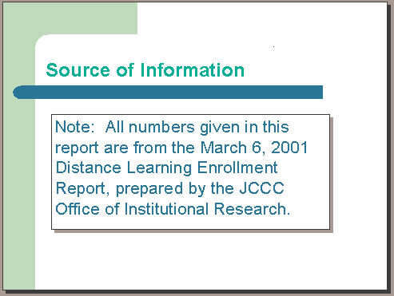
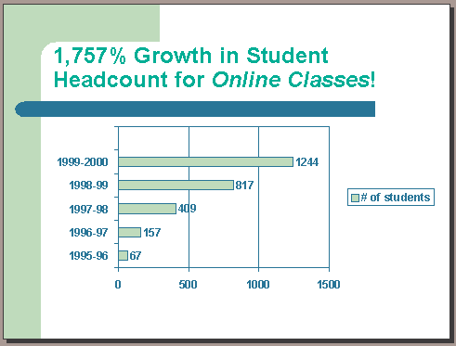
Simple Graphic

On the next page is the Peer Evaluation

Checklist for POWERPOINT PRESENTATIONS.

Source of Information

- lines of text
Note: All numbers given in this report are from the March 6, 2001 Distance Learning Enrollment Report, prepared by the JCCC Office of Institutional Research.
32-point Arial

PEER EVALUATION CHECKLIST

Writer’s Name

Reader’s Name Reader’s Name

POWERPOINT

PRESENTATIONS

QUESTIONS |  | YES | NO*
1 | Does the presentation include headings for each slide?
2 | Is an appropriate font size used for easy readability?
3 | Is the appropriate font type used for easy readability (Arial, for example, vs. a script font)?
4 | Are no more than 3 different font sizes used?
5 | Has color been used effectively for readability and emphasis, including font color and slide background?
6 | Have special effects been used effectively (vs. being overused)?
7 | Has text been limited on each screen (remembering the 6 x 6 rule)?
8 | Are graphics sized correctly for readability, avoiding ones that are too small and/or too complex?
9 | Have highlighting techniques (arrows, color) been used to emphasize key points?
10 | Have you avoided grammatical errors?

*If the answer is no, specify what is missing and suggest a solution.

Brochures

Brochures are omnipresent!

When you go to a hotel, an amusement park, a histori- cal landmark (like the Eisenhower Library in Abilene, the capitol in Topeka, or Boot Hill in Dodge City), a zoo, a museum, or a college campus, do you pick up a research paper at the door, explaining the site’s unique traits?

Many computer programs allow students to format brochures automatically. If you do not have this capa- bility, it is no less demand- ing than setting up columns on a computer and printing as landscape versus portrait. If this cannot be done, then the students will need to type and fold the pages accordingly.

Brochures can be any size, from a back and front
8½” X 3" card to four-panel or six-panel layout.
When you receive news from KNEA, TIAA, CREF, or any of your stock companies, do you get this informa- tion in a research paper? No, you do not. You either pick up a brochure at the door or receive a newsletter in the mail.

Criteria for brochures
Title Page (Font Panel). Include these three things:
- Topic: In the top one-third of the panel, name the topic about which you’re writing (product name, service, etc.).
- Graphic: In the middle third of the panel, include a graphic to appeal to your reader’s need for a visual representation of your topic. The graphic will sell the value of your subject (its beauty, its usefulness, its location, its significance, etc.) or visually represent the focus of your brochure.
- Contact Information: place contact information on the bottom third of this panel. You could include your name, your company’s name, street address, city, state, zip code, telephone number, fax number, and/or e-mail address.

Back Panel. The back panel may include any of the following:

Back
Front

Inside Fold-In

Back

Front
  - Conclusion: Use this panel to summarize your brochure’s content, highlighting your topic’s benefits or suggesting a next step for your readers to pursue.
  - Mailing: This panel could be used like the face of an envelope. On this panel, when left blank, you could provide your address, a place for a stamp or paid postage, and your reader’s address.
  - Coupons: As a tear-out, this panel could be an incentive for your readers to visit your site or use your service. Here you could provide discounts or complimentary tickets.
  - Location: Provide your address, hours of operation, phone numbers, e-mail, and a map to help them locate you.

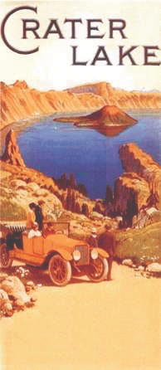
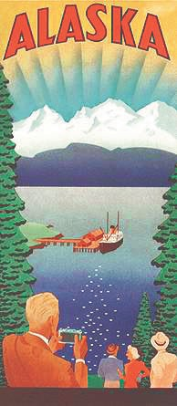
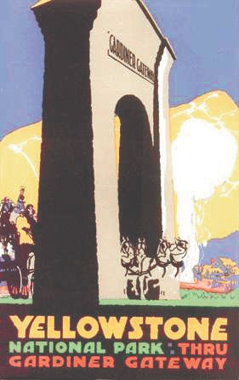
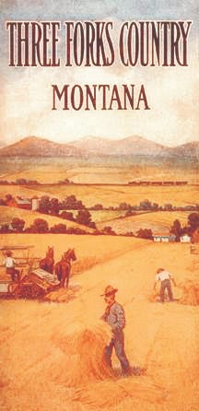
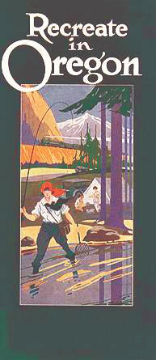
Inside

Teaching Tip
Teaching research papers is important because research is a valuable skill for students. However, that research can be packaged in a different form, one more commonplace in society.

How about teaching your students research, not by assigning a traditional essay, but by having the students write a researched brochure or newsletter?

Doing so is more fun and lets the students create a type of communication that they see in the mail and at local points of interest.

Doing so also lets the students practice technical writing skills, including document design, clarity, conciseness, audience recognition, and grammati- cal correctness.

Criteria for brochures _{(continued)}
Body Panels (Fold-in and Inside)
    - Provide headings and subheadings.
    - Use graphics (photos, maps, line drawings, tables, figures, etc.).
    - Develop your ideas. Consider including the following infor- mation, dependent upon your topic:
—Locations, maps, directions
—Technical Specifications and warranties
—Prices and payment plans
—Credentials and company history
—Unique Characteristics of the product or service
—Personnel biographies and employment opportunities
—Options
—Delivery (Dates/Methods)

Document Design. Try using only three or so different highlighting techniques for your document design. These options could include:
    - Color and graphics/tables
    - Font changes
Though you want to make your brochure interesting to look at, you don’t want to overdo the use of highlighting techniques— too much of anything is always a problem.
    - Horizontal rules
    - Bullets
    - Borders
    - Italics and boldface

Clarity. Remember to be specific and answer reporter’s questions (who, what, when, where, why, how).

Conciseness. Due to the limited size of each of your panels, you must limit your words (1-2 syllables), paragraphing (4 types lines), and sentence length (10-12 words).

Audience Recognition. Who are you writing to? Is your audience high tech, low tech, lay, or combinations of the three? To avoid problems, define any terminology, abbreviations, and/or acronyms which could cause confusion.

Audience Involvement. Brochures are very friendly methods of communication. You want to personalize your text through pronoun usage and contractions.

Accuracy. Your brochure might be the only thing a potential customer ever sees about your company. You want to make a good first impression. Poor grammar, in contrast, will make your company look very bad. Proofread to avoid any grammatical errors.

The Kansas State Department of Education _{presents}

A premier staff development opportunity focusing on developing appropriate and effective test items, including multiple choice, true/false, matching, completion, and essay. Each participant will receive a copy of. . .

More details inside. . .
Interested?
Want More Information?
Contact:
Dr. Mary Ann Smith Workshops Coordinator Washburn University 785-231-1010 x1895
e-mail: zzmasmith@washburn.edu

Is This a Trick Question?

A Short Guide
to Writing Effective Test Questions
Sample Brochure Cover

Students can create brochures for a number of topics.

- They could write bro- chures about businesses in their community, historic landmarks, parks, museums, zoos, day care centers, geriatric homes, or hospitals.

- They could create bro- chures about their school organizations, such National Honor Society, Art Club, Drama Club.

- The students could make brochures based on fiction they are reading, focusing on the charac- ters, settings, and/or themes.

- They could create a brochure about an author they are studying. The list is endless.

Following is a Peer Evaluation Checklist for BROCHURE.

PEER EVALUATION CHECKLIST

Writer’s Name

Reader’s Name

BROCHURES

QUESTIONS |  | YES | NO*
1 | Does the brochure’s Title Page (front panel) include the following:  - Topic—in the top one-third of the panel, the topic about which you’re writing  - Graphic—in the middle third of the panel, a visual representation of your topic  - Contact Information—on the bottom third of this panel, including your company’s name, street address, city, state, zip code, telephone number, fax number, and/or email address
2 | Does the brochure’s Back Panel include at least one of the following options:  - Conclusion—summarizing your brochure’s content, highlighting your topic’s benefits, or suggesting a next step for your readers to pursue  - Mailing—providing your address, a place for a stamp or paid postage, and your reader’s address  - Coupons—as a tear-out, acting as an incentive for your readers to visit your site or use your service  - Location—providing your reader with your address, hours of operation, phone num- bers, email, and a map to help them locate you
3 | Does the brochure’s Body Panels (fold-in and inside) accomplish the following:  - provide headings and subheadings  - use graphics (photos, maps, line drawings, tables, figures, etc.)  - develop your ideas
4 | Does the brochure use Highlighting techniques for access and visual appeal?
5 | Does the brochure have a Positive Tone:  - insuring that pleasant, interpersonal communication is achieved  - motivating the reader to action
6 | Is the brochure Personalized using pronouns and contractions?
7 | Does the brochure Recognize Audience by defining high-tech terms?
8 | Is the brochure Concise, fitting in each panel by using:  - short words  - short sentences  - short paragraphs
9 | Is the brochure Clear:  - achieving specificity of detail  - answering reporter’s questions
10 | Does the brochure avoid Grammatical Errors?

*If the answer is no, specify what is missing and suggest a solution.

Newsletters
Why have students write newsletters? Because we get many more newsletters in the mail than we get research papers. Newsletters are everywhere; someone writes them and gets paid to do so.

Newsletters can be one page or more.

As with brochures, newsletters can help students practice technical writing skills:
  - clarity
  - conciseness
  - accessible document design
  - audience recognition
  - accuracy.
Criteria for newsletters
- The Flag
Include the following:
  - title of your newsletter
  - the date of its publication
  - perhaps the publication volume and issue number

The Flag will be placed at the top of your newsletter in a bold, large font.

- Columns
Divide your newsletter into two to three columns. Strive for variety; the top half of the page could have two columns while the bottom half would use three, for example.

- Headlines and Subheadings
Help your readers navigate the text by providing the following:
  - a headline for the major article on page one
  - first-level headings for all other articles
  - second-level subheadings

In your headings and subheadings, use present tense, avoid excessive punctuation, omit titles (such as Dr., Mr., Mrs., Ms.), avoid abbreviations and acronyms, use strong verbs, and use short words and phrases.

Criteria for newsletters (continued)

- Pop-Up Quotes
Gain your reader’s interest through pop-up quotes. These “talk- bubbles” or “pull-out quotes” are usually:
  - printed in larger front than the articles
  - centered on a page or within a column
  - printed inside a border
  - printed in a different color

- Sidebars
Add variety to your page layout through sidebars. These are often shaded or gradient-colored textboxes which present late-breaking, additional, and/or contrasting short news items.

- Table of Contents
Include a table of contents to help your readers find information within the newsletter.

- Initial Caps
M

any newsletters begin each article with an initial cap for visual appeal. Use these larger, capital letters to preface the first word of the first sentence of an article—as shown in this paragraph.

- Newsletter Style
As in all effective technical writing:
  - limit your word length (one-two syllables)
  - limit sentence length (10-15 words)
  - limit paragraph length.

(The length of paragraphs is especially important when writing a newsletter, since columns make your writing more cramped. You want to limit your paragraphs to four to six lines.)

- Highlighting
Add interest to your newsletter by including typical highlighting techniques, such as:
  - tables and figures
  - font changes
  - bullets
  - numbering
  - boldface and italics.

- Accuracy
Proofread to avoid grammatical errors.

Teaching Tip

- Newsletters can be written about a host of topics. Rather than assigning another staid research paper, why not ask students to research a topic and turn it into a newsletter.

- They could research historical figures, literary figures, national parks, vacation spots, businesses in their community, or school-related organizations.

On the next page is a Sample Front Page of a Newsletter.

This is followed by a Peer Evaluation Checklist for Newsletters.

The Parrot Habitat
One unique feature of Parrot Beach is its bird sanctuary. Here, injured and orphaned parrots are rehabilitated. Parrots can be hurt by hunters, by “ingesting nylon fishing lines” or by pollution (Shoults 34). The habitat uses donations to educate tourists and to provide care for the birds. The habitat is open year round and provides guided tours.
Parrot Beach offers you many benefits. These include 27 miles of sand, gently rolling surf (with waves that rarely top 5
feet), and one of the state’s best collections of seashells. The beach’s shells include “ collector items like starfish, conch, murex, mussels, and nautilus shells” (Shoults 25). Parrot Beach also offers many activities such as “ bike riding, swimming, skating, sailing, and sand volleyball” (Weese 9).
Inside. . .
Meet Our Staff 2
Calendar of Events 3
Visitors Reactions 3
Current & Future Projects 4

How to Get There
We’re in the center
of it all, just ten miles 
from Tampa.
History of Parrot Beach
Recognized as a nation- al park by Theodore Roosevelt in 1908, Parrot
Beach had been a hunting ground for the Seminole Indians and then a favorite haunt for pirates and
buccaneers (Herrman 16). The president saw its natural grandeur and sought to save its beauty for generations to come.

The island is 27 miles long by 3 miles wide. The highest point in the island is only 10 feet above sea level (Shoults 12). This has caused problems during hurricane weather, when the island is in the most danger from flooding.

To solve this problem, a seawall was built in 1927. The wall is “12 feet high, 10 feet wide at its base, and 5 feet wide at the top. The concave design allows waves to roll back into the Gulf of Mexico” (Weese 2).
Sample Newsletter Front Page

Parrot Beach N ational Park
N ewsletter
October 25, 2003

Sand, Surf, and Shells!

The sunsets are spectacular!
Works Cited
Herrman, Jess. Teddy. Boston: Polar House Pub., 2000. Shoults, Whit. Parrot Beach. New York: Ornxy, 1998.
Weese, Sarah. Seawall Design. Waco: Baylor Univ. Press, 1999.

NEWSLETTERS

Reader’s Name

QUESTIONS |  | YES | NO*
1 | First Page  Does the first page provide a Flag that names the newsletter and gives the date, volume, and issue number?
 | Does the first page provide a table of contents to help the reader find information throughout the newsletter?
 | Is the headline story the most important article in the newsletter?
2 | Text  Are headings used effectively to clarify the article’s content as well as to arouse the reader’s interest?
Do the headings:
- use present tense instead of past?
- avoid excessive puncutation?
- omit titles, such as Dr., Mr., Mrs., and Ms.?
- avoid abbreviations and acronyms?
- use strong verbs, short words, and phrases?
 | Are sidebars used to introduce short additional, contrasting, and/or late-breaking information?
 | Is the text clear, answering reporter’s questions (who, what, when, where, why, how)?
Does the newsletter meet the writer’s goals?
- create awareness of the company, product, or service
- increase understanding
- advertise new aspects
- change negative attitudes
- show ways in which the topic surpasses the competition
- inform the reader of new information
3 | Access  Are subheadings used to break up blocks of paragraphing and to help the readers navigate the text?
 | Do the headings and subheadings vary font sizes and type for emphasis and visual appeal?
 | Are bullets and numbers used to itemize ideas for better access?
 | Has ample white space been used to help the reader access information and to make reading easier?
 | Has color been used effectively for visual appeal?

* If the answer is no, specify what is missing and suggest a solution.

Continued on next page…

NEWSLETTERS

Reader’s Name

QUESTIONS |  | YES | NO*
3 | Access (continued)  Have photographs, figures, and tables been used to add interest as well as to make information more clear?
 | Have pop-up quotes been used for interest and clarity?
 | Has the newsletter varied its use of two and three columns?
 | Have color, shading, and/or gradients been used for interest?
 | Have initial caps been used at the beginning of an article or new paragraph for interest, visual appeal, and to call attention to a new idea?
4 | Style  Is the text concise, using:  - short words (one to two syllables)?  - short sentences (10-15 words long)?  - short paragraphs (preferably no longer than six lines)?
5 | Audience  Are all unfamiliar terms defined?
 | Is the level of writing appropriate for the audience (high tech, low tech, lay, multiple readers)?
 | Has the appropriate tone been achieved through positive words and personalized pronouns?
6 | Accuracy  Is the technical content correct, verified by peer review?
 | Is the newsletter grammatically correct?

* If the answer is no, specify what is missing and suggest a solution.

Fliers were the dominant form of advertising in the nineteenth and early twentieth centuries.
Fliers are effective for inviting parents to orchestral concerts, dramatic plays or musicals, or dance team recitals. Agricultural Education students could create fliers about hydroponic plants; Family and Consumer
Science students could create fliers about food products, nutritional ideas, or clothing construction; Industrial Technology students could create fliers about robotics, aviation, or computer-aided drawing.
Fliers | Fliers get the word out!
Fliers, as small as a postcard or as large as one, 8½ x 11 page, are external correspondence sent to prospective or existing customers. Fliers, usually limited to one, very specific topic, highlight a way in which you or your company can meet a customer’s unique needs.

How could your students use fliers?

Fliers come with easy-to-use Microsoft Wizards

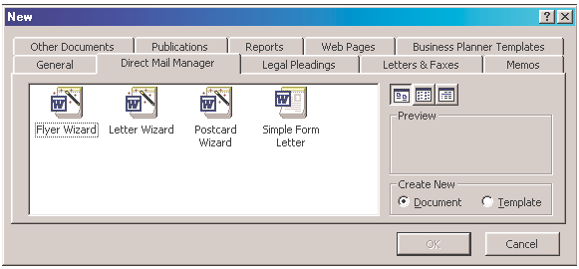
As always, the students would open Microsoft Word or Microsoft Publisher. In Word, the students would click on File, scroll to New,
click on the Direct Mail Manager tab, and then click on Flyer Wizard.
(It seems that flier can be spelled several different ways!)

Screen shot reprinted courtesy of Microsoft Corporation.
(If using Microsoft Publisher, choose the Flyers link and then one of several optional templates provided.)

Criteria for fliers

- Limit the Length of your Flier to one page (8½ x 11).

- Focus on one Specific Idea. This could be a feature, a benefit, a component, a use, a person, a place, an object, an activity, etc. Consider a technical description/specification. Then, your Flier could focus on dimension, colors, material, etc. This, of course, would only apply if you were writing about a product. For a service, a person, or a place, your Flier would focus on some other user benefit.

- Include a Title at the top of your Flier. A word, a phrase, a question—but give it impact to attract your reader’s interest!

- Limit your Text. As with all good technical writing, text should be short. Strive for no more than 100 words, or fewer. Remember, a graphic should be the key to your Flier (more on this in point number 6 below).

- Increase your Font size. You want your reader to see the key points at a glance. Increased font size, with limited text, will help
accomplish this goal. Think 20 point and up for titles, 16 point and up for subtitles, and 12 point and up for text.

- Use Graphics. This is important. Let a picture emphasize your key point and draw the reader’s attention. This could either be a technical specification, as shown in the sample, or a host of other possibilities.

- Use Color. Attract your reader’s attention, but be careful. Don’t overuse color. A little bit goes a long way.

- Use Highlighting techniques. As with color, a little bit goes a long way. Be careful. Limit yourself to no more than three or so
highlighting techniques.

- Find the “Phrase.” Be clever. Come up with 3-5 words that draw your reader in and/or that highlight your topic’s worth or reader benefit.

- Avoid Grammatical errors.

On the next page is a Sample Flier. This is followed by a
Peer Evaluation Checklist
for Fliers.

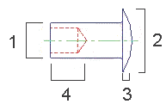
“Pop” Goes the Rivet!
Ajax can manufacture cold-headed, solid, tubular, and
semi-tubular pop rivets to your specifications.
Let us add “pop” to your
fastening system needs.
Call 1-800-PopRivet
Sample Flier

Weight | 2 oz
1. Body Diameter | .118"
2. Head Diameter | .213"
3. Head Height | .029"
4. Hole Depth | .077"

PEER EVALUATION CHECKLIST

FLIERS

Writer’s Name

Reader’s Name

Reader’s Name

QUESTIONS |  | YES | NO*
1 | Did the student limit the length of the flier to one page (8½x11)?
2 | Did the student focus on one specific idea, such as a feature, a benefit, a compo- nent, a use, etc.?
3 | Did the student include a title at the top of the flier—a word, a phrase, a ques- tion—to make it interesting and to give it impact?
4 | Did the student limit the text, striving for no more than 100 words, or fewer?
5 | Did the student increase font size, helping the reader see the key points at a glance? Did the student use 20 point and up for titles, 16 point and up for sub- titles, and 12 point and up for text?
6 | Did the student use graphics to visually depict the key idea being highlighted?
7 | Did the student use color to attract the reader’s attention? Has the student avoided overusing color?
8 | Did the student effectively use highlighting techniques? As with color, a little bit goes a long way.
9 | Did the student find the phrase, a clever, 3-5 word phrase to highlight the topic’s worth or reader benefit?
10 | Is the flier grammatically correct?

* If the answer is no, specify what is missing and suggest a solution.

Graphics
Ironically, technical writing often has more to do with graphics than writing

Graphics can be a major part of communication in the workplace. Just look throughout this book to see the importance of graphics. You’ll notice that the instruction and flier samples include line art, a memo sample includes a table, a sample PowerPoint slide include a bar chart, and the discussion of Wizards/ Templates includes screen captures.

Graphics can be divided into two categories: tables and figures. Tables are obvious. Figures include pie charts, bar charts, photographs, line drawings, icons, maps, schematics—in fact, a figure is anything that’s not a table. Tables, composed of rows and columns, allow
readers to grasp details at a glance. Notice how the following memo uses a table to clarify its conclusions.

It’s important to teach your students the importance of graphical interpretations of text. Graphics aid communication for several reasons:

  - Entertainment. Graphics add interest to the writing.

  - Clarity. Often, information is more obvious when shown visually than when discussed verbally.

  - Variety. Words, words, and more words might turn the reader off. Graphics break up the monotony of wall-to-wall words.

  - Conciseness. Sometimes, “one picture really is worth a 1,000 words.”

MEMO
Date: August 20, 2003
To: Ms. Kanakis
Cc: Dr. Jim McWard, Dr. Tom Lisk, Ms. Ellen Mohr
From: Greg Mundy
RE: Stock Purchases

Last April, I purchased 20 shares of Empire District Electric stock at
$24 per unit. Empire serves Missouri, Kansas, Oklahoma, and Arkansas. I purchased this stock because everyone uses electricity. Also, I assumed that the stock prices would go up during the summer months, as people used their air conditioners to cool their homes.

As shown in the following table, the stock price generally has gone up, increasing 75%, ending at $32 a share.

Change in Stock Value
Month | Stock Value | Gain/Loss
April | $24 | ———
May | $22 | -$2 per share
June | $28 | + $4 per share
July | $24 | ———
August | $32 | + $8 per share
Based on the overall growth of this stock, I plan to purchase 10 additional shares.

Beyond columns and rows

Whereas tables provide information in columns and rows, figures can present information in many different ways. A line drawing presents a photographic view of a topic. These are especially valuable in instructions, which help an end user perform a task. Bar charts and/or line graphs help readers make comparisons. Schematics visualize circuitry. Maps show contour or direction.

(Note how the same memo now uses a combination graph to depict the growth and decline of stock prices.)

MEMO
Date: August 20, 2003
To: Ms. Kanakis
Cc: Dr. Jim McWard, Dr. Tom Lisk, Ms. Ellen Mohr
From: Greg Mundy
RE: Stock Purchases

Last April, I purchased 20 shares of Empire District Electric stock at
$24 per unit. Empire serves Missouri, Kansas, Oklahoma, and Arkansas. I purchased this stock because everyone uses electricity. Also, I assumed that the stock prices would go up during the summer months, as people used their air conditioners to cool their homes.

As shown in the following table, the stock price generally has gone up, increasing 75%, ending at $32 a share.

35 Price of Stock vs. Stock Value
30
25
20
15
10
5
0
April May June July August

Based on the overall growth of this stock, I plan to purchase 10 additional shares.
Price of Stock
Stock Value

Chapter Four
Technical Writing Assignments

In This Chapter...
Technical writing can be in- corporated into your class- room in a host of ways. Per- haps you only want to incor- porate one technical writing assignment (a letter, memo, or report).

Maybe you would like the students to write several, grouped documents in a technical writing module. Then again, you might teach an entire term or a year-long course in technical writing. This chapter will present ways to meet each of these goals.

Here are ideas for individual letters, memos, e-mail, re- ports, resumés, instructions, web pages, brochures, newsletters, f liers, and PowerPoint presentations.

Sales Letters
- Write a letter selling a product, such as a VCR, CD player, computer, printer, car, motorcycle, roller blades, tennis racket, golf clubs, vintage records, jewelry, etc.

    - Write a letter selling a service, such as car detailing, lawn mowing, babysitting, dog walking, house painting, deck building, basement refinishing, computer installation, computer repair, tennis or golf lessons, tutoring (math, languages, science), etc.

    - Foreign Languages: write a sales letter detailing the unique aspects of foreign countries studied in class.

    - Industrial Technology: write a sales letter about class projects, including car maintenance, welding, CAD/CAM operations, wood- working, robotics, etc.

    - Art: write a sales letter focusing on the unique traits of class projects, including ceramics, jewelry, painting, mixed media, etc.

    - Literature: write a sales letter marketing sites in a novel, such as East or West Egg in The Great Gatsby, Tom’s Island in The Adventures of Tom Sawyer, or Holden Caulfield’s military school in The Catcher in the Rye.

    - Family and Consumer Sciences: write a sales letter about a food or clothing project you have been working on, highlighting the unique benefits offered.

    - Elementary: your students have just returned from a class trip to the fire station, museum, science city, zoo, or theatre. Write a sales letter about that locale, highlighting its unique values.

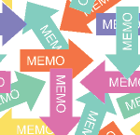

Letters of Inquiry

- Write a letter of inquiry to a company about its products, services, warranties, guarantees, costs, maintenance, etc.

- Write a letter of inquiry to a company about job openings, job require- ments, hiring trends, salary ranges, etc.

- Write a letter of inquiry to a community college, vo-tech school, col- lege, or university about its degree requirements, programs, tuition, housing fees, extracurricular activities.

- Foreign Languages: write a letter of inquiry to a travel agency for information about a country, to a country’s local ambassador, or to the country’s ambassadors at the United Nations, etc.

- Industrial Technology: write a letter of inquiry to a company about its CAD/Cam equipment, welding equipment, woodworking equipment, automotive equipment, etc.

- Art: write a letter of inquiry to an art supply company about its clay, precious and semi-precious stones, paint, mixed media, etc.

- Government: Write a letter of inquiry to a city, county, or state elected official, asking questions about governmental procedures.

- Elementary: your class will have a visitor—a dentist, firefighter, police officer, local government official, etc. Prior to the visit, have students write a letter asking the kinds of questions they would like to have answered.

Memos

  - Write an explanatory memo to your boss, teacher, parent, friend, etc., explaining the causes for your absence, tardiness, inability to do the work, inability to meet deadlines, failure to return a bor- rowed item, etc. Then explain the effects of these actions.

- Write an evaluative memo to your boss, teacher, parent, friend, etc. comparing and contrasting a topic such as two movies, two CDs, two novels (which to see or purchase or read); two cars, trucks, bikes, roller blades (which to purchase); two restaurants (which to frequent); two colleges (which to attend); or two jobs (where to seek employment).

(Continued on next page…)

Memos (continued)

  - Write an argument/persuasion memo to your teacher, boss, parent, friend, explaining why he or she should allow students to rewrite essays for a new grade or extend due dates; implement a new work schedule, pay scale, or method of promoting employees; allow a later curfew or allow you and friends to go to Padre Island for spring break; seek a career option or attend a specific college.

  - Write a problem/solution memo to your teacher, boss, parent, friend, etc. documenting a problem and suggesting solutions.

  - Business & Computer Technology: write a cause/effect memo from Stephen Jobs to Bill Gates explaining why Apple should join ranks with Microsoft (or vice versa).

  - Art: write a problem/solution memo from Michelangelo to Pablo Picasso explaining how to draw more realistic portraits.

  - Literature: write a memo from Mark Twain comparing/contrasting
Tom Sawyer to Huck Finn.

  - Social Studies: write an argument/persuasion memo from President Truman to General MacArthur explaining why the general was removed from his command; or from President Roosevelt to General Eisenhower explaining why Normandy was the best site for D-Day.

  - Physical Education/Health: write a memo explaining what causes certain health problems and what effects these problems have.

  - Elementary: your class has been involved in an “Around the World” discovery. Write an explanatory memo about one country’s culture, foods, religion, and/or history.

E-mail

    - E-mail your teachers, bosses, parents, friends, to argue a point, compare and contrast two topics, solve a problem, etc.

    - E-mail your fellow students with peer evaluations about their creative or expository writing, about their artistic achievements, about math or science tutoring, etc.

- Business & Computer Technology: write an e-mail explaining the steps for performing a computer operation, such as opening a file, saving a file, downloading graphics, copying and pasting, etc. Or, write an e-mail explaining computer ethics.
(Continued on next page…)

E-mail (continued)

- Industrial Technology: write an e-mail providing instructions for editing a video production, producing an animated cartoon, construct- ing circuit boards, or building a bridge.

- Family and Consumer Science: write an e-mail explaining the key concepts of parenting skills.

- Marketing & Management: write an e-mail explaining key concepts of personal finance or how to become a successful entrepreneur.

- English: write an e-mail from one character in a novel, play, or short story to another character. The topic will depend on the story’s context. Or, you could write an e-mail from one character in a story to another character in a totally different story—from Romeo to Ham- let, from Huckleberry Finn to Holden Caulfield, for example. These e- mail messages could focus on the character’s respective era or per- sonal challenges with family members, etc.

- Elementary: write an e-mail explaining safety procedures on the playground or about other safety issues, such as fire safety, bike safety, water safety, life saving techniques, etc.

Reports

  - Industrial Technology: write a recommendation report about im- proving safety in the classroom or a progress report about your project (clock making, race car construction, welding, automotive work).

  - English: write a progress report on your work this semester (where have you succeeded; where can you improve).

- Write a recommendation report to the school principal or school district proposing:
—a new, expanded parking lot
—new swimming pool
—new competitive sports
—new art courses in jewelry
—a new computer lab
—a school television or radio station
—improved tennis courts
—better cafeteria options (name brand food services)
—on-campus day care centers
—earlier dismissal for college-now courses
(Continued on next page…)

Reports (continued)

  - Science: write a laboratory report about one of your projects (including the purpose of the project, equipment used, activities accomplished, and lessons learned).

  - Social Studies: write a status report and/or recommendation report about stocks and bonds you’ve purchased (a mock purchase works well). How are you doing, should you sell, should you buy?

  - Art: write a trip report about a museum visit.

  - Physical Education/Health: write a feasibility report studying a health- related problem (smoking, obesity, anorexia, etc.). Then suggest solutions to the problem.

  - Elementary: your class has been studying biodegradable substances. After burying an item and then digging it up, write a report on the findings.

The Job Search (Resumés/Cover Letters)

    - Write your resumé and a cover letter (letter of application). Direct the letter to an actual job listing found in your city’s newspaper, your school’s job placement center or counseling center.

- Foreign Languages: write a resumé and cover letter about an author (Cervantes, Kafka, or Dumas) or about a literary figure (Don Quixote, Gregor Samsa, or Jean Valjean).

- Business & Computer Technology: write a resumé and cover letter for Stephen Jobs or Bill Gates.

- Literature: write a resumé and cover letter about an author (Mark Twain, F. Scott Fitzgerald, or Shakespeare ) or about a literary character (Tom Sawyer, Gatsby, or Macbeth).

- Social Studies: write a resumé and cover letter for George Washington, Sojourner Truth, Martin Luther, or Sigmund Freud.

- Art: write a resumé and cover letter for Pablo Picasso, Andy Warhol, or Andrew Wyeth.

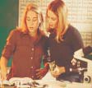

Instructions

Studies tell us that students learn best when they have to teach someone else how to do something. Have your students write any of the following instructions, geared toward another student.

  - Industrial Technology: write safety instructions or instructions for building any project.

- Business & Computer Technology: write instructions for any computer operation: printing, saving a file, opening a file, creating a folder, making a computer-generated presentation, etc.

- English: write instructions for revising an essay.

- Art: write instructions for creating a sculpture, a piece of jewelry, a photograph, a ceramic pot, etc.

- Science: write an instruction for performing any lab.

- Math: write an instruction for performing any geometric, algebraic, or trigonometric equation or project.

- Social Studies: write an instruction for purchasing stocks or bonds.

- Careers: write an instruction on how to get a job, focusing on interviewing techniques, job searches, or writing the different types of correspondence needed for a job (resumé, cover letter, follow-up thank you, etc.).

- Physical Education/Health: write an instruction on how to correctly lift weights.

- Elementary: write an instructional recipe about how to make a pizza, a taco, a peanut butter and jelly sandwich, or any food item.

Web Pages and PowerPoint Presentations

Every topic imaginable can be turned into a Web or PowerPoint presentation. And it’s good to have your students use these computer applications. After all, according to business and industry representatives, a primary skill our students need to succeed on the job is computer technology.
(Continued on next page…)

Web Pages and PowerPoint Presentations (continued)

  - Create web pages for your school or your school district; for your school club or activity; or an invented company.

  - English: create web pages or PowerPoint presentations about an author, a piece of literature, a genre, or a literary movement/era.

  - History: create web pages or PowerPoint presentations about any historical moment (the Oklahoma City Bombing, the World Trade Center attacks, the charge up San Juan Hill, the Chicago riots ac- companying the 1968 Democratic National Convention, etc.); any historical figure (presidents, revolutionaries, inventors, etc.); histori- cal eras (the Renaissance, the Enlightenment, the Victorian era, etc.).

  - Foreign Languages: create web pages or PowerPoint presentations about foreign countries and their culture.

  - Science: create web pages or PowerPoint presentations about topics studied in chemistry, geology, biology, etc.

  - Family and Consumer Sciences: create web pages or PowerPoint presentations about parenting skills, interior design, fashion mer- chandising, or foods.

  - Elementary: create web pages or PowerPoint presentations about animal habitats, dinosaurs, minerals and rocks, etc.

Brochures and Newsletters

In Chapter Three it was suggested that students do a research brochure or a newsletter instead of a research paper. Consider these possibilities.

    - Write a brochure or newsletter:
—about a vacation spot (national or local park, wildlife reserve, city, country).
—about a school organization (Key Club, Honor Society, Drama Club, Art Club, Foreign Language Club, etc.)
—about a city organization, agency, or company (a local business, geriatric home, community center, Rotary Club, Lions Club).
—about your city’s Hispanic culture and/or business owners; Native American culture and/or business owners; unique ethnic background (Swedish, German, Polish, etc.); frontier history;
railroading, agricultural, ranching, or cattle industry.

(Continued on next page…)

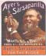
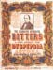
Brochures and Newsletters (continued)

- Invent a topic for a newsletter or brochure (a new country, a new planet, a new company, an invention).

- English: research an author and write a brochure or newsletter about him or her, reporting your findings. These could include biographical data, analyses of stories, critical responses, awards and accomplish- ments, etc.

- History: create a brochure or newsletter about a local historical figure (President Eisenhower, Bat Masterson, Jesse Chisolm, Amelia Earhart, General Custer, Senator Bob Dole); an occurrence of local historical importance (trail drives, dust bowl events, cow town histories, border war activities); a historical era (the Renaissance or the Great Depression).

- Family and Consumer Science: create a brochure or newsletter about parenting, interior design, fashion merchandising, or foods.

- Industrial Technology: create a brochure or newsletter reporting about a bridge construction, electricity (how to measure it, how to generate it, how to figure its cost, etc.), simple machines, and/or graphics, animation, and video production projects.

- Art: create a brochure or newsletter about an artist, type of art, or about your class’s art project(s).

- Foreign Languages: Create a brochure or newsletter based on having researched a country and its culture. Or, create a brochure or newsletter about a famous author, artist or historical figure from a country relevant to the language studied.

- Elementary: your class has been studying the regional parts of the country, climate, rocks, minerals, dinosaurs, volcanoes, ocean life, the solar system, and/or the food pyramid. Select any of these topics, and write a brochure or newsletter to report on your studies.

Fliers

Fliers are written primarily to promote, sell, or advertise a product, service, or event. Thus, your classes could create fliers about many topics. These include machines (Industrial Technology), food or clothing (Family and Consumer Sciences), an art object (Art), a locale (from a story in English), a scientific or historical invention (History and Science), a play performance or recital (Music and Drama), etc. The list is endless.

Grouped Assignments (Instructional Modules)

An excellent way to have students write more technical documents is to create technical writing modules (grouped assignments with a central focus).

For example, tell students on the first day of class that they will be employed by a company (one they will invent). For this company, they will write several, related technical documents. There are different ways to approach this assignment.

For Option #1
Students write a:
- Report to a boss recom- mending a new product/ service
- Directive memo from a boss approving the product
- Sales letter marketing the product
- Web page marketing the

Option #1

Company Client

Boss
3. Sales

product
- Instructions manual for the product
- Cover letter
- Recommendation Report

Employee
- Directive Memo
Letter
4. Web
Pages
5/6. Instructions/
Cover Letter

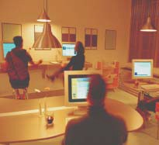
Option #2
  - Sales letter marketing a product or service
  - Flier highlighting one specific aspect of the product or service
  - Website advertising or explaining the product or service
  - PowerPoint presentation advertising or explaining the product or service
  - Newsletter informing the public or co-workers about the product or service

Option #2

Company Client
1
2
3
4
5

(Option #3 continued on next page…)

For Option #3
Students write a:
- Sales letter marketing a product or service
- Letter of inquiry from a prospective client request- ing more information
- Directive memo from the boss
- Proposal

Option #3

Company Client
1. Sales
Letter

2. Inquiry
Letter
Boss
  - Proposal 5. Instructions 6. Cover

  - Instructional manual
  - Cover letter
3. Directive Memo
Letter

Employee

Teaching modular groupings is effective because it simulates the reality of corporate communication, where one document leads to another.
The primary difference between Option #1, Option #2, and Option #3 is computer access. If you teach in a computer laboratory, students can create web pages, fliers, and powerpoint presentations. If you teach in a regular classroom without access to computers, replace the web pages,
fliers, and powerpoint presentations with reports and memos.

Variations for modular groupings

Modular groupings let students role play (boss, client, employee), write different types of documentation, and write for different purposes (to rec- ommend, sell, instruct, direct, request, etc.).

Six grouped documents may be more than you would like to assign. If so, assign fewer (the modules are flexible). Combine just two or three of the assignments. For example, the students may write (1) a directive memo from a boss asking for (2) a sales letter and (3) then create a web page. Or the students may write (1) a letter of inquiry requesting (2) a proposal and then (3) an instructional manual.

Job packages

Job packages are an excellent way to group assignments. The students could write (1) a letter of inquiry to a local company asking for information about job openings, salary ranges, job requirements, etc. (2) Upon receiv- ing answers from the company’s Human Resources staff, the students could present this information to the class or teacher by way of a report, memo, e-mail or PowerPoint presentation. (3) Then students could write a follow- up thank you letter or e-mail. (4) Students could write a resumé and (5) a cover letter/e-mail for a job of their choice within that company. (6) Fi- nally, students could perform mock interviews based on these resumés and cover letters. (These six assignments could be reduced to two or three.)

Conclusion
There is no one way to teach technical writing. Teach one assignment or many; teach stand-alone, unrelated assignments or groups of assignments unified by a central theme; teach technical writing in one term or as a year-long course. Technical writing can be incorporated successfully into any course . . . in many different ways.

However you decide to make technical writing a part of your class, your students will benefit. They will learn a type of writing that will help them get jobs and succeed in the workplace. They will learn writing that works!

The following is an example of a Scope and Sequence Outline for a year-long technical writing course titled Technical Writing and Applied Communications.
Sample Technical Writing I
Week 1 Introduction to Technical Writing
Criteria for Effective Technical Writing discussed Week 2 Sales Letters/In-class Writing Activity
HW: Prewrite and Write Rough Draft Sales Letter Prewriting and Rough Draft Due/Peer Evaluations
Week 3 Sales Letters due/Fliers/In-class Writing Activity HW: Prewrite and Write Rough Draft Flier Prewriting and Rough Draft Due/Peer Evaluations
Week 4 Fliers due/Letter of Inquiry/In-class Writing Activity
HW: Prewrite and Write Rough Draft Letter of Inquiry Prewriting and Rough Drafts due/Peer Evaluations
Week 5 Letter of Inquiry due/Memos/Prewriting HW: Write Rough Draft Memo
Rough Drafts Memo due/Peer Evaluations Week 6 Memo due/E-mail
HW: Prewrite and Write Rough Draft E-mail
E-mail due
Week 7 Begin Website Team Work Week 8 Team Work Continues Week 9 Team Websites due
Week 10 Begin Team User Manuals/Team Work Week 11 Team Work Continues
Week 12 Team User Manual due
Week 13 Progress Reports/Graphics
HW: Rough Draft
Week 14 Peer Evaluations/Progress Reports due
Week 15 Finals begin

Sample Course | Scope and Sequence of Year-
 | Long Technical Writing Course
 | Technical Writing & Applied Communications
Course Description: | Technical writing is worthy of a year-long course. If you would like to teach a year-long course in technical writing, here is an approach currently used by Carol Hailey at Shawnee Mission North High School (Overland Park, KS).
Grade Level: | - 12
Prerequisites: | - English 9, 10, 11; Introduction to Computers
Articulations: | - Johnson County Community College (JCCC) Technical Writing I; JCCC Tech Prep Trans- formations--Applied Communications
Required Text: | - Technical Writing: Process and Product (Gerson and Gerson, Prentice Hall, 1997, second edition)
Course Overview: | Technical Writing and Applied Communications is a course for career-oriented students who plan to attend two or four year college. Because the course is designed to introduce students to writing required in the work environment, students will complete assignments in both class- room and community settings. Students will learn reading, listening, and speaking skills; will explore group dynamics, interviewing and problem-solving strategies; and will write various types of technical correspondence demonstrating accuracy in grammar.
Course Objectives: | Students will read and respond to nonfiction literature including articles on applied communi- cations and career areas of interest, occupational handouts, biographies, autobiographies, and social agency and business communications. Students will demonstrate comprehension through written or oral assignments.
 | Students will demonstrate effective empathetic and critical listening skills at a 70% level on the instructor's rubric.
 | Students will perform small group or individual speaking presentations, role-playing activities, and interview situations at a 70% skill level on the instructor's rubric.
 | Students will demonstrate use of the writing process in completing written assignments for specific audience and purpose.
 | Students will demonstrate ability to work effectively in small groups to complete problem solv- ing, projects, presentations, and research.
 | Students will use word-processing and computer-generated graphics to complete written assignments.
Students will produce the following written assignments scoring a minimum of 3 on each of the 5 Traits.
- Letters
- Summaries
- Paraphrases
- Short research reports
- Resumés
- Newsletters
- Brochures
 | Students will successfully complete a college application.
 | Students will complete writing assignments that contain no more than three grammar errors per page.
 | After completing a Basic Business Grammar review module, students will demonstrate 80% accuracy on a post assessment.

 | Quarter 1
Course Objectives: |  | Introduction to Applied Communications
Rationale: |  | Course objectives Classroom management Parent letter from instructor  - Rationale for class  - Community/business involvement  - Group work/attendance  - Multi-media/technology  - Assessment  - Portfolio  - Projects  - Presentations
Introduction to Technical Writing: |  | Compare/contrast essay composition to technical writing Define criteria  Readings/analyze models  Assessment—Rewrite 6 Traits for technical writing  - Student handbook  - Student self-assessment tool
Exploring Group Dynamics: |  | Rationale for cooperative workplace  - Guest speakers from business  - Possible visit to business environment
Responsibilities in group/cooperative production
- Group responsibilities
- Attendance
Simulated group activity
- Video tape
- Identify and analyze group roles
Group roles inventory
- Identify individual roles
- Short written report/response
Effective listening skills
- Importance in group/cooperative work
- Practice activities
Assessment—Group/Problem solving activities
- Video tape
- Analysis
- Individual written/oral response
Grammar Review: |  | Pretest  Business Grammar Module Post test  Practice proofreading exercises/technical writing context Peer group editing practice and exercises
Writing Assignments: |  | Summary  - Quoting/Paraphrasing/Documentation  - Objective Summary  - Subjective response
 |  | Short Reports
Assessment Portfolio for course: |  | Introduce concept and assignment Assessment/selections to demonstrate technical writing College application and resumé

 | Quarter 2
Course Objectives: |  | Applied Communications Within the School Community
Introduction to Problem Solving: |  | Steps in problem solving Written proposals Interviewing/investigation skills  Assessment--Project: Group practice in problem solving  - Student groups identify problems within the school (parking, cafeteria food, discipline, drugs, etc.)  - Interview/investigate (principal, cafeteria administrator, counselor, etc.)  - Draft proposal/short report suggesting solutions to the problem
Writing Brochures & Newsletters: |  | Criteria Models/analyze  Computer graphics/layout Practice activity
Final Assessment--Project: |  | Student groups identify need for brochure and newsletter within the school community (Key Club, Honor Society, band, drama department, Spanish Club, etc.)  Student groups interview organization, determine needs Presentation of product to peers  Evaluation  - Peer evaluations  - Teacher evaluations  - Group work evaluations Assessment of Portfolio Revision/Update
 | Quarter 3
Course Objectives: |  | Applied Communications Within the Community
Identify community problems/ issues and organizations that  address them: |  | Research problem/issues—Secondary sources (nonfiction readings)  - Articles  - Newspapers  - Essays
Research problems/issues—Primary sources--community guest speakers
- Follow-up thank you letters
Research problems and issues
- Research techniques
- Documentation
Assessment Projects
- Short reports--reporting on the problems/suggesting solutions
- Oral presentation
Writing for the community: |  | Develop student groups  Identify a community or service organization  - Writer letter of inquiry/contact/interview  - Prepare written proposal for instructor/present to class  - Spend day in community or service organization--shadowing  - Write follow-up thank you letter Develop brochure or newsletter for organization Class presentations  - Peer evaluations/group evaluations  - Teacher evaluations  Class develops slide presentation/narrative of projects for selected audience

 | Quarter 4
Course Objectives:  Assessment Portfolio Revisions/Update:  Review Areas of Career Interest—ACT Discover Program:  Readings—Career Interest: |  | Applied Communication and Career Exploration
 |  | Student selects career for exploration Student researches bibliography/resources
Biography/autobiography
- Read
- Develop brochure or short report
Periodicals appropriate to career
- Read
- Writer summaries/response
Professional journals/occupational handbooks
- Read
- Writer summaries/response
Interview corporate personnel director, human resources administrator or employee in your field:
- Write letter of inquiry
- Interview/visit/shadow at work/on-site experience
- Follow-up thank you letter
- Short report
- Update Resumé
- Cover letter of Application
- Complete Portfolio
- Assessment: Mock interview with personnel director/present portfolio/receive feedback

Sample Five Day Technical Writing Instructional Module
Unit Objective: Upon completion of this unit, students will be able to identify criteria for writing an effective , prewrite to gather data, write a rough draft, and revise others’ work through peer group assessments.
*Students assess others’ writing based on Day #1 criteria

* Homework: Revise for submis- sion next class
Peer Review
*Students write rough drafts

*Complete at home
*Students prewrite
Individual Assignment

*Assign students to write a
*Compare/contrast to Day #1 criteria
*Assess group work on overhead projector
Instructor Review
*Collect writing to make overheads
*Group writing based on Day #1 criteria
Practice
*Review samples of good/bad
*Provide criteria for a
Introduce Topic
Day #5
Day #4
Day #3
Day #2
Day #1

Five Day Technical Writing Instructional Module

Unit Objective:

Day #1
Day #2
Day #3
Day #4
Day #5

96

