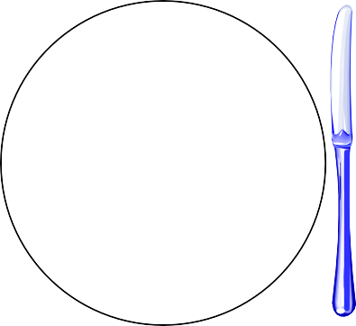

**Formal Table Setting**

Bread & Butter Plate

Salad

Water Glass

Milk Glass

Dinner Plate

Cup & Saucer

Forks

Salad, Dinner, Dessert

Knife, Spoon

Napkin