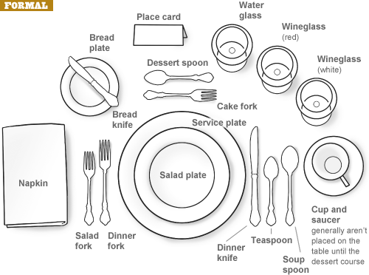

**Business Etiquette – Formal Place Setting**

With the number of forks, knives and spoons sometimes set out for a formal meal, it’s no wonder confusion arises. Here are some tips on table settings.

▪

The napkin is put in the center of the place setting, or to the left of the forks if a plate is already on the table.

The butter knife rests on the bread plate, which sits directly above the forks on the left.

As for the other cutlery, a good rule of thumb is to begin using the utensils farthest from the plate and work your way in.

The salad fork is placed to the far left, and the larger dinner fork goes next to the plate.

Dessert spoons and forks are smaller in size than regular cutlery and are either placed directly above the plate – the spoon on top, with the handle of the spoon on the right and the fork handle on the left – or brought to the table when dessert is served.

The salad plate is put directly on top of the dinner plate when salad is the first course, or set to the left of the forks.

Knives go to the right, with the dinner knife on the inside and the salad knife to the right.

A dinner spoon, useful for sauces, goes next to the salad knife, and when necessary, the soup spoon is placed to the far right.

Finally, all glasses go above and to the right of the main plate, beginning with the water goblet at the far left, then the red-wine glass, which is larger than the white- wine glass.

▪

▪

▪

▪

▪

▪

▪

▪