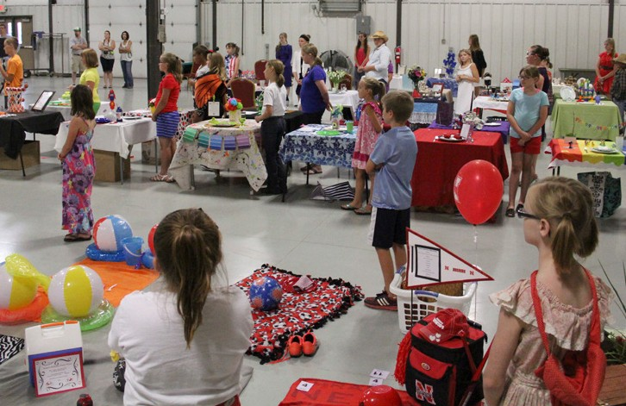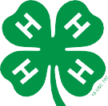

444 Cherrycreek Road, Suite A | Lincoln, NE 68528 | 402-441-7180 | [http://lancaster.unl.edu](http://lancaster.unl.edu/)

4-H Table Setting Contest — Procedures and Guidelines

The Table Setting Contest is open to all 4-H members ages 8–18 — participants need not be enrolled in a specific project. It will be held during the Lancaster County Super Fair on **Friday, July 31, 5 p.m**. at the Lancaster Event Center, 84th & Havelock, Lincoln (Exhibit Hall — use east entrance).

Participants select a theme and display one place setting, including table covering, dishes, glassware, silverware, centerpiece and menu. (Do not bring/prepare food.)

Why participate in the Table Setting Contest? It is a fun way learn how to:

* properly set a table
* plan nutritious meals using MyPlate, online at

[*www.choosemyplate.gov*](http://www.choosemyplate.gov/)

* express originality and creativity in choosing a theme
* present to the judge
* express knowledge of food, nutrition and food safety

Age divisions:

* Junior (ages 8–10)
* Intermediate (ages 11–14)
* Seniors (ages 15–18)

Preregister by July 20

Preregister by Monday, July 20 by contacting the extension office at 402-441-7180. You must give the age of youth (by January 1 of the current year) and category they will be entering. There is no entry form.

Categories

Members may enter only one category: Birthday, Casual, Formal or Picnic (holiday theme can be in any appropriate category).

Category hints:

* Formal — use candles (not lit), more than three pieces of flatware, china (no stoneware), tablecloth and/or mats are acceptable and cloth napkins.
* Casual, Picnic, Birthday — be creative! Theme can be indoors or outdoors. Use any type of cover (tablecloth, blanket, paper, etc.) and any type of table service. Overall place setting should be an expression of the youth’s

originality and creativity. Homemade items will be judged more favorably than prepacked items. The chosen theme should be clear to the judge and spectators.

Table Setting Contest Guidelines

The goal of this contest is for youth to present the table setting they created to the judge. The 4-H’er acts as the host, and the judge is their guest. The 4-H’er should extend a wel- come to their guest and guide their guest through the menu, as if actually hosting the meal. Participants should explain the ideas behind the theme, menu items and table setting techniques. For example, for the formal theme, if your dessert plate and dessert utensils will be brought in after dinner, be sure to explain that.

4-H’ers need to describe the food; including general ingredients and basic preparation. If there are temperature considerations (such as ice cream and sorbet at picnics), explain them to the judge. Try to anticipate and answer any questions the judge may have before they ask them.

5 minutes is allotted for each participant to present table setting to judge. Hint: Practice with a timer helps.

*continued on next page*

*Copyright ©2015*

Extension is a Division of the Institute of Agriculture and Natural Resources at the University of Nebraska–Lincoln cooperating with the Counties and the United States Department of Agriculture.

University of Nebraska–Lincoln Extension educational programs abide with the nondiscrimination policies of the University of Nebraska–Lincoln and the United States Department of Agriculture.

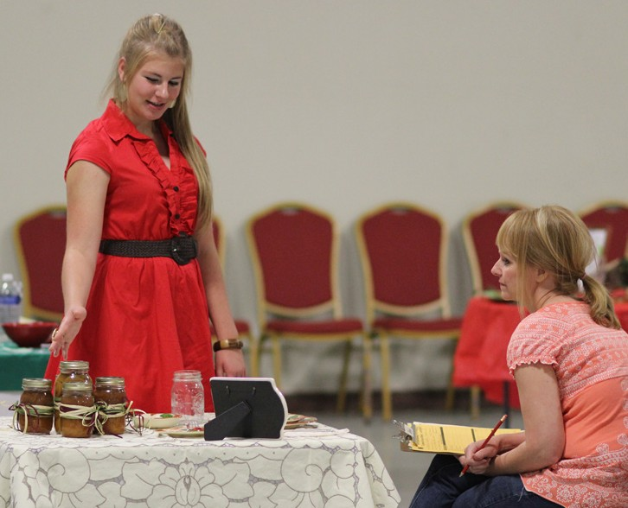

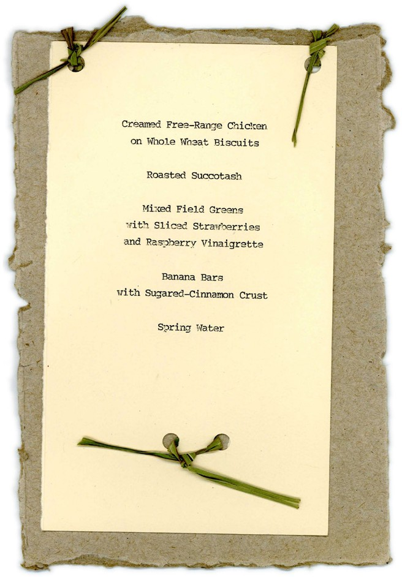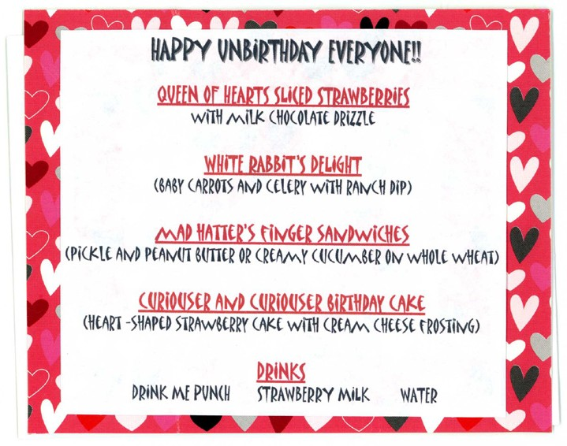

Menu — Participants are encouraged to develop interesting and creative menus. For example, consider naming a food to fit your theme. Healthy snack menus are OK. If planning a meal, refer to MyPlate, online at [*www.choosemyplate.gov.*](http://www.choosemyplate.gov/) Formal menus require a complete, healthy meal.

**NOTE: ALCOHOLIC BEVERAGES IN ANY MENU IS PROHIBITED.**

Menu must be 4" x 6" or larger on your choice of medium (index card, ceramic tile, chalkboard, etc.) printed, typed,

etc. by the participant. You may decorate and/or prop up the menu. Be creative and imaginative.

* Every menu will not include all the foods listed.

Appetizer Main Dish Vegetables Fruit Salad Bread Dessert Beverage

* List the foods in the order they are served.
* Must have correct spelling.
* When a food is commonly prepared in more than one way, avoid confusion by describing the method of cooking, such as: Roast Turkey or French Fried Potatoes.
* Condiments are not listed.
* List beverages last.
* Space and arrange menu items to fit theme.

For the Table Setting Contest, one place setting is to be displayed. Include table covering, dinnerware, stemware, flatware, centerpiece and menu. DO NOT PREPARE FOOD. You MUST bring a card table for the display (except for the picnic category, in which an appropriate blanket or other covering may be placed on the floor).

Select a Theme — What is the occasion ... a family dinner, a holiday or lunch with friends? Select a theme which fits the occasion. Let your imagination run wild. Be creative and original.

Attire — Participant’s attire should fit the theme. Partici- pants may come dressed or change in one of the restrooms.

**EXAMPLE MENUS**

**Menu Planning Hints:**

* Use your imagination to picture menu food items.
* The plated meal should be pleasing to the eye, appetizing to look at and make your guests ready to eat.
* Vary the way food is prepared (ex. not all fried or creamed).
* Use food groups appropriately for the theme.
* Consider how food is stored safely (especially for picnic).
* Serve a variety of temperatures, textures, shapes and colors.
* Make sure the food flavors compliment each other.

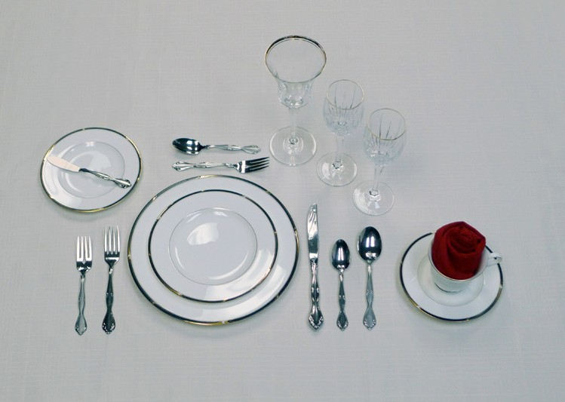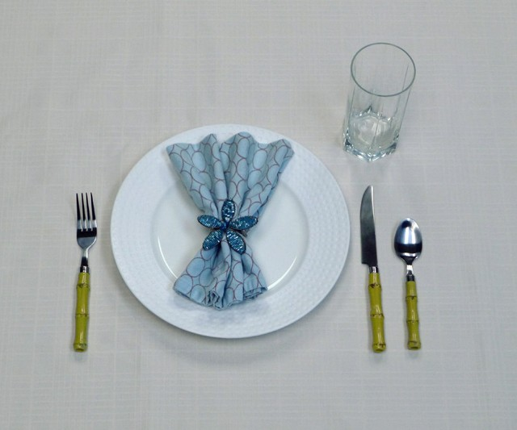

Table Appointments

These are items used to set a table. For example: tablecloth, placemats, dinnerware, glassware, flatware and centerpiece. Choose table appointments to fit the occasion and carry out the theme. Plasticware may be used for a picnic but they would not be appropriate for a formal dinner. All items must be safe to eat from and non-toxic (no paint, glitter, glue, stickers, etc. on eating surfaces).

Tableware — includes dinnerware, glassware and flatware. When selecting tableware, include only appropriate items needed for meal. Tableware selections should fit menu. Placement can vary to fit meal according to how and when food is served. For example, do not include a soup bowl if soup is not served. If serving ice cream, a dessert bowl is needed instead of a dessert plate.

Centerpiece — The centerpiece should coordinate with the table appointment and fit the theme. It should be visible to all sides of the table and not obstruct anyone’s view of each other. Do not light candles. No electrical outlets are available for use.

After the Contest — The top exhibit in each category and division will be on display in the Lincoln Room during the remainder of the fair. All other table settings may be dis- mantled after the Table Setting Contest and taken home.

Additional Information

If purple ribbon has not been achieved in a category, there will be no consideration for a top table setting award.

If you have questions, call the extension office, 402-441-7180.

NOTE: University of Nebraska–Lincoln Extension and Lancaster Event Center are not responsible for any damages.

State Fair 4-H Culinary Challenge

A State Fair 4-H Culinary Challenge Contest will be held during the Nebraska State Fair. Only teams of two people may enter, and both must be at least 10 year old by January 1 of the current calendar year. Youth will create a menu, prepare one food item, and choose an appropriate theme for their occasion while expressing their food, nutrition, and food safety knowledge during a live interview with a judge at the contest. In order to highlight knowledge and skills acquired during pre-contest preparation, youth will utilize technology as part of their interview. A challenge ingredient will be selected each year, highlighting a Nebraska commodity food product. The 2015 challenge ingredient is apples.

Each county is eligible to submit up to four teams of two

4-H members. If you are interested, Lancaster County 4-H’s selection for this contest will be on a first come, first served basis. Contact the Extension office by August 4.

At the Contest

Registration & Set Up

* Scheduled times are mailed to participants about a week prior to the fair.
* Each participant is allotted 5 minutes to present table setting to judge.
* Arrive 15 minutes prior to assigned set-up time.
* Card table is provided by participant.
* **Only contestants are allowed to set up. Contest volunteers provide assistance to 4-H’ers to help carry supplies.**
* Judging area is closed to public and family.
* Public viewing of all tables is announced after judging is completed (approximately between 7:45 and 8:15 p.m.). Ribbons are awarded after public viewing.

**FORMAL PLACE SETTING**

Cloth napkin placement may vary.

**INFORMAL PLACE SETTING**

These are general guidelines. For non-formal categories, placement may vary. Let your creativity go!

**Water glass**

**Water glass**

**Other non-alcoholic beverage glasses**

**Bread plate & bread knife**

**Dessert spoon & cake fork**

**Cup and saucer**

**Napkin placement and fold varies**

**Salad plate**

**Service plate**

**Knife**

**Soup spoon**

**Salad Dinner fork fork**

**Dinner fork**

**Plate**

**Knife Teaspoon**

**Teaspoon**

**Only the tableware needed for the meal are placed on the table.**

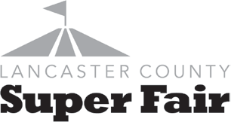

4-H Table Setting Contest Score Sheet

Name

Contestant Number

Age (as of January 1 of the current year)

Division:

Junior (ages 8–10)

Intermediate (ages 11–14)

Senior (ages 12–18)

Category:

Picnic

Birthday

Casual

Formal

Theme

o Purple

o Blue

o Red

o

Ribbon:

White

PRESENTATION

4-H’er was a good host/ hostess.

Ideas behind theme, menu and tableware choices were explained.

General food ingredients were described.

Basic food preparation was described.

4-H’er dressed to fit the theme, maintained eye contact and used a clear voice with good volume.

Presentation showed originality and creativity. Theme was obvious and well used.

TABLE SERVICE

Tableware was correctly set.

o see back

Appropriate tableware was chosen for menu.

Centerpiece was appropriate for theme and visible from all sides of table.

Presentation showed originality and creativity. Theme was obvious and well used.

MENU

Menu was easy to read with correct spelling and appropriate placement on table.

Foods complemented each

other and fit the theme.

Foods varied in texture, color, shape and size.

Presentation showed originality and creativity. Theme was obvious and well used.

**Superior**

**Excellent**

**Average**

**Comments**



4-H Table Setting Contest Score Sheet (continued)

**Rule(s) for setting a formal table**

*Note: Only the tableware needed for the meal are placed on the table.*

1.

Flatware, plate and napkin should be one inch from the edge of the table.

2.

Dinner plate

3.

Dinner fork

4.

Salad fork

5.

Cloth napkin (placement may vary)

6.

Knife

7.

Teaspoon

8.

Soup spoon

9.

Soup bowl may be placed on the salad plate and/or service plate or above fork(s)

10. Drinking glass is placed at the tip of the knife and/or above spoon if second glass is used

11. Salad, bread and/or dessert plate(s) — or bowl(s)

12. Cup with saucer

**FORMAL PLACE SETTING**

Formal categories must follow this placement, Cloth napkin placement may vary.

**INFORMAL PLACE SETTING**

These are general guidelines. For non-formal categories, placement may vary. Let your creativity go!

**Water glass**

**Water glass**

**Other non-alcoholic beverage glasses**

**Bread plate & bread knife**

**Dessert spoon & cake fork**

**Cup and saucer**

**Napkin placement and fold varies**

**Salad plate**

**Service plate**

**Knife**

**Soup spoon**

**Salad Dinner fork fork**

**Dinner fork**

**Plate**

**Knife Teaspoon**

**Teaspoon**

**Only the tableware needed for the meal are placed on the table.**