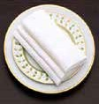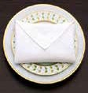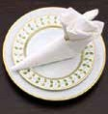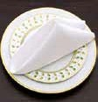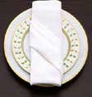



**Table setting**

Your usual starting point is your tablecloth, runner or placemat.

The key thing to remember here is: the more formal the dinner, the more coverage. At a formal gathering, you always use a fabric tablecloth and make sure it is well-ironed.

A formal table setting means all of your dishes, cutlery and glasses are on the table at the beginning of your meal. Nowadays this has been reduced to make

it easier for diners. A big trend now is the charger plate, a larger plate that frames your dinner plate and defines your space. The charger is only removed with your dinner plate.

The biggest rule with cutlery is knives are always to the right of your plate with the serrated edge pointed inwards. Spoons are to the right of the knife and forks are to the left of the plate. Traditionally, they are all on the table

at the beginning of the meal, but for a modern setting, you can bring cutlery as and when it is required.

On your traditional table, the water goblet is always above the tip of the blade of your knife and behind the glasses for your different wines.

For modern settings, simply place one water glass and one wine glass, adding any others if they are needed.

Many people try to artfully place the napkins inside water goblets, but this can cause the glass to tip. It is better to fold and lay napkins in the centre of the plate.

The overall look you want to achieve in your restaurant is simplicity. The room should not be too light nor too dark. If there is a chandelier above the table, use a dimmer, or candlelight for a romantic touch. Fresh flower arrangements are pleasant, but they should not block the guests’ view of each other. Smaller vases along the table with a couple of fresh cut flowers can look more tasteful.

warm up

**1**

**1**

**Quickly read the text about the art of table setting and match a heading**

**with each paragraph.**

a n cutlery b n glasses c n napkins

1. n ambiance

and finishing

touches

1. n table coverings
2. n dishes

**2**

**3**

**4**

**5**

**6**

reading comprehension

**2 Read the text again and decide if these sentences are true (T) or false (F).**

**T**

**F**

1

2

3

A table covered with a fabric cloth indicates a formal dinner.

For a formal dinner bring dishes and cutlery to the table as required. The use of a charger plate is fashionable at the moment.

4 Place forks and spoons to the left of the plate and knives to the right.

5

6

7

8

Contemporary table setting only requires two glasses on the table. It is dangerous to arrange napkins in glasses.

Use candlelight or dimmers to create a suitably dark atmosphere. Flowers should be small and tasteful but not in the way.

listening

**3**

**15**

**Listen to a maître d’hôtel describing the different types of napkin folds and match the correct**

**name with the picture.**

**A**

**B**

**C**

**D**

**E**

n n

n n

n

1

2

diagonal pocket fold envelope fold

3

4

pyramid fold slipper fold

5

up-the-steps fold

Activities

Module 7 - Worksheet 1

n n

n n

n n

n n

n n

n n

n n

n n

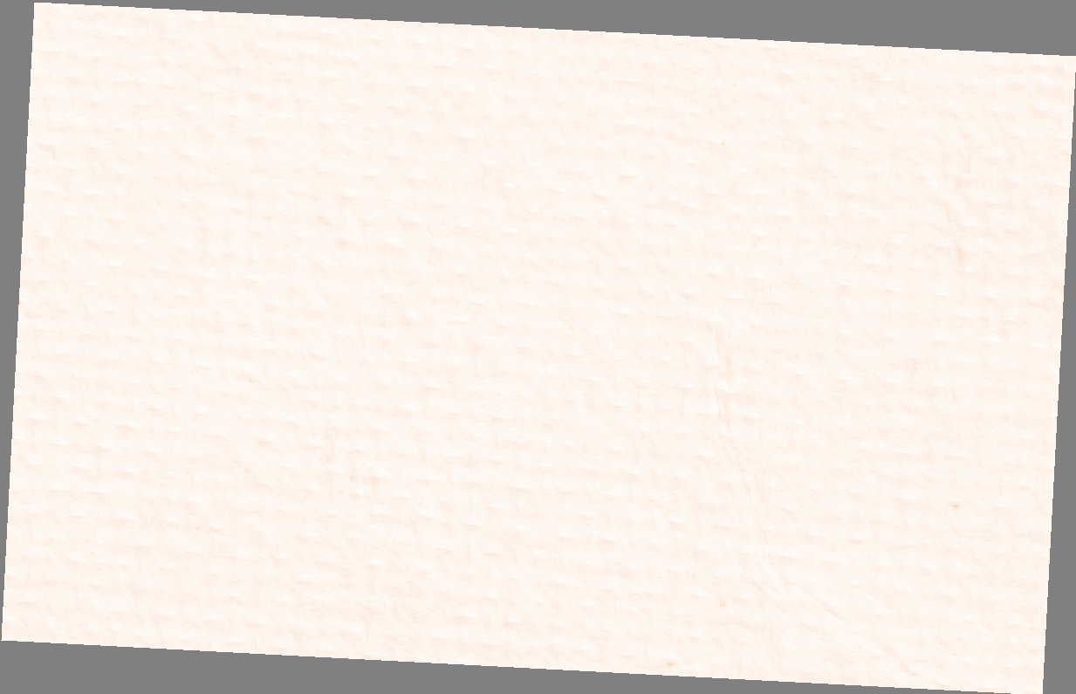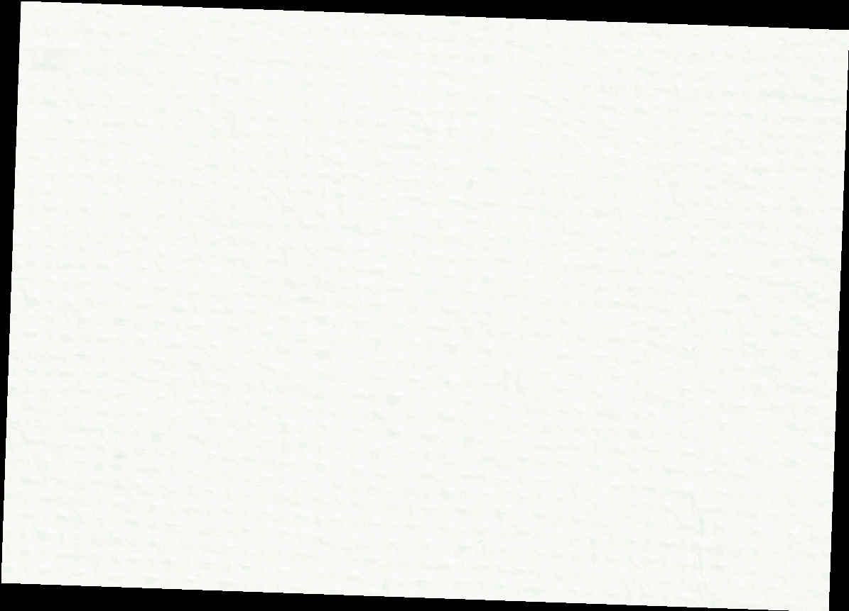

WORKSHEET 1 | Module

7

listening

**4**

**15**

**Listen again and complete the missing information about how to do each fold.**

**DIAGONAL POCKET FOLD**

* Fold a square napkin in half, then into quarters with all open corners together at top right.
* (1) the top layer at top right and gradually roll up diagonally towards you as far as it goes and press roll it flat to form a band.
* (2) the second layer down from top corner (not rolling), tucking the corner behind the band so the fold (3) a second band parallel to first.
* (4) this with the third layer.
* Keeping the bands diagonal, (5) both sides under the back to form a neat rectangle.

**PYRAMID FOLD**

* Place a square napkin on the table like a diamond, with one point (13) you.
* Fold it in half upwards, point to point, to make a triangle.
* Fold the (14) corner up to meet the top corner.
* Turn the napkin over and fold it (15) in half by bringing the bottom point up to meet the top. You now have a triangle.
* Lift up the base of the triangle towards you while bringing the outer (16) closer together under it.

**UP-THE-STEPS FOLD**

* Place a square napkin on the table with one edge facing you.
* Fold it (21) into thirds, like a letter, by folding the bottom up and then the top down.
* Fold in the left and right edges about 2.5 cm to make hems.
* Fold the right edge over the left edge, bringing the hemmed edges almost (22) but not quite aligning them, so you have a step at the bottom.
* Do not crease fold, but fold the right edge over the left (23) meeting the second fold to make another (24) .

speaking

**5 Work in pairs and take it in turns to explain to each other how to do different folds. Use a napkin or a square piece of paper and refer back to the instructions in exercise 4 if you need to.**

A *OK.We’re going to do a pyramid fold.*

B *That’s easy.*

A *So, first…*

writing

**6 Write the instructions for some different napkin folds you know, such as a sail, a flower, a fan or a crown. Then pass them on to someone else to see if they can follow your instructions***.*

Activities