**Table Setting Contest Helpful Hints**

The purpose of a table setting is to make the act of eating easy.

Objects that are used in the right hand are placed to the right of the plate: knives, spoons and beverage

containers. The fork is laid to the left of the plate because historically it **was** used only in the left hand.

The *cover* consists of the dinnerware, beverageware, flatware, and linens to be used by each person; it is

the individual’s place at the table. The cover size for the place setting contest is no more than 22” wide (left to right).

**Linens**

Linens consist of the table cloths, placemats and other table covers and napkins used on the dining

table, regardless of fiber content. Linens should be spotless and wrinkle-free. Plastic and paper tablecloths, placemats and napkins are permissible if they compliment the theme of the place setting.

**Napkins:**

The napkin is usually placed to the left of the fork(s). However, if the covers are close together, it can

be placed in the center of the plate, in a glass etc. A 12-inch size napkin is usually for breakfast and lunch. For the dinner meal, the eighteen-inch (or larger) napkin is preferred.

**Placemats:**

Lay placemats flush with the table edge or not more than approximately ½” from it. (If using a

tablecloth- fold to the appropriate size designated for the cover.)

**Table Decorations**

Table decorations should be appropriate for viewing while dining. Resist the temptation to make the

centerpiece too grand as it can be a distraction. Keep it low so your guests can easily see over it and feel comfortable talking with those across the table. Centerpieces should be in good taste.

**Dinnerware**

**Bread-and-Butter Plate:**

Place the bread-and-butter plate to the left of the cover near the tip of the fork. In this position, it

balances the glass or glasses on the right of the cover. In addition, the bread and butter plate can be used for celery, olives, and other relishes eaten with the fingers. The dinner or luncheon plate, if not overcrowded with food, is a suitable place for bread and butter, especially when the bread is served hot. The bread-and-butter plate is used when a table is large enough to accommodate it, but it is not a “must” in table setting.

**The Cover**

*Page 2 of 5*

**Salad Plate:**

Unless served at the table, the salad is placed at each cover shortly before serving time. It may be

placed in any of several positions.

•

If no bread-and-butter plate is at the cover, place the salad at or near the tip of the fork. This is a

widely used position and one that allows good leverage in cutting salad vegetables.

•

When a bread-and-butter plate is included in the cover, you may place the salad to the left and a

little below the bread-and-butter plate; however, unless covers are spacious, such a position is often not possible. Where covers are close together, you may move the bread-and-butter plate a little to the left and place the salad to the right of it; in this position, it is above the luncheon or dinner plate.

**Flatware**

Lay pieces of flatware (silverware) in the order of use from the outside toward the plate. This is done for

convenience during dining. Pieces should be laid close together but not touching.

**Knife:**

Lay the dinner knife to the right of the plate with the cutting edge directed toward the plate. All knives

are laid with the cutting edge toward the plate, a position that protects the fingers of the right hand as it grasps the knife.

When no dinner knife is required for the eating of a simple family meal, it can be omitted from the

setting.

Butter Knife: You may place the butter knife on the bread-and-butter plate.

**Spoons:**

Lay spoons with the bowls facing up at the right of the knife. Spoons should be placed in the order they

will be used, with the spoon used first farthest from the plate.

**Forks:**

Always lay the fork(s) with the tines facing up at the left of the plate, with this exception- a fork for

eating seafood is laid to the right of any spoons in the cover because this fork is used in the right hand only. Lay the salad fork nearest the plate and the dinner fork to the left of it if you intend that the salad be eaten with the main course or after it. Lay the dinner fork nearest the plate and the salad fork to the left of it if you intend that the salad be eaten before the main course.

**It is not necessary to provide a salad fork when the salad accompanies the main course.

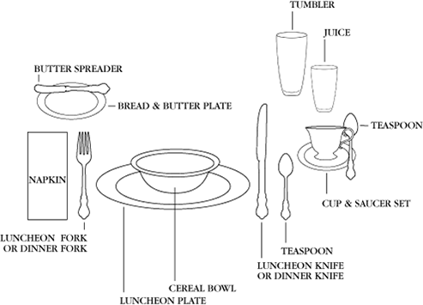

*Page 3 of 5*

**Beverageware**

Place the water glass at the tip of the knife, or a little to the right or left of the knife, depending on the

size of the table, the cover etc.

Glasses placed in addition to the water glass are positioned successively closer to the table edge but not

so as to modify the position of the flatware on the right side of the cover. Generally no more than three glasses appear within a cover.

**Misc. Notes for Place Setting Contest**

•

If your table is marred, you may cover it with a tablecloth, and then use the placemat you would

normally use. (Keep in mind your space allocation.)

•

If using a formal table setting, the arrangement of the cover may look cramped, but the judge will

understand.

•

Breakfast and lunches are usually simpler meals with most food items on the same plate. Dinners

may be served in courses with necessary dishes stacked in order of use with first item used on top.

**Sample Place Settings**

**Breakfast/Lunch:**

(Dinnerware, flatware and beverageware may vary depending on *your* menu.)

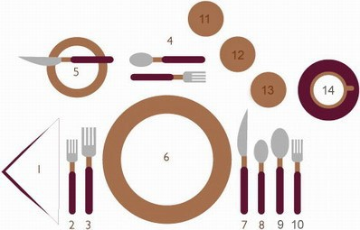

*Page 4 of 5*

**Formal Dinner:**

(Dinnerware, flatware and beverageware may vary depending on *your* menu.)

Napkin Salad fork Dinner fork

Dessert fork & spoon

Bread & butter plate with spreader Dinner plate

Dinner knife

Teaspoon Soup spoon Cocktail fork Water glass

Beverage glass Beverage glass

Coffee cup and saucer

1.

2.

3.

4.

5.

6.

7.

8.

9.

10.

11.

12.

13.

14.

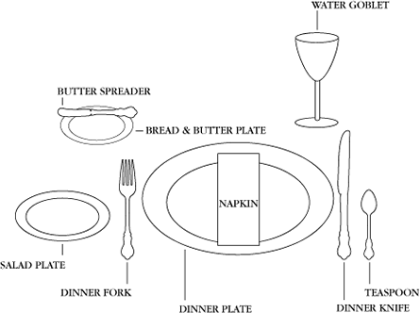

*Page 5 of 5*

**Family Dinner:**

(Dinnerware, flatware and beverageware may vary depending on *your* menu.)

**Additional place setting/menu information can be found by going on-line.