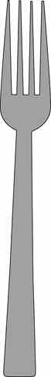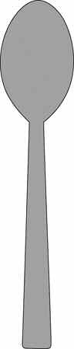

**SETTING THE TABLE**

**Glossary of Table Setting Utensils:**

**Spoon**

**Dinner Fork**

**Salad Fork**

**Knife**

**Dessert**

**Napkin**

4-H Special Foods Handbook

14

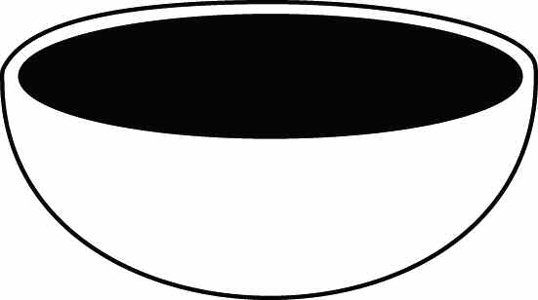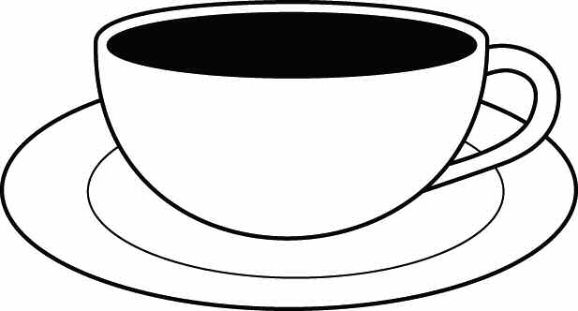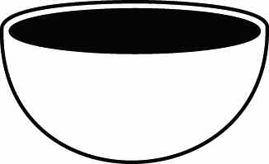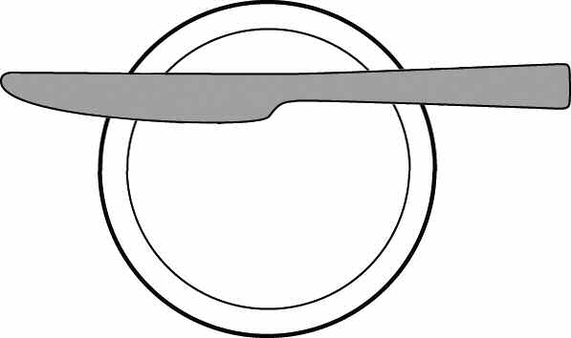

**Milk Glass**

**Juice/Water Glass**

**Dinner Plate**

**Salad Plate**

**Cup and Saucer**

**Dessert Cup**

**Dessert Plate**

**Bread and Butter Plate with Knife**

**Bowl**

4-H Special Foods Handbook

15

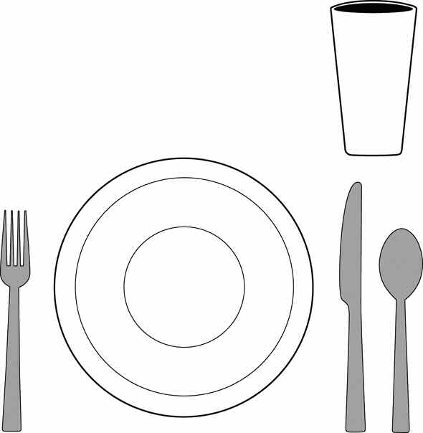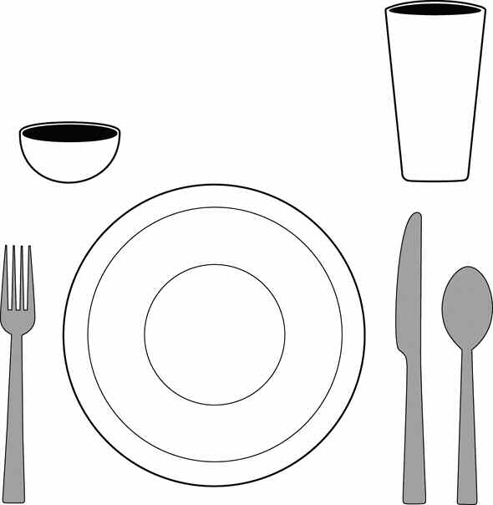

**Basic Table Setting:**

*(may be used at any meal)*

Your menu and recipe influence the number and type of dinnerware, flatware, and glasses/cups that you choose for your place setting.

**Unfolded Napkin**

**Folded Napkin**

**Fold**

**Open edges**

**Fold**

*Grilled Reuben Sandwich* Dill Pickles

*German Potato Salad* Milk

**Open edges**

**Fold**

*Turkey Tetrazzini* Crisp Relishes French Bread Chocolate Pudding Milk

**Open edges**

4-H Special Foods Handbook

16

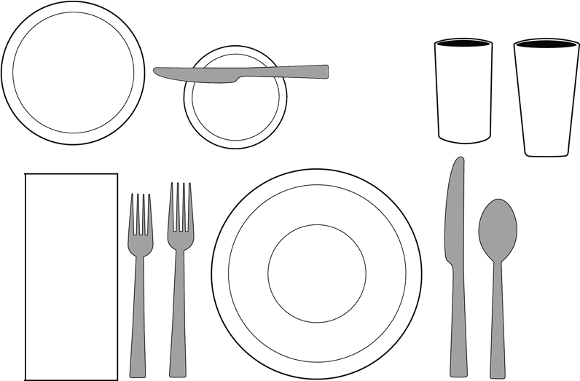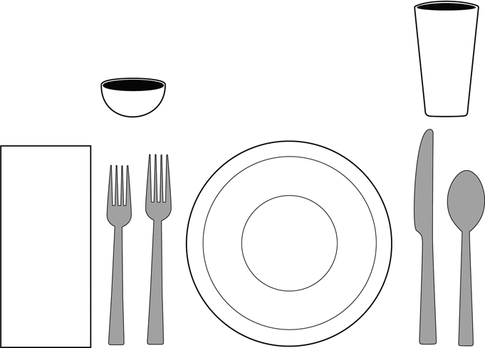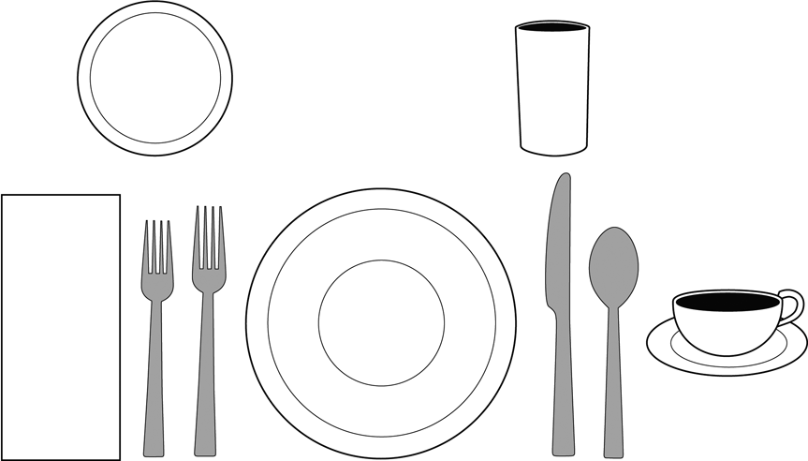

**Dinner/Lunch:**

Your menu and recipe influence the number and type of dinnerware, flatware, and glasses/cups that you choose for your place setting. In casual family settings, bread plates are often not needed.

*Sweet & Sour Pork* Chow Mien Noodles Asparagus-Lettuce Salad Fan-Tan Rolls

*Milk Iced Tea*

*Raspberry Pie* (the dessert is served following the meal)

*Tossed Green Salad*

*Lasagna* Skillet Zucchini Garlic Bread

*Fresh Fruit Compote* Cookies

*Milk*

*(Salad served before meal)*

*Beef Roll-Ups* Buttered Noodles

*Green Peas w/ Mushrooms* Perfection Salad

*Crusty Rolls* Coffee Milk

*Blueberry Cheesecake* (the dessert is served following the meal)

4-H Special Foods Handbook

17

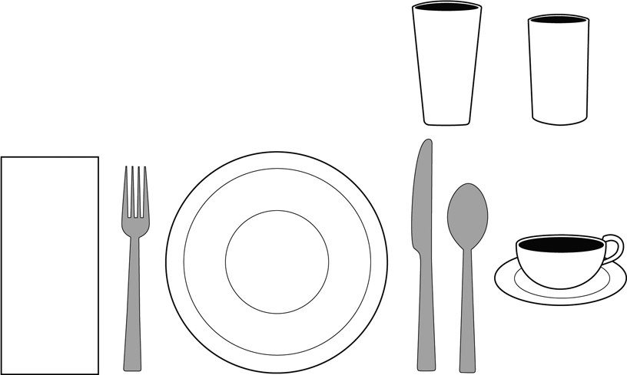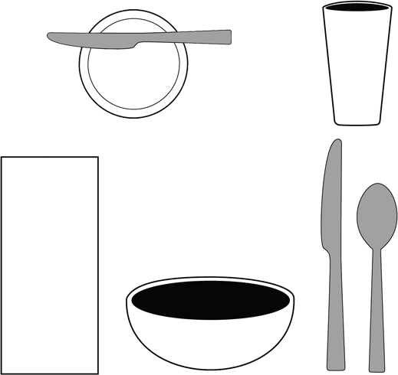

**Breakfast:**

Your menu and recipe influence the number and type of dinnerware, flatware, and glasses/cups that you choose for your place setting.

*Tomato Juice* Toasted English Muffins

*Sausage Links* Milk Coffee

*Oatmeal Granola* with Fresh Strawberries

*\*Toast Orange Marmalade* Milk

*\*May use a separate bread plate or the plate under the bowl.*

4-H Special Foods Handbook

18

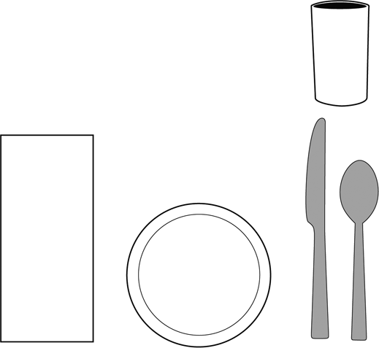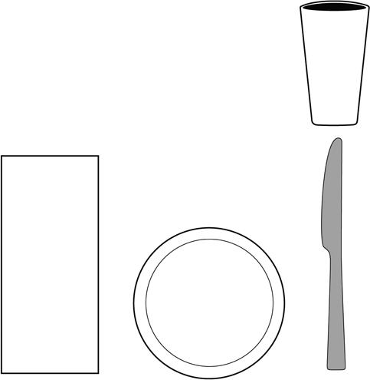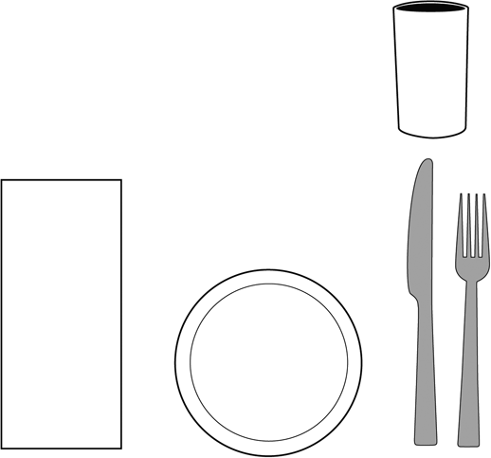

**Snack Menu:**

Your menu and recipe influence the number and type of dinnerware, flatware, and glasses/cups that you choose for your place setting.

*Lemon Bread*

*Refreshing Orange Sipper*

*Whole Wheat Muffins*

*Whipped Strawberry Butter*

*Milk*

*Pizza Sandwiches*

*Strawberry-flavored Milk*

4-H Special Foods Handbook

19