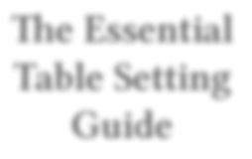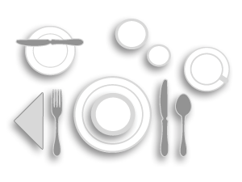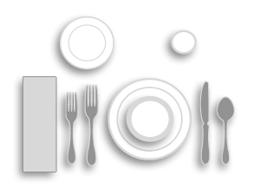

**The Essential Table Setting Guide**

Proper table setting is an art form. Whether casual or formal, traditional or modern, presentation is everything. When properly set, tableware arrangements enhance the dining experience.

Make a lasting impression using our ﬂatware, dinnerware and drinkware setting tips. This guide gives a quick summary of the proper use of china, ﬂatware and glassware and how much to keep on hand. Happy setting!

Table Settings by Meal

**Breakfast**

Flatware: [Dinner Fork,](http://www.rwsmithco.com/Dining-Room/Flatware/Forks/Dinner-Forks/c1343_1347_1348_1384/) [Dinner Knife,](http://www.rwsmithco.com/Dining-Room/Flatware/Knives/Dinner-Knives/c1343_1347_1385_1386/) [Teaspoon,](http://www.rwsmithco.com/Dining-Room/Flatware/Spoons/Teaspoons/c1343_1347_1350_1381/) [Butter Knife](http://www.rwsmithco.com/Dining-Room/Flatware/Knives/Butter-Knives/c1343_1347_1385_1593/)

Dinnerware: [Dinner Plate,](http://www.rwsmithco.com/advanced_search_result.php?ecosid=1479e221d7cd30adcc29b43edd4b90d3&search_in_description=1&q=Dinner%2BPlate&x=0&y=0) [Cereal Bowl,](http://www.rwsmithco.com/advanced_search_result.php?ecosid=1479e221d7cd30adcc29b43edd4b90d3&search_in_description=1&q=Soup%2BBowl&x=0&y=0) [B&B Plate,](http://www.rwsmithco.com/Dining-Room/Dinnerware/China-Dinnerware/Round-Plates/c1343_1367_1368_1369/%23/?_=1&filter.diameter=3%201%2F2%20in&filter.diameter=3%203%2F4%20in&filter.diameter=4%201%2F2%20in&filter.diameter=3.31%20in&filter.diameter=4%20in&filter.diameter=5%201%2F2%20in&filter.diameter=5%201%2F4%20in&filter.diameter=5%203%2F4%20in&filter.diamete) [Coﬀee/Tea Cup & Saucer](http://www.rwsmithco.com/Dining-Room/Dinnerware/China-Dinnerware/China-Cups-and-Saucers/c1343_1367_1368_1508/)

***Quick Tip***

The ﬁrst meal of the day typically has a more relaxed, casual feel.

Keep the number of utensils at a minimum.

Drinkware: [Water Tumbler](http://www.rwsmithco.com/Dining-Room/Glassware/Beverage-Glasses/Water-and-Beverage-Glasses/c1343_1422_1535_1536/) or [Juice Glass](http://www.rwsmithco.com/Dining-Room/Glassware/Beverage-Glasses/Juice-Glasses/c1343_1422_1535_1550/)

Accessories: [Napkin](http://www.rwsmithco.com/advanced_search_result.php?ecosid=33d1ffb6904cc2814768360d4f730dde&search_in_description=1&q=napkin&item-name)

**Lunch**

Flatware: [Salad Fork,](http://www.rwsmithco.com/Dining-Room/Flatware/Forks/Salad-Forks/c1343_1347_1348_1414/) [Dinner Fork,](http://www.rwsmithco.com/Dining-Room/Flatware/Forks/Dinner-Forks/c1343_1347_1348_1384/) [Dinner Knife,](http://www.rwsmithco.com/Dining-Room/Flatware/Knives/Dinner-Knives/c1343_1347_1385_1386/) [Teaspoon](http://www.rwsmithco.com/Dining-Room/Flatware/Spoons/Teaspoons/c1343_1347_1350_1381/)

Dinnerware: [Dinner Plate,](http://www.rwsmithco.com/advanced_search_result.php?ecosid=1479e221d7cd30adcc29b43edd4b90d3&search_in_description=1&q=Dinner%2BPlate&x=0&y=0) [Soup Bowl,](http://www.rwsmithco.com/advanced_search_result.php?ecosid=1479e221d7cd30adcc29b43edd4b90d3&search_in_description=1&q=Soup%2BBowl&x=0&y=0) [B&B Plate](http://www.rwsmithco.com/Dining-Room/Dinnerware/China-Dinnerware/Round-Plates/c1343_1367_1368_1369/%23/?_=1&filter.diameter=3%201%2F2%20in&filter.diameter=3%203%2F4%20in&filter.diameter=4%201%2F2%20in&filter.diameter=3.31%20in&filter.diameter=4%20in&filter.diameter=5%201%2F2%20in&filter.diameter=5%201%2F4%20in&filter.diameter=5%203%2F4%20in&filter.diamete)

Drinkware: [Water Tumbler](http://www.rwsmithco.com/Dining-Room/Glassware/Beverage-Glasses/Water-and-Beverage-Glasses/c1343_1422_1535_1536/) Accessories: [Napkin](http://www.rwsmithco.com/advanced_search_result.php?ecosid=33d1ffb6904cc2814768360d4f730dde&search_in_description=1&q=napkin&item-name)

***Quick Tip***

Lunch can be a casual or upscale aﬀair. Pare down your presentation for informal settings.

**Dinner**

Flatware: [Salad Fork](http://www.rwsmithco.com/Dining-Room/Flatware/Forks/Salad-Forks/c1343_1347_1348_1414/), [Dinner Fork,](http://www.rwsmithco.com/Dining-Room/Flatware/Forks/Dinner-Forks/c1343_1347_1348_1384/) [Butter Knife,](http://www.rwsmithco.com/Dining-Room/Flatware/Knives/Butter-Knives/c1343_1347_1385_1593/) [Dinner Knife,](http://www.rwsmithco.com/Dining-Room/Flatware/Knives/Dinner-Knives/c1343_1347_1385_1386/) [Teaspoon](http://www.rwsmithco.com/Dining-Room/Flatware/Spoons/Teaspoons/c1343_1347_1350_1381/)

Dinnerware: [Dinner Plate](http://www.rwsmithco.com/advanced_search_result.php?ecosid=1479e221d7cd30adcc29b43edd4b90d3&search_in_description=1&q=Dinner%2BPlate&x=0&y=0), [Salad Plate,](http://www.rwsmithco.com/advanced_search_result.php?ecosid=51c4bf346ce98f36e85e7fcd73b64371&search_in_description=1&q=Salad%2BPlate&x=0&y=0) [Soup Bowl,](http://www.rwsmithco.com/advanced_search_result.php?ecosid=1479e221d7cd30adcc29b43edd4b90d3&search_in_description=1&q=Soup%2BBowl&x=0&y=0) [B&B Plate](http://www.rwsmithco.com/Dining-Room/Dinnerware/China-Dinnerware/Round-Plates/c1343_1367_1368_1369/%23/?_=1&filter.diameter=3%201%2F2%20in&filter.diameter=3%203%2F4%20in&filter.diameter=4%201%2F2%20in&filter.diameter=3.31%20in&filter.diameter=4%20in&filter.diameter=5%201%2F2%20in&filter.diameter=5%201%2F4%20in&filter.diameter=5%203%2F4%20in&filter.diamete)

Drinkware: [Water Tumbler,](http://www.rwsmithco.com/Dining-Room/Glassware/Beverage-Glasses/Water-and-Beverage-Glasses/c1343_1422_1535_1536/) [Wine Glass](http://www.rwsmithco.com/advanced_search_result.php?ecosid=51c4bf346ce98f36e85e7fcd73b64371&search_in_description=1&q=Wine%2BGlass&x=0&y=0) Accessories: [Napkin](http://www.rwsmithco.com/advanced_search_result.php?ecosid=33d1ffb6904cc2814768360d4f730dde&search_in_description=1&q=napkin&item-name)

***Quick Tip***

How you dress the table depends entirely on how sophisticated your dining room feels. To enhance the look of your tables at dinner, add a tablecloth or [placemats,](http://www.rwsmithco.com/advanced_search_result.php?ecosid=8885cb5933a7a8eab5b498f236908775&search_in_description=1&q=placemat&x=0&y=0) and consider candle [lighting](http://www.rwsmithco.com/Dining-Room/Tabletop/Table-Lighting/c1343_1363_1653/) and other accents.

*Table Setting Guide information courtesy of Oneida and Churchill*

1 | [www.rwsmithco.com](http://www.rwsmithco.com/)

[info@rwsmithco.com](mailto:info@rwsmithco.com)

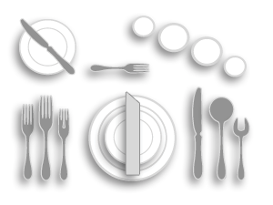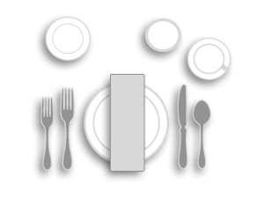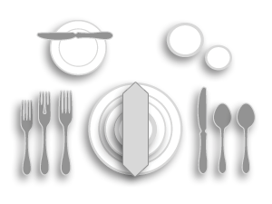

**Formal Dinner**

Flatware: [Salad Fork,](http://www.rwsmithco.com/Dining-Room/Flatware/Forks/Salad-Forks/c1343_1347_1348_1414/) [Fish Fork](http://www.rwsmithco.com/Dining-Room/Flatware/Forks/Fish-and-Seafood-Forks/c1343_1347_1348_1660/), [Dinner](http://www.rwsmithco.com/Dining-Room/Flatware/Forks/Dinner-Forks/c1343_1347_1348_1384/) [Fork](http://www.rwsmithco.com/Dining-Room/Flatware/Forks/Dinner-Forks/c1343_1347_1348_1384/), [Butter Knife,](http://www.rwsmithco.com/Dining-Room/Flatware/Knives/Butter-Knives/c1343_1347_1385_1593/) [Dinner Knife,](http://www.rwsmithco.com/Dining-Room/Flatware/Knives/Dinner-Knives/c1343_1347_1385_1386/) [Soup/Bouillon Spoon](http://www.rwsmithco.com/Dining-Room/Flatware/Spoons/Soup-and-Bouillon-Spoons/c1343_1347_1350_1382/), [Teaspoon](http://www.rwsmithco.com/Dining-Room/Flatware/Spoons/Teaspoons/c1343_1347_1350_1381/)

Dinnerware: [Dinner Plate,](http://www.rwsmithco.com/advanced_search_result.php?ecosid=1479e221d7cd30adcc29b43edd4b90d3&search_in_description=1&q=Dinner%2BPlate&x=0&y=0) [Salad Plate,](http://www.rwsmithco.com/advanced_search_result.php?ecosid=51c4bf346ce98f36e85e7fcd73b64371&search_in_description=1&q=Salad%2BPlate&x=0&y=0) [Soup Bowl,](http://www.rwsmithco.com/advanced_search_result.php?ecosid=1479e221d7cd30adcc29b43edd4b90d3&search_in_description=1&q=Soup%2BBowl&x=0&y=0) [B&B Plate](http://www.rwsmithco.com/Dining-Room/Dinnerware/China-Dinnerware/Round-Plates/c1343_1367_1368_1369/%23/?_=1&filter.diameter=3%201%2F2%20in&filter.diameter=3%203%2F4%20in&filter.diameter=4%201%2F2%20in&filter.diameter=3.31%20in&filter.diameter=4%20in&filter.diameter=5%201%2F2%20in&filter.diameter=5%201%2F4%20in&filter.diameter=5%203%2F4%20in&filter.diamete)

Drinkware: [Wine Glass,](http://www.rwsmithco.com/advanced_search_result.php?ecosid=51c4bf346ce98f36e85e7fcd73b64371&search_in_description=1&q=Wine%2BGlass&x=0&y=0) [Water Goblet,](http://www.rwsmithco.com/advanced_search_result.php?ecosid=51c4bf346ce98f36e85e7fcd73b64371&search_in_description=1&q=Water%2BGoble&x=0&y=0) [Champagne Flute](http://www.rwsmithco.com/Dining-Room/Glassware/Stemware/Champagnes/c1343_1422_1537_1554/)

Accessories: [Napkin](http://www.rwsmithco.com/advanced_search_result.php?ecosid=33d1ffb6904cc2814768360d4f730dde&search_in_description=1&q=napkin&item-name)

***Quick Tip***

Formal dining room settings require more ﬂatware and glassware pieces than casual settings. When using this display, utensils should be placed in order of the courses oﬀered, allowing guests to work from the outside in, toward the plate.

**European Dinner**

Flatware: [Cocktail Fork,](http://www.rwsmithco.com/Dining-Room/Flatware/Forks/Cocktail-Forks/c1343_1347_1348_1349/) [Salad Fork,](http://www.rwsmithco.com/Dining-Room/Flatware/Forks/Salad-Forks/c1343_1347_1348_1414/) [Fish Fork,](http://www.rwsmithco.com/Dining-Room/Flatware/Forks/Fish-and-Seafood-Forks/c1343_1347_1348_1660/) [European Dinner Fork,](http://www.rwsmithco.com/advanced_search_result.php?ecosid=1479e221d7cd30adcc29b43edd4b90d3&search_in_description=1&q=European%2BDinner%2BFork&x=0&y=0) [Butter Knife](http://www.rwsmithco.com/Dining-Room/Flatware/Knives/Butter-Knives/c1343_1347_1385_1593/), [European Dinner Knife,](http://www.rwsmithco.com/advanced_search_result.php?ecosid=1479e221d7cd30adcc29b43edd4b90d3&search_in_description=1&q=European%2BDinner%2BKnife&x=0&y=0) [Soup/Bouillon Spoon](http://www.rwsmithco.com/Dining-Room/Flatware/Spoons/Soup-and-Bouillon-Spoons/c1343_1347_1350_1382/), [Teaspoon,](http://www.rwsmithco.com/Dining-Room/Flatware/Spoons/Teaspoons/c1343_1347_1350_1381/) [Dessert Spoon](http://www.rwsmithco.com/Dining-Room/Flatware/Spoons/Teaspoons/c1343_1347_1350_1381/)

Dinnerware: [Dinner Plate,](http://www.rwsmithco.com/advanced_search_result.php?ecosid=1479e221d7cd30adcc29b43edd4b90d3&search_in_description=1&q=Dinner%2BPlate&x=0&y=0) [Salad Plate,](http://www.rwsmithco.com/advanced_search_result.php?ecosid=51c4bf346ce98f36e85e7fcd73b64371&search_in_description=1&q=Salad%2BPlate&x=0&y=0) [B&B Plate](http://www.rwsmithco.com/Dining-Room/Dinnerware/China-Dinnerware/Round-Plates/c1343_1367_1368_1369/%23/?_=1&filter.diameter=3%201%2F2%20in&filter.diameter=3%203%2F4%20in&filter.diameter=4%201%2F2%20in&filter.diameter=3.31%20in&filter.diameter=4%20in&filter.diameter=5%201%2F2%20in&filter.diameter=5%201%2F4%20in&filter.diameter=5%203%2F4%20in&filter.diamete)

Drinkware: [Red Wine Glass](http://www.rwsmithco.com/Dining-Room/Glassware/Stemware/Red-Wines/c1343_1422_1537_1538/), [White](http://www.rwsmithco.com/Dining-Room/Glassware/Stemware/White-Wines/c1343_1422_1537_1547/) [Wine Glass,](http://www.rwsmithco.com/Dining-Room/Glassware/Stemware/White-Wines/c1343_1422_1537_1547/) [Sherry Glass](http://www.rwsmithco.com/advanced_search_result.php?ecosid=99532c4cdb822130c24ce7d1a63ac78f&search_in_description=1&q=sherry%2Bglass&item-name)

Accessories: [Napkin](http://www.rwsmithco.com/advanced_search_result.php?ecosid=33d1ffb6904cc2814768360d4f730dde&search_in_description=1&q=napkin&item-name)

***Quick Tip***

This tabletop conﬁgura- tion is intended for the most opulent occasions and typically includes a ﬁsh course.

**Banquet / Brunch**

Flatware: [Salad Fork,](http://www.rwsmithco.com/Dining-Room/Flatware/Forks/Salad-Forks/c1343_1347_1348_1414/) [Dinner Fork,](http://www.rwsmithco.com/Dining-Room/Flatware/Forks/Dinner-Forks/c1343_1347_1348_1384/) [Dinner Knife](http://www.rwsmithco.com/Dining-Room/Flatware/Knives/Dinner-Knives/c1343_1347_1385_1386/)

Dinnerware: [Dinner Plate](http://www.rwsmithco.com/advanced_search_result.php?ecosid=1479e221d7cd30adcc29b43edd4b90d3&search_in_description=1&q=Dinner%2BPlate&x=0&y=0), [B&B Plate,](http://www.rwsmithco.com/Dining-Room/Dinnerware/China-Dinnerware/Round-Plates/c1343_1367_1368_1369/%23/?_=1&filter.diameter=3%201%2F2%20in&filter.diameter=3%203%2F4%20in&filter.diameter=4%201%2F2%20in&filter.diameter=3.31%20in&filter.diameter=4%20in&filter.diameter=5%201%2F2%20in&filter.diameter=5%201%2F4%20in&filter.diameter=5%203%2F4%20in&filter.diamete) [Coﬀee/Tea Cup & Saucer](http://www.rwsmithco.com/Dining-Room/Dinnerware/China-Dinnerware/China-Cups-and-Saucers/c1343_1367_1368_1508/)

Drinkware: [Water Goblet](http://www.rwsmithco.com/Dining-Room/Glassware/Stemware/Goblets/c1343_1422_1537_2061/) Accessories: [Napkin](http://www.rwsmithco.com/advanced_search_result.php?ecosid=33d1ffb6904cc2814768360d4f730dde&search_in_description=1&q=napkin&item-name)

***Quick Tip***

This type of table display is ideal for events and buﬀet-style service.

Forgo the dinner plate when they are stacked at the initial serving station.

**Insights and Best Practices for Setting an Unforgettable Table**

Infuse diﬀerent shapes and sizes to bring appeal and excitement to your table presentation

Consider table size and portions when planning your settings

Choose colors, textures and styles that complement the overall look of your dining room

**For more tips on table setting, view these resources:**

[The Emily Post Institute – Table Setting Guides](http://emilypost.com/advice/table-setting-guides/)

[Etiquette Scholar – Table Setting](http://www.etiquettescholar.com/dining_etiquette/table_setting.html)

[Oneida – Table Setting Guide](http://foodservice.oneida.com/setting-guide)

2 | [www.rwsmithco.com](http://www.rwsmithco.com/)

[info@rwsmithco.com](mailto:info@rwsmithco.com)

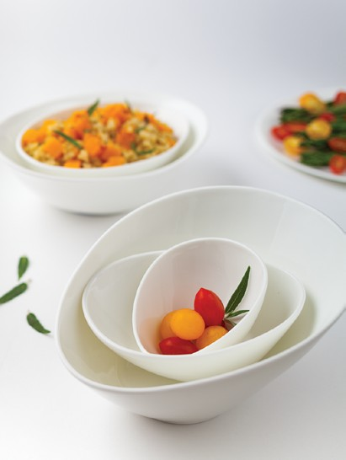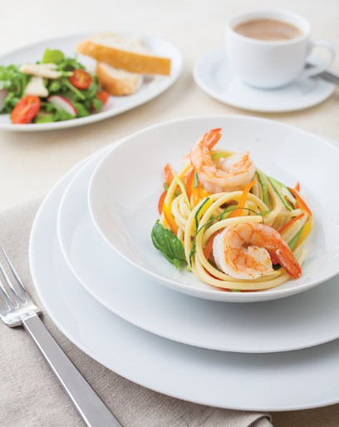

Functionality is more important than accents – make the dining experience your primary focus

Train staﬀ on the proper handling and care of tabletop products to reduce breakage and control costs

Allow at least 24 inches for each place setting

Keep all tableware approximately one inch from the edge of the table

Place all [knives](http://www.rwsmithco.com/Dining-Room/Flatware/Knives/c1343_1347_1385/) with the cutting edge toward the plate

Arrange [ﬂatware](http://www.rwsmithco.com/Dining-Room/Flatware/c1343_1347/) in order of use, working from the outside toward the plate for each course served

If salad is served after entrée, place [salad fork](http://www.rwsmithco.com/Dining-Room/Flatware/Forks/Salad-Forks/c1343_1347_1348_1414/) next to plate

[Glass](http://www.rwsmithco.com/Dining-Room/Glassware/c1343_1422/) placement: from right to left, white wine, red wine, and water/iced beverage. Champagne may be placed behind red and white wine glasses.

A [seafood/](http://www.rwsmithco.com/Dining-Room/Flatware/Forks/Fish-and-Seafood-Forks/c1343_1347_1348_1660/)[cocktail](http://www.rwsmithco.com/Dining-Room/Flatware/Forks/Cocktail-Forks/c1343_1347_1348_1349/) fork is always placed to the right of the [soup spoon,](http://www.rwsmithco.com/Dining-Room/Flatware/Spoons/Soup-and-Bouillon-Spoons/c1343_1347_1350_1382/) unless served with a seafood cocktail. It may be placed on the cocktail plate.

Make it neat and straight, with all pieces generally equidistant from each other

**Table Setting Beneﬁts**

**Maximize Your Investment**

The number of place settings should match daily usage and the types of specialty pieces should match the menu. Too many items are unnecessary, too few means extra warewashing.

**Control Sanitation Costs**

The correct place settings for each meal during the day will eliminate warewashing of unnecessary pieces, saving you money.

**Create the Proper Ambience/Atmosphere**

A customer’s ﬁrst impression is their lasting impression. Make the atmosphere of your establishment unforget- table with a table setting presentation that inspires your guests, and complements the menu and decor.

3 | [www.rwsmithco.com](http://www.rwsmithco.com/)

[info@rwsmithco.com](mailto:info@rwsmithco.com)

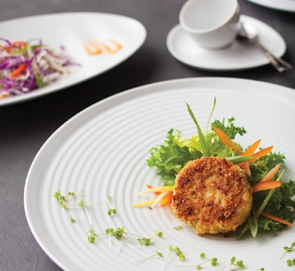

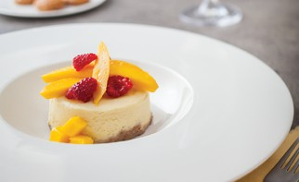

**Importance of**

**Proper Care, Handling & Ordering**

Tableware is an invaluable investment for your restaurant. Though durable, commercial china, glass and ﬂatware experience high-volume and rigorous use. Extend the life of your tabletop supplies with our tips for proper handling, cleaning and storage.

In addition to proper handling, maintain correct supply levels to ensure smooth service and lessen warewashing demands for dinnerware, ﬂatware and glassware in your restaurant. Follow the ordering guidelines included here to calculate the quantities needed for your dining room.

USE OUR BUYING GUIDE TO ORGANIZE YOUR NEXT TABLETOP ORDER >>

[China](http://www.rwsmithco.com/Dining-Room/Dinnerware/c1343_1367/)

Wash all china at least once before its ﬁrst use.

Do not put detergent directly onto china. An excessive concentration of alkaline detergent can cause permanent damage to decorations, especially those with gold and platinum.

A wash temperature of 60º C (140º F) is recognized as the most eﬀective. Excessively high water temperature will reduce the washing eﬃciency and may damage decorations.

Use [racks and baskets](http://www.rwsmithco.com/Maintenance/Warewashing-Racks/Additional-Warewashing-Racks/c1411_1412_1425/) made from plastic or ones that are plastic coated so items do not vibrate against each other.

In hard water areas, deposits may form on your china in time if the water is allowed to dry on the china.

These soluble deposits can easily be removed with a diluted acid such as vinegar.

The most severe test of chinaware quality and cost eﬀectiveness is its ability to maintain appearance and resist damage and breakage under the demanding conditions of bussing, scraping, racking, warewashing, and storage.

Washing

Unattractive stains and discolorations can be caused by inattention to cleaning procedures such as allowing china to remain unwashed after use, pre-soaking in water over 160°F, improper detergent concentrations, hard water or iron content, lime content in old equipment, and clogged or eroded spray nozzles. The above can be avoided with these easy to follow tips.

Metal Markings

Metal markings are the appearance of small black marks on the surface of a ceramic product and are caused if two hard substances are rubbed together. These marks are also known as “pencil marks” and can be caused by mineral deposits of metal from certain types of ﬂatware.

Lower grade ﬂatware is softer and is more prone to leaving marks. Markings can also be caused by metal surfaces such as dishwashers and drainers and can usually be successfully removed by rubbing with vinegar, a mild bleach solution, lemon juice and proprietary cleaners.

4 | [www.rwsmithco.com](http://www.rwsmithco.com/)

[info@rwsmithco.com](mailto:info@rwsmithco.com)

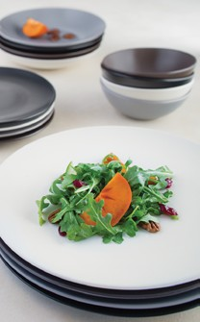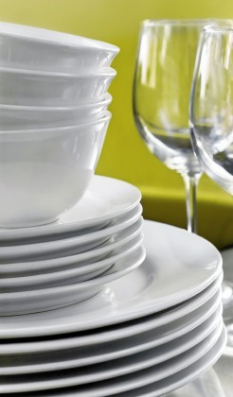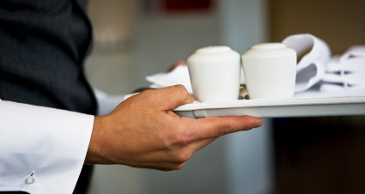

Remember to:

Stack china to the proper level Sort all items in bus tray

Have an adequate supply of china for rush periods

Carry dishes carefully Place cups in racks

Keep receiving area neat and clean

Remove scraps carefully with rubber scraper or water spray

Load like items in each dish rack

Avoid:

Stacking cups

Carrying more dishes than you can safely handle Overloading bus trays

Allowing dirty dishes to pile up

Using abrasive pads or other dishes to remove scraps

Loading loose, mixed items into the dishwasher Stacking dishes more than 16 inches high

China Ordering Guide • [Bowls](http://www.rwsmithco.com/advanced_search_result.php?ecosid=5e16bb8197569a56ed65775d18af03bd&search_in_description=1&q=bowls&item-name)

To determine the needed quantity of each item, multiply the number of seats times the ordering factor for each item.

*Care, Handling & Order Guide information courtesy of Churchill, Libbey and Royal Doulton.*

5 | [www.rwsmithco.com](http://www.rwsmithco.com/)

[info@rwsmithco.com](mailto:info@rwsmithco.com)

ITEMS SUGGESTED USE FAST FOOD DINING BANQUET CATERING

Bouillon, Handled or Unhandled

Soup, Packaged Sugar, Custard, Egg Cup, Crackers, Condiments, Gelatin

1

1 1/2

1 1/2

1 1/2

4 1/4” – 5”

Fruit Bowl

“Monkey” Dish for Vegetables, Fruits, Puddings, Desserts, Bake & Serve

2

3

6

2 1/2

8 7/8” – 9 1/4”

Rim Deep Soup

A La Carte Soup, Salad, Pasta, Chili, Oyster Stew, Bouillabaisse

1/2

1/2

-

1/2

11” – 12 1/2” Pasta Bowl

Entrée Pastas, Salads

1/2

1/2

-

1/2

China Ordering Guide • [Plates](http://www.rwsmithco.com/advanced_search_result.php?ecosid=5e16bb8197569a56ed65775d18af03bd&search_in_description=1&q=Plates&item-name)

To determine the quantity of each item, multiply the number of seats times the ordering factor shown for each item. Then, order the closest dozen quantity.

China Ordering Guide • [Pitchers](http://www.rwsmithco.com/advanced_search_result.php?ecosid=f210084af0a5fc3dc53158f132abfda2&search_in_description=1&q=Pitchers&item-name) & [Mugs](http://www.rwsmithco.com/advanced_search_result.php?ecosid=f210084af0a5fc3dc53158f132abfda2&search_in_description=1&q=Mugs&item-name)

To determine the quantity of each item, multiply the number of seats times the ordering factor shown for each item. Then, order the closest dozen quantity.

6 | [www.rwsmithco.com](http://www.rwsmithco.com/)

[info@rwsmithco.com](mailto:info@rwsmithco.com)

ITEMS SUGGESTED USE FAST FOOD DINING BANQUET CATERING

Coﬀee/Tea Cup

Coﬀee, Tea, Hot Chocolate, Soup

3

3

2

2

Mug

Hot & Cold Beverages

3

3

2

2

Coﬀee/Tea Saucer

Underliner for Cups, Bouillon, Fruit

3

3

2

2

Coﬀee/Teapot

Hot & Cold Beverages

1/3

1/3

-

1/3

Creamer, 3.50 oz

Cream for Beverages, Syrup, Melted Butter

1/2

1/2

-

1/2

ITEMS SUGGESTED USE FAST FOOD DINING BANQUET CATERING

5 1/2” – 6 1/8”

Plate

Bread & Butter, Desserts, Bouillon Underliner

1 1/2

2

6

2

7 1/2” – 7 1/8”

Plate

Sandwiches, Salads, Desserts, Underliner for Grapefruit, Salad Bowls

1 1/2

2

-

2

8 1/2” – 9 1/8”

Plate

Luncheon, Entrée, Dinner Plate, Pastries,

Underliner for Salad Plate

1 1/2

2

2

2

9 3/4” – 10”

Plate

Dinner, Breakfast, Luncheon, Steaks, Underliner for Salad

1 1/2

3

2

1 1/2

10 1/4” – 10 3/8”

Plate

Entrée, Steaks, Prime Rib, Fish, Mexican Dishes, Service Plate, Poultry

2

2

-

1

7 1/4” – 9 7/8”

Oval Plate/Bowl

Baked Potato, Asparagus, Salad, Cold Seafood

1

1 1/2

-

1

11” – 15”

Large Platter

Steaks, Fish, Soup & Sandwich, Lobster, Prime Rib, Surf N’ Turf, Sandwich Underliner

1

1 1/2

1/2

1

Service Plate 12” – 13”

Tabletop Decoration, Place Plate, Serving Plate, Special Presentations

1 1/2

1 1/2

-

1 1/2

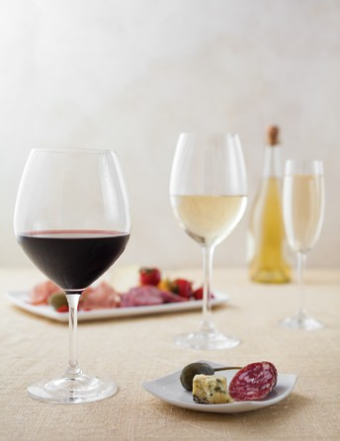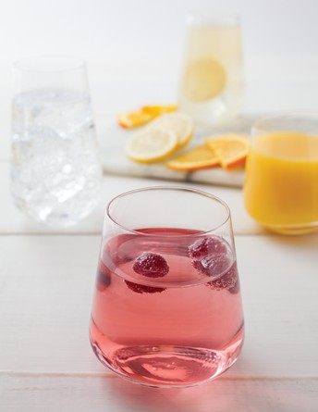

[Glassware](http://www.rwsmithco.com/Dining-Room/Glassware/c1343_1422/)

Remember to:

Keep adequate supplies of glassware on hand in order to prevent recently washed items from going directly into service

Check dishwasher temperature twice daily Replace worn [glass washer brushes](http://www.rwsmithco.com/advanced_search_result.php?ecosid=a8d330c2224afb8ae6f35fe12c278102&search_in_description=1&q=glass%2Bwasher%2Bbrushes&item-name)

Bus glassware directly into racks, or use divided bus trays with ﬂatware baskets

Pre-heat glasses with hot water when pouring hot drinks

Handle glassware gently; remove abraded, cracked, or chipped glassware from service

Dump ice and let glassware reach room temperature before washing

Remove glasses from bus pans one at a time Clean (scrape) glassware, ﬂatware and then china Store glasses in their properly sized [glass racks](http://www.rwsmithco.com/Maintenance/Warewashing-Racks/Dish-Racks-and-Dollies/Glass-Racks/c1411_1412_1632_2129/)

Avoid:

Putting cold water or ice into a warm or hot glass Picking up glasses in bouquets

Stacking glasses Scooping ice with glasses

Glass-to-glass contact in overhead racks and anywhere else

Contacting glasses with the beer tap Putting ﬂatware into glasses

[Restaurant glassware is varied with numerous uses and styles. For information on diﬀerent glassware types, proper care and optimal storage, view our comprehensive Glassware Guide.](http://www.rwsmithco.com/catalog/TriMark-RW-Smith-Glassware-Guide.pdf?source=GlassGuide)

*Care, Handling & Ordering Guide information courtesy of Churchill, Libbey and Royal Doulton.*

7 | [www.rwsmithco.com](http://www.rwsmithco.com/)

[info@rwsmithco.com](mailto:info@rwsmithco.com)

Glass Ordering Guide [• Restaurants](http://www.rwsmithco.com/Dining-Room/Glassware/c1343_1422/)

Glass Ordering Guide [• Banquets](http://www.rwsmithco.com/Dining-Room/Glassware/c1343_1422/)

Glass Ordering Guide • Room Service

[Upgrade Your](http://www.rwsmithco.com/community/industry-insights/effective-tips-for-hotel-room-service/)

[Room Service Program](http://www.rwsmithco.com/community/industry-insights/effective-tips-for-hotel-room-service/)

[Helpful Tips >>](http://www.rwsmithco.com/community/industry-insights/effective-tips-for-hotel-room-service/)

*Care, Handling & Ordering Guide information courtesy of Libbey.*

8 | [www.rwsmithco.com](http://www.rwsmithco.com/)

[info@rwsmithco.com](mailto:info@rwsmithco.com)

ITEMS

8 oz Tumbler Glassware

Minimum 2 to a room

Ashtray

Minimum 2 to a room

Floral Accessories

Minimum 1 to a room

ITEMS 100 SEATS 200 SEATS 300 SEATS

(in dozens) (in dozens) (in dozens)

5 oz Juice Glass

12

24

36

12 oz Iced Tea Glass

12

24

36

10 oz Water Goblet

24

48

72

5.50 oz Sherbet

12

24

36

6 oz Flute

12

24

36

8.50 oz Wine Glass

12

24

36

Sugar Packet Holder

10

20

30

ITEMS 100 SEATS 200 SEATS 300 SEATS

(in dozens) (in dozens) (in dozens)

5 oz Juice Glass

12

24

36

12 oz Iced Tea Glass

12

24

36

10 oz Water Glass

24

48

72

6 oz Sherbet

12

24

36

6 oz Flute

12

24

36

Sugar Packet Holder

10

20

30



[Flatware](http://www.rwsmithco.com/Dining-Room/Flatware/c1343_1347/)

*Presoaking Tips*

Presoaking is recommended, after which utensils should be immediately washed in high temperatures — low temperatures or chlorine baths will attack silver and metal. To prevent corrosion and ﬁlm build-up, ﬂatware must be rinsed thoroughly and dried immediately after rinsing.

Remember To:

Load ﬂatware into presoak containers immediately after use

Change presoak solution frequently

Store ﬂatware in a dry area away from cooking fumes and corrosive materials

Wash ﬂatware in a vertical position in temperatures above 135˚F, and rinse in clean water at 180˚F

Use a nonabrasive, noncorrosive cleaning agent and a water softener or wetting agent

Avoid:

Presoaking ﬂatware for longer than 15 minutes

Loading ﬂatware into aluminum, copper, or copper alloy containers for presoaking; use only plastic or stainless steel

Putting ﬂatware into glasses or cups Leaving ﬂatware soiled overnight

Flatware Ordering Guide

This chart is based on standard restaurant settings. Your speciﬁc need may vary according to individual operation. Multiply your number of seats by the ordering factors listed below for an approximation. Your reserve stock should be at least 25% of that in active service. *\*Accessory items to be considered separately, depending on type of service and menu.*

*Care, Handling & Ordering Guide information courtesy of Libbey.*

9 | [www.rwsmithco.com](http://www.rwsmithco.com/)

[info@rwsmithco.com](mailto:info@rwsmithco.com)

ITEMS DELUXE SEMI-FORMAL STANDARD

Teaspoon

5

3

3

Dessert Spoon

2

2

2

Tablespoon

1/4

1/4

-

Iced Tea Spoon

1 1/2

1 1/2

1 1/2

Demitasse Spoon

2

-

-

Bouillon Spoon

2

2

2

Utility/Dessert Fork

3

3

3

Dinner Fork

2

-

-

Salad or Fish Fork

*

*

*

Cocktail Fork

1 1/2

1 1/2

1 1/2

Dinner Knife

2

1 1/2

1 1/2

Utility/Dessert Knife

2

1 1/2

*

B&B Knife or Butter Spreader

2

-

-

Steak Knife

*

*

-

Fish Knife

*

*

-