

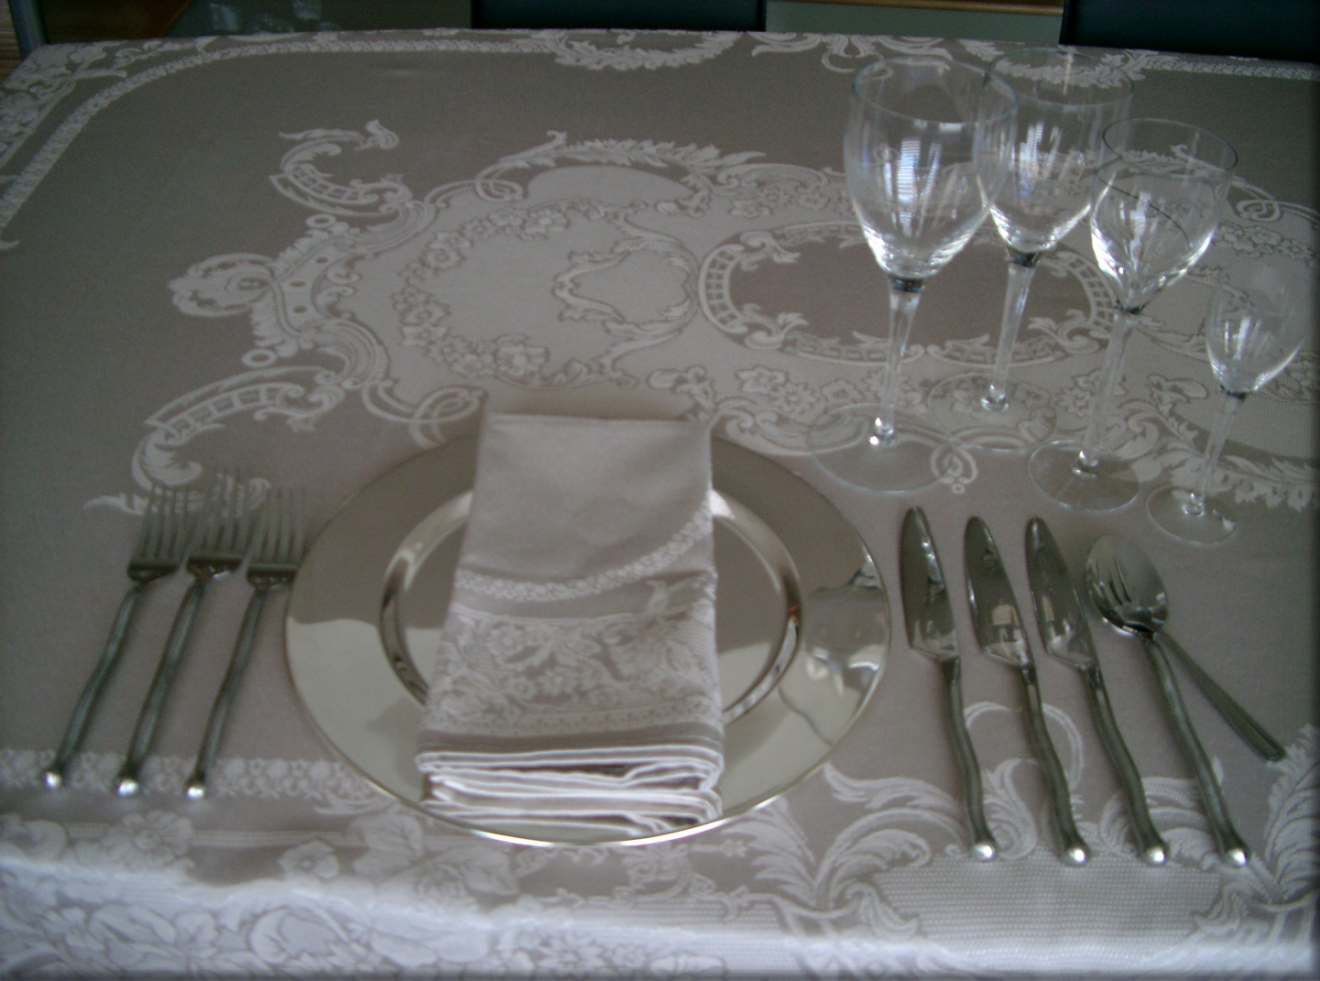

**Table Settings**

**Self-Study & Group Activities**

The following activities work well to reinforce learning outcomes with individuals and groups and may be incorporated into your presentations:

© 2015 Personal Impact International

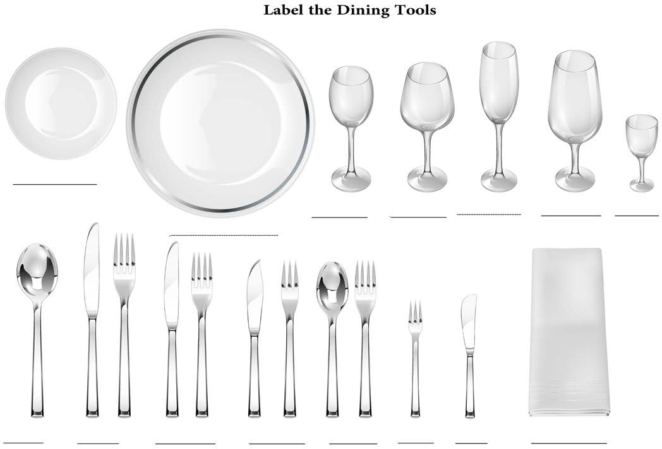

**Label the Dining Tools & Place Settings**

**Exercise 1: Label the Dining Tools & Place Settings**

1.

2.

3.

4.

Identify the dining tools

Identify the number of courses in each of the following place settings Check the Key included in this activity.

Review

**Notes:**

**__________________________________________________________________________________________**

**__________________________________________________________________________________________**

**__________________________________________________________________________________________**

© 2015 Personal Impact International

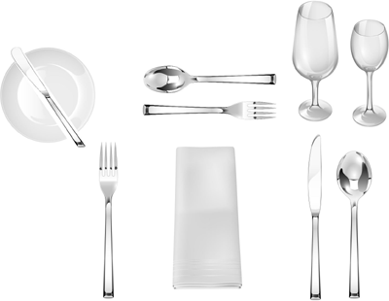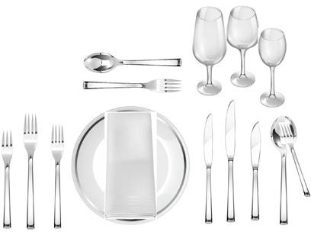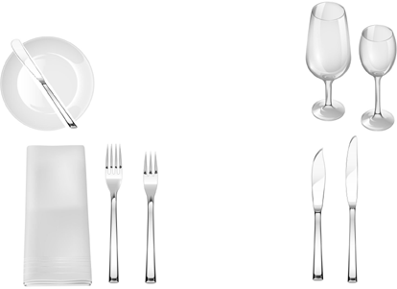

**Label the Dining Tools & Place Settings**

**Exercise 1**

Top Row - Left to Right:

_

_

_

Bottom Row – Left to Right:

_

_

_

**Exercise 2**

Top Row - Left to Right:

_

_

_

Bottom Row – Left to Right:

_

_

_

**Exercise 3**

Top Row - Left to Right:

_

_

_

Bottom Row – Left to Right:

_

_

_

© 2015 Personal Impact International

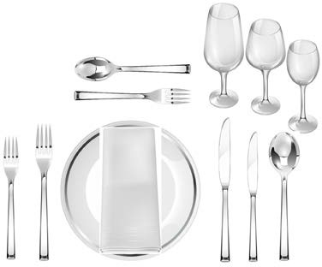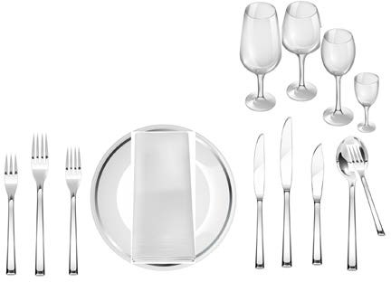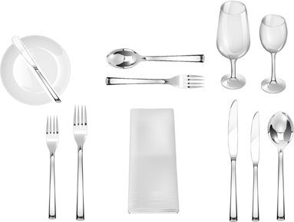

**Label the Dining Tools & Place Settings**

**Exercise 4**

Top Row - Left to Right:

_

_

_

Bottom Row – Left to Right:

_

_

_

**Exercise 5**

Top Row - Left to Right:

_

_

_

Bottom Row – Left to Right:

_

_

_

**Exercise 6**

Top Row - Left to Right:

_

_

_

Bottom Row – Left to Right:

_

_

_

© 2015 Personal Impact International

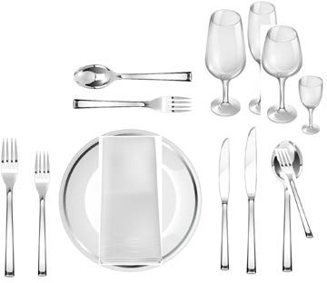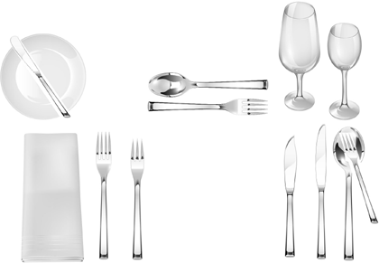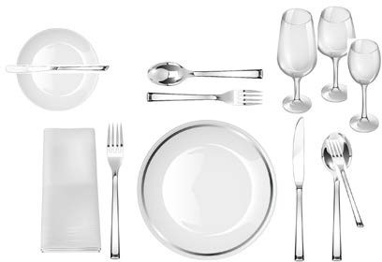

**Label the Dining Tools & Place Settings**

**Exercise 7**

Top Row - Left to Right:

_

_

_

Bottom Row – Left to Right:

_

_

_

**Exercise 8**

Top Row - Left to Right:

_

_

_

Bottom Row – Left to Right:

_

_

_

**Exercise 9**

Top Row - Left to Right:

_

_

_

Bottom Row – Left to Right:

_

_

_

© 2015 Personal Impact International

**Label the**

**Dining Tools & Place Settings KEY**

**The following pages may be used to evaluate your answers in the previous exercise:**

© 2015 Personal Impact International

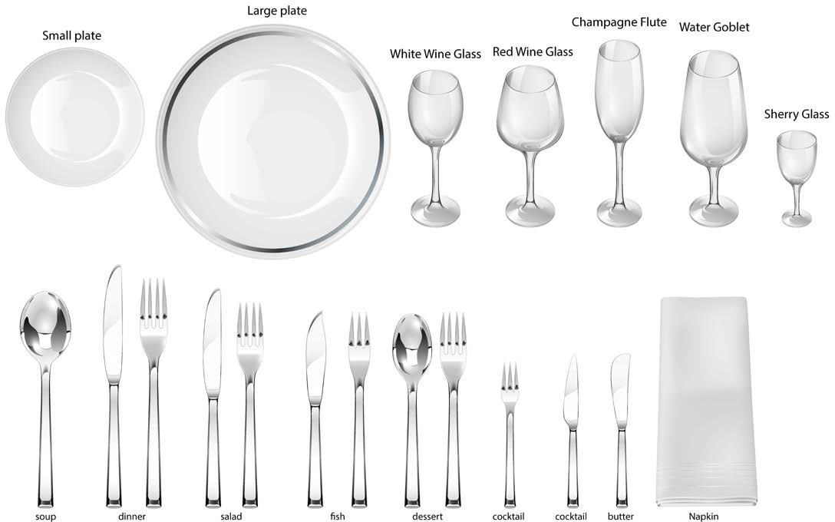

**Dining Tools at a Glance**

**Notes:**

**__________________________________________________________________________________________**

**__________________________________________________________________________________________**

**__________________________________________________________________________________________**

**__________________________________________________________________________________________**

**__________________________________________________________________________________________**

**__________________________________________________________________________________________**

© 2015 Personal Impact International



**Place Settings at a Glance**

**Exercise 1**

Top Row - Left to Right:

*bread plate; butter spreader; dessert spoon; dessert fork; water goblet; white wine;*

Bottom Row – Left to Right:

*dinner fork; napkin; dinner knife; soup spoon;*

**Exercise 2**

Top Row - Left to Right:

*dessert spoon; dessert fork; water goblet; red wine; white wine;*

Bottom Row – Left to Right:

*fish fork; dinner fork; salad fork; charger; napkin; salad knife; dinner knife; fish knife; soup spoon; cocktail fork;*

**Exercise 3**

Top Row - Left to Right:

*bread plate; butter spreader; water goblet; white wine;*

Bottom Row – Left to Right:

*napkin; salad fork; fish knife; salad knife;*

© 2015 Personal Impact International



**Place Settings at a Glance**

**Exercise 4**

Top Row - Left to Right:

*dessert spoon; dessert fork; water goblet; red wine; white wine;*

Bottom Row – Left to Right:

*salad fork; dinner fork; charger; napkin; dinner knife; salad knife; soup spoon;*

**Exercise 5**

Top Row - Left to Right:

*water goblet; red wine; white wine; sherry;*

Bottom Row – Left to Right:

*fish fork; dinner fork; salad fork; charger; napkin; salad knife; dinner knife; fish knife; soup spoon; cocktail fork;*

**Exercise 6**

Top Row - Left to Right:

*bread plate; butter spreader; dessert spoon; dessert fork; water goblet; white wine;*

Bottom Row – Left to Right:

*salad fork; dinner fork; napkin; dinner knife; salad knife; soup spoon;*

© 2015 Personal Impact International



**Place Settings at a Glance**

**Exercise 7**

Top Row - Left to Right:

*dessert spoon; dessert fork; water goblet; champagne; red wine; sherry;*

Bottom Row – Left to Right:

*dinner fork; salad fork; charger; napkin; salad knife; dinner knife; soup spoon; cocktail fork;*

**Exercise 8**

Top Row - Left to Right:

*bread plate; butter spreader; dessert spoon; dessert fork; water goblet; white wine;*

Bottom Row – Left to Right:

*napkin; salad fork; fish fork; fish knife; salad knife; soup spoon; cocktail fork;*

**Exercise 9**

Top Row - Left to Right:

*bread plate; butter spreader; dessert spoon; dessert fork; water goblet; red wine; white wine;*

Bottom Row – Left to Right:

*napkin; dinner fork; charger; dinner knife; soup spoon; cocktail fork;*

© 2015 Personal Impact International

**Create Your Own Place Setting**

**Exercise 2: Group Activity – Create Your Place-setting**

**Option 1 – This option works well in class room settings or for individual practice:**

1. Cut out utensil drawings
2. Laminate utensil drawings (optional)
3. Read menu read each sample menu
4. Create place setting based on sample menu
5. Identify the number of courses in each place setting.

**Option 2 – Fun activity for dining practicums (luncheons & dinners)**

1.

2.

Show actual menu on PowerPoint

Arrange with catering staff to have all appropriate dining tools stacked on one side of table for each participant.

Ask each participant to set their own place setting, based on menu. Review place setting, before meal is served

Discussed and demonstrate utensils prior to meal being served.

3.

4.

5.

© 2015 Personal Impact International

**Create Your Own Place Setting**

© 2015 Personal Impact International

***MENU II***

*Freshly Baked Breads & Rolls*

*~*

*Soup of the Day*

*~*

*Grilled New York Steak, Garlic Pepper Sauce, Roasted Root Vegetables , nugget potatoes*

*~*

*Lemon Cheesecake, Blueberry compote*

*~*

*Freshly Brewed Regular & Decaffeinated Coffee or Tea*

*~*

*Cabernet Sauvignon, JLOR*

***MENU I***

*A Selection of Flat Breads and Rolls*

*~*

*Carrot and Parsnip Soup with Candied Ginger*

*~*

*Roasted Free Range Chicken Breast with Wild Rice and Pancetta Croquette, Smoked Tomato Vin Blanc*

*~*

*Milk Chocolate Mousse Tart, Breton Shortbread& Pepper Caramel*

*~*

*Freshly Brewed Cafe Milano Coffee and a Collection of Teas*

*~*

*Mission Hill 'Five Vineyards' Bin 88 Chardonnay*

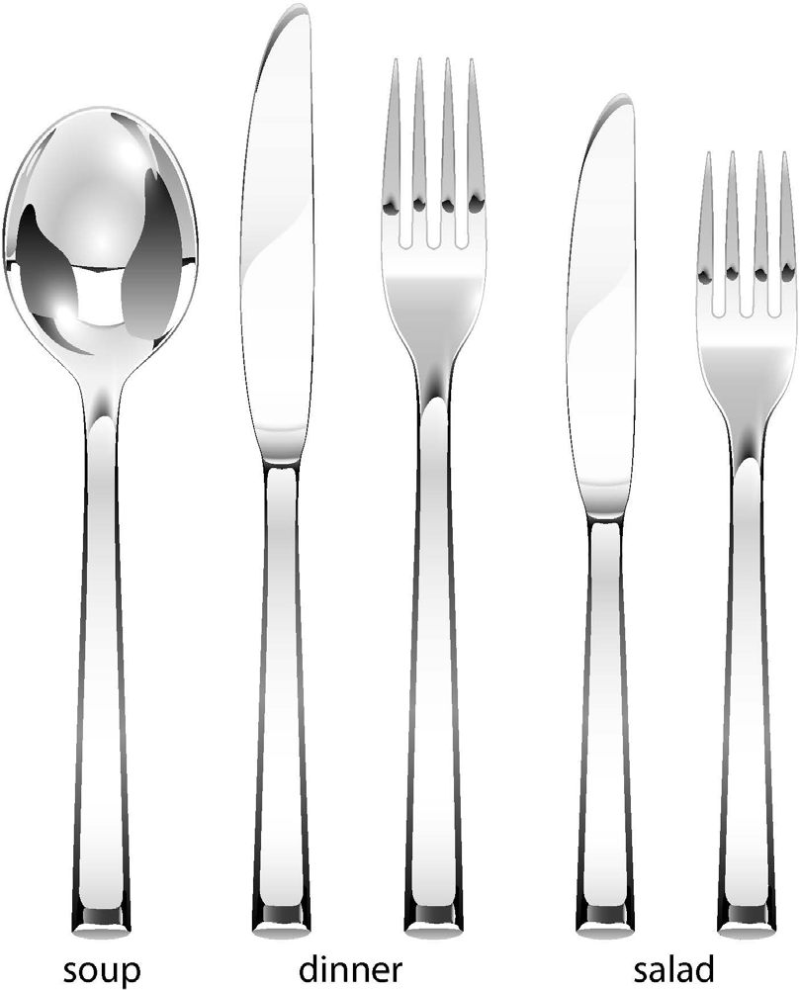

**Create Your Own Place Setting**

© 2015 Personal Impact International

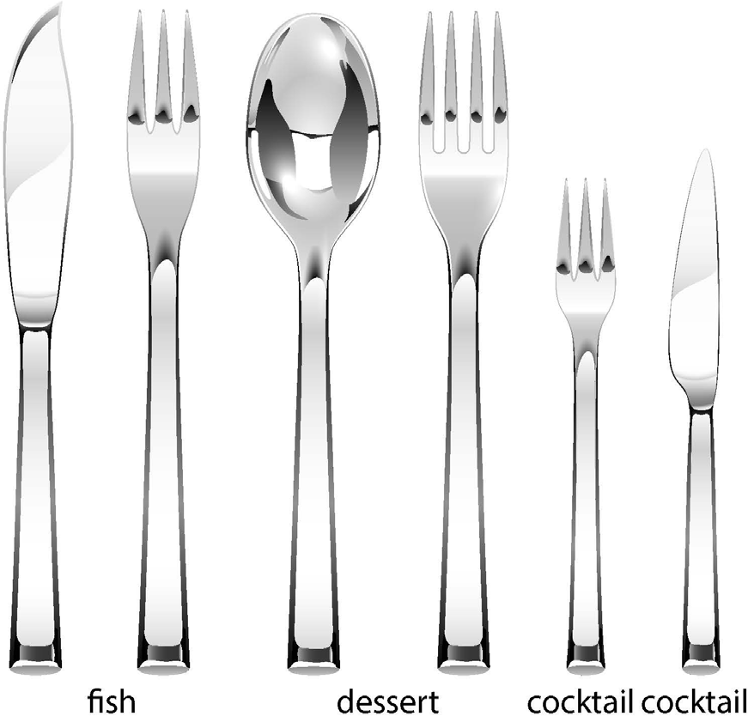

**Create Your Own Place Setting**

© 2015 Personal Impact International

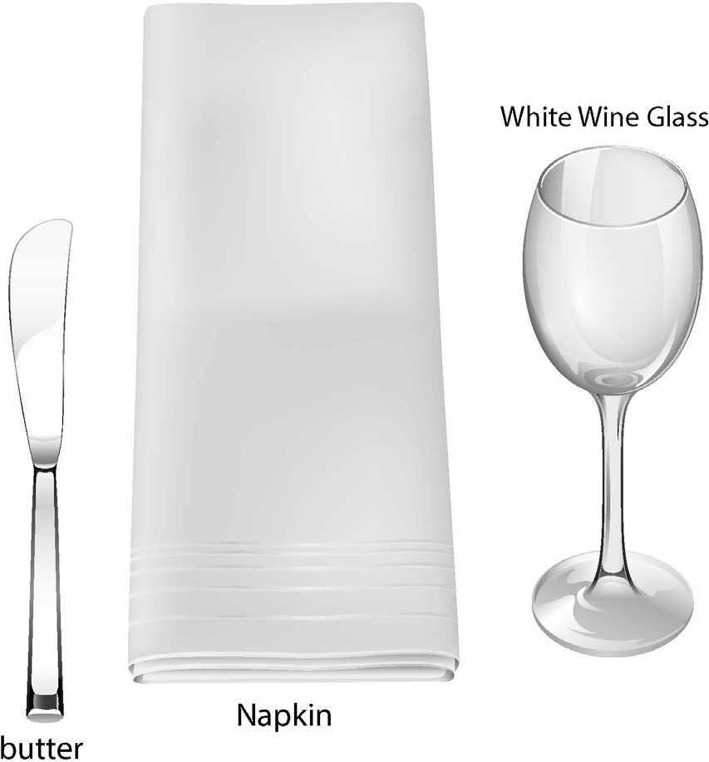

**Create Your Own Place Setting**

© 2015 Personal Impact International

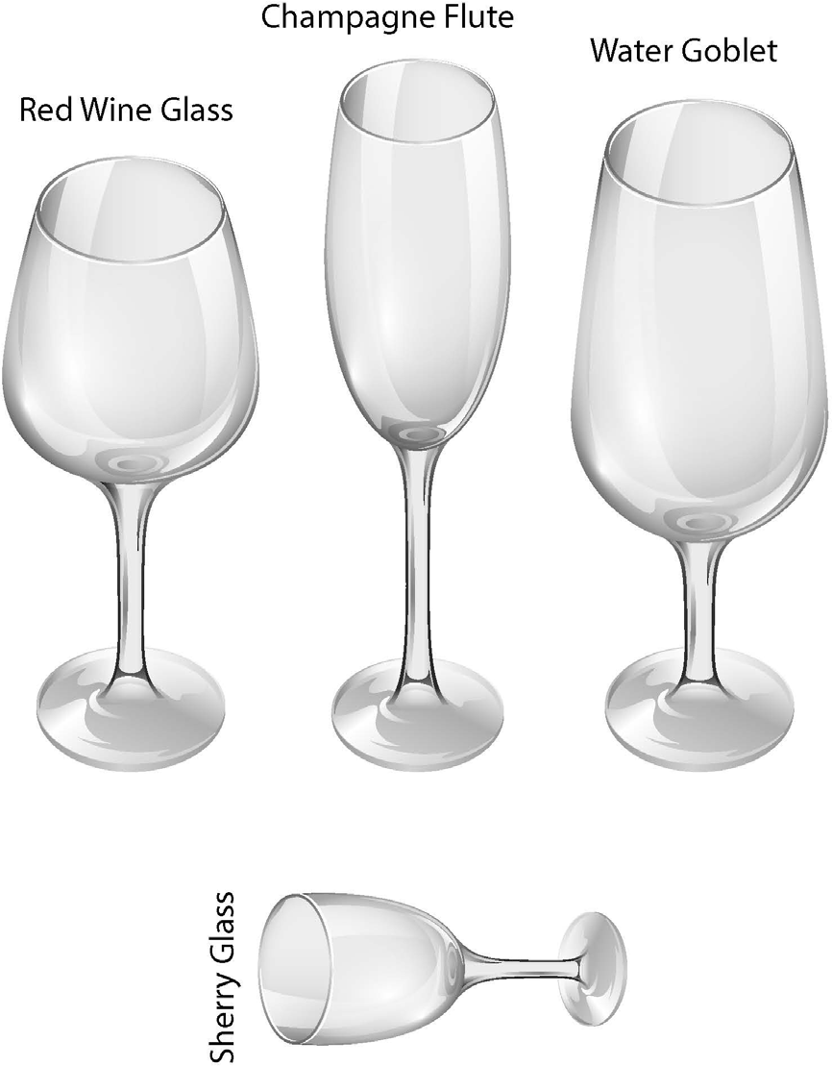

**Create Your Own Place Setting**

© 2015 Personal Impact International



**Create Your Own Place**

**Setting**

© 2015 Personal Impact International

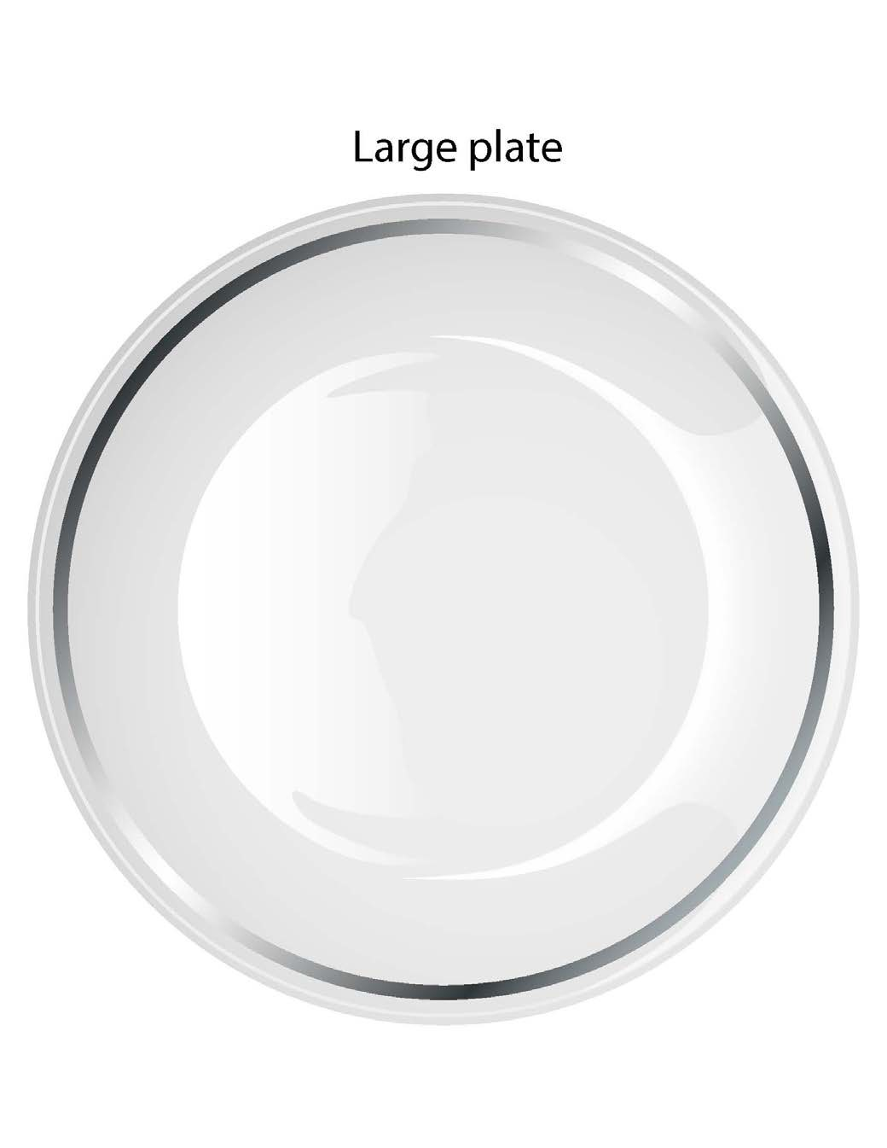

**Create Your Own Place Setting**

© 2015 Personal Impact International