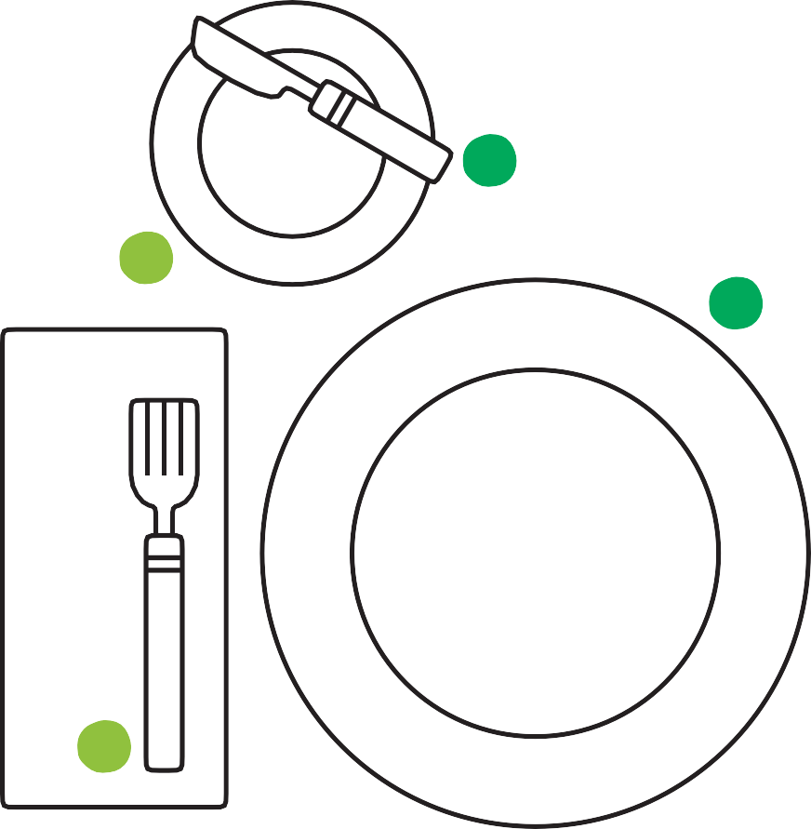

Setting the Table

1

4

7

2

5

8

3

6

9

1

7

8

9

4

5

2

6

3