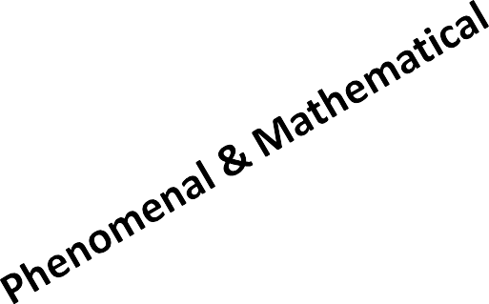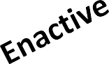

**Theme**

Root Word:

Alternate Names

**Sub-Theme**

**Corresponding term in native**

**language/other languages**

**Concept**

Similar Terms

**Key Word**

**Derived Relationships**

Synonyms:

**Equation(s)**

**DEFINITION**

Antonyms:

Chart/Tables/Flowcharts/Concept Maps

Labs/Mini labs/Inquiry

**Symbol**

**Unit**

Graphs

Real World

Phenomena

**Figures/Pictures**

Resources

for Further Reading

**Possible Projects/Extension**

**Activities**

**Page - 1**

…………………………………

………………………………..

…………………………………………………………………..

………………………………………………………………………………

………………………………………………………………………………

…………………………………………………………………………….

**2nd order**

**Extra order**

**1st Order**

**Characteristics**

**3rd order**