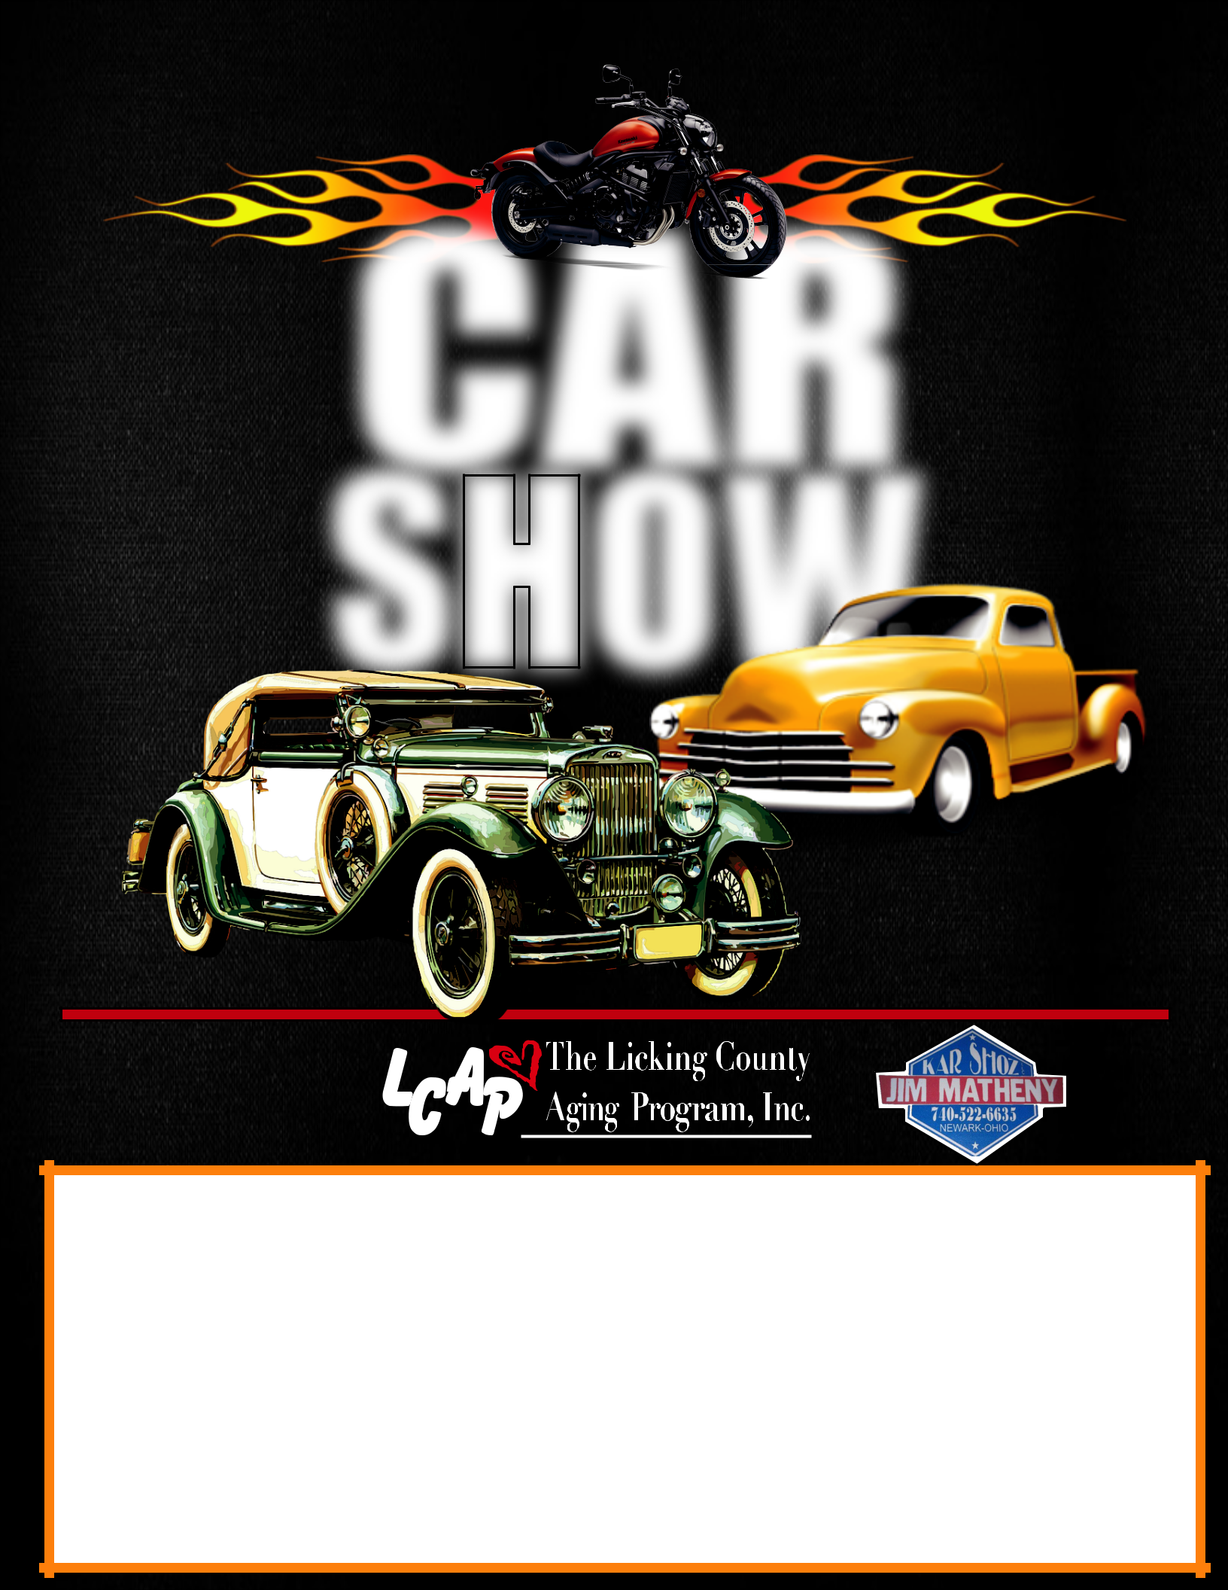
Licking County Aging Program
4th Annual CAR
2018_{SHOW}

Cars
Trucks
Motorcycles

Presented by

DATE: Friday, July 13th, 2018

TIME: 5:00 - 8:00 p.m. (Registration starts at 4 p.m.)

REGISTRATION: $10.00 (Day of Event)

Dash plaques to the rst 100 registered vehicles.

LOCATION: Licking County Aging Program

(Heritage Hall Senior Center) 1058 E. Main Street, Newark For more information visit www.lcap.org

Live DJ, Food Trucks, Awards, Prizes, Kids Activities and more.

 “LCAP Car Show”

