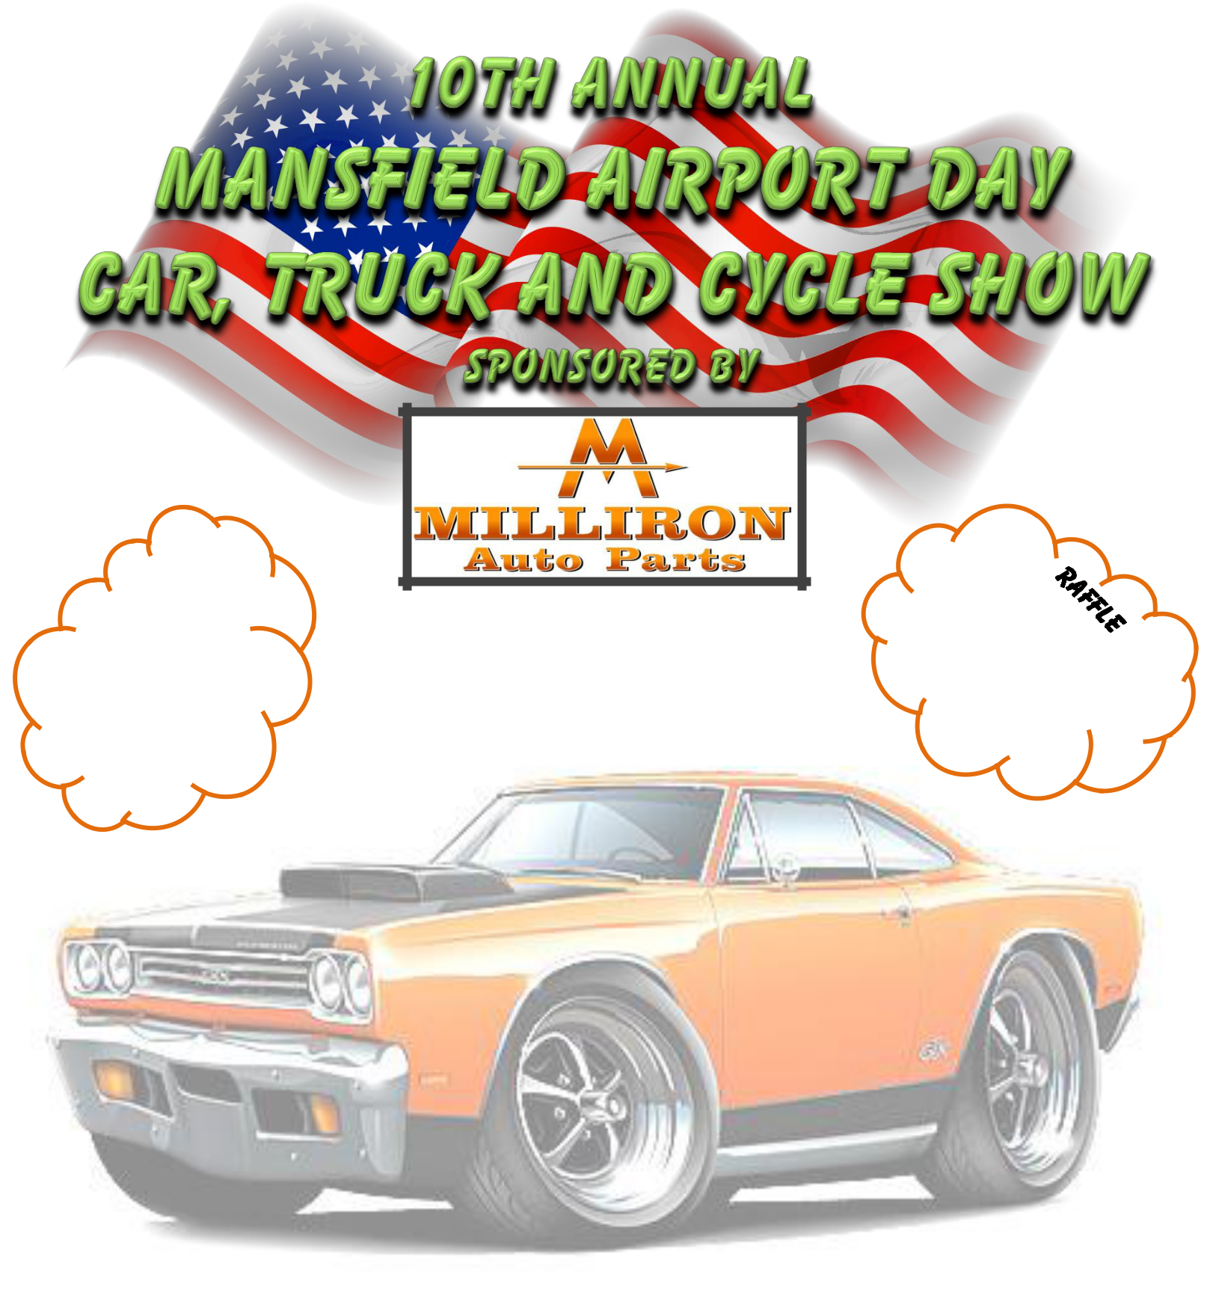

“A Day At The Airport”

Mansfield Lahm Airport

Harrington Memorial Road

Saturday July 6, 2019

Registration 9 – 12 PM

Show Hours 11 – 3 PM

Awards at 2:30 PM

Registration Fee $10.00

$1.00 of Registration Fee goes to the 50/50 draWINg

Each entrant will receive a 50/50 ticket with their registration

125 Dash Plaques
goodie bags to 1st 100 Entries
All Years and Models Welcome

Pancake Breakfast Served from 8 – 11 AM

Lunch Available

Free Airplane Rides for youngsters ages 8 – 17

Proceeds to (Must be accompanied by parent or guardian)
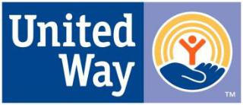

Sign-up at 9:30 am – flights from 10 – 12 pm

For More Information

Contact Ron Odson at 419-756-8100

OF RICHLAND COUNTY Or e-mail: rodson1556@aol.com

Canopies for shade will be allowed on the outer perimeter of the Car Show area or on the grass area only

