Rockford, Michigan’s 43rd Annual
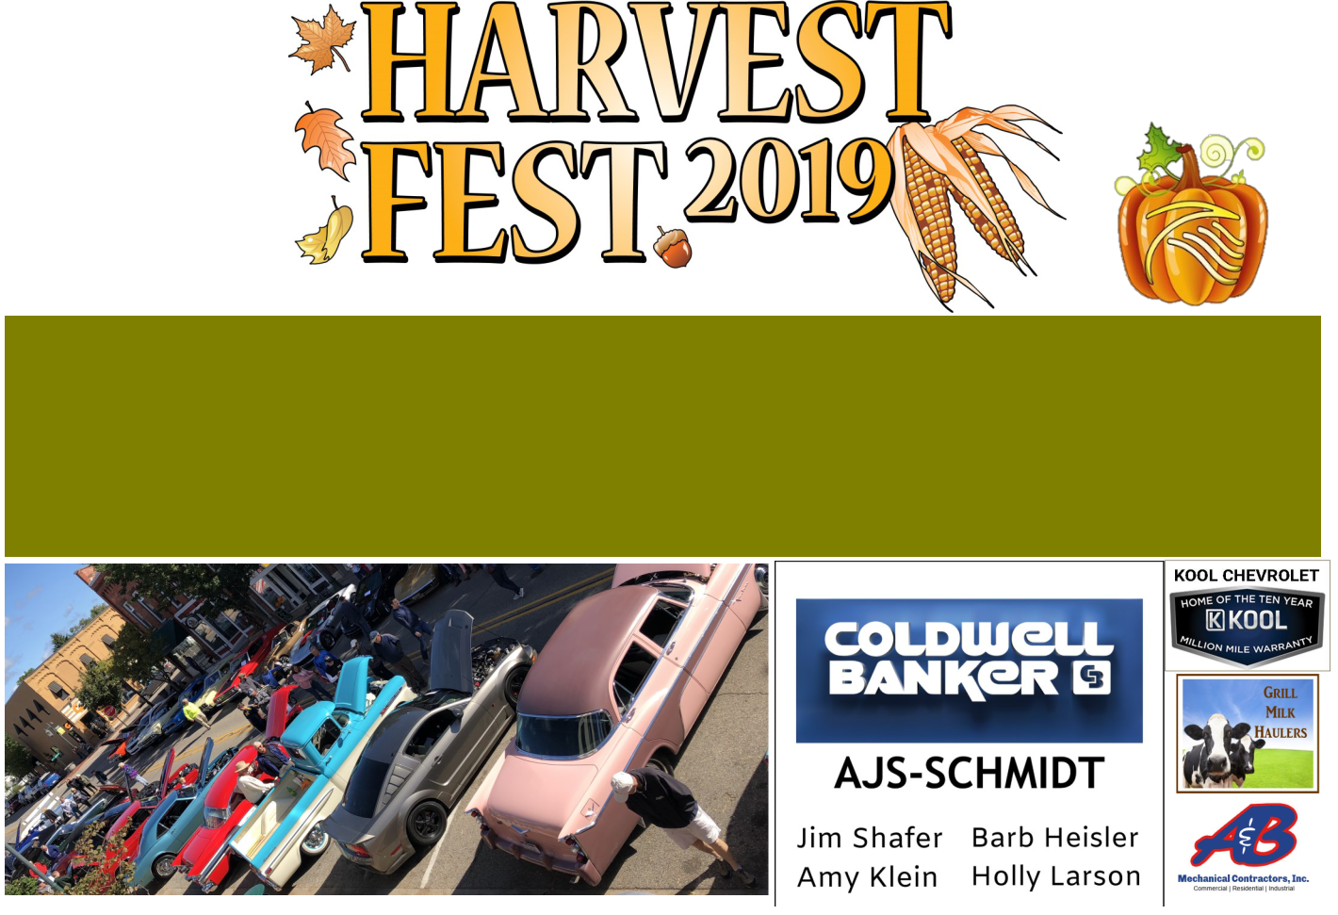

Classic Car Show

Sponsored by:


Saturday, September 28, 2019 Main Street, Downtown Rockford

Registration starts at 9am

Show starts at 10am | Awards presented at 2pm

$10 Entry Fee to benefit

Dash Plaques and Goodie Bags for the first 100 entries—20 Awards!

More information: 616-866-1081 vorpichiro@aol.com

 | Presented by
Pancake Breakfast | Special Photo Ops
8:30am—10:30am @ | with Veterans and
United Methodist Church | their pups all day!

Special Guest

