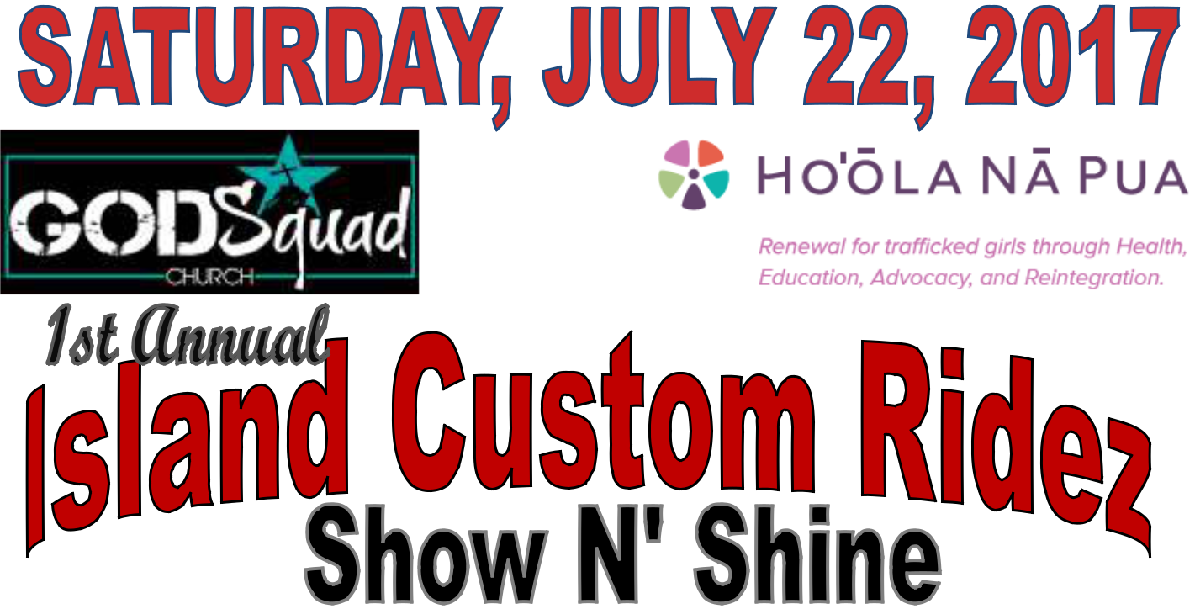

Presents

A Benefit for:

ALL CUSTOM HOT RODS, MUSCLE CARS, CLASSICS, CUSTOM TRUCKS AND CARS, MOTORCYCLES, AND RIGS ARE WELCOME
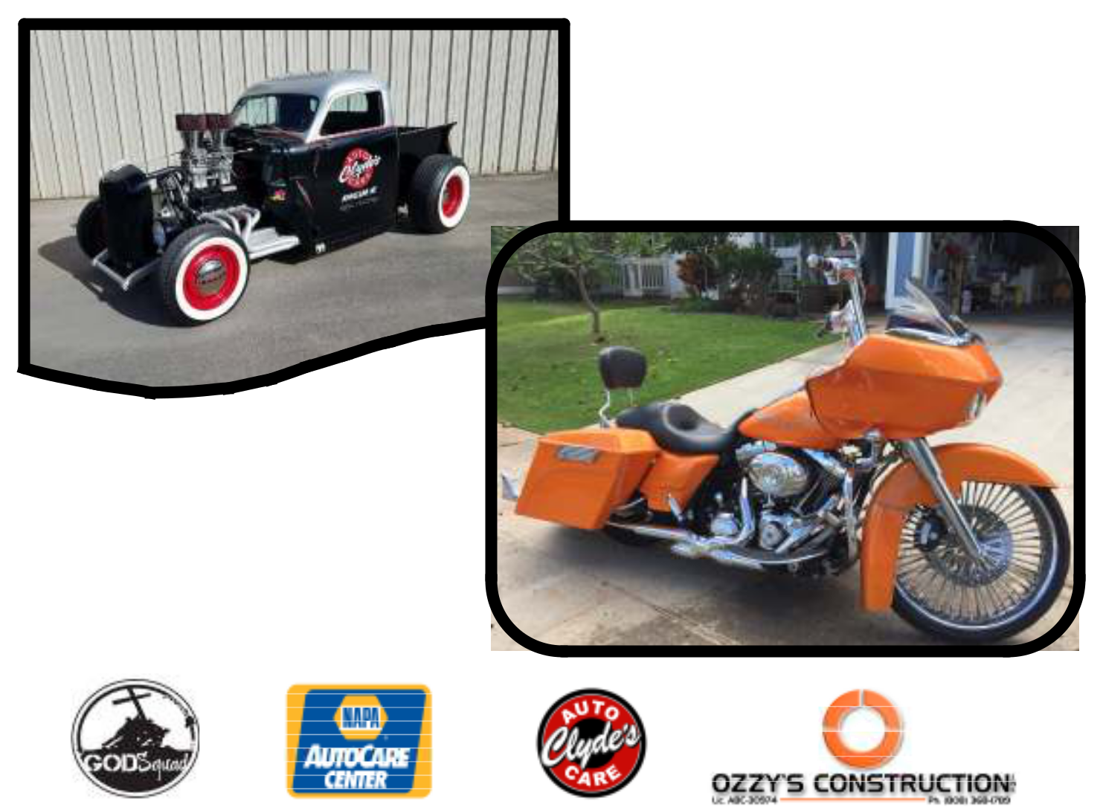

ALOHA STADIUM LOWER PARKING LOT

99-500 Salt Lake Blvd

Aiea, HI. 96701

Show Hours 10am—5pm

LIVE ENTERTAINMENT, FOOD, VENDORS, GAMES,

PETTING ZOO AND RAFFLES FOR EVERYONE

Sponsorship & Vendor Booth Opons

Space is limited—Deadline to register is June 30, 2017

Contact Kiki @ (808) 855-5577 for more informaon o r

email @ infogodsquad@gmail.com

