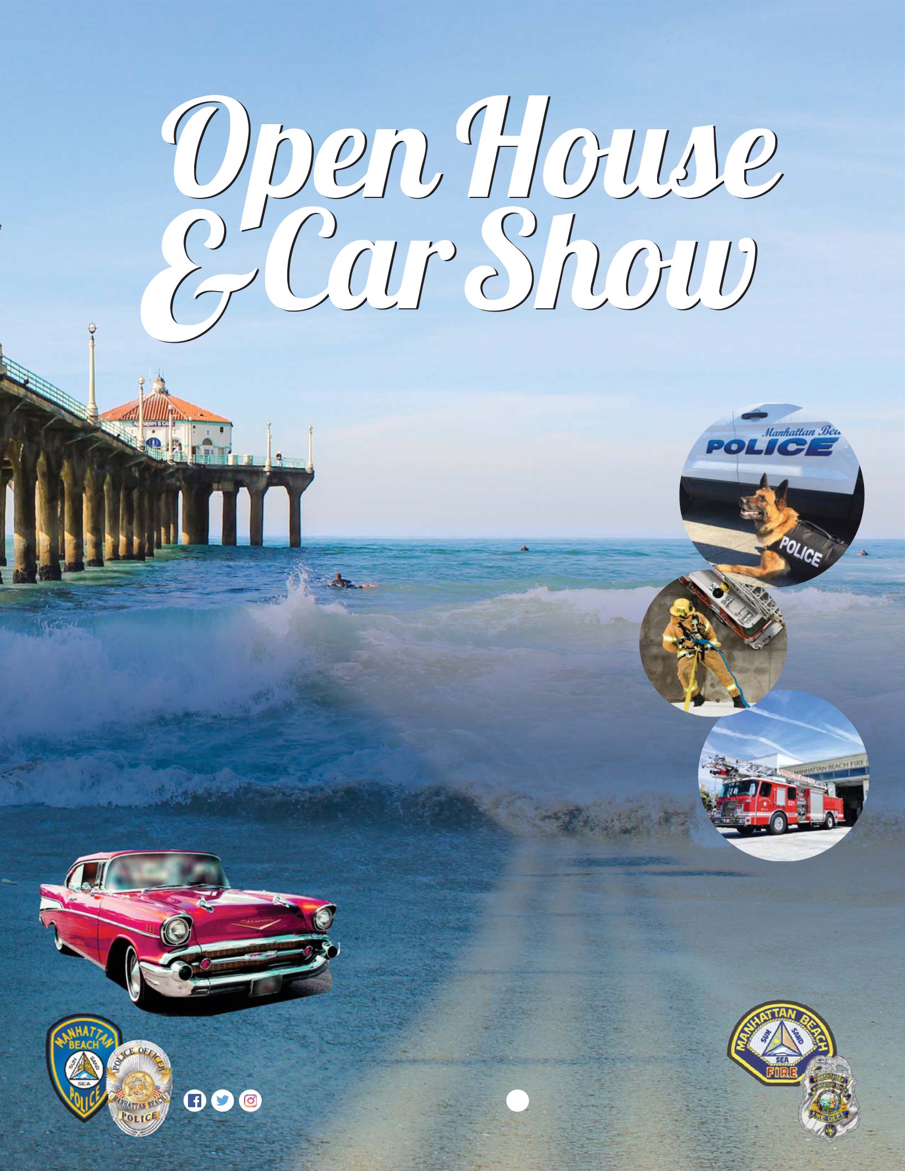
MANHATTAN BEACH POLICE & FIRE DEPARTMENT

SATURDAY, JUNE 1, 2019

10AM - 2PM
Police & Fire Stations

  - 15th Street

- Meet Police Officers & Firefighters

- See Fire Engines, Police SUVs, SWAT van & more

- Jail Tours

- Auto extrication using Jaws of Life

- K9 & SWAT demo

- Photo Opportunities

- Equipment displays, Safety information, donuts & coffee (while supplies last) & more!

Car Show: 8AM - 3PM

No Fee - No Registration

For information, email bcobian@citymb.info

www.citymb.info

 @manhattanbchpd  @manhattanbeachfire

