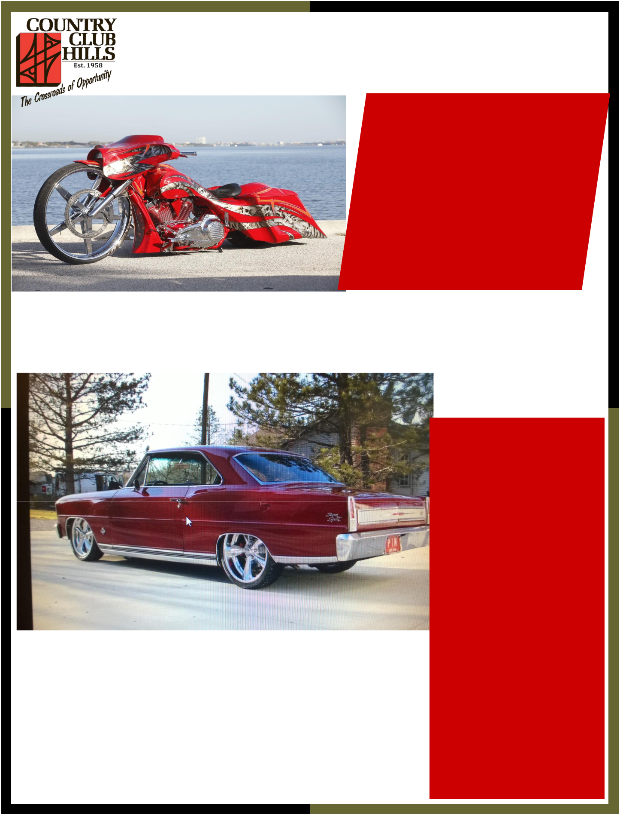
City of County Club Hills

1st Annual Father’s Day Car & Bike Show

FREE TO THE PUBLIC Saturday June 20,2015 12:00pm -6:00pm On-Site & Pre-Registration fee: $20.00 Cars on display only: $5.00

Come out and enjoy fellowship with the community at The City of Country Club Hills First Annual Father’s Day Car & Bike Show. It will be a day of friendly competition, family ,food, fun, activities for the kids, raffles and prizes.

Contacts:

Monique Thurman, Country Club Hills Program Coordinator 708-250-4827

Adrianne Taylor 847-401-1436
Kiev BrownLee, President, Enlightened Riders 773-770-5286

Vendor Opportunities Available
No Alcoholic Beverages Allowed. This is a Family Friendly Event Rain Date: June 27, 2015
Registration taken at Country Club Hills City Hall 4200 w 183rd

Located in the: Country Club Hills Theater Pavilion 4150 W 183rd

·FIRST PLACE

·SECOND PLACE

·THIRD PLACE

·“BEST OF SHOW” CAR

- MOTORCYCLE

·“PEOPLE’S CHOICE”

AWARD FOR CAR &

MOTORCYCLE

